Optical Polarized Orthogonal Matrix
Shujun Zheng^{1,†}, Jiaren Tan^{2,†}, Xianmiao Xu¹, Hongjie Liu¹, Yi Yang³, Xiao Lin³, and Xiaodi Tan^{3,*}
¹ Information Photonics Research Center, College of Photonic and Electronic Engineering, Fujian Normal University, Fuzhou 350117, China
² Faculty of Arts and Science, University of Toronto, Toronto, Ontario, M5S 1A1, Canada;
³ College of Photonic and Electronic Engineering, Key Laboratory of Opto-Electronic Science and for Medicine of Ministry of Education, Fujian Provincial Key Laboratory of Photonics Technology, Fujian Provincial Engineering Technology Research Center of Photoelectric Sensing Application, Fujian Normal University, Fuzhou 350117, China;
* Correspondence: xtan@fjnu.edu.cn
† Equal contribution
This document provides supplementary information to “Optical Polarized Orthogonal Matrix”.

This file includes:

Section 1: The experimental design and setup

Section 1: The experimental design and setup
Table 1 Polarization holography with orthogonal reference waves under fixed signal wave and interference angle
Recording |  | Reading | Reconstructing
Sig. | Ref. | Ref. | Rec. | Rec. (θ=90°)
p | p | s | Acosθs | 0
p | p | p | (A+B)cos²θp+Bp | Bp
p | s | s | Bp | Bp
p | s | p | Bcosθs | 0
Here, A and B represented the intensity and polarization response coefficients of the material, respectively. As illustrated in Table 1, with specific values assigned to the signal wave and interference angle, orthogonal polarized light served as reference wave for recording and reading, resulting in faithful and null reconstruction characteristics. The combination of these two reconstruction characteristics facilitated dual-channel recording and reconstruction ^{S1}. When extending reference waves to include any orthogonally linear polarized lights, as depicted in Table 2 with any real numbers represented by a and b, the results consistently showed 0 when orthogonal polarized lights were used for both recording and reading each other. Otherwise, faithful reconstruction was achieved. Therefore, it was concluded that satisfying orthogonal conditions with multiple groups of polarized lights allowed their utilization as reference waves for recording and reading, facilitating crosstalk-free multichannel polarization holography.
Table 2 Polarization holography with arbitrary orthogonal reference waves under fixed signal wave and interference angle
Recording |  | Reading | Reconstructing
Sig. | Ref. | Ref. | Rec. (θ=90°)
p | ap+bs | bp-as | 0
p | ap+bs | ap+bs | (a²+b²)Bp
p | bp-as | bp-as | (a²+b²)Bp
p | bp-as | ap+bs | 0
Each column vector of the OPOM is mutually orthogonal, making them suitable as the reference waves for recording and reading polarization holograms. The experimental setup was designed as shown in Fig. S1. The light source was a fundamental TEM₀₀ 532 nm laser with a waist radius was approximately 0.75 mm. The beam was divided into s-polarize and p-polarized lights through a polarization beam splitter (PBS). The s-polarized light served as the incident light on the reference wave path, while the p-polarized light served as the signal wave. In the reference wave path, a PBS was employed to separate the beam into s- and p- polarized lights. Subsequently, half wave plates (HWP1 and HWP2) were employed to modulate the polarization state individually. A beam splitter (BS) was then used to generate a parallel beam with two distinct polarization states by non-overlapping. The purpose of the HWP before the PBS was to adjust the components of the s and p polarization after the PBS. Similarly, a BS was employed for beam splitting, while HWP3 and HWP4 were employed to modulate the polarization states. Another BS was employed for non-overlapping beam combining, resulting in parallel beams with four distinct polarization states. By rotating the fast axis positions of HWP1-HWP4, four different polarization states can be designed. As illustrated in Table 3, different the fast axis positions of HWP1-HWP4 allowed for the realization of different polarization combinations on various column vectors of OPOM_{4×8}. In the signal wave path, an amplitude-based spatial light modulation (A-SLM) was employed to modulate the signal images. A 4f imaging system was used to assess image quality. The signal wave, along with the modulated reference wave, was incident into the PQ/PMMA material to create the polarization hologram. After 8 recording cycles, using only the reference wave to illuminate the material, a diffracted beam can be received by a charge-coupled device (CCD detector) in the reconstruction wave path.
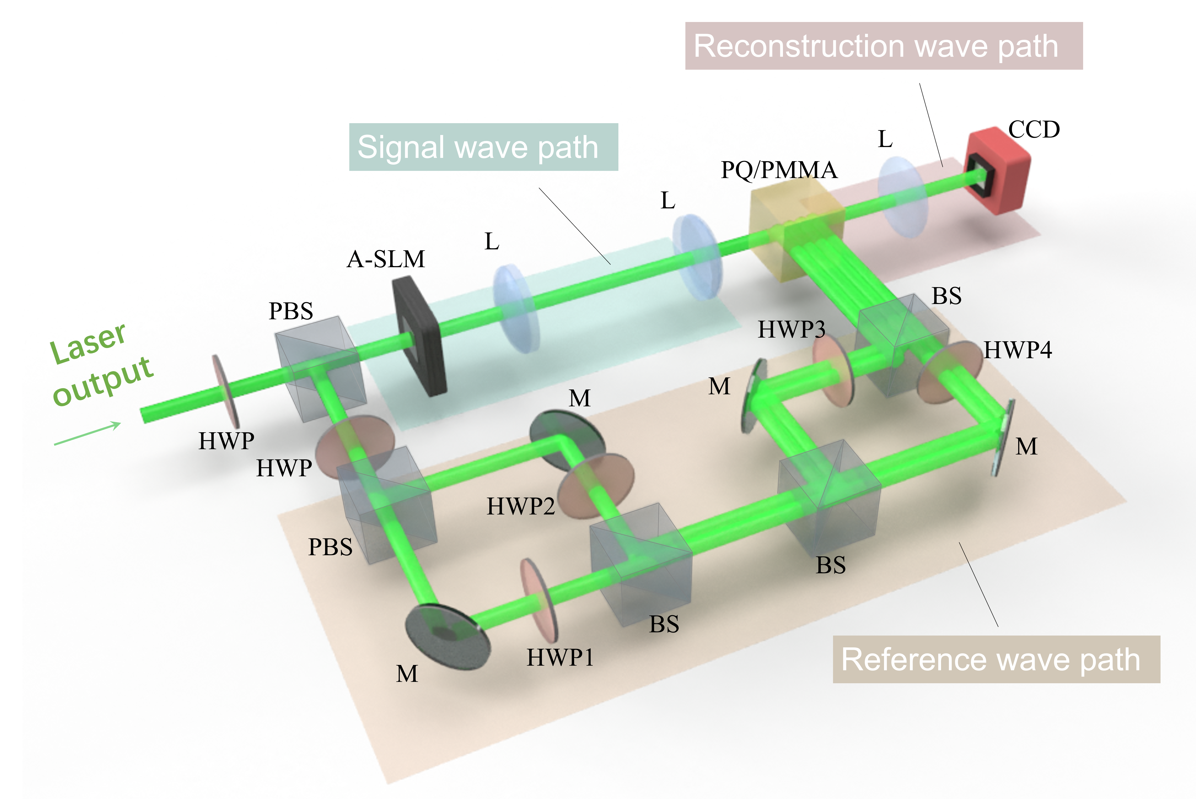
Fig. S1. Experimental setup for multi-dimensional polarization multiplexing. HWP, half wave plate; PBS, polarization beam splitter; M, mirror; L, lens; Bs, beam splitter; A-SLM, amplitude-based spatial light modulator; PQ/PMMA, a photoinduced polymer; CCD, a charge-coupled device.

Table 3 Obtained different PCs according to the different fast axes of HWP1- HWP4
HWP1(°) | HWP2(°) | HWP3(°) | HWP4(°) | Obtained PC
0 | 0 | 45 | 45 | (s, p, s, p)
0 | 0 | 0 | 0 | (p, s, p, s)
0 | 90 | 45 | 45 | (s, -p, s, -p)
0 | 90 | 0 | 0 | (p, -s, p, -s)
0 | 0 | 45 | 135 | (s, p, -s, -p)
0 | 0 | 0 | 90 | (p, s, -p, -s)
0 | 90 | 45 | 135 | (s, -p, -s, p)
0 | 90 | 0 | 90 | (p, -s, -p, s)
References
- Zang, J. et al. Dual-channel recording based on null reconstruction effect of orthogonal linear polarization holography. Opt Lett. 42, 1377 (2017).

