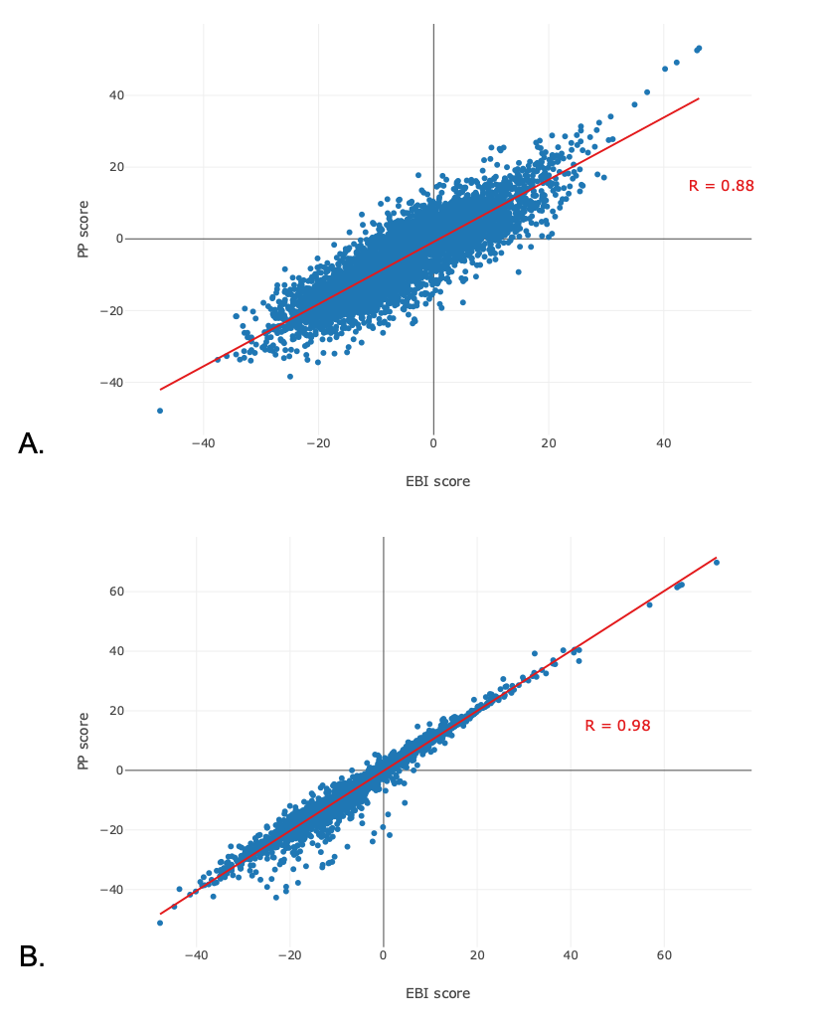
Figure S1: Correlation analysis between prediction scores returned for the eMolecules validation set by the Pipeline Pilot and the internal models trained with the MMV – St. Jude dataset. (A) Training and validation compounds are described with FCFP6 fingerprints only or RDKit equivalent; (B) Training and validation compounds are described with ECFP6 fingerprints only or RDKit equivalement.

