SUPPLEMENTAL MATERIALS
Screening for lung cancer using thin-slice low-dose computed tomography in a Chinese physical examination population: a population-based real-world study

Section1: Specific evaluation criteria and classification criteria based on nodule density............ 2
Section 2: Classification of pulmonary nodules according to the nature.................................3
Section 3: Quality control of the research................................................................................... 4
Figure S1. CT images of nodules with different densities............................................................. 5
Table S1. Lung cancer detection of chest LDCT in different screening result groups of healthy individuals .................................................................................................................................... 6
Table S2. Comparison of lung cancer stages detected by LDCT baseline screening and follow-up in healthy physical examination population..............................................................7
Table S3. Lung cancer screening results of chest LDCT during baseline and follow-up in healthy physical examination population....................................................................................8
Table S4. Stage IA1 Lung cancer screening results of chest LDCT in healthy physical examination population.......................................................................................................................................8
Table S5 Histological types of lung cancer screened by chest LDCT in different tumor stages in healthy physical examination population.......................................................................................9

Section 1 : Specific evaluation criteria and classification criteria based on nodule density
- Definition of solid and subsolid nodules
a) Solid nodule: Round or round-like increased density shadows were found in the lung, and the lesion density was sufficient to mask the walking blood vessels and bronchi.
2) Subsolid nodule: All pulmonary nodules with ground glass density are called subsolid pulmonary nodules. Among them, ground glass lesion refers to the increased density of the lung with clear or unclear boundary on CT, but the density of the lesion is not enough to cover the walking blood vessels and bronchial shadow. Subsolid pulmonary nodules include pure ground-class nodule (pGGN), mixed ground-class nodule (mGGN) with both ground glass density and solid density. The latter is also called part solid nodule. If the lesion does not contain solid components, it is called pGGN; If it contains a solid component, it is called mGGN. CT images of nodules with different densities were shown in Figure S1(A、B、C).
3) Definition of screening negative
It refers to lesions with no abnormal findings or clinical manifestations, such as completely calcified nodules or lesions with obvious clinical manifestations and low probability of malignancy, such as filament shadow, pulmonary interstitial fibrosis, pneumonia, and benign lesions with typical morphology, such as pulmonary cysts.
4) Definition of screening positive
It refers to any lesion that may be malignant, such as non-calcified nodules, masses, soft tissue shadows, patchy hyperdense shadows, obstructive atelectasis, etc., on any level. Pulmonary nodules are focal, quasi-circular, dense solid or subsolid pulmonary shadows that occur in the lungs ≤3 cm in diameter. They can be isolated or multiple, and are not accompanied by pulmonary atelectasis hilar lymph node enlargement, or pleural effusion. Non-calcified nodules with a diameter greater than 3mm were referred to as positive pulmonary nodules.

Section2 : Classification of pulmonary nodules according to the nature:
1) Identified benign nodules or calcified nodules: These nodules have clear boundaries and high density. Diffuse calcification, central calcification, sliceed calcification or popcorn calcification can be seen.
2) Nodules of uncertain nature: Usually non-calcified nodules, this category includes solid nodules, partially solid nodules, and ground glass density nodules. According to the probability of malignancy, the nodules were divided into high-risk nodules, intermediate-risk nodules and low-risk nodules. Different treatment strategies were adopted for nodules with different malignant probability.
a) High-risk nodules include nodules ≥ 15mm in diameter or solid nodules between 8mm and 15mm in diameter that exhibit malignant CT signs (lobular sign, burr sign, pleural indentation sign, bronchial air sign and vacuole sign, eccentric thick-wall cavity, etc.) or partial solid nodules >8mm in diameter. High-risk nodules should be discussed in a multidisciplinary setting involving physicians from various specialties including respiratory medicine, thoracic surgery, oncology, and radiology. This discussion aims to determine whether further examinations such as enhanced CT scans or positron emission tomography (PET)-CT scans are necessary, or if invasive procedures such as bronchoscopy and percutaneous lung biopsy are required for definitive diagnosis, and to decide on the appropriate treatment approach.
b) Intermediate-risk nodules include solid nodules with a diameter between 5 mm and 15 mm, without apparent malignant CT features, or partially solid nodules with a diameter less than 8 mm, or ground-glass opacity nodules with a diameter greater than 5 mm. Once medium-risk nodules are found, they need to be re-examined 3 months later to follow up the growth changes of lung nodules. If there are growth signs such as enlarged diameter and increased solid components, high-risk nodules will be included in the treatment; if there are no growth signs, follow-up should be continued.
c) Low-risk nodules include solid nodules <5mm in diameter or ground glass density nodules <5mm in diameter. It is recommended to follow up after 1 year. If there are signs of growth such as an increase in diameter or an increase in the solid component of the nodule, it should be considered as a high-risk nodule for management. If there are no signs of growth, annual follow-up is suggested.

Section3: Quality control
1 Composition and Division of Labor
1）Data recorder：The staff of the health Management Center of our hospital conducted a baseline investigation on the subjects who came to our center for physical examination, and strictly screened the enrolled people according to the inclusion and exclusion criteria and signed the informed consent. The data recorders compile the baseline screening results and promptly call the screened individuals based on the follow-up plan determined by the screening results, ensuring completion of subsequent follow-up and annual review tasks.
2）Statistical analyst：The data were collated and statistically analyzed by the full-time scientific researchers of the health Management Center of our hospital.
2 Data collection and management
1) Data entry: Baseline database, longitudinal follow-up database and follow-up review database were established. The data entry work is in the charge of special personnel, and double input is implemented. For inconsistent results, the original questionnaire is checked and corrected in time.
2) Data cleaning and feedback: The data cleaning work shall be carried out in a phased manner. According to the completion of data entry, the missing value, extreme value and logical verification shall be carried out in time, the data problems shall be timely reported to the on-site data recording personnel, and the results shall be re-investigated and re-modified, confirmed and entered when necessary

Figure S1 CT images of nodules with different densities

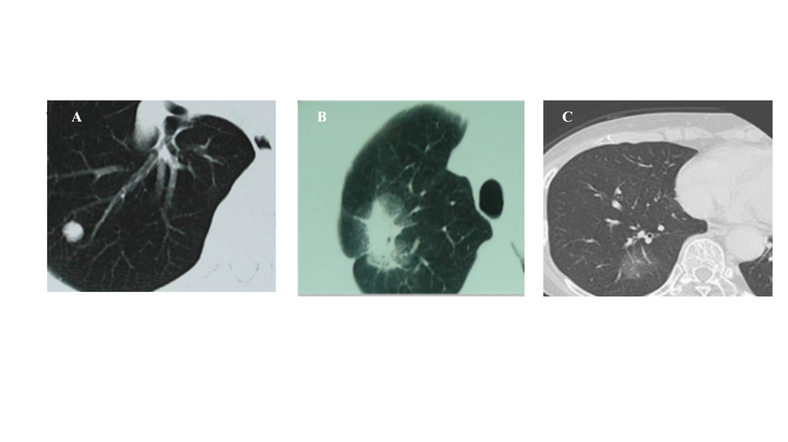
Figure S1. A Solid nodules of the right lung B Partial solid nodules of the right lung C Pure ground glass nodules of right lung

A. Solid nodules of the right lung
B. Partial solid nodules of the right lung
C. Pure ground glass nodules of right lung

Supplementary table 1. Lung cancer detection of chest LDCT in different screening result groups of healthy individuals.
Characteristics | thin-slice (%) | thick-slice (%) | P-value
Characteristics | (N=132) | (N=121) | P-value
Number of lung cancers detected |  |  | < 0.001
Screening positive | 103 (78.0) | 64 (52.9)
Screening negative | 21 (32.0) | 57 (47.1)

Supplementary table 2. Comparison of lung cancer stages detected by LDCT baseline screening and follow-up in healthy physical examination population
Stage | Thin-slice |  |  |  | Thick-slice
Stage | Number of lung cancers detected by baseline screening | Number of lung cancers detected at follow-up | Total |  | Number of lung cancers  detected by baseline screening | Number of lung  cancers detected  at follow-up | Total
Stage | (N=87) | (N=45) | (N=132) |  | (N=65) | (N=56) | (N=121)
Stage
IA1 | 39/86 (45.3) | 26/40 (65.0) | 65/126 (51.6) |  | 24/61 (39.3) | 24/51 (47.1) | 48/112 (42.9)
IA2 | 30/86 (34.9) | 11/40 (27.5) | 41/126 (32.5) |  | 28/61 (45.9) | 17/51 (33.3) | 45/112 (40.2)
IA3 | 10/86 (11.6) | 2/40 (5.0) | 12/126 (9.5) |  | 5/61 (8.2) | 6/51 (11.8) | 11/112 (9.8)
IB | 6/86 (7.0) | 0/40 (0.0) | 6/126 (4.8) |  | 1/61 (1.6) | 2/51 (3.9) | 3/112 (2.7)
II | 1/86 (1.2) | 0/40 (0.0) | 1/126 (0.8) |  | 0/61 (0.0) | 1/51 (2.0) | 1/112 (0.9)
III | 0/86 (0.0) | 1/40 (2.5) | 1/126 (0.8) |  | 2/61 (3.3) | 1/51 (2.0) | 3/112 (2.7)
IV | 0/86 (0.0) | 0/40 (0.0) | 0/126 (0.0) |  | 1/61 (1.6) | 0/51 (0.0) | 1/112 (0.9)

Supplementary table 3. Lung cancer screening results of chest LDCT during baseline and follow-up in healthy physical examination population.
Characteristics | thin-slice (%) | thick-slice (%) | P-value
Characteristics | (N=132) | (N=121) | P-value
Number of lung cancers detected |  |  | 0.048
Number of lung cancers detected at baseline | 87 (65.9) | 65 (53.7)
Number of lung cancers detected at follow-up | 45 (34.1) | 56 (46.3)

Supplementary table4. Stage IA1 Lung cancer screening results of chest LDCT in healthy physical examination population
Characteristics | thin-slice (%) | thick-slice (%) | P-value
Characteristics | (N=65) | (N=48) | P-value
Number of stage IA1 lung cancers detected |  |  | 0.290
Number of stage IA1 lung cancers detected at baseline | 39 (60.0) | 24 (50.0)
Number of stage IA1 lung cancers detected at follow-up | 26 (40.0) | 24 (50.0)

Supplementary table5. Histological types of lung cancer screened by chest LDCT in different tumor stages in healthy physical examination population
Histological types | Total | Stage
Histological types | Total | IA |  |  | IB | II | III | IV
Histological types | Total | IA1 | IA2 | IA3
Thin-slice
adenocarcinoma | 112 | 59/109 (54.1) | 33/109 (30.3) | 10/109 (9.2) | 6/109 (5.5) | 0/109 (0.0) | 1/109 (0.9) | 0/109 (0.0)
Squamous carcinoma | 3 | 0/1 (0.0) | 0/1 (0.0) | 0/1 (0.0) | 0/1 (0.0) | 1/1 (100.0) | 0/1 (0.0) | 0/1 (0.0)
Small cell carcinoma | 2 | 1/2 (50.0) | 0/2 (0.0) | 1/2 (50.0) | 0/2 (0.0) | 0/2 (0.0) | 0/2 (0.0) | 0/2 (0.0)
Other types | 15 | 5/14 (35.7) | 8/14 (57.1) | 1/14 (7.1) | 0/14 (0.0) | 0/14 (0.0) | 0/14 (0.0) | 0/14 (0.0)
Total | 132 | 65/126 (51.6) | 41/126 (32.5) | 12/126 (9.5) | 6/126 (4.8) | 1/126 (0.8) | 1/126 (0.8) | 0/126 (0.0)
Thick-slice
adenocarcinoma | 82 | 31/79 (39.2) | 34/79 (43.0) | 9/79 (11.4) | 0/79 (0.0) | 1/79 (1.3) | 3/79 (3.8) | 1/79 (1.3)
Squamous carcinoma | 8 | 1/5 (20.0) | 2/5 (40.0) | 1/5 (20.0) | 1/5 (20.0) | 0/5 (0.0) | 0/5 (0.0) | 0/5 (0.0)
Small cell carcinoma | 4 | 1/2 (50.0) | 1/2 (50.0) | 0/2 (0.0) | 0/2 (0.0) | 0/2 (0.0) | 0/2 (0.0) | 0/2 (0.0)
Other types | 27 | 15/26 (57.7) | 8/26 (30.8) | 1/26 (3.8) | 2/26 (7.7) | 0/26 (0.0) | 0/26 (0.0) | 0/26 (0.0)
Total | 121 | 48/112 (42.9) | 45/112 (40.2) | 11/112 (9.8) | 3/112 (2.7) | 1/112 (0.9) | 3/112 (2.7) | 1/112 (0.9)

