Supplementary Figures
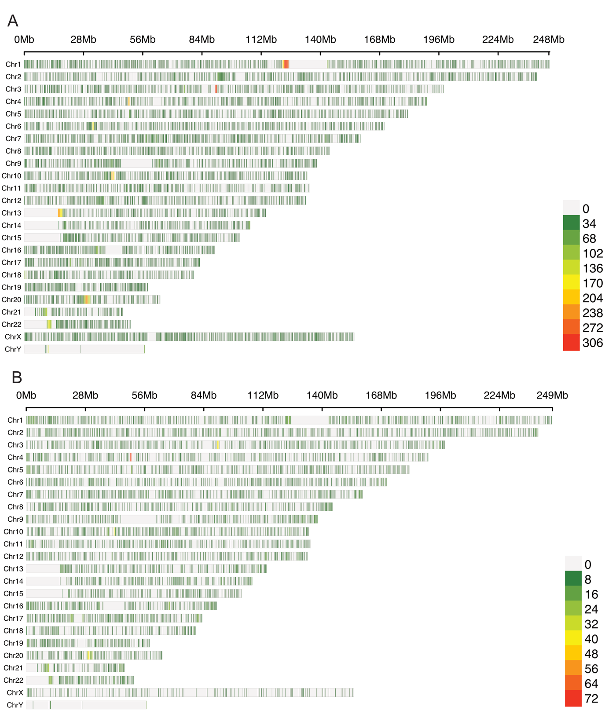
Figure S1. Density of de novo mutations. (A) SNPs density plot. (B) InDels density plot. the window size is 1e6. In the set window, the number of mutations is represented by different colors, ranging from green to red to indicate increasing quantities, while gray indicates a count of zero.

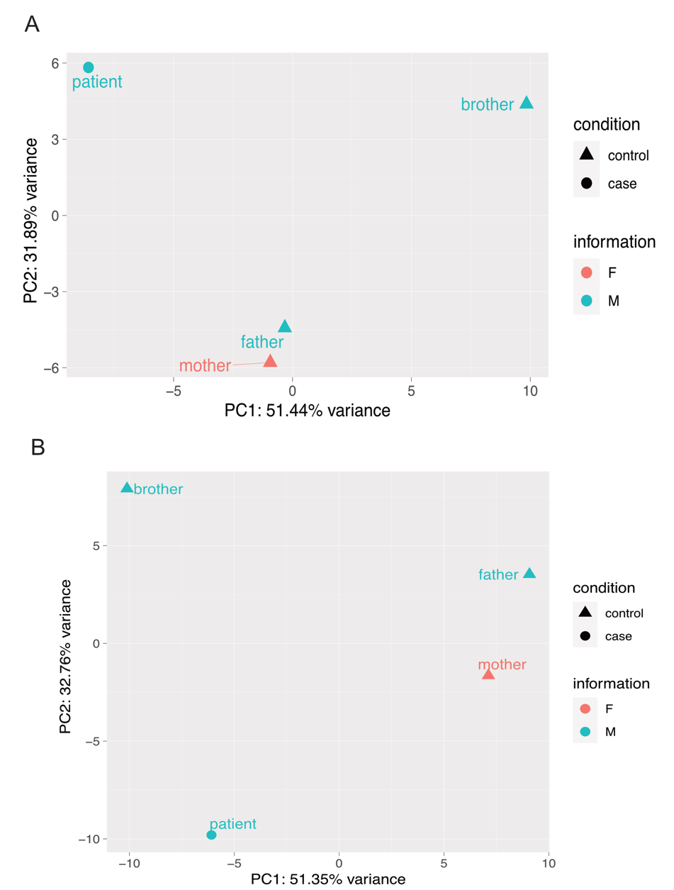
Figure S2. Principal Component Analysis (PCA) analysis of gene (A) or micro-RNA (miRNA) expression (B) across different samples. Triangles represent control healthy samples; circles represent case samples. Red indicates female, and blue indicates male.

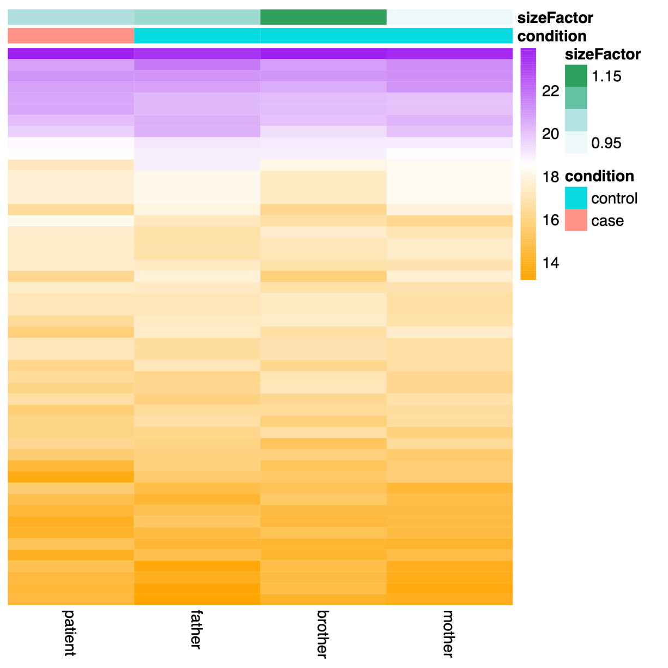
Figure S3. The top 50 differentially expressed miRNAs profile. Each column represents patient and patient-relative samples. Red indicates females, blue indicates males. The size of the factors is represented by shades of green, where expression levels range from high (purple) to low (orange).

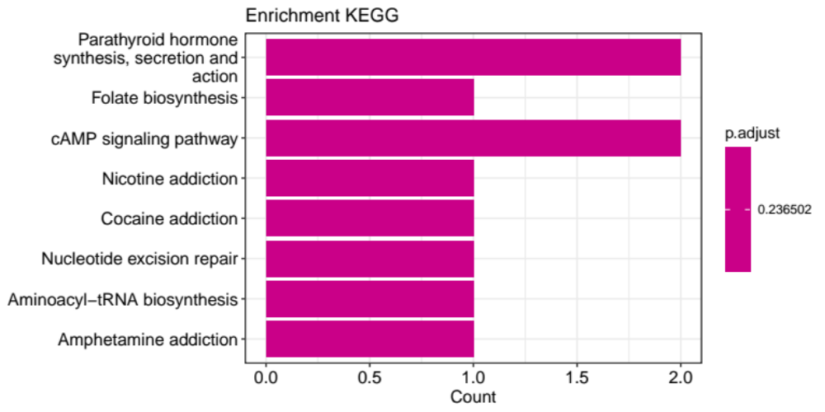
Figure S4. The KEGG pathway enrichment analysis results. The x-axis represents the number of differentially expressed genes in each pathway, while the y-axis shows the description information of the enriched pathways. Adjusted p-value is 0.236502.

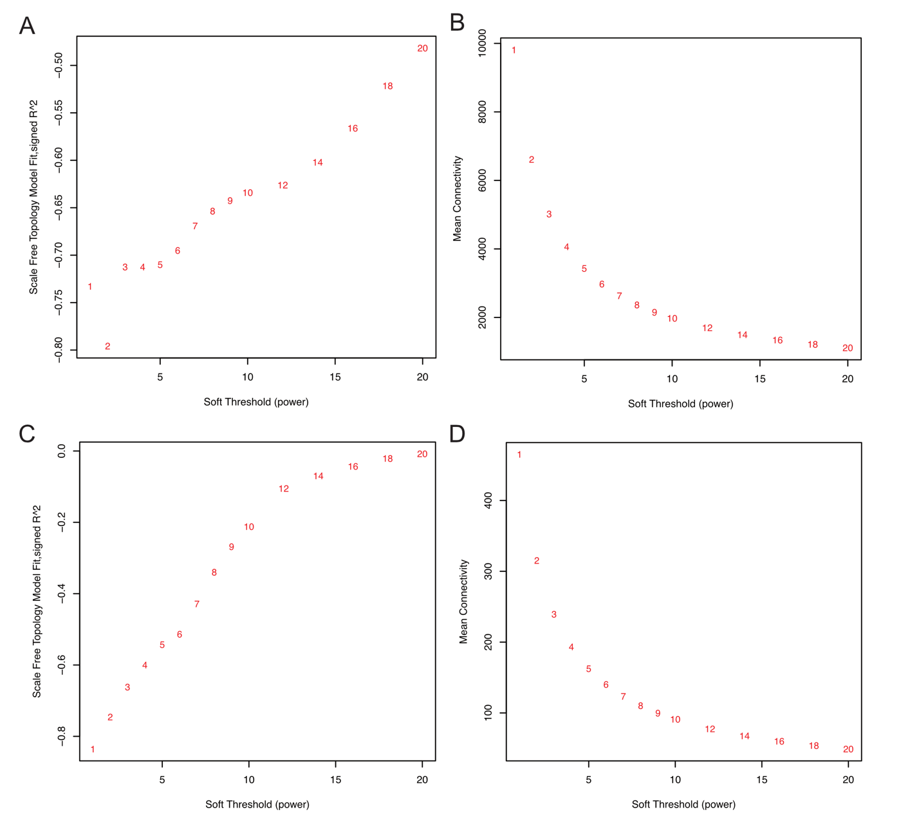
Figure S5. Analysis of network topology for various soft-thresholding powers. (A) Scale independence of gene expression profile. (B) Mean connectivity of gene expression profile. (C) Scale independence of miRNA expression profile. (D) Mean connectivity of miRNA expression profile. The left panel shows the scale-free fit index (y-axis) as a function of the soft-thresholding power (x-axis). The right panel displays the mean connectivity (degree, y-axis) as a function of the soft-thresholding power (x-axis).

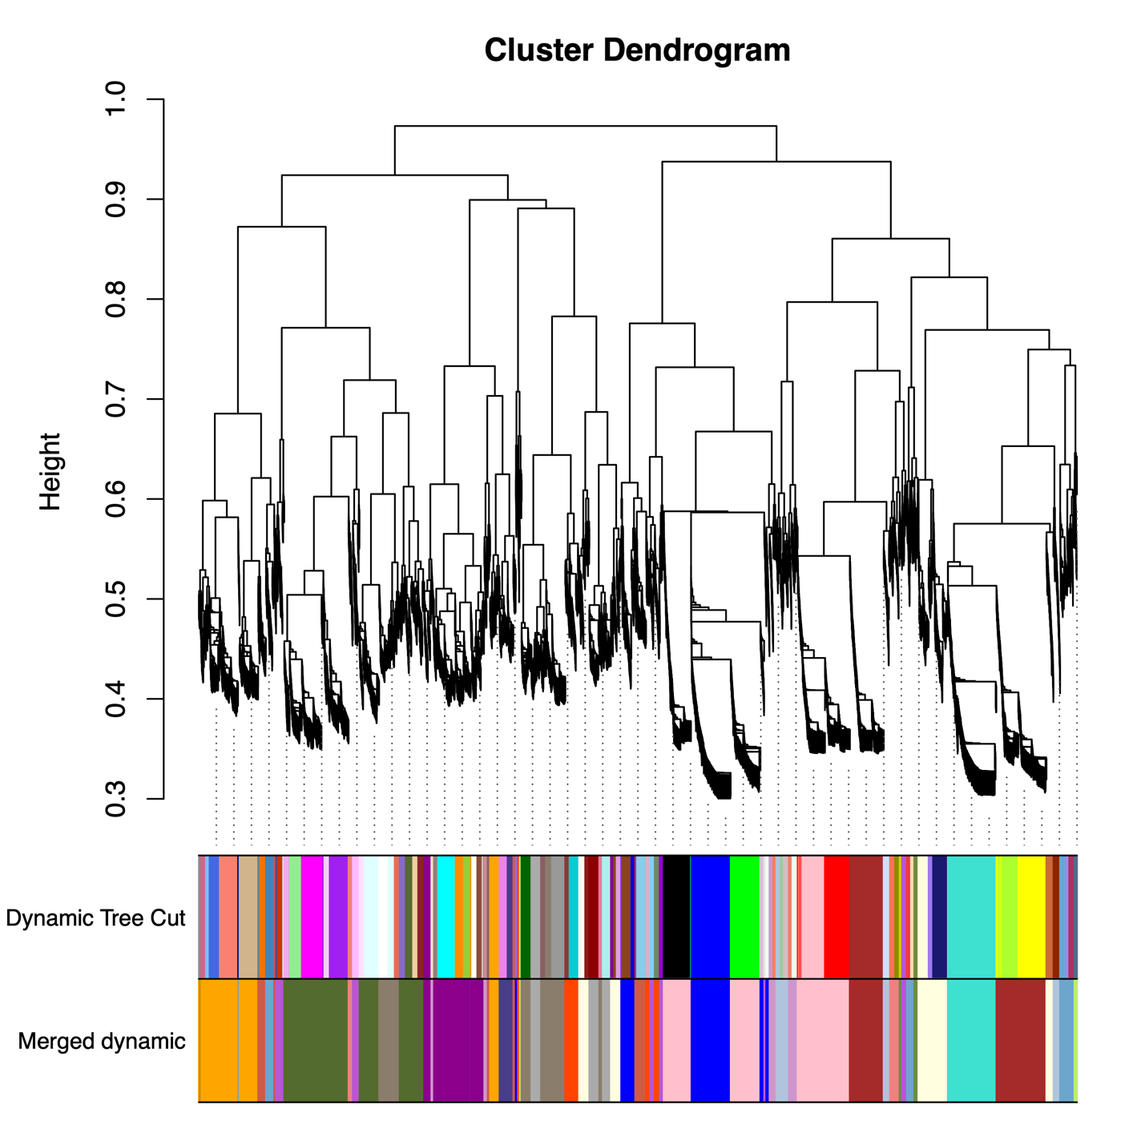
Figure S6. Cluster Dendrogram. Gene dendrogram obtained by average linkage hierarchical clustering. The color row underneath the dendrogram shows the module assignment determined by the Dynamic Tree Cut.

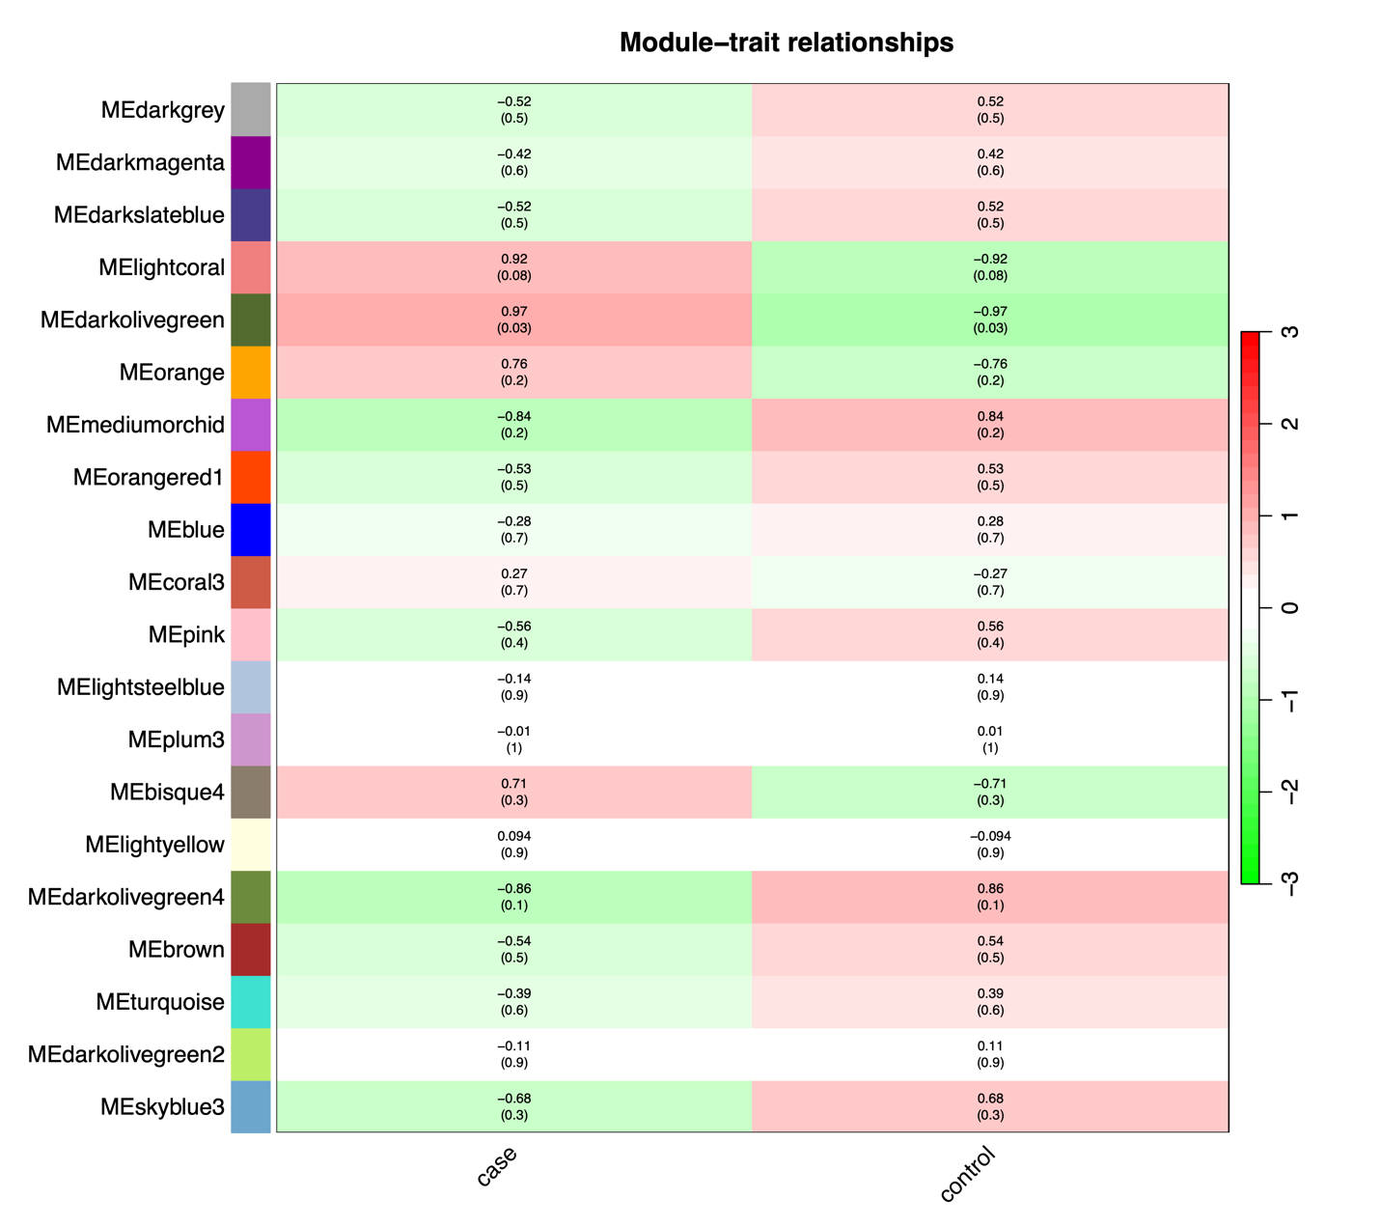
Figure S7. Module-trait associations. Each row corresponds to a module eigengene, column to a trait. Each cell contains the corresponding correlation and p-value. The table is color-coded by correlation according to the color legend.

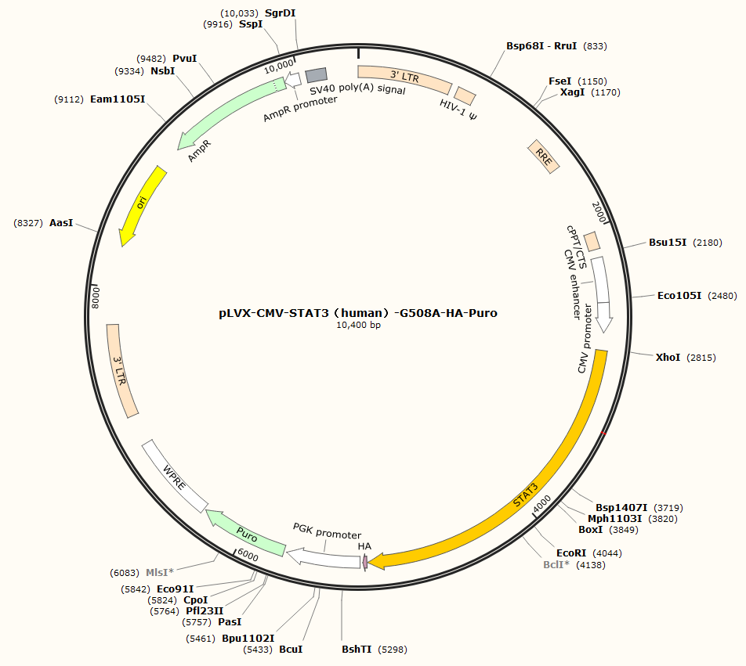
Figure S8. The lentiviral expression vector (pLVX-CMV-STAT3-G508A-HA-Puro) is depicted, with the inserted STAT3c.508G>A fragment highlighted in orange.

