Supplementary File: Chromosomal aberrations and early mortality in a non-mammalian vertebrate: example from triploid-induced Atlantic salmon (Salmo salar)
Table S1: Results and model selection of the Generalized Linear Mixed Models (Experiment 1) and Generalized Linear Models (Experiment 2), testing the incidence of triploids and aneuploids across hydrostatic pressure treatments, families, and developmental stages (eyed egg or parr). ΔAIC reports the difference in AIC when compared to the retained model (in bold).
Experiment 1
Sample size |  |  | Fixed effects |  |  | Random effects
Egg | Parr | Response | Pressure | Family | Stage | Replicate | AIC |  | ΔAIC
437 | 1,098 | Triploid* | x | x | x | x | 459.7
 |  |  |  | x | x | x | 485.6 |  | 25.9
 |  |  | x |  | x | x | 642.6 |  | 182.9
 |  |  | x | x |  | x | 533.3 |  | 73.6
 |  | Aneuploid | x | x | x | x | 663.2
 |  |  |  | x | x | x | 672.2 |  | 9.0
 |  |  | x |  | x | x | 685.0 |  | 21.8
 |  |  | x | x |  | x | 811.5 |  | 148.3
Experiment 2
Sample size |  |  | Fixed effects
Egg | Parr | Response | Pressure | Family | Stage |  | AIC |  | ΔAIC
470 | 2,179 | Triploid | x | x | x |  | 348.3
 |  |  |  | x | x |  | 3637.2 |  | 3288.9
 |  |  | x |  | x |  | 385.2 |  | 36.9
 |  |  | x | x |  |  | 399.1 |  | 50.8
 |  | Aneuploid | x | x | x |  | 567.4
 |  |  |  | x | x |  | 571.5 |  | 4.1
 |  |  | x |  | x |  | 616.6 |  | 49.2
 |  |  | x | x |  |  | 678.3 |  | 110.9
* Model convergence problem in the initial model due to quasi-complete separation. This model was run after dropping the 0 PSI pressure treatment.

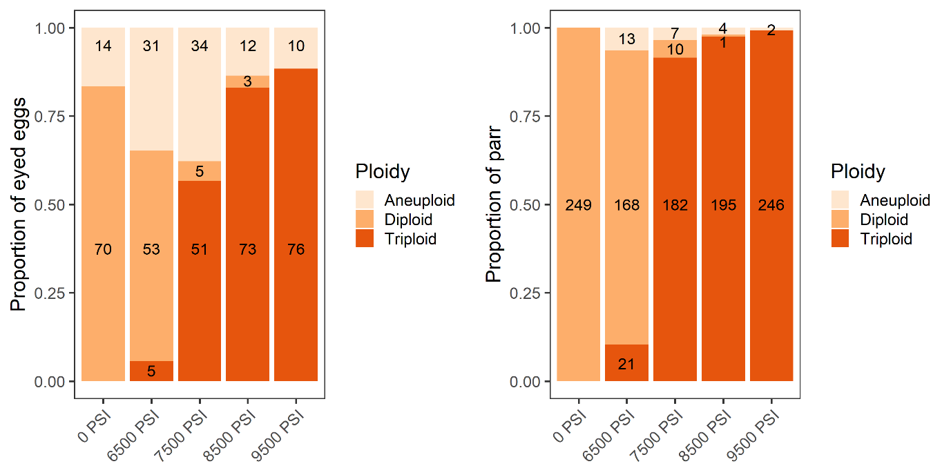
Supplementary Figure 1: The proportion of eyed eggs (N=437) and surviving parr (N=1,098) from three families (pooled) subjected to five hydrostatic pressure treatments in Experiment 1 categorised as diploids, triploids, or aneuploids based on microsatellite analysis. Numbers of individuals in each group are shown.

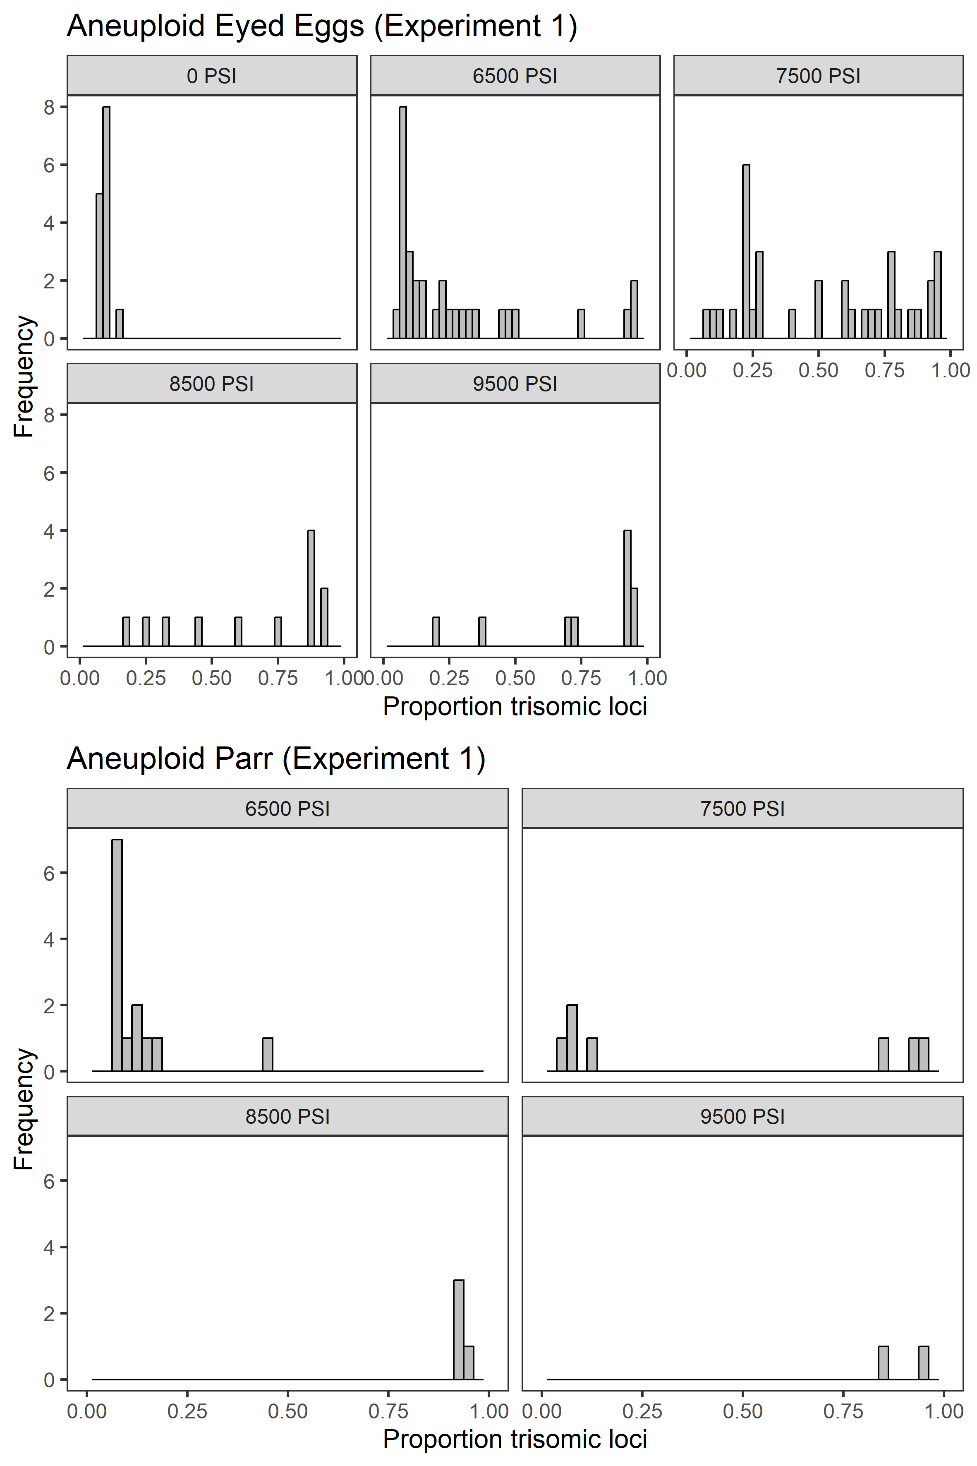
Supplementary Figure 2: Proportion of heterozygotic loci displaying trisomy among aneuploid eyed eggs (top) subjected to five hydrostatic pressure treatments (Experiment 1), and among surviving aneuploid parr (bottom).

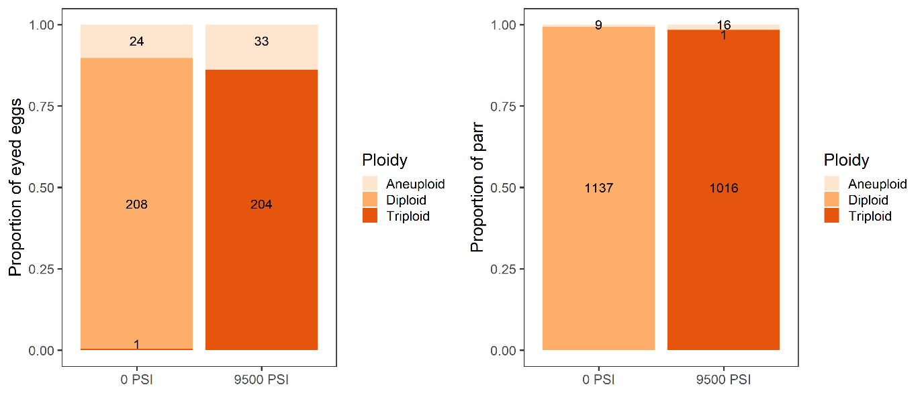
Supplementary Figure 3: The proportion of eyed eggs (N=470) and surviving parr (N=2,179) from 12 families (pooled) subjected to standard diploid (0 PSI) and triploid (9500 PSI) pressure treatments in Experiment 2 categorised as diploids, triploids, or aneuploids based on microsatellite analysis. Numbers of individuals in each group are shown.

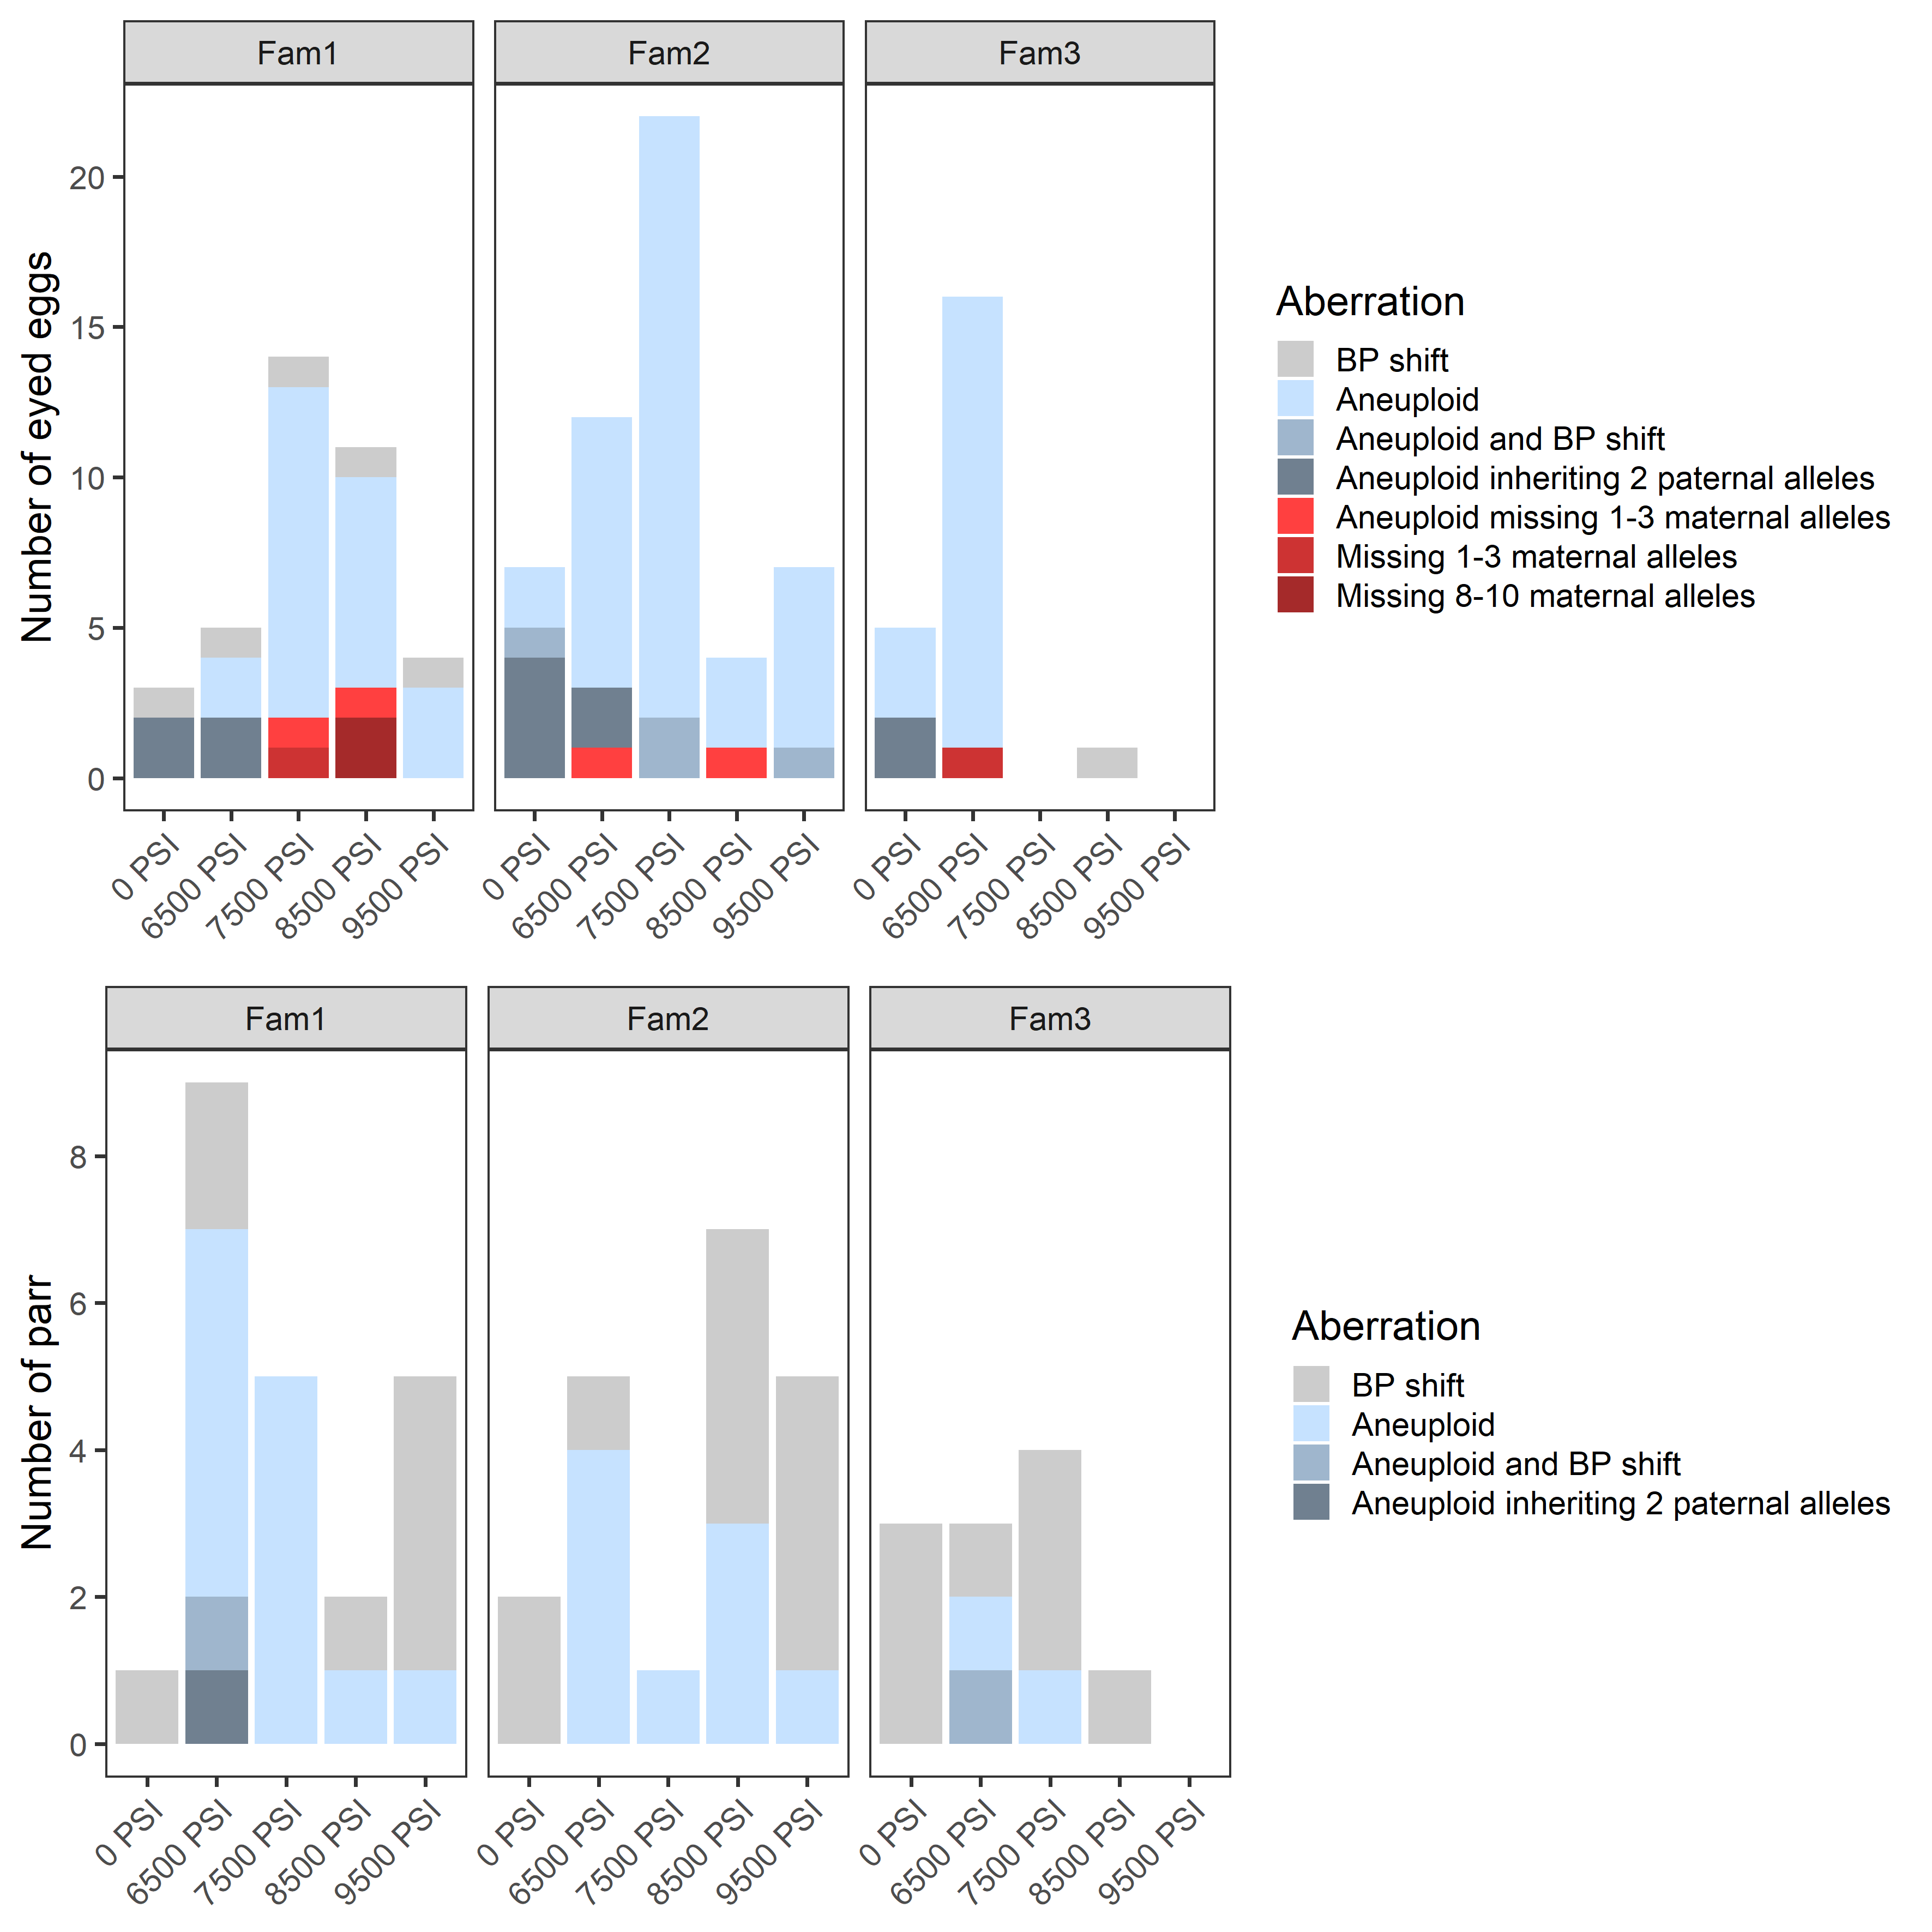
Supplementary Figure 4: Incidence of inheritance aberrations among eyed eggs (top, N=438) and surviving parr (bottom, N=1,098) subjected to 5 hydrostatic pressure treatments (Experiment 1), grouped by family.

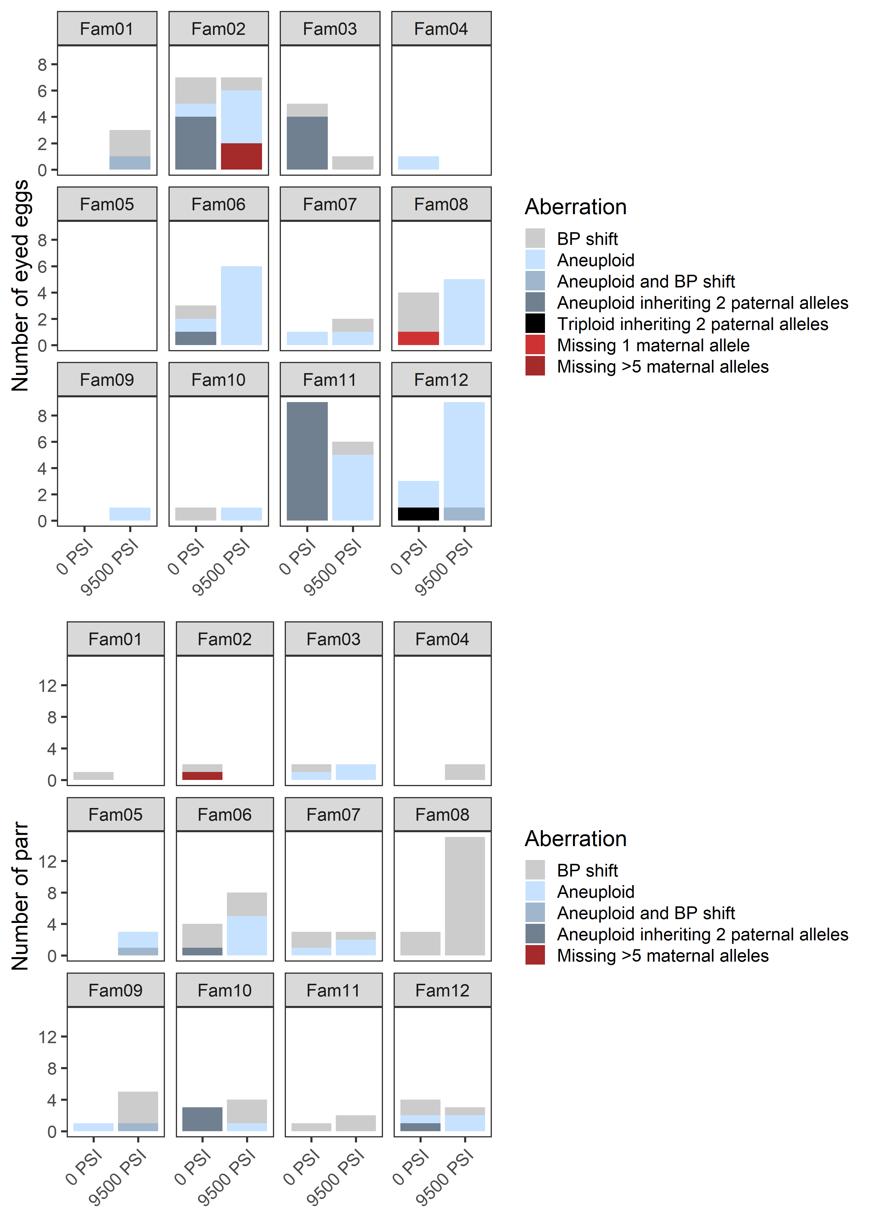
Supplementary Figure 5: Incidence of inheritance aberrations among eyed eggs (top, N=472) and surviving parr (bottom, N=2,179) from the diploid (0 PSI) and triploid (9500 PSI) pressure treatments (Experiment 2), grouped by family.
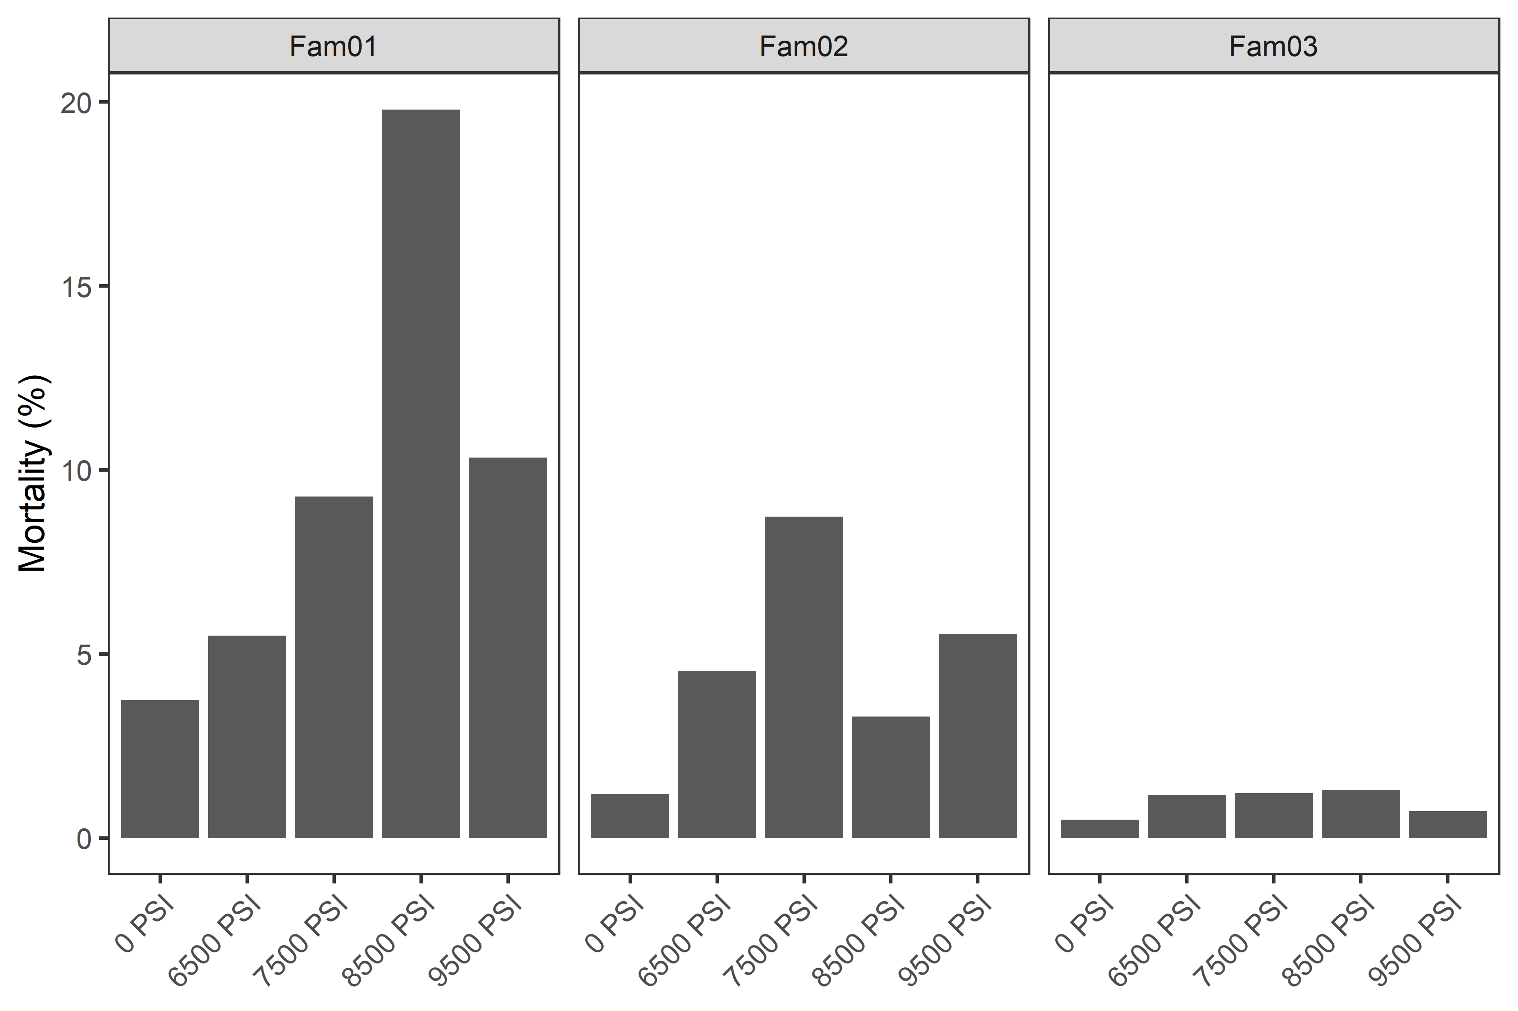
Supplementary Figure 6: Mortality rates from fertilization until the eyed egg stage in Atlantic salmon from three half-sibling families subjected to five hydrostatic pressure treatments (Experiment 1).

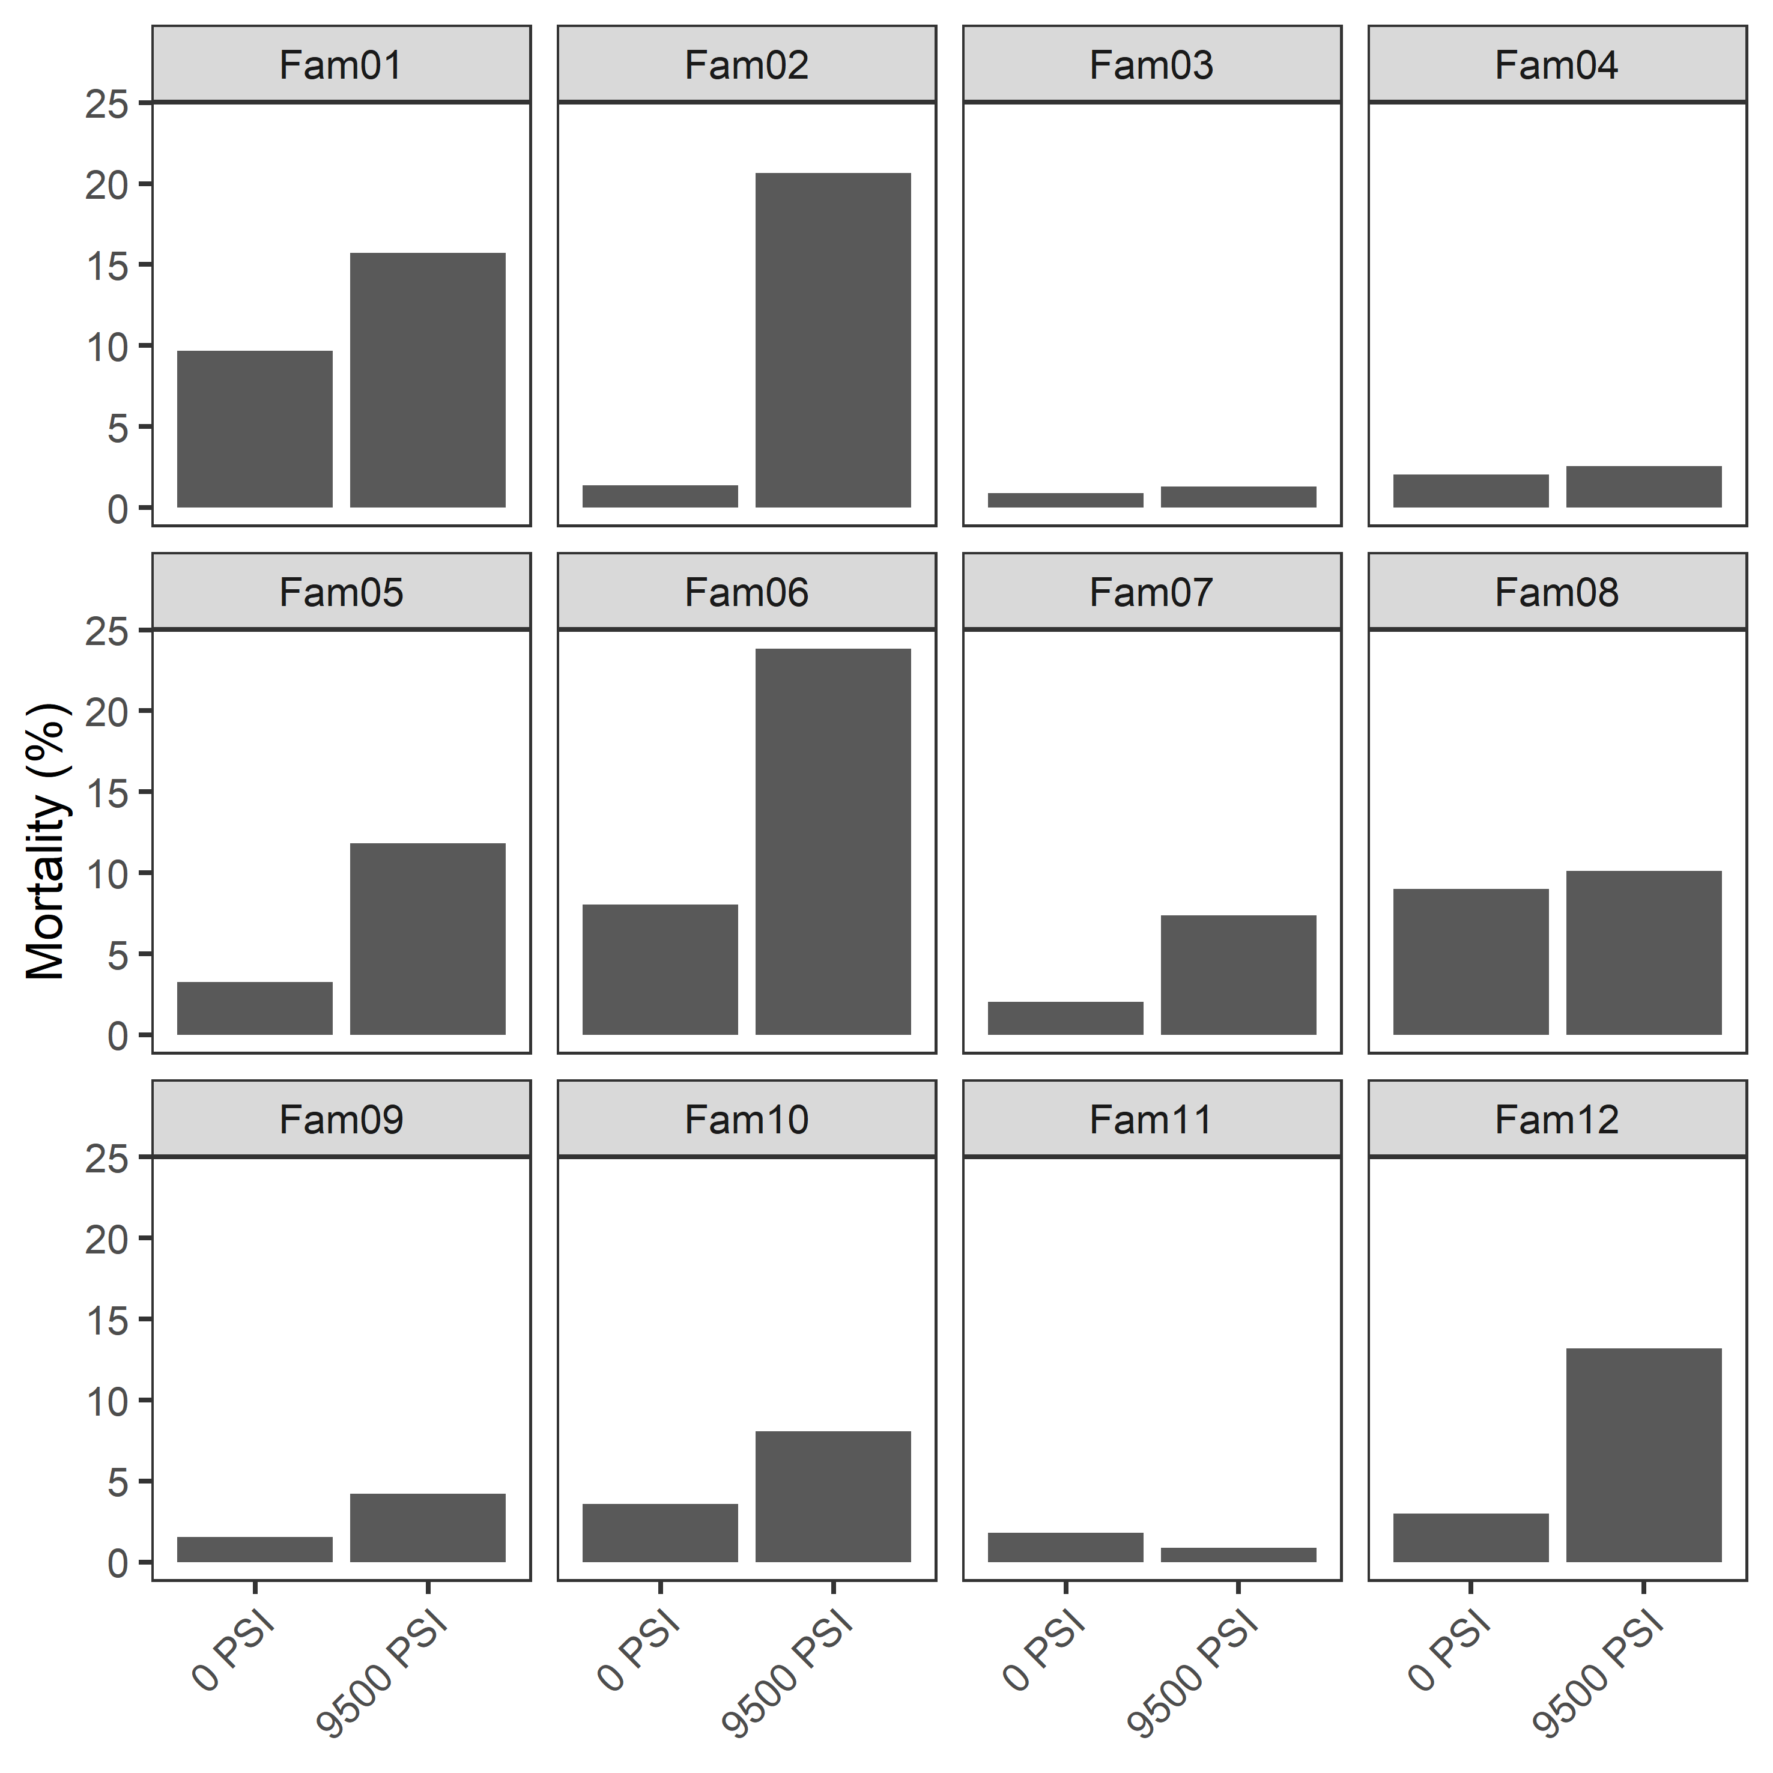
Supplementary Figure 7: Mortality rates from fertilization until the eyed egg stage in Atlantic salmon from 12 families subjected to two hydrostatic pressure treatments (Experiment 2).

