Supplementary figure number 1:

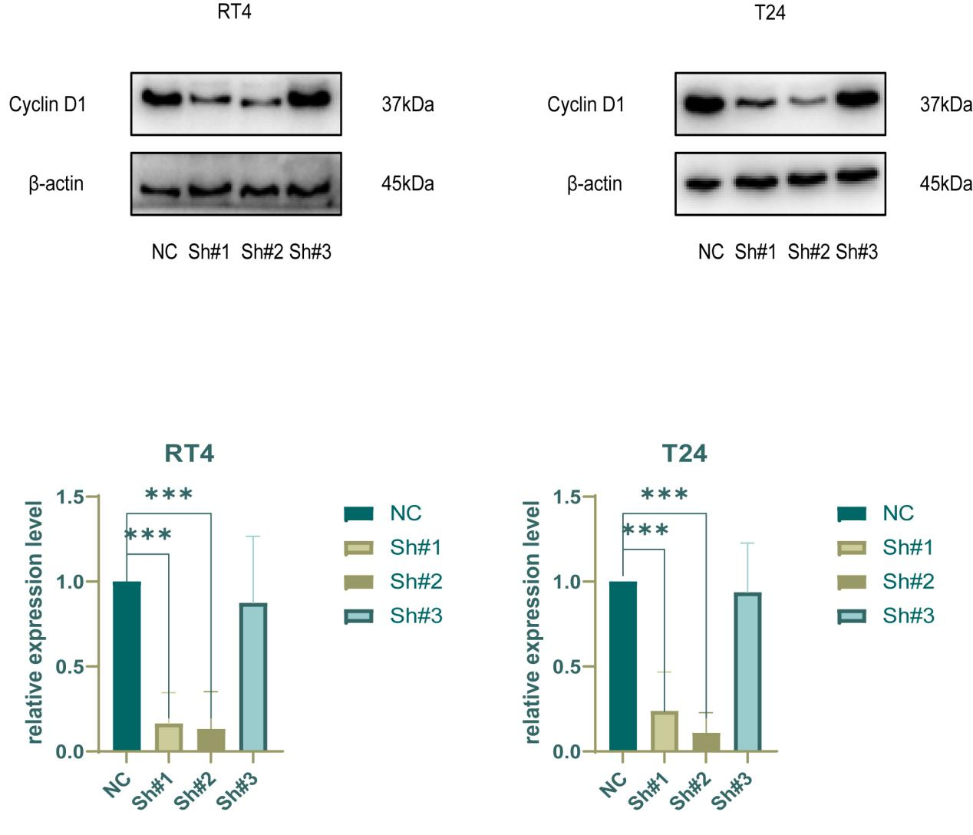

Figure S1. Two effective sequences were selected from three Sh CCND1 sequences.
In RT4 and T24 cells, sequences 1 and 2 showed better silencing of the CCND1 gene. Protein expression level were measured three times (n = 3 biologically independent samples; *p < 0.05; data are presented as mean ± SD).

Supplementary figure number 2:
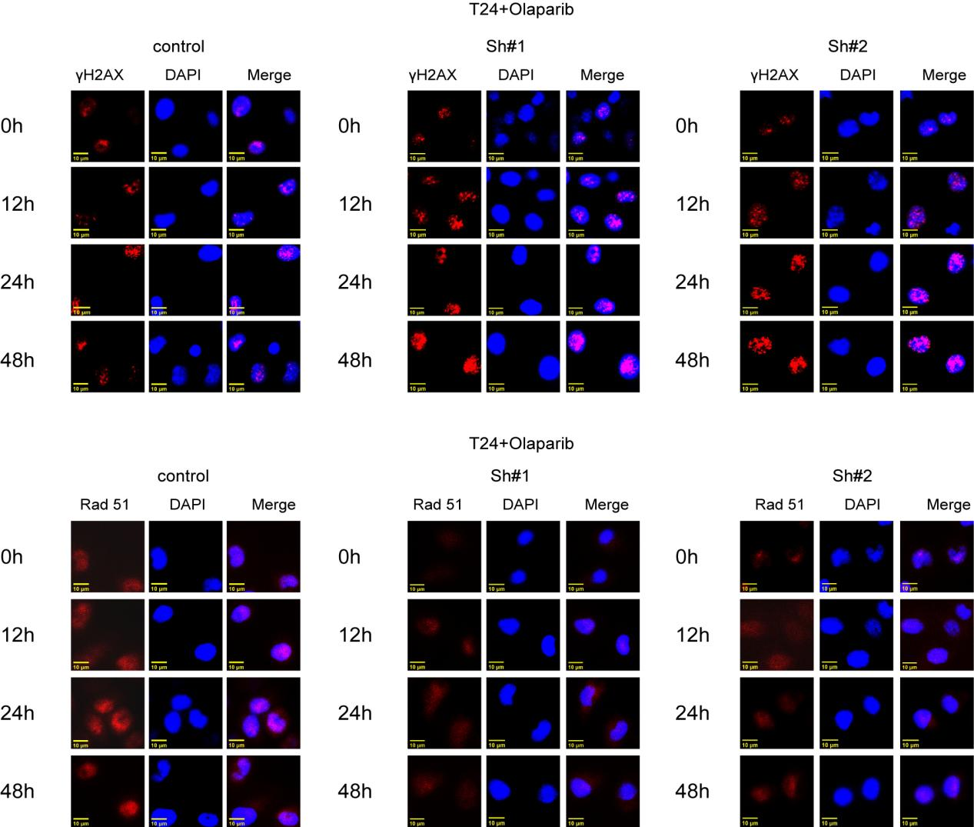

Figure S2. Changes in DNA damage and repair-related proteins treated with Olaparib after silencing CCND 1.
Immunofluorescence results showed that γH2AX nuclear aggregation was exacerbated and Rad 51 was attenuated treated with Olaparib in the two cell lines with CCND 1 silencing.

Supplementary table number 1:
Primers for human genes in RT-PCR, Related to Figure 1 and Figure 3.
Gene | Forward Primer(F) | Reverse Primer(R)
CCNA1 | AAGCAGCCAGACATCACGGAAG | CCAGGAAGTTGACAGCCAGATACAG
CCNA2 | TCGTGGACTGGTTAGTTGAAGTAGG | AGCACTGACATGGAAGACAGGAAC
CCNB1 | ATACTGCCTCTCCAAGCCCAATG | AGCTCCATCTTCTGCATCCACATC
CCNB2 | ACTGCTCTGCTCTTGGCTTCC | CTCGGATTTGGGAACTGGTATAAGC
CCND1 | GCGGAGGAGAACAAACAG | GCGGTAGTAGGACAGGAA
CCND2 | CCGACAACTCCATCAAGCCTCAG | TGCCAGGTTCCACTTCAACTTCC
CCND3 | AGCCTCAGGGAAGCCTCTCAG | CATCTGTAGGAGTGCTGGTCTGG
CCNE | TGTCCTGGATGTTGACTGCCTTG | TTCTCTATGTCGCACCACTGATACC

Supplementary table number 2:
shRNA sequences for the targeted genes as indicated, Related to Figure 6 and Figure S2.
Gene | Forward Primer(F) | Reverse Primer(R)
Sh-CCND1-1 | CcggGAACAAACAGATCATCCGCAACTCGAGTTGCGGATGATCTGTTTGTTCTTTTTg | aattcaaaaaGAACAAACAGATCATCCGCAACTCGAGTTGCGGATGATCTGTTTGTTC
Sh-CCND1-2 | CcggGCACGATTTCATTGAACACTTCTCGAG AAGTGTTCAATGAAATCGTGCTTTTTg | aattcaaaaaGCACGATTTCATTGAACACTTCTCGAGAAGTGTTCAATGAAATCGTGC
Sh-CCND1-3 | CcggGCCCTCGGTGTCCTACTTCAACTCGAGTTGAAGTAGGACACCGAGGGCTTTTTg | aattcaaaaaGCCCTCGGTGTCCTACTTCAACTCGAGTTGAAGTAGGACACCGAGGGC
Sh-NC | CCGGTTCTCCGAACGTGTCACGTTTCAAGAGAACGTGACACGTTCGGAGAATTTTTG | AATTCAAAAATTCTCCGAACGTGTCACGTTCTCTTGAAACGTGACACGTTCGGAGAA

