Supplementary data
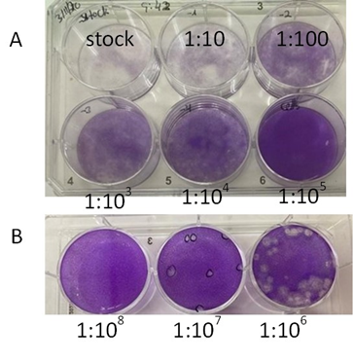

1S Fig: Representative Plaque assay for hCoV-OC43 on VeroE6 cells.
A) VeroE6 cells were infected with serially diluted HCoV-OC43 (10¹ to 10⁸). After 90min at 33°C of virus adsorption, agarose overlay was added and incubated for 9 days. After 9 days, cells were washed with PBS and fixed with 1% crystal violet solution (Sigma V5265).
B) There are 6 plaques on the plate made from the 10⁷ dilutions. The virus titer stock is therefore 1.2 x 10⁷ PFU/ml.

Toxicity of ivermectin
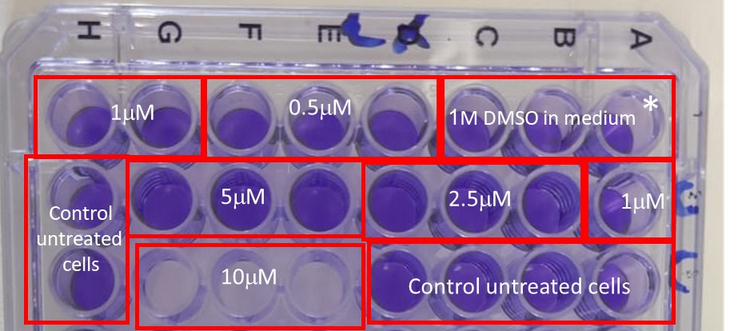

2S Fig: Representative of the effect of different concentrations of ivermectin on Vero E6 cells.
Vero E6 cells were seeded on a 96-plate dish treated with the written concentration of ivermectin for 24 h. After 24 hours, the cells were washed with PBS and fixed with 1% crystal violet solution.
*Control wells treated with solution ivermectin was prepared. The ivermectin was solubilized in DMSO at a stock concentration of 1M and then diluted in a medium (EMEM or DMEM).

Effects of ivermectin on NL-63 infection
on VERO-E6 cells, 48h after treatment

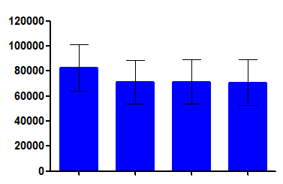
Calculated Virus particles
control
1μM
2.5μM
5μM
Ivermectin

S3 Fig: CaCo cells, infected with HCoV-NL63, (0.01 MOI) for 2h before the addition of a fresh medium or ivermectin at the indicated concentrations. 72h after infection, the supernatant was collected, viral RNA was purified and analyzed by RT-PCR. The results represent the copy number calculation of viral RNA in treated cells compared to infected untreated cells. The graphs represent three independent experiments. Error bars show ± SEM. Statistics were performed using one-way ANOVA and Turkey's Multiple Comparison Test

The effects of ivermectin on SARS-CoV-2 Omicron varient infection
of VERO-E6 cells 24h after treatment
The effects of ivermectin on SARS-CoV-2 infection
of VERO-E6 cells 24h after treatment
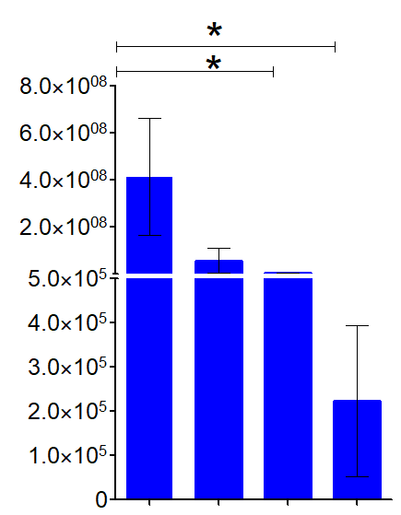
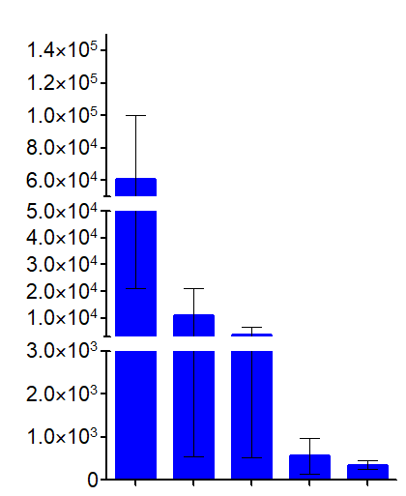

Calculated Virus particles
Calculated Virus particles

2.5μM
5μM
1μM
0.5μM
control
Ivermectin
Ivermectin
control
1μM
2.5μM
5μM

S4 Fig: Vero E6 cells were infected with A) SARS-CoV2 or B) Omicron SARS-CoV2, (0.01 MOI) for 2 h before the addition of a fresh medium or ivermectin at the indicated concentrations. After 24h, the supernatant was collected, and viral RNA was analyzed by RT-PCR. The results represent Calculated Virus particles in treated cells compared to infecteduntreated cells. The graphs represent three independent experiments. Error bars show ± SEM. Statistics were performed using one-way ANOVA and Tukey's Multiple Comparison Test; *p <0.05.

Supplementary methods
We generated calibration curves for the envelope protein (E), nucleocapsid protein (N), and RNA-dependent RNA polymerase (RdRp) qPCR reactions that were described by Corman et al. [1] and are frequently used in many studies.
The primers were designed so that they would be adapted to several strains of the viruses SARS Betacoronavirus,[ Sarbecovirus (Sarbeco)]. We also performed a similar analysis for the SARS-2-CoV N1 reaction that was developed and recommended by the US CDC (https://www.cdc.gov/coronavirus/2019-ncov/lab/rt-pcr-panel-primer-probes.html). This allowed us to accurately convert the quantification cycle (Cq) values described in each such study, and compare the results of different analysis methods, which is very complicated to perform otherwise.
Generation of RNA standards for the E, N, and RdRp reactions
DNA products corresponding to the target regions of the E, N, and RdRp regions were amplified using primers that contained the minimal T7 promoter sequence in the 5’p end of the Fwd primer. This enabled In vitro transcription of the PCR products using the MEGAscript™ T7 Transcription Kit (Thermo Fisher Scientific Inc, Catalog number: AM1334). The resulting RNA products were purified and their concentration was measured.
The RNA was aliquoted and stored at -80°C until further use.
Generation of Standard calibration curves
The RNA targets were diluted 10-fold and used in the corresponding RT-qPCR assays as described by Corman et al. [1] and according to the CDC guidelines (https://www.cdc.gov/coronavirus/2019-ncov/lab/virus-requests.html).

Results
The quantification cycle (Cq) values obtained from the standard calibration qRT-PCR assays were plotted against each RNA target's measured and calculated concentration. A regression formula was calculated from the semi-logarithmic correlation between the Cq values and the copy number for each target (Figure S5).
Based on the formula of each reaction, the conversion of Cq values to viral target copy number was calculated.

S5 Fig. Calibration standards of the E-Sarbeco, RdRp, N-Sarbeco, and CDC N1 reactions
The Cq values used to generate the calibration curves are detailed below in Supplementary Tables S1 to S4, for each target.
A

S1 Table. Calibration assay for E-sarbeco reaction
E Sarbeco sample dilution | RNA Copies | Average Quantification cycle | stdev
1 | 1.76E+07 | 16.73
2 | 1.76E+06 | 18.83 | 0.39
3 | 1.76E+05 | 23.01 | 1.66
4 | 1.76E+04 | 26.13 | 2.11
5 | 1.76E+03 | 29.25 | 1.66
6 | 1.76E+02 | 32.76 | 2.89
7 | 1.76E+01 | 35.64 | 0.81
8 | 1.76E+00 | 37.90 | 1.49

S2 Table. Calibration assay for CDC N1 reaction
N1 CDC sample dilution | RNA Copies | Average Quantification cycle | stdev
1 | 6.74E+05 | 20.10 | 0.007
2 | 6.74E+04 | 23.10 | 0.463
3 | 6.74E+03 | 26.90 | 0.548
4 | 6.74E+02 | 30.38 | 0.964
5 | 6.74E+01 | 34.52 | 2.253
6 | 6.74E+00 | 37.77 | 1.143
7 | 6.74E-01 | 41.87 | 2.126

Table S3. Calibration assay for N-sarbeco reaction
N-sarbeco  Sample dilution | RNA Copies | Average Quantification cycle | stdev
1 | 1.35E+07 | 21.87 | 0.55
2 | 1.35E+06 | 25.59 | 0.18
3 | 1.35E+05 | 28.84 | 0.25
4 | 1.35E+04 | 32.40 | 0.57
5 | 1.35E+03 | 33.92 | 1.07
6 | 1.35E+02 | 38.38 | 0.93

Table S4. Calibration assay for RdRP reaction
RdRp  Sample dilution | RNA Copies | Average Quantification cycle | stdev
1 | 2.48E+07 | 24.22 | 0.026529
2 | 2.48E+06 | 26.57 | 1.420449
3 | 2.48E+05 | 30.29 | 1.315342
4 | 2.48E+04 | 33.86 | 1.187385
5 | 2.48E+03 | 37.75 | 0.450568
6 | 2.48E+02 | 40.88 | 1.041671
7 | 2.48E+01 | 43.525 | 0.912168

Referances

1. Corman VM, Landt O, Kaiser M, Molenkamp R, Meijer A, Chu DK, et al. Detection of 2019 novel coronavirus (2019-nCoV) by real-time RT-PCR. Euro surveillance : bulletin Europeen sur les maladies transmissibles = European communicable disease bulletin. 2020;25(3). Epub 2020/01/30. doi: 10.2807/1560-7917.es.2020.25.3.2000045. PubMed PMID: 31992387; PubMed Central PMCID: PMCPMC6988269.

