Supplementary figures
Supplementary Figure S1 | Specimen collector and fecal liquefaction treatment equipment.
Supplementary Figure S2 | Methylation levels of DMPs between eCRC and aCRC in TCGA datasets.
Supplementary Figure S3 | Heatmap of probe pairs with collinearity.
Supplementary Figure S4 | The methylation frequencies of five target DMPs in our nine specimens.
Supplementary Figure S5 | Pie chart of hyper-methylation ratio of the five target genes.
Supplementary Figure S6 | Performance of LPFSM in the training set.
Supplementary Figure S7 | Performance of LPFSM in the validation set.
Supplementary Figure S8 | Mutation rates and types of three target genes in TCGA-CRC datasets.
Supplementary Figure S9 | Pan-cancer analysis of PRDM12 gene.
Supplementary Figure S10 | The relationship between methylation and gene expression of PRDM12.
Supplementary Figure S11 | Functional analysis of PRDM12.

Supplementary Figure S1. Fecal pretreatment system. (a) specimen collector. (b) Fecal liquefaction treatment equipment.

Supplementary Figure S2. Methylation levels of DMPs between eCRC and aCRC in TCGA datasets.

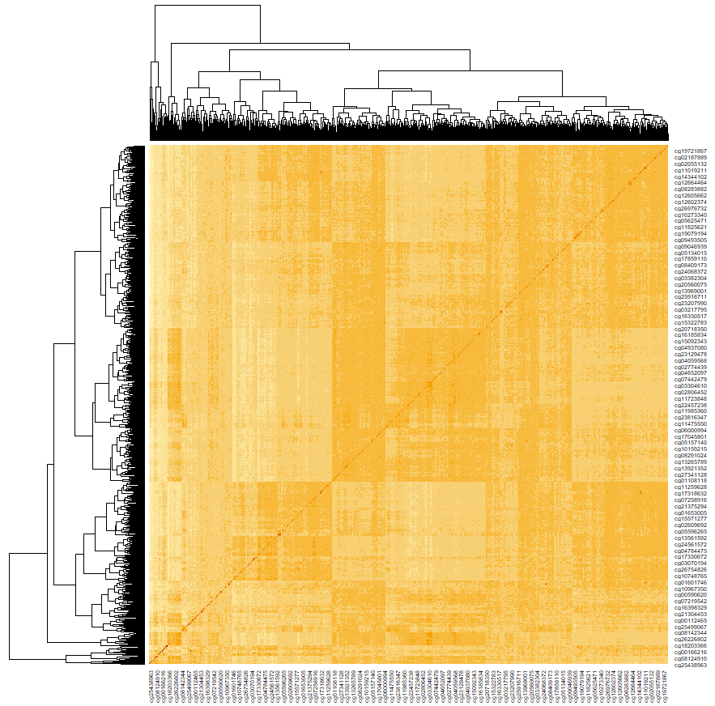
Supplementary Figure S3. Methylation β values of probes with collinear. Methylation β values are represented by darker colors, indicating that the correlation coefficient r is closer to 1. Conversely, lighter colors indicate that r is closer to 0. Probes with a correlation coefficient r > 0.8 were considered to have collinear expression.

Supplementary Figure S4. The methylation frequencies of five target DMPs in our nine specimens. The MiGS data were uploaded to UCSC Track Data Hubs, and each brown bar representing a CGI and the brown thick line indicating higher methylation frequency at the corresponding site.

Supplementary Figure S5. Pie chart of hyper-methylation ratio of the five target genes in cohort Ⅲ (n = 31).

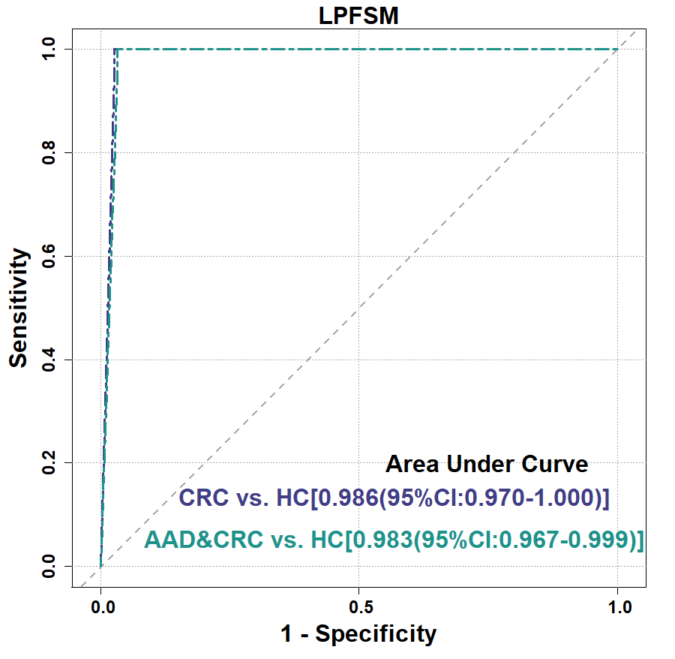
Supplementary Figure S6. Performance of LPFSM in the training set. When HCs serve as the control group, LPFSM performs diagnostic ROC curves on CRC (or CRC and AAD) diagnosis.

Supplementary Figure S7. Performance of LPFSM in the validation set. ROC and the associated AUCs showed the diagnosing efficiency of LPFSM. (A-B) When HCs serve as the control group, LPFSM performs diagnostic ROC curves on different case groups. (C) When HCs and IFD serve as the control group, LPFSM performs diagnostic ROC curves on CRC and AAD. (D) Using HC and IFD without STAD as the control group, LPFSM conducts diagnostic ROC curves for CRC and AAD. LPFSM: Combined diagnostic model. AAD: Advanced adenoma; IFD: Interfering disease; STAD: Stomach adenocarcinoma.

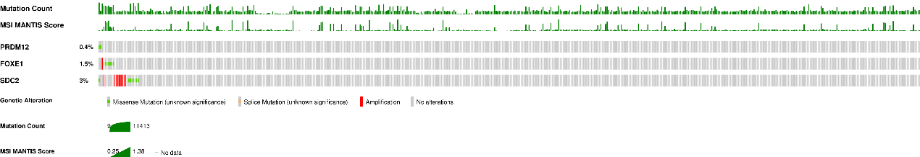

Supplementary Figure S8. Mutation rates and types of three target genes in TCGA-CRC datasets.

Supplementary Figure S9. Pan-cancer analysis of PRDM12 gene. (A) Comparison of PRDM12 expression levels between 33 types of PTs and their NATs. The correlations between PRDM12 levels with tumor mutation burden (TMB) (B), microsatellite instability (MSI) (C), and immune scores (D) in 33 types of cancer. The closer the correlation coefficient ® is to 1, the stronger the correlation with the corresponding index. ACC: Adrenocortical carcinoma; BLCA: Bladder Urothelial Carcinoma; BRCA: Breast invasive carcinoma; CESC: Cervical squamous cell carcinoma and endocervical adenocarcinoma; CHOL: Cholangio carcinoma; COAD: Colon adenocarcinoma; DLBC: Lymphoid Neoplasm Diffuse Large B-cell Lymphoma; ESCA: Esophageal carcinoma; GBM: Glioblastoma multiforme; HNSC: Head and Neck squamous cell carcinoma; KICH: Kidney Chromophobe; KIRC: Kidney renal clear cell carcinoma; KIRP: Kidney renal papillary cell carcinoma; LAML: Acute Myeloid Leukemia; LGG: Brain Lower Grade Glioma; LIHC: Liver hepatocellular carcinoma; LUAD: Lung adenocarcinoma; LUSC: Lung squamous cell carcinoma; MESO: Mesothelioma; OV: Ovarian serous cystadenocarcinoma; PAAD: Pancreatic adenocarcinoma; PCPG: Pheochromocytoma and Paraganglioma; PRAD: Prostate adenocarcinoma; READ: Rectum adenocarcinoma; SARC: Sarcoma; SKCM: Skin Cutaneous Melanoma; STAD: Stomach adenocarcinoma; TGCT: Testicular Germ Cell Tumors; THCA: Thyroid carcinoma; THYM: Thymoma; UCEC: Uterine Corpus Endometrial Carcinoma; UCS: Uterine Carcinosarcoma; UVM: Uveal Melanoma.
Supplementary Figure S10. (A) The consensus dataset consists of normalized expression (nTPM) levels for 55 tissue types, created by combining the HPA and GTEx transcriptomics datasets using the internal normalization pipeline. Color-coding is based on tissue groups, each consisting of tissues with functional features in common (https://www.proteinatlas.org/). (B) The β values of 8 probes (cg13931725, cg01621054, cg13795948, cg09191327, cg13928649, cg15700165, cg13726887, and cg13943217) were significantly correlated with the expression level of PRDM12 (https://mexpress.ugent.be/).

Supplementary Figure S11. Functional analysis of PRDM12 gene. According to the RNA expression level of PRDM12 in PTs, CRC cases in the TCGA public dataset were divided into low-expression group (n=321) and high-expression group (n=319). (A) Top 20 upregulated DEGs and top 20 downregulated DEGs between low-expression group and high-expression group. DMFold2 predicted Gene Ontology (GO) Terms on biological process (BP) (B), Cellular Component (CC) (C), and Molecular Function (MF) (D). The base color of the prediction terms represents different predicted values, red represents [0.9,1.0], purple represents [0.4,0.5), a higher value indicates a better confidence in predicting the function using the template.

