Supplement 1
Keywords used to search case reports of peritoneal dialysis catheter-related infection by Non-tuberculous Mycobacteria. The literature search was conducted on August 15th, 2022.

PubMed:
("Peritoneal Dialysis"[Text Word] OR "Peritoneal Dialyses"[Text Word]) AND ("Mycobacterium"[MeSH Terms] OR "Mycobacterium Infections"[MeSH Terms] OR ("Mycobacterium"[Text Word] OR "mycobacterial"[Title/Abstract] OR "mycobacteriosis"[Title/Abstract]))

Embase: (('peritoneal dialysis'/exp OR 'peritoneal dialysis') OR 'peritoneal dialyses') AND (('mycobacterium'/exp OR 'mycobacterium') OR ('mycobacteriosis'/exp OR 'mycobacteriosis') OR mycobacterial)

Ichu-shi: ((Mycobacterium/TH or mycobacterium [Japanese]/AL)) and (((peritoneal dialysis [Japanese]/TH or peritoneal dialysis [Japanese]/AL)) or (((dialysis [Japanese]/TA) or (dialysis [Japanese]/TH)) and (peritoneal [Japanese]/TA or peritoneal/TA)))
Supplement 2
Flow chart of the review process of this study. The authors independently reviewed the titles and abstracts of database records, retrieved full texts for an eligibility assessment, and extracted data from these cases. We excluded articles other than case reports of NTM infection related to PD, duplicates retrieved from other databases, and abstracts not written in English or Japanese.
N, the number of articles; n, the number of cases.
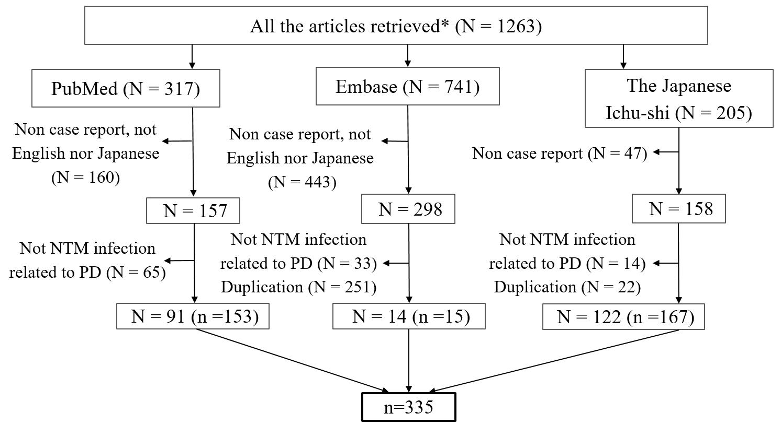
Supplement 3
The trend in the number of published papers on and cases of PD-related infection by NTM (PubMed, Embase and Ichu-shi). The data for the year 2022 represent the number of publications until August 15th.
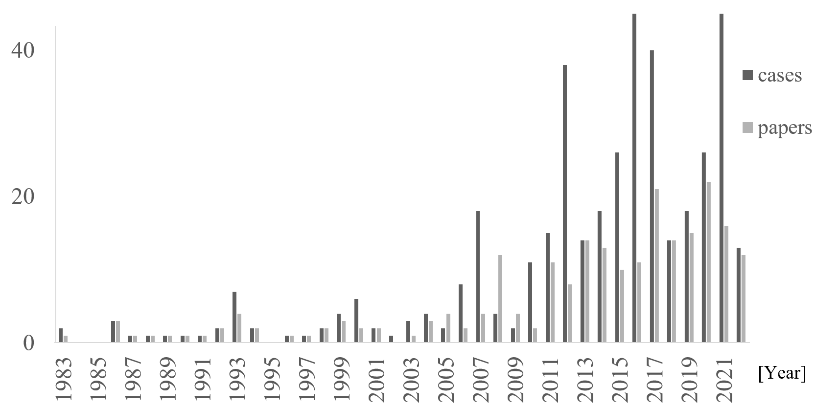

Supplement 4
The trend in the number of published papers and cases of PD infection by NTM (Ichu-shi). There were no reports before the year 1998. The data for the year 2022 represent the number of publications until August 15th.
