Fischer-Tropsch synthesis using carbon dioxide, water and electricity
Yansong Zhou¹, Antonio José Martín², Federico Dattila³, Shibo Xi⁴, Núria López³*, Javier Pérez-Ramírez²*, Boon Siang Yeo¹*
¹Department of Chemistry, Faculty of Science, National University of Singapore, Singapore
²Institute for Chemical and Bioengineering, Department of Chemistry and Applied Biosciences, ETH Zürich, Zürich, Switzerland
³Institute of Chemical Research of Catalonia (ICIQ), The Barcelona Institute of Science and Technology (BIST), Tarragona, Spain
⁴Institute of Chemical and Engineering Sciences, A*STAR, Singapore
*Email: nlopez@iciq.es, jpr@chem.ethz.ch, chmyeos@nus.edu.sg

Supplementary Notes

Supplementary Note 1 | Effects of under-coordinated sites on CO₂RR towards multi-carbon products. Under-coordinated metal sites claimed in the metal oxygenates-derived metal electrodes¹ are thought to affect the catalytic performance. We checked their role (Supplementary Fig. 19) by testing s-Ni samples in which the average coordination number of Ni (i.e., 7.5) was much lower than in bulk Ni (i.e., 12), see Supplementary Fig. 7. A FE_{C2+} = 2.2% was achieved on s-Ni, which is ca. 1/7 that of NP-d (14.1%). Hence, we concluded that the formation of C₂₊ products on NP-d electrocatalysts was not caused by under-coordinated Ni sites.

Supplementary Note 2 | Competition between reduction pathways of nickel phosphate under alkaline pH. During electrochemical CO₂ reduction, the pH at the surface (pH_{s} ≥ 9) differs significantly from its bulk neutral value (pH = 6.8, Ref. 2). Thus, at the experimental reaction conditions (–1.2 V, 0.1 M KHCO₃, pH = 6.8), Ni₃(PO₄)₂ reduction to either metallic Ni, Supplementary equation (1), or Ni(OH)₂, Supplementary equation (2) occurs using water molecules as a proton source due to the alkaline surface pH³. The Gibbs free energy for both processes can be calculated from basic thermodynamic data for bulk phases⁴ and corrected by electric potential and pH effects through the Computational Hydrogen Electrode formalism⁵, see Supplementary equation (3). The electric potential in Supplementary equation (3) is calculated versus reversible hydrogen electrode (RHE) scale by correcting for pH = 6.8, as measured in the bulk electrolyte of the experimental system.
$${\text{Ni}}_{\text{3}}{\left({\text{PO}}_{\text{4}}\right)}_{\text{2}}\text{ + 2}{\text{H}}_{\text{2}}\text{O + 6}{\text{e}}^{\text{–}} \underset{→}{ }\text{ 3Ni + 2}{\text{HP}{\text{O}}_{\text{4}}}^{\text{2–}}\text{+ 2}{\text{OH}}^{\text{–}}$$ | (1)
$${\text{Ni}}_{\text{3}}{\left({\text{PO}}_{\text{4}}\right)}_{\text{2}}\text{ + 6}{\text{H}}_{\text{2}}\text{O + 4}{\text{e}}^{\text{–}} \underset{→}{ }\text{ 3Ni}{\left(\text{OH}\right)}_{\text{2}}\text{ + 2}{\text{HP}{\text{O}}_{\text{4}}}^{\text{2–}}\text{+ 2}{\text{H}}_{\text{2}}$$ | (2)
$$\text{∆}\text{G} \left({\text{U}}_{\text{RHE}}\right)\text{ = }\sum_{\text{products}}{\text{G}} \text{– }\sum_{\text{reactants}}{\text{G}}\text{ + }{\text{n}}_{{\text{e}}^{\text{–}}}\left({\text{U}}_{\text{SHE}}\text{ + }{\text{k}}_{\text{B}}\text{∙}\text{T}\text{∙ln}\left(\text{10}\right)\text{∙pH}\right)$$ | (3)

Supplementary Note 3 | Extension of the thermodynamic linear scaling relationship for CO₂ reduction intermediates. For complex reactions such as the CO₂ reduction, bond order conservation theory and electron counting rules imply thermodynamic and kinetic linear-scaling relationships (LSR) between the energies of the reaction intermediates⁶. Abild-Pedersen et al.⁷ first demonstrated LSR of adsorption energies for CH_{x} molecules on transition metal surfaces, which are summarized for C-containing molecules by means of Supplementary equation (4), whilst Bagger et al.⁸ reported similar LSR of adsorption energies for COOH and H. The variables ΔE^{CHx} and ΔE^{C} represent the adsorption energy of CH_{x} and C, respectively. The subscript d and sp indicate the contribution of both transition metal bands to the intermediate-surface bonds. N_{bonds} indicates the number of bonds between surface and reaction intermediates. Since transition metals interact with adsorbates mainly through their d band, the contribution of sp states to adsorption energy can be included by using a ξ parameter, which is independent of the given metal, as shown in Supplementary equation (5).
$$\text{∆}{\text{E}}^{\text{C}{\text{H}}_{\text{x}}}\text{ = ∆}{\text{E}}_{\text{d}}^{\text{C}{\text{H}}_{\text{x}}}\text{ + ∆}{\text{E}}_{\text{sp}}^{\text{C}{\text{H}}_{\text{x}}}\text{ = }\frac{{\text{N}}_{\text{bonds}}}{\text{4}}\text{∆}{\text{E}}_{\text{d}}^{\text{C}}\text{ + ∆}{\text{E}}_{\text{sp}}^{\text{C}{\text{H}}_{\text{x}}}\text{ = }\frac{{\text{N}}_{\text{bonds}}}{\text{4}}\text{∆}{\text{E}}_{}^{\text{C}}\text{ + }\text{ξ}$$ | (4)
$$\text{ξ}\text{ = ∆}{\text{E}}_{\text{sp}}^{\text{C}{\text{H}}_{\text{x}}} \text{– }\frac{{\text{N}}_{\text{bonds}}}{\text{4}}\text{∆}{\text{E}}_{\text{sp}}^{\text{C}}$$ | (5)
Supplementary equations (4) and (5) account for metals (oxidation state = 0). DFT results for CO₂ reduction intermediates on nickel (Supplementary Fig. 25) suggest that the degree of polarization (charge) of the adsorption site M, q_{M}, affects the LSR, Supplementary equation (4), via an additive term, Supplementary equation (6). The proposed charge-dependent qLSR formalism here includes the additional charge contribution through the parameter q_{M}, independent of ΔE^{C}, which effectively tunes the adsorption energies of reaction intermediates.
$$\text{∆}{\text{E}}^{\text{C}{\text{H}}_{\text{x}}}\left({\text{q}}_{\text{M}}\right)\text{=∆}{\text{E}}^{\text{C}{\text{H}}_{\text{x}}}\left({\text{q}}_{\text{M}}\text{=0} \text{|}{\text{e}}^{\text{–}}\text{|}\right)\text{ + }{\text{N}}_{\text{bonds}} {\text{q}}_{\text{M}}\text{=}\frac{{\text{N}}_{\text{bonds}}}{\text{4}}\text{ ∆}{\text{E}}_{}^{\text{C}}\text{+ }\text{ξ }\text{+ }{\text{N}}_{\text{bonds}} {\text{q}}_{\text{M}}$$ | (6)
We demonstrated the validity of Supplementary equation (6) for relevant CO₂ reduction and hydrogen evolution reaction intermediates (Supplementary Table 6) through Supplementary Fig. 32. The difference of adsorption energies on polarized (q_{M}) and metallic (q_{M} = 0 |e–|) sites for an intermediate X indeed correlates with the degree of polarization q_{M}, see Supplementary equation (7), Supplementary Table 9.
$$\text{∆}{\text{E}}^{\text{X}}\left({\text{q}}_{\text{M}}\right)\text{ – ∆}{\text{E}}^{X}\left({\text{q}}_{\text{M}}\text{=0 }\text{|}{\text{e}}^{\text{–}}\text{|}\right)\text{=}{\text{q}}_{\text{M} }{\text{N}}_{\text{bonds}}$$ | (7)

Supplementary Note 4 | Estimation of energy efficiencies for the e-FTS in an integrated scheme. In order to calculate the energy efficiency of the e-FTS, we first consider the value of the thermoneutral cell voltage (E_{i}^{n}) for product i. For endothermic reactions (like CO₂ reduction) in electrolyzers with no external heat supply, heat must also come from electricity through the Joule effect; otherwise the reaction would extract heat from the surroundings until the reaction stopped⁹. It is therefore necessary to apply an additional overvoltage to the cell to account for the entropic term. E_{i}^{n} is thus defined as the minimum cell voltage to provide the required enthalpy change only through electricity, as shown in Supplementary equation (8),
$${\text{E}}^{\text{n}}\text{ = –}\frac{\text{∆}\text{H}}{\text{n}\text{F}}$$ | (8)
where n is the number of electrons transferred per mole of product and F is the Faraday’s constant. Taking this into consideration, the minimum applied cell voltage under standard conditions for the water-splitting reaction is E^{n} = 1.48 V¹⁰.
The energy efficiency of an electrolyzer γ_{e-X} toward the set of desired products (X) can be expressed in terms of their Faradaic efficiencies (FE_{i}), their thermoneutral voltages (E_{i}^{n}), and the measured cell voltage E_{cell}, as reflected in Supplementary equation (9):
$${\text{γ}}_{\text{e-}\text{X}}\text{ = }\sum_{\text{i}}{\frac{{\text{E}}_{\text{i}}^{\text{n}}\text{F}{\text{E}}_{\text{i}}}{{\text{E}}_{\text{cell}}}}$$ | (9)
In order to estimate the upper limit of the energy efficiency for the set of C₃₊ products obtained in this work, we consider the following assumptions:
- The anodic process is the oxygen evolution reaction from water.
- E_{i}^{n} = 1.30 V for C₂₊ products, given that complex multi-carbon products tend to show a standard reduction potential of ca. 0.1 V versus RHE¹¹.
- Ideal electrolyzer with no ohmic losses and a state-of-the-art anode requiring an overpotential of 250 mV to provide ca. 15 mA cm⁻² ¹². This results in an estimated E_{cell} = 2.68 V.
Taking into consideration the yields reported in Fig. 1a, where the total FE_{C3+} approaches 7% for the NP-d electrocatalyst, Supplementary equation (6) yields γ _{e-C3+} = 3.5%.
When considering the integrated scheme depicted in Fig. 4, where the hydrogen byproduct is transformed by a polymeric membrane fuel cell into electrical energy that contributes to power the e-FTS module, the total energy efficiency γ _{X} can be expressed in terms of the fuel cell energy efficiency γ _{FC} and γ _{e-X} as reflected in Supplementary equation (10), if we assume that H₂ is the only additional product apart from the set of X products:
$${\text{γ}}_{\text{C}{\text{X}}^{\text{+}}}\text{ = }\frac{{\text{γ}}_{\text{e-C}{\text{X}}^{\text{+}}}}{\text{1-}{\text{γ}}_{\text{FC}}\text{+}{{\text{γ}}_{\text{FC}}\text{γ}}_{\text{e-C}{\text{X}}^{\text{+}}}}$$ | (10)
Considering a state-of-the-art fuel cell with γ _{FC} = 51%¹³, the overall efficiency for C₃₊ products is γ _{C3+} = 7.0%. If C₂₊ products are considered (mainly ethylene), the corresponding efficiencies become γ _{e-C2+} = 6.5% and γ _{C2+} = 12.5%.

Supplementary Figures

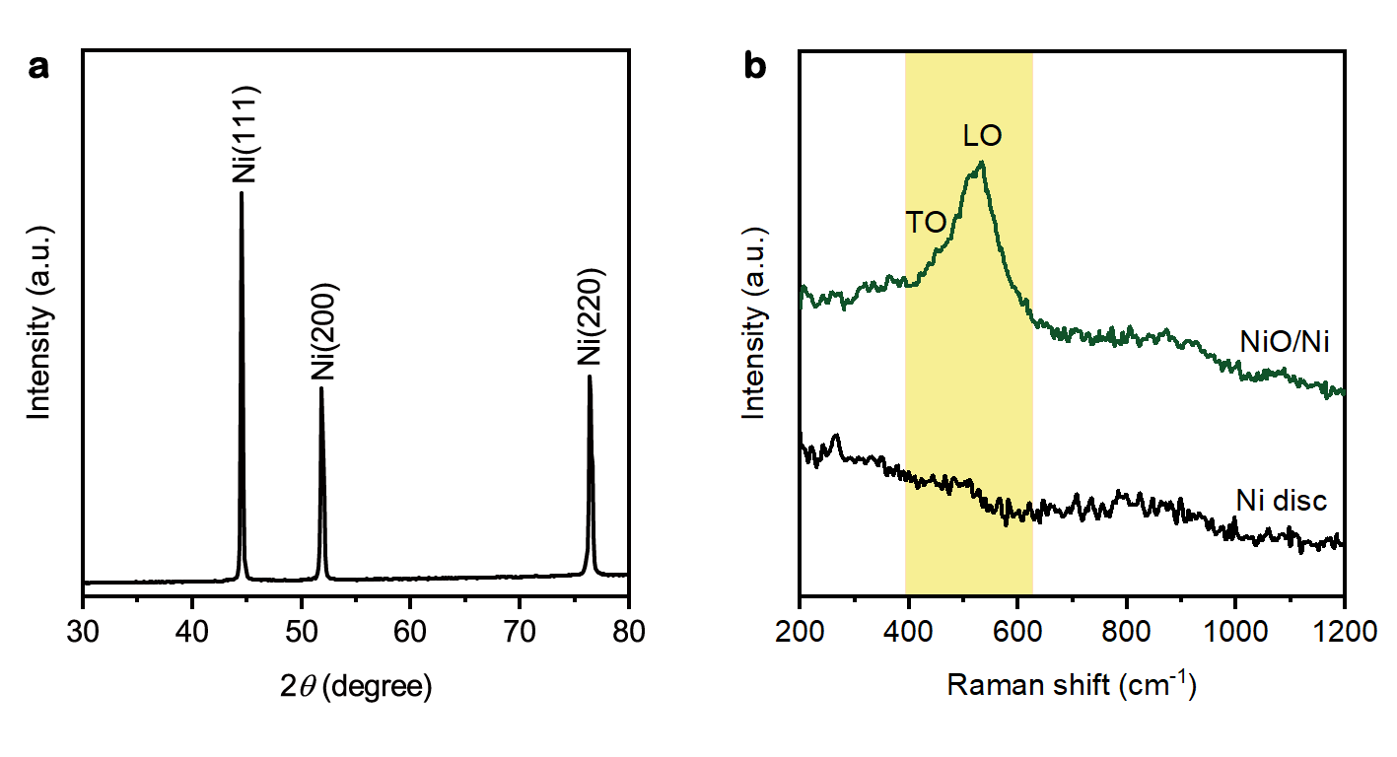
Supplementary Fig. 1 | Characterization of Ni disc and NiO-modified Ni disc (NiO/Ni). a, X-ray diffraction (XRD) pattern of a Ni disc. The reflections correspond to face-centered cubic nickel in a metallic state (JCPDS card No. 03-1051). b, Raman spectra. No clear Raman signals were detected for the Ni disc. In the Raman spectrum of NiO/Ni, the peaks at ~460 cm^{–1} and ~ 540 cm^{–1} correspond to the transverse optic (TO) and longitudinal optic (LO) modes of NiO¹⁴.

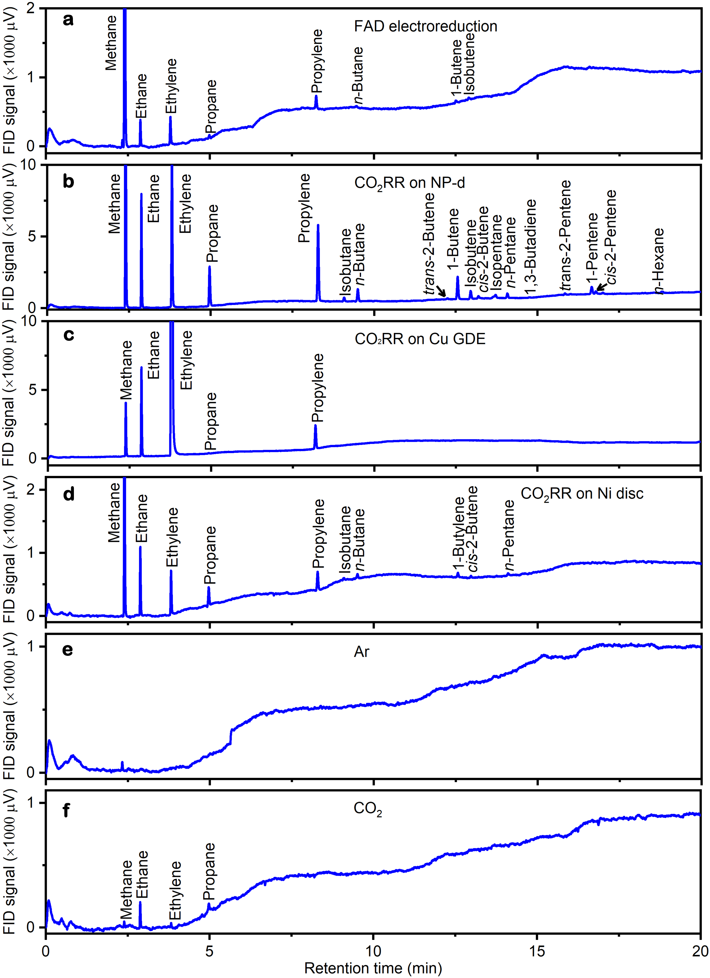
Supplementary Fig. 2 | On-line analysis of gaseous products obtained with the flame ionization detector (FID). a, Gaseous products from CH₂O (FAD) reduction on NP-d gas diffusion electrode (GDE) using Ar as carrier gas. b, Gaseous products from CO₂RR on NP-d GDE. c, Gaseous products from CO₂RR on Cu GDE. d, Gaseous products from CO₂RR on Ni disc. e, Ar gas. f, CO₂ feed. Reaction conditions: 0.1 M KH₂PO₄ at –1.2 V versus RHE in a flow cell for a; 0.1 M KHCO₃ at –1.2 V versus RHE in a flow cell for b; 0.1 M KHCO₃ at –1.0 V versus RHE in a flow cell for c; 0.1 M KHCO₃ at –1.2 V versus RHE in a H-type cell for d.

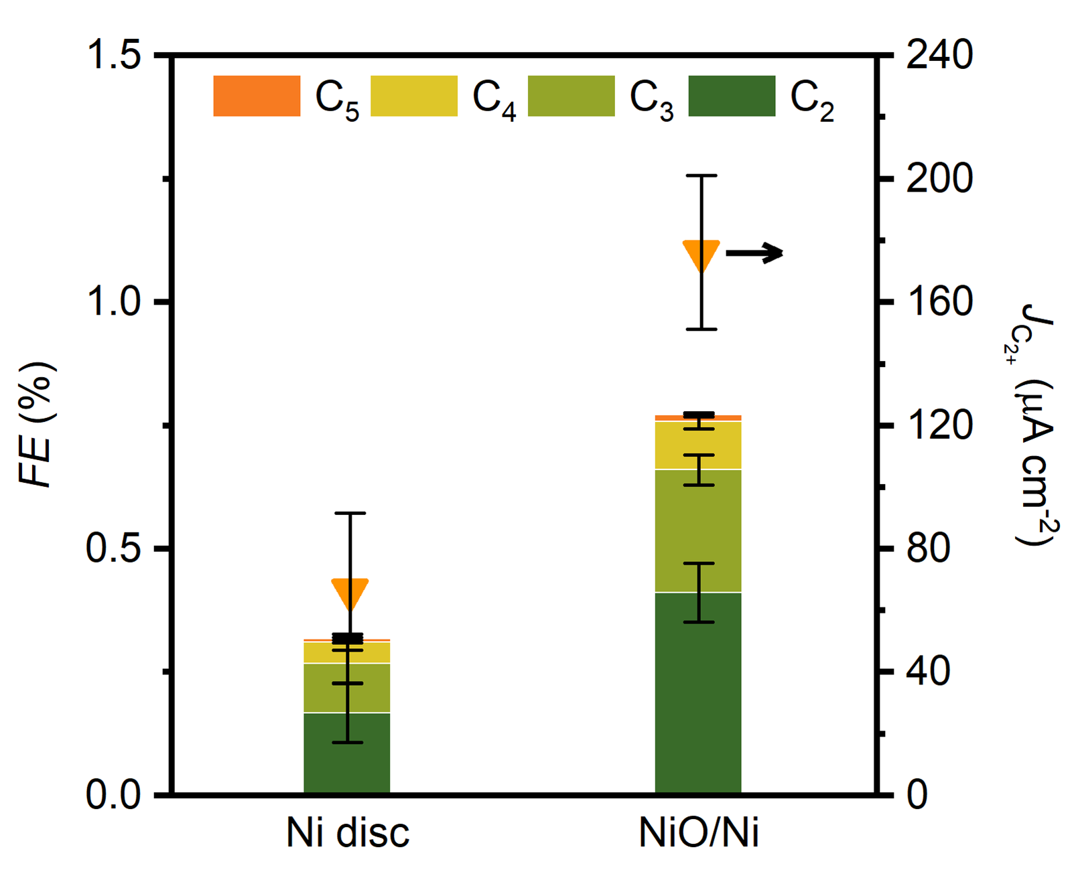
Supplementary Fig. 3 | Comparison of the CO₂RR to C₂₊ performance of Ni disc and NiO/Ni. C₂₊ Faradaic efficiency (left) and C₂₊ partial current density (right) from CO₂RR on Ni disc and NiO-modified Ni disc (NiO/Ni). More active sites for C-C coupling were introduced on the NiO-derived surface as proved by the increase in C₂₊ Faradaic efficiency and partial current density. Reaction conditions: 0.1 M KHCO₃ at –1.2 V versus RHE in a H-type cell.

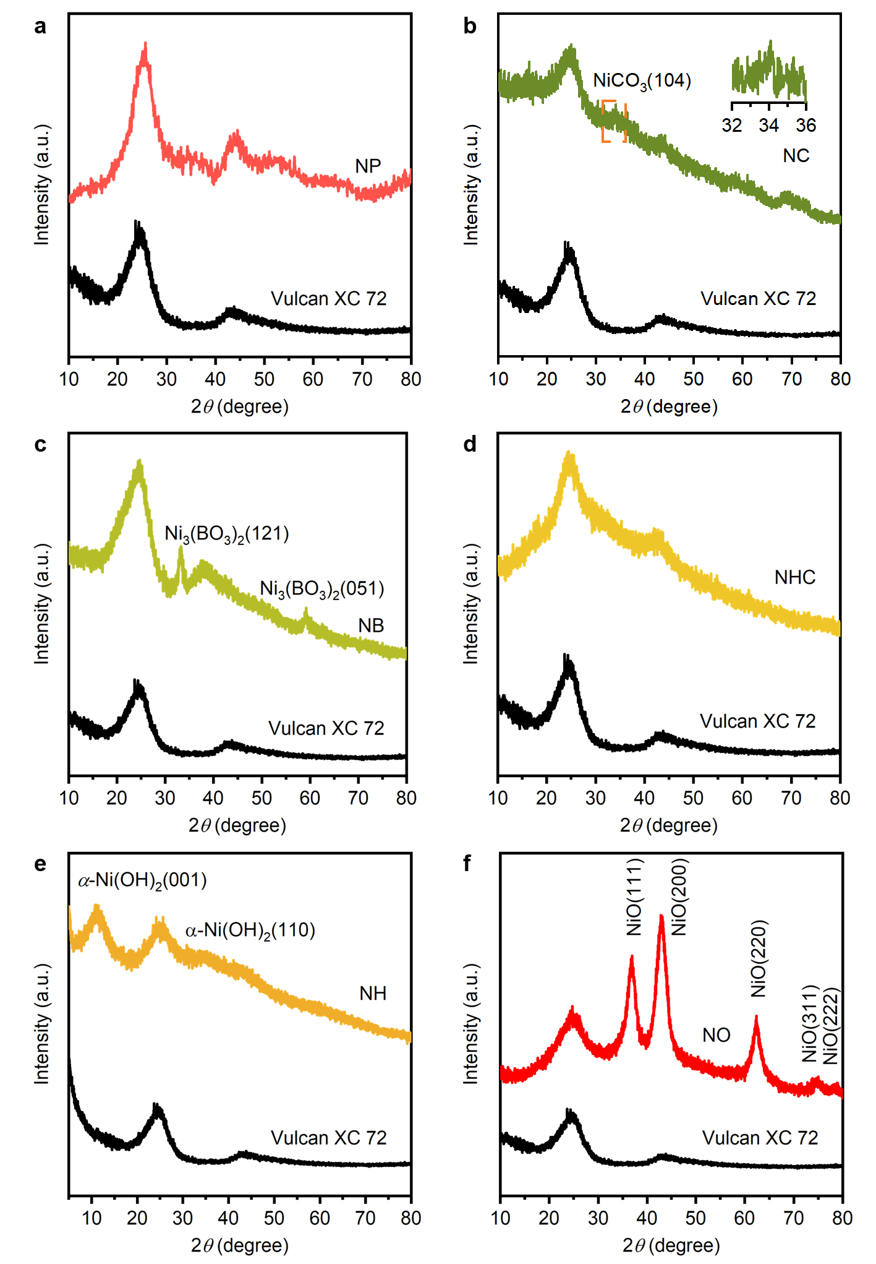
Supplementary Fig. 4 | XRD patterns of as-synthesized Ni oxygenate compounds supported on Vulcan XC 72 carbon. a, NP. b, NC: the weak diffraction at 33.9º 2θ (inset) can be indexed to the strongest reflection of the hexagonal NiCO₃ phase (JCPDS No. 12-0771). c, NB: the reflections correspond to the orthorhombic phase of Ni₃(BO₃)₂ (JCPDS No. 75-1809). d, NHC. e, NH: the reflections are assigned to the alpha phase (JCPDS No. 22-0444). f, NO: the reflections correspond to the face-centered cubic NiO (JCPDS No. 04-0835). The pattern of Vulcan XC 72 support is shown as a control. No reflections ascribable to Ni compounds are observed in XRD patterns of NP (a) and NHC (d), suggesting their nanocrystalline nature.

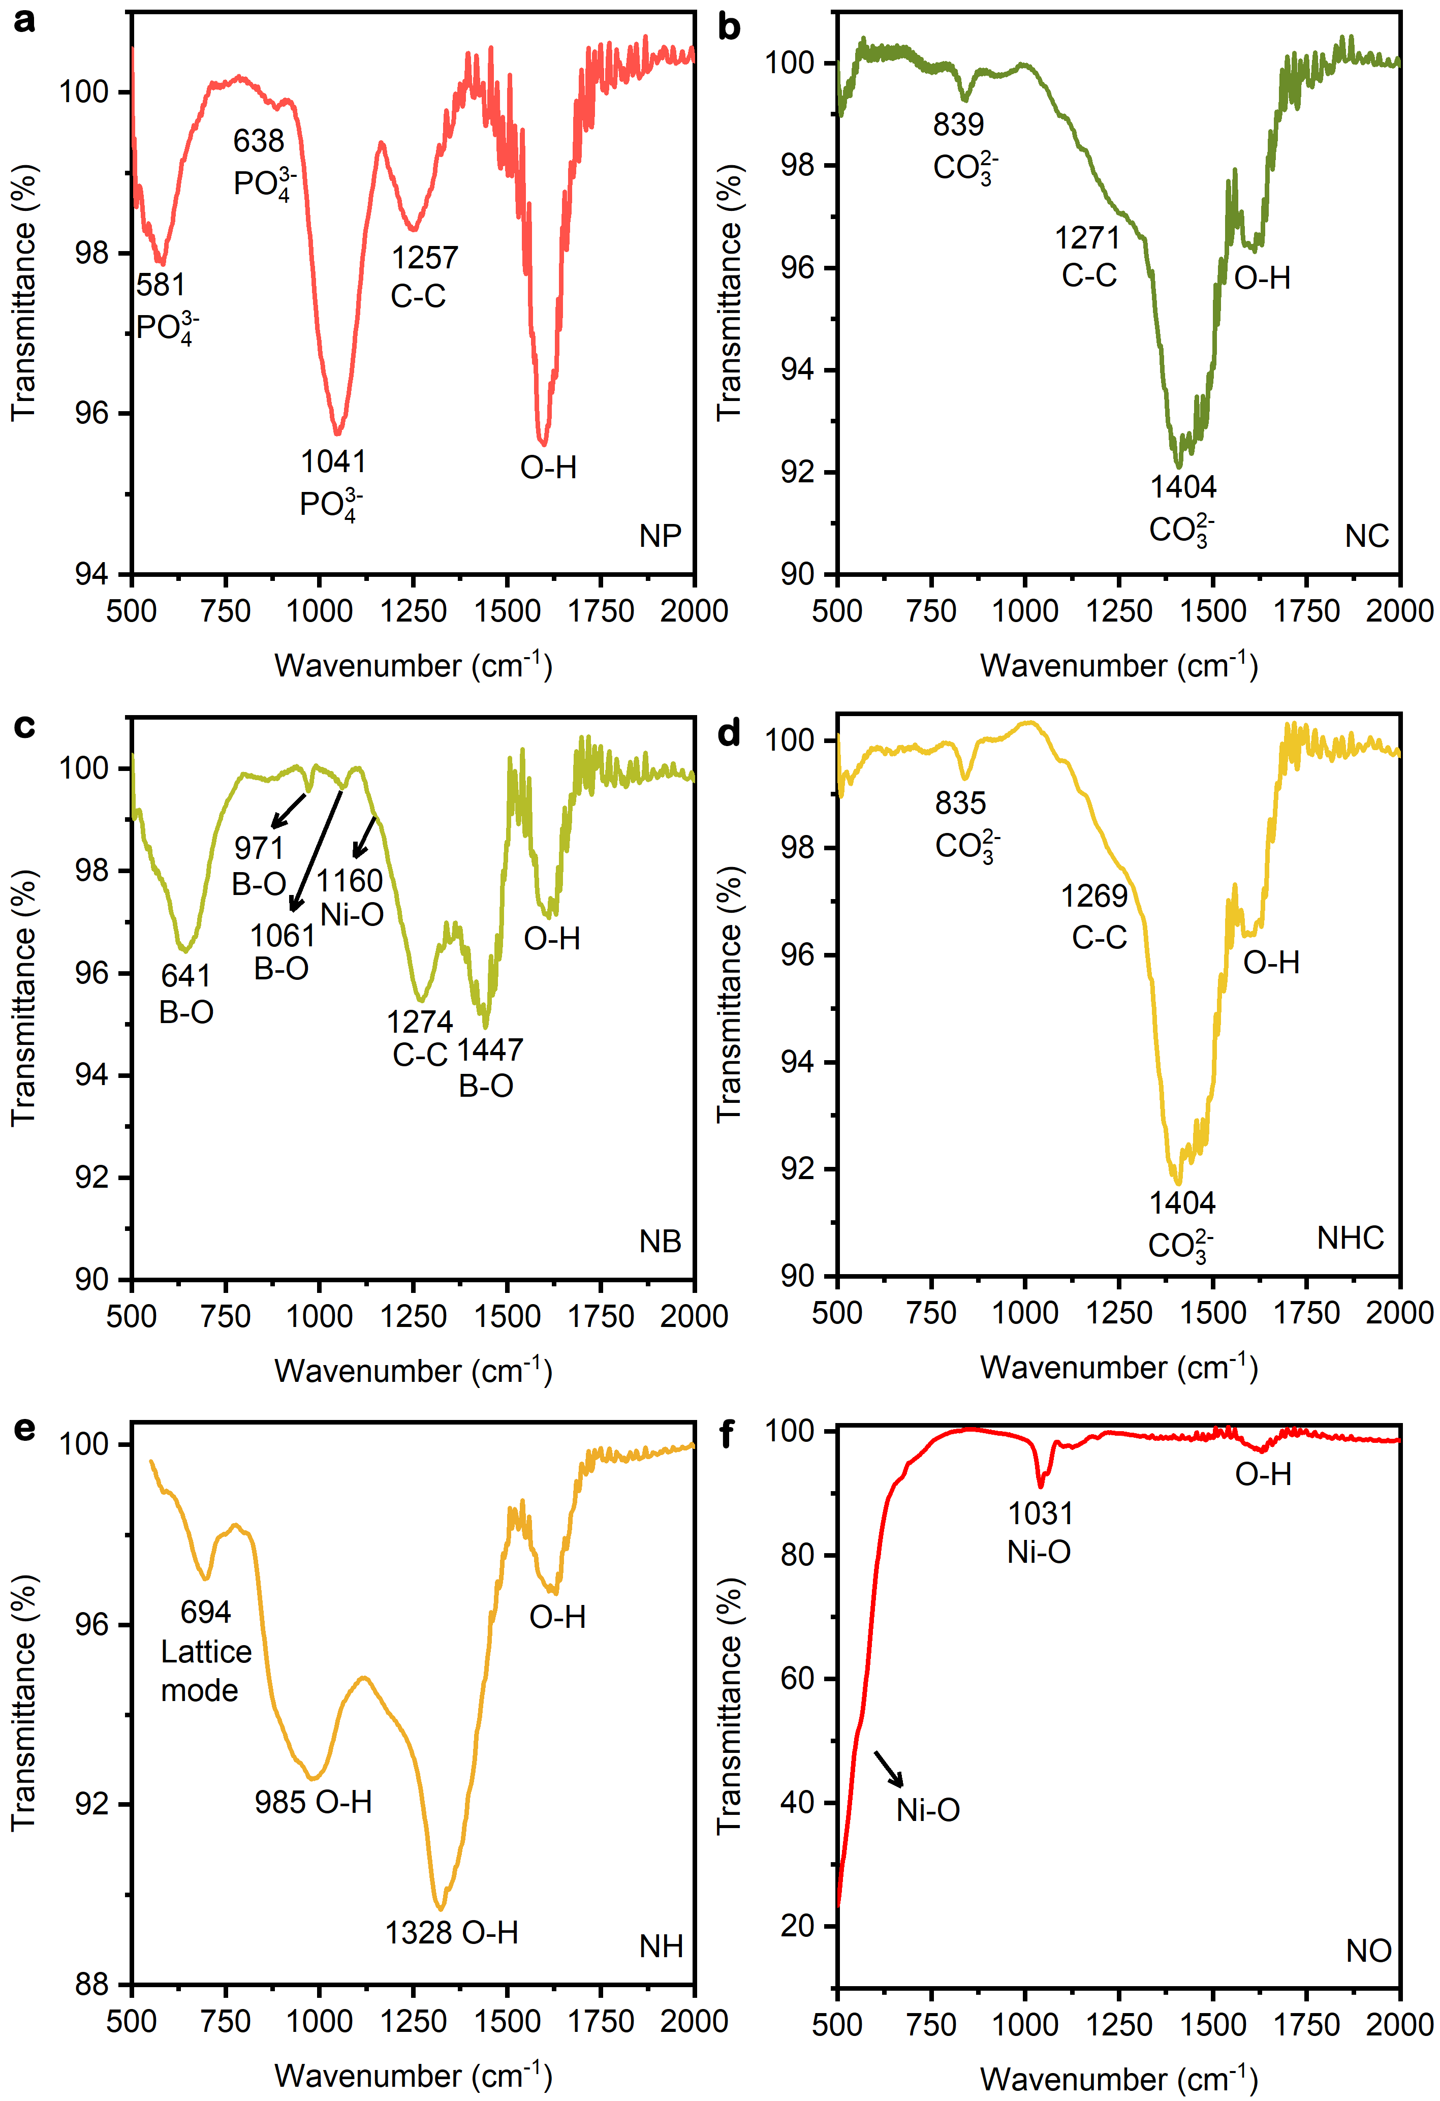
Supplementary Fig. 5 | Fourier-transform infrared spectroscopy (FTIR) spectra of as-synthesized oxygen-containing Ni compounds supported on Vulcan XC 72 carbon. a, NP. b, NC. c, NB. d, NHC. e, NH. f, NO. The functional groups are labeled with their corresponding wavenumber.

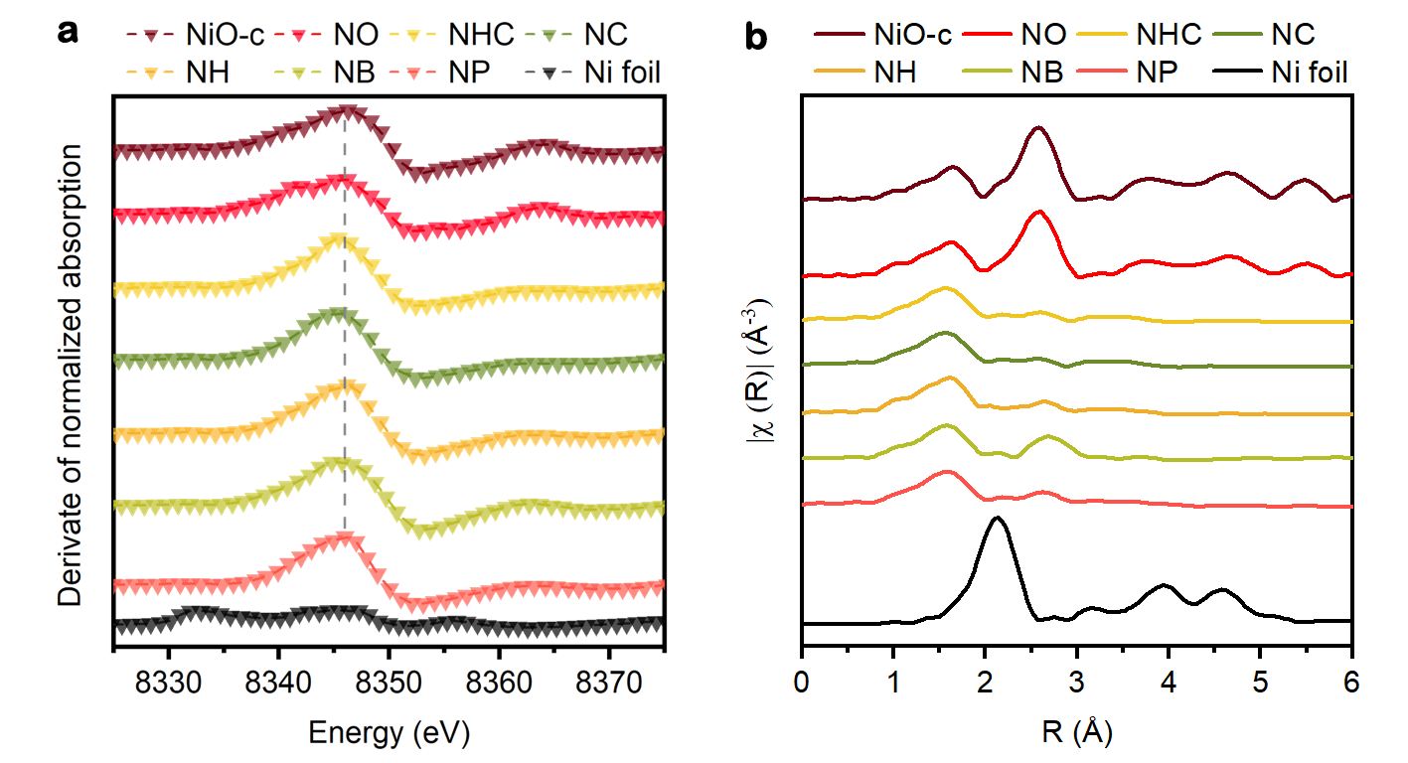
Supplementary Fig. 6 | X-ray absorption spectroscopy (XAS) of the as-synthesized Ni-based samples. a, The first derivative curves of the Ni-K edge X-ray absorption near-edge spectra (XANES). The peaks at ~8345.5 eV indicate that the oxidation state of Ni in all as-synthesized Ni oxygenates is +2. b, Ni-K edge extended X-ray absorption fine structure spectra (EXAFS). The peak at ~1.6 Å corresponds to the Ni-O bond. Ni foil and NiO-c were used as references.

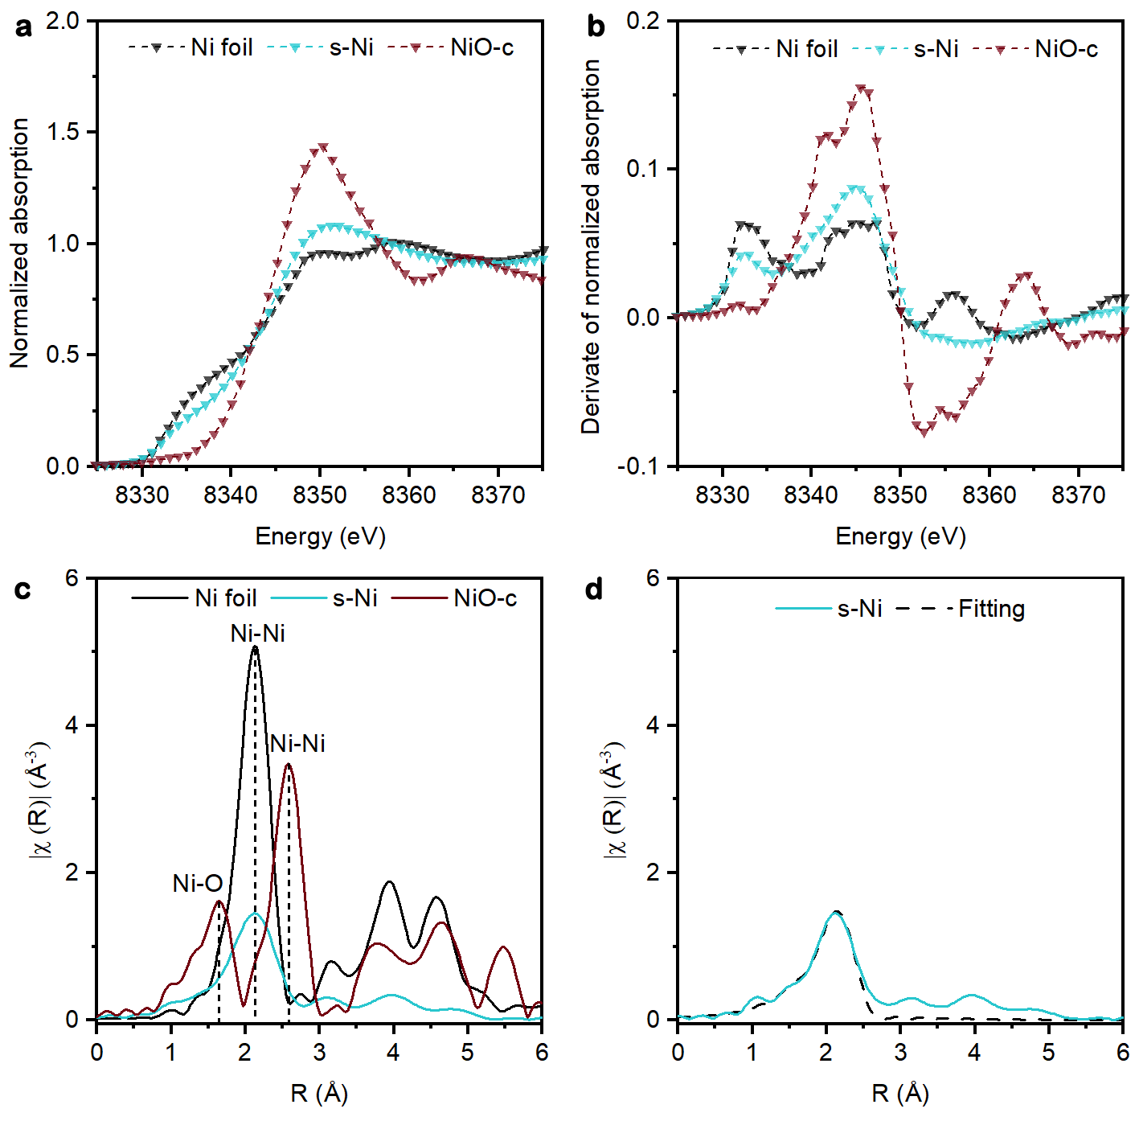
Supplementary Fig. 7 | XAS analysis of sputtered Ni. a, Ni K-edge XANES spectra of Ni foil, sputtered Ni (s-Ni) and commercial NiO (NiO-c), and b, their corresponding first derivative curves. c, Ni K-edge EXAFS r space curves. d, Ni K-edge EXAFS spectrum and corresponding fitting. The slight oxidation of the sputtered Ni is revealed by the Ni K-edge XANES spectra. The average coordination number in sputtered Ni is 7.45, which is much lower than coordination number of an ideal metallic state, 12. Thus, there is a large number of under-coordinated Ni sites in the sputtered Ni sample.

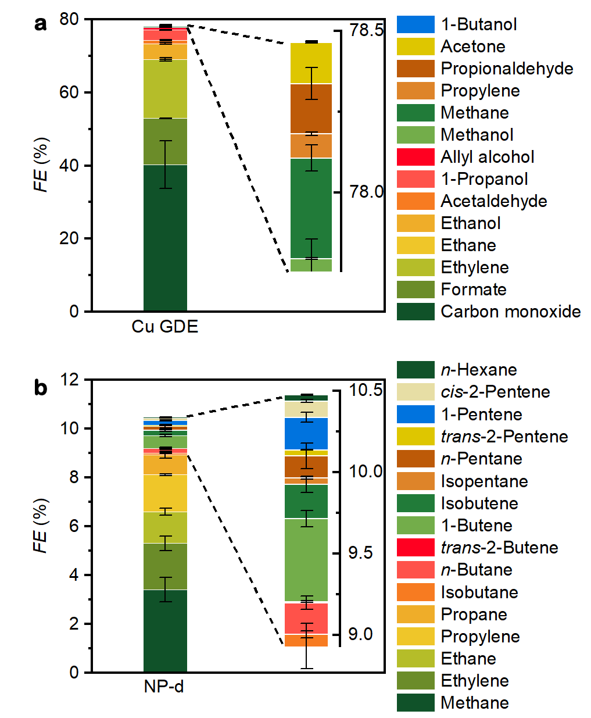
Supplementary Fig. 8 | Product distributions on Cu GDE and NP-d electrocatalyst. a, Carbon products distribution on Cu GDE. b, Hydrocarbons produced on NP-d derived electrocatalyst. Reaction conditions: 0.1 M KHCO₃ at –1.0 V versus RHE.

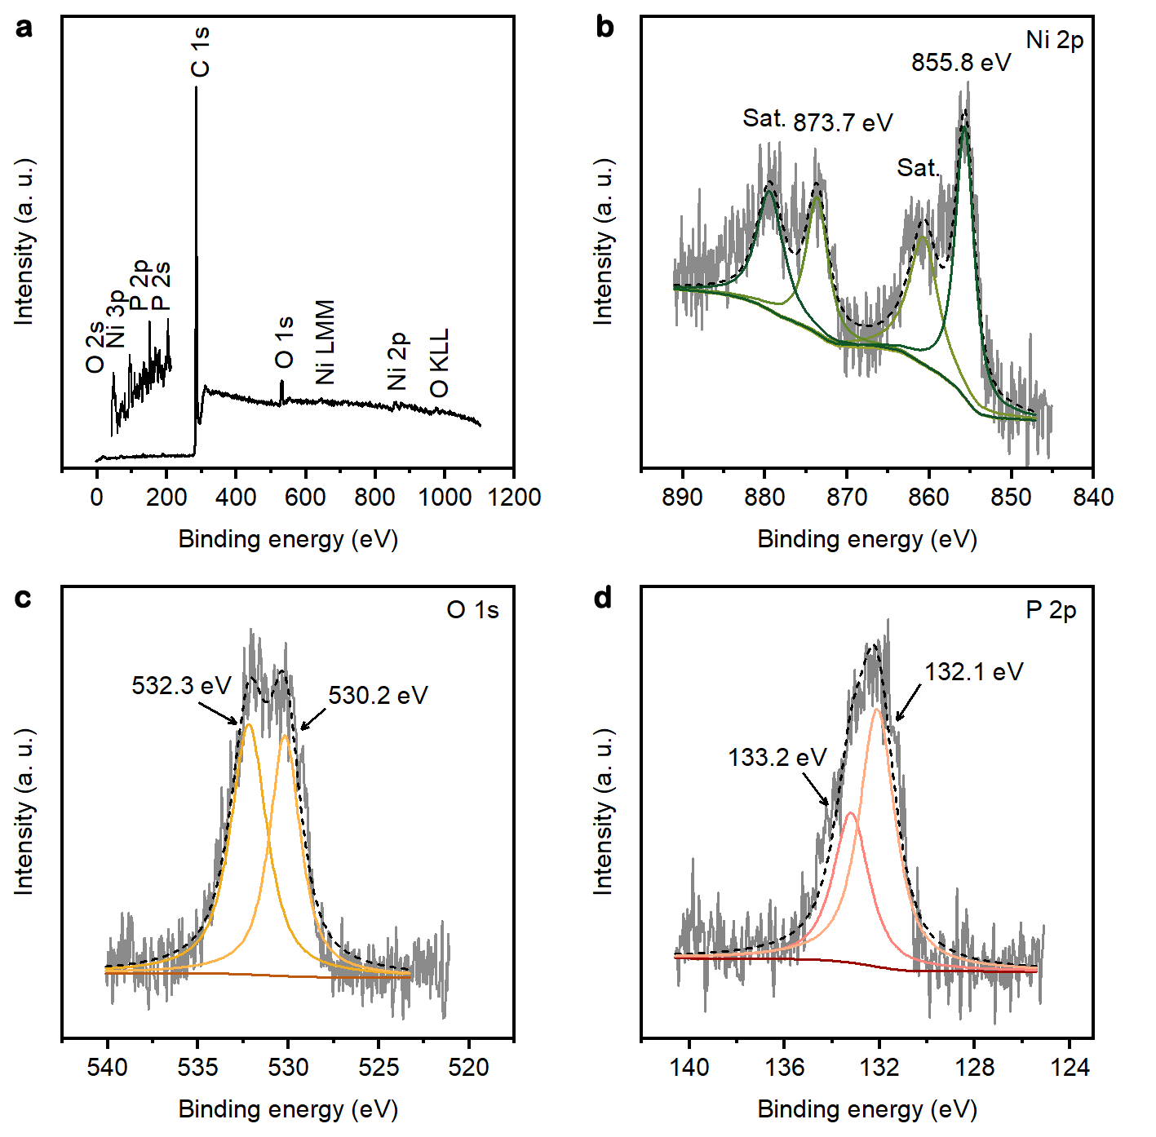
Supplementary Fig. 9 | X-ray photoelectron spectroscopy (XPS) of the as-synthesized NP. a, XPS survey spectrum. Only Ni, P, O, and C were detected. High-resolution spectra and deconvolution around the region b, Ni 2p, c, O 1s and d, P 2p. The Ni 2p peaks at 855.8 eV and 873.7 eV were assigned to Ni²⁺ 2 p_{3/2} and Ni²⁺ 2 p_{1/2} respectively¹⁵. The peaks at 133.2 eV and 132.1 eV in the P 2p spectrum indicate the existence of PO₄³⁻ and (HPO₄²⁻) ¹⁶. The O 1s peaks at 532.3 eV and 530.2 eV can be attributed to the P-O^{16,17} and Ni-O ¹⁸ bonds respectively.

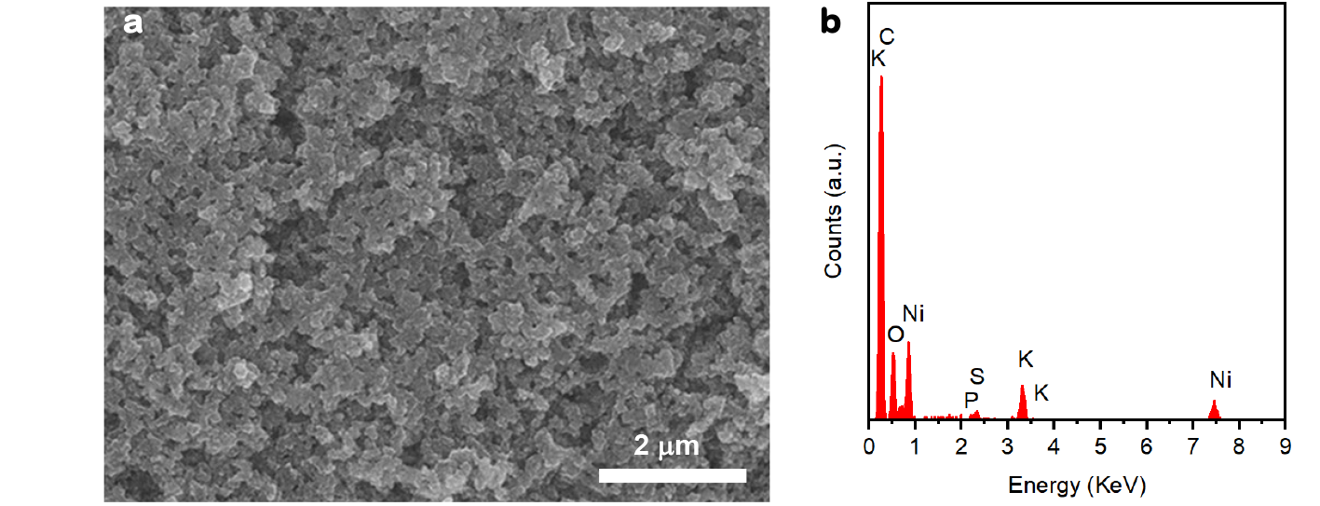
Supplementary Fig. 10 | Energy-dispersive X-ray spectroscopy (EDS) elemental analysis of the NP-d electrode after CO₂RR for 12 h. The S signal in the spectrum originates from Nafion®.

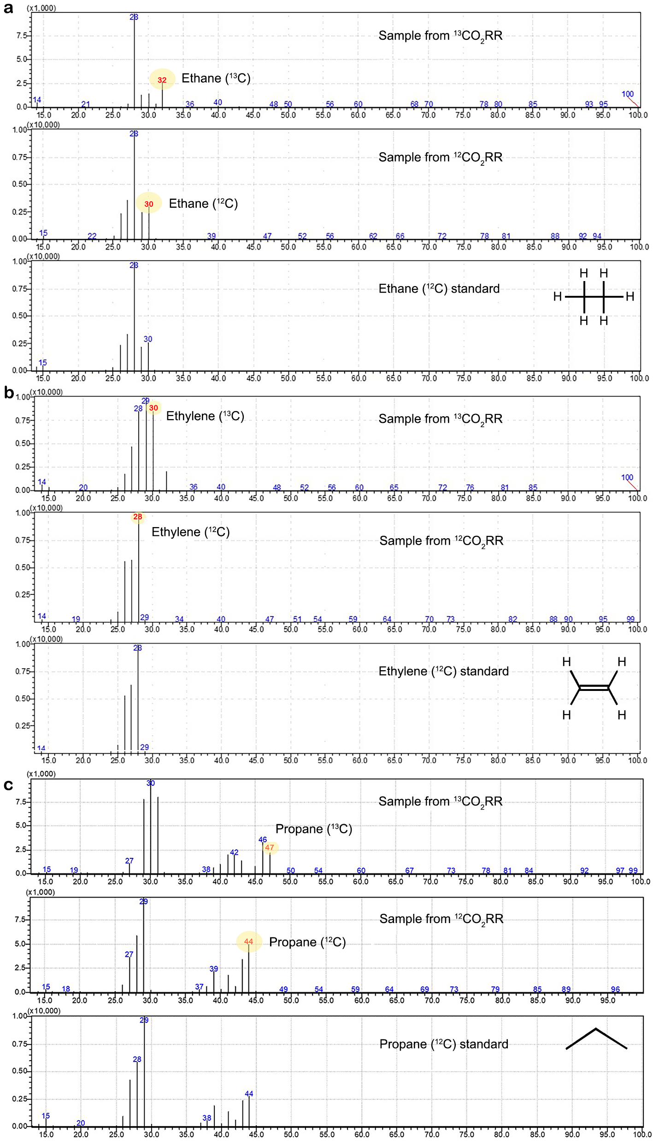
Supplementary Fig. 11 | Measured GC-MS spectra. a, Ethane, b, ethylene, and c, propane from ¹³CO₂RR and ¹²CO₂RR. The fragments highlighted with m/z = 32 in a, m/z = 30 in b and m/z = 47 in (c) correspond to ethane (¹³C), ethylene (¹³C), and propane (¹³C), respectively. Standard GC-MS spectra of ethane (¹²C), ethylene (¹²C), and propane (¹²C) were retrieved from the NIST 14 Mass Spectral Library¹⁹.
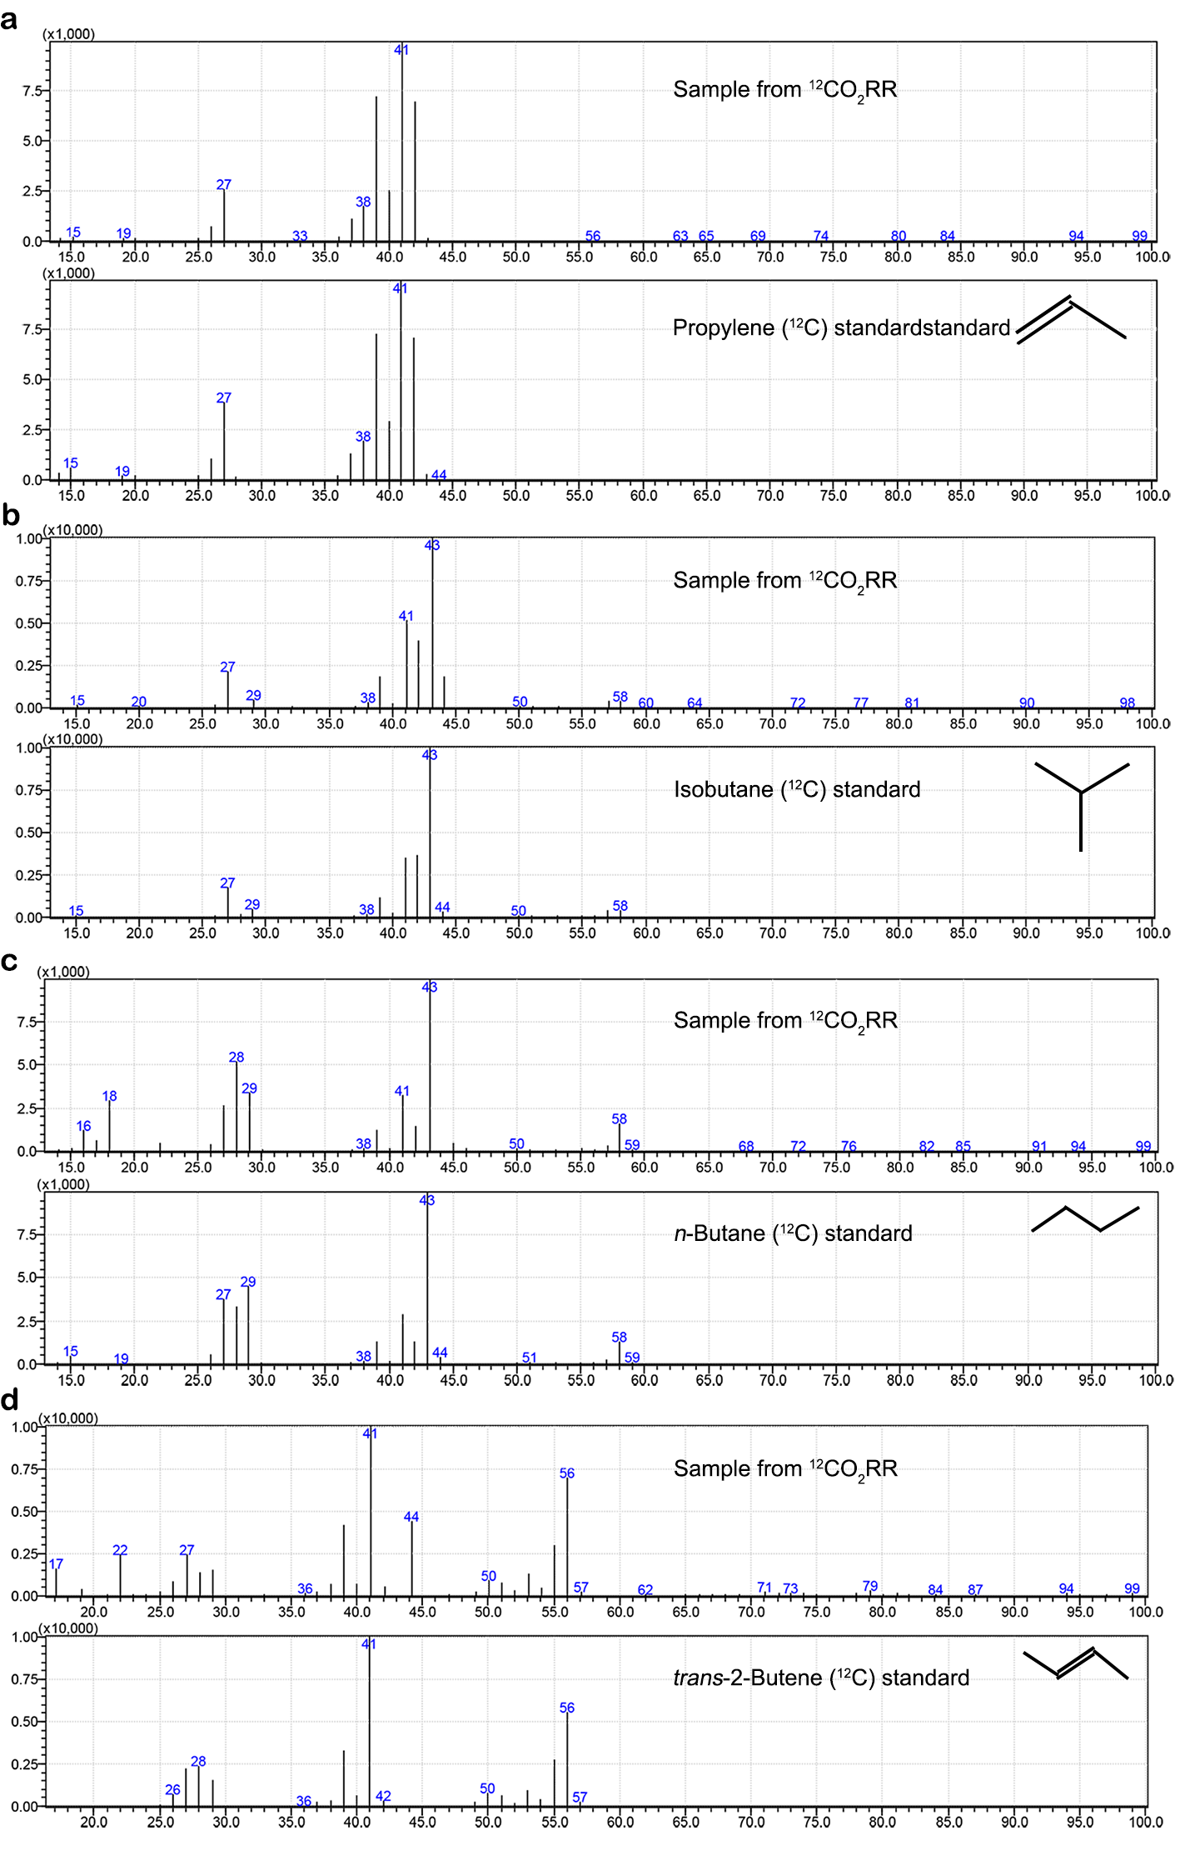
Supplementary Fig. 12 | Measured GC-MS spectra. a, propylene, b, isobutane, c, n-butane, and d, trans-2-butene from ¹²CO₂RR and the corresponding ¹²C standards retrieved from the NIST 14 Mass Spectral Library¹⁹.

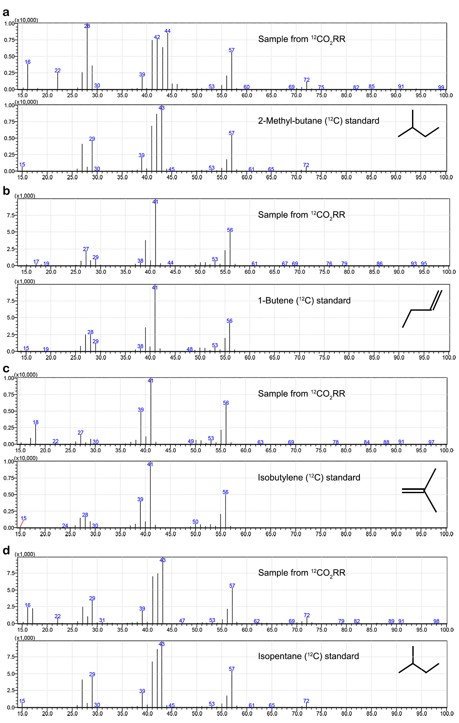
Supplementary Fig. 13 | Measured GC-MS spectra. a, 2-methyl-butane, b, 1-butene, c, isobutylene, and d, isopentane from ¹²CO₂RR and the corresponding ¹²C standards retrieved from the NIST 14 Mass Spectral Library¹⁹.

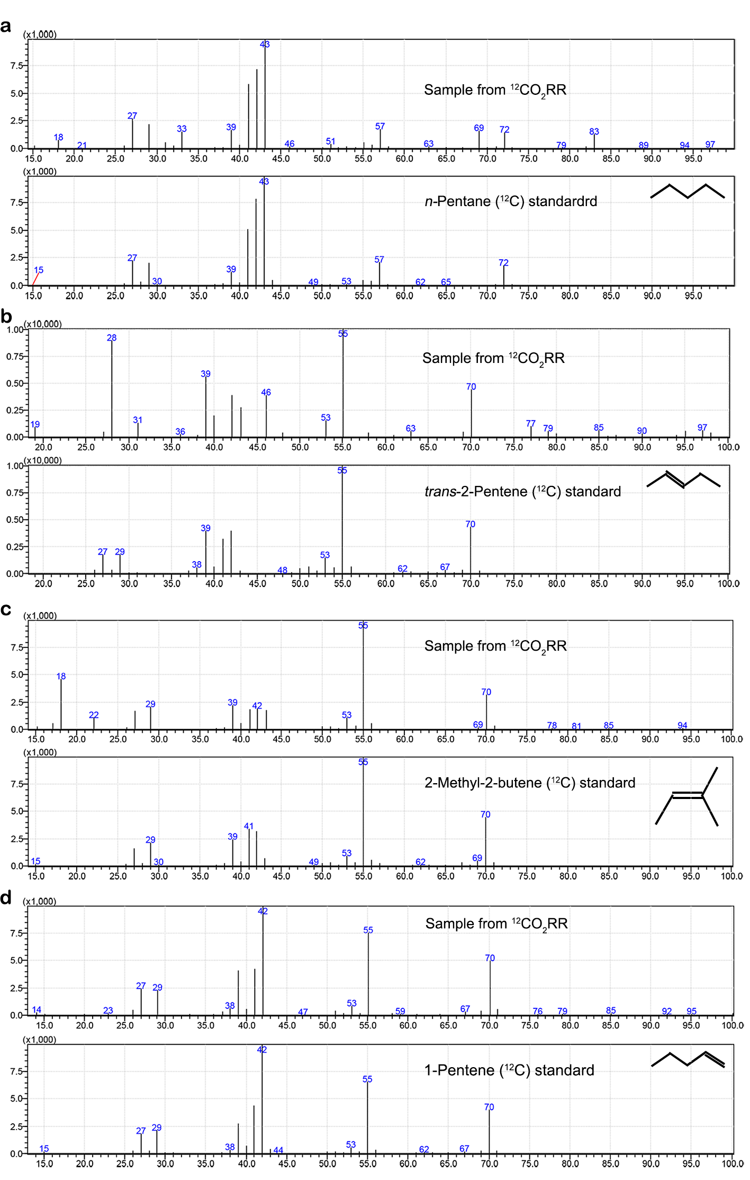
Supplementary Fig. 14 | Measured GC-MS spectra. a, n-pentane, b, trans-2-pentene, c, 2-methyl-butene, and d, 1-petene from ¹²CO₂RR and the corresponding ¹²C standards retrieved from the NIST 14 Mass Spectral Library¹⁹.

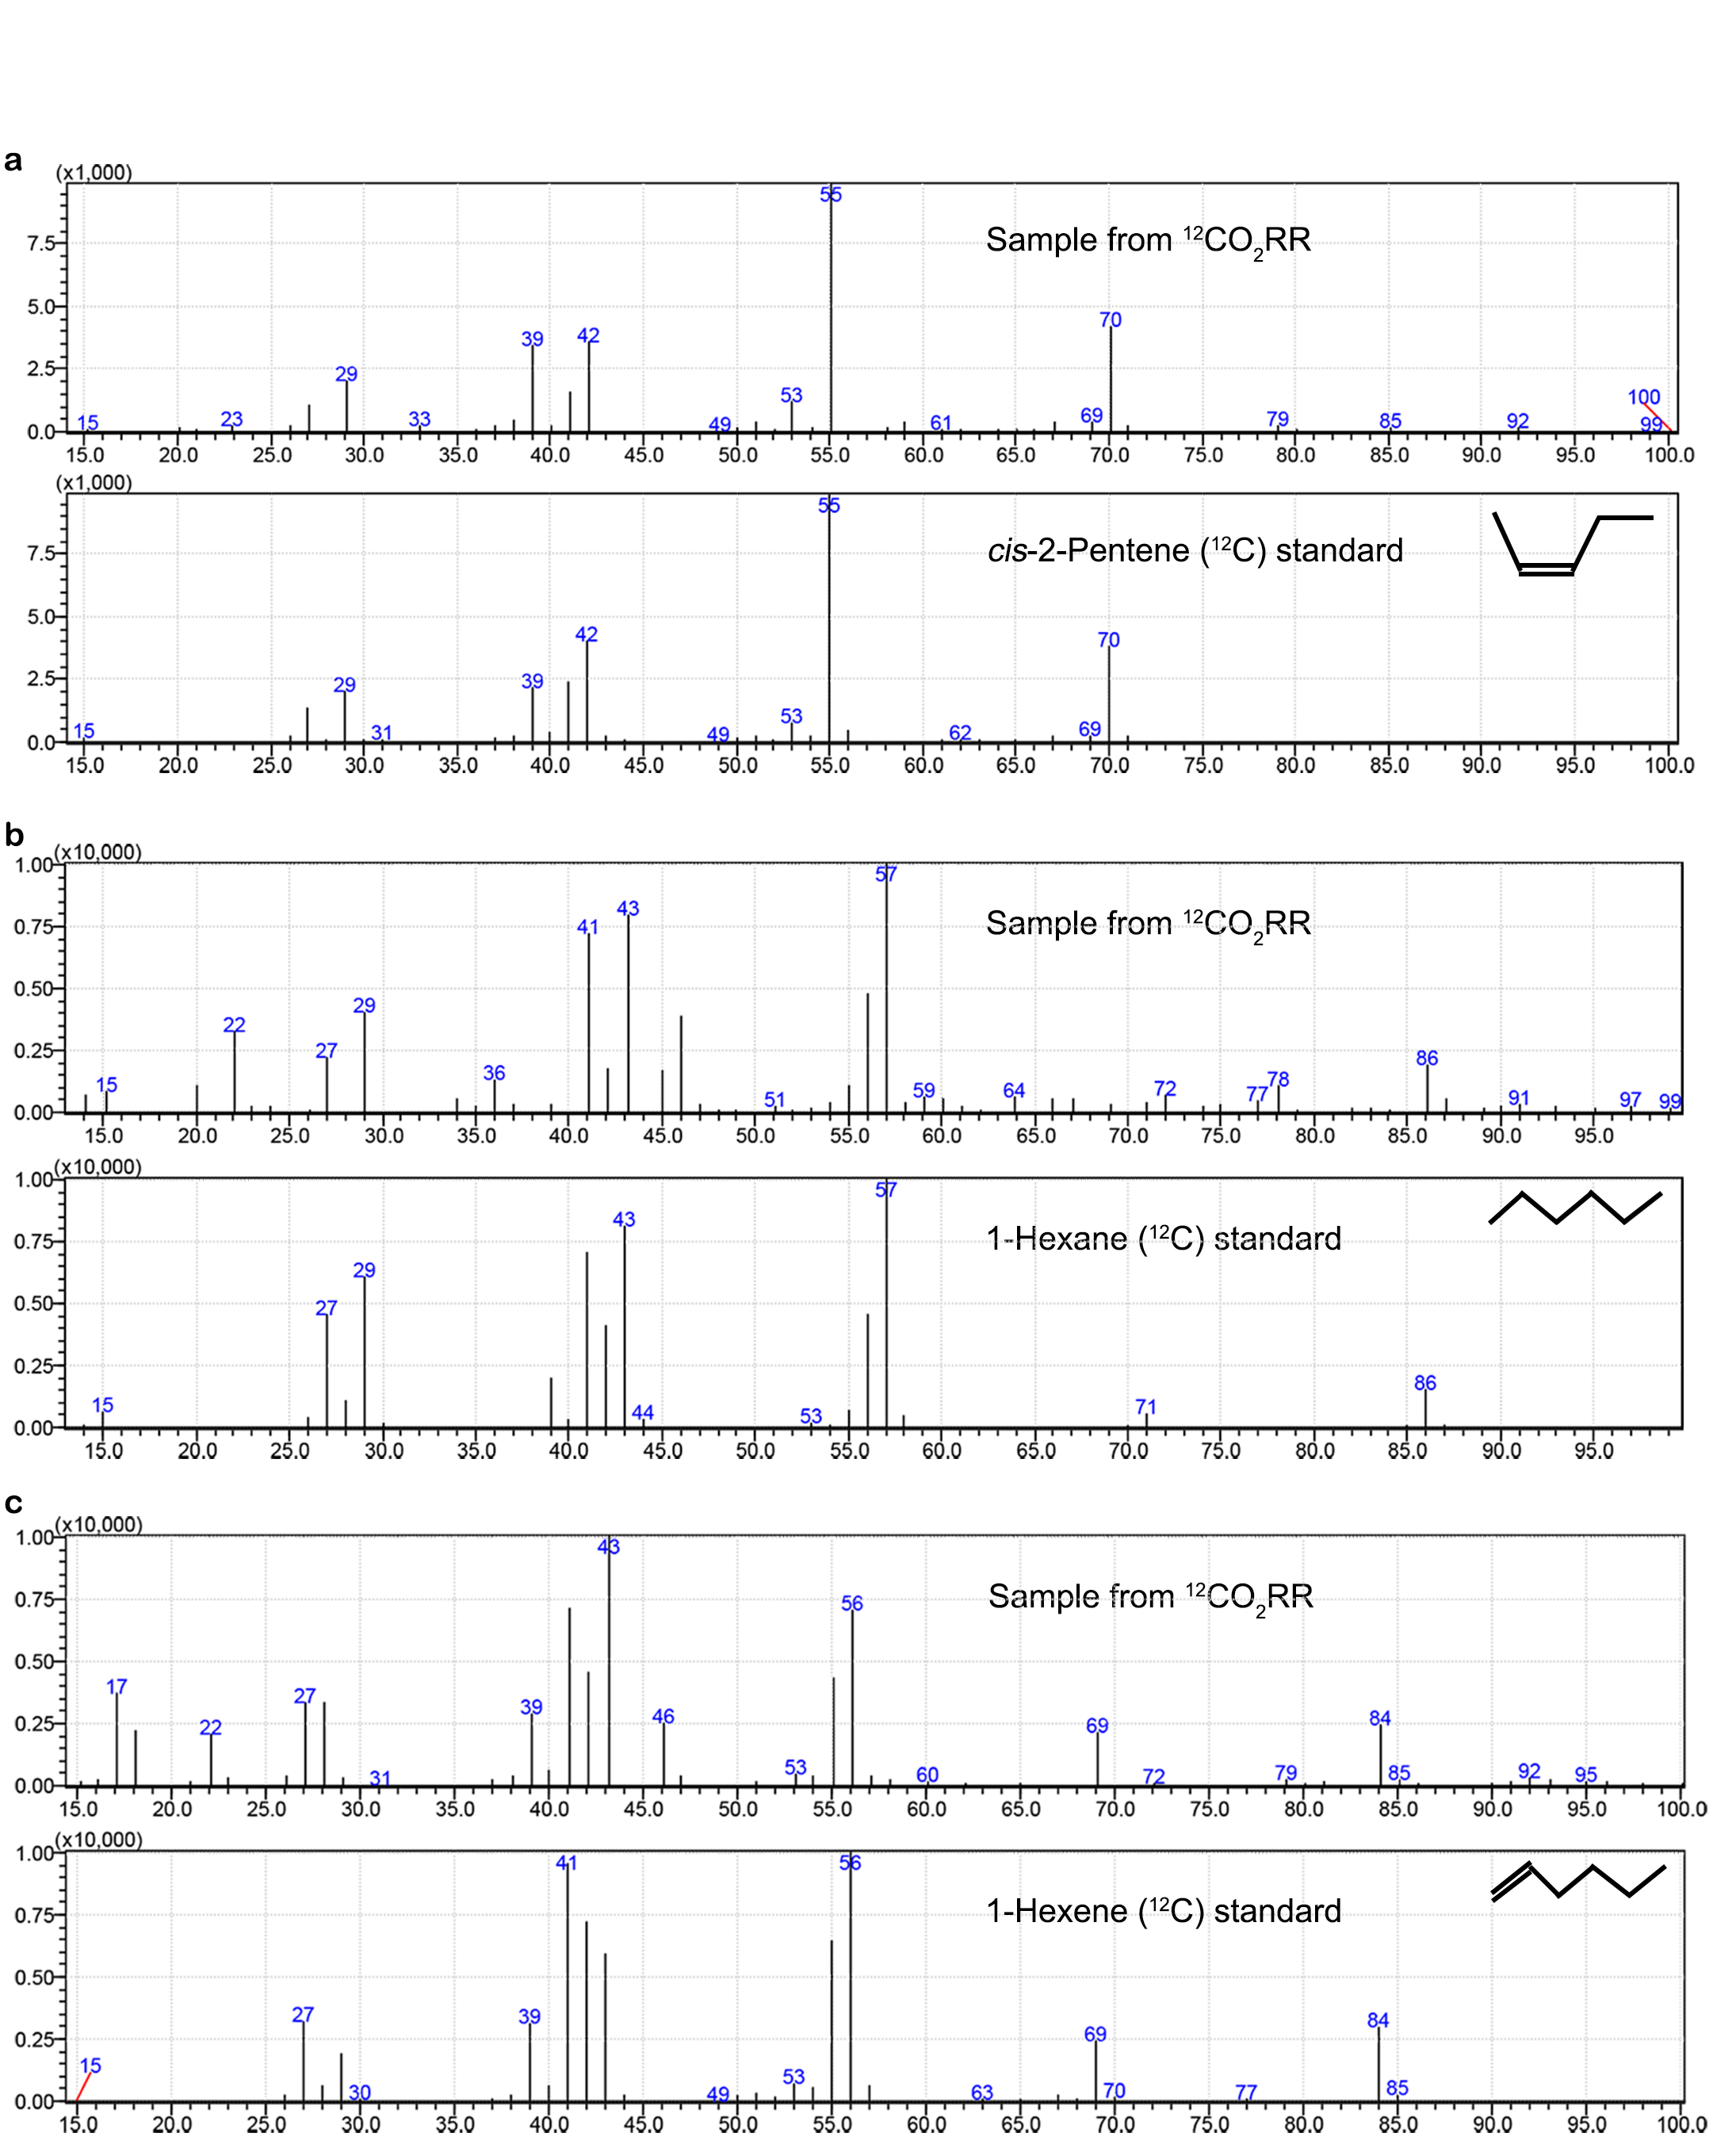
Supplementary Fig. 15 | Measured GC-MS spectra. a, n-pentane, b, cis-2-pentene, c, 1-hexane, and d, 1-hexene from ¹²CO₂RR and the corresponding ¹²C standards retrieved from the NIST 14 Mass Spectral Library¹⁹.

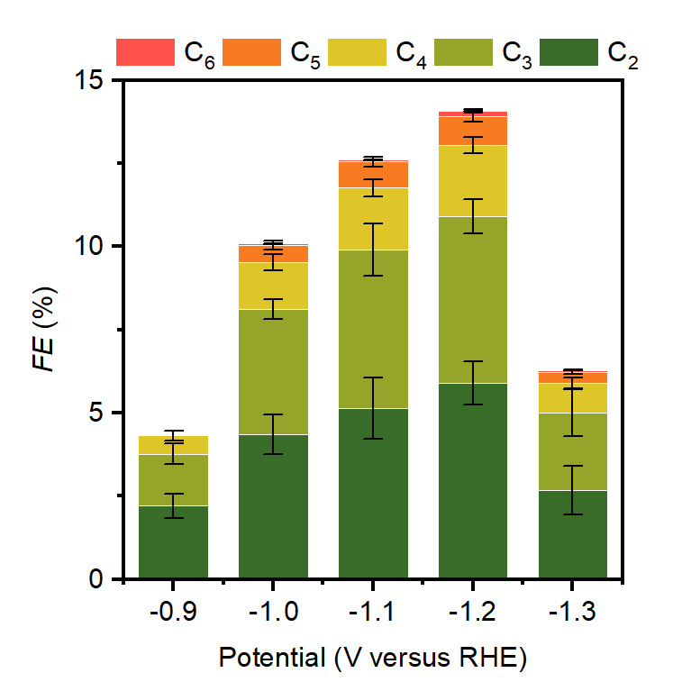
Supplementary Fig. 16 | CO₂RR on NP-d electrocatalyst with different applied potentials. C₂₊ Faradaic efficiency from CO₂RR at different applied potentials on NP-d electrocatalyst in 0.1 M KHCO₃.

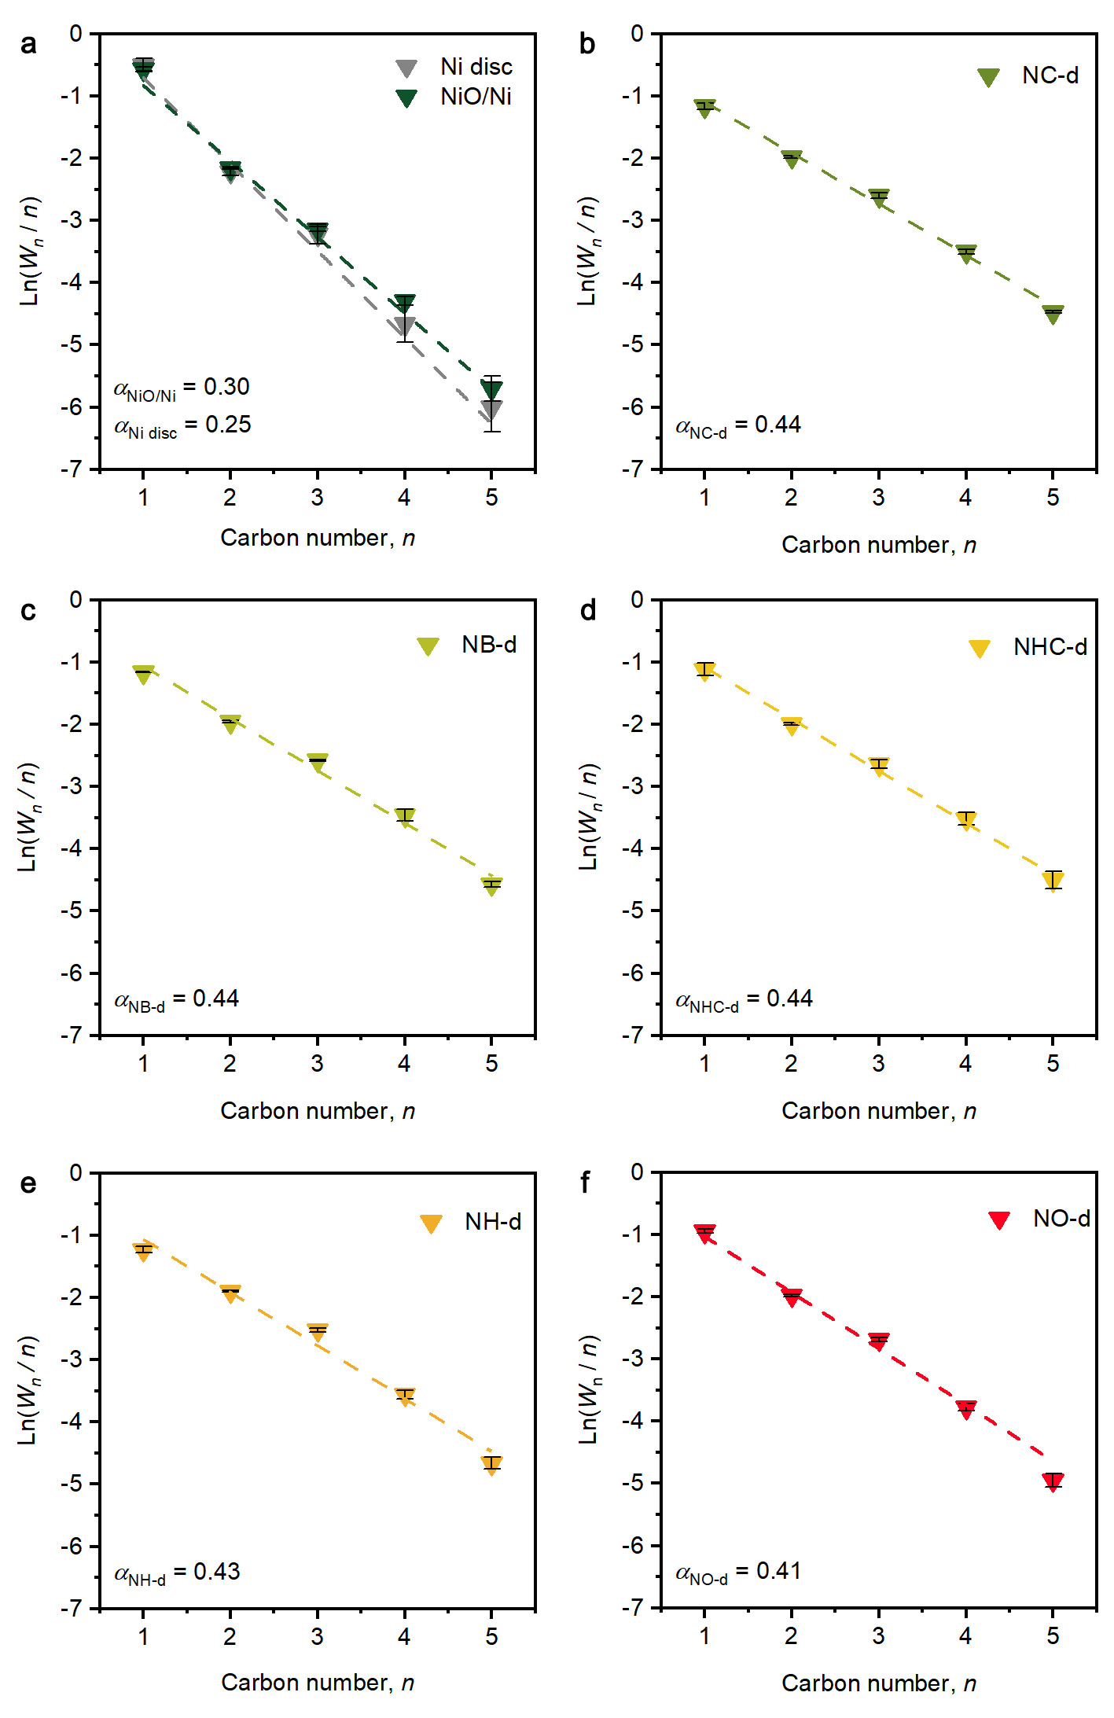
Supplementary Fig. 17 | Anderson-Schulz-Flory product distribution considering C₁-C₅ hydrocarbons produced on Ni-based electrocatalysts. a, Ni disc and NiO/Ni. b, NC-d. c, NB-d. d, NHC-d. e, NH-d. f, NO-d. Reaction conditions: 0.1 M KHCO₃ at –1.2 V versus RHE in a H-type cell for a; 0.1 M KHCO₃ at –1.2 V versus RHE in a flow cell for b-f.

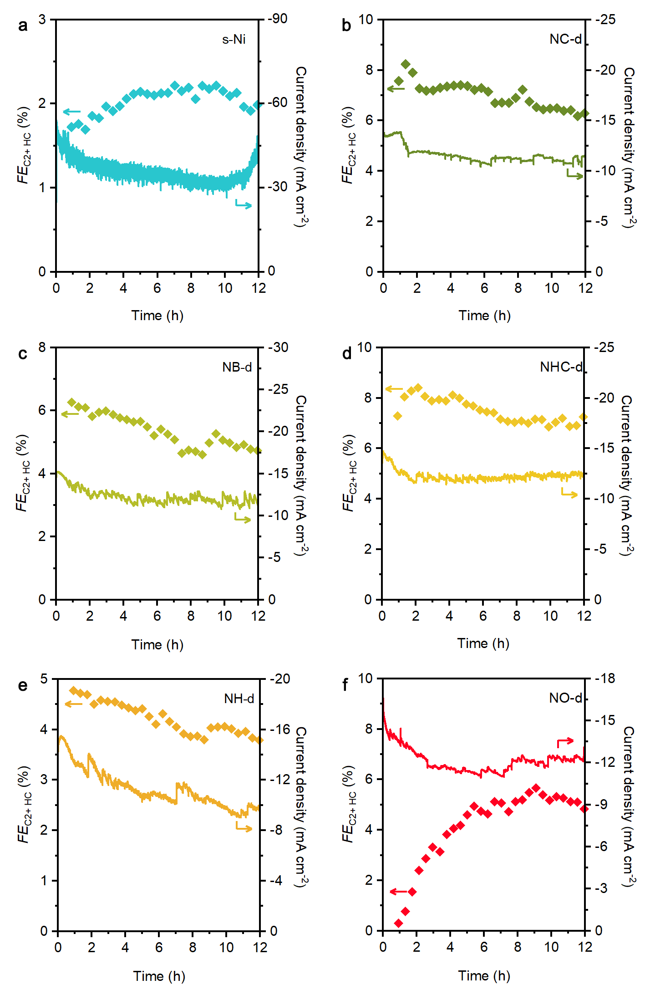
Supplementary Fig. 18 | Durability test for the Ni oxygenate-derived catalysts and sputtered Ni. a, s-Ni. b, NC-d. c, NB-d. d, NHC-d. e, NH-d. f, NO-d. Reaction conditions: 0.1 M KHCO₃ at –1.2 V versus RHE using a flow cell. HC = hydrocarbon.

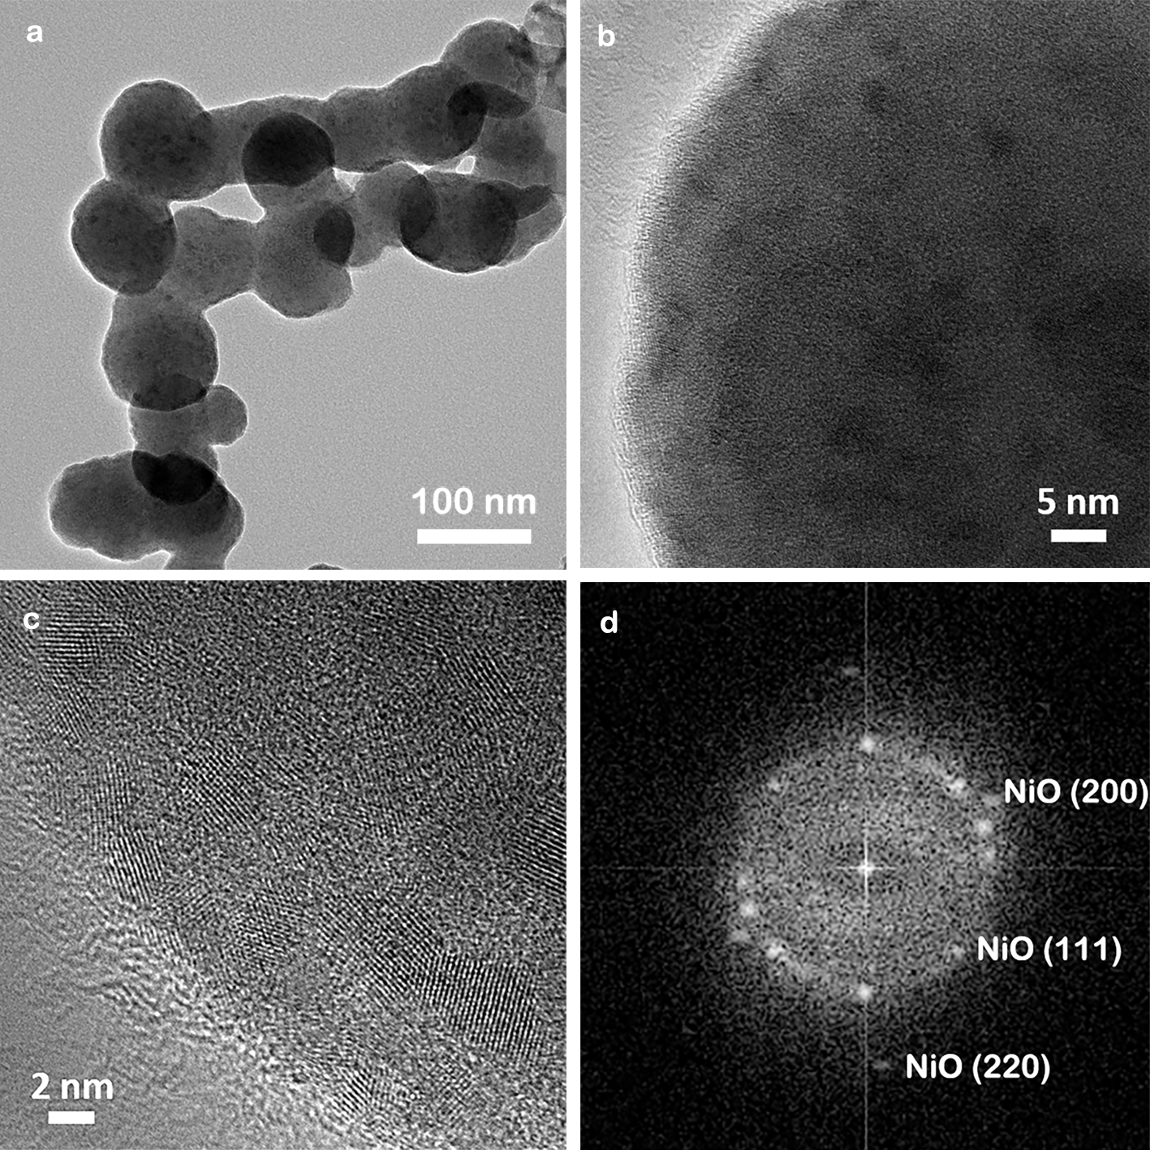
Supplementary Fig. 19 | Microscopy analysis of NP-d after CO₂RR. a-b, Transmission electron microscopy images; c, high-resolution transmission electron microscopy images; d, Fast Fourier transform analysis of c. The Vulcan sphere is covered by ~2 nm NiO nanoparticles. Thus, the rapid oxidation in air of Ni⁰ to NiO in the NP-d electrode after CO₂RR makes the ex situ extended X-ray absorption fine structure (EXAFS) analysis of Ni unreliable. Similarly, the in situ EXAFS analysis of Ni is unreliable due to the presence of gas bubbles. Reaction conditions: 1 h at –1.2 V versus RHE in 0.1 M KHCO₃.

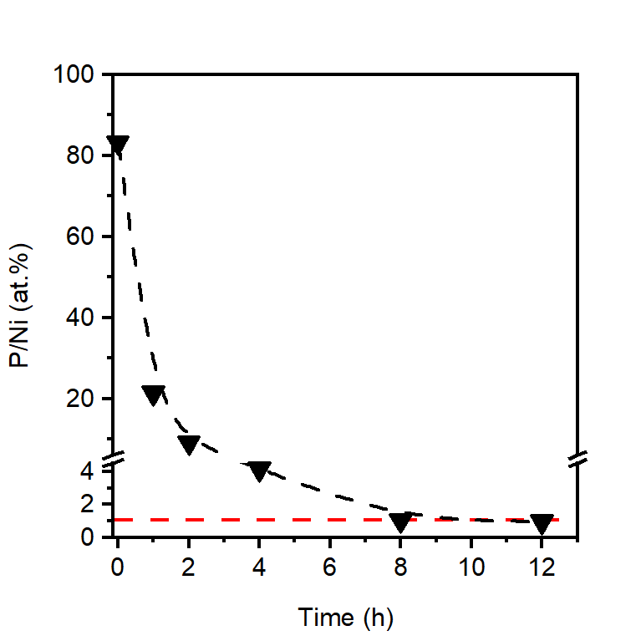
Supplementary Fig. 20 | Evolution of the content of P in NP-d samples after different CO₂RR times. The P and Ni concentrations were determined by inductively coupled plasma optical emission spectrometry (ICP-OES). The atomic P/Ni bulk ratio stabilizes at ~1% in the sample during the 12 h continuous CO₂RR reaction.

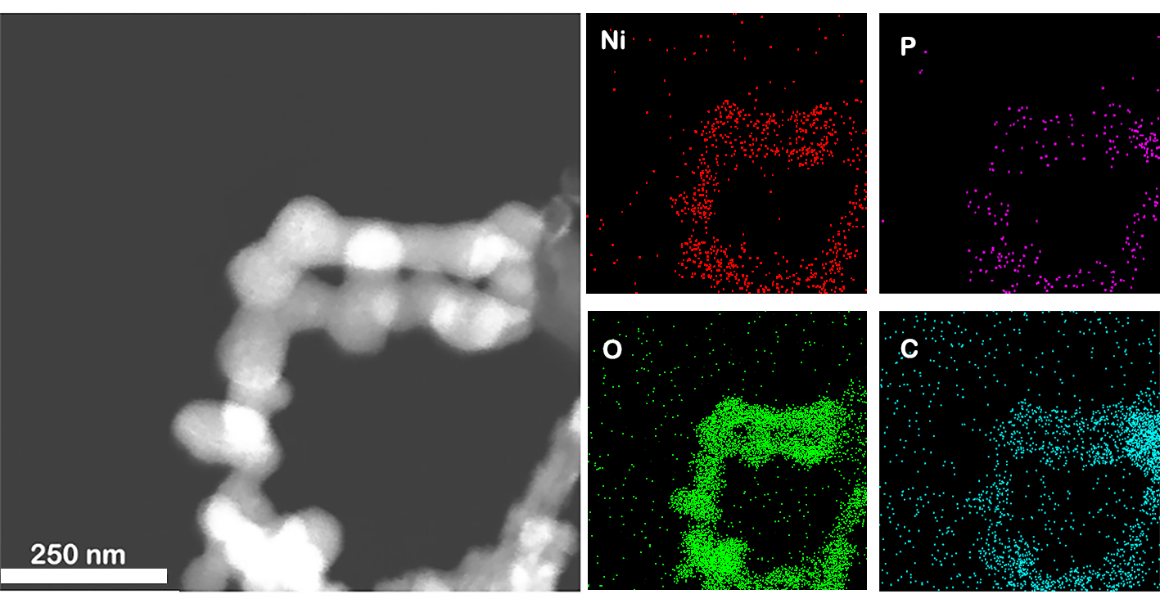
Supplementary Fig. 21 | EDS elemental maps of NP-d after CO₂RR. P is distributed uniformly along with Ni and O, supporting the presence of PO₄^{3–} under operation. Reaction conditions: 1 h at –1.2 V versus RHE in 0.1 M KHCO₃.

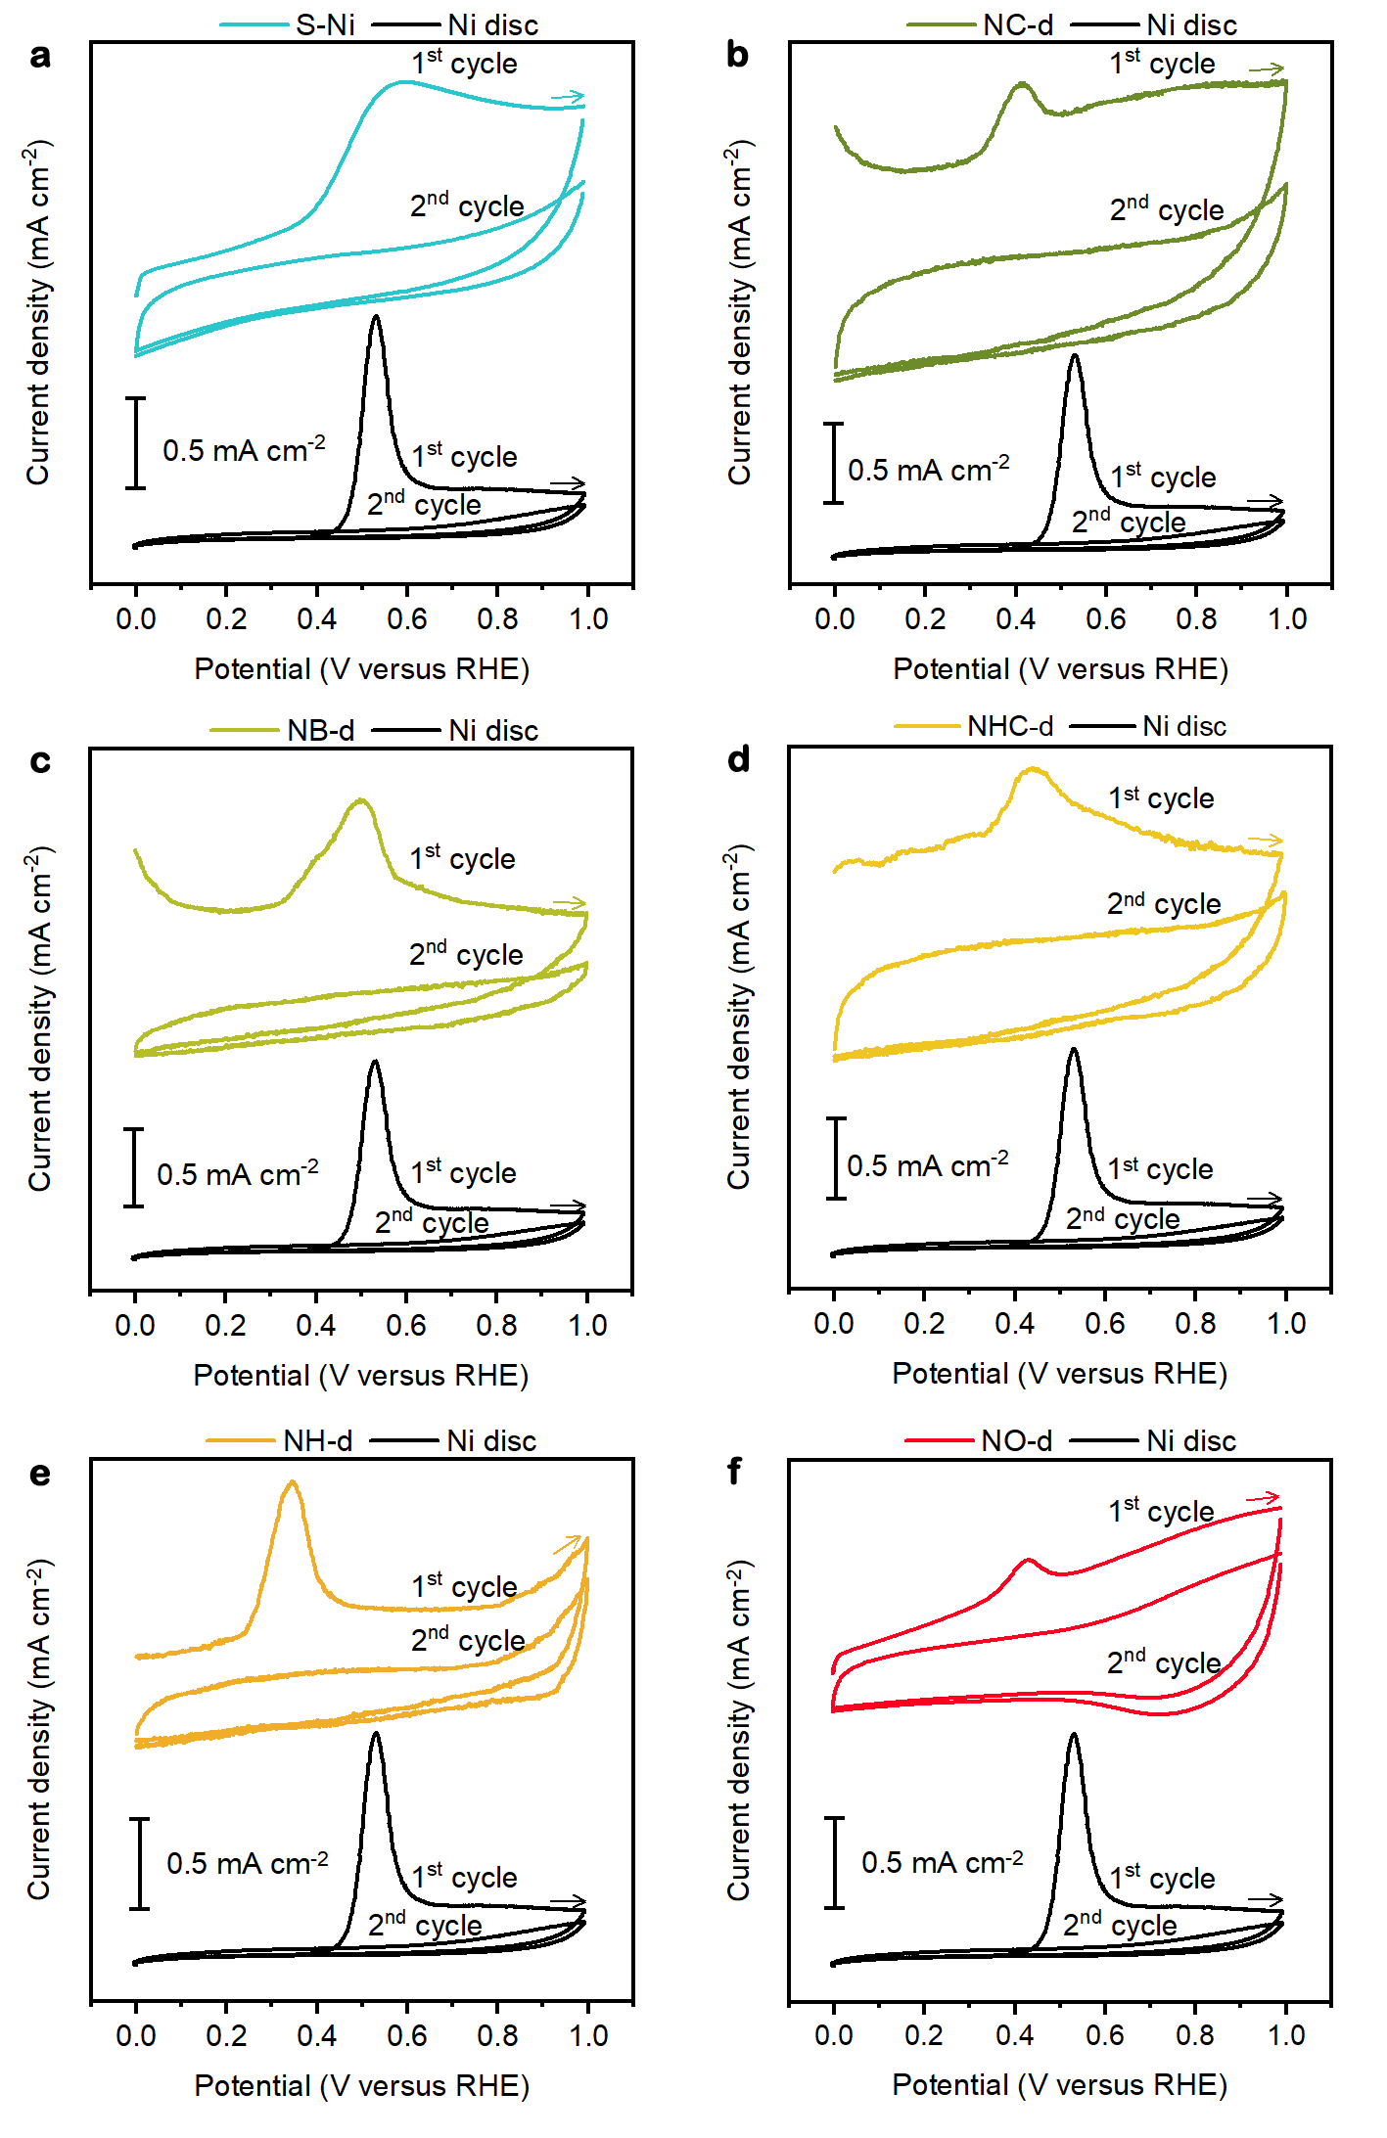
Supplementary Fig. 22 | CO stripping on the Ni oxygenate-derived electrocatalysts and sputtered Ni. a, s-Ni. b, NC-d. c, NB-d. d, NHC-d. e, NH-d. f, NO-d.

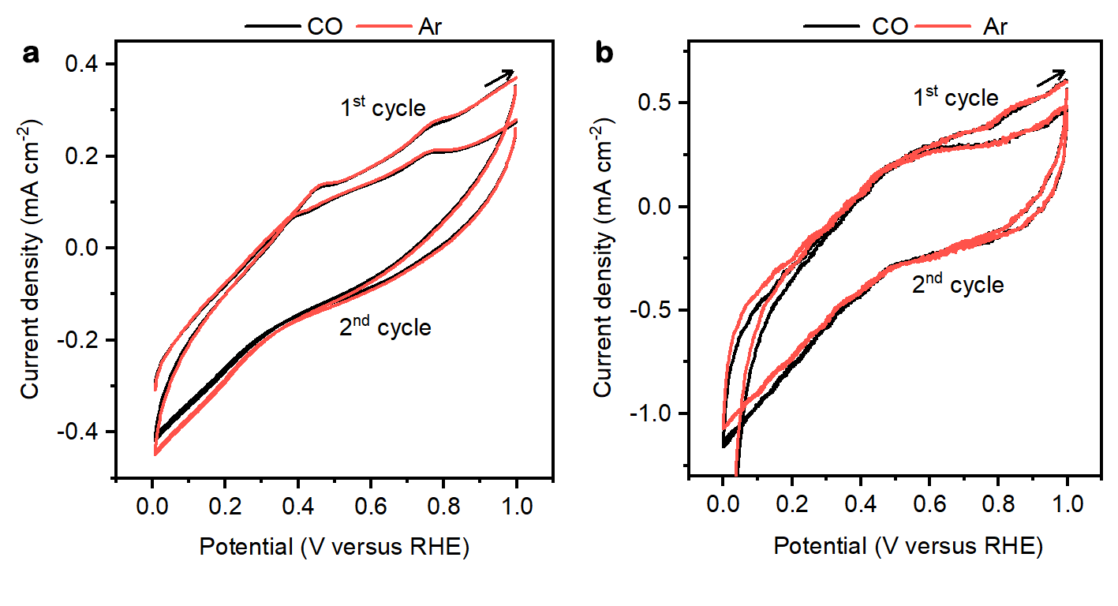
Supplementary Fig. 23 | CO stripping characterization. CO stripping signals on a, NiO-c and b, freshly synthesized NP. Significant peaks were not observed when bubbling CO into the electrochemical cell. Besides, no obvious difference in the CV curves under CO and Ar atmosphere can be observed. These results suggest that the pure oxygenated Ni surface and the as-synthesized NP showed negligible interaction with CO.
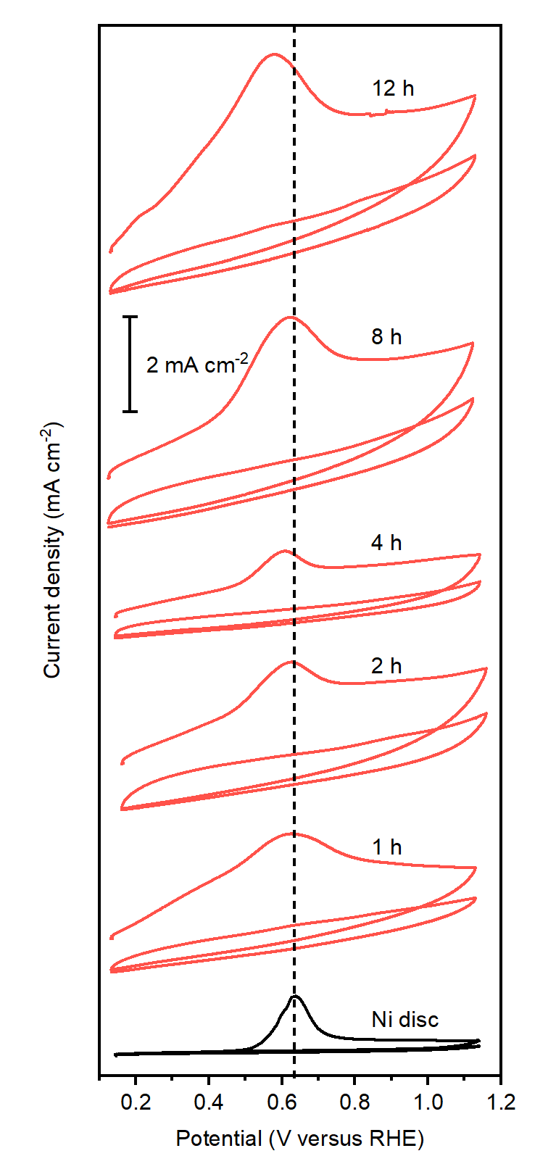
Supplementary Fig. 24 | CO stripping curves on NP-d electrodes at different reaction times. Reaction conditions: 0.1 M KHCO₃, –1.2 V versus RHE. Since the pH value of the cathode electrolyte increases to 12.5 after 12 h reaction for NP-d, a 0.1 M KHCO₃ electrolyte at pH 12.5 (adjusted by 0.1 M KOH) was used for Ni disc.

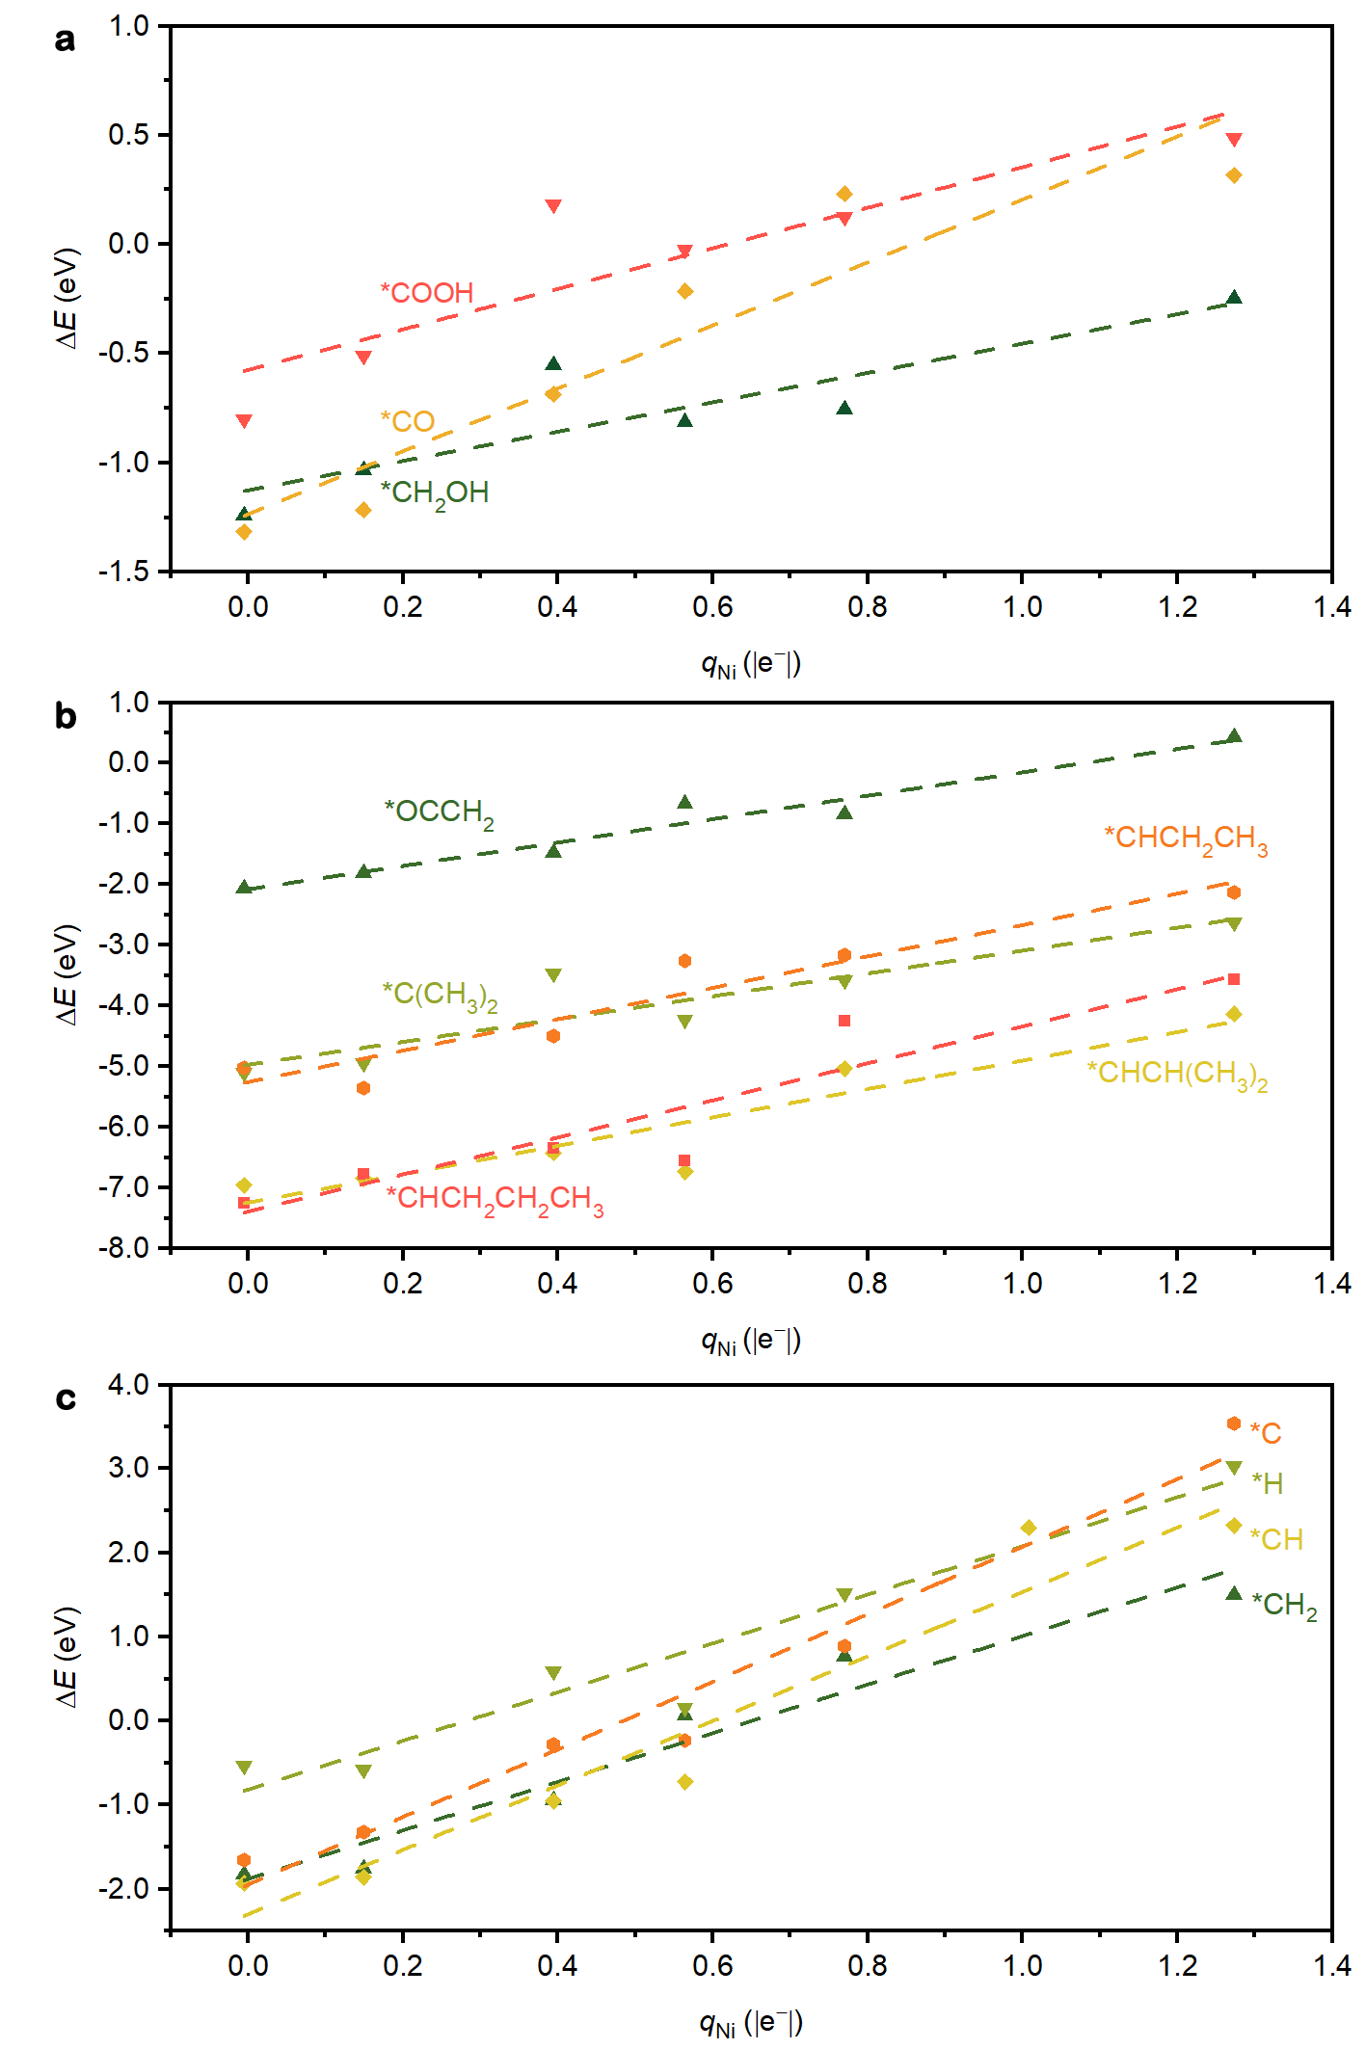
Supplementary Fig. 25 | Adsorption energy of relevant intermediates for CO₂ reduction and hydrogen evolution reaction versus Ni polarization. Intermediates characterized by a, 1-2, b, 2, c, 3-4 bonds between surface and adsorbate, N_{bonds}. Ni polarization is here approximated by the Bader charge of the adsorption site q_{Ni}. Regression parameters are reported in Supplementary Table 8.

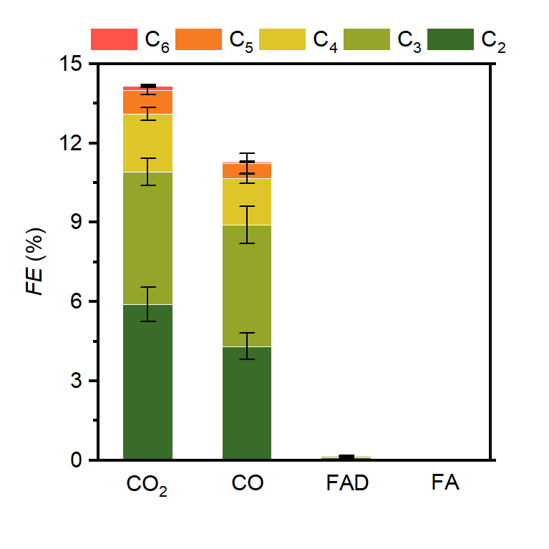
Supplementary Fig. 26 | Faradaic efficiencies toward multicarbon products using different C₁ reagents (CO₂, CO, CH₂O (FAD), and HCOOH (FA) on NP-d electrocatalyst. CO₂ yields the highest total multicarbon product Faradaic efficiency. Reaction conditions: 0.1 M KH₂PO₄, –1.2 V versus RHE.

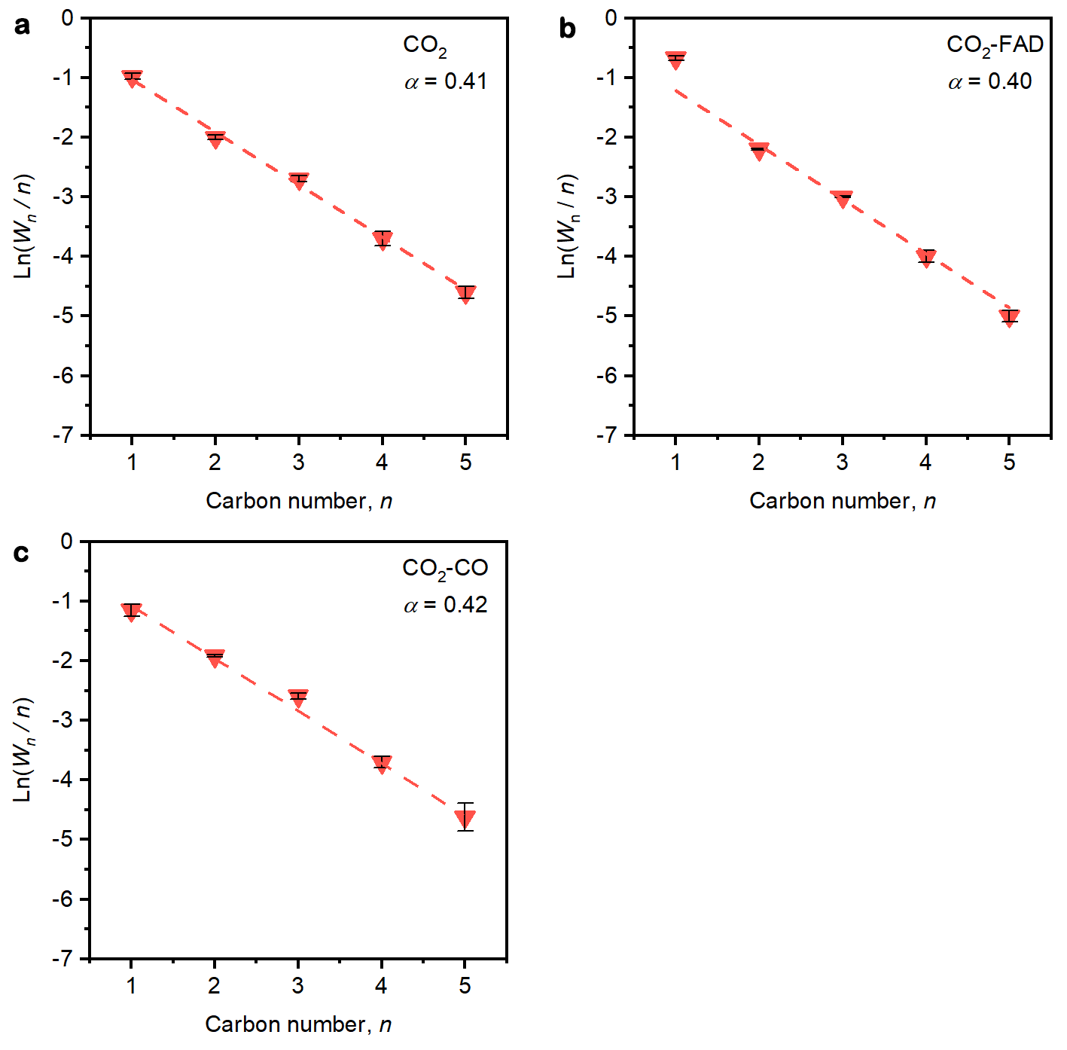
Supplementary Fig. 27 | Anderson-Schulz-Flory product distribution considering C₁ to C₅ hydrocarbon products using different C₁ feeds on NP-d electrocatalyst. a, CO₂, b, CO₂-FAD, and c, CO₂-CO. Reaction conditions: 0.1 M KH₂PO₄, –1.2 V versus RHE in a flow cell.

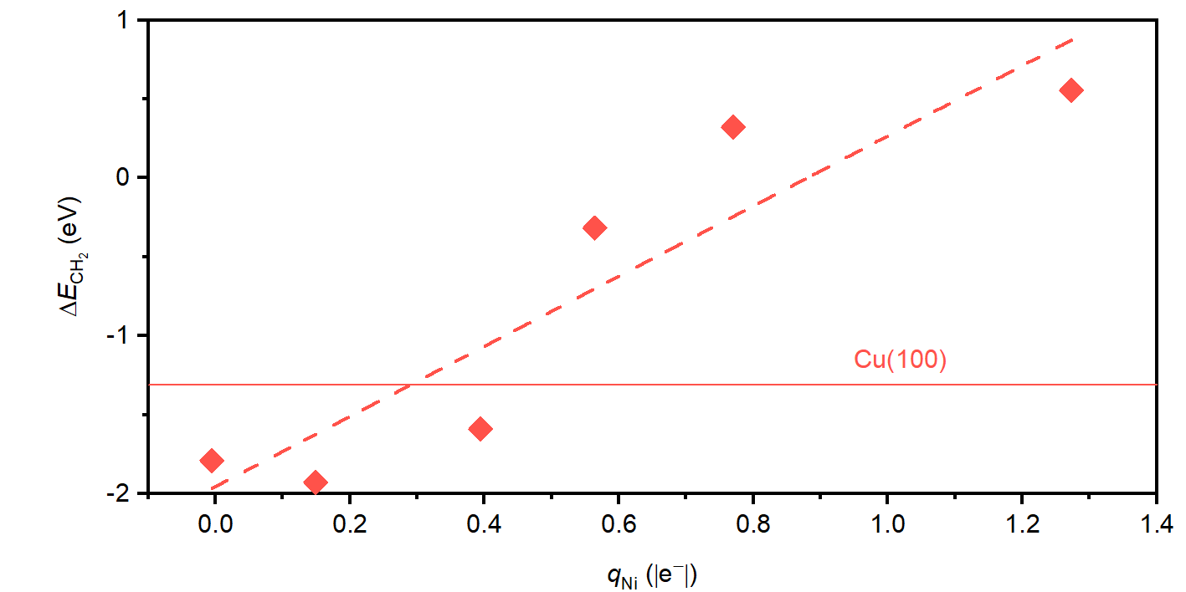
Supplementary Fig. 28 | CH₂OH reduction to CH₂ and H₂O at U = –1.2 V versus polarization of Ni adsorption sites. This process is promoted by the applied electric potential since it occurs via a proton-coupled electron transfer: *CH₂OH + H⁺ + e– → *CH₂ + H₂O; ΔE_{CH2}. *CH₂ formation energy from *CH₂OH on Cu(100) is shown as a reference (solid line).

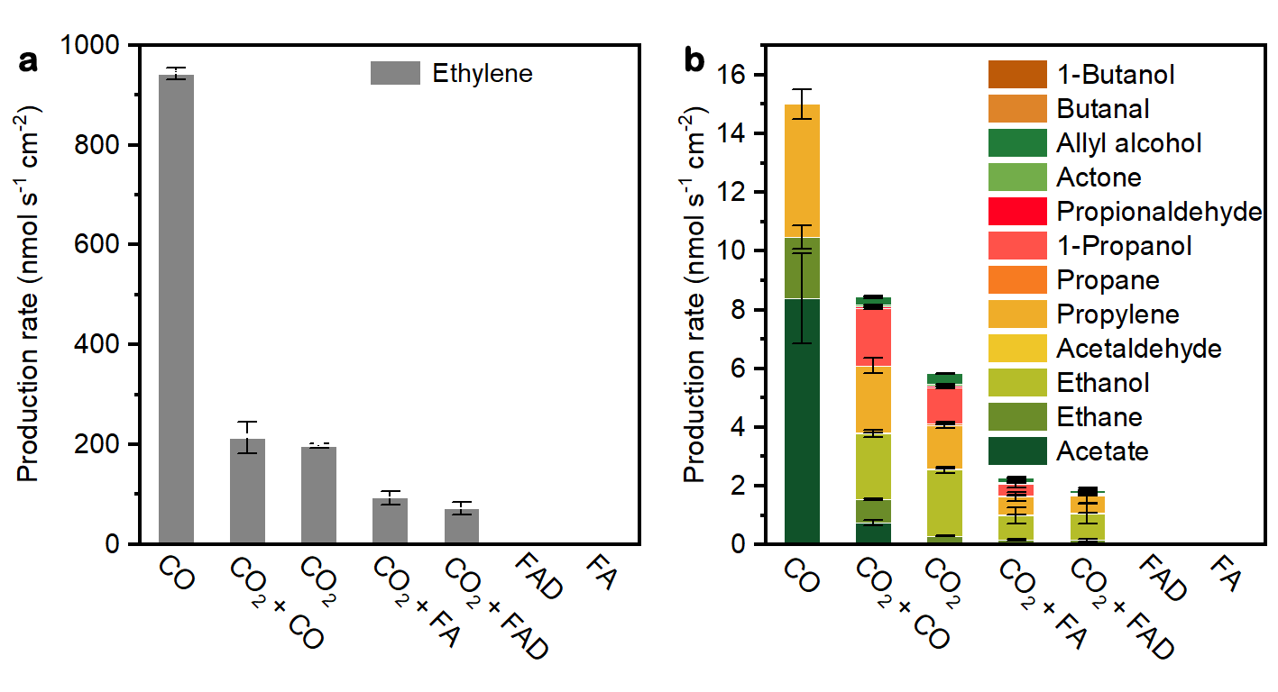
Supplementary Fig. 29 | Electrocatalytic reduction of selected C₁ compounds on Cu electrode. Production rate of the a, major (i.e., ethylene) and b, minor multicarbon compounds. Reaction conditions: 0.1 M KH₂PO₄ at –1.0 V versus RHE in a flow cell.

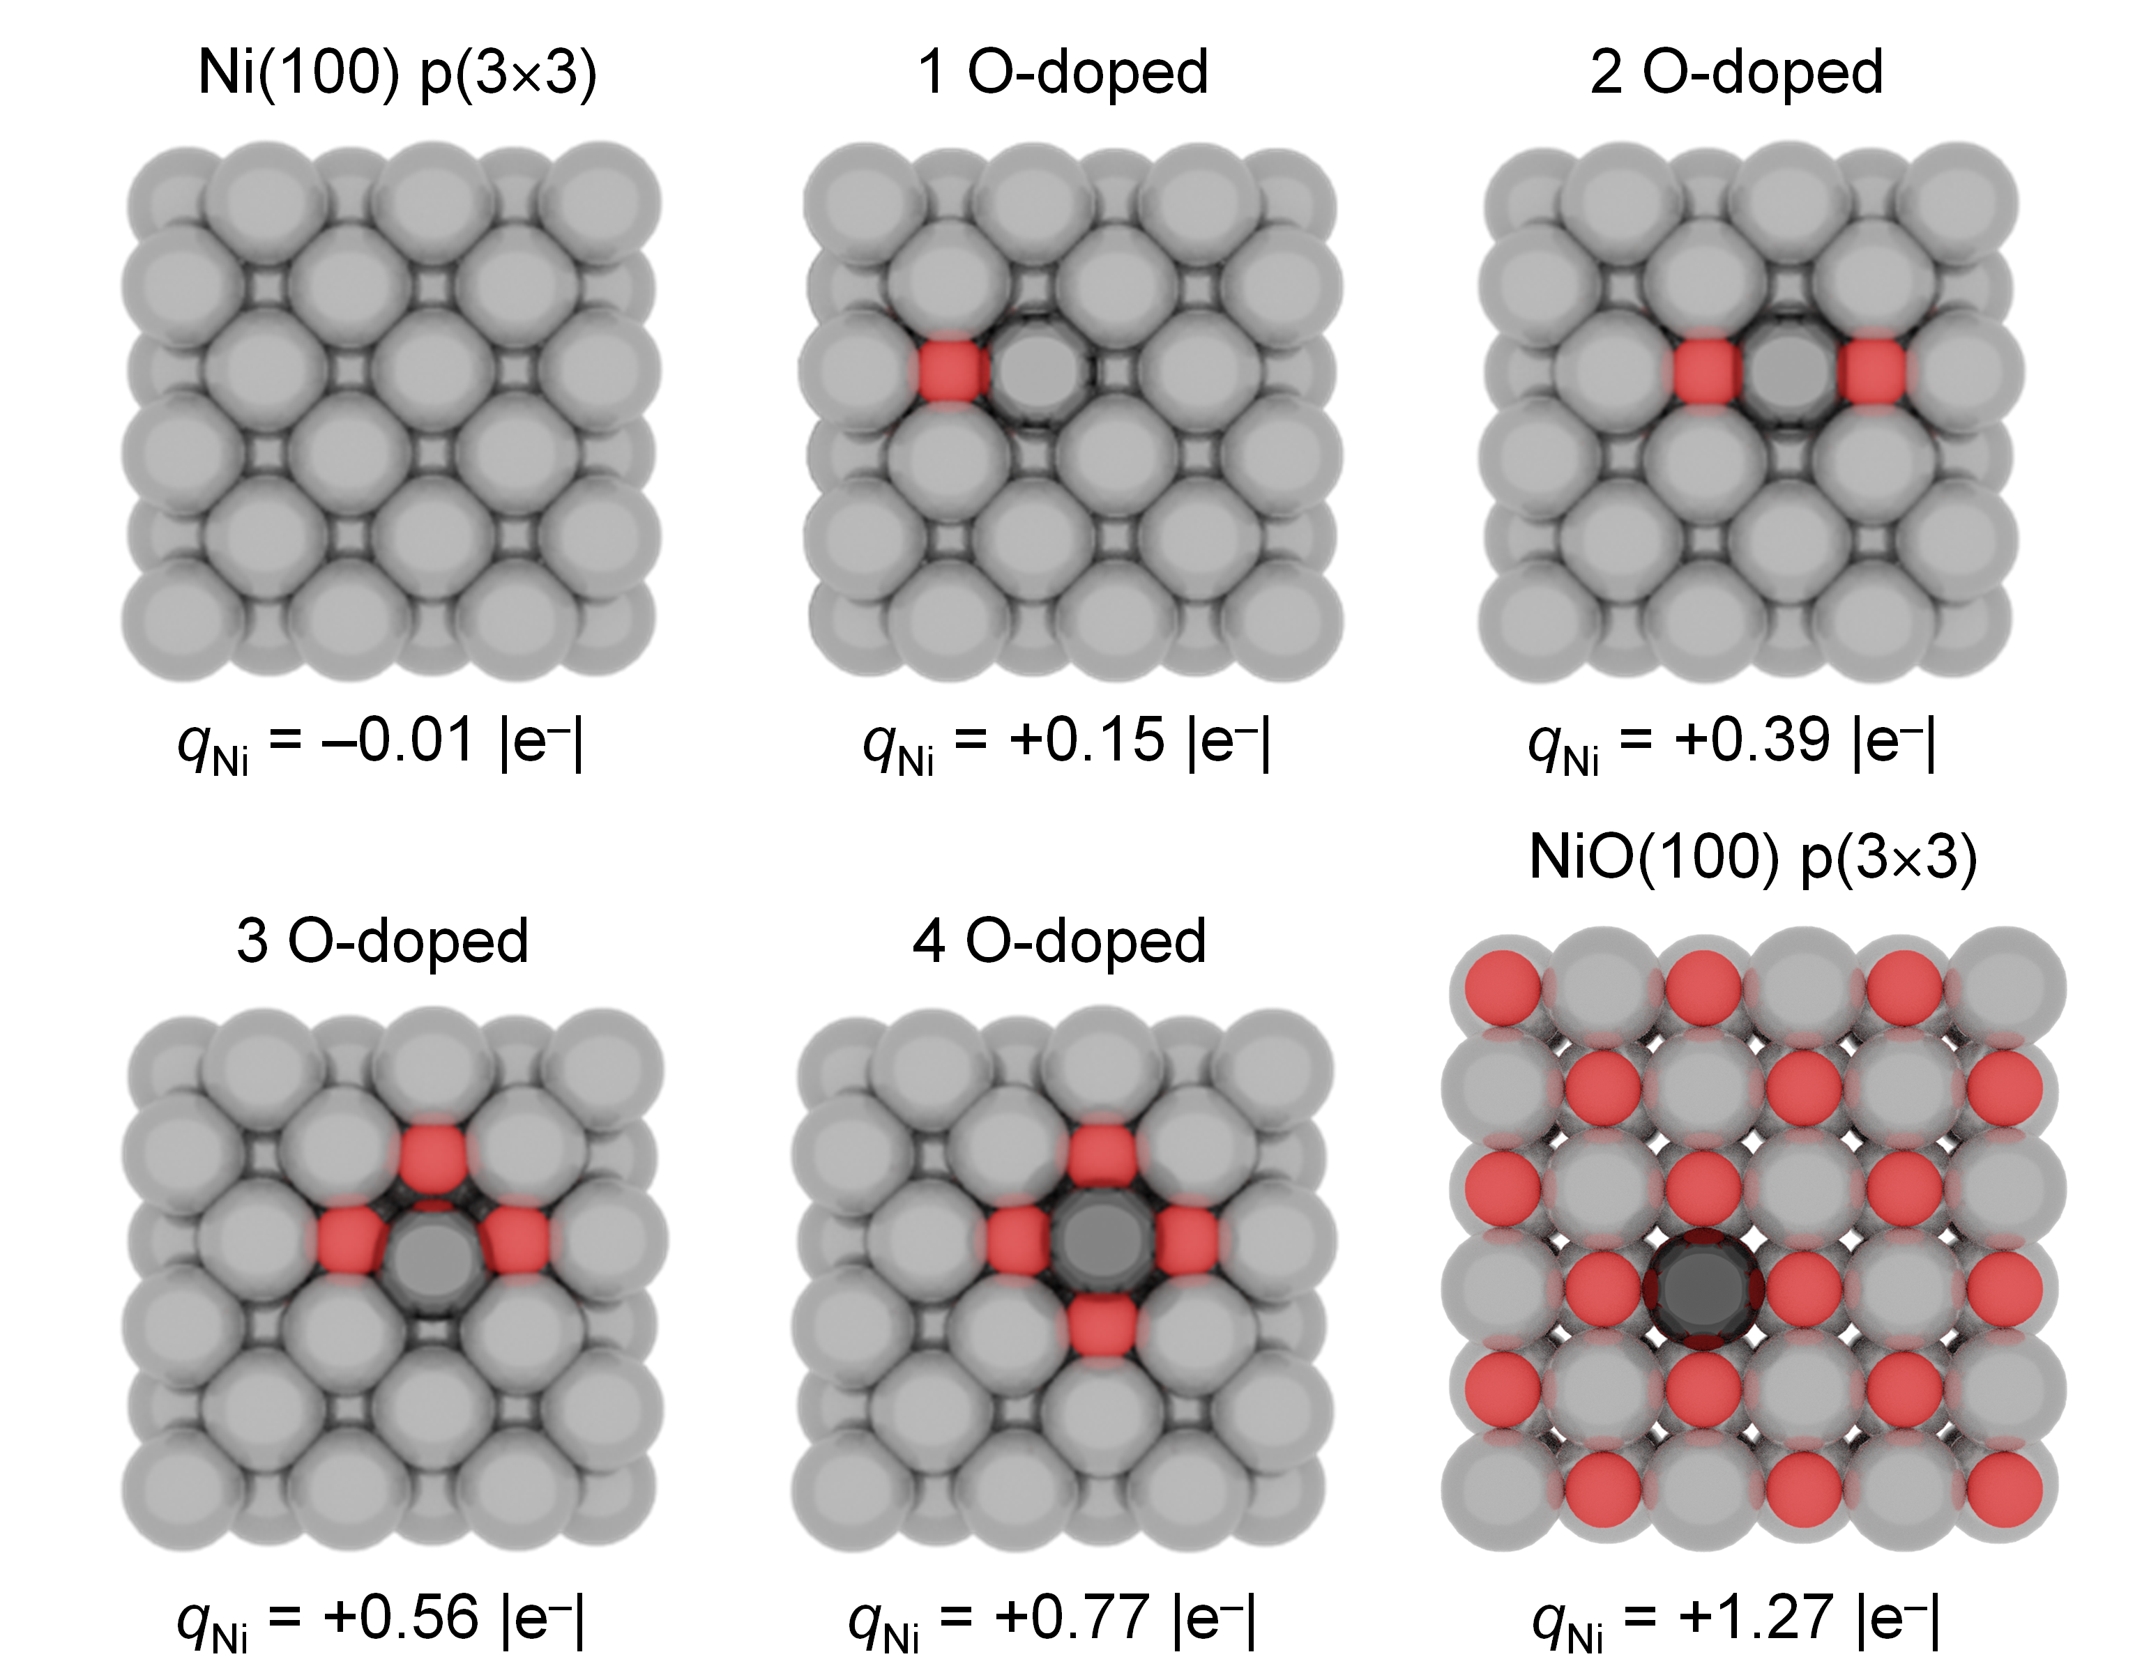
Supplementary Fig. 30 | Density Functional Theory models employed. Top view for the DFT models employed: Ni(100) p(3×3), (1-4) O-doped Ni(100) p(3×3), and NiO(100) p(3×3). q_{Ni} represents the Bader charge of the selected adsorption site: from light to dark gray depending on nickel oxidation state, Ni⁰, Ni^{δ+}, or Ni²⁺.

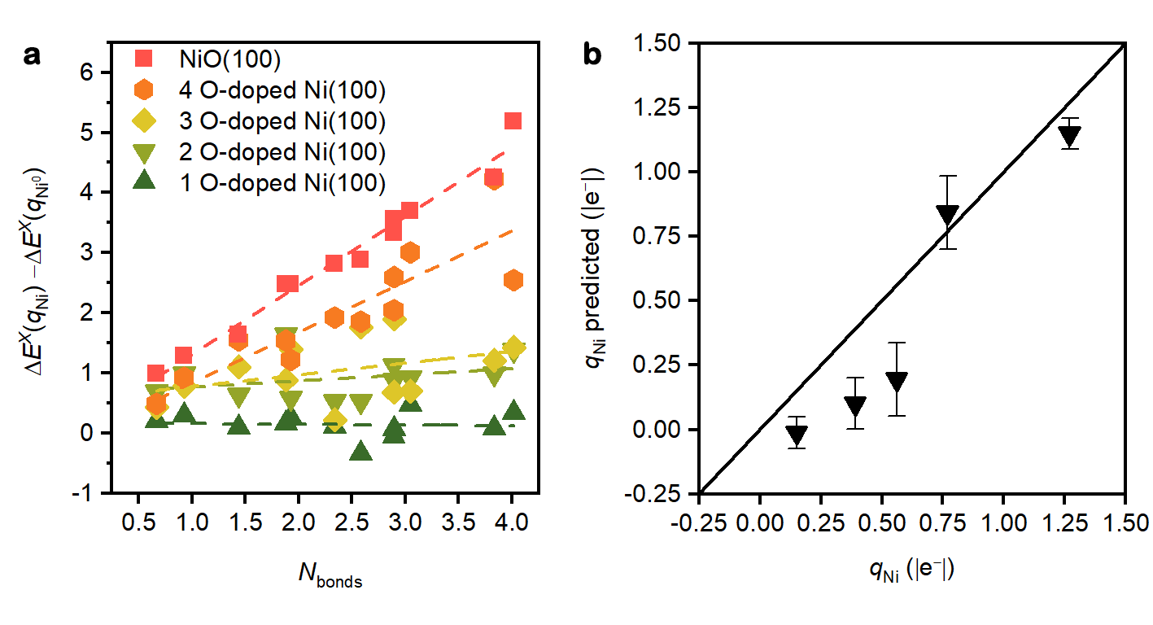
Supplementary Fig. 31 | Validity of the expanded linear scaling relationships. a, The difference for intermediates adsorption energies on polarized (q_{Ni}) and metallic (q_{Ni0} = 0 |e–|) adsorption sites, $\text{∆}{\text{E}}^{\text{X}}\left({\text{q}}_{\text{Ni}}\right)\text{ – ∆}{\text{E}}^{\text{X}}\left({\text{q}}_{{\text{Ni}}^{\text{0}}}\right)$, correlates with the number of bonds between surface and intermediate, N_{bonds}, Supplementary equation (7). b, The slope of this linear correlation represents the predicted degree of polarization q_{Ni} expected to affect the adsorbate, which correlates with the charge of the adsorption site, q_{Ni}, obtained through Bader charge analysis.

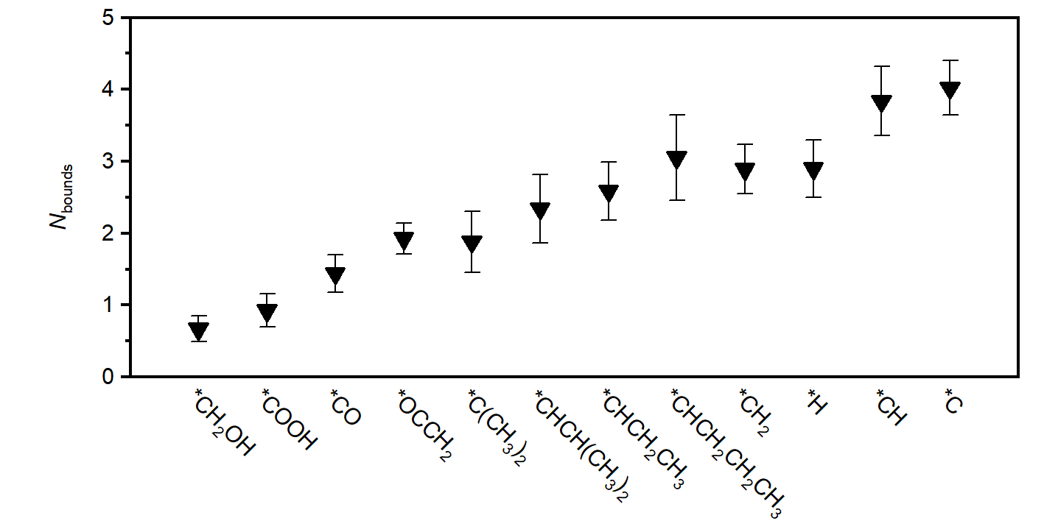
Supplementary Fig. 32 | Gradient of adsorption energy of relevant reaction intermediates versus Ni polarization. N_{bonds}, Supplementary equation (6) represents the number of bonds between the intermediate and surface, equivalent to ΔE q_{Ni}^{–1} taken from Supplementary Fig. 25.

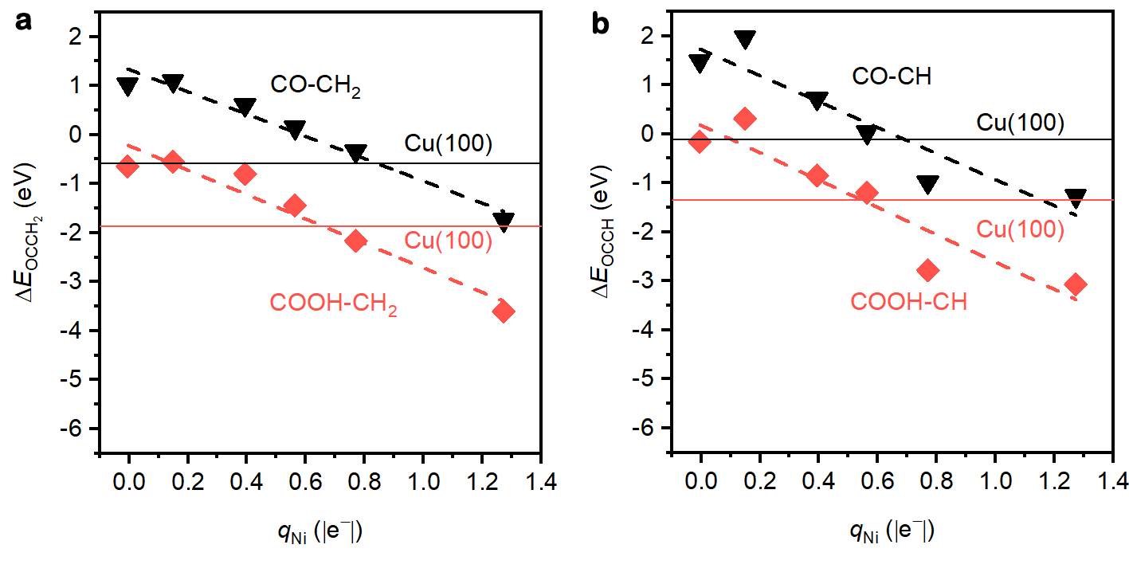
Supplementary Fig. 33 | Energies for different C-C coupling processes at U = –1.2 V versus polarization of Ni adsorption sites. a, *OCCH₂ formation energy from *COOH+*CH₂ (red) and *CO+*CH₂ (black) couplings. b, *OCCH formation energy from *COOH+*CH (red) and *CO+*CH (black) couplings. *COOH+*CH_{x} (x = 1 or 2) is the most favorable process under electrochemical conditions since it is promoted by the applied potential, whilst *CO-*CH_{x} (x = 1 or 2) is a potential independent coupling since it does not require any electron transfer. Energies on Cu(100) are shown as a reference (solid lines).
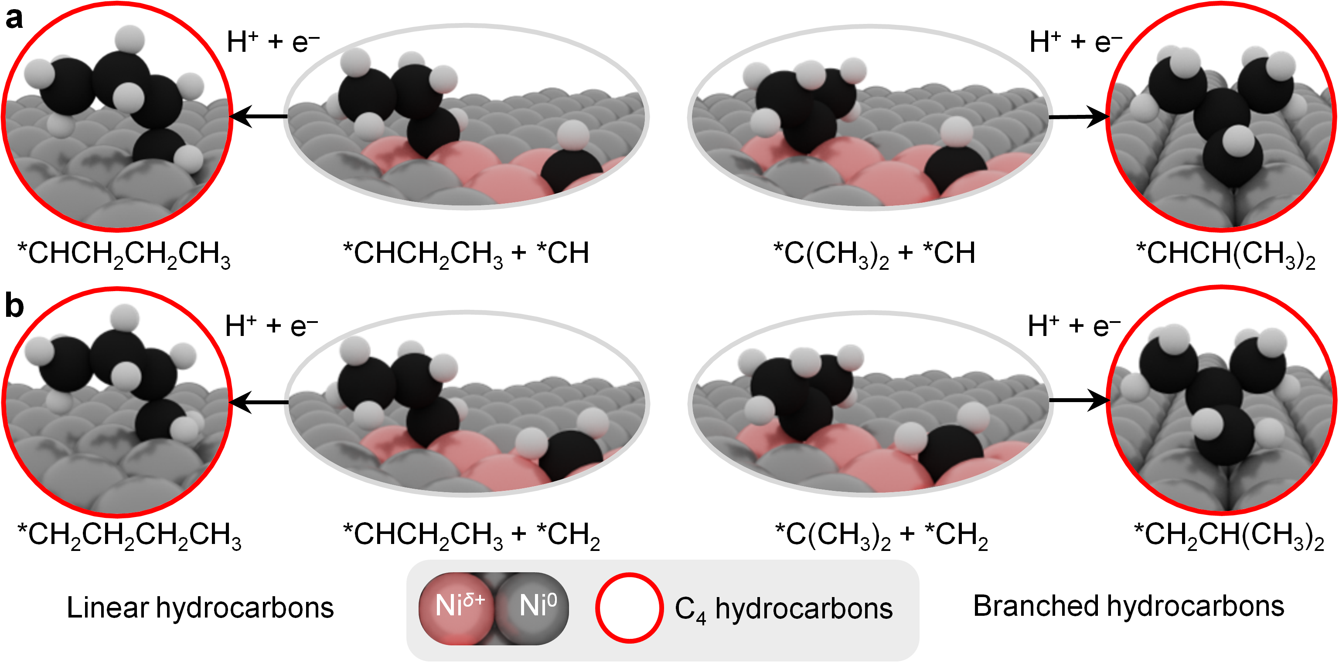
Supplementary Fig. 34 | Proposed reaction schemes for C₄ hydrocarbons formation. Polarized Ni sites (red shaded) favor a, *CH and *CHCH₂CH₃/ *CH(CH₃)₂ couplings to form *CHCH₂CH₂CH₃ (linear) and *CHCH(CH₃)₂ (branched) hydrocarbons; b, *CH₂ and *CHCH₂CH₃/ *CH(CH₃)₂ couplings to form *CH₂CH₂CH₂CH₃ (linear) and *CH₂CH(CH₃)₂ (branched) hydrocarbons.

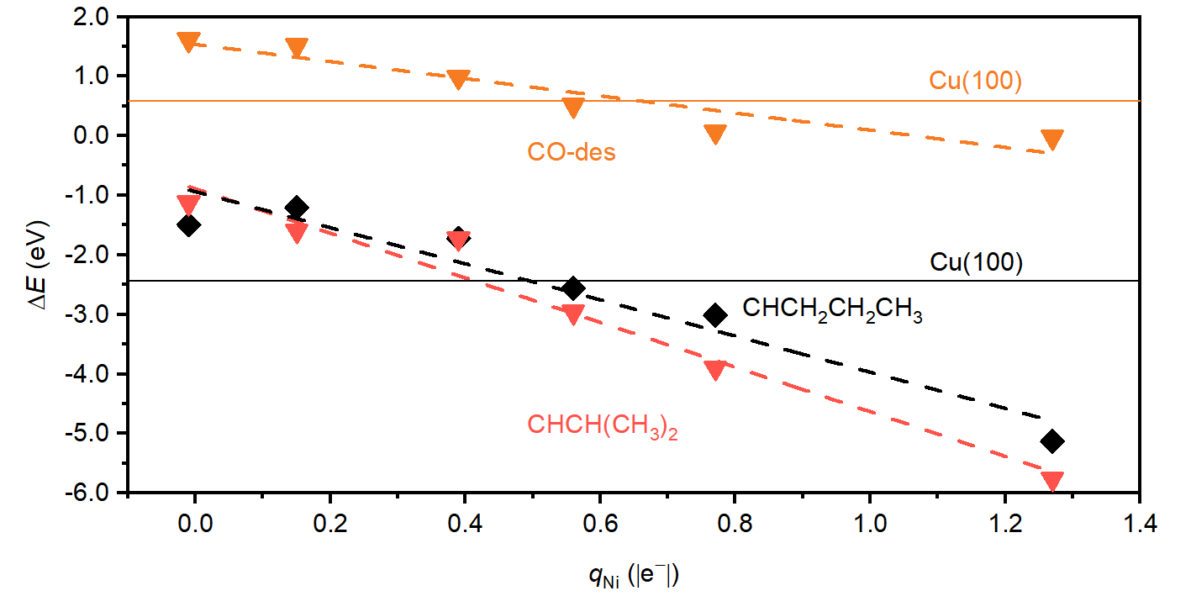
Supplementary Fig. 35 | Formation energies for C₄ hydrocarbons from a CH precursor. CHCH₂CH₂CH₃ (black dashed line) and CHCH(CH₃)₂ (red dashed line) formation energies from *CH and *CHCH₂CH₃/*CH(CH₃)₂ couplings at U = –1.2 V versus Ni polarization. CO desorption energy (CO-des) is shown in orange. Energies on Cu(100) are shown as a reference (solid lines).

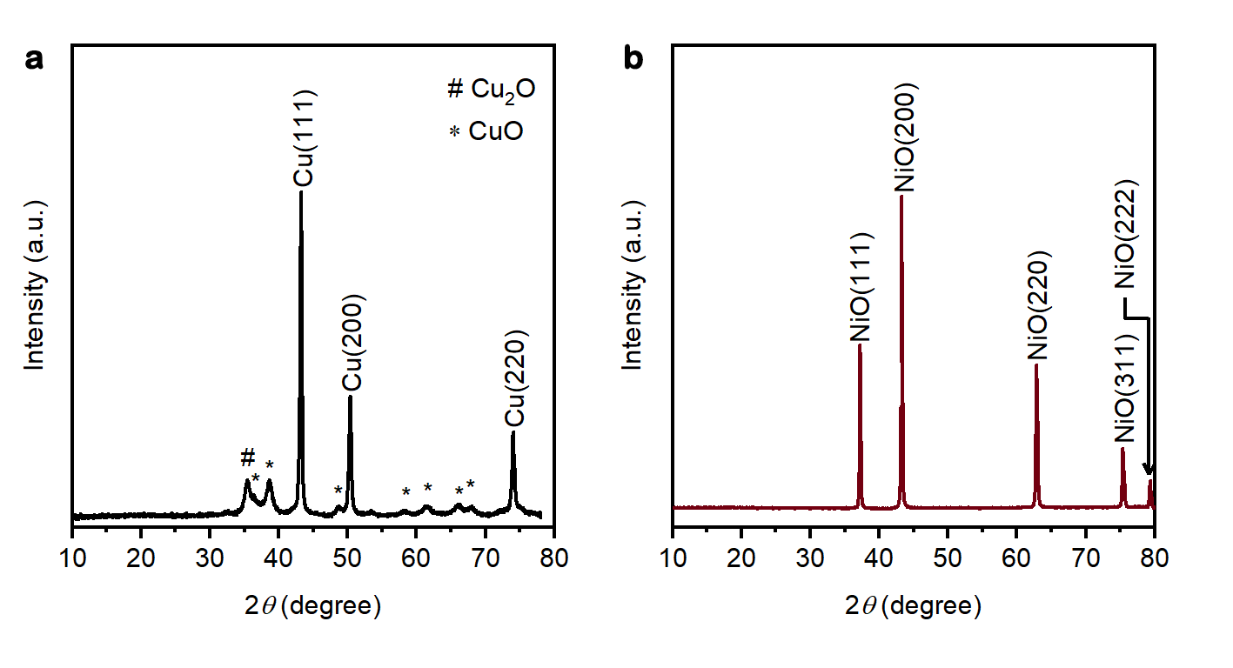
Supplementary Fig. 36 | XRD patterns of the commercial samples. a, Cu nanoparticles (25 nm, Sigma-Aldrich). b, NiO-c.

Supplementary Tables

Supplementary Table 1 | Summary of reports on CO₂RR to C₃₊ hydrocarbons under ambient conditions. FE = Faradaic efficiency.

Catalyst | Potential, electrolyte and cell setup | C₃₊ hydrocarbon FE  (%) | Partial current density  (mA cm^{–2}) | α | Reference
Cu₂O-Cu | –1.8 V versus RHE, 0.1 M KCl, H-type cell | 2.9 | ~0.22ª | NA^{c} | Ref. 20
Cu foil | −1.9 V versus Ag/AgCl, 0.1 M KHCO₃, one-compartment electrochemical cell | ~0.4ª | ~0.02ª | 0.24 | Ref. 21
CuO-derived Cu | –0.58 V versus RHE, 1.0 M KOH, GDE^{b} | 0.61 | 2.55 | N.A.^{c} | Ref. 22
AuPd | –1.4 V versus RHE,  0.1 M KH₂PO₄/0.1 M K₂HPO₄  GDE^{b} | 0.51 | ~0.08ª | 0.34 | Ref. 23
Ni | –1.8 V versus Ag/AgC1, 0.1 M KHCO₃, high pressure | 0.06 | ~0.004ª | ~0.27ª | Ref. 24
NP-d | –1.2 V versus RHE, 0.1 M KHCO₃, GDE^{b} | 6.2 ± 0.8 | 0.81 | 0.42 | This work
NC-d | –1.2 V versus RHE, 0.1 M KHCO₃, GDE^{b} | 6.5 ± 0.8 | 0.91 | 0.44 | This work
NB-d | –1.2 V versus RHE, 0.1 M KHCO₃, GDE^{b} | 6.0 ± 0.5 | 0.78 | 0.44 | This work
NHC-d | –1.2 V versus RHE, 0.1 M KHCO₃, GDE^{b} | 5.7 ± 1.7 | 0.70 | 0.44 | This work
NH-d | –1.2 V versus RHE, 0.1 M KHCO₃, GDE^{b} | 3.7 ± 1.7 | 0.49 | 0.43 | This work
NO-d | –1.2 V versus RHE, 0.1 M KHCO₃, GDE^{b} | 2.7 ± 0.2 | 0.31 | 0.41 | This work
ª The number is calculated/estimated from the data in the corresponding literature.
^{b} GDE = Gas diffusion electrode.
^{c} N.A. = Not applicable.

Supplementary Table 2 | C₂₊ products and their corresponding Faradaic efficiencies on NP-d electrocatalyst. Electrolyte: 0.1 M KHCO₃; applied potential: –1.2 V versus RHE.

 | C₂₊ product | Faradaic efficiency (%)
C₂ | Ethylene | 2.50 ± 0.20
C₂ | Ethane | 1.70 ± 0.20
C₂ | Ethanol | 1.20 ± 0.10
C₂ | Acetaldehyde | 0.50 ± 0.15
C₃ | Propene | 2.20 ± 0.20
C₃ | Propane | 1.20 ± 0.20
C₃ | 1-Propanol | 0.53 ± 0.05
C₃ | Propionaldehyde | 0.55 ± 0.03
C₃ | Acetone | 0.41 ± 0.03
C₃ | Allyl alcohol | 0.11 ± 0.02
C₄ | Isobutane | 0.12 ± 0.01
C₄ | n-Butane | 0.33 ± 0.02
C₄ | trans-2-Butene | 0.031 ± 0.004
C₄ | 1-Butene | 0.78 ± 0.09
C₄ | Isobutylene | 0.29 ± 0.03
C₄ | cis-Butene-2 | 0.14 ± 0.05
C₄ | 1-Butanal | 0.18 ± 0.02
C₄ | 1-Butanol | 0.28 ± 0.02
C₅ | Isopentane | 0.08 ± 0.007
C₅ | n-Pentane | 0.19 ± 0.02
C₅ | 1,3-Butadiene | 0.006 ± 0.002
C₅ | trans-2-Pentene | 0.083 ± 0.02
C₅ | 1-Pentene | 0.47 ± 0.11
C₅ | cis-2-Pentene | 0.04 ± 0.003
C₆ | n-Hexane | 0.16 ± 0.05

Supplementary Table 3 | Summary of the reports of CO₂RR on oxygen-containing Cu compound-derived electrocatalysts. FE = Faradaic efficiency.

Catalyst | Potential, electrolyte, and cell setup | Product: FE (%) | Partial current density (mA cm^{–2}) | Reference
Cu phosphate | –1.45 V versus NHE  0.1 M tetrabutylammonium tetrafluoroborate in acetonitrile, H-type cell | HCOOH: ~80 | ~1.6ª | Ref. 25
Boron doped-CuO | –1.1 V versus RHE  0.1 M KHCO₃, H-type cell | Ethylene: 58.4 | 10.6ª | Ref. 26
Boron doped-CuO | −0.62 V versus RHE  1 M KOH, GDE^{b} | C₂₊: 62.1 | 83ª | Ref. 27
CuCO₃⋅Cu(OH)₂ | N. M.^{c} | Ethylene: N. M.^{c} | N.M.^{c} | Ref. 28
CuCO₃ | −0.95 V versus RHE  0.1 M KHCO₃, H-type cell | C₂₊: 71 | 14.2ª | Ref. 29
Cu(OH)₂ | −1.08 V versus RHE  0.1 M KHCO₃, H-type cell | Ethylene: 38.1 | 7.3 | Ref. 30
CuO-derived Cu | –0.58 V versus RHE, 1.0 M KOH, GDE^{b} | 1-Butanol: 0.056 | 0.080 | Ref. 22
ª The number is calculated or estimated from the data in the corresponding literature.
^{b} GDE = Gas diffusion electrode.
^{c} N.M. = Not mentioned.

Supplementary Table 4 | Ratio of Ni⁰ and Ni²⁺ in the NP-d sample during CO₂RR obtained by analysis of XANES data. The ratios were obtained by linear combination fitting using the data of NP before application of potential and Ni foil as references.

Time (min) | Ni²⁺ : Ni⁰
0 | 1 : N.D.ª
5 | 0.65 : 0.35
15 | 0.33 : 0.67
25 | 0.34 : 0.66
35 | 0.34 : 0.66
ª N.D. = Not detectable.

Supplementary Table 5 | Gibbs free energy normalized per number of electrons (n_{e}) for Ni₃(PO₄)₂ reduction to Ni⁰ and conversion to Ni(OH)₂. Reaction conditions: pH at the bulk electrolyte = 6.8, pH at the electrode surface ≥ 9 (water molecules as the proton source)^{2,3}, T = 298.15 K.

Process | n_{e} | ΔG (U_{RHE} = 0 V)/n_{e}^{–1} (eV) | ΔG (U_{RHE} = –1.2 V)/n_{e}^{–1} (eV)
Ni₃(PO₄)₂ → Ni | 6 | +0.54 | –1.06
Ni₃(PO₄)₂ → Ni(OH)₂ | 4 | +0.54 | –1.06

Supplementary Table 6 | Adsorption energy, ∆E, of relevant CO₂, CO, and CH₂O reduction intermediates. H₂, CO₂, and H₂O were used as energy references. H adsorption is reported for comparative purposes.

∆E (eV) | Cu(100) | Ni(100)
*CH₂OH | –0.65 | –1.24
*COOH | –0.14 | –0.80
*CO | –0.28 | –1.32
*H | –0.21 | –0.53
*CH₂ | –0.76 | –1.83
*CH | –0.62 | –1.93
*C | +0.23 | –1.65
*OCCH₂ | –1.62 | –2.06
*C(CH₃)₂ | –4.08 | –5.10
*CHCH₂CH₃ | –4.27 | –5.02
*CHCH(CH₃)₂ | –6.01 | –6.95
*CHCH₂CH₂CH₃ | –6.08 | –7.26
*CH₂CH(CH₃)₂ | –7.02 | –7.56
*CH₂CH₂CH₂CH₃ | –6.65 | –7.19

Supplementary Table 7 | Summary of the hydrocarbons produced upon electroreduction of formaldehyde on the NP-d electrocatalyst.

Name | Retention time (min) | Concentration (ppm)
Methane | 2.4 | 117.65
Ethane | 2.9 | 1.77
Ethylene | 3.8 | 2.25
Propane | 5.0 | 0.23
Propene | 8.2 | 1.05
n-Butane | 9.5 | 0.10
1-Butene | 12.5 | 0.18
Isobutene | 12.9 | 0.17

Supplementary Table 8 | Regression parameters for the linear fits of the expression ΔE^{X} (q_{M}) – ΔE^{X} (q_{M} = 0 |e–|) versus N_{bonds}. Data points and linear fits are shown in Supplementary Fig. 31 and the resulting regression parameters validate Supplementary equation (7), derived from the extended qLSR formalism, Supplementary equation (6).

Model | a (eV) | b (|e–|) | r² | χ²
Ni(100) p(3×3)-1O | +0.2 ± 0.2 | –0.01 ± 0.06 | –0.10 | 0.46
Ni(100) p(3×3)-2O | +0.7 ± 0.3 | +0.10 ± 0.10 | 0.003 | 1.21
Ni(100) p(3×3)-3O | +0.6 ± 0.4 | +0.20 ± 0.14 | 0.07 | 2.50
Ni(100) p(3×3)-4O | +0.0 ± 0.4 | +0.84 ± 0.14 | 0.76 | 2.47
NiO(100) p(3×3) | +0.2 ± 0.2 | +1.15 ± 0.06 | 0.97 | 0.44

Supplementary Table 9 | Regression parameters for the linear fits of formation (∆E_{X}), desorption (∆E_{X-des}), and adsorption energies (∆E_{*X}) versus Ni polarization. Data points and associated regressions, ∆E = a + b q_{Ni}, are reported in Supplementary Figs. 25, 28, 34-35. * indicates adsorption energies. Formation and desorption energies are calculated at U = –1.2 V versus RHE, adsorption energies at U = 0 V versus RHE. Ni polarization is approximated here by the Bader charge of the adsorption site q_{Ni}.

Process | Intermediate X | a (eV) | b (eV |e–|^{–1}) | r² | χ²
Formation | CH₂ (from CH₂OH) | –2.0 ± 0.3 | +2.2 ± 0.5 | 0.81 | 0.96
Formation | OCCH₂ (from CO₂) | –0.2 ± 0.2 | –2.5 ± 0.3 | 0.92 | 0.43
Formation | OCCH₂ (from CO + CH₂) | +1.32 ± 0.14 | –2.3 ± 0.2 | 0.96 | 0.19
Formation | OCCH (from COOH + CH) | –0.2 ± 0.4 | –2.8 ± 0.5 | 0.84 | 1.21
Formation | OCCH (from CO + CH) | +1.7 ± 0.3 | –2.7 ± 0.5 | 0.84 | 1.10
Formation | CHCH₂ | +0.5 ± 0.3 | –5.4 ± 0.4 | 0.97 | 0.82
Formation | CHCH₂CH₂CH₃ | –0.9 ± 0.3 | –3.0 ± 0.4 | 0.91 | 0.72
Formation | CHCH(CH₃)₂ | –0.9 ±0.2 | –3.7 ± 0.4 | 0.96 | 0.52
Formation | CH₂CH₂CH₂CH₃ | –0.6 ± 0.7 | –4.6 ± 1.0 | 0.81 | 4.08
Formation | CH₂CH(CH₃)₂ | –1.3 ± 0.6 | –3.5 ± 0.9 | 0.76 | 3.09
Desorption | CO-des | +1.5 ± 0.2 | –1.4 ± 0.3 | 0.85 | 0.29
Adsorption | *CH₂OH | –1.13 ± 0.12 | +0.7 ± 0.2 | 0.73 | 0.13
Adsorption | *COOH | –0.6 ± 0.2 | +0.9 ± 0.2 | 0.75 | 0.22
Adsorption | *CO | –1.2 ± 0.2 | +1.5 ± 0.3 | 0.85 | 0.29
Adsorption | *OCCH₂ | –2.08 ± 0.14 | +1.9 ± 0.2 | 0.94 | 0.20
Adsorption | *C(CH₃)₂ | –5.0 ± 0.3 | +1.9 ± 0.4 | 0.79 | 0.75
Adsorption | *CHCH(CH₃)₂ | –7.2 ± 0.3 | +2.3 ± 0.5 | 0.82 | 0.95
Adsorption | *CHCH₂CH₃ | –5.3 ± 0.3 | +2.6 ± 0.4 | 0.89 | 0.70
Adsorption | *CHCH₂CH₂CH₃ | –7.4 ± 0.4 | +3.1 ± 0.6 | 0.84 | 1.49
Adsorption | *CH₂ | –1.9 ± 0.2 | +2.9 ± 0.4 | 0.93 | 0.51
Adsorption | *H | –0.8 ± 0.3 | +2.9 ± 0.4 | 0.91 | 0.68
Adsorption | *CH | –2.3 ± 0. 4 | +3.8 ± 0.5 | 0.93 | 1.13
Adsorption | *C | –2.0 ± 0.3 | +4.0 ± 0.4 | 0.96 | 0.61

Supplementary Table 10 | Summary of control experiments. C₄₊ hydrocarbons are not listed here since they were only detected on the Ni-based electrocatalysts with CO₂ or CO.

 | Concentration (ppm) |  |  |  |  |  | Concentration (µM)
 | CH₄ | CO | C₂H₄ | C₂H₆ | C₃H₆ | C₃H₈ | HCOOH | CH₃OH | C₂H₅OH | C₂H₄O | C₃H₇OH | C₃H₆O | (CH₃)CO | C₄H₈O | C₄H₉OH
CO₂ | 0.35  ± 0.05 | N.D.^{d} | 0.15  ± 0.01 | 0.90  ± 0.04 | 0.24  ± 0.05 | N.D.^{d} | – | – | – | – | – | – | – | – | –
CO | 7.1  ± 0.1 | – | N.D.^{d} | N.D.^{d} | N.D.^{d} | N.D.^{d} | – | – | – | – | – | – | – | – | –
Ar | 0.67  ± 0.05 | – | N.D.^{d} | N.D.^{d} | N.D.^{d} | N.D.^{d} | – | – | – | – | – | – | – | – | –
KHCO₃ | – | – | – | – | – | – | N.D.^{d} | tr^{c} | tr^{c} | tr^{c} | N.D.^{d} | N.D.^{d} | tr^{c} | N.D.^{d} | N.D.^{d}
CO₂ feed without biasª | 0.35  ± 0.05 | N.D.^{d} | 0.13  ± 0.02 | 0.73  ± 0.02 | N.D.^{d} | N.D.^{d} | N.D.^{d} | tr^{c} | tr^{c} | tr^{c} | N.D.^{d} | N.D.^{d} | tr^{c} | N.D.^{d} | N.D.^{d}
Ar feed with biasª | nd^{d} | N.D.^{d} | N.D.^{d} | N.D.^{d} | N.D.^{d} | N.D.^{d} | N.D.^{d} | tr^{c} | tr^{c} | tr^{c} | N.D.^{d} | N.D.^{d} | tr^{c} | N.D.^{d} | N.D.^{d}
CO₂RR on Vulcan^{b} | 1.4  ± 0.2 | 21.7  ± 1.3 | 0.17  ± 0.03 | 0.83  ± 0.04 | 0.23  ±0.04 | N.D.^{d} | 98.8  ± 1.1 | N.D.^{d} | tr^{c} | tr^{c} | N.D.^{d} | N.D.^{d} | tr^{c} | N.D.^{d} | tr^{c}
CO₂RR on NP-d | 228.9  ± 2.6 | 903.3 ± 14.0 | 76.6  ± 1.8 | 40.9  ± 0.4 | 41.7  ± 2.8 | 22.9  ± 2.9 | 480.4  ± 3.0 | 130.5  ± 12.6 | 48.2  ± 0.5 | 26.6  ± 2.8 | 14.0  ± 0.3 | 16.5  ± 1.0 | 12.1  ± 0.3 | 4.0  ± 0.4 | 5.7  ± 0.1
ª On NP-d electrocatalyst.
^{b} On Vulcan GDE with an applied potential of –1.2 V versus RHE in 0.1 M KHCO₃.
^{c} tr stands for traces.
^{d} N. D. stands for not detectable.

References
1 Wang, Y., Han, P., Lv, X., Zhang, L. & Zheng, G. Defect and interface engineering for aqueous electrocatalytic CO₂ reduction. Joule 2, 2551-2582 (2018).
2 Zhang, F. & Co, A. C. Direct evidence of local pH change and the role of alkali cation during CO₂ electroreduction in aqueous media. Angew. Chem. Int. Ed. 59, 1674-1681 (2020).
3 Birdja, Y. Y. et al. Advances and challenges in understanding the electrocatalytic conversion of carbon dioxide to fuels. Nat. Energy 4, 732-745 (2019).
4 Gamsjäger, H., Bugajski, J., Gajda, T., Lemire, R. J. & Preis, W. Chemical Thermodynamics of Nickel, 1st Edition. Vol. 6 (Elsevier Science, 2005).
5 Nørskov, J. K. et al. Origin of the overpotential for oxygen reduction at a fuel-cell cathode. J. Phys. Chem. B 108, 17886-17892 (2004).
6 Pérez-Ramírez, J. & López, N. Strategies to break linear scaling relationships. Nat. Catal. 2, 971-976 (2019).
7 Abild-Pedersen, F. et al. Scaling properties of adsorption energies for hydrogen-containing molecules on transition-metal surfaces. Phys. Rev. Lett. 99, 016105 (2007).
8 Bagger, A., Ju, W., Varela, A. S., Strasser, P. & Rossmeisl, J. Electrochemical CO₂ reduction: A classification problem. ChemPhysChem 18, 3266-3273 (2017).
9 Harrison, K. W., Remick, R., Markin, G. D. & Hoskin, A. “Hydrogen Production: Fundamentals and Case Study Summaries” in 18th World Hydrogen Energy Conference. (Essen, Germany, 2010).
10 Martín, A. J., Larrazábal, G. O. & Pérez-Ramírez, J. Towards sustainable fuels and chemicals through the electrochemical reduction of CO₂: lessons from water electrolysis. Green Chem. 17, 5114-5130 (2015).
11 Zhang, W. et al. Progress and perspective of electrocatalytic CO₂ reduction for renewable carbonaceous fuels and chemicals. Adv. Sci. 5, 1700275 (2018).
12 Song, J. et al. A review on fundamentals for designing oxygen evolution electrocatalysts. Chem. Soc. Rev. 49, 2196-2214 (2020).
13 Wang, Y., Ruiz Diaz, D. F., Chen, K. S., Wang, Z. & Adroher, X. C. Materials, technological status, and fundamentals of PEM fuel cells – A review. Mater. Today 32, 178-203 (2020).
14 Cordoba‐Torresi, S. I., Hugot‐Le Goff, A. & Joiret, S. Electrochromic behavior of nickel oxide electrodes: II . Identification of the bleached state by Raman spectroscopy and nuclear reactions. J. Electrochem. Soc. 138, 1554-1559 (2019).
15 Biesinger, M. C., Payne, B. P., Lau, L. W. M., Gerson, A. & Smart, R. S. C. X-ray photoelectron spectroscopic chemical state quantification of mixed nickel metal, oxide and hydroxide systems. Surf. Interface Anal. 41, 324-332 (2009).
16 Wu, G., Wang, A., Li, X., Wang, Y. & Hu, Y. Facile fabrication of nickel phosphate nanotubes via a urea-assisted hydrothermal route. Mater. Chem. Phys. 132, 96-103 (2012).
17 Fa, D., Yu, B. & Miao, Y. Synthesis of ultra-long nanowires of nickel phosphate by a template-free hydrothermal method for electrocatalytic oxidation of glucose. Colloids Surf., A Physicochem. Eng. Asp. 564, 31-38 (2019).
18 Rameshan, R. et al. Near-ambient-pressure X-ray photoelectron spectroscopy study of methane-induced carbon deposition on clean and copper-modified polycrystalline nickel materials. J. Phys. Chem. C 119, 26948-26958 (2015).
19 Stein, S. E. The NIST 14 mass spectral library, https://www.nist.gov/srd/nist-standard-reference-database-1a-v14 (2014).
20 Lee, S., Kim, D. & Lee, J. Electrocatalytic production of C₃-C₄ compounds by conversion of CO₂ on a chloride-induced bi-phasic Cu₂O-Cu catalyst. Angew. Chem. Int. Ed. 127, 14914-14918 (2015).
21 Shibata, H., Moulijn, J. A. & Mul, G. Enabling electrocatalytic Fischer-Tropsch synthesis from carbon dioxide over copper-based electrodes. Catal. Lett. 123, 186-192 (2008).
22 Ting, L. R. L. et al. Electrochemical reduction of carbon dioxide to 1‐butanol on oxide‐derived copper. Angew. Chem. Int. Ed. 59, 21072–21079 (2020).
23 Kortlever, R. et al. Palladium-gold catalyst for the electrochemical reduction of CO₂ to C₁-C₅ hydrocarbons. Chem. Commun. 52, 10229-10232 (2016).
24 Kudo, A., Nakagawa, S., Tsuneto, A. & Sakata, T. Electrochemical reduction of high pressure CO₂ on Ni electrodes. J. Electrochem. Soc. 140, 1541-1545 (1993).
25 Zhao, J. et al. Phosphate tuned copper electrodeposition and promoted formic acid selectivity for carbon dioxide reduction. J. Mater. Chem. A 5, 11905-11916 (2017).
26 Wan, Q. et al. Boron-doped CuO nanobundles for electroreduction of carbon dioxide to ethylene. Green Chem. 22, 2750-2754 (2020).
27 Patra, K. K. et al. Operando spectroscopic investigation of a boron-doped CuO catalyst and its role in selective electrochemical C–C coupling. ACS Appl. Energy Mater. 3, 11343-11349 (2020).
28 Eilert, A., Roberts, F. S., Friebel, D. & Nilsson, A. Formation of copper catalysts for CO₂ reduction with high ethylene/methane product ratio investigated with in situ X-ray absorption spectroscopy. J. Phys. Chem. Lett. 7, 1466-1470 (2016).
29 Gao, D. et al. Selective CO₂ electroreduction to ethylene and multicarbon alcohols via electrolyte-driven nanostructuring. Angew. Chem. Int. Ed. 58, 17047-17053 (2019).
30 Lee, S. Y. et al. Mixed copper states in anodized Cu electrocatalyst for stable and selective ethylene production from CO₂ reduction. J. Am. Chem. Soc. 140, 8681-8689 (2018).

