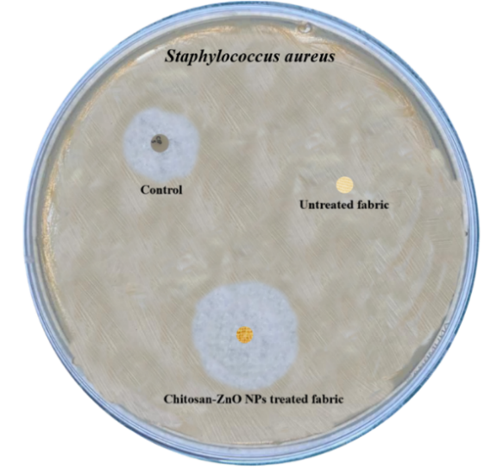  (a) | 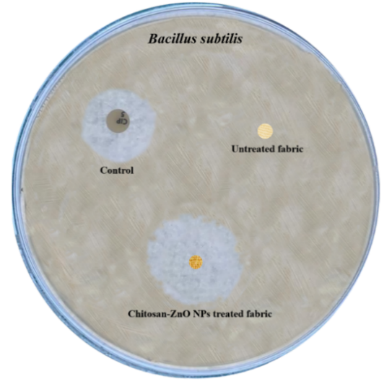  (b)
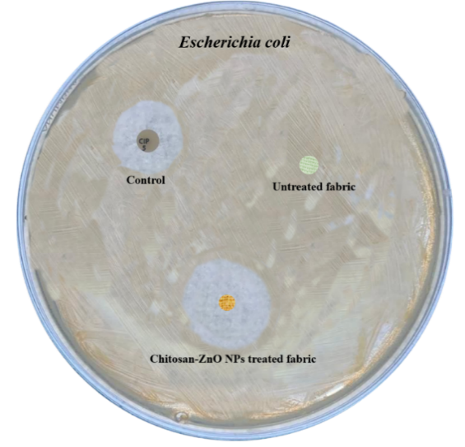  (c) | 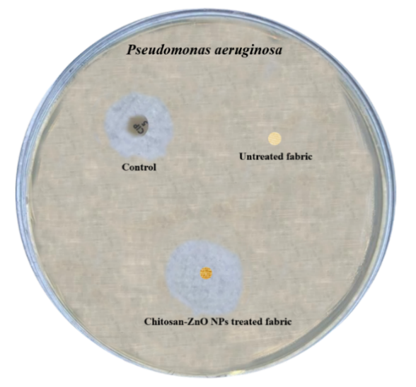  (d)
Fig. S1: Untreated Sample, treated sample and control against (a) S. Aureus, b) B. subtilis, c) E. coli, d) P. aeruginosa

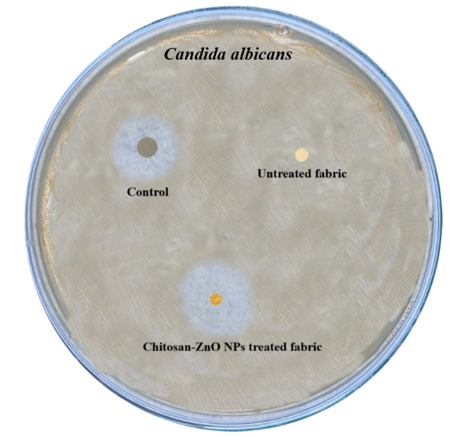  (a) | 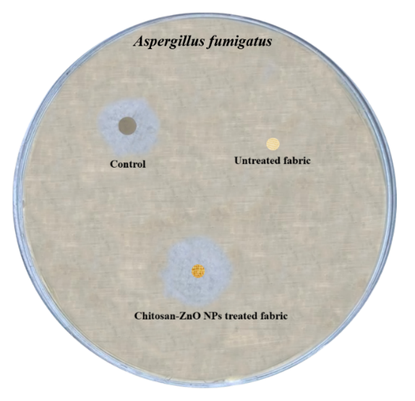  (b)
Fig. S2: Fig. S1: Untreated Sample, treated sample and control against (a) C. albicans, b) A. fumigates

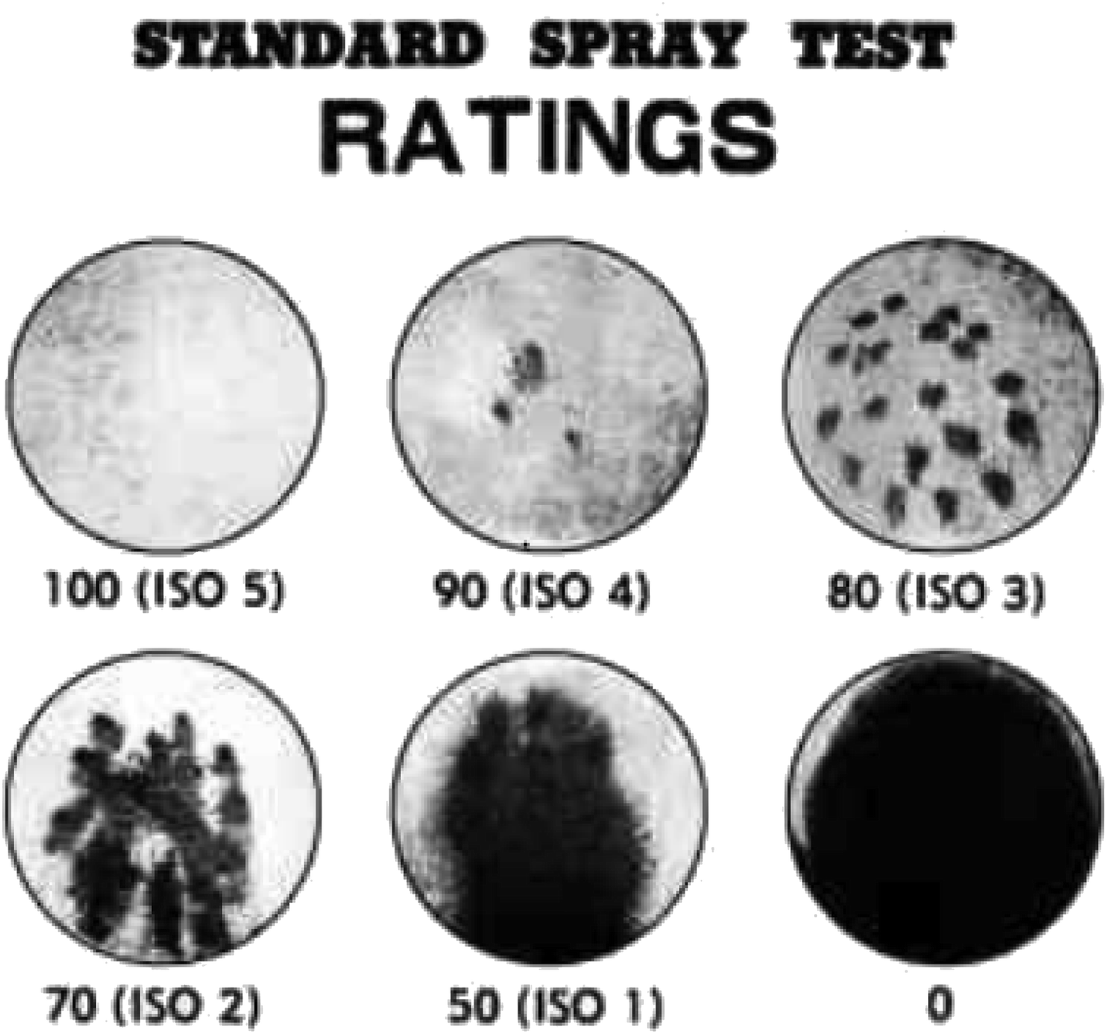

Fig. S3: ISO Standard Scale of Spray Rating.

