Supplementary Materials
Dual-wavelength switchable single-mode lasing from a lanthanide-doped resonator
Yunkai Wu^{#1}, Xian Chen^{#2†}, Limin Jin^{#1†}, Xiangzhe Ai², Xiaoli Yang¹, Shumin Xiao^{13†}, Qinghai Song^{13†}
(#These authors contributed equally to this work.)
¹Y. Wu, X. Yang, Dr. L. Jin, Dr. S. Xiao, Dr. Q. Song
State Key Laboratory on Tunable laser Technology, Ministry of Industry and Information Technology Key Lab of Micro-Nano Optoelectronic Information System, Harbin Institute of Technology, Shenzhen, 518055, P. R. China
E-mail: jinlimin@hit.edu.cn, shumin.xiao@hit.edu.cn, qinghai.song@hit.edu.cn
²Dr. X. Chen, X. Ai
College of Materials Science of Engineering, Shenzhen University, Shenzhen 518060, P. R. China.
E-mail: x.chen87@outlook.com
³Dr. S. Xiao, Dr. Q. Song
Collaborative Innovation Center of Extreme Optics, Shanxi University, Taiyuan, 030006, Shanxi, P. R. China

Section-1. Synthesis and characterization of upconversion nanocrystals (UCNCs) and photonic device
Reagents: Y(CH₃CO₂)₃·xH₂O (99.9%), Yb(CH₃CO₂)₃·xH₂O, Nd(CH₃CO₂)₃·xH₂O (99.9%), Gd(CH₃CO₂)₃·xH₂O (99.9%), Tm(CH₃CO₂)₃·xH₂O (99.9%), Ho(CH₃CO₂)₃·xH₂O (99.9%), Ho(CH₃CO₂)₃·xH₂O (99.9%), Ca(CH₃CO₂)₂·H₂O (99.9%), NaOH (>98%), NH₄F (>98%), 1-octadecene (ODE) (90%), oleic acid (OA) (90%), were all purchased from Sigma-Aldrich. Absolute ethanol (99.85%), methyl alcohol (99.99%), and cyclohexane (99.9%) were purchased from J&K. All chemicals were used as received without further purification.
Synthesis of NaGdF₄:Yb/Nd core nanoparticles. The NaGdF₄:Yb/Nd core nanoparticle was synthesized by using our previously established methods[1]. Firstly, 4-mL water solution of RE(CH₃CO₂)₃ (0.2 M, RE = Gd, Yb and Nd) was added to a binary solvent mixture of OA (8 mL) and ODE (12 mL) in a 50 mL flask. The mixture was heated at 160 ºC for 60 min before cooling down to 45 ºC. Thereafter, 6.5 ml of NH₄F (0.4 M) and 2 mL of NaOH (1 M) in methanol solution was added, and the resultant solution was stirred for 90 min. After the methanol was evaporated, the solution was heated to 300 ºC under argon protection for 1 h and then cooled down to room temperature. The resulting nanoparticles in mixture were precipitated by addition of ethanol, collected by centrifugation at 6000 rpm for 3 min, washed with ethanol and methanol for 3 times, and finally re-dispersed in 4 mL cyclohexane for further use.
General procedure for the epitaxial growth of shell layers: The shell precursor was first prepared by mixing 4 mL water solution of corresponding lanthanide acetates (0.2 M) with 8 mL of oleic acid and 12 mL of 1-octadecene in a 50 mL flask followed by heating at 160 ºC for 40 min. After cooling down to 50 ºC, preformed core nanoparticles dispersed in 4 mL of cyclohexane were added along with a 5 mL methanol solution of NH₄F (1.5 mmol) and NaOH (1 mmol). The resulting mixture was stirred at 50 ºC for 30 min, at which time the solution was heated to 290 ºC under argon for 1 h and then cooled down to room temperature. The resulting nanoparticles were precipitated by addition of ethanol, collected by centrifugation at 6000 rpm for 5 min, washed with ethanol several times, and re-dispersed in 4 mL of cyclohexane. The procedures were repeated for layer-by-layer growth of multishelled nanocrystals.
General sample characterizations: Powder X-ray diffraction (XRD) analysis was performed on a Bruker AXS D2 phaser with a graphite-monochromatized Cu Kα radiation (λ = 1.5406 Å). Low-resolution transmission electron microscopy (TEM) measurement was carried out on a FEI spirit T12 transmission electron microscope operating at an acceleration voltage of 120 kV. High-resolution TEM was performed on a FEI F30 transmission electron microscope operating at an acceleration voltage of 200 kV. Scanning electron microscopy (SEM) images were obtained from a Hitachi Model S-4700 scanning electron microscope with an accelerating voltage of 10-30 kV. The thickness of the film was analyzed by Dektak 150 thickness gauge. Photoluminescence spectra were recorded from cyclohexane dispersion of nanoparticles (1 wt %) under the excitation of 808/980 nm diode lasers (20 W cm⁻²).
Table 1 The previously reported tunable laser from a fixed luminescent material
Ref | Year | Journal | Tuning range  (nm) | Gain medium | Switching mechanism
[2] | 2010 | J. Am. Chem. Soc. | 458-536 nm | fluorescent molecular sheet | stimuli-dependent phase transition
[3] | 2012 | Adv. Opt. Mater. | 592-617 nm | conjugated polymer | change the electric field
[4] | 2013 | Nano Lett. | 530-637 nm | CdSSe alloy nanowire | gradient composition of nanowire
[5] | 2015 | Angew. Chem. Int. Ed. Engl. | 458-594 nm | supermolecular | Förster resonance energy transfer
[6] | 2015 | Nat. Commun. | 862-891 nm | IR-140 dye | change the dielectric environment
[7] | 2015 | Angew. Chem. Int. Ed. Engl. | 514-537 nm | organic dye | excited-state intramolecular proton transfer
[8] | 2016 | J. Am. Chem. Soc. | 570-620 nm | supermolecular | temperature-dependent luminescence
[9] | 2017 | Sci. Adv. | 464-555 nm | organic compound | radiative coupling mechanism
[10] | 2018 | ACS Nano | 528-582nm nm | organic dye | changing the proton-donating ability of the solvent
[11] | 2019 | J. Am. Chem. Soc. | 489-508 nm | pure MOF microcrystals | control the steric hindrance around the linkers
[12] | 2020 | Nano Energy | 480-525 nm | perovskite microwire | gradient composition of nanowire
[13] | 2020 | Adv. Opt. Mater. | 629-725 nm | MOFs heterostructures | gradient composition of nanowire
[14] | 2021 | Nanoscale | 538-630 nm | rhodamine 6G | gain spectrum shift from the binding molecular concentrations

Section-2. The proposed core-multishelled UCNCs.
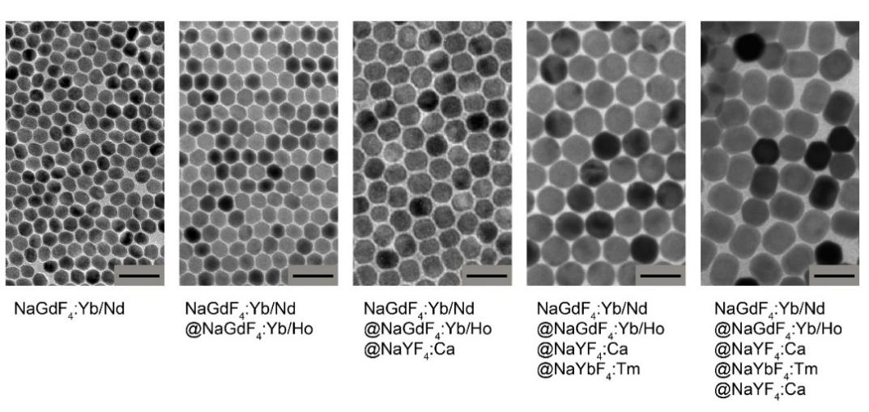
Figure S1. TEM images of the nanoparticles obtained at different stage of synthesis. Scale bar is 50 nm.


Figure S2. The proposed energy exchange interactions in the multishelled nanocrystals under 808 nm (Nd³⁺→Yb³⁺→Ho³⁺) and 980 nm (Yb³⁺→Tm³⁺) excitation, respectively.
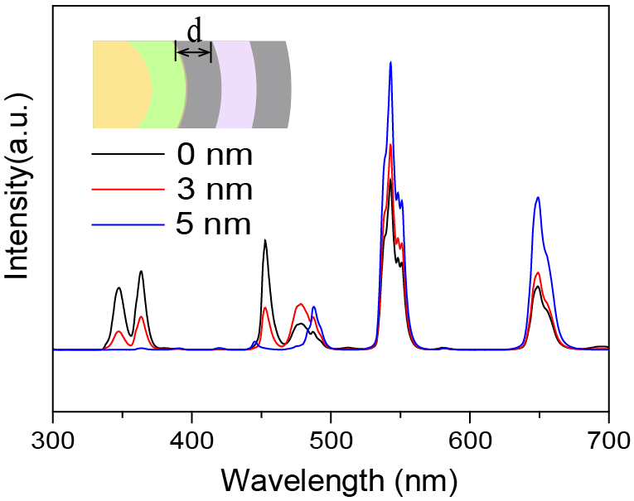

Figure S3. Emission spectra of the nanoparticles with different shell thickness of intra NaYF₄:Ca intralayer under 808 nm excitation.

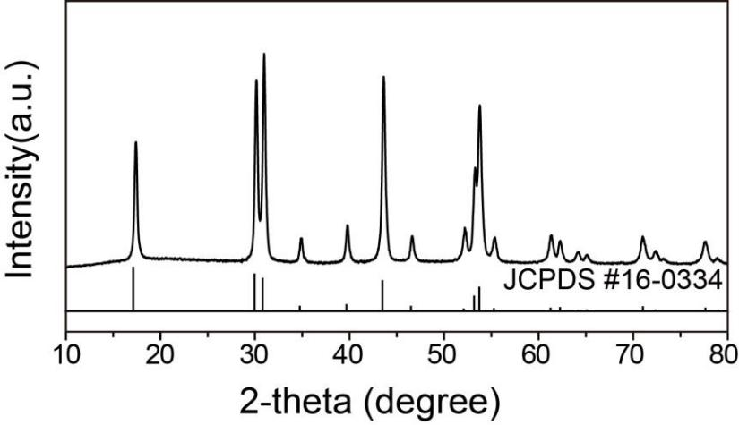
Figure S4. XRD pattern of the as-synthesized multilayer core-shell nanocrystals. The line spectrum is literature data for the hexagonal-phase NaYF₄.

Section-3. The characterization of UCNCs-based microdisk lasers.

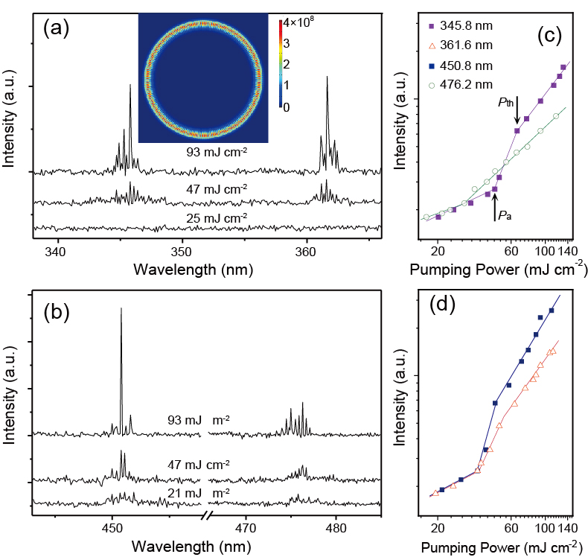
Figure S5. The lasing actions of an individual UCNCs-based microdisk (d= ~100 μm, t= ~300 nm) under 980 nm excitation. (a-d) Emission spectra of UCNCs-based microdisk at different power. The inset in Figure S5a plots the simulation of the excited microdisk with the diameter of 3 μm in 2D geometry. (e, f) Lasing thresholds of four dominant peaks of Tm³⁺ ions. Solid lines are fitted for guidance.

Figure S5 gives the lasing characteristics of the UCNCs-based microdisk. The lasing spectra from the microcavity with the diameter equal to 100 μm, illuminated with a 980 nm pulsed laser of variable fluence, were recorded in Figure S5a-d. The pumping light was directly focused onto the top of microdisk, with the emitting light collected from the edge of cavity. For low pumping power, six broad emission bands emerge from the spectrum with the wavelengths centered at 345.8 nm, 361.6 nm, 450.8 nm, and 476.2 nm, respectively. As the pump fluence increases, sharp peaks with periodic mode spacing (Δλ) ascend from six bands, with their intensity grow rapidly on the onset of lasing emission. Furthermore, the dependence of integrated output intensity on the pumping power (Figure S5c) exhibits an “S”-like shape with three regions of distinct slopes, implying the transition from spontaneous emission (i.e., < P_{a}) through amplification (i.e., P_{a} < P < P_{th}) to gain saturation (i.e., > P_{th}). (Figure S5c-d). The transparent threshold values are identified to be P_{345.8nm} = 47.02 , P_{361.6 nm} = P_{450.8 nm} = 36.31, and P_{476.2 nm} = 29.79 mJ cm⁻² respectively, as given by the first kink of the fitted line (solid lines in Figure S5c and d) from the corresponding light-light curves. It is observed that the experimental Δλ values, recorded as Δλ_{345.8 nm} = 0.24, Δλ_{361.6 nm} = 0.26, Δλ_{450.8 nm} = 0.40, and Δλ_{476.2 nm} = 0.44 nm respectively, is in well accordance with the calculated values from the equation Δλ = λ₀²/n_{eff}L. All these results unambiguously demonstrate multicolour lasing through the formation of whispering gallery modes (WGMs) at the boundary of the microdisk cavity, which is consistent with our simulation given in the inset of Figure S5a.

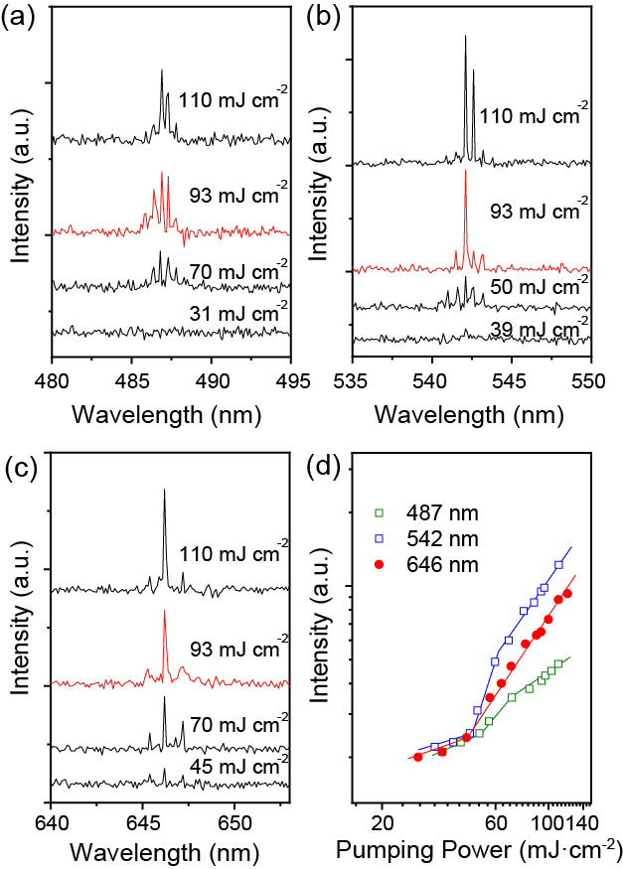
Figure S6 The lasing actions of an individual UCNCs-based microdisk (d= ~100 μm, t= ~300 nm) under 808 nm excitation. (a-c) Emission spectra of UCNCs-based microdisk at different power. (d) Lasing thresholds of three dominant peaks of Ho³⁺ ions. Solid lines are fitted for guidance.

Figure S6a-c plot the emission spectra of the UCNCs-based microdisk (d= ~100 μm, t= ~300 nm) as a function of 808 nm pumping power, with the corresponding light-light curves in Figure S6d. On increasing the pumping fluences, periodic sharp peaks centered at 486.9 nm, 542.1 nm and 646.2 nm are excited from the broad emission bands and quickly dominate the spectra at high power density. In the experiment, the Δλ values read as Δλ_{486.9 nm} = 0.48 nm, Δλ_{542.1 nm} = 0.58 nm, and Δλ_{646.2 nm} = 0.85 nm respectively, and the threshold values locate at P_{486.9 nm} = 51.31, P_{542.1 nm} = 46.79 and P_{646.2 nm} = 45.28 mJ cm⁻² respectively. Following the equation Δλ = λ₀²/n_{eff}L (i.e., where n_{eff} ≈ 1.58), the calculated L well matches the perimeter length of UCNCs-doped microdisk with the diameter of 100 μm. Hence, the microdisk can simultaneously support the resonance of WGMs at blue, green and red band, which verifies the multicolour lasing characteristics in the UCNCs-based microdisk.

Section-4. The characterization of UCNCs-based PM lasers.

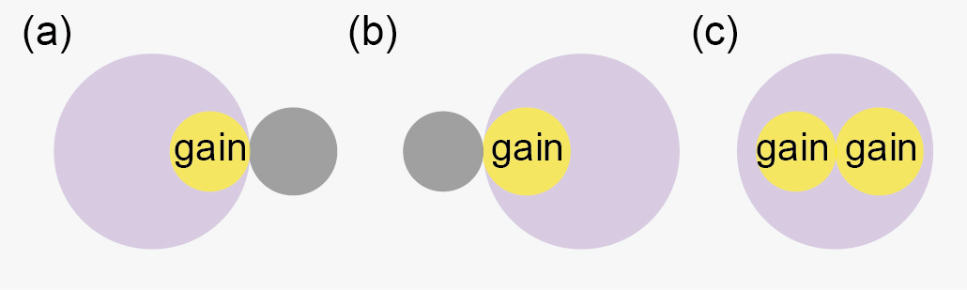
Figure S7. Three types of pumping configuration in the experiment, including (a) left pumping, (b) right pumping, and (c) uniform pumping scheme. The gray, yellow and big violet circles represent unexcited cavity, excited cavity and pumping light, respectively.

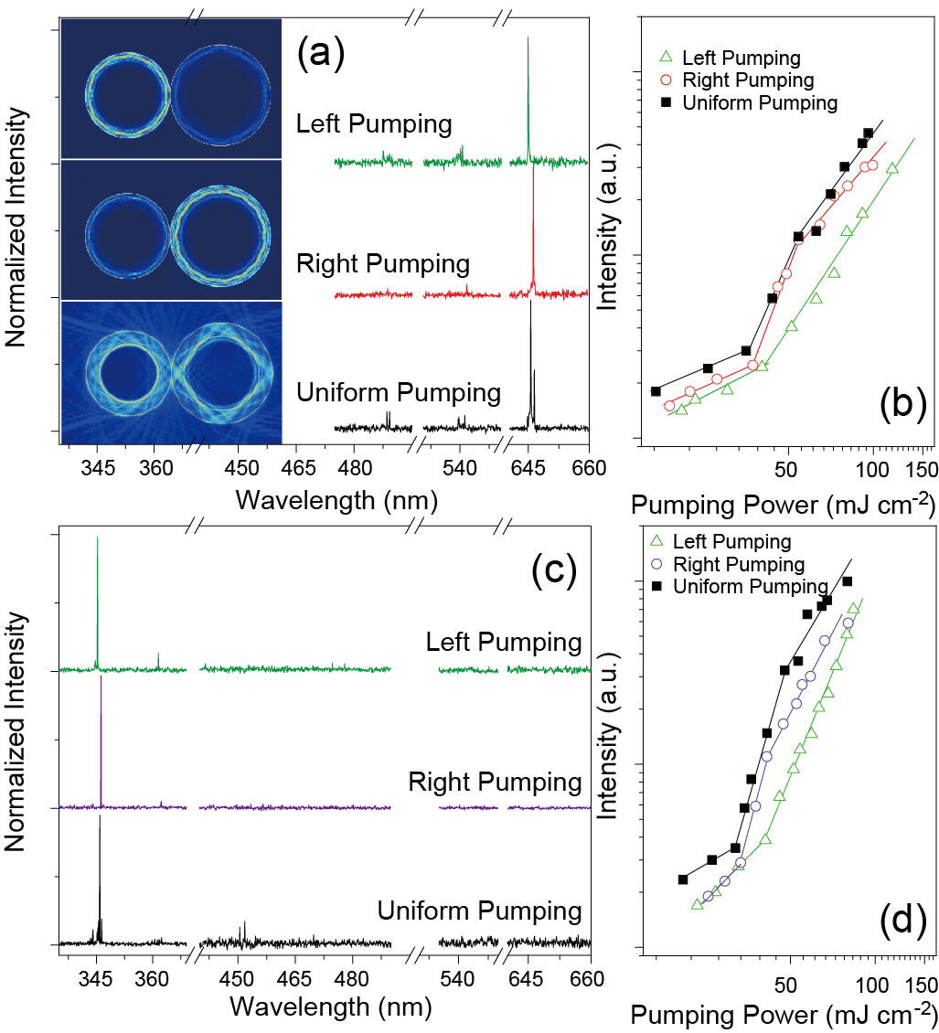
Figure S8 PM laser under three types of pumping configuration. Normalized emission spectra under (a) 808 nm, and (c) 980 nm left, right and uniform pumping with the corresponding light-light curves in (b,d) respectively. Solid lines are linear fitting to guide the eyes. The insets give the corresponding computer simulation of excited PM structure.

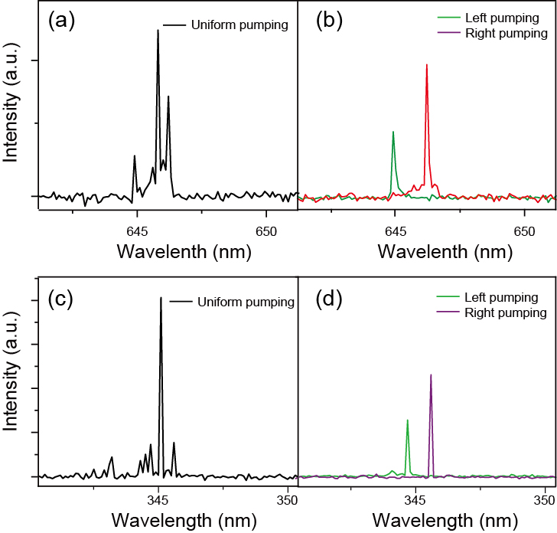
Figure S9. Lasing spectra of excited PM. Lasing spectra (a-b) under 808 nm, and (c-d) 980 nm pumping at the power density of ~80 mJ cm⁻².

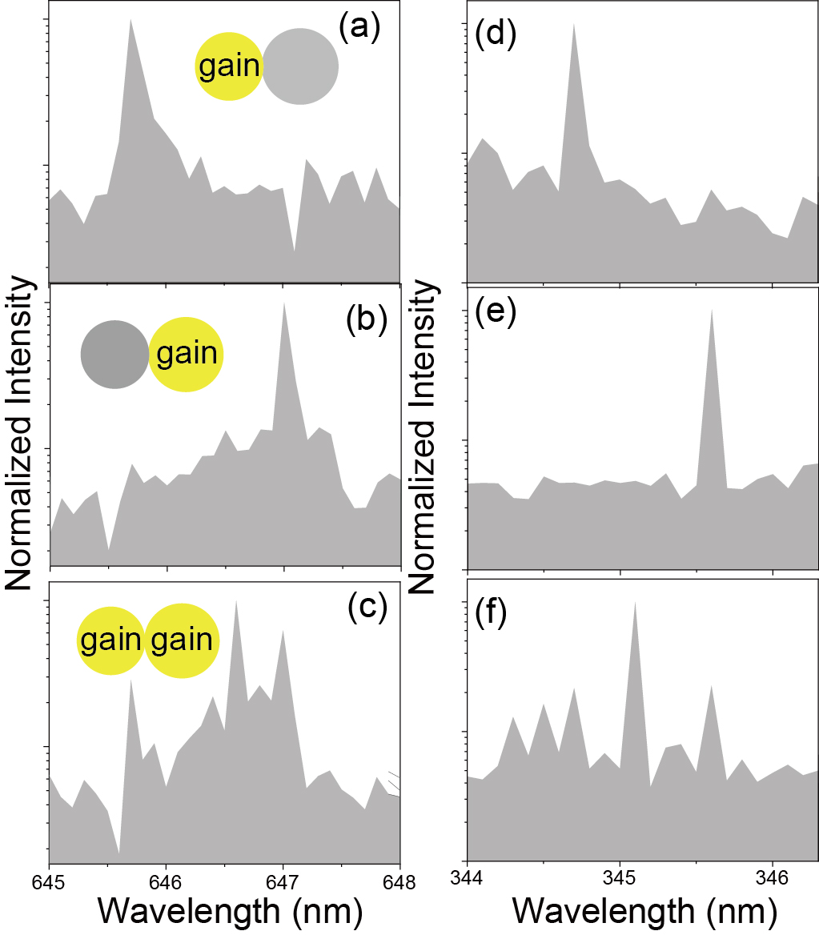
Figure S10. Experimental observation of single-mode lasing actions in UCNCs-based quasi-PT symmetric system. (a-c) are the corresponding laser spectra of figure S5a with the wavelengths centered at 644.9, 646.2 and 645.6 nm under left, right and uniform 808 nm pumping, respectively. (d-f) are the corresponding laser spectra of figure S5c with the wavelengths centered at 344.7, 345.6 and 345.3 nm under left, right and uniform 980 nm pumping, respectively. It is observed that the emission spectrum exhibits single-mode output while only one of the constituent resonators being excited, whereas it shows conventional multimode lasing in uniformly pumped PM structure.

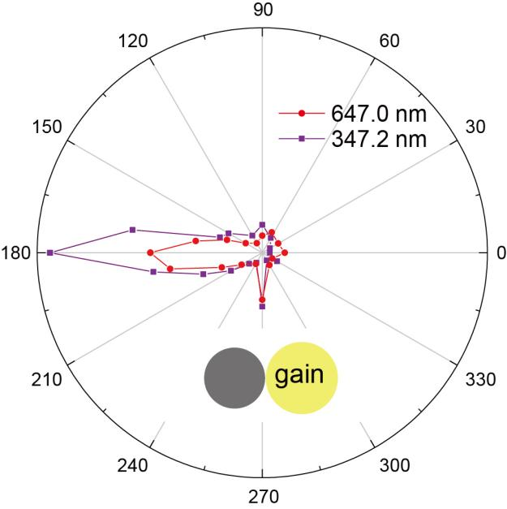
Figure S11. Far field pattern of the experimental lasing action at 646.2/345.6 nm under 808/980 nm right pumping, respectively.

Reference
[1] Chen, X. et al. Confining energy migration in upconversion nanoparticles towards deep ultraviolet lasing. Nat. Commun. 7, 10304 (2016).
[2] Zhang, G. et al. Multistimuli two-color luminescence switching via different slip-stacking of highly fluorescent molecular sheets. J. Am. Chem. Soc. 49, 10747-10749 (2010).
[3] Camposeo, A. et al. Electrically tunable organic distributed feedback lasers embedding nonlinear optical molecules. Adv. Opt. Mater. 24, OP221-225 (2012).
[4] Liu, Z. et al. Dynamical color-controllable lasing with extremely wide tuning range from red to green in a single alloy nanowire using nanoscale manipulation. Nano Lett. 13, 4945-4950 (2013).
[5] Kim, H. J. et al. High-contrast red-green-blue tricolor fluorescence switching in bicomponent molecular film. Angew. Chem. Int. Ed. Engl. 54, 4330-4333 (2015).
[6] Yang, A. et al. Real-time tunable lasing from plasmonic nanocavity arrays. Nat. Commun. 6, 6939 (2015).
[7] Zhang, W. et al. Low-threshold wavelength-switchable organic nanowire lasers based on excited-state intramolecular proton transfer. Angew. Chem. Int. Ed. Engl. 54, 7125-7129 (2015).
[8] Dong, H. et al. Broadband tunable microlasers based on controlled intramolecular charge-transfer process in organic supramolecular microcrystals. J. Am. Chem. Soc. 138, 1118-1121 (2016).
[9] Zhang, C. et al. Dual-color single-mode lasing in axially coupled organic nanowire resonators. Sci. Adv. 3, e1700225 (2017).
[10] Gao, Z. et al. Proton-controlled organic microlaser switch. ACS Nano 12, 5734-5740 (2018).
[11] Lv, Y. et al. Steric-hindrance-controlled laser switch based on pure metal-organic framework microcrystals. J. Am. Chem. Soc. 141, 19959-19963 (2019).
[12] Tang, B. et al. Energy transfer and wavelength tunable lasing of single perovskite alloy nanowire. Nano Energy 71, 104641 (2020).
[13] Li, H. et al. Switchable two-photon pumped polarized lasing performance in composition-graded MOFs based heterostructures. Adv. Opt. Mater. 8, 2001089 (2020).
[14] Yuan, Z. et al. Bioresponsive microlasers with tunable lasing wavelength. Nanoscale 13, 1608-1615 (2021).

