Supporting Information
HIF-1 stabilizing nanofibers for in situ regeneration of infected developing dental roots
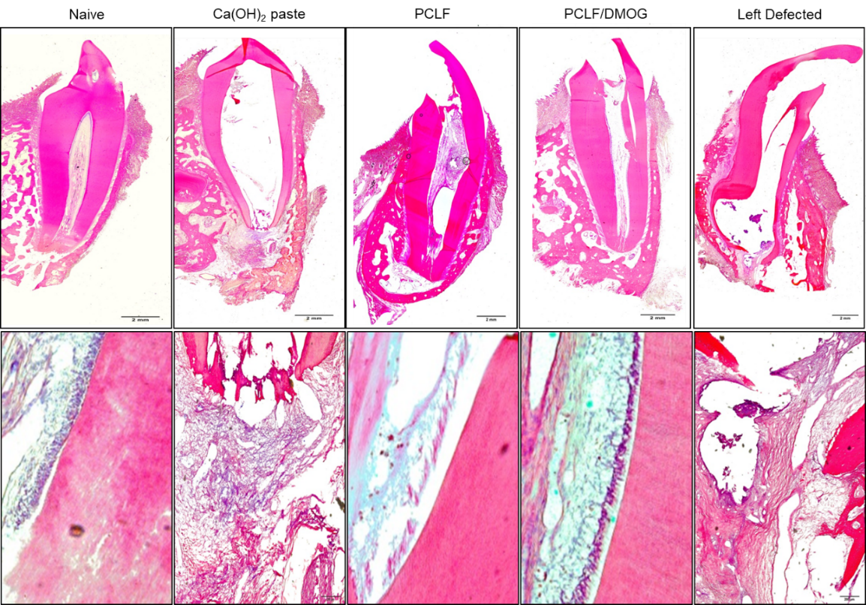
Figure S1. Histology of a whole tooth (upper) and the enlarged ones (lower; apical pulp - naïve, PCLF, PCLF/DMOG; alveolar bones around apex - Ca(OH)2, left defected). Scale bars represent 2 mm and 200 μm, upper and lower, respectively.

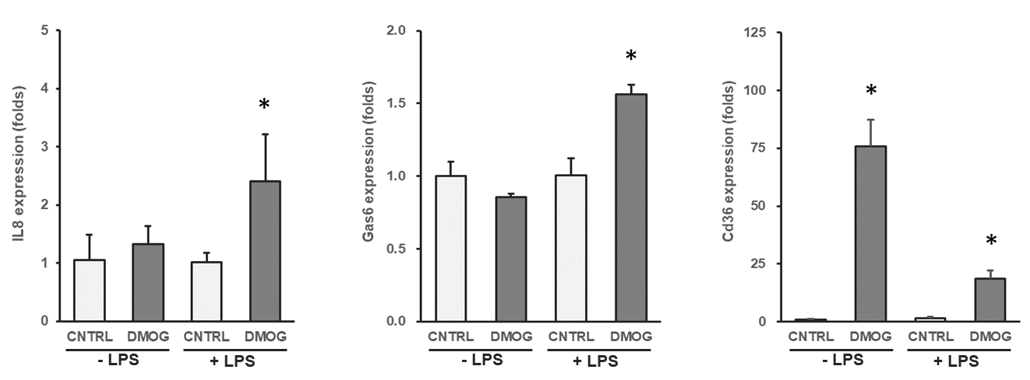
Figure S2. Expression of phagocytosis- and efferocytosis-related genes in the bone marrow-derived macrophages cultured for 7 days. DMOG (100nM) was treated for the last 24 h). Data are shown as mean ± SD (n = 4). *Significantly different from control (p < 0.05).

