Supplementary Material:

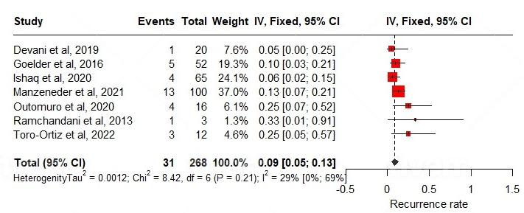

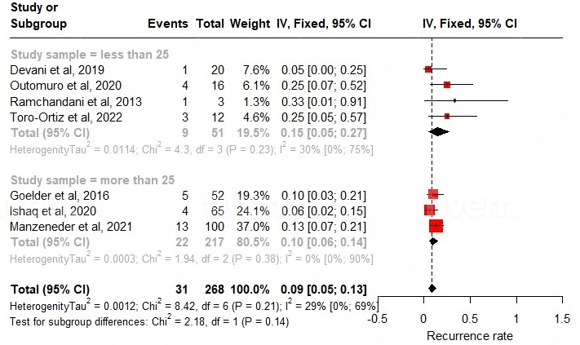
Figure 2 Forest plot of random effect of (a) complication rate, (b) Subgroup analysis of complication rate

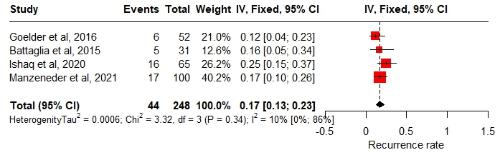
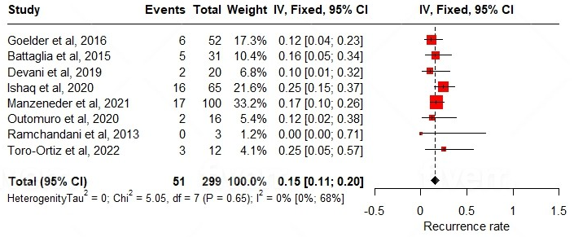
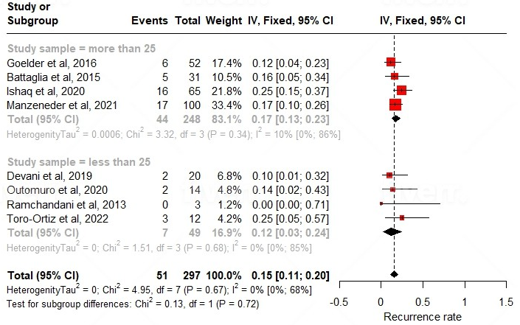
Figure 3 Forest plot of random effect of (a) recurrence rate _more than 25, (b) overall recurrence rate, and (c) subgroup analysis of recurrence rate

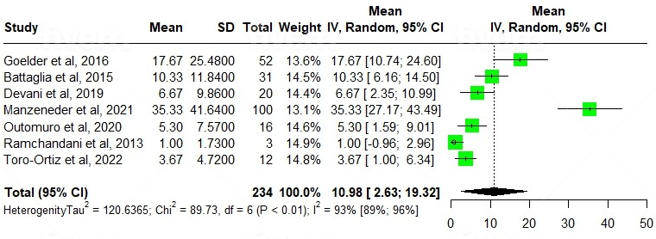

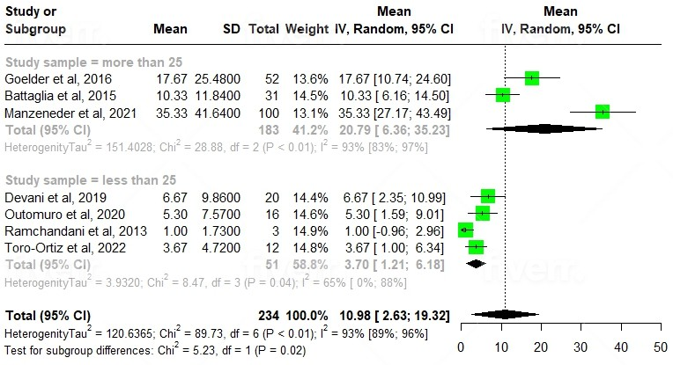

Figure 4 Forest plot of random effect of (a) session number for treating ZD, (b) subgroup analysis of session number

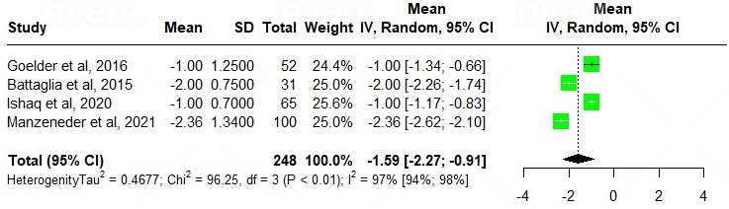

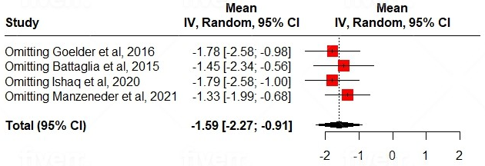

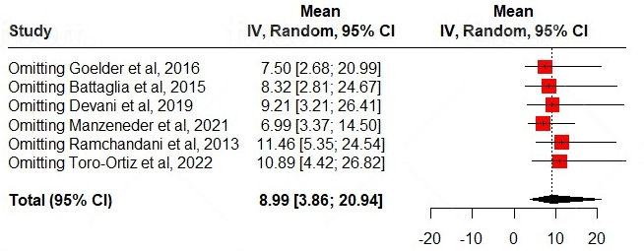
Figure 5 Forest plot of random effect model of (a) dysphagia score_all for more than 25, (b) dysphagia score_leave one out (c) leave one out meta-analysis_session number

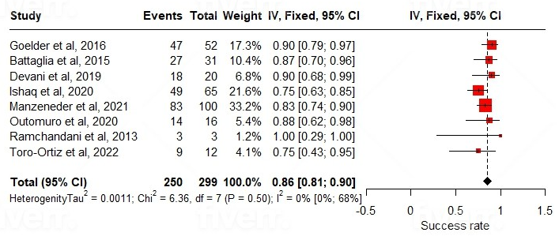

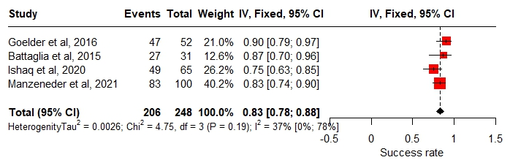

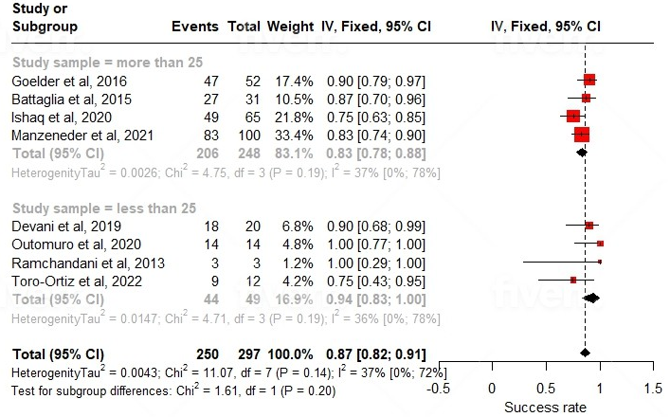
Figure 6 Forest plot of random effect of (a) overall success rate, (b) success rate_more than 25, (c) subgroup analysis of success rate

