Supplementary Material

Influences of Pulsed Electric Field Parameters on Cell Electroporation and Electrofusion Events: Comprehensive Understanding by Experiments and Molecular Dynamics Simulations

Sujun Qu^{a†}, Qiang Ke^{b,c†}, Xinhao Li^{c}, Liangpeng Ge^{d}, Lin Yu ^{e}*, Shuheng Huang^{f}*
ª Jingmen central hospital, Jingmen, China
^{b} Nanjing Research Institute of Electronics Technology, Nanjing, China
^{c} State Key Laboratory of Power Transmission Equipment & System Security and New Technology, School of Electrical Engineering, Chongqing University, Chongqing, China
^{d} Chongqing Academy of Animal Sciences, Chongqing, China
^{e} Institute of Translational Medicine, Medical College, Yangzhou University, Yangzhou, 225001, Jiangsu, China.
^{f} Key Laboratory of Tropical Biological Resources of Ministry of Education, School of Pharmaceutical Sciences, Hainan University, Haikou, China

† These authors contribute equally to this work.
* Corresponding Author: Shuheng Huang, E-mail address: shhuang@hainanu.edu.cn; Lin Yu, E-mail address: linyu@yzu.edu.cn

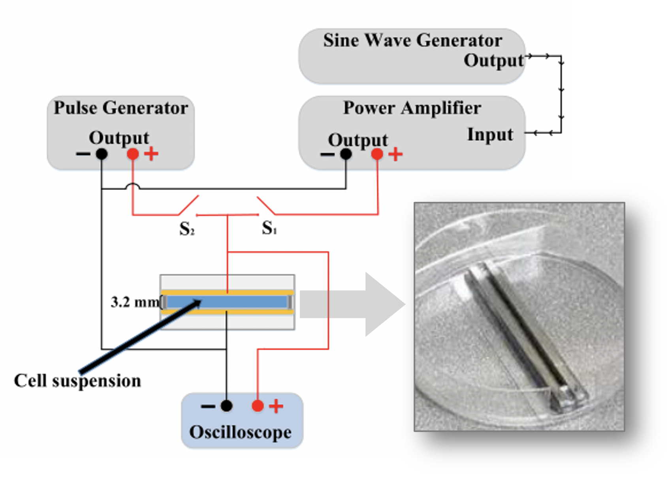
Figure S1. The schematic diagram of the homemade instrument. The cathodes of the pulse generator, power ampliﬁer and oscilloscope were connected (black line). S1 and S2 were used to switch the sine waves and pulse waves, respectively.

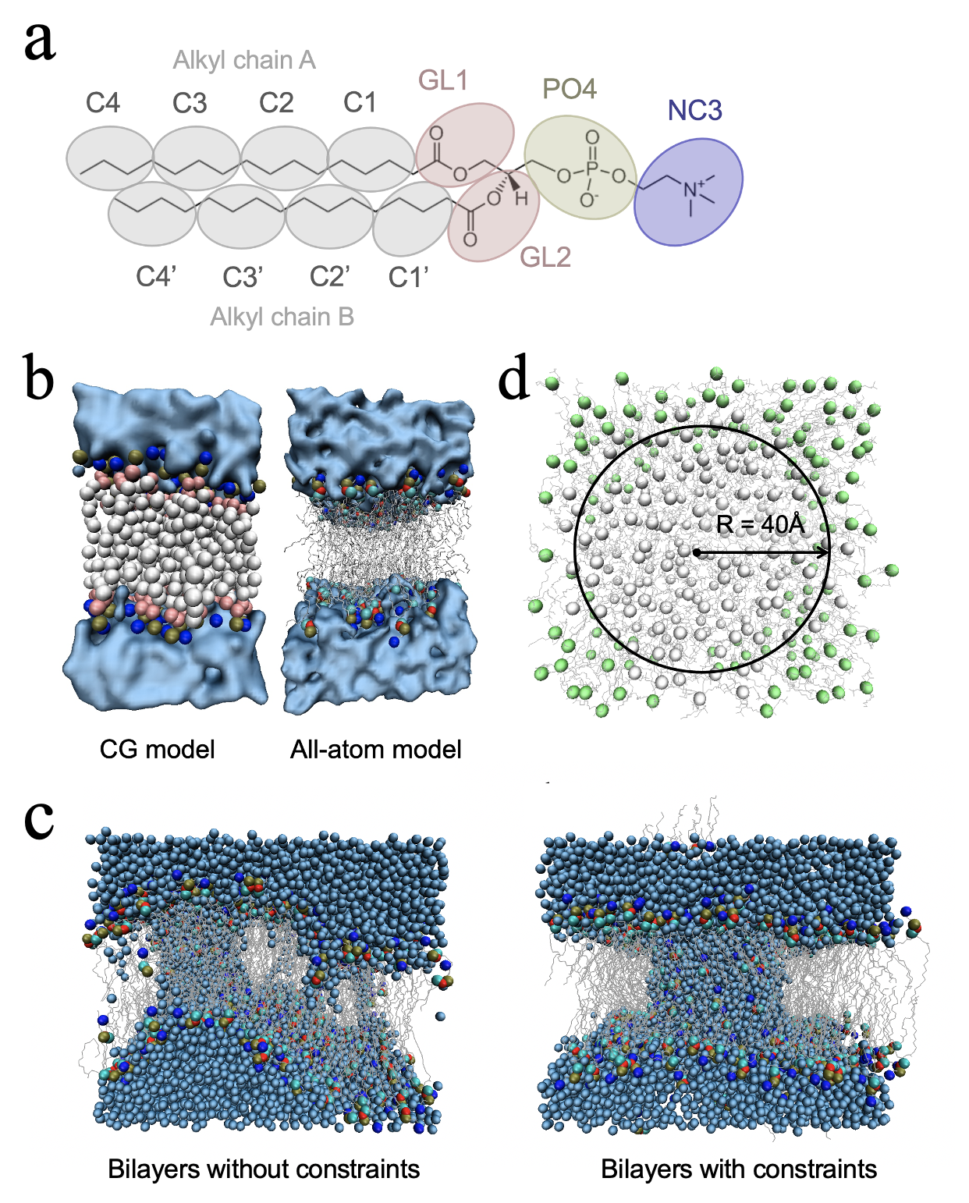
Figure 2. System preparations of MD simulations. (a) Schematic diagram of CG and all-atom models in the water box. The representative models were intercepted along the X-axis from bilayers models. (b) Correspondence relationships between the CG and all-atom models for DPPC molecules. NC3: choline group; PO4: phosphate group; GL: glycerol group; C1-4: alkyl chains. (c) Snapshot in all-atom MD simulation of phospholipid bilayers electroporation (E = 0.7 V/nm) under the conditions of non-constraint and with harmonically constrained by a force of 100 kcal/mol·Å². (d) The range of harmonic constraints in all-atom model is colored green. The glycerol Cα-atoms and DPPC backbone are represented as spheres and lines, respectively.

