Network analysis of multidimensional symptoms and inflammatory biomarkers in Chinese patients with glioma
Huayu Li¹ · Xiaohan Shi² · Jing Li³ · Xinrui Zhang² · Alphonce M K Nyalali^{3,4} · Feng Li³

Correspondence: Feng Li lidoc@163.com
Department of Neurosurgery, Shandong Cancer Hospital and Institute, Shandong First Medical University and Shandong Academy of Medical Sciences, Jinan, 250117, China

Note: S1: Pain; S2: Fatigue; S3: Nausea; S4: Sleepy; S5: Distress; S6: Shortness of breath; S7: Difficulty remembering; S8: Lack of appetite; S9: Drowsy; S10: Dry month; S11: Sad; S12: Vomiting; S13: Numbness; S14: Weakness; S15: Difficulty understanding; S16: Difficulty speaking; S17: Seizures; S18: Difficulty concentrating; S19: Vision; S20: Change in appearance; S21: Change in bowel pattern; S22: Irritability.

Table 1 Symptom percent reporting as moderate to severe of patients across the three assessments (n = 334)
Item | T1 Rating (≥5)  No. (%) | T2 Rating (≥5)  No. (%) | T3 Rating (≥5)  No. (%)
Symptoms
Pain | 208 (62.3) | 109 (32.6) | 79 (23.7)
Fatigue | 320 (95.8) | 287 (85.9) | 285 (85.3)
Nausea | 221 (66.2) | 171 (51.2) | 61 (18.3)
Sleepy | 113 (33.8) | 160 (47.9) | 243 (72.8)
Distress | 100 (29.9) | 91 (27.2) | 155 (46.4)
Shortness of breath | 64 (19.2) | 48 (14.4) | 76 (22.8)
Difficulty remembering | 139 (41.6) | 124 (37.1) | 95 (28.4)
Lack of appetite | 70 (21.0) | 43 (12.9) | 80 (24.0)
Drowsy | 250 (74.9) | 221 (66.2) | 100 (29.9)
Dry mouth | 114 (34.1) | 167 (50.0) | 59 (17.7)
Sad | 85 (25.4) | 109 (32.6) | 210 (62.9)
Vomiting | 240 (71.9) | 40 (12.0) | 109 (32.6)
Numbness | 62 (18.6) | 48 (14.4) | 56 (16.8)
Weakness | 78 (23.4) | 172 (51.5) | 80 (24.0)
Difficulty understanding | 193 (57.8) | 257 (76.9) | 69 (20.7)
Difficulty speaking | 71 (21.3) | 32 (9.6) | 64 (19.2)
Seizures | 36 (10.8) | 19 (5.7) | 31 (9.3)
Difficulty concentrating | 143 (42.8) | 57 (17.1) | 99 (29.6)
Vision | 123 (36.8) | 84 (25.1) | 84 (25.1)
Change in appearance | 99 (29.6) | 116 (34.7) | 69 (20.7)
Change in bowel pattern | 62 (18.6) | 69 (20.7) | 91 (27.2)
Irritability | 154 (46.1) | 115 (34.4) | 53 (15.9)
Activity related
Work | 140 (41.9) | 127 (38.0) | 181 (54.2)
General activity | 200 (59.9) | 145 (43.4) | 74 (22.2)
Walking | 157 (47.0) | 132 (39.5) | 87 (26.0)
Mood related
Mood | 159 (47.6) | 112 (33.5) | 144 (43.1)
Relations | 91 (27.2) | 125 (37.4) | 130 (38.9)
Enjoyment of life | 218 (65.3) | 125 (37.4) | 117 (35.0)

Table 2 Mean symptom severity of participants across the three assessments (n = 334)
Item | T1  (M$±$SD) | T2  (M$±$SD) | T3  (M$±$SD) | LSD*
Symptoms
Pain | 4.90$±$2.66 | 3.40$±$2.92 | 3.19$±$2.46 | 1>2,1>3
Fatigue | 7.30$±$1.66 | 6.54$±$1.82 | 6.45$±$2.04 | 1>2,1>3
Nausea | 5.41$±$2.75 | 4.43$±$2.67 | 2.33$±$2.35 | 1>2>3
Sleepy | 4.18$±$2.48 | 4.63$±$2.06 | 5.77$±$2.08 | 1<2<3
Distress | 3.51$±$2.56 | 3.19$±$2.49 | 4.42$±$2.49 | 1<3,2<3
Shortness of breath | 2.02$±$2.68 | 2.09$±$2.11 | 2.80$±$2.37 | 1<3.2<3
Difficulty remembering | 3.96$±$2.95 | 4.01$±$2.33 | 3.40$±$2.53 | 1>3,2>3
Lack of appetite | 3.14$±$2.40 | 2.01$±$2.24 | 2.99$±$2.52 | 1>2,2<3
Drowsy | 5.95$±$2.79 | 5.35$±$2.80 | 3.35$±$2.91 | 1>2>3
Dry mouth | 3.87$±$2.98 | 4.18$±$2.22 | 2.89$±$2.11 | 1>3,2>3
Sad | 3.74$±$2.48 | 3.74$±$2.70 | 5.36$±$2.63 | 1<3,2<3
Vomiting | 5.94$±$2.49 | 1.87$±$2.18 | 3.74$±$2.70 | 1>3>2
Numbness | 2.02$±$2.54 | 2.86$±$1.93 | 2.55$±$2.23 | 1<2,1<3
Weakness | 2.57$±$2.88 | 4.45$±$2.95 | 2.82$±$2.68 | 1<2,2>3
Difficulty understanding | 4.66$±$2.70 | 5.81$±$2.37 | 2.84$±$2.52 | 3<1<2
Difficulty speaking | 2.88$±$2.13 | 1.54$±$2.12 | 2.67$±$2.55 | 1>2,2<3
Seizures | 1.19$±$2.27 | 1.50$±$1.81 | 1.81$±$2.13 | 1<3
Difficulty concentrating | 3.66$±$3.15 | 2.60$±$2.24 | 3.21$±$2.81 | 2<3<1
Vision | 4.11$±$2.53 | 2.88$±$2.59 | 2.88$±$2.59 | 1>2,1>3
Change in appearance | 3.17$±$2.90 | 3.45$±$2.94 | 2.52$±$2.43 | 1>3,2>3
Change in bowel pattern | 2.44$±$2.80 | 2.52$±$2.43 | 3.19$±$2.49 | 1<3,2<3
Irritability | 4.10$±$2.31 | 3.60$±$2.36 | 2.66$±$1.99 | 1>2>3
Activity related
Work | 3.74$±$2.86 | 4.10$±$2.45 | 4.96$±$2.43 | 1<3,2<3
General activity | 5.39$±$2.83 | 4.36$±$2.37 | 3.49$±$1.93 | 1>2>3
Walking | 4.02$±$3.38 | 4.08$±$2.63 | 3.57$±$2.00 | 1>3,2>3
Mood related
Mood | 4.60$±$2.85 | 3.70$±$2.46 | 4.26$±$2.40 | 1>2,2<3
Relations | 3.02$±$2.66 | 4.06$±$2.38 | 4.17$±$1.89 | 1<2,1<3
Enjoyment of life | 5.53$±$2.98 | 4.14$±$2.66 | 4.07$±$2.27 | 1>2,1>3
Note：*P<0.05.
Table 3 Weights matrix for GGM network in patients with glioma at T1
 | S1 | S2 | S3 | S4 | S5 | S6 | S7 | S8 | S9 | S10 | S11 | S12 | S13 | S14 | S15 | S16 | S17 | S18 | S19 | S20 | S21
S1
S2 | -0.02
S3 | 0.14 | 0.00
S4 | 0.00 | 0.15 | 0.08
S5 | 0.00 | 0.06 | 0.00 | 0.05
S6 | 0.00 | 0.00 | 0.00 | 0.07 | 0.00
S7 | 0.19 | -0.05 | 0.08 | 0.00 | 0.00 | 0.03
S8 | 0.07 | 0.00 | 0.05 | 0.02 | 0.00 | 0.10 | 0.04
S9 | 0.02 | -0.06 | 0.09 | -0.02 | 0.00 | 0.00 | 0.13 | 0.02
S10 | 0.14 | 0.00 | 0.09 | 0.00 | 0.04 | 0.05 | 0.20 | 0.17 | 0.00
S11 | 0.00 | 0.06 | 0.00 | 0.16 | 0.28 | 0.01 | 0.00 | 0.04 | 0.00 | 0.00
S12 | 0.22 | 0.08 | 0.23 | -0.04 | 0.00 | 0.00 | 0.10 | 0.01 | 0.02 | 0.11 | 0.00
S13 | 0.00 | 0.00 | 0.00 | 0.01 | 0.07 | 0.40 | 0.08 | 0.11 | 0.00 | 0.04 | 0.00 | 0.00
S14 | 0.00 | 0.03 | 0.00 | 0.00 | 0.07 | 0.06 | 0.04 | 0.02 | 0.00 | 0.04 | 0.01 | 0.00 | 0.11
S15 | 0.09 | 0.00 | 0.12 | 0.00 | 0.00 | 0.00 | 0.11 | 0.06 | 0.10 | 0.00 | 0.05 | 0.20 | 0.00 | 0.09
S16 | 0.08 | 0.00 | 0.00 | 0.00 | 0.02 | 0.04 | 0.00 | 0.01 | 0.05 | 0.00 | 0.07 | 0.00 | 0.02 | 0.05 | 0.02
S17 | 0.01 | 0.00 | 0.00 | 0.02 | 0.00 | 0.12 | 0.03 | 0.08 | 0.00 | 0.00 | 0.00 | 0.00 | 0.01 | 0.00 | 0.00 | 0.00
S18 | 0.02 | 0.00 | 0.00 | 0.00 | 0.07 | 0.01 | 0.01 | 0.00 | 0.00 | 0.04 | 0.00 | 0.03 | 0.00 | 0.11 | 0.19 | 0.01 | 0.03
S19 | 0.00 | 0.19 | 0.00 | 0.00 | 0.14 | 0.00 | 0.04 | 0.08 | 0.01 | 0.02 | 0.06 | 0.00 | 0.01 | 0.27 | 0.00 | 0.01 | 0.00 | 0.09
S20 | -0.02 | 0.01 | 0.00 | 0.05 | 0.08 | 0.09 | 0.00 | 0.01 | 0.00 | 0.00 | 0.08 | 0.00 | 0.11 | 0.05 | 0.00 | 0.00 | 0.00 | 0.00 | 0.02
S21 | 0.00 | 0.00 | 0.00 | 0.09 | 0.14 | 0.15 | 0.00 | 0.11 | 0.00 | 0.05 | 0.03 | 0.00 | 0.15 | 0.06 | 0.00 | 0.01 | 0.04 | 0.00 | 0.10 | 0.13
S22 | 0.00 | 0.00 | 0.04 | 0.00 | 0.00 | 0.00 | 0.04 | 0.07 | 0.00 | 0.00 | 0.04 | 0.05 | 0.00 | 0.00 | 0.02 | -0.01 | 0.00 | 0.11 | 0.12 | 0.23 | 0.00

Table 4 Weights matrix for GGM network in patients with glioma at T2
 | S1 | S2 | S3 | S4 | S5 | S6 | S7 | S8 | S9 | S10 | S11 | S12 | S13 | S14 | S15 | S16 | S17 | S18 | S19 | S20 | S21
S1
S2 | 0.00
S3 | 0.07 | 0.00
S4 | 0.05 | 0.08 | 0.37
S5 | 0.09 | 0.00 | 0.02 | 0.09
S6 | 0.03 | 0.00 | 0.12 | 0.06 | 0.00
S7 | 0.00 | 0.00 | 0.07 | 0.00 | 0.00 | 0.04
S8 | 0.05 | 0.00 | 0.00 | 0.00 | 0.03 | 0.00 | 0.00
S9 | 0.00 | 0.19 | 0.02 | 0.01 | 0.02 | 0.02 | 0.00 | 0.00
S10 | 0.00 | 0.04 | 0.02 | 0.02 | 0.05 | 0.00 | 0.12 | 0.05 | 0.05
S11 | 0.22 | 0.20 | 0.07 | 0.05 | 0.19 | 0.05 | 0.24 | 0.05 | 0.00 | 0.05
S12 | 0.04 | 0.00 | 0.00 | 0.00 | 0.06 | 0.04 | 0.03 | 0.11 | 0.05 | 0.03 | 0.09
S13 | 0.07 | 0.00 | 0.01 | 0.08 | 0.10 | 0.00 | 0.00 | 0.11 | 0.00 | 0.09 | 0.02 | 0.04
S14 | 0.00 | 0.07 | 0.00 | 0.15 | 0.00 | 0.06 | 0.00 | 0.02 | 0.06 | 0.00 | 0.00 | 0.00 | 0.00
S15 | 0.00 | 0.00 | 0.02 | 0.00 | 0.00 | 0.02 | 0.00 | 0.00 | 0.10 | 0.00 | 0.05 | 0.08 | 0.00 | 0.00
S16 | 0.00 | 0.02 | 0.01 | 0.00 | 0.08 | 0.01 | 0.02 | 0.07 | 0.01 | 0.00 | 0.05 | 0.02 | 0.00 | 0.02 | 0.03
S17 | 0.00 | 0.00 | 0.00 | 0.00 | 0.04 | 0.00 | 0.00 | 0.00 | 0.00 | 0.00 | 0.00 | 0.00 | 0.04 | 0.00 | 0.00 | 0.02
S18 | 0.00 | 0.01 | 0.00 | 0.00 | 0.08 | 0.00 | 0.09 | 0.02 | 0.00 | 0.00 | 0.05 | 0.02 | 0.00 | 0.00 | 0.00 | 0.05 | 0.00
S19 | 0.05 | 0.00 | 0.00 | 0.00 | 0.12 | 0.01 | 0.03 | 0.00 | 0.00 | 0.00 | 0.11 | 0.04 | 0.09 | 0.00 | 0.00 | 0.00 | 0.03 | 0.00
S20 | 0.00 | 0.27 | 0.05 | 0.00 | 0.20 | 0.03 | 0.00 | 0.00 | 0.02 | 0.03 | 0.03 | 0.00 | 0.00 | 0.15 | 0.06 | 0.05 | 0.00 | 0.10 | 0.03
S21 | 0.08 | 0.00 | 0.00 | 0.19 | 0.17 | 0.02 | 0.04 | 0.13 | 0.05 | 0.02 | 0.02 | 0.08 | 0.02 | 0.04 | 0.00 | 0.00 | 0.13 | 0.04 | 0.19 | 0.00
S22 | 0.06 | 0.00 | 0.09 | 0.08 | 0.08 | 0.06 | 0.04 | 0.02 | 0.01 | 0.00 | 0.05 | 0.00 | 0.00 | 0.00 | 0.00 | 0.00 | 0.03 | 0.00 | 0.08 | 0.00 | 0.10

Table 5 Weights matrix for GGM network in patients with glioma at T3
 | S1 | S2 | S3 | S4 | S5 | S6 | S7 | S8 | S9 | S10 | S11 | S12 | S13 | S14 | S15 | S16 | S17 | S18 | S19 | S20 | S21
S1
S2 | 0.00
S3 | 0.09 | 0.00
S4 | 0.04 | 0.07 | 0.00
S5 | 0.00 | 0.02 | 0.00 | 0.00
S6 | 0.05 | 0.00 | 0.04 | 0.10 | 0.08
S7 | 0.00 | 0.07 | 0.00 | 0.03 | 0.01 | 0.11
S8 | 0.00 | 0.01 | 0.31 | 0.00 | 0.01 | 0.16 | 0.00
S9 | 0.00 | 0.00 | 0.00 | 0.00 | 0.07 | 0.29 | 0.00 | 0.01
S10 | 0.10 | 0.00 | 0.00 | 0.00 | 0.00 | 0.02 | 0.00 | 0.05 | 0.03
S11 | 0.00 | 0.00 | 0.00 | 0.19 | 0.09 | 0.01 | 0.00 | 0.00 | 0.12 | 0.01
S12 | 0.10 | 0.08 | 0.06 | 0.09 | 0.05 | 0.03 | 0.18 | 0.05 | 0.13 | 0.06 | 0.00
S13 | 0.04 | 0.02 | 0.12 | 0.01 | -0.03 | 0.00 | 0.00 | 0.24 | 0.01 | 0.02 | 0.02 | 0.00
S14 | 0.02 | 0.00 | 0.02 | 0.00 | 0.00 | 0.06 | 0.03 | 0.18 | 0.08 | 0.22 | 0.00 | 0.05 | 0.07
S15 | 0.00 | 0.00 | 0.00 | 0.00 | 0.06 | 0.05 | 0.13 | 0.00 | 0.26 | 0.02 | 0.07 | 0.05 | 0.00 | 0.07
S16 | 0.00 | 0.06 | 0.00 | 0.00 | 0.00 | 0.00 | 0.00 | 0.00 | 0.22 | 0.03 | 0.00 | 0.00 | 0.01 | 0.18 | 0.16
S17 | 0.00 | 0.00 | 0.00 | 0.00 | -0.03 | 0.00 | 0.00 | 0.00 | 0.00 | 0.09 | -0.01 | 0.00 | 0.08 | 0.03 | 0.00 | 0.08
S18 | 0.00 | 0.06 | 0.00 | 0.00 | 0.00 | 0.00 | 0.26 | 0.03 | 0.00 | 0.00 | 0.00 | 0.12 | 0.00 | 0.00 | 0.02 | 0.15 | 0.09
S19 | 0.00 | 0.00 | 0.00 | 0.00 | 0.02 | 0.05 | 0.02 | 0.09 | 0.00 | 0.01 | 0.00 | 0.04 | 0.00 | 0.06 | 0.00 | 0.00 | 0.00 | 0.13
S20 | 0.08 | 0.00 | 0.00 | 0.10 | 0.00 | 0.03 | 0.00 | 0.00 | 0.00 | 0.05 | 0.00 | 0.00 | 0.06 | 0.17 | 0.03 | 0.00 | 0.18 | 0.18 | 0.12
S21 | 0.06 | 0.04 | 0.04 | 0.03 | 0.20 | 0.04 | 0.00 | 0.12 | 0.01 | 0.00 | 0.00 | 0.14 | 0.05 | 0.00 | 0.08 | 0.02 | 0.03 | 0.08 | 0.09 | 0.09
S22 | 0.00 | 0.05 | 0.00 | 0.00 | 0.02 | 0.00 | 0.00 | 0.00 | 0.00 | 0.05 | 0.01 | 0.00 | 0.00 | 0.00 | 0.07 | 0.04 | 0.00 | 0.00 | 0.00 | 0.11 | 0.17

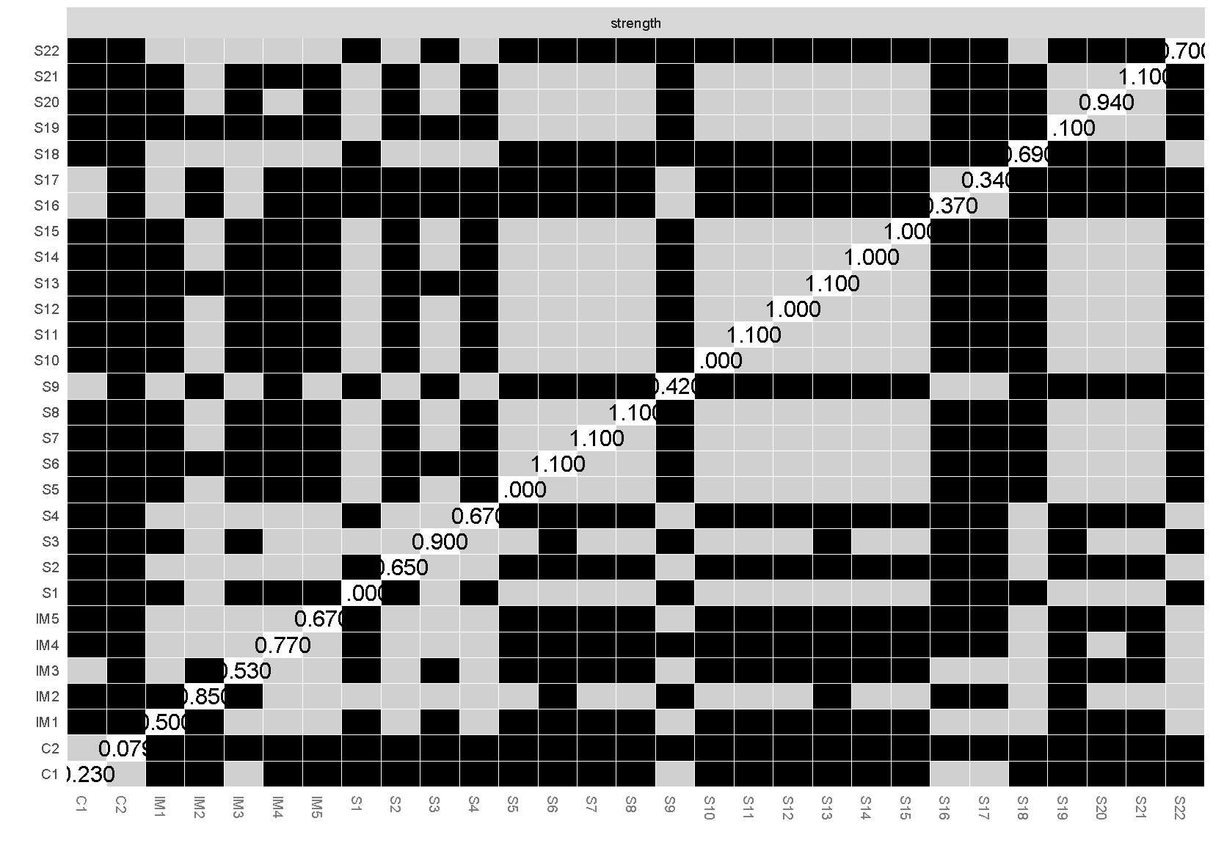
Fig. 1. Results of bootstrapped difference test for nodes within the symptom-cytokine network
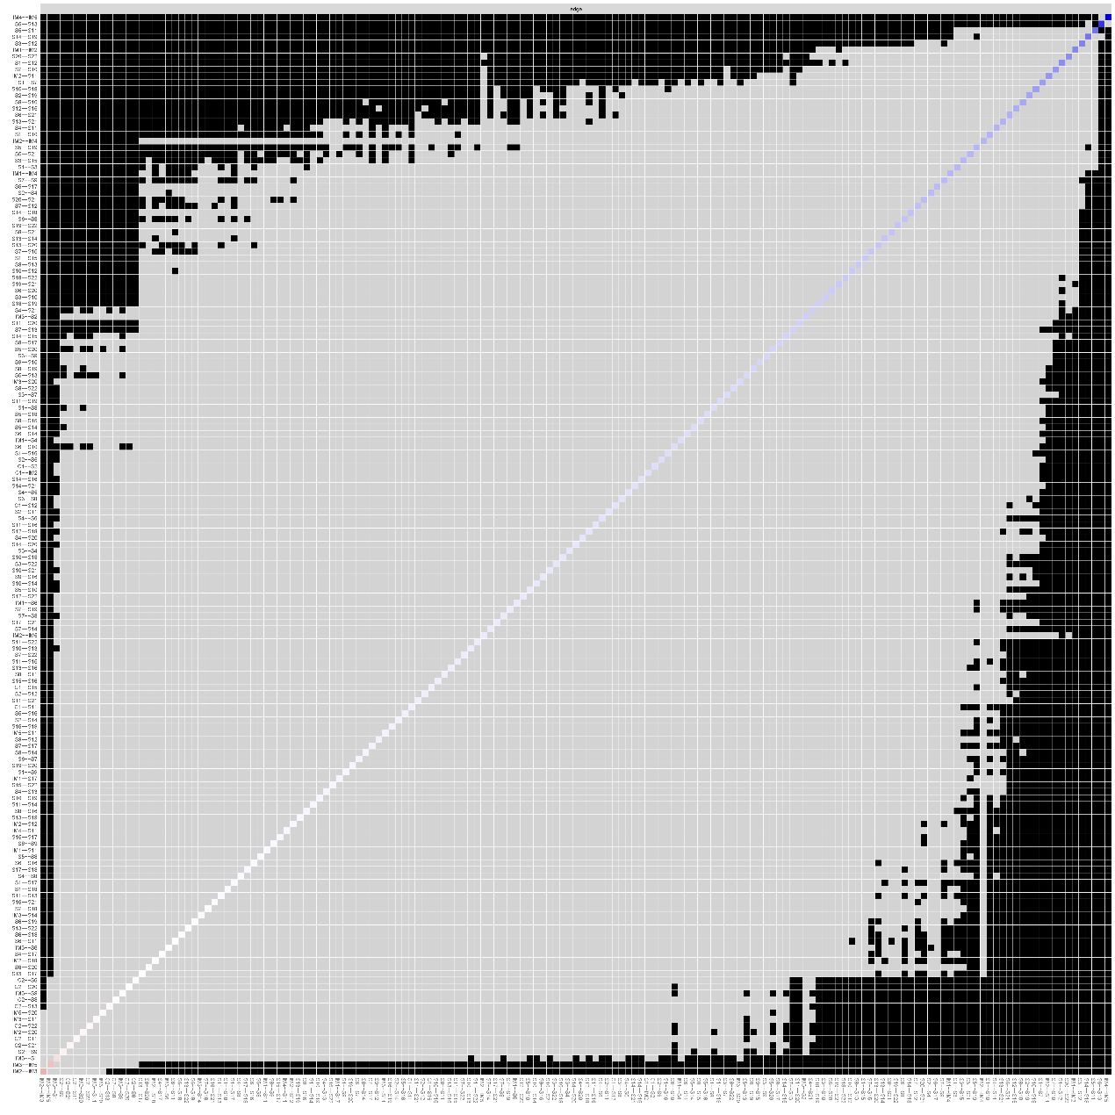
Fig. 2. Bootstrapped difference test for edges within the symptom-cytokine network

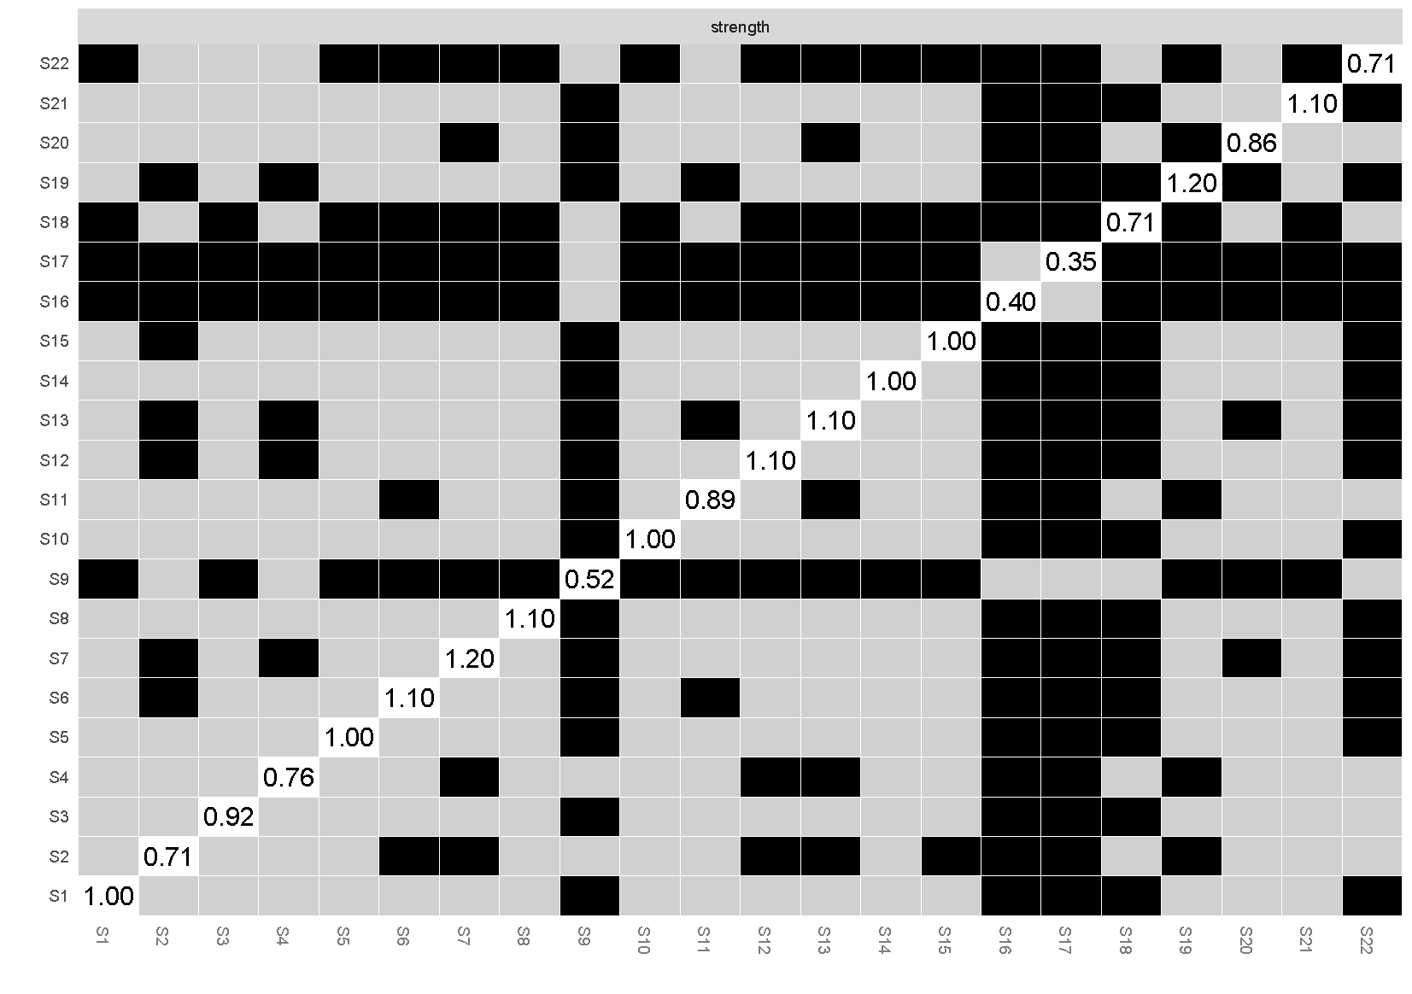
Fig. 3. Results of bootstrapped difference test for nodes at T1
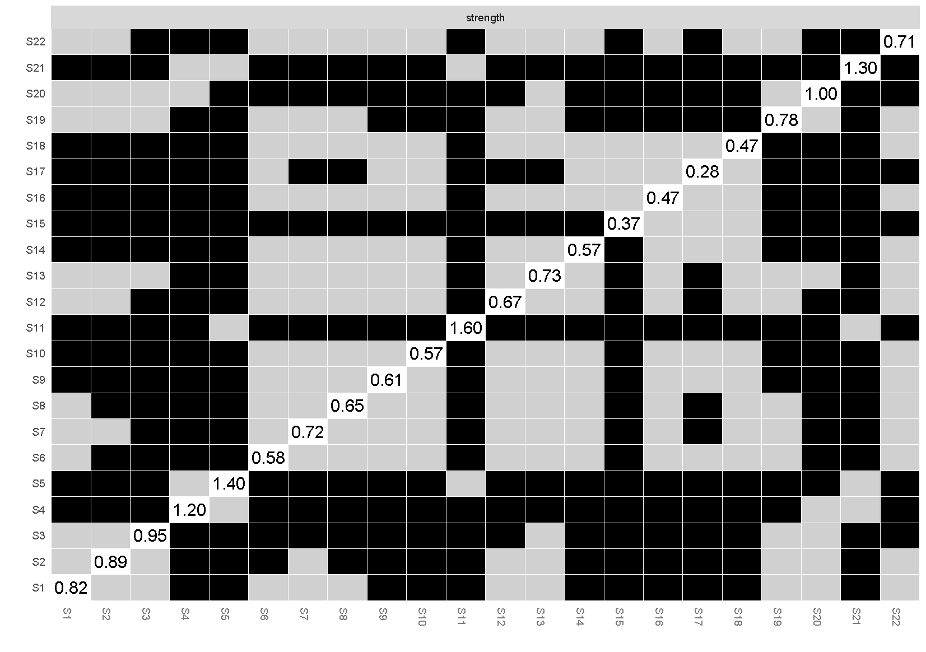
Fig. 4. Results of bootstrapped difference test for nodes at T2
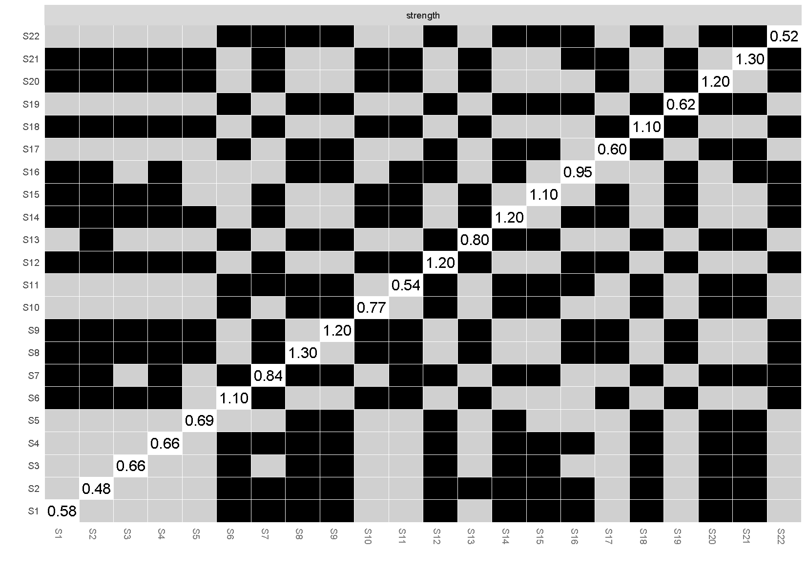
Fig. 5. Results of bootstrapped difference test for nodes at T3
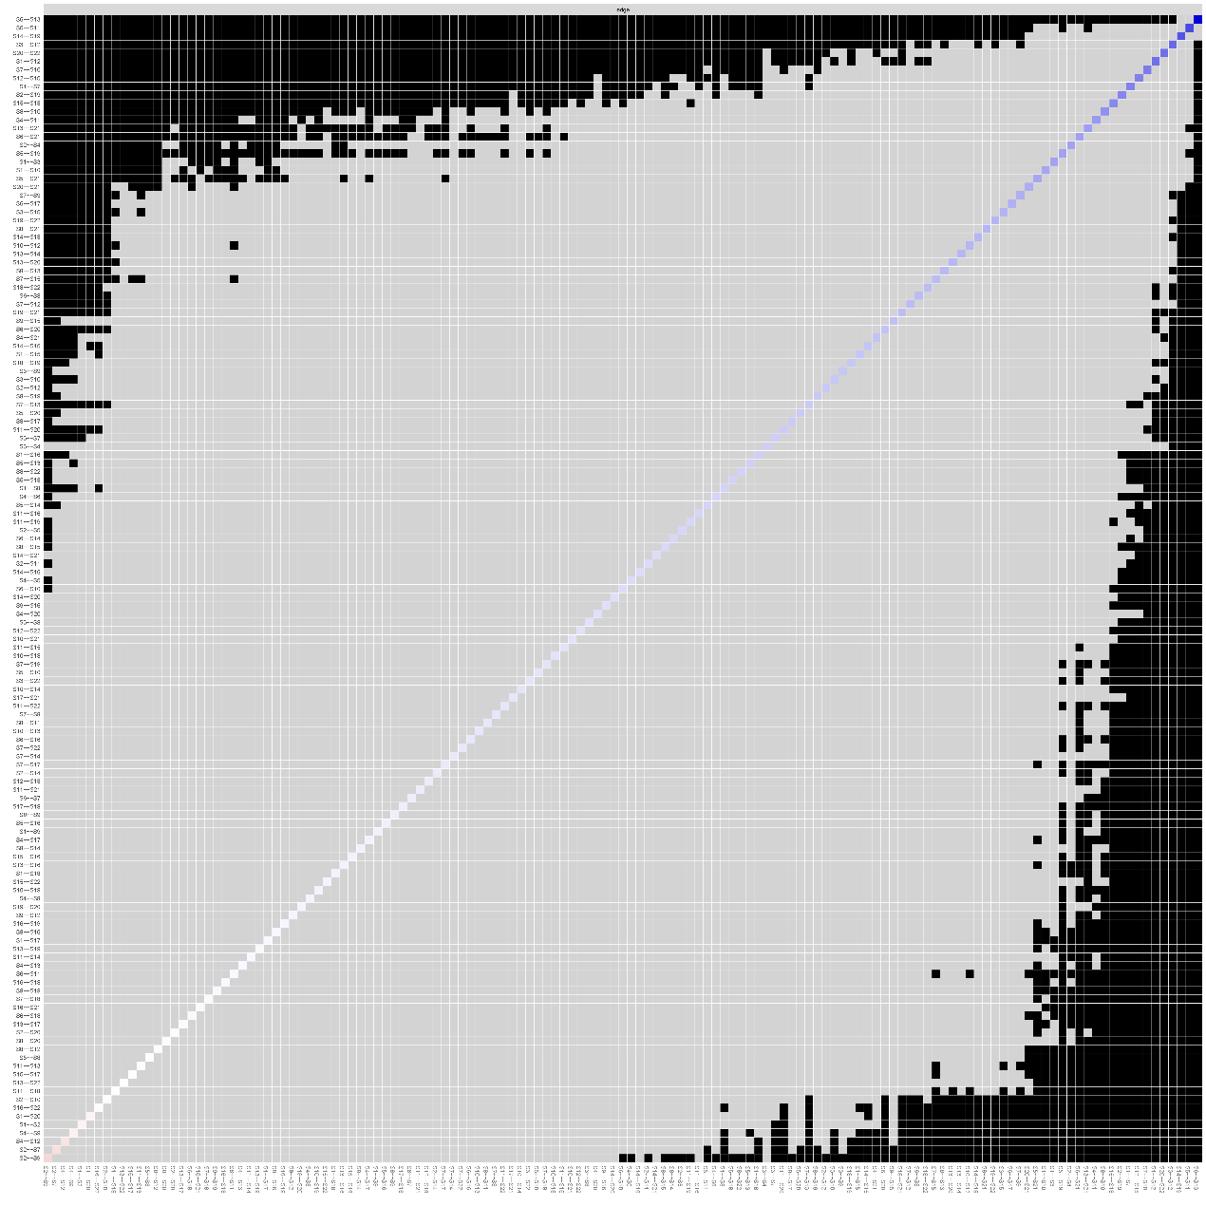
Fig. 6. Bootstrapped difference tests for the symptom network edge weights of symptoms in patients with glioma at T1
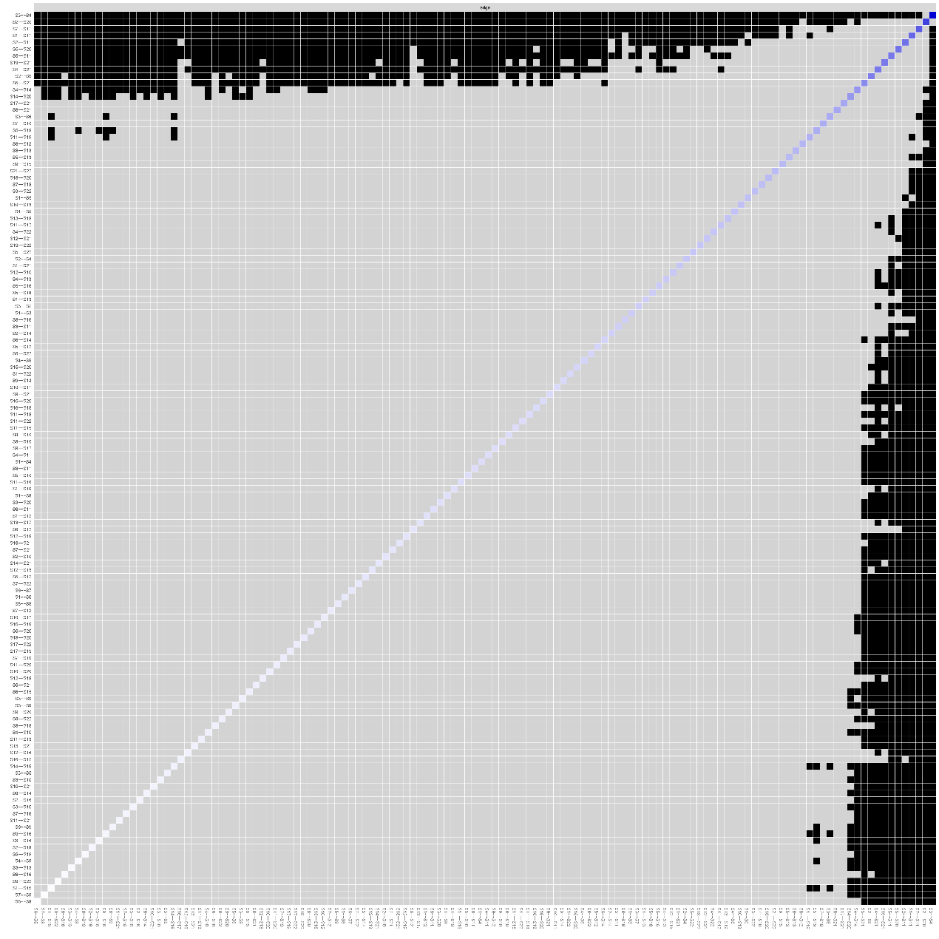
Fig. 7. Bootstrapped difference tests for the symptom network edge weights of symptoms in patients with glioma at T2

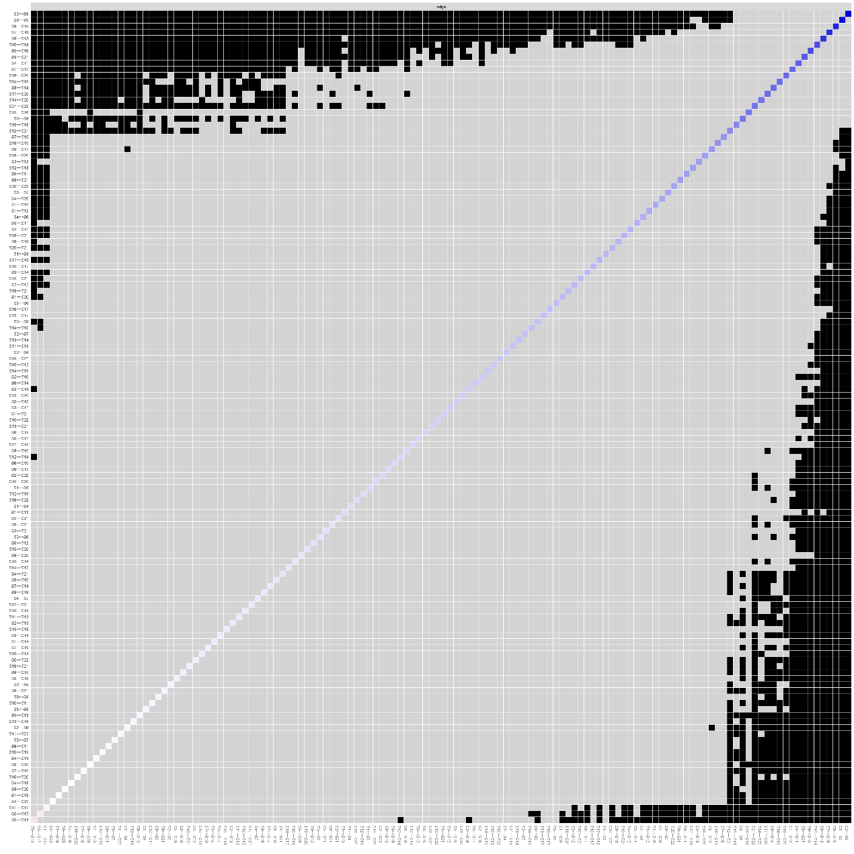
Fig. 8. Bootstrapped difference tests for the symptom network edge weights of symptoms in patients with glioma at T3

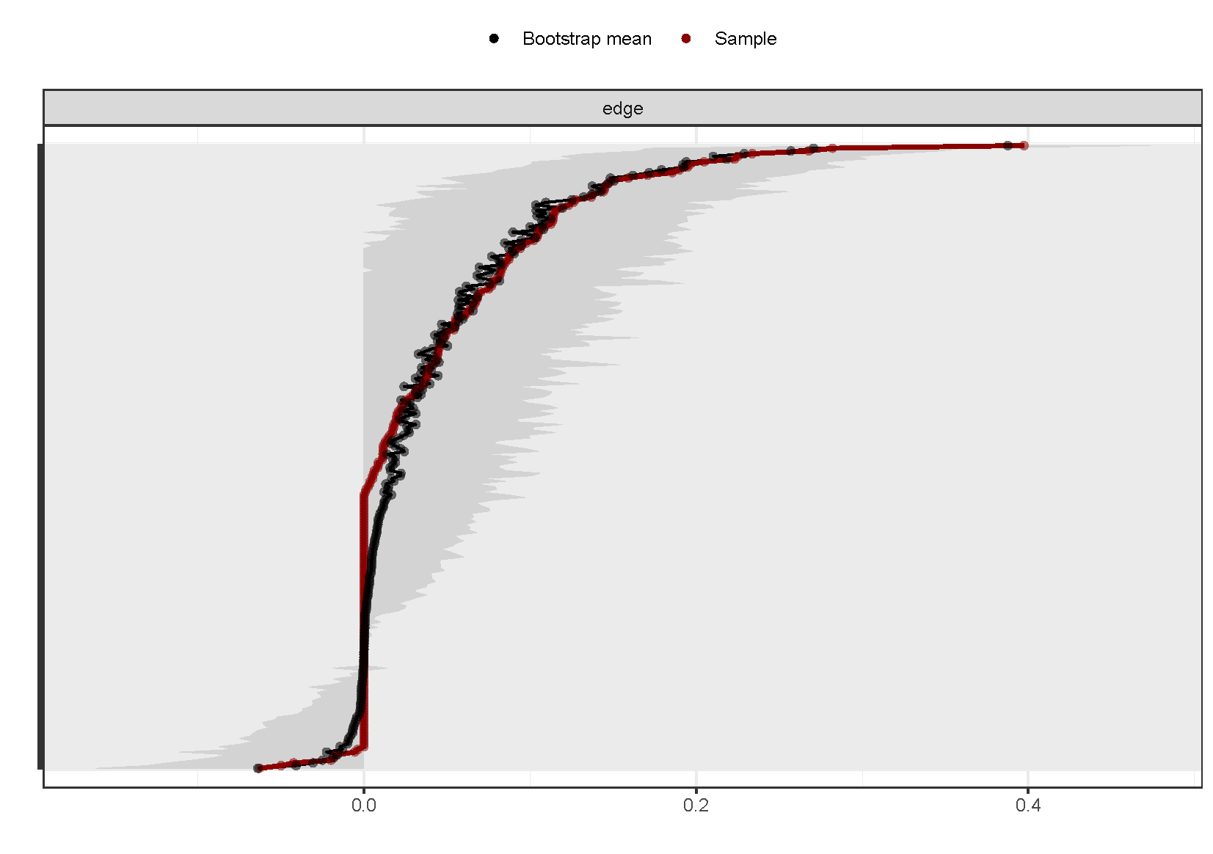
Fig. 9. Bootstrap analysis results of the edge weights at T1
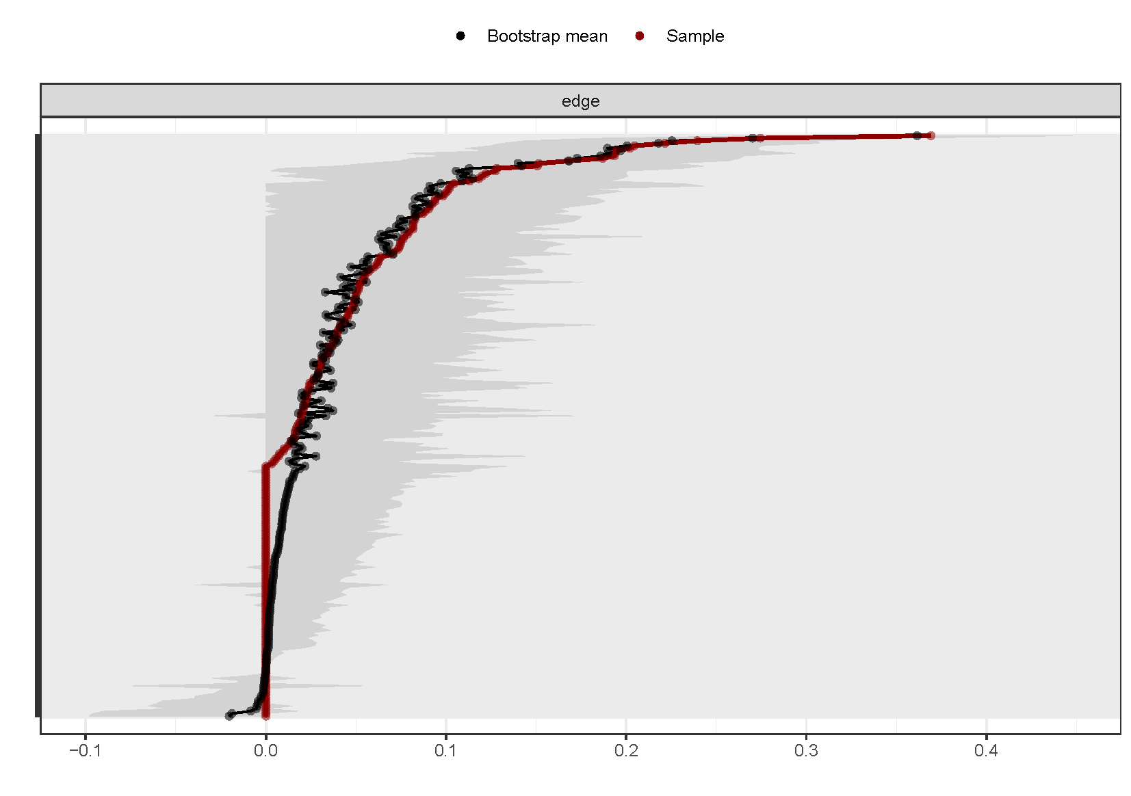
Fig. 10. Bootstrap analysis results of the edge weights at T2
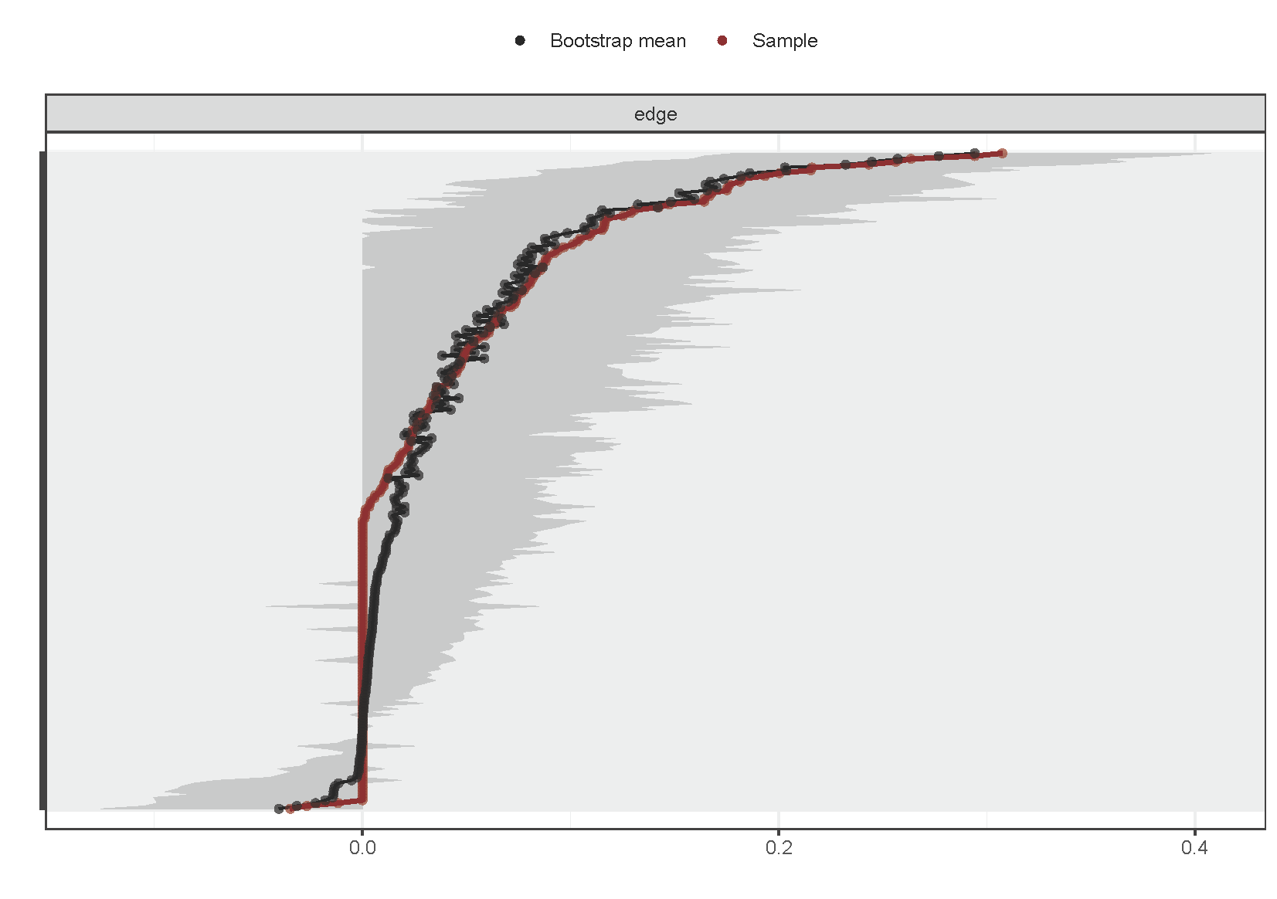
Fig. 11. Bootstrap analysis results of the edge weights at T3
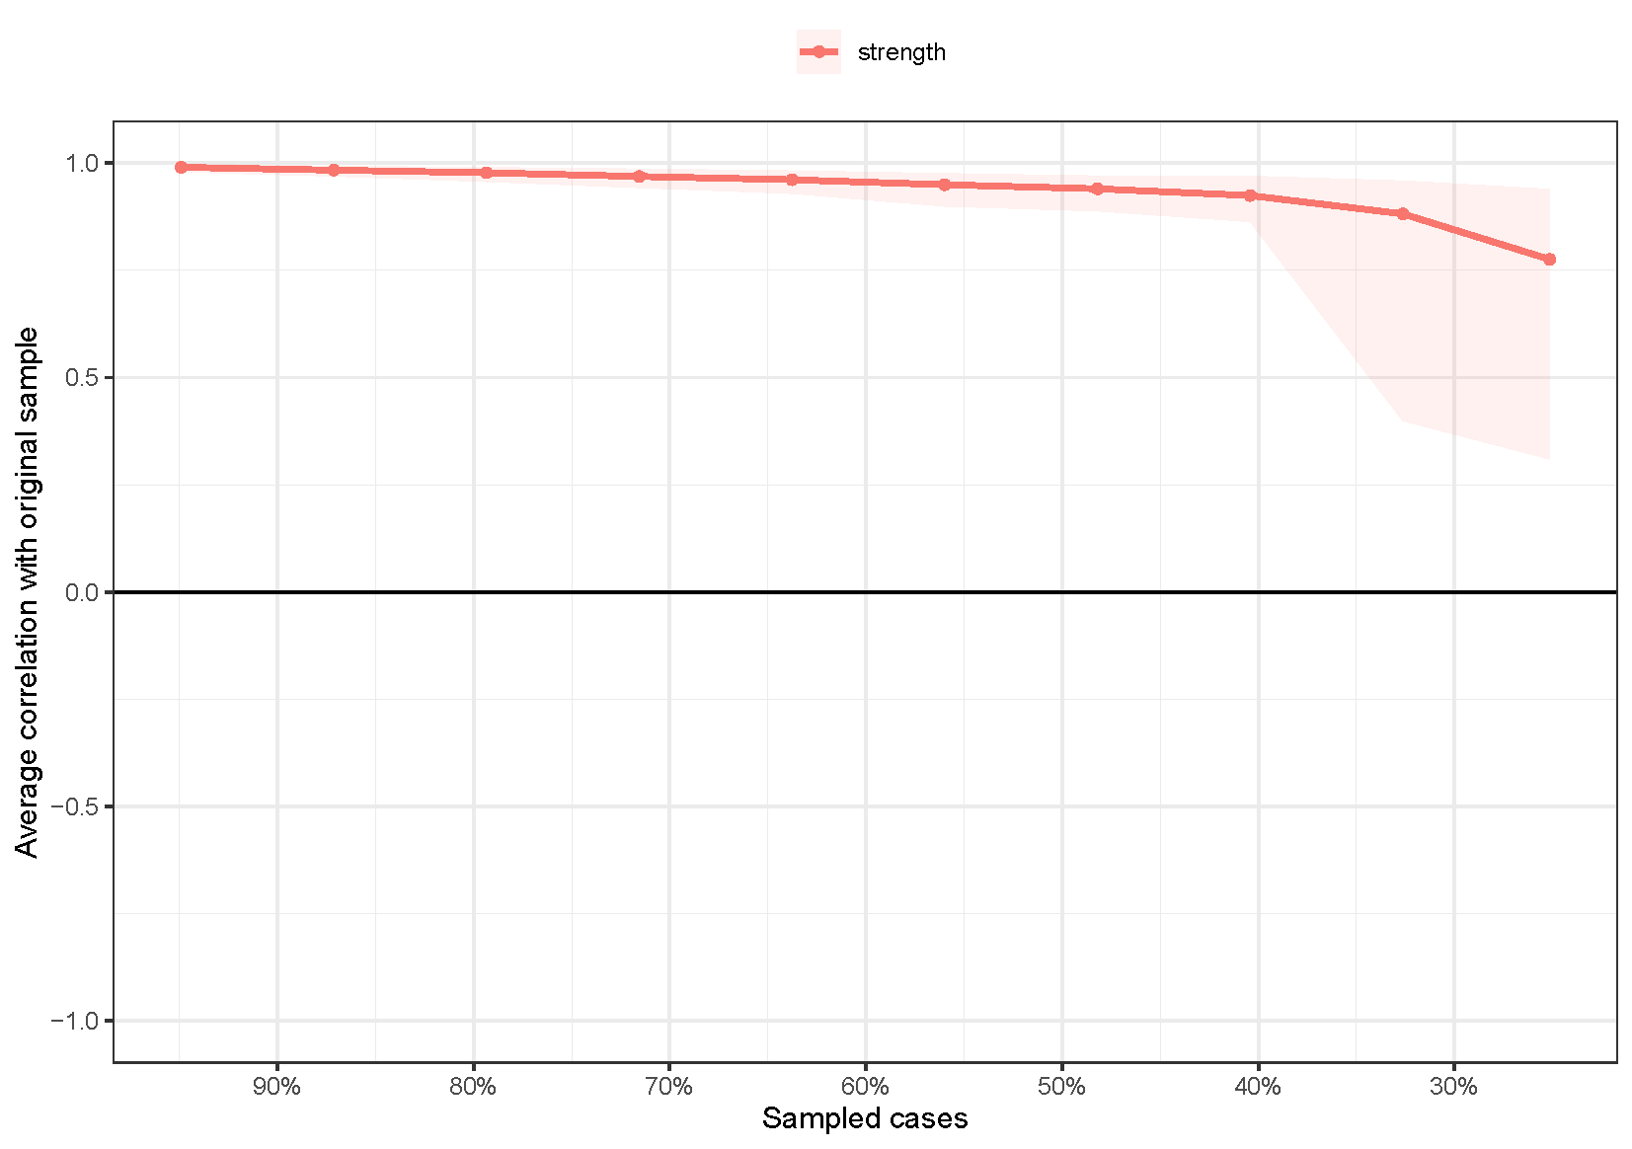
Fig. 12. Stability of centrality indices by case dropping subset bootstrap at T1
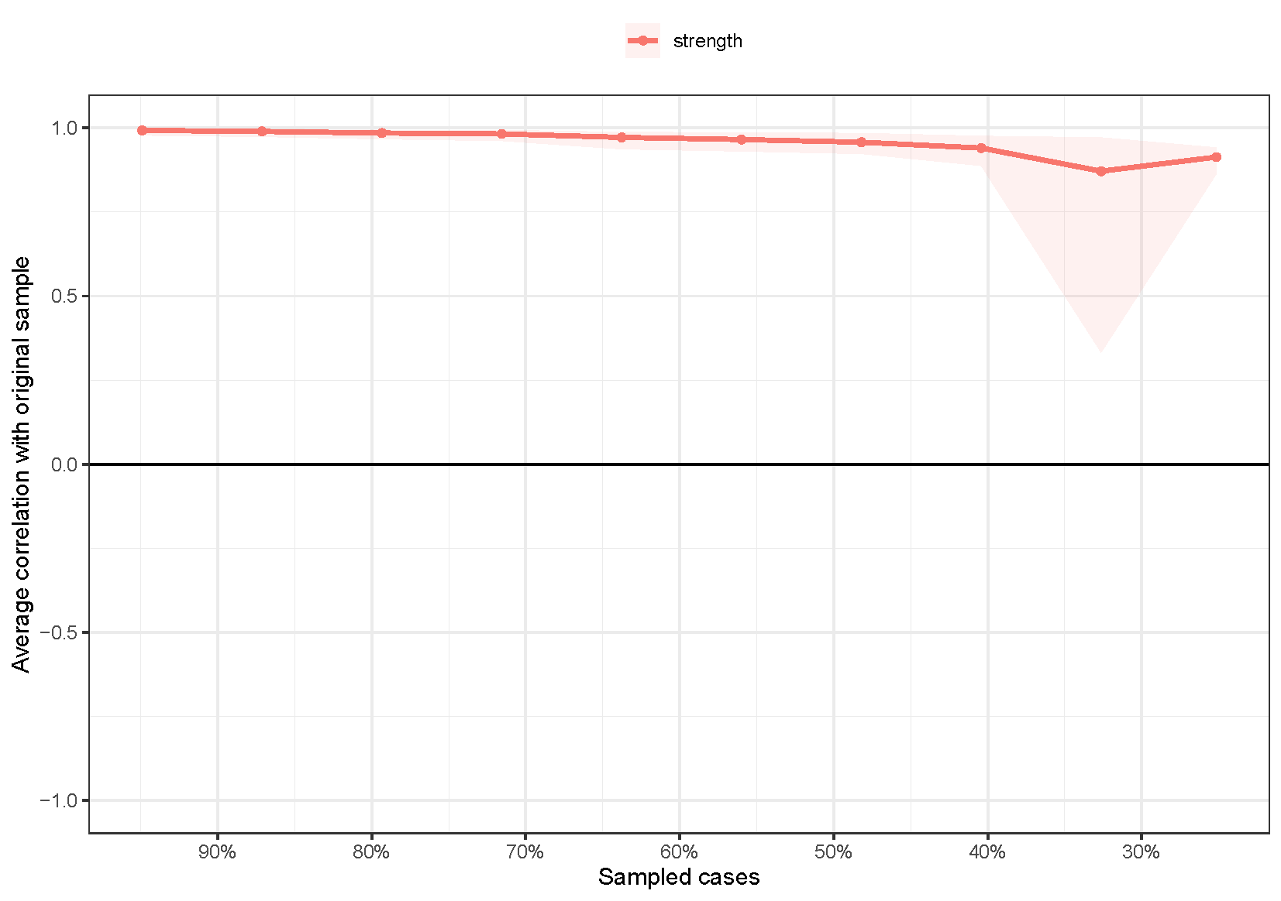
Fig. 13. Stability of centrality indices by case dropping subset bootstrap at T2
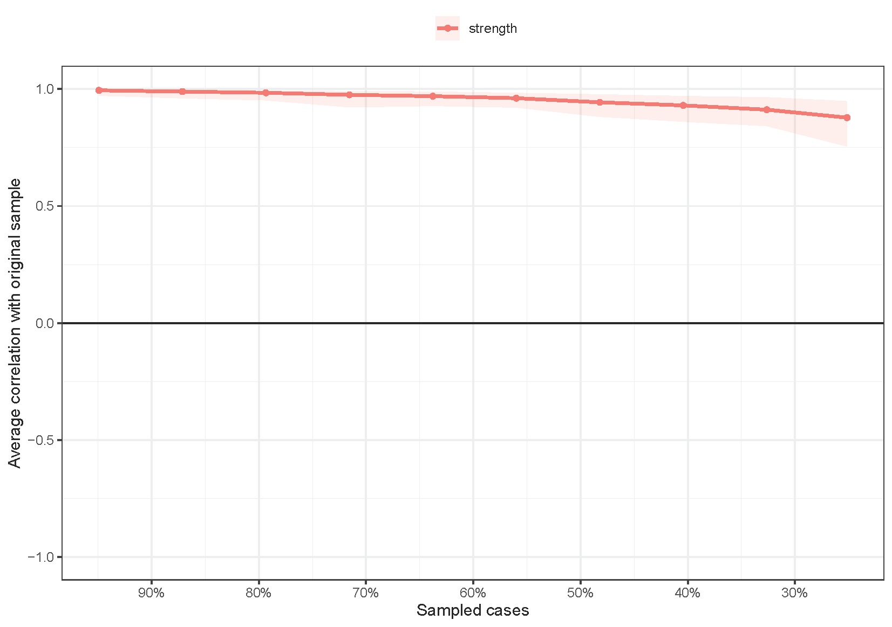
Fig. 14. Stability of centrality indices by case dropping subset bootstrap at T3

