 | The percent of cells in each phase
Groups | G1 | S | G2
shCtrl | 52.35 | 23.32 | 24.33
shCtrl | 52.1 | 23.97 | 23.93
shCtrl | 51.78 | 24.08 | 24.15
shFERMT1 | 59.27 | 15.61 | 25.12
shFERMT1 | 59.89 | 15.26 | 24.85
shFERMT1 | 62.79 | 12.07 | 25.14
Average | G1 | S | G2
shCtrl | 52.08 | 23.79 | 24.14
shFERMT1 | 60.65 | 14.31 | 25.04
STDEV. | ST.G1 | ST.S | ST.G2/M
shCtrl | 0.29 | 0.41 | 0.20
shFERMT1 | 1.88 | 1.95 | 0.16
T-Test analysis |  |  | P VALUE
 |  |  | G1 | S | G2
shCtrl | vs | shFERMT1 | 0.014030906 | 0.00118616 | 0.003763828

shCtrl

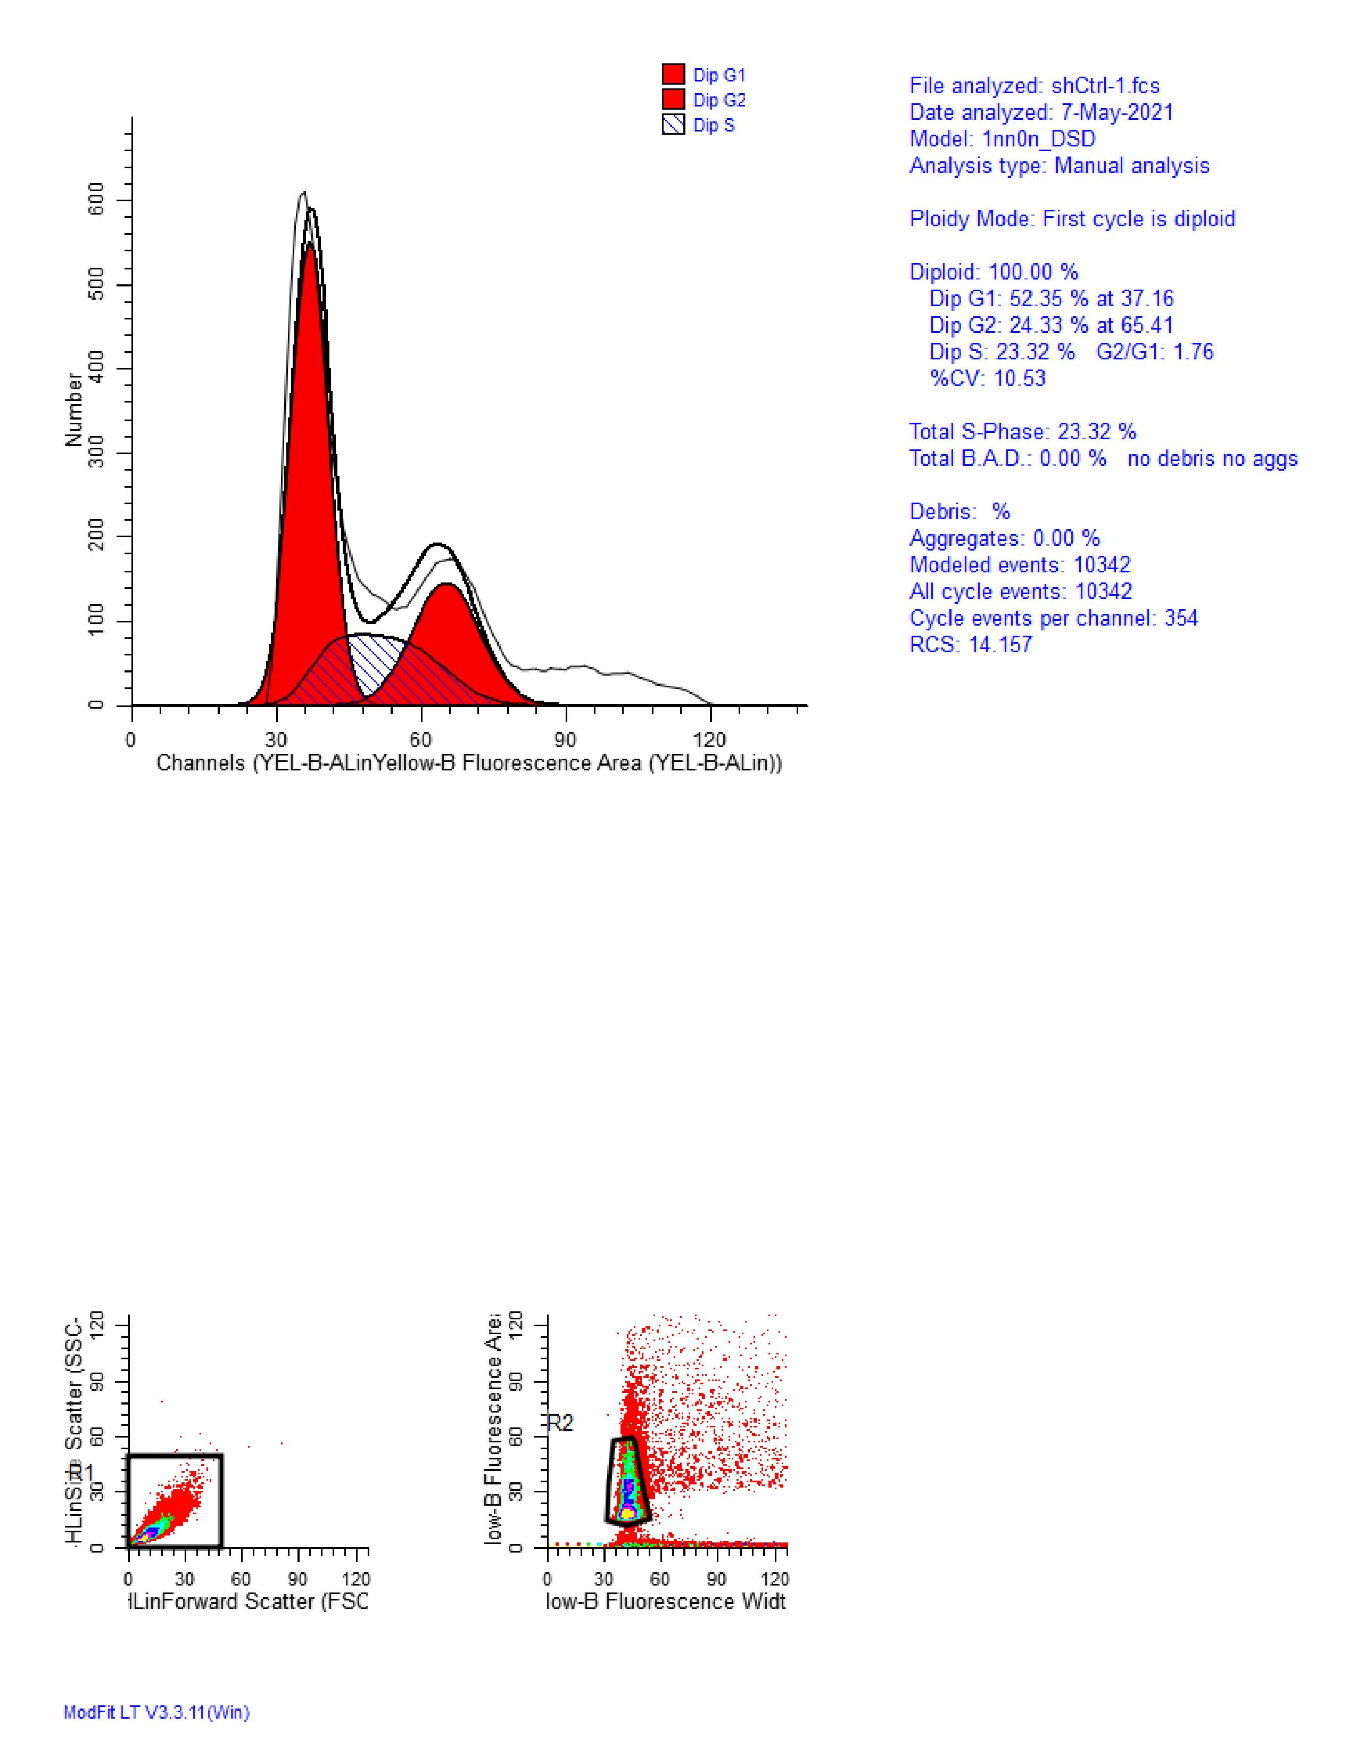
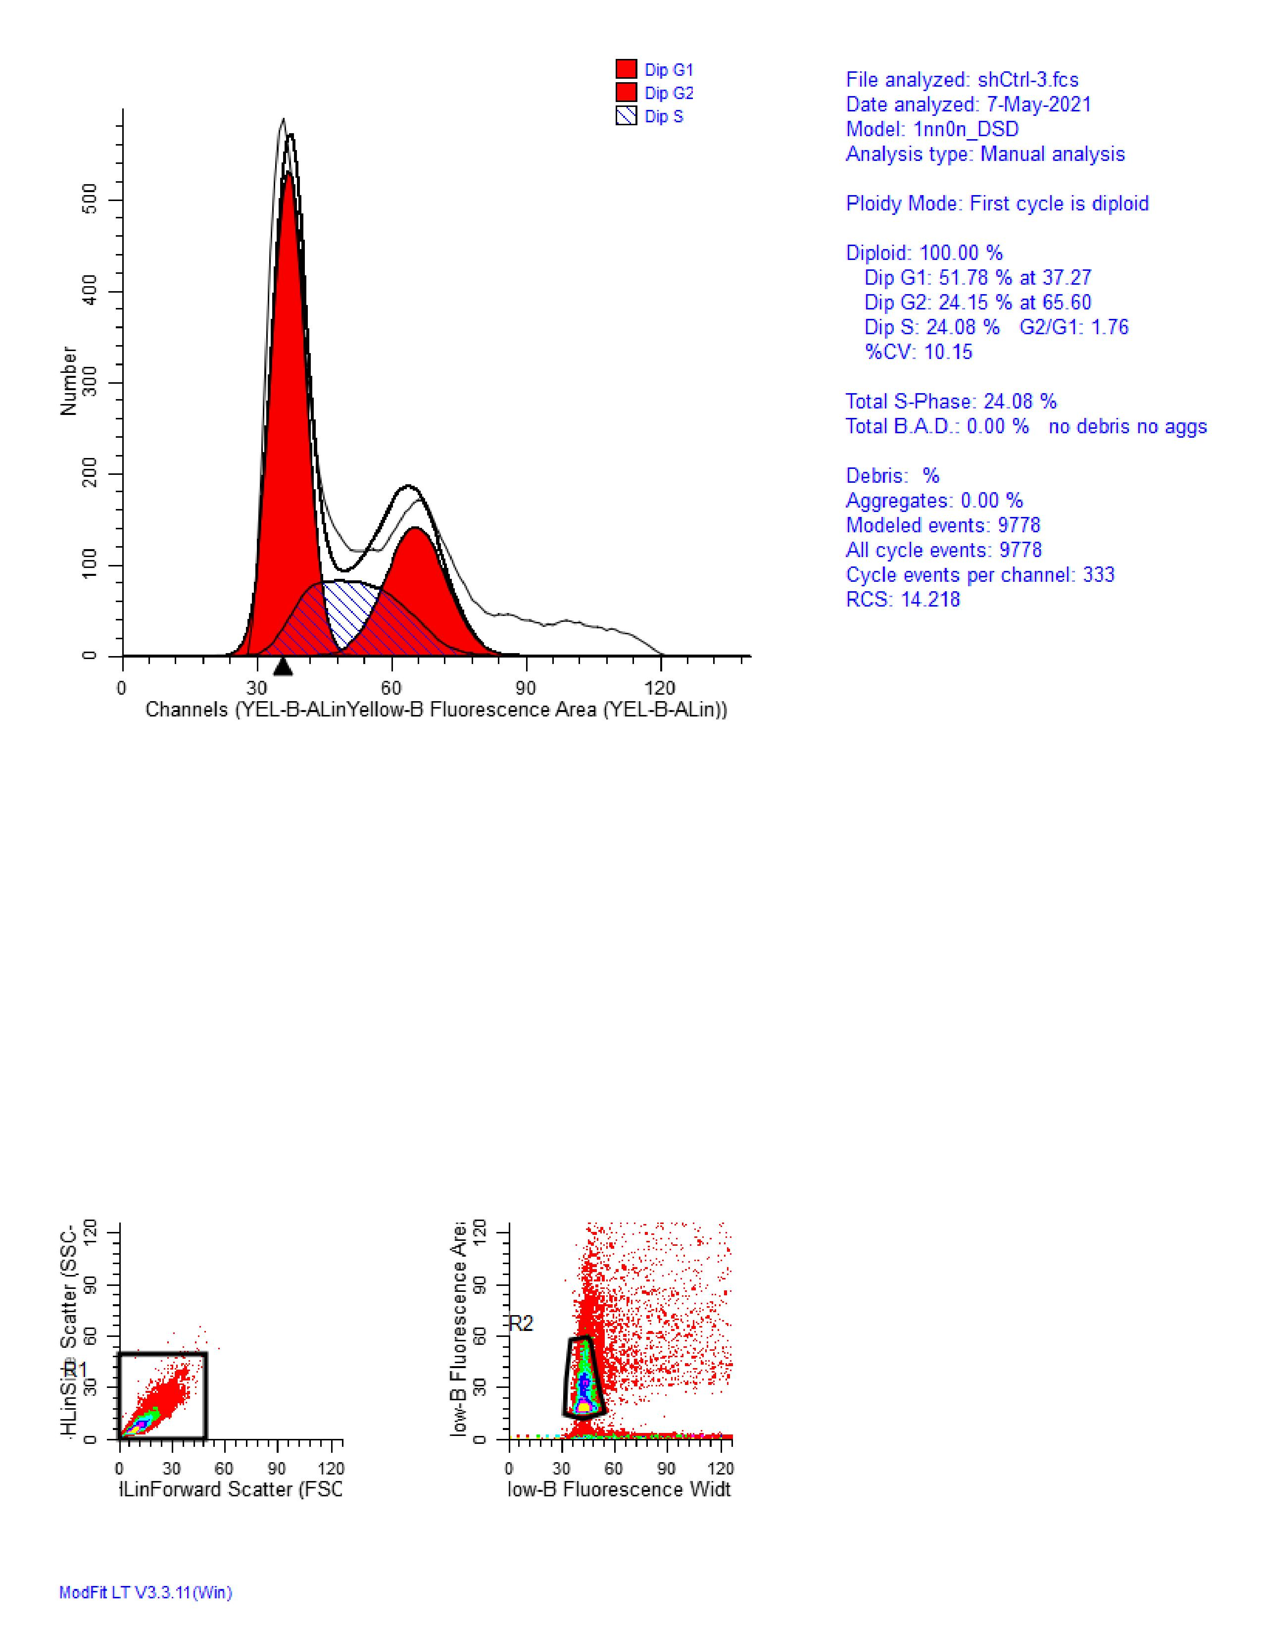
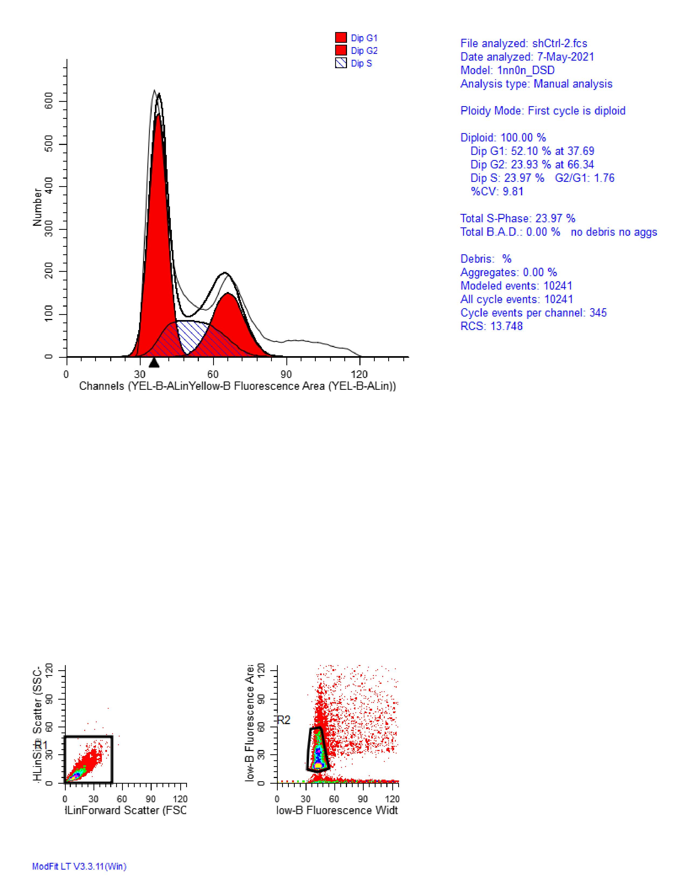

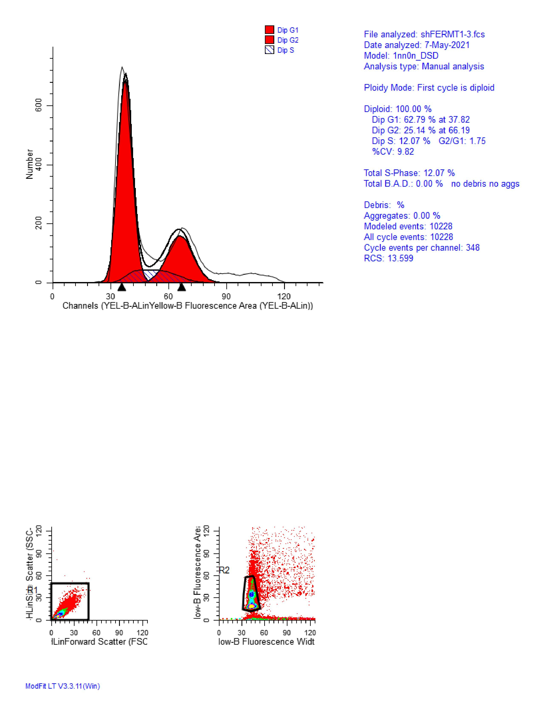
shFERMT1