Yunchengibacter salinarum gen. nov., sp. nov., a novel bacterium of the family Kordiimonadaceae isolated from sediment in Yuncheng Salt Lake

Hao-Ran Guo¹, Fan Wang ¹, Hui-Ying Yu ², Chuan-Xu Wang², Zhuo Wang ², Bao-Zhu Fang³, Xin Li^{1,} * & Wen-Jun Li^{2, 3, 4,} *

¹College of Food Science and Engineering, Shanxi Agricultural University, Taigu 030801, Shanxi, People's Republic of China
²Shanxi Key Laboratory of Yuncheng Salt Lake Ecological Protection and Resource Utilization, Yuncheng University, Yuncheng 044000, Shanxi, People's Republic of China
³State Key Laboratory of Desert and Oasis Ecology, Xinjiang Institute of Ecology and Geography, Chinese Academy of Sciences, Urumqi 830011, Xinjiang, People's Republic of China
⁴State Key Laboratory of Biocontrol, Guangdong Provincial Key Laboratory of Plant Resources and Southern Marine Science and Engineering Guangdong Laboratory (Zhuhai), School of Life Sciences, Sun Yat-Sen University, Guangzhou, 510275, People's Republic of China

*Authors for correspondence:
Li Xin
E-mail: lixin-eva@163.com
Wen-Jun Li
E-mail: liwenjun3@mail.sysu.edu.cn
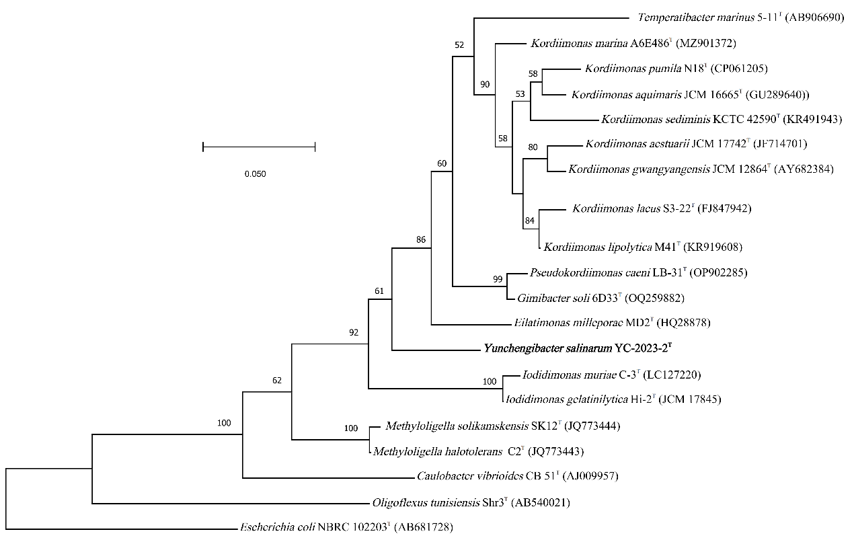
Fig. S1 Maximum-likelihood phylogenomic tree based on 16S rRNA gene sequences of strain YC-2023-2^{T} was constructed with closely related type species in the family Kordiimonadaceae. Escherichia coli NBRC 102203^{T} (AB681728) is selected to be the outgroup. Bar, 0.05 substitutions per nucleotide position. Bootstrap values of above 50 % are shown at the branch points.

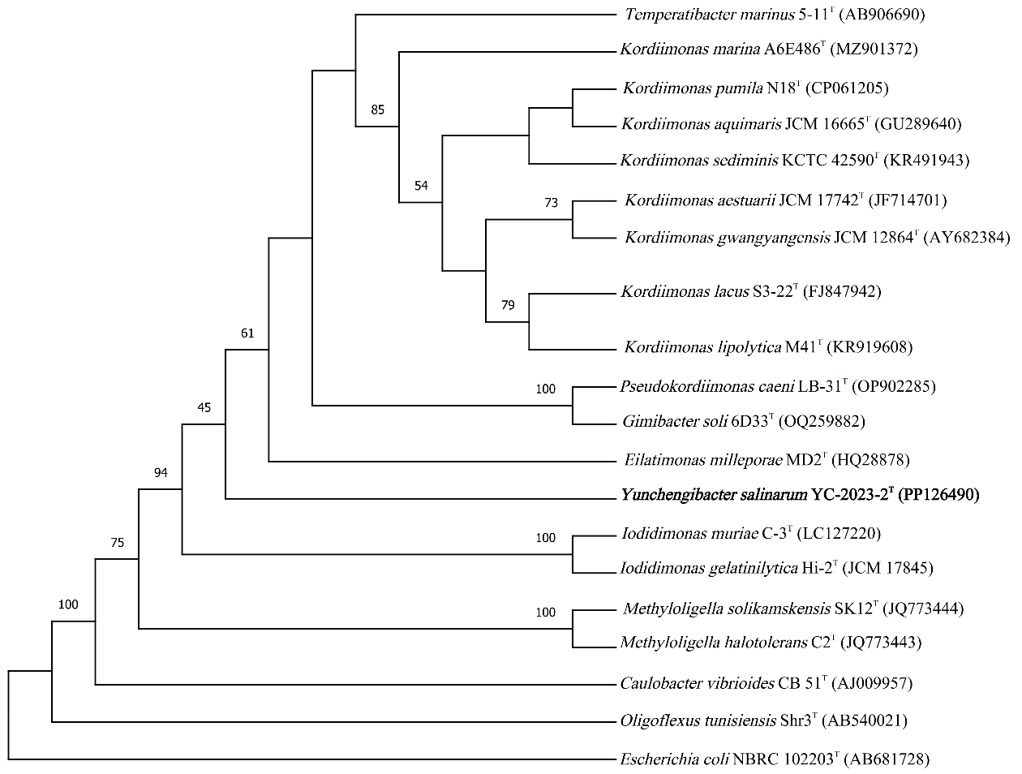Fig. S2 The maximum-parsimony (MP) tree based on 16S rRNA gene sequences analysis of strain YC-2023-2^{T} with related type species in the family Kordiimonadaceae. Escherichia coli NBRC 102203^{T} (AB681728) is selected to be the outgroup. Bootstrap values of above 50 % are shown at the branch points.

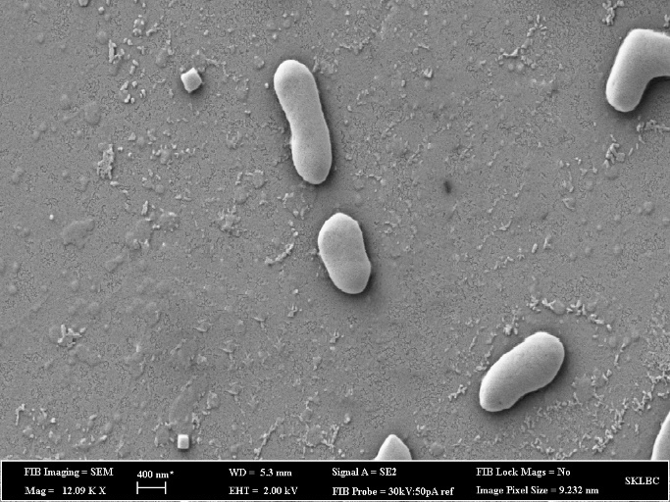
Fig. S3 Scanning electron microscope of strain YC-2023-2^{T} grown on MA at 37℃ for 2 weeks. Bar, 400 nm.
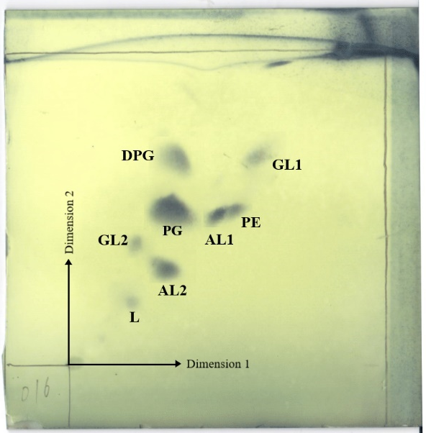
Fig. S4 Polar lipids result of strain YC-2023-2^{T} using thin layer chromatography stained with 10% ethanolic molybdophosphoric acid.
Abbreviations: DPG, diphosphatidylglycerol, PE, phosphatidylethanolamine; AL, unidentified aminolipid; PG, phosphatidylglycerol; GL, unidentified glycolipid; L, unidentified lipid.

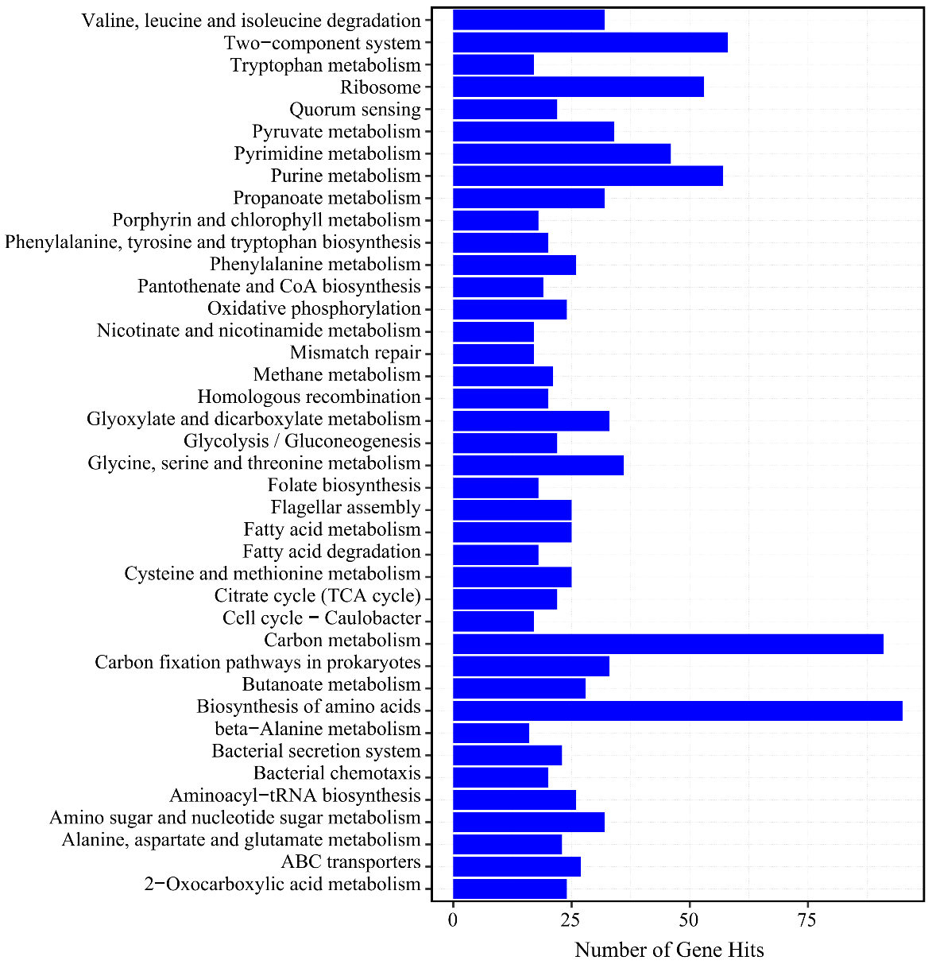
Fig. S5 The metabolic potential of strain YC-2023-2^{T}.

Table S1. The API 20NE results of strain YC-2023-2^{T} and its closely related type strains.
Strains: 1, Strain YC-2023-2^{T}; 2, Gimibacter soli 6D33^{T} (Liu et al. 2023); 3, Kordiimonas lipolytica M41^{T} (Wu et al. 2016); 4, Eilatimonas milleporae DSM 25217^{T} (Paramasivam et al. 2013); 5, Kordiimonas gwangyangensis JCM 12864^{T} (Kwon et al. 2005) 6. Temperatibacter marinus 5-11^{T} (Teramoto and Nishijima 2014). 7. Pseudokordiimonas caeni LB-31^{T} (Li et al. 2023). Symbols: -, negative; +, positive; w, weakly positive.
API 20NE | 1 | 2 | 3 | 4 | 5
Enzyme
Nitrate reduction | + | - | + | + | -
Indole | - | - | - | - | -
Glucose fermentation | - | - | - | + | +
Arginine dihydrolase | - | - | - | + | -
Urease | - | - | - | - | -
Aesculin hydrolysis | + | + | - | + | -
Gelatin hydrolysis | + | + | + | + | -
P-nitro-β-_{D}-methylgalactose | + | + | + | + | -
carbon utilize
Glucose | - | w | - | + | +
Arabinose | - | - | - | - | -
Mannose | - | - | - | - | -
Mannitol | - | - | - | - | -
N-acetyl-_{D}-glucosamine | - | + | - | + | +
Malic acid | + | + | + | - | -
gluconate | - | - | - | - | -
capric acid | - | - | - | - | -
Adipate | - | + | - | - | -
Maltose | + | + | + | - | +
Citric acid | - | - | - | - | -
Phenylacetic acid | - | - | - | - | -

Table S2. The result of API ZYM of the strain YC-2023-2^{T} and related strains.
Strains:1, Strain YC-2023-2^{T}; 2, Gimibacter soli 6D33^{T} (Liu et al. 2023); 3, Kordiimonas lipolytica M41^{T} (Wu et al. 2016); 4, Eilatimonas milleporae DSM 25217^{T} (Paramasivam et al. 2013); 5, Kordiimonas gwangyangensis JCM 12864^{T} (Kwon et al. 2005) 6. Temperatibacter marinus 5-11^{T} (Teramoto and Nishijima 2014). 7. Pseudokordiimonas caeni LB-31^{T} (Li et al. 2023). Symbols: -, negative; +, positive; w, weakly positive; ND, no data available.
ZYM | 1 | 2 | 3 | 4 | 5
Alkaline phosphatase | ＋ | ＋ | ＋ | ＋ | +
Esterase (C₄) | + | ＋ | ＋ | ＋ | +
Lipid esterase (C₈) | + | ＋ | ＋ | ＋ | +
Esterase (C₁₄) | - | + | - | + | -
Leucine Aramide | ＋ | ＋ | - | ＋ | +
Valine arylamidase | ＋ | ＋ | ＋ | ＋ | +
Cystine arylamidase | + | ＋ | ＋ | ＋ | +
Trypsin | - | ＋ | ＋ | + | +
Chymotrypsin | - | ＋ | ＋ | ＋ | +
Acid phosphatase |  | ＋ | ＋ | ＋ | -
Naphthol AS-BI-Phosphohydrolase | ＋ | ＋ | ＋ | ＋ | -
α-galactosidase | - | - | - | - | -
β-galactosidase | - | - | - | - | -
β-glucuronidase | - | - | - | - | -
α-glucosidase | - | - | - | - | -
β-glucosidase | - | - | - | - | -
N-acetyl-glucosaminidase | w | ＋ | - | - | -
α-mannosidase | - | - | - | - | -
β-fucosidase | - | - | - | - | -

Table S3. The KEGG analysis result of strain YC-2023-2^{T}.

Gene function | number
Amino acid metabolism | 192
Carbohydrate metabolism | 154
Endocrine system | 16
Lipid metabolism | 55
Energy metabolism | 99
Metabolism of other amino acids | 48
Transport and catabolism | 9
Cancers | 16
Metabolism of cofactors and vitamins | 128
Biosynthesis of other secondary metabolites | 37
Metabolism of terpenoids and polyketides | 31
Xenobiotics biodegradation and metabolism | 39
Glycan biosynthesis and metabolism | 18
Nucleotide metabolism | 82
Signal transduction | 69
Neurodegenerative diseases | 8
Infectious diseases | 17
Drug resistance | 28
Circulatory system | 3
Endocrine and metabolic diseases | 9
Folding, sorting and degradation | 42
Cell motility | 38
Translation | 80
Cellular community - prokaryotes | 46
Cardiovascular diseases | 10
Environmental adaptation | 10
Replication and repair | 40
Digestive system | 1
Cell growth and death | 24
Aging | 6
Immune diseases | 1
Nervous system | 2
Substance dependence | 1
Membrane transport | 54
Immune system | 7
Transcription | 4

Table S4. The ANI and AAI values among strain YC-2023-2^{T} and closely related type strains.
1, Strain YC-2023-2^{T}; 2, Gimibacter soli 6D33^{T} (Liu et al. 2023); 3, Kordiimonas lipolytica M41^{T} (Wu et al. 2016); 4, Eilatimonas milleporae DSM 25217^{T} (Paramasivam et al. 2013); 5, Kordiimonas gwangyangensis JCM 12864^{T} (Kwon et al. 2005) 6. Temperatibacter marinus 5-11^{T} (Teramoto and Nishijima 2014). 7. Pseudokordiimonas caeni LB-31^{T} (Li et al. 2023).
Type strains | 1 | 2 | 3 | 4 | 5 | 6 | 7
1 | 100 | 58.11 | 59.12 | 59.15 | 58.87 | 53.81 | 58.27
2 | 74.47 | 100 | 61.91 | 58.98 | 62.05 | 55.20 | 88.06
3 | 74.85 | 75.98 | 100 | 59.38 | 69.62 | 56.31 | 61.91
4 | 75.35 | 75.14 | 74.73 | 100 | 59.06 | 53.86 | 59.01
5 | 74.70 | 76.11 | 77.34 | 74.72 | 100 | 55.94 | 62.15
6 | 73.94 | 74.08 | 74.13 | 74.00 | 74.15 | 100 | 55.37
7 | 74.50 | 88.63 | 76.08 | 75.70 | 76.01 | 83.21 | 100
Average Nucleotide Identity (ANI) values (%) are below the diagonal;
Average amino acid identity Identity values (%) are above the diagonal.

Table S5. Fatty acid profiles of strain YC-2023-2^{T} and closely related strains in the family Kordiimonadaceae.

Characteristic | 1 | 2 | 3 | 4 | 5 | 6 | 7
C_{12:0} | 2.4 | - | - | - | - | 0.3 | -
C_{12:0} 3OH | 2.1 | - | - | - | - | - | -
C_{14:0} | - | tr | 0.5 | tr | 0.7 | tr | 0.8
anteiso-C_{14:0} | tr | - | - | - | - | - | -
C_{14:0} 2OH | - | tr | - | - | 0.6 | - | -
C_{15:0} | - | - | 6.9 | - | - | - | 3.6
C_{15:0} 2OH | - | 0.5 | - | tr | 1.0 | - | -
anteiso-C_{15:0} | - | - | tr | - | - | - | -
C_{16:0} | 12.2 | 6.7 | 4.6 | 1.3 | 4.8 | 6.2 | 6.5
C_{17:0} | 1.8 | 3.6 | 1.0 | 4.1 | 2.0 | 2.5 | 1.6
anteiso-C_{17:0} | 0.6 | - | tr | - | - | - | -
C_{18:0} | 2.5 | tr | - | tr | 0.7 | 2.3 | 0.5
C_{20:0} | - | - | 3.9 | - | - | - | -
C_{15:1} ω6c | - | 0.6 | tr | tr | - | 0.5 | -
C_{15:1} ω8c | - | 1.4 | 0.8 | - | - | 1.1 | 1.8
C_{16:1} ω9c | - | - | tr | - | - | 0.6 | 0.9
C_{17:1} ω6c | 1.7 | 6.6 | 4.5 | 18.5 | 3.3 | 3.8 | 2.0
C_{17:1} ω8c | - | 8.5 | 4.6 | 2.3 | 1.7 | 8.4 | 6.0
C_{18:1} ω5c | - | - | tr | - | - | - | -
C_{18:1} ω7c 11-methyl | 6.7 | - | - | - | - | - | -
C_{18:1} ω7c | - | - | 2.2 | - | - | - | -
C_{18:1} ω9c | - | - | tr | - | - | 0.5 | 0.6
C_{18:3} ω6c (6, 9, 12) | - | - | - | tr | 0.7 | - | -
C_{19:0} ω8c cyclo | 17.2 | - | - | - | - | - | -
iso-C_{13:0} | - | - | tr | - | - | - | -
iso-C_{15:0} | 10.2 | 10.0 | 17.6 | 2.1 | 9.7 | 9.2 | 15.8
iso-C_{15:0} 3OH | - | - | - | tr | 0.8 | - | -
iso-C_{15:1} F | - | 1.1 | 1.1 | tr | 1.1 | 1.2 | 4.1
iso-C_{15:1} h | - | tr | - | 1.5 | - | - | -
iso-C_{16:0} | 1.0 | tr | 1.3 | 0.8 | 1.0 | 0.2 | 1.3
iso-C_{16:1} h | - | - | - | - | - | 0.8 | 0.7
iso-C_{17:0} | 8.6 | 5.8 | 4.5 | 13.3 | 6.5 | 10.2 | 5.1
iso-C_{17:0} 3OH | 1.2 | tr | tr | 0.6 | 1.0 | - | -
iso-C_{17:1} ω9c | - | - | 23.9 | - | - | 36.6 | 28.0
iso-C_{18:1} | 0.6 | - | tr | - | - | 0.6 | -
Summed feature 3* | 3.2 | 20.1 | 15.3 | 11.6 | 41.8 | 9.3 | 13.7
Summed feature 4* | - | tr | 1.2 | 3.0 | 1.3 | 0.7 | -
Summed feature 7* | - | - | - | 1.9 | - | - | -
Summed feature 8* | 11.4 | 5.6 | - | 1.8 | 3.2 | 3.4 | -
Summed feature 9* | 12.6 | 26.3 | - | 34.1 | 17.1 | - | -
1, Strain YC-2023-2^{T}; 2, Gimibacter soli 6D33^{T} (Liu et al. 2023); 3, Kordiimonas lipolytica M41^{T} (Wu et al. 2016); 4, Eilatimonas milleporae DSM 25217^{T} (Paramasivam et al. 2013a); 5, Kordiimonas gwangyangensis JCM 12864^{T} (Kwon et al. 2005) 6. Temperatibacter marinus 5-11^{T} (Teramoto and Nishijima 2014). 7. Pseudokordiimonas caeni LB-31^{T} (Li et al. 2023). Symbols: Fatty acids present at>10% are indicated in bold. -, not detected. tr, lower than 0.5%.
*Summed features are fatty acids that cannot be resolved reliably from another fatty acid using the chromatographic conditions chosen. The midi system groups these fatty acids together as one feature with a single percentage of the total. Summed feature 3, C_{16:1} ω6c and/or C_{16:1} ω7c; summed feature 4, iso-C_{17:1} I and/or anteiso-C_{17:1} B; summed feature 7, C_{19:1} ω6c and/or C_{19:1} ω7c; summed feature 8, C_{18:1} ω6c and/or C_{18:1} ω7c; summed feature 9, C_{16:0} 10-methyl and/or iso-C_{17:1} ω9c.

