Supplementary Information

^{99m}Tc-Labelled Photoacoustic Imaging Probe for Detection of Bacterial Infection

Rowan Swann¹, Daniel Hernández-Valdés¹, Luis Rafael Silva¹, Yusra Mahmood Marfatia¹, Mohamed E. El-Zaria¹, Afaf R. Genady¹, Jacek M. Kwiecien², John F. Valliant¹, & Saman Sadeghi^{1,*}

¹ Department of Chemistry and Chemical Biology, McMaster University, ON L8S 4L8, Canada
² Department of Pathology and Molecular Medicine, McMaster University, Hamilton, ON L8S 4L8, Canada

Corresponding Author
* Saman Sadeghi: Phone: (905) 525-9140 ext. 22537; Email: sadegs10@mcmaster.ca

Table of Contents
SI-1: Supplementary Methods | ii
Equation SI-1: Activity Yield Calculation  Equation SI-2: Bacterial Percent Binding Calculation | ii  ii
SI-2: Supplementary Data | iii
Figure SI-1. Radiosynthesis of 4.  Table SI-1. Summary of reaction conditions tested in the synthesis of 6.  Figure SI-2. Characterization of [^{99m}Tc]-TcPSVue794 (6) radiolabeling.  Figure SI-3. Stability analysis of 6.  Table SI-2. Stability analysis of 6, quantified from radio-TLC.  Table SI-3. Biodistribution Data for 7. | iii  iv  v  vi  vi  vii
SI-3: Supplementary References | vii

SI-1: Supplementary Methods
Equation SI-1: Activity Yield Calculation (non-decay corrected):
$$Activity Yield=\left(\frac{A_{f}}{A_{0}}\right)×100$$

Where A₀ is the initial amount of radioactivity (at t=0) added to the reaction and A_{f} is the final activity remaining after purification of the product.

Equation SI-2: Bacterial Percent Binding Calculation:

$$\% Binding=[\frac{\left(A_{pellet}\right)}{\left(A_{100\% signal}\right)}]×100$$

Where A_{pellet} is the counts per minute (CPM) measured in the washed pellet and A_{100% signal} is the CPM measured in the sample that represents 100 % of the signal possible from the amount of 7 that was added to the bacteria and no-cell controls.

SI-2: Supplementary Data
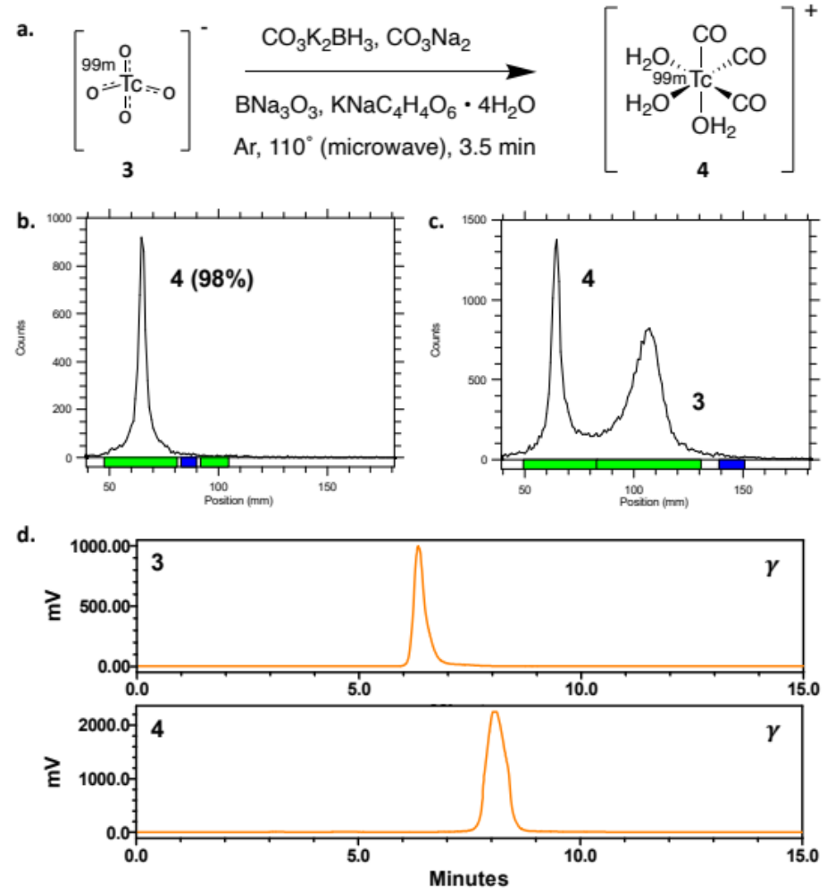
Figure SI-1. a. Radiosynthesis of [^{99m}Tc][Tc(CO)₃(H₂O)₃]⁺ (4) from [^{99m}Tc][TcO₄]⁻ (3), as reported by Causey, et al. (2008).¹ b. Radio-TLC analysis of 4 on aluminum oxide plate, eluted with 1% HCl in MeOH. c. Radio-TLC analysis of 4 with a co-spot of 3 on aluminum oxide plate, eluted with 1% HCl in MeOH. d. HPLC gamma traces of 3 and 4 using HPLC method A.

Table SI-1. Summary of reaction conditions tested in the synthesis of 6.
Reaction Number | Zn(NO₃)₂ Added* | Temperature (˚C) | Time  (min) | Radio-TLC Conversion | Degradation**
1 | After | 90 | 20 | 96 % | Yes
2 | After | 110 | 3.5 | >99 % | Yes
3 | After | 37 | 60 | 96 % | Yes
4 | After | r.t. | 60 | 90 % | No
5 | Before | r.t. | 90 | 70 % | No
* Zinc Nitrate was either added before or after the coordination of [^{99m}Tc][Tc(CO)₃(H₂O)₃]⁺.
** Degradation observed by gamma and UV HPLC.

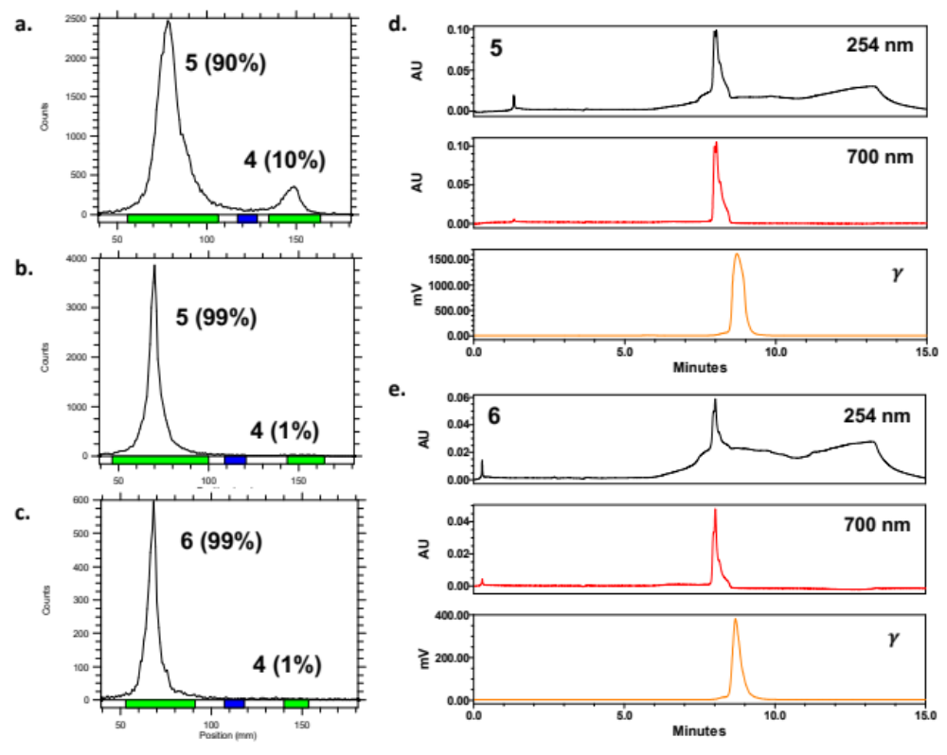
Figure SI-2. Characterization of [^{99m}Tc]-TcPSVue794 (6) radiolabeling, resulting in 90% crude radiochemical conversion, 99% RCP, and 57 MBq activity yield starting from 108 MBq at end of synthesis. Radio-TLC and gamma HPLC analysis of 5 (crude) (a), 5 isolated by C18 SepPak extraction (b,d), and 6 after 30-minute incubation with Zn(NO₃)₂ (37˚C) (c,e). Radio-TLC plates eluted with 1% HCl in MeOH.

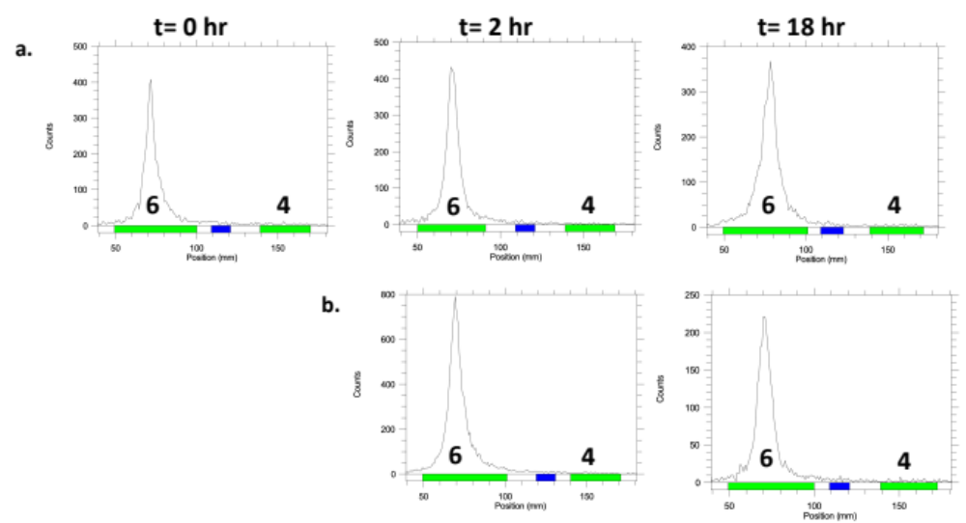Figure SI-3. Stability analysis of 6 in formulation buffer (r.t.) (a) and mouse serum (37 ˚C) (b) at 0, 2, and 18 hours, assessed by radio-TLC using 1% HCl in methanol as an eluent.

Table SI-2. Stability analysis of 6, quantified from radio-TLC.
[^{99m}Tc]TcPSVue794  (6) | Duration of Incubation
[^{99m}Tc]TcPSVue794  (6) | 0 h | 2 h | 18 h
Formulation Buffer | 98.7 % | 98.7 % | 97.7 %
Mouse Serum | - | 98.7 % | 97.1 %

Table SI-3. Biodistribution Data for 6 in (a) mice with bacterial infection and (b) healthy mice.

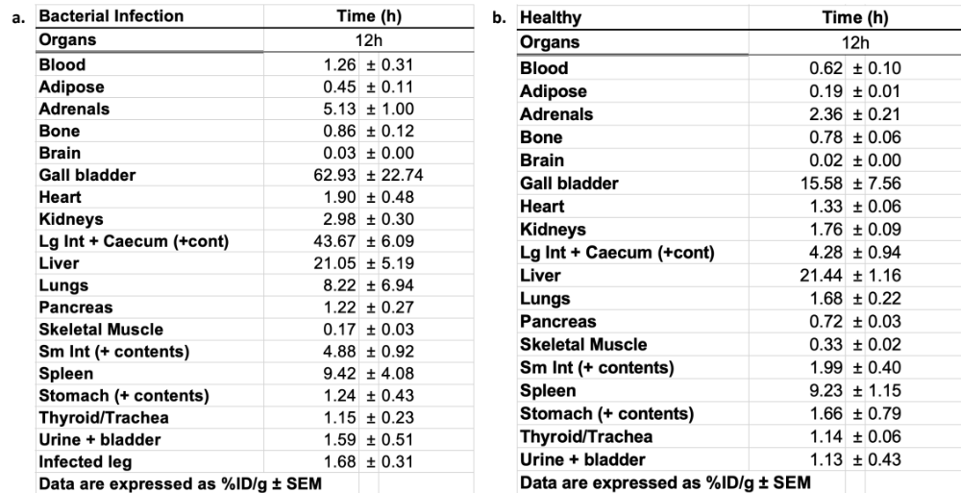

SI-3: Supplementary References
1. Causey, P. W., Besanger, T. R., Schaffer, P. & Valliant, J. F. Expedient Multi-Step Synthesis of Organometallic Complexes of Tc and Re in High Effective Specific Activity. A New Platform for the Production of Molecular Imaging and Therapy Agents. Inorg. Chem. 47, 8213–8221 (2008).

