Supplementary Material

Supplementary Methods
Surgical procedures
Surgical techniques were similar at the two sites (Site 1 and 2), with use of a stereotaxic head frame. High-resolution MRI was used for STN targeting, followed by intraoperative confirmation using microelectrode recording and macrostimulation testing. Postoperative stimulation paradigms were adjusted by the patients’ neurologist to achieve maximal improvement in contralateral motor symptoms in the absence of side effects.

Imaging procedures
Site 1A (Manhasset, USA): 14 PD patients from Site 1A cohort underwent PET imaging in the off- and on-stimulation (OFF and ON, respectively) conditions on two consecutive days in random order with [¹⁸F]-fluorodeoxyglucose (FDG PET for mapping regional cerebral glucose metabolism). On one of the days, stimulators were switched off approximately 3 hours before FDG PET and switched back on afterward. On the other day, FDG PET imaging was carried out in the on-stimulation condition. All patients fasted overnight (>6 hours); antiparkinsonian medications were withheld for at least 12 hours before imaging. For each patient, motor ratings were evaluated according to the United Parkinson Disease Rating Scale (UPDRS III); ratings were separately recorded for each PET imaging session and stimulation condition. A schematic of the study design is presented in Figure 1B.
FDG and [¹⁵O]-water (H₂¹⁵O PET for mapping regional cerebral blood flow, described below) were performed as described elsewhere using the GE Advance tomograph (General Electric Medical Systems, Milwaukee, WI, USA) at The Feinstein Institutes for Medical Research (Manhasset, NY, USA) [71, 72]. The studies were performed in the resting state with eyes open in a dimly lit room. UPDRS III ratings were recorded in the off-medication state (after at least 12 hours of washout) by a movement disorders specialist prior to each scan session in each stimulation condition. A separate group of Site 1A patients (n=12) were scanned with FDG PET, an average of 8.7 months before STN-DBS surgery with UPDRS III ratings performed in the medication-off/stimulation-on condition an average 17.3 months after surgery. Ethical permission for the PET studies was obtained from the Institutional Review Board of Northwell Health. Written consent was obtained from each patient after detailed explanation of the procedures.
Site 1B (Manhasset, USA): For validation of the network across imaging modalities a separate cohort of 15 PD patients at Site 1 underwent rs-fMRI on the 3T Magnetom Prisma scanner (Siemens, Munich, Germany) at North Shore University Hospital (Manhasset, NY, USA) as part of routine imaging before DBS surgery approximately 12 days prior to their STN-DBS surgery. The resulting scans were compared to those from 10 age- and sex- matched healthy volunteer subjects studied on the same platform. Acquisition parameters for the rs-fMRI sequences differed slightly across the two groups. For PD patients, rs-fMRI scans were 5 min in duration and produced 333 volumes with the following parameters: FOV = 200, TR/TE = 900/35 ms, flip angle = 52°, and 60 slices of 2.5 mm thickness. For each patient, a T1-weighted structural MRI scan was performed with FOV = 256 mm, TR/TE = 2400/2.35 ms, flip angle = 8°, and 208 slices of 0.8 mm thickness. For healthy volunteers, rs-fMRI scans were 7 min in duration and produced 583 volumes with the following parameters: FOV = 231, TR/TE = 720/33 ms, flip angle = 52°, and 72 slices of 2 mm thickness. For each subject, a T1-weighted structural MRI scan was performed with FOV = 256 mm, TR/TE = 2400/2.2 ms, flip angle = 8°, and 208 slices of 0.8 mm thickness. UPDRS III ratings were performed in the off (after at least 12 hours of medication washout) and on-medication state by a movement disorders specialist for levodopa challenge testing, an average of 3.2 months prior to STN-DBS surgery. Postoperatively, after a period of stimulation optimization, motor ratings recorded in the off-medication/on-stimulation condition an average of 5.4 months after implantation.
Site 2 (Milan, Italy): FDG PET was performed six months after STN-DBS surgery using the GE Discovery 1.5 PET/CT tomograph (General Electric Medical Systems, Milwaukee, WI, USA) at the San Raffaele Hospital (Milan, Italy). The imaging studies were conducted in the resting state after >12 hours of medication washout. Scans in the stimulation ON and OFF conditions were acquired over two consecutive days as described elsewhere [73].

Image preprocessing
PET images from both sites were preprocessed with coregistration and spatial normalization to a standard FDG template [74]. To improve signal to noise, images were smoothed with an isotropic Gaussian kernel of 10 mm for FDG PET and 12 mm for H₂¹⁵O PET [75]. Because STN stimulation is applied to each hemisphere independently, and predominantly affects the limbs contralateral to the electrode, network analysis was performed on each hemisphere (electrode) separately. We therefore created a hemispheric gray matter (GM) mask that included the midbrain, basal ganglia, thalamus, and cerebral cortex ipsilateral to the electrode, and the contralateral pons and cerebellum.
Preoperative MRI images from Site 1B were preprocessed using the FMRIB Software Library (FSL; http://www.fmrib.ox.ac.uk/fsl). Preprocessing included motion correction, brain extraction, spatial smoothing (kernel = 5 mm; FWHM) and high‐pass filtering (cutoff = 100 s). The resulting fMRI volumes were registered to the individual subject's structural T1 image and then to the standard Montreal Neurological Institute (MNI) 152 template. Scans were intensity normalized to reduce variability and improve the reliability. To compute the expression of the PET derived STN StimNet in the rs-fMRI time-series data we used the fractional amplitude of low-frequency fluctuation (fALFF) approach using the REST toolkit [76, 77].

Ordinal Trends Canonical Variates Analysis (OrT/CVA)
In brief, PCA is performed on a Helmert-transformed data matrix to isolate the top five PC patterns, which together account for >75% of the subject × voxel variance. Subject scores for these PCs are then entered individually and in all possible linear combinations into a series of logistic regression models with treatment condition (stimulation ON/OFF) as the dependent variable. The simplest model that fits best to the data was selected according to the Akaike Information Criteria (AIC). The relevant PCs are linearly combined to yield a composite pattern, which is considered to be significant if a consistent monotonic change in expression level is present with treatment in all or nearly all the subjects (p<0.05; permutation test, 1000 iterations). Voxel weights (PC loadings) on the pattern were evaluated by bootstrap resampling. The weight on a given voxel was considered reliable (i.e., not a reflection of outlier effects) for an inverse coefficient of variation (ICV│z│≥ 1.64, p<0.05, one tailed; 1000 iterations) [21].

Relationship of network expression to stimulation intensity
To assess the relationship of STN StimNet expression to varying stimulation intensity, we used [¹⁵O]-water (H₂¹⁵O) PET to measure network expression in cerebral blood flow (CBF) scans obtained in the OFF, Sub-ON, ON, and Supra-ON conditions in individual DBS patients. Because the half-life of [¹⁵O] is only 40 seconds, the CBF scans in these patients were acquired in a single imaging session. The use of H₂¹⁵O PET in this context is justified by the close coupling of expression values for PD-related metabolic patterns [78] and for STN StimNet (Fig. S4A) computed ON and OFF STN stimulation in scans of regional cerebral blood flow (H₂¹⁵O PET) and glucose metabolism (FDG PET). By varying stimulation voltage and keeping pulse width and frequency constant, we scanned a subset of Site 1A participants in either the subtherapeutic (Sub-ON, n=15 electrodes) or supratherapeutic (Supra-ON, n=8 electrodes) conditions in imaging session as ON and OFF. Sub-ON was defined as the smallest reduction in stimulation voltage (relative to the patient’s clinically optimized settings) at which re-emergence of tremor was observed, whereas Supra-ON was defined as the smallest increase in voltage that was associated with stimulation side effects such as abnormal involuntary movements. Differences in network expression across OFF, Sub-ON, and ON stimulation conditions were evaluated with one-way repeated measures ANOVA (RMANOVA) with post-hoc pairwise Bonferroni tests to correct for multiple comparisons. Due to the small numbers, differences in network expression across OFF, ON and Supra-ON stimulation conditions were evaluated with the non-parametric Friedman’s test with post-hoc pairwise Dunn’s tests to correct for multiple comparisons. Results were considered significant for p<0.05.

Treatment effects
To examine the specificity of STN StimNet for therapeutic STN stimulation, we evaluated the changes that occurred with other antiparkinsonian interventions of similar efficacy: (1) GPi-DBS: To evaluate the changes in network expression that were induced by stimulation at a different site along the basal ganglia-thalamocortical motor pathway, we measured STN StimNet expression in 10 patients who underwent FDG PET on- and off-GPi-DBS as reported previously [43]. (2) STN lesioning: To compare the changes achieved with STN stimulation with therapeutic ablation of the nucleus, STN StimNet values were computed in six previously reported PD patients who were scanned with FDG PET at baseline and 1 year after unilateral subthalamotomy [79]. (3) Levodopa infusion: To compare the effects of STN stimulation with levodopa administration, we evaluated treatment-mediated changes in STN StimNet expression during each of the interventions. To this end, we compared 10 PD patients scanned on- and off-levodopa with a second group of 10 patients scanned on- and off-STN stimulation. The two groups were matched for age, gender, baseline UPDRS motor ratings, and for the change in motor ratings during treatment. We also assessed the within-subject reproducibility of expression values for this network in PD patients who underwent test-retest evaluation with FDG PET over 8 weeks (n=22) [71] or 52 weeks (n=21) [15]. STN StimNet responses to STN- and GPi-DBS and with levodopa infusion were compared with test-retest reliability of the measure over 8 weeks [71]. The changes in network expression following unilateral subthalamotomy were compared to corresponding differences over 12 months in PD patients who underwent sham surgery (burr holes) as part of blinded gene therapy trial [15]. The demographic details and clinical characteristics of these groups are provided in Table S1A. In addition to the Site 1 and Site 2 STN-DBS cohorts, we measured the changes in STN StimNet expression that were observed for the other interventions (GPi-DBS, and subthalamic lesioning, and levodopa infusion). Treatment-mediated effects on the network were evaluated for each intervention according to the Wilcoxon signed rank test; the results were considered significant for p<0.05.

Parkinson’s disease cohorts: Untreated cohorts
(1) Preclinical syndrome: STN StimNet expression was computed in FDG PET scans from 13 individuals (13M; age 63.5±8.4 years) with REM sleep behavior disorder (RBD), a preclinical syndrome in which motor symptoms are not initially present but which frequently evolves into PD or a related movement disorder [80, 81]. (2) Drug naïve PD: Similarly, we computed network expression values in a group of early-stage PD patients matched in age and duration to those in the first PD block (0-3 years; Table S1B) but who were drug naïve, i.e., without prior exposure to dopaminergic medication [31]. Drug naïve PD patients are typically not referred to DBS surgery without an intervening period of chronic oral dopaminergic medication. (3) Atypical parkinsonian syndromes: Network expression was computed in scans from 10 patients (4M; age 66.3±6 years) with autopsy-confirmed atypical parkinsonian syndromes (APS) such as multiple system atrophy (MSA) or progressive supranuclear palsy (PSP) [13, 82]. Patients with APS can be clinically confused with PD but are typically not suitable for STN stimulation [83].

Relationship with electrode position
To visualize the effects of varying stimulation amplitude on the individual VTA in relation to surrounding anatomical structures, we used the standardized pipeline in Lead-DBS V3.0 and the DBS Tractography Atlas [68, 70]. Electrodes were localized and VTAs modeled using the standardized pipeline in Lead-DBS. In brief, thin-cut postoperative CT scans were sequentially registered first to the preoperative MRI using the Advanced Normalization Tools (ANTs) [84]. Paired images were then normalized to the MNI template using SPM and corrected for brainshift using a subcortical mask [85]. Finally, electrodes were localized using the PaCER algorithm and manually inspected for accuracy. Electric fields around the active contacts to estimate the VTA were modeled using Fastfield; active contacts and stimulation parameters selected as inputs for each individual patient that were in use during the postoperative clinical evaluation [86, 87]. Proximity of the active electrode to the STN “sweetspot” was computed for each electrode by calculating the DICE coefficient [2(A∩B)/(A+B)] as a measure of spatial overlap between this region and the calculated VTA using 3D Slicer as described elsewhere [88].

Statistical analysis
All statistical analysis and graphical plots were carried out using IBM SPSS Statistics for Windows, Version 28.0 (Armonk, NY, USA) and Graphpad Prism, Version 9.5.1 for Windows (Boston, MA, USA). Illustrations were prepared in part using BioRender.com.

Supplementary Results
1. Specificity of treatment-induced network changes
To determine the specificity of the STN StimNet for PD interventions of comparable clinical efficacy, we computed changes in STN StimNet expression in a number of treatment cohorts (Fig. S1) (see Supplementary Methods). Intravenous levodopa infusion (yellow) acts by repleting nigrostriatal dopamine. Despite similar clinical responses to those recorded during STN stimulation over a comparable time period (24 hours) (Table S1A), this treatment had no effect on STN StimNet expression (p=0.31; Wilcoxon signed rank test). By contrast, stimulation of the internal globus pallidus (GPi) (brown), an alternative DBS target for PD that is also clinically effective, also modulated network expression (p<0.05; Wilcoxon signed rank test). Stereotaxic lesioning of the STN (subthalamotomy) (blue), also therapeutically effective, gave rise to reductions rather than increases in STN StimNet expression (p<0.05; Wilcoxon signed rank test), which differed significantly from the effects of sham surgery (p=0.005; Mann-Whitney U-test) over the same time period (12 months). In aggregate, the data point to STN StimNet as a marker of stereotactic PD interventions targeting the STN and related structures.

2. Changes in network expression induced by varying stimulation intensity
In addition to correlations of STN StimNet modulation with stimulation-mediated motor improvement, we found changes in network expression correlated with intensity of stimulation at the STN electrode. In general, the delivery of insufficient current to the active contacts on the electrode fails to modulate the STN (Fig. S5A, top), whereas excessively high current may produce large volumes of tissue activated (VTA), which can extend beyond the target to involve neighboring structures. Excessive voltage may therefore be associated with troubling side effects (Fig. S5B, top). To determine the relationship of stimulation intensity to changes in STN StimNet expression, we used [¹⁵O]-water (H₂¹⁵O) PET to rapidly measure hemispheric STN StimNet expression in scans of cerebral blood flow (CBF) (duration 40 seconds) acquired in 12 PD patients (23 hemispheres) under varying stimulation conditions in the same imaging session (see Methods). In keeping with our previous findings [65], measurements of stimulation-mediated network expression computed in CBF scans correlated closely with corresponding values computed in scans of cerebral glucose metabolism obtained with FDG PET in the same subjects (r=0.89, p<0.0005; Pearson correlation) (Fig. S4A). Indeed, in the CBF scans, higher stimulation voltages were associated with greater increases in STN StimNet expression relative to the off-stimulation (OFF) condition (r=0.42, p<0.05) (Fig. S4B). In a similar vein, we computed STN StimNet expression values for each hemisphere in the baseline (OFF), subtherapeutic (Sub-ON) and therapeutic (ON) conditions (15 hemispheres), and in the supratherapeutic (Supra-ON) condition in a subgroup of these patients (8 hemispheres). Stimulation conditions for each subject were defined with reference to the individual’s usual stimulation parameters; voltage was varied while keeping frequency and pulse width constant (see Methods). We found that network expression increased as stimulation intensity rose across conditions (F=10.1, p<0.001; RMANOVA) (Fig. S5A, bottom) with higher values in ON compared to OFF (p<0.001) and Sub-ON (p<0.05, Bonferroni corrected post-hoc contrasts). Interestingly, STN StimNet expression fell as stimulation intensity increased from the ON to the Supra-ON conditions (X²(2) = 7.0, p<0.05; Friedman test with Dunn’s post-hoc adjustment for multiple comparisons) (Fig. S5B, bottom).

Supplementary Figures
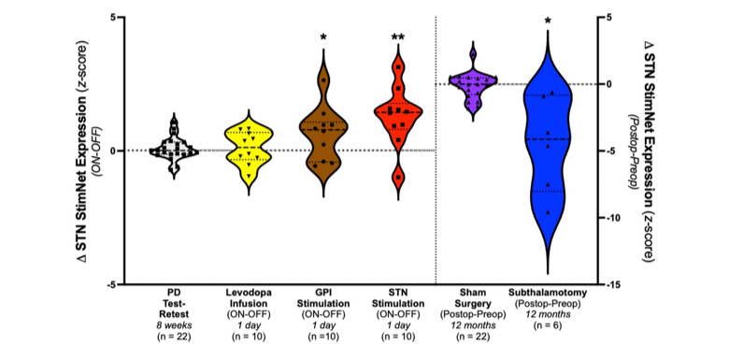
Figure S1. Changes in STN StimNet expression in response to STN-DBS compared to other interventions. Left: Changes in STN StimNet expression during different antiparkinsonian interventions. Significant treatment-mediated network modulation was observed for STN-DBS (p<0.01) and GPi-DBS (p<0.05; Wilcoxon signed rank tests). By contrast, intravenous levodopa infusion titrated to achieve motor benefit similar to STN-DBS (39.4% and 43.8% reductions in UPDRS motor ratings for the two interventions; see Table S1A) did not alter STN StimNet expression levels (p>0.3). Right: Comparable motor benefit was also observed 12 months after unilateral subthalamotomy (see Table S1A). That said, STN StimNet expression declined rather than increased following the procedure (p<0.05; Wilcoxon signed rank test), differing significantly from those observed 12 months after sham surgery (p=0.005; Mann-Whitney test). *p<0.05, **p<0.01.

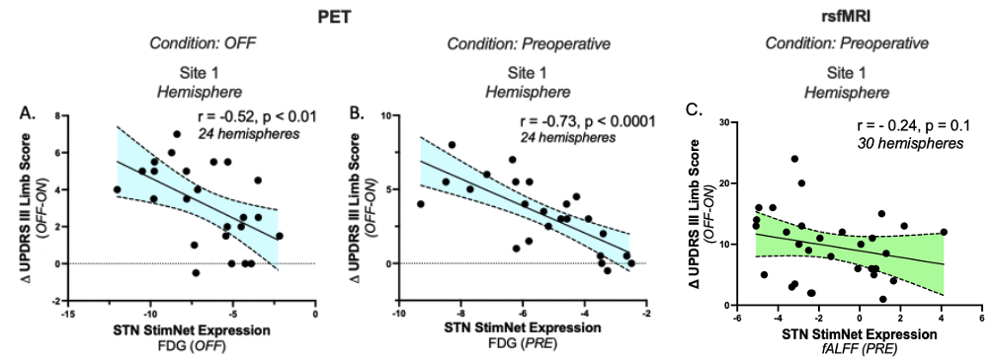Figure S2. Correlations of stimulation-mediated improvement limb ratings with baseline STN StimNet expression measured in the contralateral hemisphere. (A) Hemispheric STN StimNet expression measured off-stimulation (OFF) in Site 1A correlated with stimulation-mediated motor improvement in the contralateral limbs recorded in these individuals during FDG PET imaging (r=-0.52, p<0.01; Pearson correlation). (B) Significant correlations were also seen between stimulation-mediated motor improvement in contralateral limbs and in patients with preoperative (PRE) STN StimNet expression measured in Site 1A patients (r=-0.73, p<0.0001). (C) A similar relationship, which was only significant at the trend level (r=-0.24, p=0.1) was seen with preoperative hemispheric STN StimNet values in Site 1B patients in whom baseline scanning was conducted with resting-state fMRI (see text).

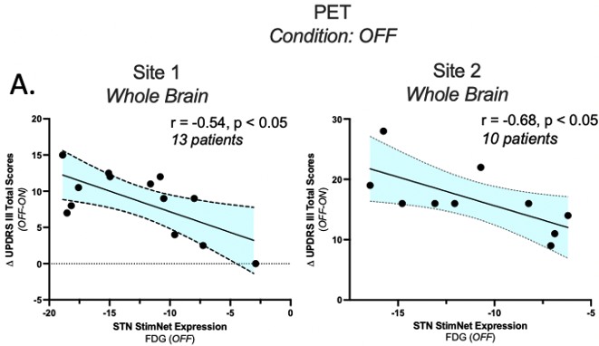

Figure S3. Network expression measured off stimulation correlated with the magnitude of motor improvements measured on stimulation. (A) Left: Whole brain STN StimNet expression measured in the off-stimulation condition (OFF) in the Site 1A patients correlated with stimulation-mediated improvement in whole-body motor ratings obtained during PET (r=-0.54, p<0.05; Pearson correlation) (see text). (B) A similar correlation with clinical motor responses was seen for the off-state network values measured in the Site 2 testing data (r=-0.68, p<0.05). Individual patient motor ratings on or off STN stimulation were not used for network identification or to compute expression values for subjects studied at either site.

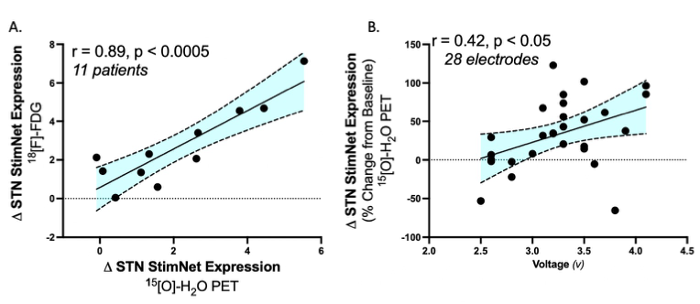
Figure S4. Changes in STN StimNet expression in relation to STN-DBS stimulation intensity. (A) A tight correlation (r=0.89, p<0.0005; Pearson correlation) was observed between stimulation-mediated changes in STN StimNet expression measured in [¹⁸F]-FDG PET scans of cerebral glucose metabolism and [¹⁵O]-H₂O PET scans of cerebral blood flow from the same PD patients (see text). (B) Correlation was also observed between stimulation amplitude (volts) and the magnitude of the precent change from baseline (OFF) in STN StimNet expression measured in [¹⁵O]-H₂¹⁵O PET scans (r=0.42, p<0.05).

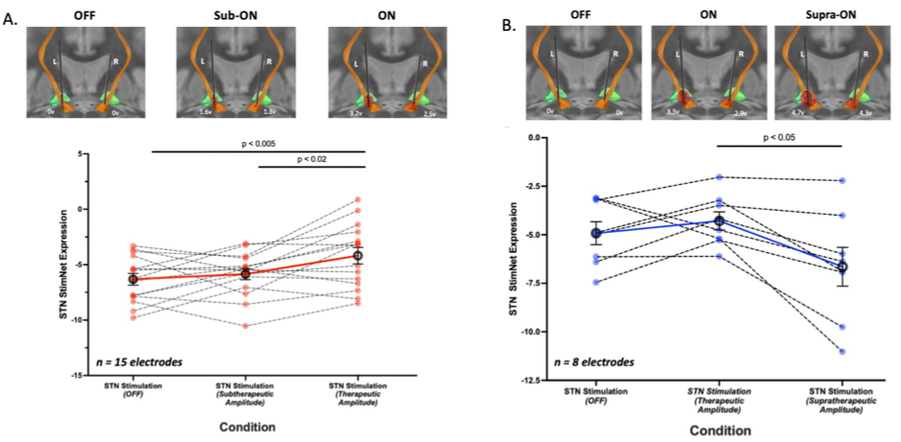
Figure S5. Relationship of STN StimNet modulation to stimulation intensity. (A) Top: Larger volumes of tissue activated (VTA, red) were observed with increasing stimulation voltage while keeping pulse width and frequency constant in a representative PD patient with bilateral STN-DBS (see Methods). Subtherapeutic (Sub-ON) and therapeutic (ON) voltages in the left and right electrodes gave rise to progressively larger VTA within the STN (orange) and along adjacent white mater tracts (orange fibers). Bottom: Increasing stimulation voltage within the range of clinically optimized parameters for 15 electrodes from Site 1A (See Methods). Measurement of STN StimNet expression was performed using scans of cerebral blood flow (CBF) obtained in each stimulation condition with [¹⁵O]-water (H₂¹⁵O) PET. Consistent elevations in STN StimNet expression were seen in the therapeutic ON condition relative to OFF (p<0.005) and relative to the subtherapeutic MID condition (p<0.02; post-hoc Bonferroni tests. [Circles denote the mean STN StimNet expression (±SE) for each condition. Differences in mean values across conditions are represented by solid red lines; individual patient data are represented by dashed black lines.] (B) Top: Larger volumes of tissue activated (VTA, red) were observed with increasing stimulation voltage in a representative PD patient with bilateral STN-DBS; pulse width and frequency were held constant. Therapeutic and supratherapeutic voltages in the left and right electrodes are associated with progressively larger VTA within the STN (orange) and adjacent white matter tracts (orange fibers). Bottom: We found that increasing stimulation voltage for 8 electrodes, keeping pulse width and frequency constant, resulted in significant changes in STN StimNet expression (p<0.001; Friedman test). Increasing the voltage from OFF to optimal clinically titrated parameters (ON) increased network expression levels. However, a shift from ON to supratherapeutic (Supra-ON) resulted in a significant decline in STN StimNet expression (p<0.05; post-hoc Dunn correction) (see text).

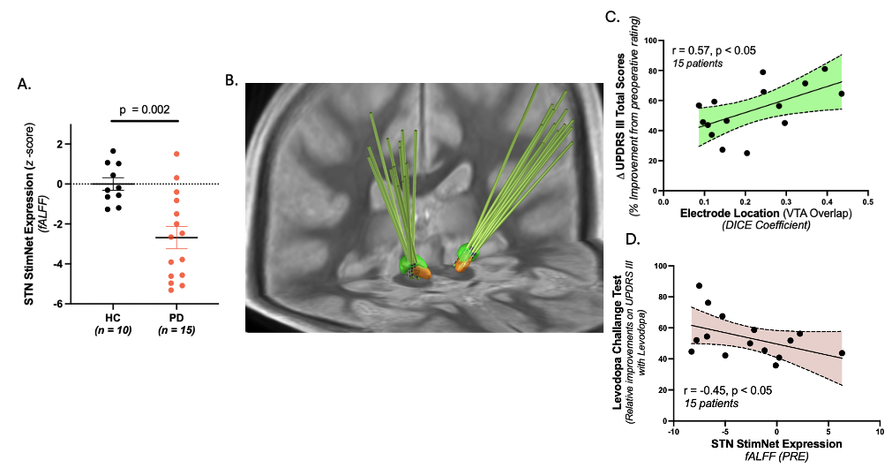
Figure S6. STN StimNet expression quantified in rs-fMRI. (A) Similar to Figure 6, STN StimNet expression levels were significantly lower in the preoperative rs-fMRI PD cohort (Site 1B) compared to 10 age and gender matched HC subjects (p=0.002; Mann-Whitney test). (B) 3D rendering of left and right electrodes with the STN “sweetspot” (green) [18] and STN (orange) for the whole group. (C) A significant correlation between the distance from the sweetspot, as measured by the DICE coefficient (see Methods), and the degree of stimulation-mediated motor improvement was seen in this cohort (r=0.57, p<0.05; Pearson correlation). (D) A significant correlation (r=-0.45, p<0.05) was seen between preoperative STN StimNet scores from rs-fMRI and results of a levodopa challenge test (LCT) conducted in the same patients within 3 months of imaging.

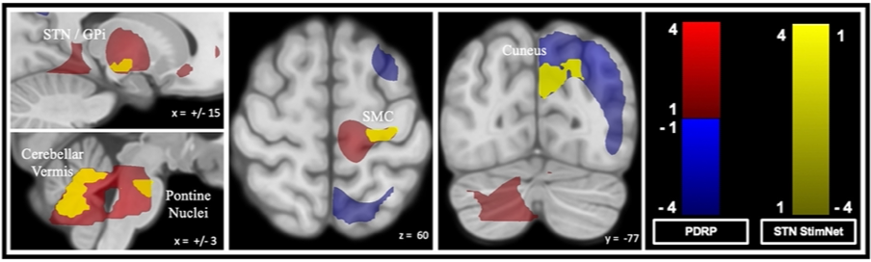
Figure S7. Topographic relationship of STN StimNet and the generic Parkinson’s disease-related pattern (PDRP). Relationship of the STN StimNet topography to the generic Parkinson’s disease (PD) network termed the PD-related metabolic pattern (PDRP) (see text). Sagittal, axial, and coronal slices showing areas of spatial overlap between the two networks (yellow). Overlap with metabolically active (red) PDRP regions was seen in the globus pallidus and subthalamic nucleus, cerebellar vermis, and pons (left), and in the sensorimotor cortex (SMC) (middle). Overlap with underactive (blue) PDRP regions was seen in the cuneus (right).

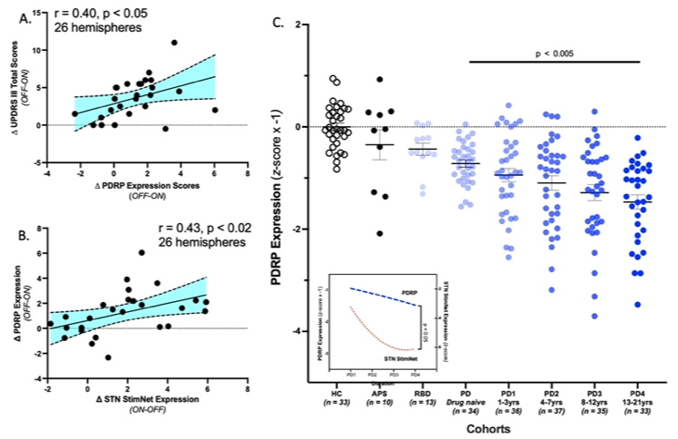
Figure S8. PDRP expression measurements in the patient samples used to characterize STN StimNet. (A) Hemispheric changes in PDRP expression induced by STN-DBS (Site 1A; 26 hemispheres) exhibited a modest correlation with concurrent improvement in contralateral limb ratings (r=0.40, p<0.05; Pearson correlation). By contrast, corresponding hemispheric changes in StimNet expression in the same patients (Fig. 3A, left) exhibited a stronger correlation with contralateral limb responses (p=0.59, p<0.005). (B) The correlation between stimulation-mediated changes in PDRP and STN StimNet expression in this group was also relatively weak (r=0.43, p<0.02), consistent with the topographic differences between the two networks as described previously (Fig. S6). (C) Expression values for PDRP were computed in FDG PET scans from the large patient cohort for whom STN StimNet values were presented in Figure 6 (see text). The trajectory of PDRP change with advancing disease differed from that seen for STN StimNet expression in the same patients. Specifically, the PD patients in the four duration blocks (PD1-PD4; see Methods) exhibited stepwise increases in PDRP expression (displayed for convenience as declines) at longer disease durations (p<0.001; one-way ANOVA) (inset: dashed blue line). This differed from the curvilinear trajectory observed for STN StimNet expression (inset: dotted red line) across the same blocks (p<0.05; 2×4 RMANOVA, network × block interaction effect). [For purposes of display, individual PDRP expression values were multiplied by -1 in all groups.]

Supplementary Table

Table S1A. Treatment cohorts
Cohort | Patients | Demographics |  |  | UPDRS Motor Ratings*
Cohort | Patients | Age*  (Years) | Gender  (Male: Female) | Disease Duration*  (Years) | OFF | ON
STN-DBS
Site 1A ¹  (PET) | 24 | 60.8 ± 10.6 | 17:7 | 12.0 ± 5.3 | 32.0 ± 13 | 22.8 ± 11.1
Site 1B ²  (MRI) | 15 | 61.3 ± 9.7 | 10:5 | 8.1 ± 5.0 | 47.6 ± 17 | 27.0 ± 1
Site 2 ^{3, a}  (PET) | 10 | 62.1 ± 8.3 | 7:3 | 12.9 ± 3.5 | 43.3 ± 11.9 | 26.6 ± 13
GPi-DBS ^{4, b} | 10 | 53.5 ± 10.1 | 7:3 | 12.0 ± 5.1 | 49.9 ± 17.1 | 34.2 ± 11
Sub- thalamotomy ^{c} | 6 | 56.2 ± 9 | 3:3 | 10.3 ± 2.9 | 63.3 ± 17.7 | 37.3 ± 15.7
Levodopa Infusion | 10 | 63.0 ± 7.6 | 8:2 | 10.8 ± 5.6 | 31.7 ± 6.1 | 18.3 ± 7.3
*Mean ± standard deviation (SD)
Stimulation parameter (mean): Voltage (v), Frequency (Hz), Pulse Width (μs):
¹ 3.1v, 175 Hz, 73.1 μs
² 2.7 mA, 130.9 Hz, 57.7 μs
³ 2.5v, 175 Hz, 60 μs
⁴2.8v, 135.4 Hz, 152.1 μs
ªVolonté (2012)⁷³; ^{b}Asanuma (2006)⁴³; ^{c}Trost (2006)⁴⁴

Table S1B. Parkinson’s disease patients and healthy control subject cohorts: Off treatment
Cohort | Number  (Patients) | Demographics |  |  | UPDRS Motor Ratings  OFF *
Cohort | Number  (Patients) | Age*  (Years) | Gender  (Male: Female) | Disease Duration*  (Years) | UPDRS Motor Ratings  OFF *
Healthy Control Subjects ª (HC)  PET imaging | 33 | 55 ± 13.4 | 10:23 | - | -
Healthy Control Subjects (HC)  MRI imaging | 10 | 62.8 ± 8.3 | 4:6 | - | -
Atypical PD (APS) ^{b}  (Pathological Dx) | 10 | 66.3 ± 6 | 4:6 | 3.25 ± 1.5 | -
REM Sleep Behavior Disorder (RBD) ^{c} | 13 | 63.5 ± 8.4 | 13:0 | - | -
PD  Natural History | 175
PD ^{d}  Drug naïve | 34 | 58.8 ± 9.3 | 26:8 | 1.9 ± 1.6 | 16.1 ± 8.2
PD1 ^{e}  (0-3 yrs) | 36 | 58.5 ± 12.1 | 23:13 | 1.9 ± 0.8 | 16.1 ± 7.9
PD2 e  (4-7 yrs) | 37 | 57.8 ± 12 | 29:8 | 5.6 ± 1 | 29 ± 14
PD3 e  (8-11 yrs) | 35 | 62.1 ± 9 | 27:8 | 9.9 ± 1.6 | 30.7 ± 13.9
PD4 e  (12-21 yrs) | 33 | 60.6 ± 9.6 | 24:9 | 17.1 ± 4.5 | 37.7 ± 14.4
*Mean ± standard deviation (SD)
ªMa (2007)⁷¹; ^{b}Schindlbeck (2021)⁸³; ^{c}Holtbernd (2014)⁸²; ^{d}Schindlbeck (2020)³¹; ^{e}Spetsieris (2023)³⁰

