Supplementary Information

Supplementary Figures
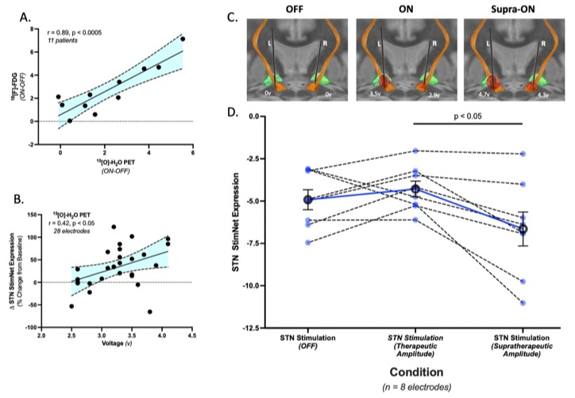

Figure S1. (A) A tight correlation (r=0.89, p<0.0005) was observed between stimulation-mediated changes in STN StimNet expression measured in [¹⁸F]-FDG PET scans of cerebral glucose metabolism and [¹⁵O]-H₂O PET scans of cerebral blood flow from the same PD patients (see text). (B) A correlation (r=0.42, p<0.05) was also observed between stimulation amplitude (volts) and the magnitude of the precent change from baseline (OFF) in STN StimNet expression measured in the H₂¹⁵O PET scans. (C) Larger volumes of tissue activated (VTA, red) were observed with increasing stimulation voltage in a representative PD patient with bilateral STN-DBS; pulse width and frequency were held constant (see Methods and Figs. 1A and 3). Therapeutic and supratherapeutic voltages in the left and right electrodes are associated with progressively larger VTA within the STN (orange) and adjacent white matter tracts (orange fibers). (D) Within the whole cohort, we found that increasing stimulation voltage for each patient, while keeping pulse width and frequency constant, resulted in significant changes in STN StimNet expression (p<0.001; Friedman Test). Increasing the voltage from OFF to optimal clinically titrated parameters (ON) increased network expression levels. That said, a shift from ON to supratherapeutic (Supra-ON) resulted in a significant decline in STN StimNet expression (p<0.05; Dunn correction). We hypothesize that this effect is caused by non-specific spread of current beyond the motor STN target.

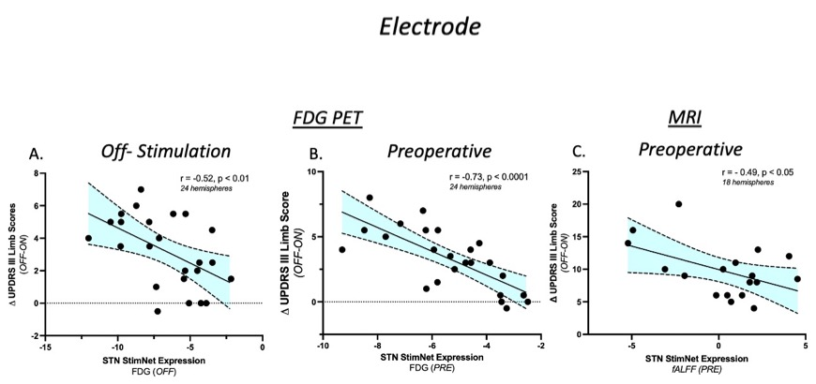

Figure S2. (A) Hemispheric STN StimNet expression measured off-stimulation (OFF) in each of the Site 1 patients correlated with stimulation-mediated motor improvement in the contralateral limbs recorded during imaging (r=-0.52, p<0.01; Pearson correlation). (B) Similarly, significant correlations between stimulation-mediated motor improvement and preoperative (PRE) measurements of STN StimNet expression were also seen at the hemispheric level (r=0.73, p<0.0001). (C) Analogous measurements of STN StimNet from Preoperative BOLD imaging maintained similar relationships with DBS related motor outcomes (r=-0.49, p< 0.05)

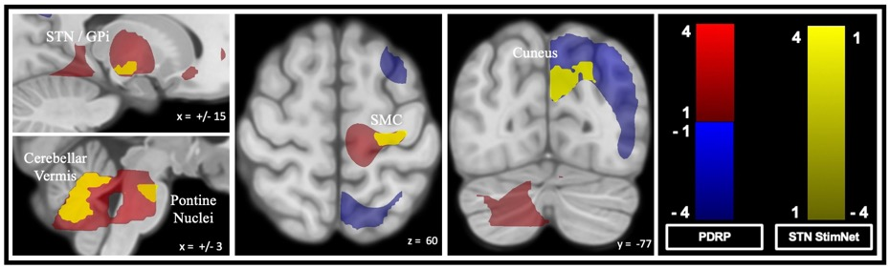

Figure S3. Relationship of the STN StimNet topography to the previously validated Parkinson’s disease-related metabolic covariance pattern (PDRP) [55]. Sagittal, axial, and coronal slices showing areas of spatial overlap between the two networks (yellow). Overlap with metabolically active (red) PDRP regions was seen in the globus pallidus and subthalamic nucleus, cerebellar vermis, and pons (left), and in the sensorimotor cortex (SMC) (middle). Overlap with underactive (blue) PDRP regions was seen in the cuneus (right).

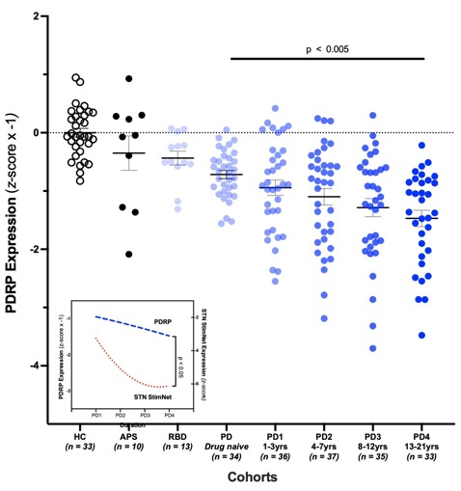
Figure S4. Expression values for PDRP were computed in FDG PET scans from the same patients as in Figure 5 (see text). The trend in PDRP expression across groups differed from corresponding STN StimNet values. Specifically, the PD patients in the four duration blocks (PD1-PD4; see Methods) exhibited linear changes in PDRP expression with advancing disease (p<0.001; one-way ANOVA) (inset; dashed blue line). This differed from the non-linear trend (inset; dotted red line) noted for STN StimNet expression across the same blocks (p<0.05; 2×4 RMANOVA, network × block interaction effect). [For purposes of display, individual PDRP expression values were multiplied by -1 in all groups.]

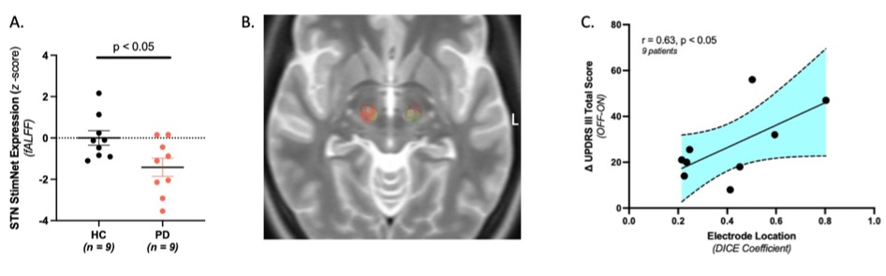Figure S5. (A) Similar to the results from Figure 5, STN StimNet expression levels were significantly lower in the preoperative rs-fMRI PD cohort compared to age and gender matched HC subjects (p<0.05; Mann-Whitney test, one-tailed). Acquisition parameters for the rs-fMRI sequences differed slightly across the two groups: PD – rs-fMRI scans were 5 mins in duration and produced 333 volumes with the following parameters: FOV = 200, TR/TE = 900/35 ms, flip angle = 52°, and 60 slices of 2.5 mm thickness. For each patient, a T1-weighted structural MRI scan was performed with FOV = 256 mm, TR/TE = 2400/2.35 ms, flip angle = 8°, and 208 slices of 0.8 mm thickness. HC – rs-fMRI scans were 7 mins in duration and produced 583 volumes with the following parameters: FOV = 231, TR/TE = 720/33 ms, flip angle = 52°, and 72 slices of 2 mm thickness. For each subject, a T1-weighted structural MRI scan was performed with FOV = 256 mm, TR/TE = 2400/2.2 ms, flip angle = 8°, and 208 slices of 0.8 mm thickness. (B) Axial slice of a T2W template from 3D slicer that depicts overlap of VTAs from left and right electrodes with the STN “sweetspot” (left (green) and right (red)) for the whole group (n=18). Electrodes were localized and VTAs modeled using the standardized pipeline in Lead DBS. In brief, thin-cut postoperative CT scans were sequentially registered first to the preoperative MRI using the Advanced Normalization Tools (ANTs) [78]. Paired images were then normalized to the MNI template using SPM and corrected for brainshift using a subcortical mask [79]. Finally, electrodes were localized using the PaCER algorithm and manually inspected for accuracy. Electric fields around the active contacts to estimate the VTA were modeled using Fastfield; active contacts and stimulation parameters selected as inputs for each individual patient that were in use during the postoperative clinical evaluation [80, 81]. Proximity of the electrode to the STN “sweetspot” was computed for each electrode by calculating the DICE coefficient [2(A∩B)/(A+B)] as a measure of spatial overlap between this region and calculated the volume of tissue activated (VTA). (C) A significant correlation between the DICE coefficient and magnitude of motor improvement with stimulation was seen in this cohort (r=0.63, p<0.05, one-tailed).

Supplementary Table

Table S1A.
Cohort | Number  (Patients) | Demographics |  |  | UPDRS Motor Ratings
Cohort | Number  (Patients) | Age*  (Years) | Gender  (Male: Female) | Disease Duration*  (Years) | OFF* | ON* (Treatment)
STN-DBS
Site 1 ¹  (USA)  PET Imaging | 24 | 60.8 ± 10.6 | 17:7 | 12 ± 5.3 | 32 ± 13 | 22.8 ± 11.1
Site 1 ²  (USA)  MRI Imaging | 9 | 62.4 ± 11.4 | 5:4 | 9.8 ± 5.7 | 51.2 ± 19.8 | 22 ± 12
Site 2 ^{a,3}  (Italy)  PET Imaging | 10 | 62.1 ± 8.3 | 7:3 | 12.9 ± 3.5 | 43.3 ± 11.9 | 26.6 ± 13
GPi-DBS ^{b, 4} | 10 | 53.5 ± 10.1 | 7:3 | 12 ± 5.1 | 49.9 ± 17.1 | 34.2 ± 11
Levodopa Infusion | 10 | 63 ± 7.6 | 8:2 | 10.8 ± 5.6 | 31.7 ± 6.1 | 18.3 ± 7.3
Sub- thalamotomy ^{c} | 6 | 56.2 ± 9 | 3:3 | 10.3 ± 2.9 | 63.3 ± 17.7 | 37.3 ± 15.7
*Mean ± standard deviation (SD)
Stimulation parameter (mean): Voltage (v), Frequency (Hz), Pulse Width (μs):
¹ 3.1v, 175 Hz, 73.1 μs
² 2.5 mA, 124.4 Hz, 55.3 μs
³ 3.1v, 175 Hz, 73.1 μs
⁴ 2.5v, 175 Hz, 60 μs
⁵ 2.8v, 135.4 Hz, 152.1 μs
ªVolonté (2012); ^{b}Asanuma (2006); ^{c}Trost (2006)

Table S1B.
Cohort | Number  (Patients) | Demographics |  |  | UPDRS Motor Ratings  OFF *
Cohort | Number  (Patients) | Age*  (Years) | Gender  (Male: Female) | Disease Duration*  (Years) | UPDRS Motor Ratings  OFF *
Healthy Control Subjects ª (HC)  PET imaging | 33 | 55 ± 13.4 | 10:23 | - | -
Healthy Control Subjects (HC)  MRI imaging | 9 | 62.2 ± 9.1 | 4:5 | - | -
Atypical PD (APS) ^{b}  (Pathological Dx) | 10 | 66.3 ± 6 | 4:6 | 3.25 ± 1.5 | -
REM Sleep Behavior Disorder (RBD) ^{c} | 13 | 63.5 ± 8.4 | 13:0 | - | -
PD  Natural History | 175
PD ^{d}  Drug naïve | 34 | 58.8 ± 9.3 | 26:8 | 1.9 ± 1.6 | 16.1 ± 8.2
PD1 ^{e}  (0-3 yrs) | 36 | 58.5 ± 12.1 | 23:13 | 1.9 ± 0.8 | 16.1 ± 7.9
PD2 e  (4-7 yrs) | 37 | 57.8 ± 12 | 29:8 | 5.6 ± 1 | 29 ± 14
PD3 e  (8-11 yrs) | 35 | 62.1 ± 9 | 27:8 | 9.9 ± 1.6 | 30.7 ± 13.9
PD4 e  (12-21 yrs) | 33 | 60.6 ± 9.6 | 24:9 | 17.1 ± 4.5 | 37.7 ± 14.4
*Mean ± standard deviation (SD)
ªMa (2007); ^{b}Schindlbeck (2020); ^{c}Holtbernd (2014); ^{d}Schindlbeck (2021); ^{e}Spetsieris (2023)

