Mapping Cutaneous Tissue Distribution of Sesquiterpene Lactone Goyazensolide Using MALDI Imaging
Norberto P. Lopes¹, Natalia N. Kato¹, Gabriela A. Buqui¹, Jacqueline N. Mendonça¹, João Luis Callegari Lopes¹, Renata F. V. Lopez¹

Affiliation
¹ Faculdade de Ciências Farmacêuticas de Ribeirão Preto - Universidade de São Paulo, Avenida Professor Doutor Zeferino Vaz, s/n, Campus da USP Ribeirão Preto CEP 14040-903, São Paulo, Brasil

1) Structural determination of goyazensolide

For high-resolution mass determination, a hybrid triple quadrupole time-of-flight mass spectrometer (UltraTOF-QBruker- Daltonics) with electrospray ionization (ESI) in positive mode was used. NMR analyzes were carried out for 1H and 13C, using the Bruker-Advance spectrometer equipment model DRX 400, operating at 400 MHz for the 1H analyzes and Bruker-Advance spectrometer model DPX 300, operating at 75 MHz for the 13C analyses. Samples were prepared in CDCL3 solvent. For structural confirmation of the isolated compound, it was based on the results obtained by high-resolution mass spectrometry and nuclear magnetic resonance analyses.
The molecular formula C₁₉H₂₀O₇ was obtained using the observed mass of 361.1294 [M+H]⁺ and the calculated error in relation to the theoretical mass of 7.2 ppm. An analysis of the fragmentation of GOYA (m/z 361) was also carried out in the positive ionization mode operating in a mass window between 100 and 450 units. The spectra obtained are shown in figures S1 and S2. Fragment ions were observed at m/z 275, 257, 239, 229, 211 and 183, characteristic of this molecule after the neutral elimination of the side chain (CROTTI et al., 2012). Crotti and collaborators studied in detail the mechanism of formation of fragment ions in a homologous series of GOYA-type sesquiterpene lactones and their epimer at position 8, the substance budlein. In all cases, after the neutral elimination of the side chain, the ion formed [M+H-RCOOH]⁺, for the analyte in question at m/z 275, it undergoes successive neutral losses of H2O molecules (m/z 257 ) followed by CO (m/z 229). It was observed in this study that only derivatives containing the alcohol function in position 15, as occurs for GOYA, present a second elimination of H2O from the ion [M+H-RCOOH- H2O-CO]⁺ (m/z 229) leading, in this case, to the formation of the ion at m/z 239, which quickly initiates sequential CO eliminations leading to the formation mainly of ions at m/z 211 and 183, respectively.
One of the main diagnostic ions at m/z 69, related to the elimination by anchimeric assistance of the side chain, was not observed, as the acylium ion formed would be outside the analysis window. However, we chose to work in a range of masses possibly compatible with MALDI studies.
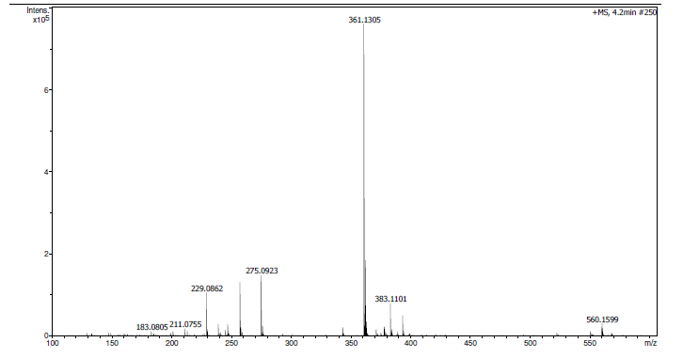
Figure S1. GOYA mass spectrum in positive mode. Observed ion at m/z 361.1294 [M+H]⁺.

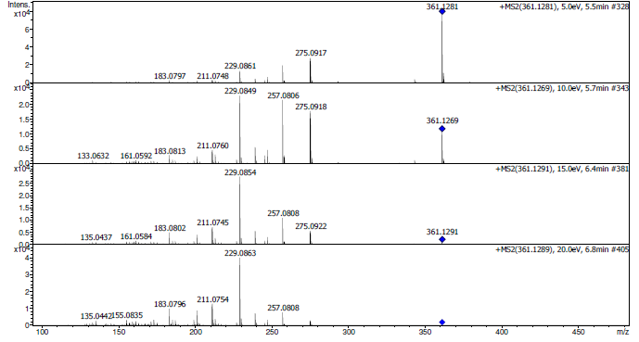
Figure S2. MS/MS spectrum of goyazensolide in positve mode. Isolated ion at m/z 361,1294 [M+H]⁺. Applied collision energies 5, 10, 15 e 20 eV.

As noted above, mass spectrometry data confirmed the presence of the substance goyazensolide, but we believe it is important to also evaluate the isolated product through 1H and 13C NMR analyses, which can be found in figures S3 and S4. In the 1H spectrum it is possible to observe the presence of two doublets at δ 5.48 and 6.19 referring to the olefinic hydrogens H-13a and H-13b of exocyclic α-methylene groups of γ-lactones. There is also a simplet at δ 5.81 that refers to the H-2 olefinic hydrogen of dihydrofuranone rings. These signals together with those at δ 5.30 (H-6), δ 3.79 (H-7), δ 4.50 (H-8) and at δ 2.27 and 2.51 (H-9 ) can characterize the presence of sesquiterpene lactones of the furanoheliangolide type. The double bond between carbons 4 and 5 can be confirmed by the unprotected H-5 signal at δ 6.23, as well as the shift of the carbon signals at δ 134 and 133 (Figure S4) to positions 4 and 5, respectively. . The signals of H-4' and H-14 methyls can be visualized as singlets at δ 1.80 and 1.50, respectively. The simplet at δ 4.34 integrated for two hydrogens characterizes the presence of H-15 linked to carbinolic carbon with a typical displacement at δ 62. In addition to these signals, there are two other signals in the form of simplets at δ 5.99 for H-3 'a and δ 5.54, for H-3'b which are typical of the olefinic hydrogens of the methacrylate type side chain. These data in comparison with those published in the literature (SOARES et al., 2012; SOUZA et al., 2012) were considered compatible for the isolated compound.
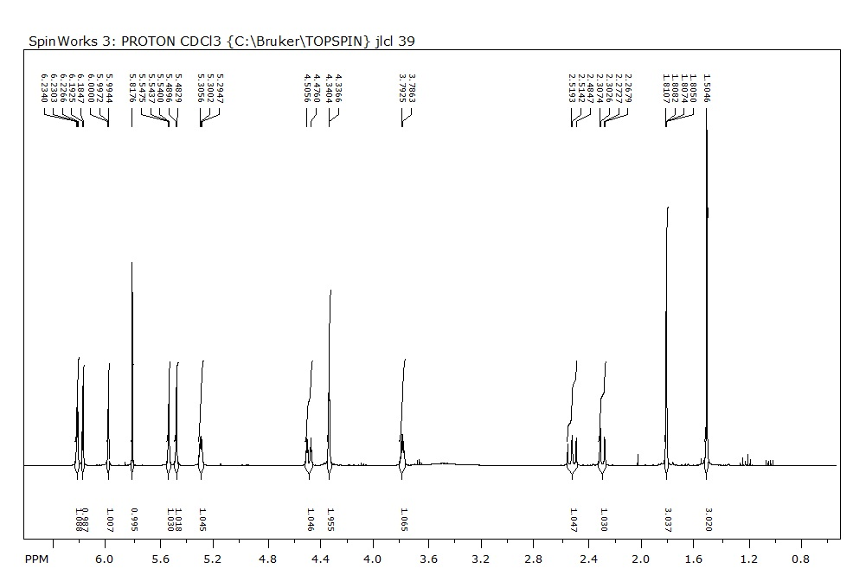

Figure S3. NMR ¹H spectra of goyazensolide (CDCl3/400 MHz).

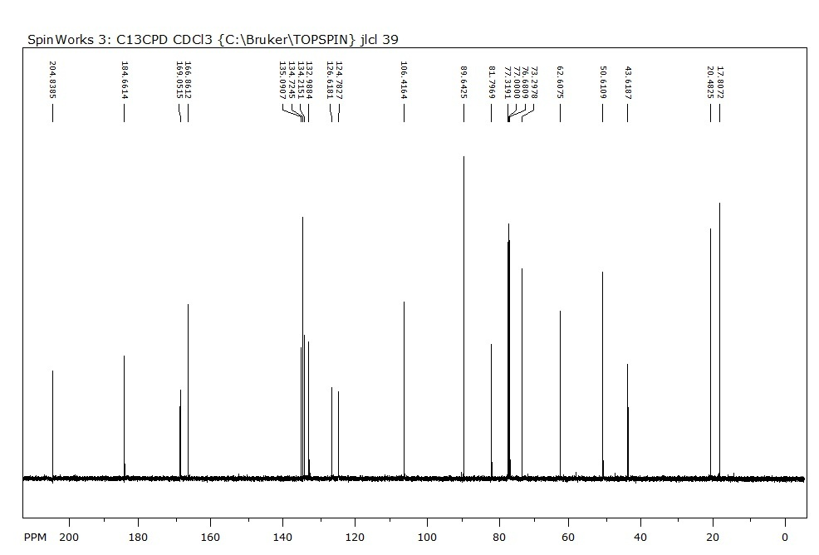
Figura S4. NMR ¹³C spectra of goyazensolide (CDCl3/100 MHz).

Therefore, the joint analysis of all the data obtained and discussed above allows us to affirm that the re-isolation was carried out successfully and with a high degree of purity, thus allowing the continuity of the studies proposed in the article.

2) Analysis of the occurrence of goyazensolide in the recipient liquid medium and in tissues by UPLC-MS/MS

To confirm the initial data obtained by MALDI-MSI from goyazensolide, UPLC-MS/MS analyzes were carried out on skin samples and recipient media from the goyazensolide experiments at 1h, 3h and 6h. In figure 24 we can see the skin samples, which a random aliquot of approximately 1 mm was selected from each sample previously used for the MALDI-MSI assays. However, these results reveal that goyazensolide passed from the donor medium to the skin, probably being retained in the stratum corneum layer.
In the receiving medium samples goyazensolide was not detected (Figure S5 – A). These results increase the confirmation that GOYA is retained in the skin, probably with a strong interaction with the stratum corneum layer and, therefore, there was no penetration and passage into the receptor environment.

Figure S5. Determination of goyazensolide in skin samples in MRM mode (361>275). A) receiving medium; B) goyazensolide standard 1µg.mL-1 (goyazensolide elution time: 2.24 minutes); C), D) and E) Skin sample at 1h, 3h and 6h, respectively.

