A homochiral hexagadolinium phosphonate cluster with a large magnetocaloric effect
Qing-Qing Qianª, Jian-Huang^{b,c}, Jia-Ge Jia^{a,b}*, Wu Qiongª*, Min Ren^{b}, Li-Min Zheng^{b}

ªMagnetism Key Laboratory of Zhejiang Province, College of Materials and Chemistry, China Jiliang University, Hangzhou, 310018, P. R. China. *Corresponding author. E-mail: jgjia322@cjlu.edu.cn
^{b}State Key Laboratory of Coordination Chemistry, School of Chemistry and Chemical Engineering, Collaborative Innovation Center of Advanced Microstructures, Nanjing University, Nan Jing, 210023, P. R. China.
^{c} Nantong Customs Comprehensive Technology Center, Nantong, 226006, P. R. China.

Table S1. Crystal data and structure reﬁnement parameters for compound R-1
Empirical formula | C₅₆H₉₆Gd₆N₁₀O₉₅P₈
Formula weight | 3691.36
Temperature | 296
Crystal system | monoclinic
space group | P2₁
a/[Å] | 14.8793(6)
b/[Å] | 23.7170(10)
c/[Å] | 20.0088(9)
β[º] | 109.0150(10)
Z | 2
Volume/[Å3] | 6675.7(5)
Calculated density/[ g·cm⁻³] | 1.836
μ/[mm⁻¹] | 3.148
F(000) | 3688.0
Crystal size | 0.36 × 0.15 × 0.13
Flack parameter | 0.015(6)
Limiting indices | -12<=h<=19, -30<=k<=30, -26<=l<=16
Reflections collected | 28987
Independent reflections | [R_{int} = 0.0149] R_{sigma} = 0.0422]
Goodness-of-fit on F² | 1.002
R₁, wR₂^{[a]} [I>2σ(I)]  (all data) | R₁ = 0.0239, wR₂ = 0.0574
R₁, wR₂^{[a]} [I>2σ(I)]  (all data) | R₁ = 0.0251, wR₂ = 0.0578
Largest diff. peak and hole/[ e·Å⁻³] | 1.60, -0.95
ªR₁ = Σ||F_{o}| - |F_{c}||/Σ|F_{o}|, wR₂ = [Σw(F_{o}² - F_{c}²)²/Σw(F_{o}²)²]^{1/2}

Table S2 Part bond length (Å) and bond angle (°) of compound R-1
Bonds | Length/Å | Bonds | Length/Å
Gd1-O19 | 2.2585(4) | Gd4-O14 | 2.311(4)
Gd1-O24 | 2.319(4) | Gd4-O39 | 2.324(4)
Gd1-O21 | 2.363(4) | Gd4-O11 | 2.372(4)
Gd1-O16 | 2.403(4) | Gd4-O36 | 2.382(4)
Gd1-O1 | 2.403(4) | Gd4-O31 | 2.418(4)
Gd1-O36 | 2.434(4) | Gd4-O16 | 2.425(4)
Gd1-O37 | 2.448(4) | Gd4-O17 | 2.460(4)
Gd1-O2 | 2.509(4) | Gd4-O32 | 2.500(4)
Gd2-O29 | 2.284(4) | Gd5-O13 | 2.327(4)
Gd2-O4 | 2.360(4) | Gd5-O3 | 2.329(4)
Gd2-O1 | 2.4282(1) | Gd5-O8 | 2.334(4)
Gd2-O26 | 2.390(4) | Gd5-O18 | 2.350(4)
Gd2-O21 | 2.405(4) | Gd5-O1W | 2.436(4)
Gd2-O6 | 2.430(4) | Gd5-O2W | 2.448(4)
Gd2-O7 | 2.453(4) | Gd5-O3W | 2.464(4)
Gd2-O22 | 2.505(4) | Gd5-O4W | 2.469(4)
Gd3-O9 | 2.298(4) | Gd6-O23 | 2.326(4)
Gd3-O34 | 2.300(4) | Gd6-O38 | 2.327(4)
Gd3-O31 | 2.373(4) | Gd6-O33 | 2.333(4)
Gd3-O6 | 2.386(4) | Gd6-O28 | 2.345(4)
Gd3-O26 | 2.420(4) | Gd6-O8W | 2.443(4)
Gd3-O11 | 2.420(4) | Gd6-O7W | 2.443(4)
Gd3-O27 | 2.481(4) | Gd6-O6W | 2.455(4)
Gd3-O12 | 2.504(4) | Gd6-O5W | 2.458(4)

Table S3 The theoretical calculation of the shape of Gd3 and Gd6 polyhedral geometrical configuration
Label | Shape | Gd3 | Gd6
OP-8 | Octagon | 30.381 | 28.858
HPY-8 | Heptagonal pyramid | 23.351 | 23.642
HBPY-8 | Hexagonal bipyramid | 12.496 | 14.748
CU-8 | Cube | 8.636 | 7.445
SAPR-8 | Square antiprism | 4.343 | 0.515
TDD-8 | Triangular dodecahedron | 1.904 | 1.620
JGBF-8 | Johnson - Gyrobifastigium | 11.691 | 15.542
JETBPY-8 | Johnson - Elongated triangular bipyramid | 23.915 | 28.495
JBTPR-8 | Johnson Biaugmented trigonal prism | 2.848 | 2.659
BTPR-8 | Biaugmented trigonal prism | 2.443 | 2.067
JSD-8 | Snub disphenoid | 4.581 | 4.766
TT-8 | Triakis tetrahedron | 9.370 | 8.322
ETBPY-8 | Elongated trigonal bipyramid | 20.296 | 23.271

Figure S1. Packing arrangement of polyanions of 1 viewed along the a-axis.

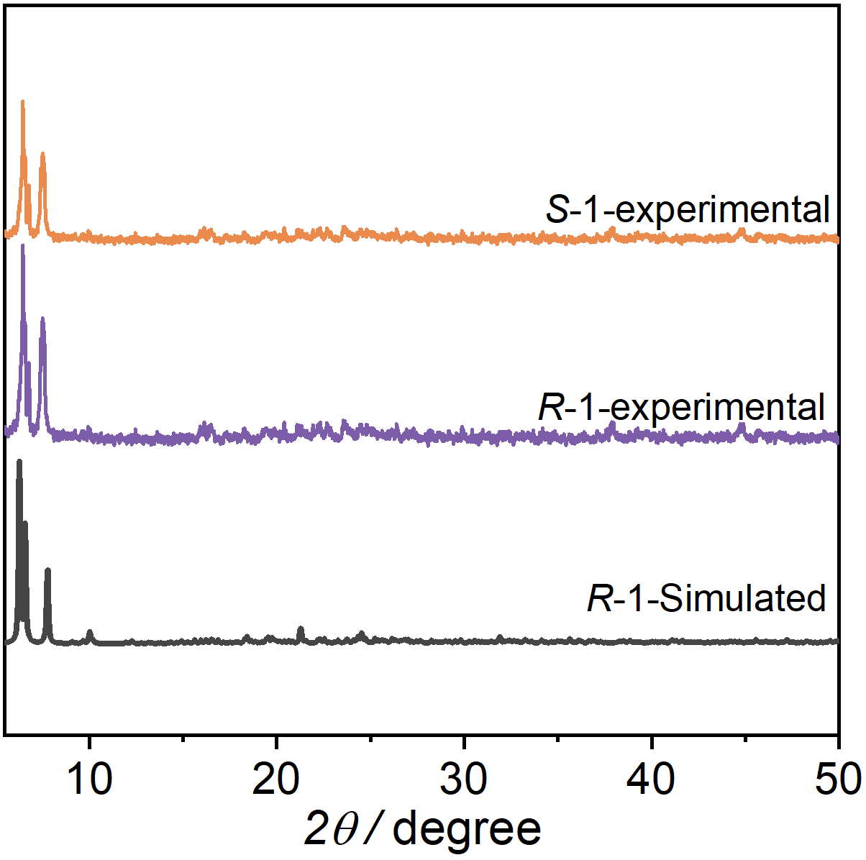
Figure S2. PXRD pattern of R, S-1.

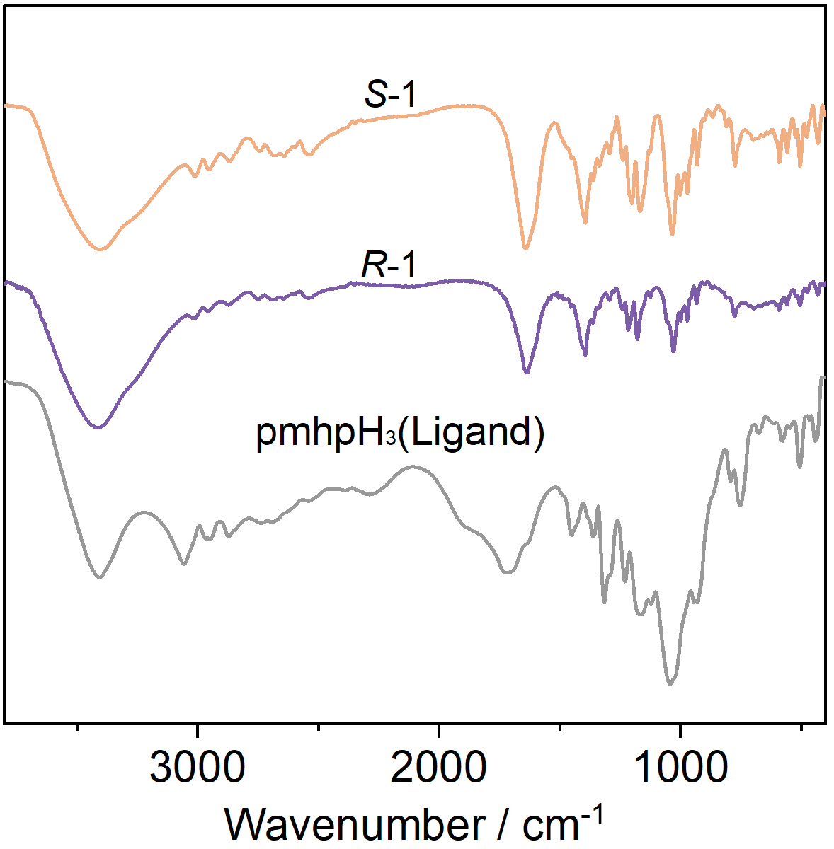
Figure S3. IR spectra (KBr pellets) of R, S-1

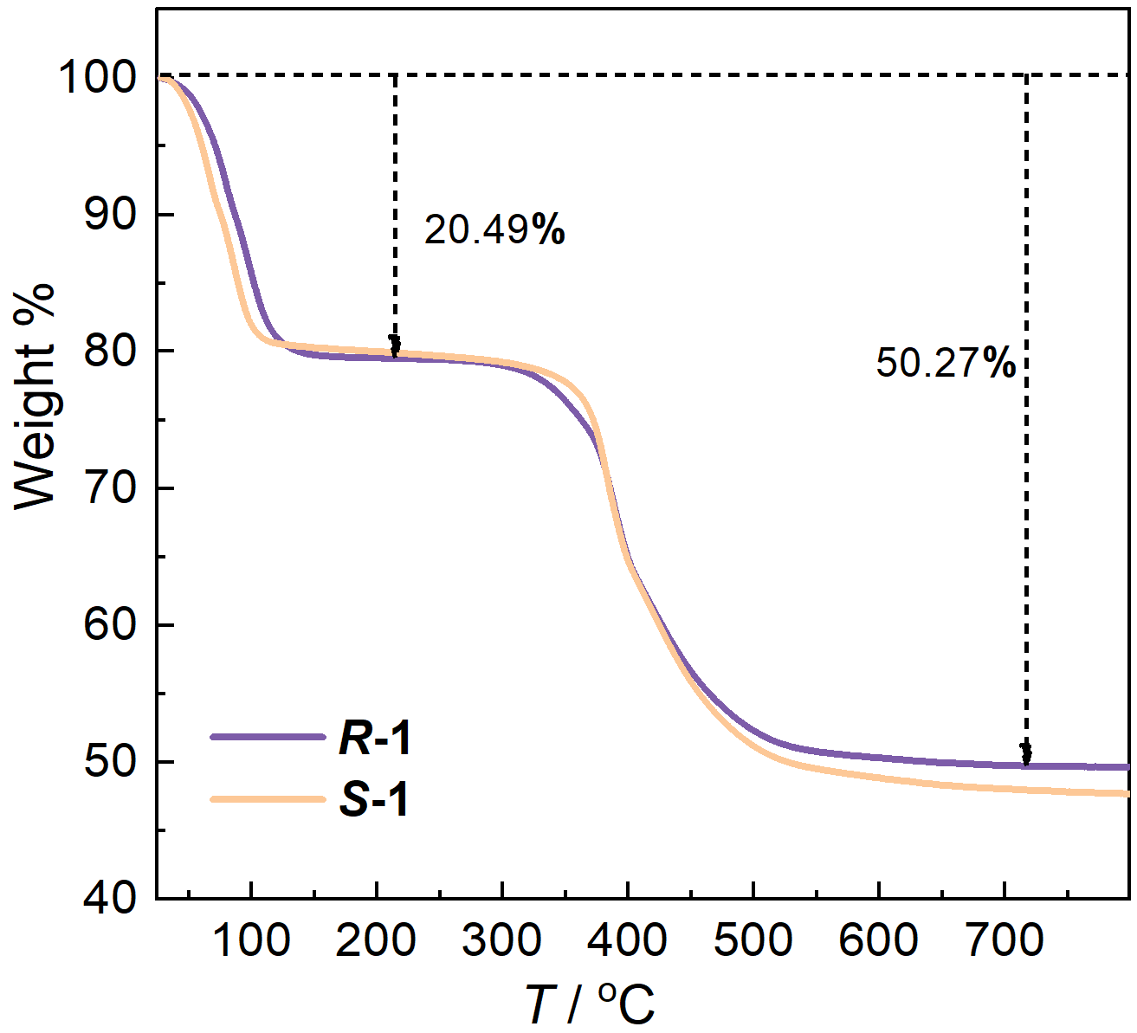
Figure S4. The TGA curves of R, S-1.

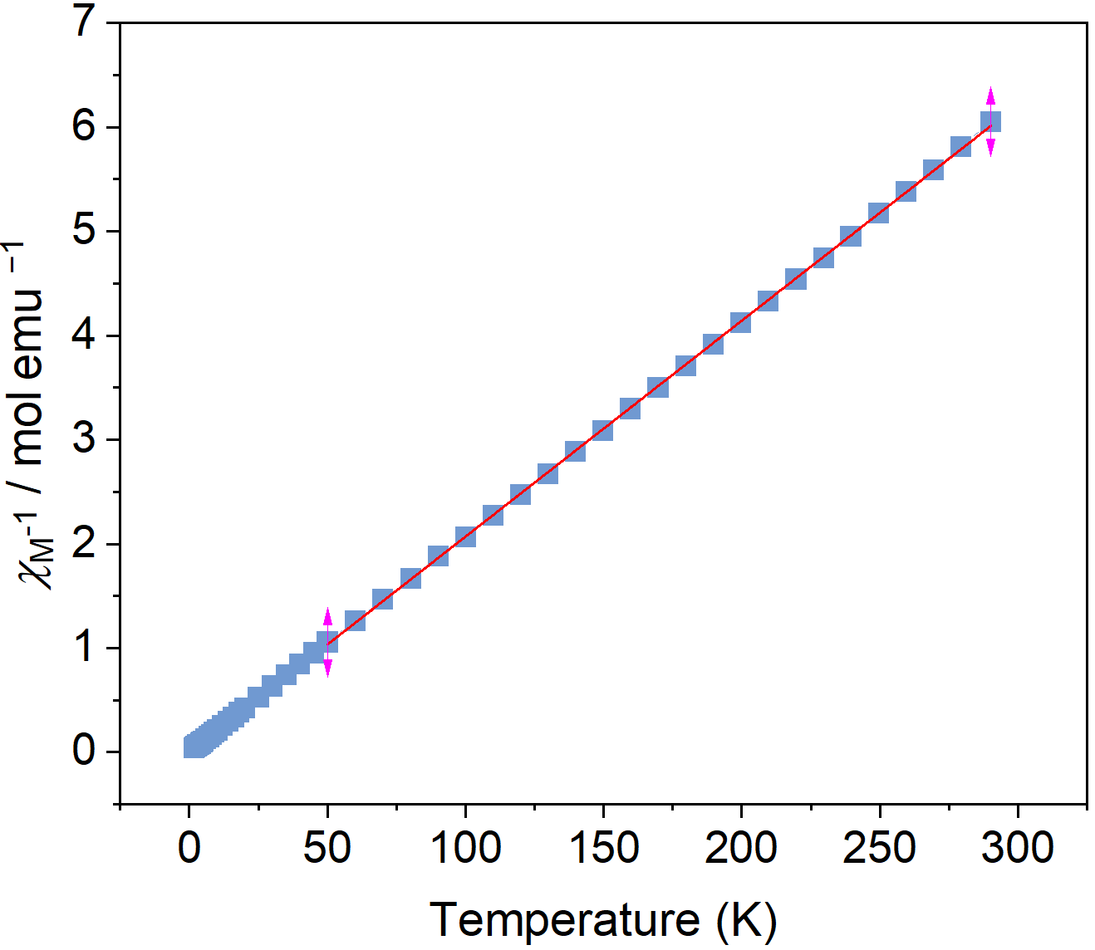
Figure S5. The plots of χ_{M}⁻¹ versus T for R-1. The red curve means the best fitting of the plot of χ_{M}⁻¹ vs. T above 50 K to the Curie–Weiss law.

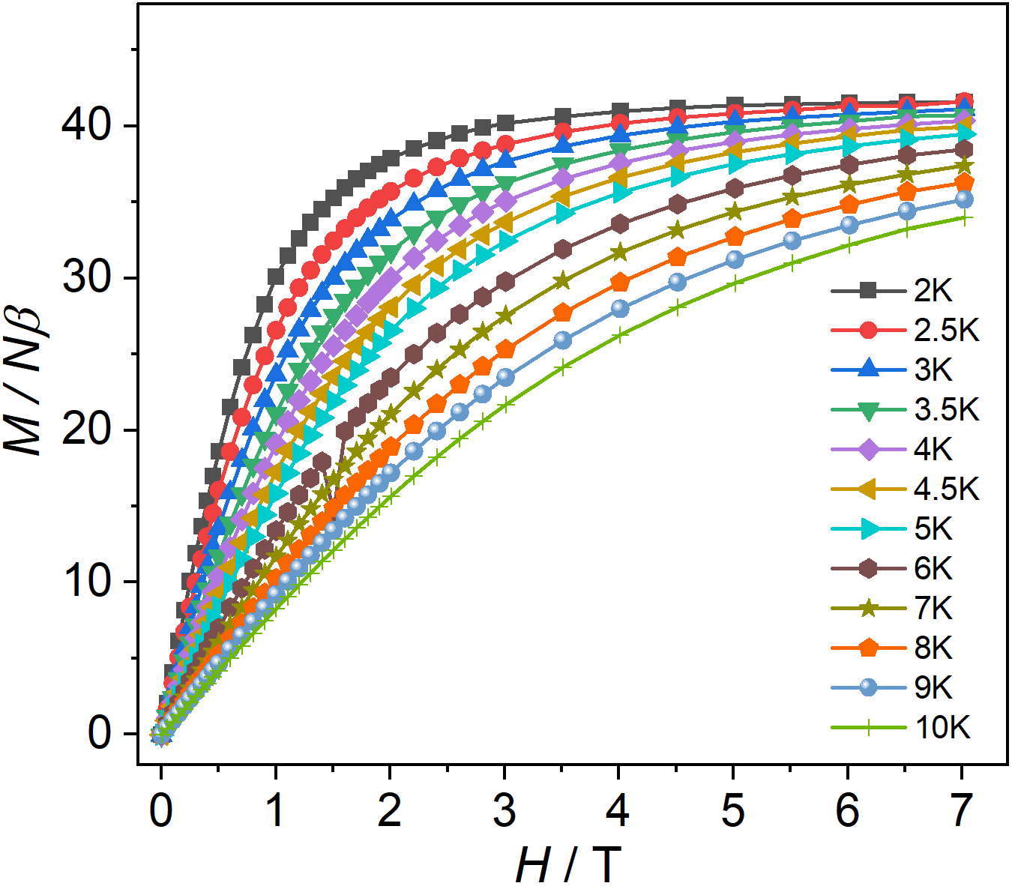
Figure S6. The isothermal field dependence of magnetization for R-1 at different temperature.

