Supplemental Information

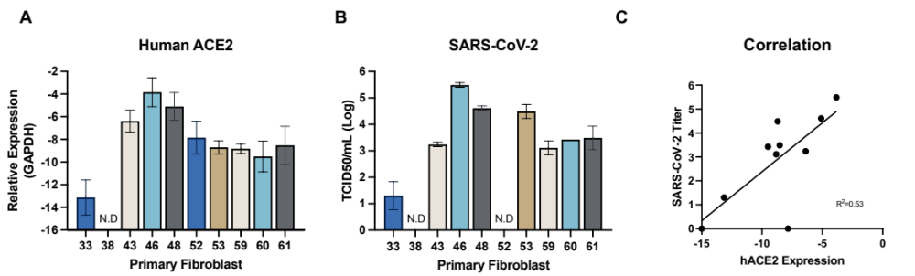
Supplemental figure 1. hACE2 transcript levels correlate with susceptibility to SARS-CoV-2. (A) Primary cells were generated from ear notches taken from transgenic pigs. Total RNA was harvested and hACE2 transcript levels determined by RT-qPCR. hACE2 levels were normalized to GAPDH and shown as relative expression. (B) To test susceptibility, fibroblast cells were infected at an MOI of 3. Supernatant was harvest 24 HPI and infectious virus quantified by TCID50. N=2, error bars = SD. ND = not detected. (C) Correlation of SARS-CoV-2 titre and hACE2 expression levels are shown. Cells from P52 were not susceptible to SARS-CoV-2 infection despite expression of hACE2.

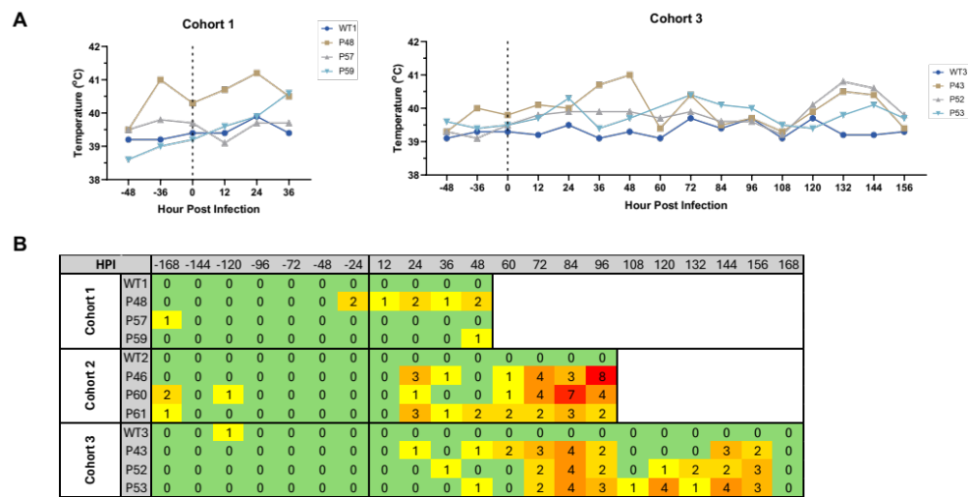

Supplemental figure 2. (A) Rectal temperatures of pigs infected with SARS-CoV-2. Data grouped according to cohorts culled at 2 and 7 DPI. Temperatures for cohort 2 shown in Figure 1B. (B) Summary of clinical scores for human ACE2 infected pigs. A clinical assessment scheme was established prior to the study, in which pigs were scored against several criteria including demeanor, appetite, temperature, respiration and other respiratory signs (cough, sneeze). Pigs were scored daily and the cumulative score recorded. Increases in temperature and respiratory stress were recorded in all hACE2-transgenic pigs but not in the wild-type animals. Cumulative scores ≥7 are defined as moderate severity in this model. HPI = hours post infection.

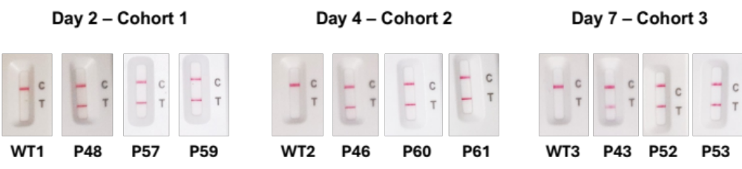

Supplemental figure 3. Lateral flow nasal swab tests were performed at 2, 4 and 7 DPI according to the manufacturers’ instructions. C indicates control line; T indicates test line. All hACE2 transgenic pigs tested positive for SARS-CoV-2 infection, while all non-transgenic pigs were negative.

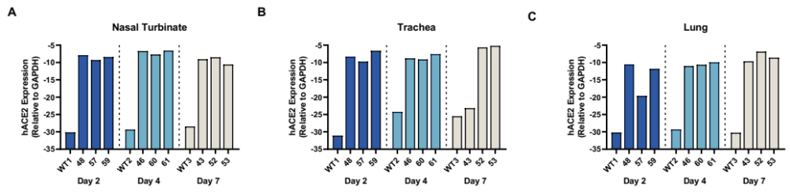

Supplemental figure 4. Human ACE2 RNA expression detected in nasal turbinates, trachea and lung of transgenic pigs.

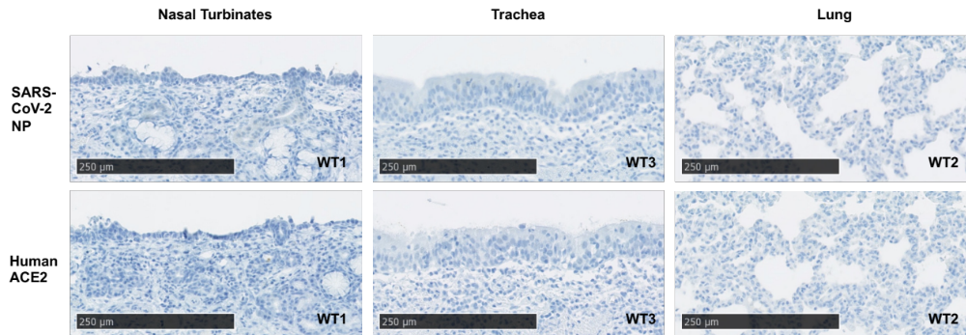

Supplemental figure 5. Representative staining of non-transgenic pigs infected with SARS-CoV-2. No staining was observed for hACE2 or SARS-CoV-2 hACE2 and SARS-CoV-2 Nucleoprotein. Positive staining results in brown signal against blue haematoxylin counterstain. Bar = 250μM.

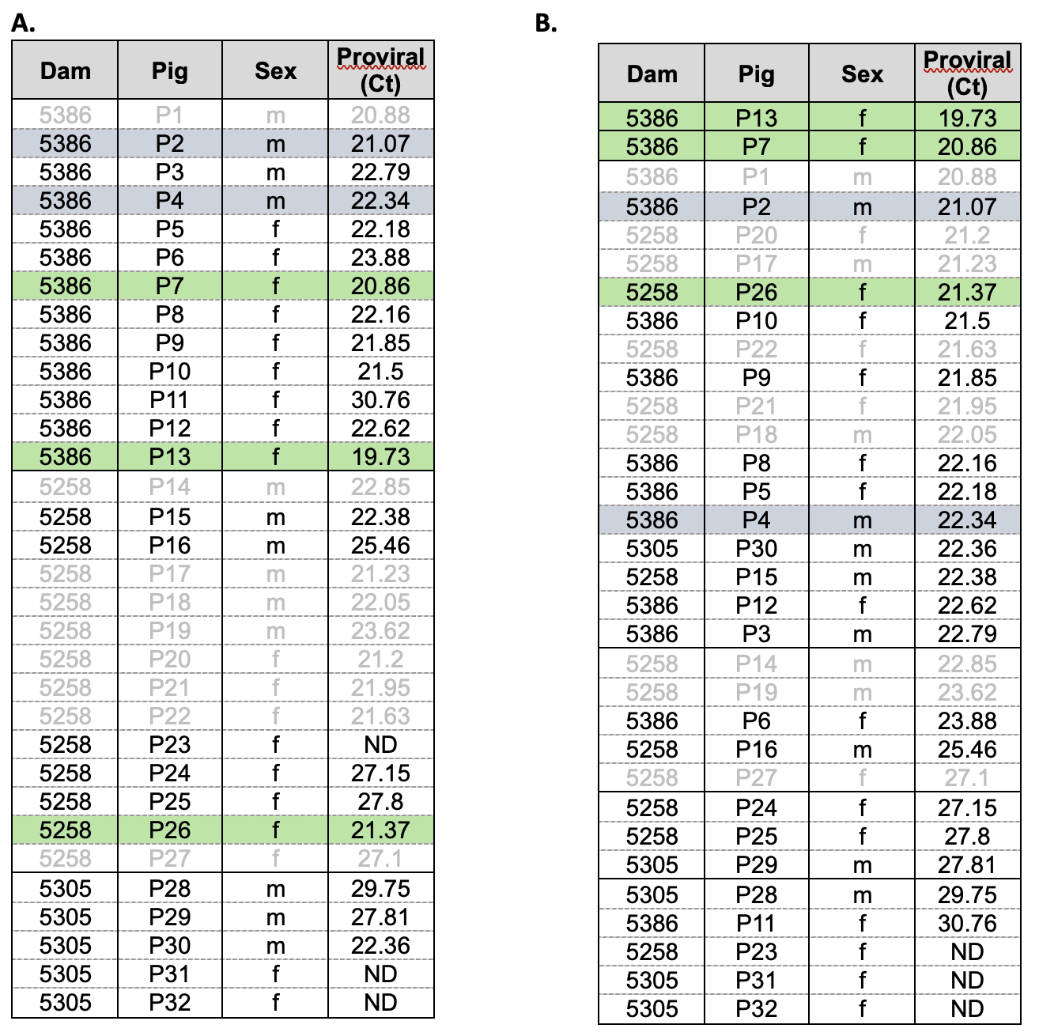

Supplemental table 1. Relative levels of lentivirus integrated into the genome of F0 transgenic pigs was determined using the Lenti-X Provirus Quantitation Kit. For each pig, the surrogate dam is indicated and the sex (m = male, f = female). ND indicates not detected. Pigs selected for breeding of F1 cohort highlighted in green (females and blue (males). Grey text indicates pigs that were culled due to an outbreak of Staphylococcus hyicus. (A) ordered by pig reference number. (B) Ordered by relative proviral Ct.

Parentage | Cohort | Sex | Pig | Relative hACE2 expression
P2xP7 | 1 | F | P48 | 31.12
P2xP13 | 1 | F | P57 | 25.99
P2xP13 | 1 | F | P59 | 39.95
P2xP7 | 2 | F | P46 | 51.27
P2xP13 | 2 | F | P60 | 27.28
P2xP13 | 2 | F | P61 | 53.82
P2xP7 | 3 | F | P43 | 25.46
P2xP13 | 3 | M | P52 | 19.56
P2xP13 | 3 | M | P53 | 19.16
P2xP13 | UN | F | P56 | 15.45
P2xP13 | UN | F | P58 | 15.45
P2xP7 | UN | M | P38 | 0.02
P2xP7 | UN | M | P35 | 0.02
P2xP13 | X | M | P54 | 15.35
P2xP13 | X | M | P51 | 13.18
P2xP7 | X | M | P39 | 8.88
P2xP7 | X | F | P44 | 7.46
P2xP7 | X | M | P37 | 7.21
P2xP13 | X | M | P55 | 6.15
P4xP26 | X | F | P62 | 2.39
P2xP7 | X | F | P50 | 2.23
P2xP7 | X | F | P45 | 1.71
P2xP7 | X | F | P47 | 1.49
P2xP7 | X | M | P34 | 1.29
P2xP7 | X | M | P36 | 1.06
P2xP7 | X | M | P33 | 1
P2xP7 | X | F | P42 | 0.23
P2xP7 | X | F | P49 | 0.03
P2xP7 | X | M | P40 | 0.03

Supplemental table 2. Relative expression of Human ACE2 transcript in ear tissue from F1 pigs. Total RNA was extracted from ear tags and hACE2 transcript levels determined by RT-qPCR. Levels were normalised to GAPDH and relative levels determined against P33. F0 parentage is shown and selection for cohort for challenge study indicated. UN indicates pigs selected for uninfected controls. X indicates pigs not used in challenge study.

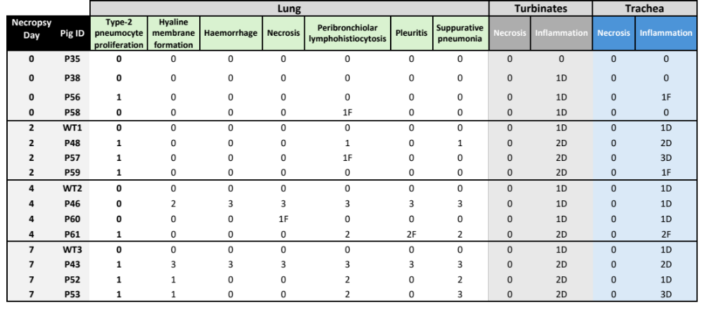
Supplemental table 3. Histology scores from hACE2 and wild type (WT) pigs (P) experimentally challenged with SARS-CoV-2 at D0. A cohort of the hACE2 pigs were housed in a separate facility and euthanized at D0 to serve as negative control (P35, P38, P56 and P58). The pigs were euthanized at day 2, 4 and 7 post SARS-CoV-2 challenge. Lung, turbinates and trachea samples were collected in 10% neutral buffered formalin, routinely processed in histopathology and stained with haematoxylin and eosin. The slides were assessed by two independent pathologists blinded to the treatment status of the pigs. Scores ranged from 0 = normal, 1 = mild, 2 = moderate and 3 = severe. Distribution of a certain type of lesion is indicated by F (focal), MF (multifocal) and D (diffuse).

