Supplementary information
Liquid crystalline structuring in dilute suspensions of high aspect ratio clay nanosheets.

Osvaldo Trigueiro Neto¹, Sabine Rosenfeldt², Paulo Henrique Michels-Brito¹, Konstanse Kvalem Seljelid¹, Andrew Akanno¹, Bruno Ceccato Telli¹, Rini P.R^{1,3}, Leander Michels¹, Josef Breu², Kenneth D. Knudsen^{1,3}, Jon Otto Fossum¹
¹ Department of Physics, Norwegian University of Science and Technology (NTNU), Trondheim, Norway.
² Department of Inorganic Chemistry I and Bavarian Polymer Institute, University of Bayreuth, Germany.
³ Institute for Energy Technology (IFE), Kjeller, Norway.

- Characterization of suspensions
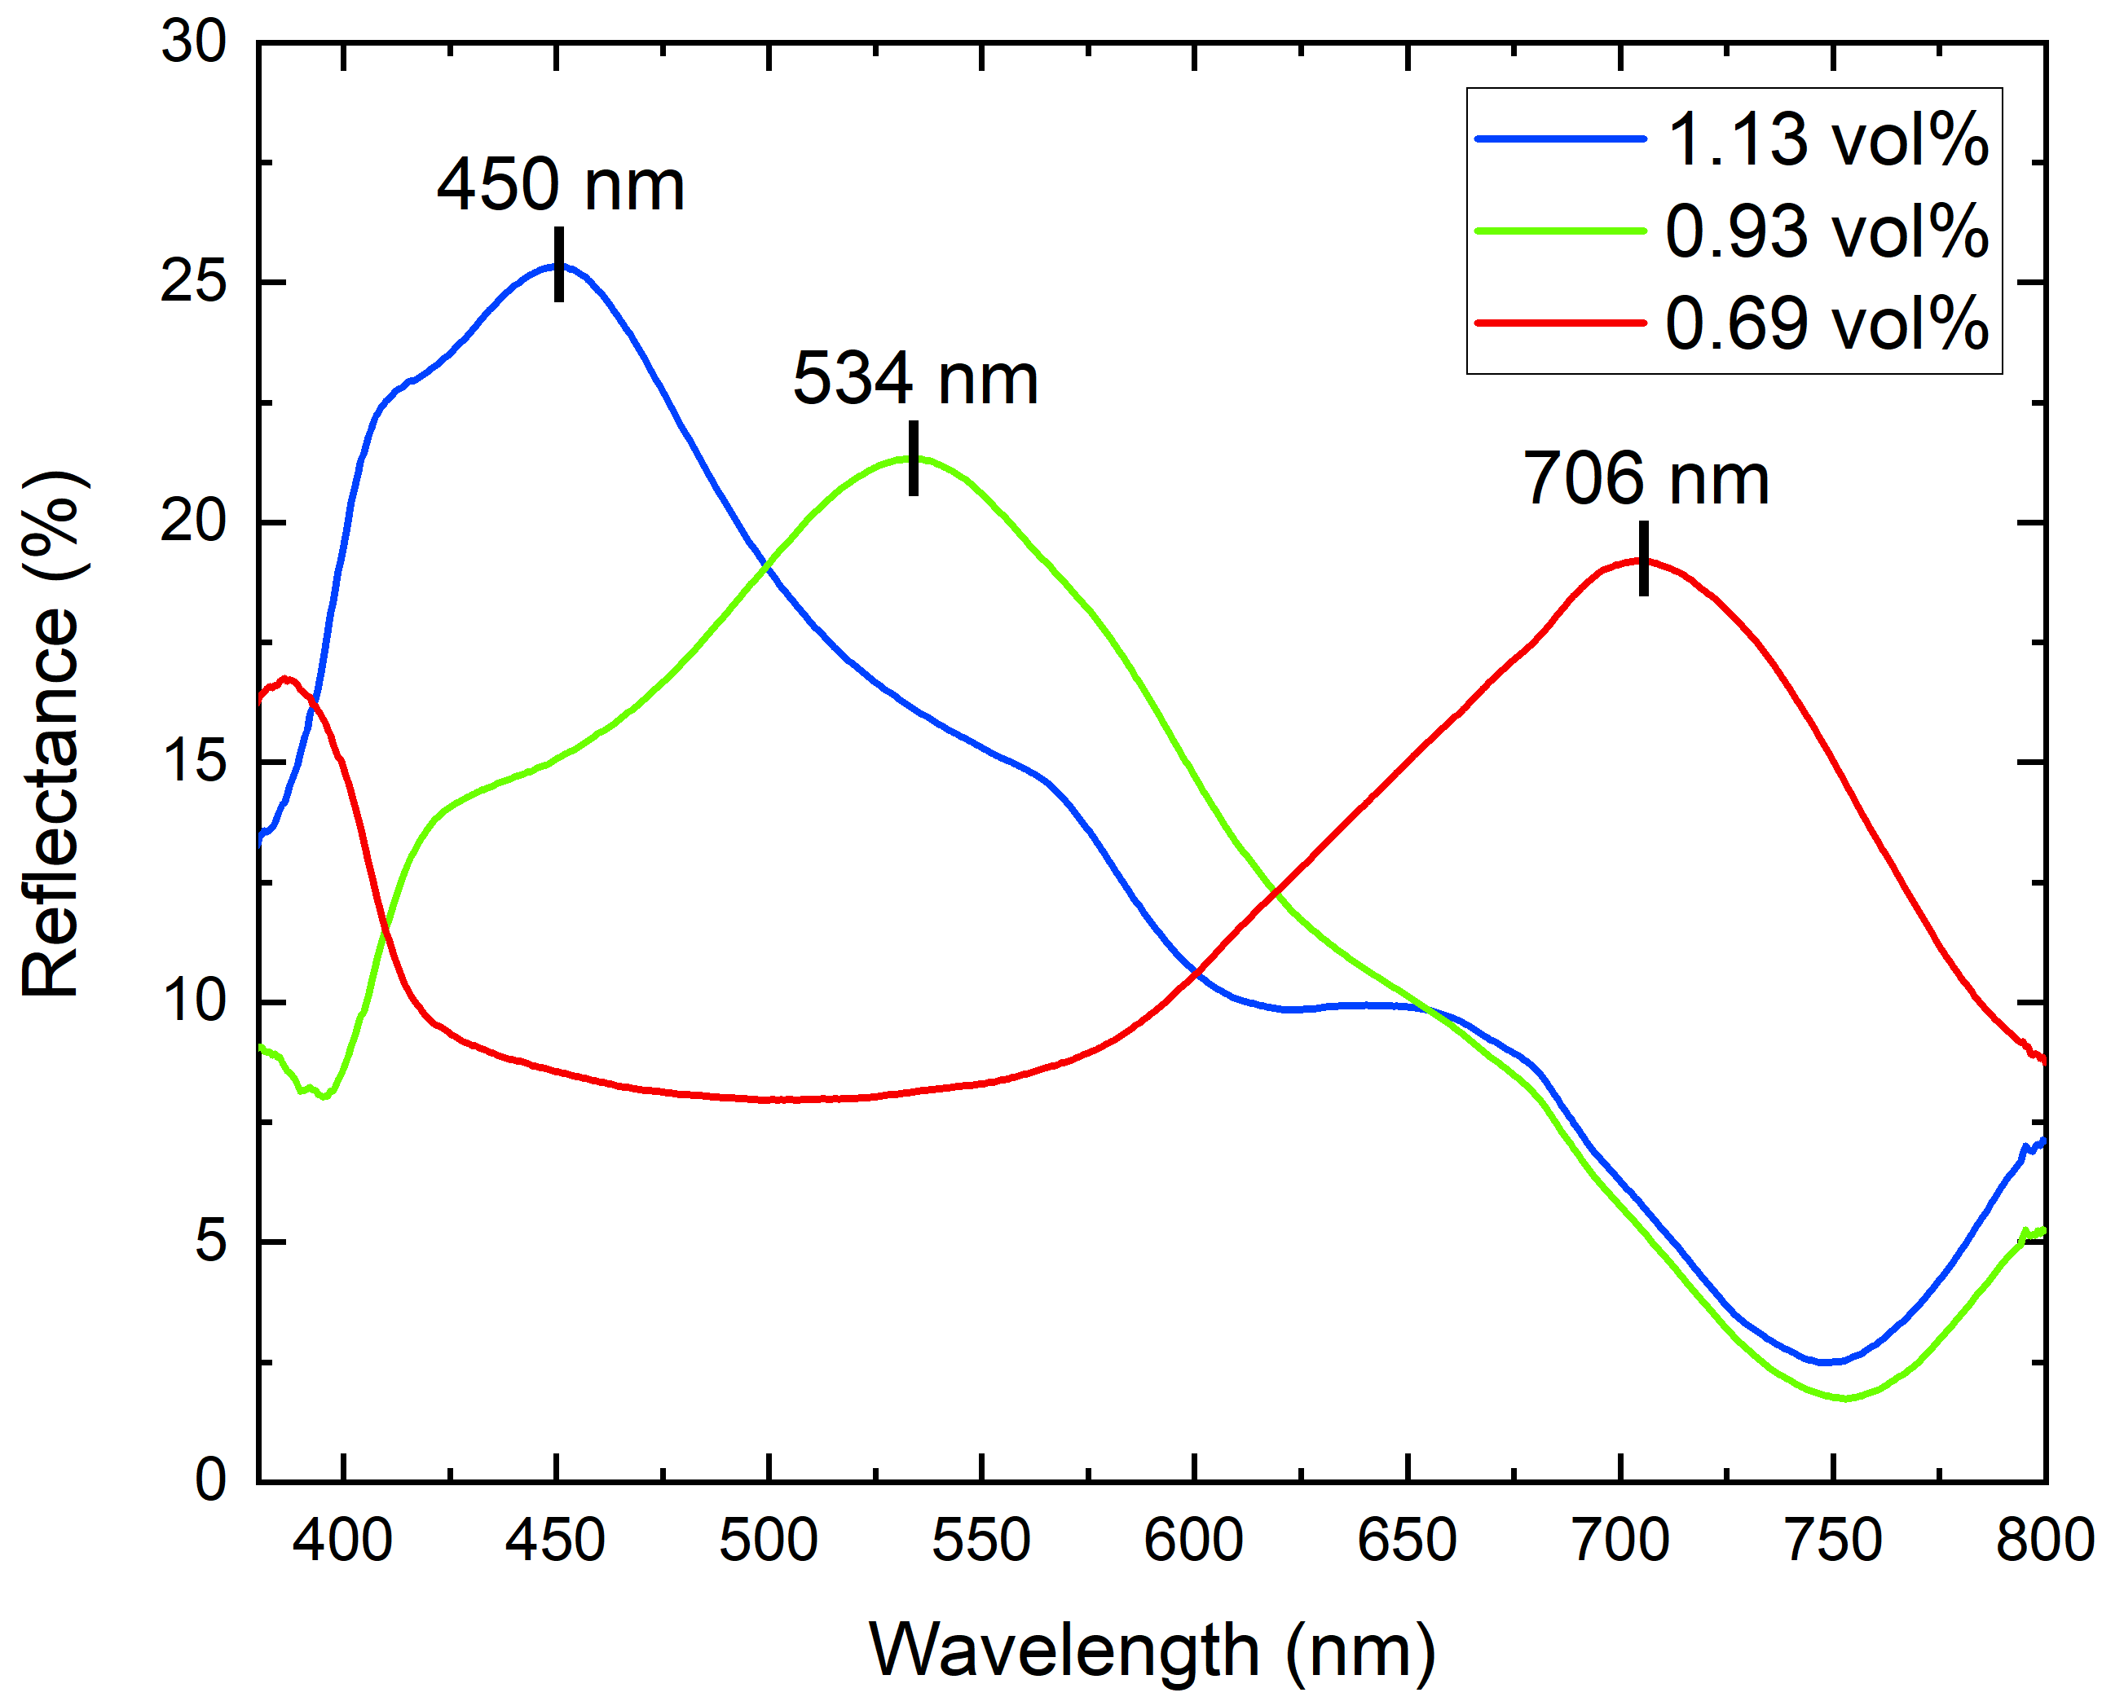
Fig. S1 - Reflectance spectra of DBL suspensions. DBL samples used for structural coloration displaying similar colors to our samples (Data from Michels-Brito et al. Sci. Adv. 2022, 8 (4), doi: 10.1126/sciadv.abl8147).
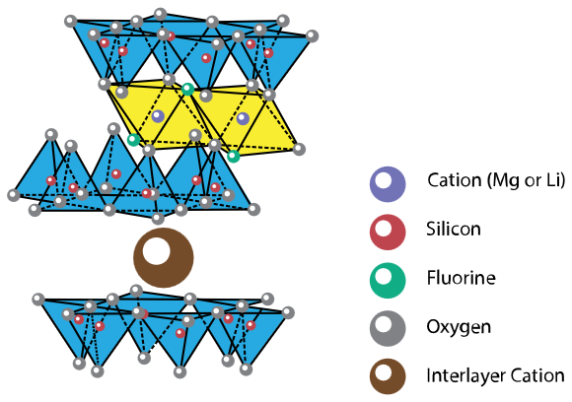
Fig. S2 - Crystalline structure of Na-Fluorohectorite clay. The clay nanosheets are composed of one octahedral layer, in yellow, sandwiched between two tetrahedral layers, in blue. Inside the octahedral layer, the purple spheres are magnesium and lithium cations. While inside the tetrahedral layer only silicon is found (red spheres). The green spheres are fluorine, and the gray spheres are oxygen. The big brown sphere is the interlayer cation, in our case, either always $Na^{+}$ for the SGL samples or $Na^{+}$ alternating with $Cs^{+}$ in the case of the DBL samples.

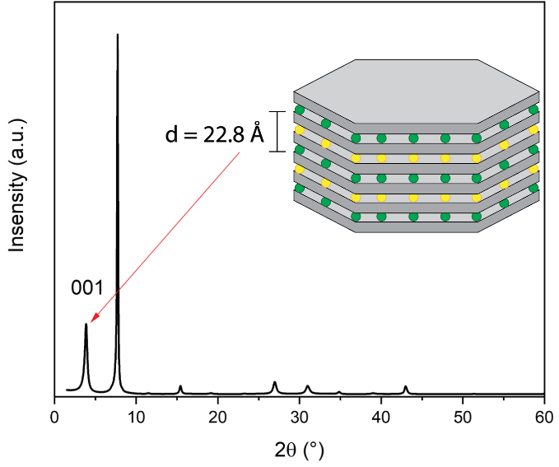
Fig. S3 – X-ray diffractogram of clay particle with ordered interstratification. The 001 peak gives d = 22.8 Å, which is a sum of an interlayer with a hydrated $Na^{+}$ cation ($\sim 12.5 Å$) and another interlayer with a $Cs^{+}$ which is not solvated with water ($\sim 10.1 Å$).
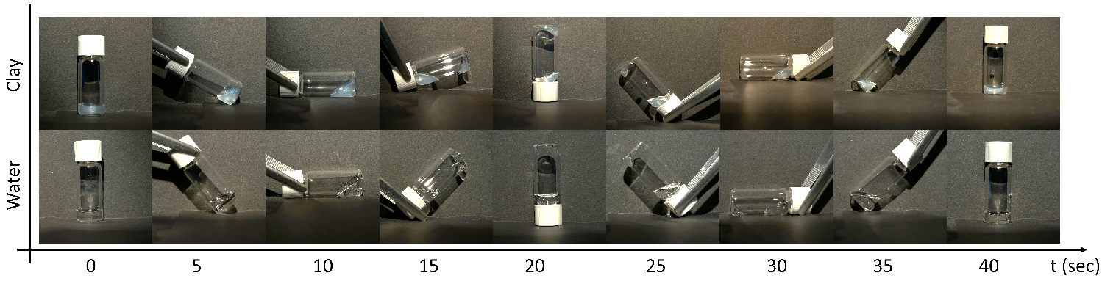
Fig. S4 - Flow behavior of a DBL suspension compared to water. The suspensions are turned, starting at 0 ° (vertical), doing a 360 ° rotation and taking pictures every 5 seconds. A blue DBL suspension and pure water sample were rotated to display the liquid behavior, showing that the clay suspension is not in a gel state.
- SAXS data
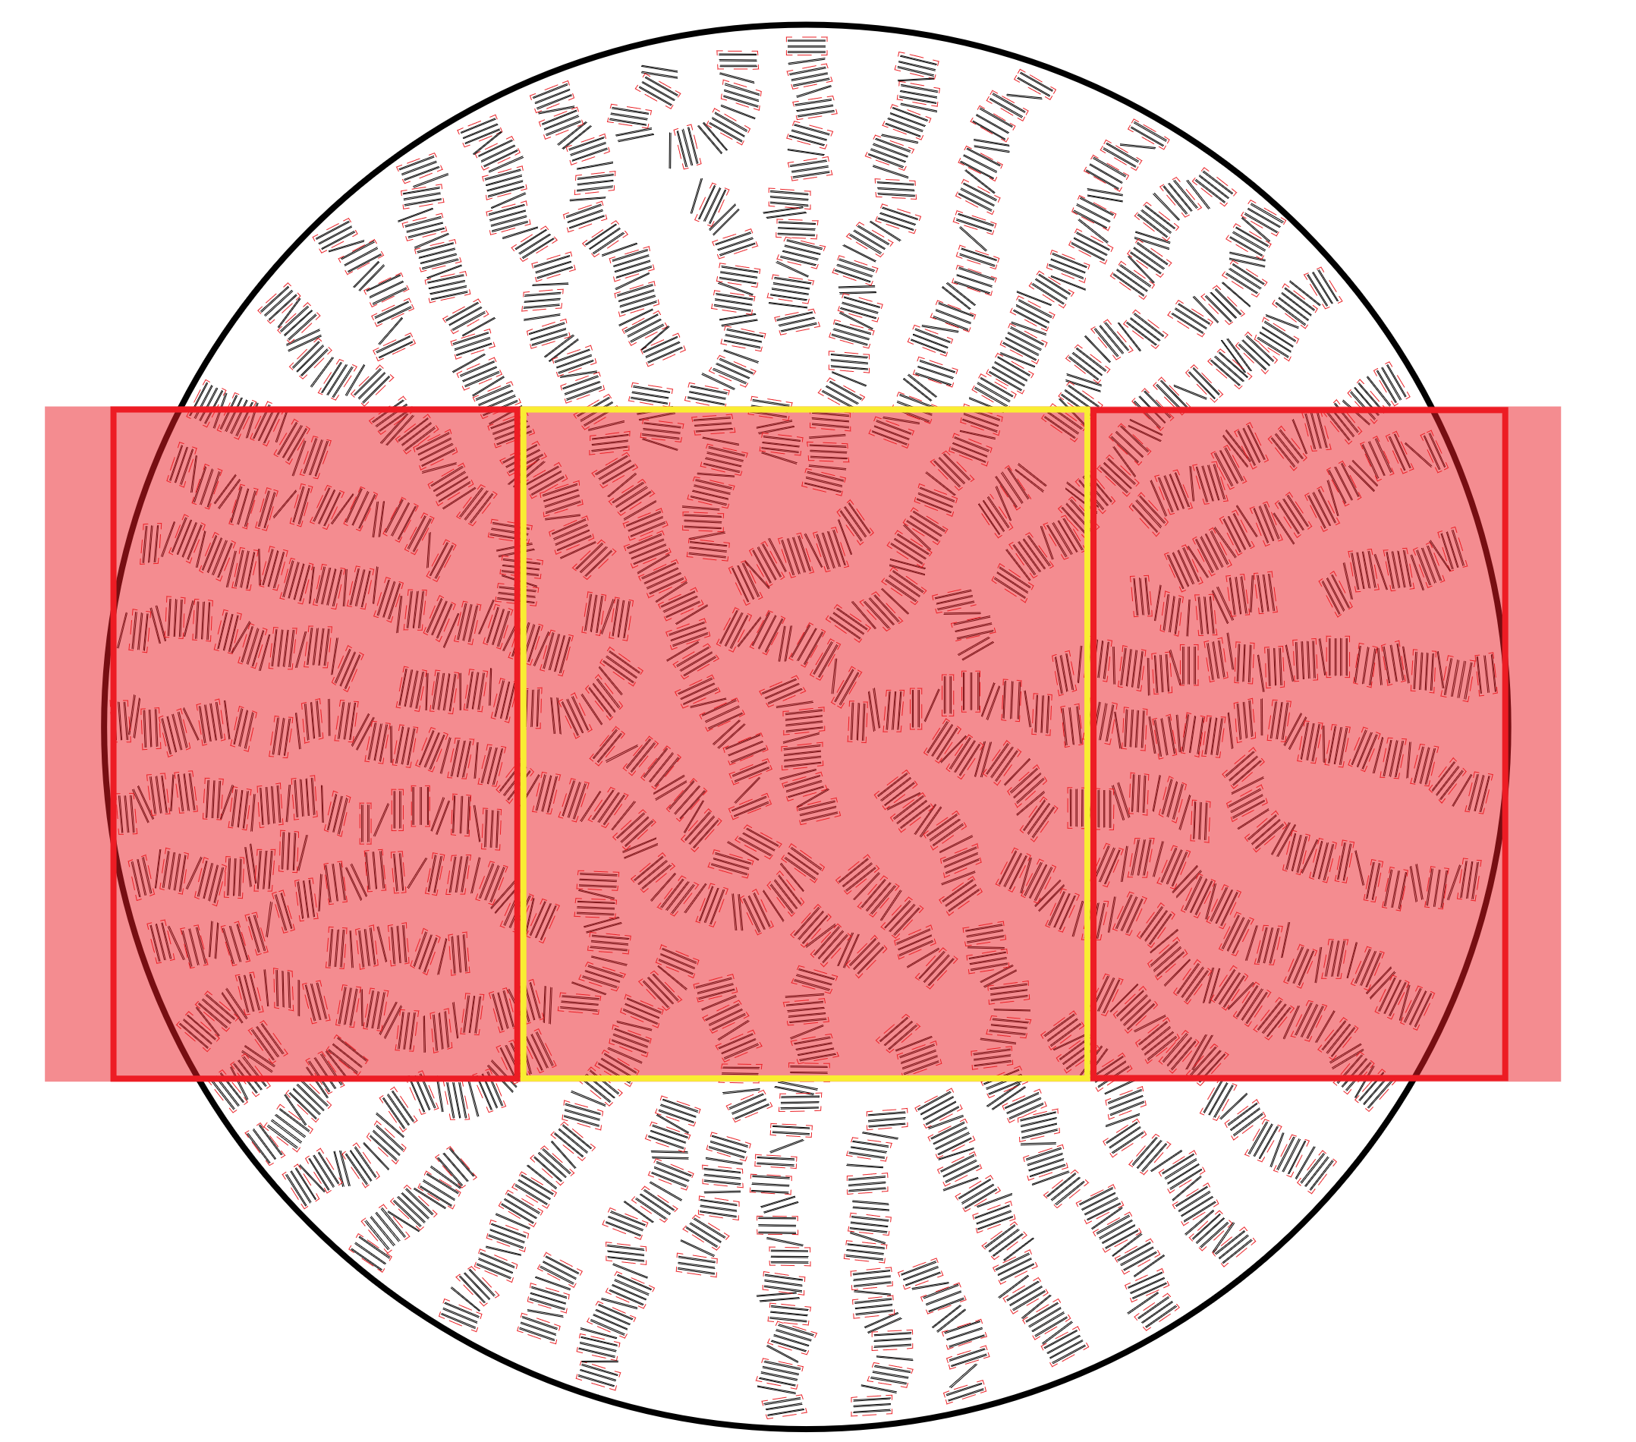
Fig. S5 – Sketch of the effective scattering volume for capillaries. The yellow zone represents the main scattering volume in the capillary case, while only a few nematic domains in the red zones contribute to it. Note that the aspect ratio of nanosheets in coplanar arrangement are not to scale by fare and that they are shifted relative to each other resembling a nematic phase.

Table S1 - Fit results for DBL and SGL suspensions for different ϕ values and the two container geometries. Their d-spacing d, the d-spacing displacement Δd and coherence length obtained from the fitting in Scatter. The standard error is assumed to be 1% for all the model parameters.
Sample Name | ϕ (%) | Container Type | d (nm) | Displacement Δd  (nm) | Relative displacement $(\frac{Δd}{d}*100)$  (%) | Ideal coherence length $ξ$ $=\frac{d^{2}}{Δd}$ (nm) | Correlation length after melting (nm)
DBL Blue | 1.15 | Capillary | 148 | 20 | 13.5 | 1095 | 237
DBL Blue | 1.15 | Cuvette | 152 | 20 | 13.2 | 1155 | 260
DBL Green | 0.92 | Capillary | 177 | 20.7 | 11.7 | 1513 | 300
DBL Green | 0.92 | Cuvette | 189 | 19.5 | 10.3 | 1832 | 365
DBL Orange | 0.68 | Capillary | 213 | 26.3 | 12.3 | 1725 | 369
DBL Orange | 0.68 | Cuvette | 242 | 25 | 10.3 | 2342 | 500
SGL Blue | 0.48 | Capillary | 150 | 24 | 16.0 | 937 | 300
SGL Blue | 0.48 | Cuvette | 158 | 28 | 17.7 | 891 | 320
SGL Green | 0.40 | Capillary | 165 | 30 | 21.2 | 919 | 350
SGL Green | 0.40 | Cuvette | 192 | 29 | 15.1 | 1271 | 400
SGL Orange | 0.28 | Capillary | 213 | 47.3 | 22.2 | 959 | 400
SGL Orange | 0.28 | Cuvette | 245 | 43 | 17.5 | 1395 | 450

$SasView 5.0.4$
Since a proper model did not previously exist on the software’s list, a combination of two different models was applied. The first model being the “Power Law” representing the form factor contribution from the nematically ordered coherent sub-domains, and the second model being the “Lamellar Stack Paracrystal”, representing the scattering (form factor and structure factor) from the lamellar ordering internally in the coherent sub-domains. Within the investigated q-range the clay layers have infinite lateral dimensions. This gives a final scattering intensity:
$$I\left(q\right)=A*q^{-n}+ B*\frac{P_{bil}\left(q\right)}{q^{2}}Z_{N}\left(q\right)+background$$
$A and B$ are relative scaling parameters for the two models. $A and B$ include terms for the volume fraction of the material and the contrast $Δρ$, among others. The power, $n$ , was at first set free and quickly converged to a value very close to $2$, and therefore it was fixed at $2$ for all the diffractograms, as is expected for the form factor of platelets. The factor $P_{bil}\left(q\right)$ in the “Lamellar Stack Paracrystal model” is approximated as the cross section of an infinite, planar bilayer of thickness $t$. $Z_{N}\left(q\right)$ is the structure factor which describes the interference effects of Bragg stack domains consisting of more than one bilayer. Both models have background terms in them, which in this description are merged as $background$. More details on the functions used for modeling can be found in SasView’s documentation (https://www.sasview.org/docs/old_docs/5.0.4/user/qtgui/Perspectives/Fitting/models/index.html).

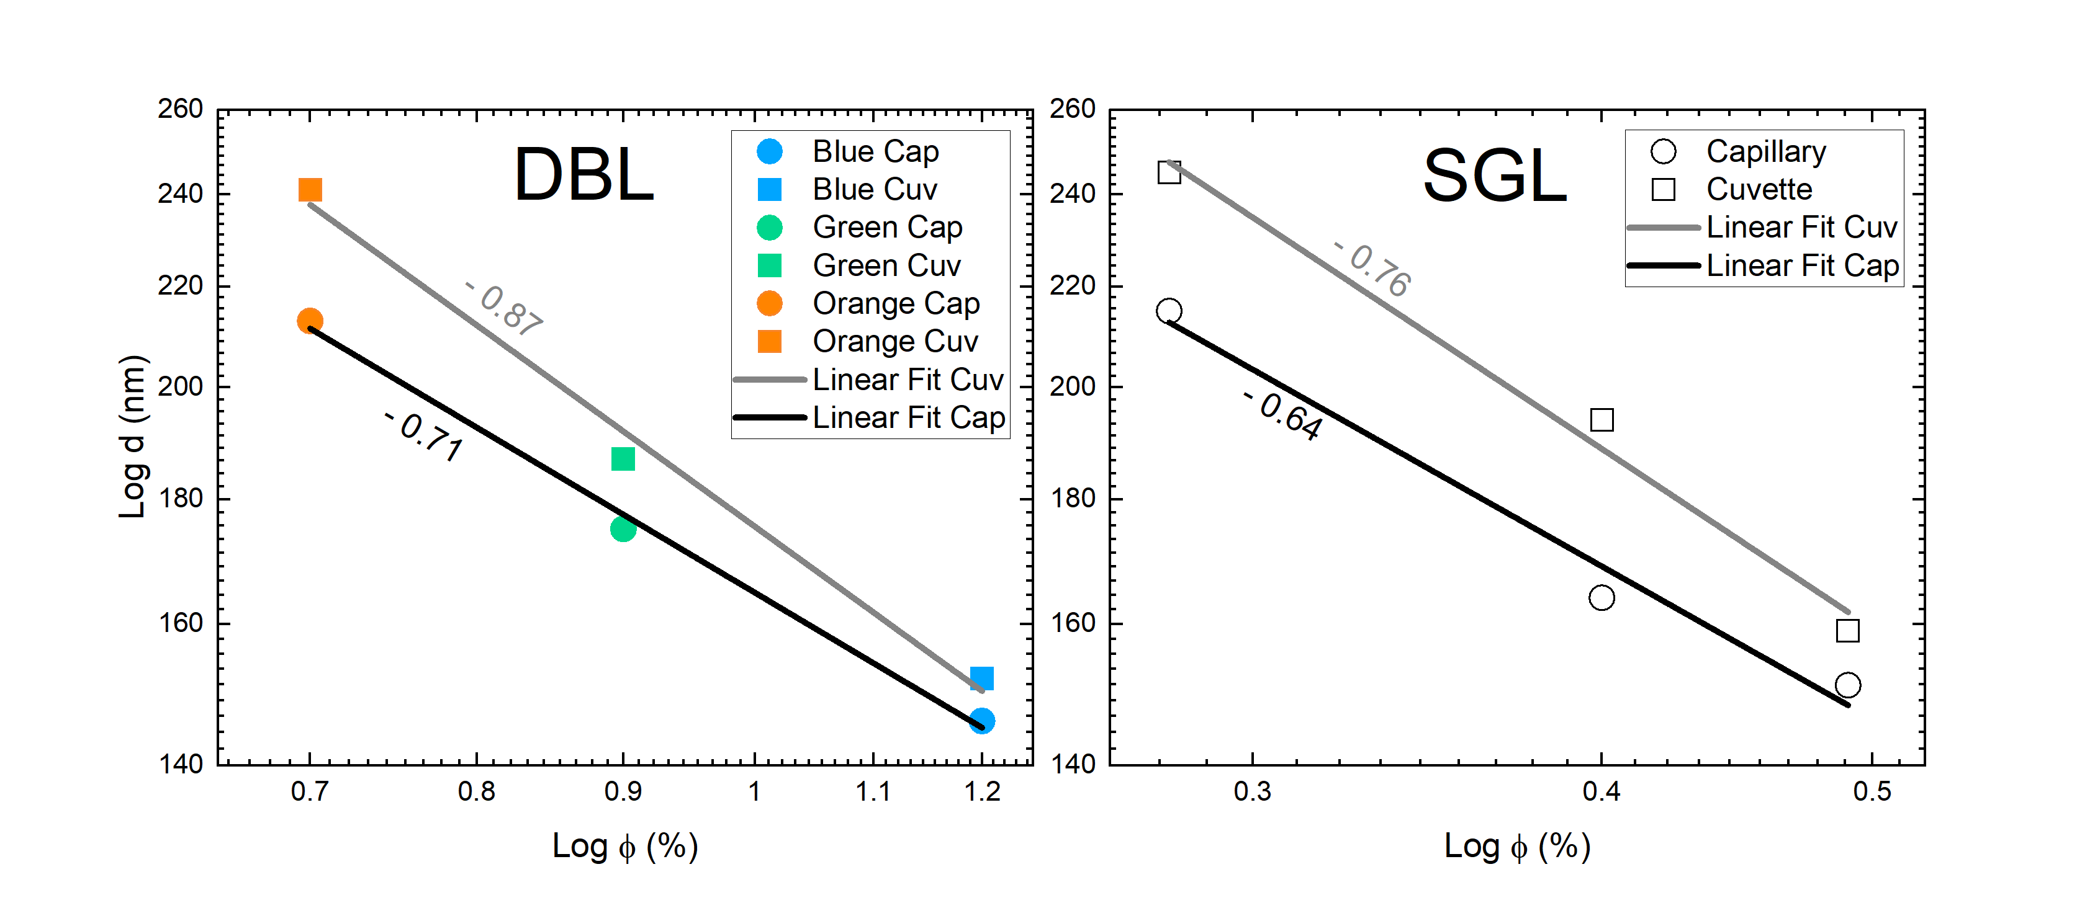
Fig. S6 - Power law behavior of d-spacings obtained by using SasView for modeling. $log-log$ plots of d-spacing versus volume % for DBL and SGL suspensions with their respective fits (for samples in cuvettes, Cuv, and in capillaries, Cap).
Normalized intensity vs. Azimuthal angle:
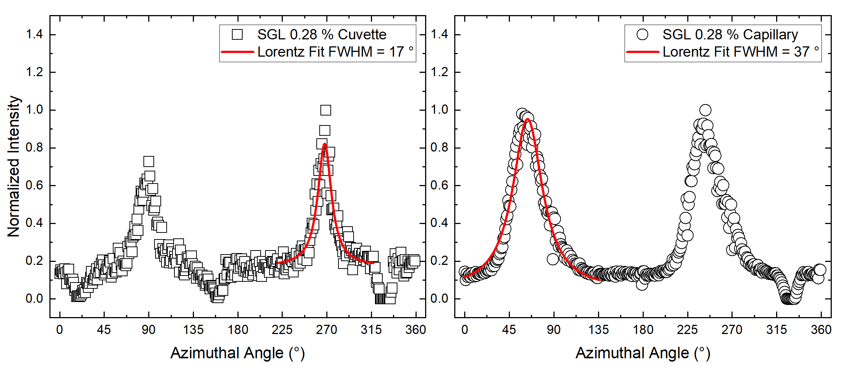
Fig. S7- Azimuthal angle plots for SGL samples. The $0.28 \%$ SGL solution in cuvette (left) and capillary (right) are shown. Similar to DBL, the FWHM for cuvette samples is smaller than for capillaries.

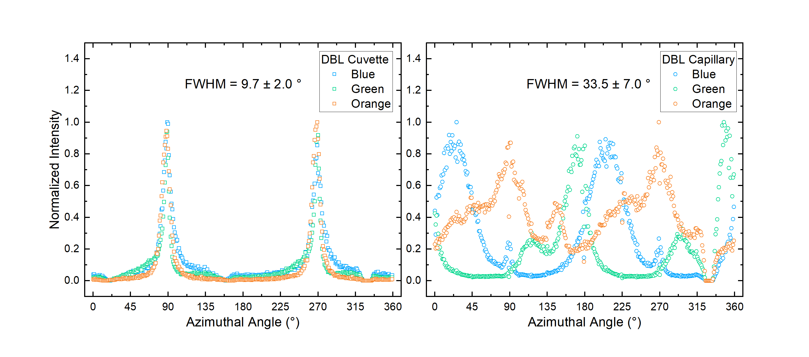
Fig. S8 - Azimuthal angle plots for DBL in cuvettes and capillaries. The normalized intensities vs. azimuthal angle for all three concentrations of DBL in cuvettes and capillaries are shown.

Movies:
Movie S1 – Demonstration of wall anchoring of the subdomains by rotating the capillary shown in Fig. 2 (c) by $180°$ around its axis. This also demonstrates that the structural coloration comes from Bragg interference and not from refraction, which would result in iridescence during such a rotation. Turning the samples shows that parts of the samples may appear more iridescent than others, however this may be a result of the removal of the injection syringe which causes some non-uniformity in the concentration of the suspension.

