Timeline
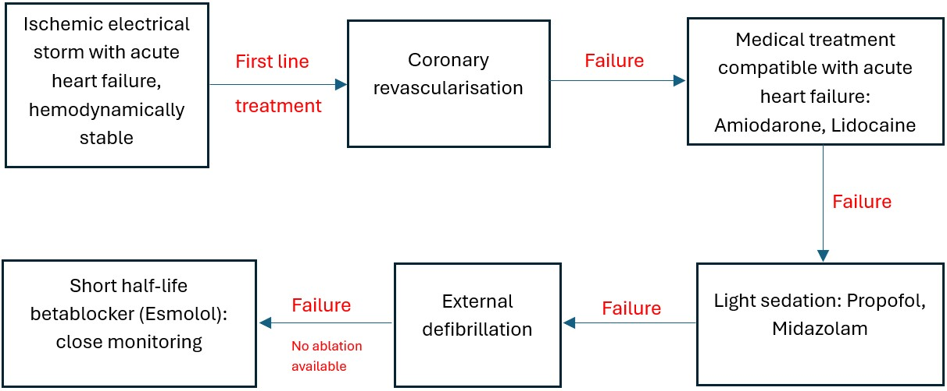
Timeline. Despite being theoretically contraindicated in acute decompensated heart failure, Esmolol, a unique intravenous betablocker due to its short half-life and thus his rapid elimination, can be safely used under close monitoring to terminate electrical storm resistant to other drugs and therapy, without causing a cardiogenic shock.

