A mono-coordinated gallium(I) ambiphile with redox-active and redox-inert reactivity
Simon H. F. Schreiner,^{[a]} Tobias Rüffer,^{[a]} and Robert Kretschmer^{*[a,b]}

a) Institute of Chemistry, Chemnitz University of Technology, Straße der Nationen 62, 09111 Chemnitz, Germany
b) Jena Center for Soft Matter (JCSM), Friedrich Schiller University Jena, Philosophenweg 7, 07743 Jena, Germany

E-mail: robert.kretschmer@chemie.tu-chemnitz.de

Table of contents
1. Experimental Details 3
1.1 General Information 3
1.2 Characterization 3
1.3 Synthetic Procedures 5
2. Crystallographic Details 15
3. Computational details 24
4. Spectra 27
5. XYZ-coordinates 52
6. References 62

Experimental Details

General Information
All preparations were performed under an inert atmosphere of dinitrogen by means of standard Schlenk-line and glovebox (GS Systemtechnik and MBraun) techniques. Prior to usage, all glassware was stored in a 120 °C oven overnight. n-Pentane was distilled from LiAlH₄ while toluene was distilled from sodium. Tetrahydrofuran (THF) was distilled from sodium/benzophenone. Benzene-d₆ (99.5 %, Eurisotop) and toluene-d₈ (99.5 %, deutero) were distilled from sodium while DCM-d₂ (99.6 %, deutero) was distilled from CaH₂. All solvents were stored over molecular sieves (4 Å). ^{t}Bu-M^{s}Fluind–Br,^{1–3} ^{t}Bu-M^{s}Fluind–Li·THF,³(modified procedure, see synthetic procedure) and GaCp*⁴ were synthesized according to literature procedures. Sodium (coated in a film of protective hydrocarbon oil, 99 %) was purchased from Alfa Aesar. Iodomethane (99 %, stabilized with silver) was purchased from abcr. 4-Dimethylaminopyridine (DMAP, 99 %) and 3,3-dimethyl-1-butyne (96 %) were purchased from TCI. Hexafluorobenzene (99 %) and 1-azidoadamantane (97%) were purchased from sigmaaldrich. Phenylacetylene (98 %) and diphenylacetylene (99 %) were purchased from thermo fisher scientific. All liquid reagents were stored over molecular sieves (4 Å).

Characterization
¹H chemical shifts are referenced to the residual solvent signals of benzene-d₆ (¹H, 7.16 ppm), toluene-d₈ (¹H, 7.09, 7.01, 6.97, 2.08 ppm), and dichloromethane-d₂ (¹H, 5.32 ppm). ¹³C chemical shifts are referenced to the residual solvent signals of benzene-d₆ (¹³C, 128.06 ppm), toluene-d₈ (¹³C, 137.48, 128.87, 127.96, 125.13, 20.43 ppm), and dichloromethane-d₂ (¹³C, 53.84 ppm). The chemical shifts are reported in δ [ppm] and the coupling constants J are given in Hertz [Hz]. NMR experiments were performed at room temperature (293 K) on a Bruker Avance III-500 MHz spectrometer or on a Bruker Avance Neo-600 MHz spectrometer. ⁷Li chemical shifts are referenced relative to LiCl. ¹⁹F{¹H} chemical shifts are referenced relative to CFCl₃. Assignment of the signals: s = singlet, d = doublet, dd = doublet of doublets, t = triplet, q = quartet, m = multiplet, br = broad signal.

Elemental analyses were performed on site by Khrystyna Gerlach using a Vario MICRO cube from Elementar Analysensysteme GmbH. The samples were prepared under an inert nitrogen glovebox atmosphere and loaded in a tin boat. The combustion of the substance takes place in a combustion tube at 1150 °C in a helium atmosphere enriched with oxygen. During combustion, the gaseous products CO₂, H₂O, N₂, NO, NO₂, SO₂, and SO₃ are formed from C, H, N, and S elements. In a downstream reduction tube (filled with wire-shaped copper), the nitrogen oxides and sulfur oxides are reduced to N₂ and SO₂. The gas mixture is separated in U-shaped separation columns on special adsorbents. After separation, the gases are quantitatively detected with a thermal conductivity detector (WLD).
Solution high-resolution mass spectrometry (HRMS) analysis was performed by Khrystyna Gerlach on a timsTOF Pro device from Bruker Daltonik GmbH. Solid samples were prepared under an inert nitrogen glovebox atmosphere in a Schlenk vessel. The dissolved (DCM) samples were injected directly. Samples were measured with an electrospray ionization (ESI) source in positive mode. An ESI-Tune Mix from Agilent was used as the calibration substance. Calibration was performed in the mass range m/z: 50-3000.
ESI-source parameters: Scan Range m/z: 50-3000; Capillary Voltage: 4500 V; Nebulizer: 0.4 bar; Dry Gas Flow (N₂): 4.0 l/min; Dry Heater Temperature: 180 °C.
Table S1. Quadrupole Parameter for compounds 3 and 4.
 | 3 | 4
Ion Energy [eV] | 2.0 | 5.0
Collision Energy [eV] | 3.0 | 3.0
Collision Cell RF [Vpp] | 1200.0 | 1200.0
Transfer Time [µs] | 95.0 | 100.0
PrePulse Storage Time [µs] | 10.0 | 10.0

IR spectra (given in cm⁻¹) were recorded with an Agilent Cary 630 FT-IR spectrometer using a diamond ATR unit inside a nitrogen-filled glovebox.

Synthetic Procedures

Synthesis of ^{t}Bu-M^{s}Fluind–Li·THF 1 (modified literature procedure)³
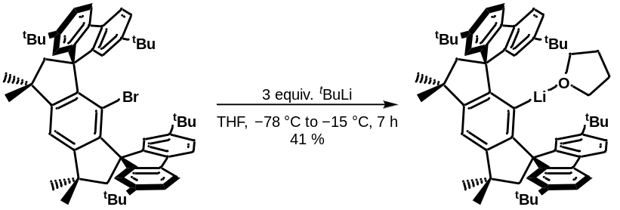
Inside a Glovebox, a Schlenk flask was charged with ^{t}Bu-M^{s}Fluind–Br (3.00 g, 3.67 mmol, 1.0 equiv.) and suspended in THF (16 mL). The Schlenk tube was connected to a Schlenk line, the suspension cooled down to –78 °C and tert-butyllithium (1.7 M in pentane, 11.01 mmol, 3.0 equiv.) added slowly, which led to an immediate yellow coloration. The yellow mixture was stirred at –78 °C for 2 hours and stirred for a further 7 hours at –15 °C to give a pale-brown/orange suspension. All volatiles were removed in vacuo and the off-white/pale-yellow solid residue was dried in vacuo for 20 min. Subsequently, the product was extracted with toluene (25 mL) to give a yellow solution, which was concentrated to a volume of ca. 15 mL. The Schlenk flask was stored at –25 °C for 12 h and after that time colorless crystals were isolated by filtration, washed with n-pentane (3 x 4 mL) and dried in vacuo to give ^{t}Bu-M^{s}Fluind–Li·THF 1 as white solid (1.23 g, 1.51 mmol, 41 %).
¹H NMR (500 MHz, C₆D₆): δ [ppm] = 7.52 (d, J = 1.8 Hz, 4H, H^{Ar}), 7.38 (d, J= 7.9 Hz, 4H, H^{Ar}), 7.21 (s, 1H, H^{Ar}), 7.12 (dd, J = 8.0, 1.8 Hz, 4H, H^{Ar}), 2.64 (s, 4H, 2xCH₂), 2.52 – 2.47 (m, 8H, THF), 1.82 (s, 12H, 4xCH₃), 1.22 (s, 36H, ^{t}Bu), 1.18 – 1.14 (m, 8H, THF).
⁷Li NMR (194 MHz, C₆D₆): δ [ppm] = 0.0
¹³C{¹H} NMR (126 MHz, C₆D₆): δ [ppm] = 160.5, 157.8, 150.1, 146.6, 137.7, 122.9, 122.8, 118.2, 111.0, 68.2 (THF), 67.3, 57.9, 42.8, 35.0, 34.2, 31.9, 25.4 (THF).

Synthesis of ^{t}Bu-M^{s}Fluind–Ga^{I} 2
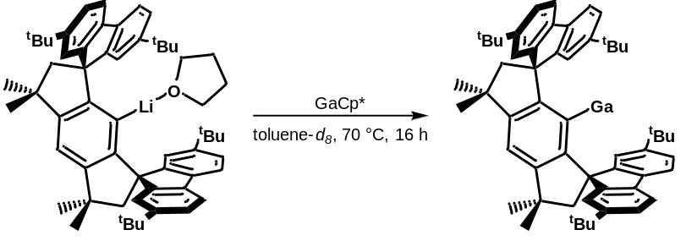
Inside a Glovebox, a J. Young NMR tube was charged with a solution of ^{t}Bu-M^{s}Fluind–Li·THF (20 mg, 0.0225 mmol, 1.0 equiv.) in toluene-d₈ (0.5 mL). GaCp* (4.6 mg, 0.0225 mmol, 1.0 equiv.) was added via Hamilton syringe. The J. Young NMR tube was heated at 70 °C for 16 hours to give a sticky yellow mixture. Yellow crystals of ^{t}Bu-M^{s}Fluind–Ga^{I} were observed at the wall of the NMR tube (see Figure S1) by thermal convection, which could be reproduced. It was not possible to isolate ^{t}Bu-M^{s}Fluind–Ga^{I} by applying vacuo since an immediate decolorization to a white solid was observed. NMR spectroscopy identified the white solid to be proteo-ligand ^{t}Bu-M^{s}Fluind–H. Thus, ^{t}Bu-M^{s}Fluind–Ga^{I} was freshly prepared in toluene or benzene solutions and directly used for further reactions.
¹H NMR (500 MHz, toluene-d₈): δ [ppm] = 7.37 (d, J = 8.1 Hz, 4H, H^{Ar}), 7.35 (d, J = 1.8 Hz, 4H, H^{Ar}), 7.14 (dd, J = 8.0, 1.8 Hz, 4H, H^{Ar}), 7.07 (s, 1H, H^{Ar}), 2.44 (s, 4H, 2xCH₂), 1.60 (s, 12H, 4xCH₃), 1.20 (s, 36H, ^{t}Bu).
¹³C{¹H} NMR (126 MHz, toluene-d₈): δ [ppm] = 174.1 (C₁), 158.2 (C^{Ar}), 156.1 (C^{Ar}), 155.6 (C^{Ar}), 151.5 (C^{Ar}), 150.2 (C^{Ar}), 124.2 (C^{Ar}), 121.9 (C^{Ar}), 120.3 (C^{Ar}), 115.7 (C₇), 64.7 (C_{3,11}), 55.0 ($C_{4,10}^{CH2}$), 44.5 ($C_{5,9}^{Me(q)}$), 35.1 ($C_{29,33,49,53}^{tBu(q)}$), 33.3 ($C_{13,14,15,16}^{Me}$), 31.8 ${(C}_{Me}^{tBu}$).
For elemental analysis and ATR-IR spectroscopy, yellow crystals were separated from the solution and the solvent slowly evaporated over three weeks inside a nitrogen-filled glovebox.
Elemental Analysis for C₅₆H₆₅Ga: C, 83.26; H, 8.11. Found (%): C, 83.09; H, 9.01.
IR [cm⁻¹]: 3007, 2949, 2902, 2861, 2274, 1609, 1577, 1473, 1457, 1412, 1388, 1359, 1251, 1192, 1116, 871, 818, 743, 541.
The ¹H NMR spectra of ^{t}Bu-M^{s}Fluind–Br and ^{t}Bu-M^{s}Fluind–Ga^{I} were compared to exclude the presence of Br instead of Ga (see Figure S26 and S27). Additionally, the IR spectrum was recorded to exclude the formation of a dihydride species (see Figure S25). Final prove of the low valent Gallium(I) compound was achieved by oxidative addition of iodomethane (see below, synthesis of ^{t}Bu-M^{s}Fluind–Ga^{III}MeI 3).

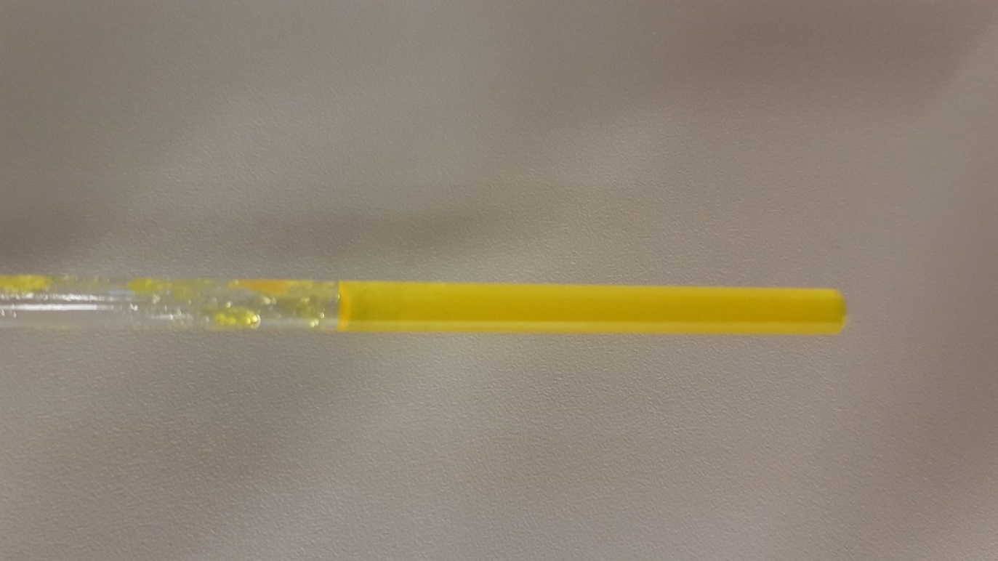
Figure S1. After heating ^{t}Bu-M^{s}Fluind–Li·THF and GaCp* at 70 °C overnight inside a J. Young NMR tube an intense yellow color of ^{t}Bu-M^{s}Fluind–Ga^{I} (toluene-d₈) was observed.

Synthesis of ^{t}Bu-M^{s}Fluind–Ga^{III}MeI 3
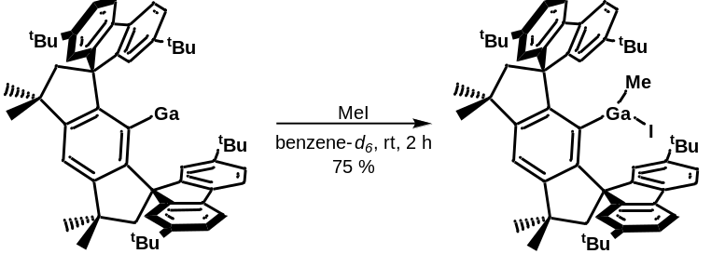
Inside a Glovebox, a J. Young NMR tube was charged with a solution of ^{t}Bu-M^{s}Fluind–Li·THF (30 mg, 0.0367 mmol, 1.0 equiv.) in benzene-d₆ (0.45 mL). A solution of GaCp* (7.5 mg, 0.0367 mmol, 1.0 equiv.) in benzene-d₆ (0.15 mL) was added to the NMR tube and heated at 75 °C for 3 days to give a sticky yellow mixture. Iodomethane (5.2 mg, 0.0367 mmol, 1.0 equiv.) was added and the NMR tube rotated for 2 hours at room temperature. Subsequently, all volatiles were removed in vacuo, the white residue washed with pentane (3 x 1 mL) and dried again in vacuo to give ^{t}Bu-M^{s}Fluind–Ga^{III}MeI (26 mg, 0.0274 mmol, 75 %) as white solid. XRD-quality crystals were grown from a concentrated toluene solution at –30 °C or by slow evaporation of a benzene solution.
¹H NMR (500 MHz, DCM-d₂): δ [ppm] = 7.41 (d, J = 8.0 Hz, 2H, H^{Ar}), 7.36 (d, J = 8.0 Hz, 2H, H^{Ar}), 7.29 (s, 2H, H^{Ar}), 7.27 (d, J = 1.8 Hz, 1H, H^{Ar}), 7.22 (dd, J = 8.0, 1.8 Hz, 2H, H^{Ar}), 7.10 (d, J = 1.8 Hz, 2H, H^{Ar}), 7.07 (d, J = 1.8 Hz, 2H, H^{Ar}), 2.45 (d, J = 13.9 Hz, 2H, CH₂), 2.36 (d, J = 14.0 Hz, 2H, CH₂), 1.65 (s, 6H, 2xCH₃), 1.60 (s, 6H, 2xCH₃), 1.21 (s, 18H, ^{t}Bu), 1.19 (s, 18H, ^{t}Bu), -1.47 (s, 3H, GaMe).
¹³C{¹H} NMR (126 MHz, DCM-d₂): δ [ppm] = 154.0 (C^{Ar}), 153.6 (C^{Ar}), 152.7 (C^{Ar}), 152.1 (C^{Ar}), 151.7 (C^{Ar}), 151.7 (C^{Ar}), 141.9 (C^{Ar}), 138.6 (C^{Ar}), 136.7 (C^{Ar}), 126.3 ${(C}_{H}^{Ar}$), 125.4 ${(C}_{H}^{Ar}$), 122.8 ${(C}_{H}^{Ar}$), 122.3 ${(C}_{H}^{Ar}$), 120.1 ${(C}_{H}^{Ar}$), 119.8 ${(C}_{H}^{Ar}$), 118.2 ${(C}_{5}^{Ar}$), 64.4 (C_{8,13}), 57.0 ${(C}_{9,14}^{CH2})$, 44.1 (C_{10,15}), 35.2 ${(C}_{21,34-41,54}^{tBu(q)})$, 35.1 ${(C}_{21,34-41,54}^{tBu(q)})$, 33.4 ${(C}_{11,12-16,17}^{Me})$, 32.7 ${(C}_{11,12-16,17}^{Me})$, 31.7${(C}_{Me}^{tBu}$), 31.7 ${(C}_{Me}^{tBu}$), 5.7 C^{Ga-Me}).
HRMS (ESI): m/z calculated for [C₅₇H₆₈GaI]-I⁺: 821.4571 (M-I^{*+}); m/z found: 821.4572 (M-I^{*+}).
Elemental Analysis for C₅₇H₆₈GaI·C₆H₆: C, 73.61; H, 7.26. Found (%): C, 73.65; H, 7.30.

Synthesis of ^{t}Bu-M^{s}Fluind–Ga^{III}-(C₆F₅)-F·DMAP 4
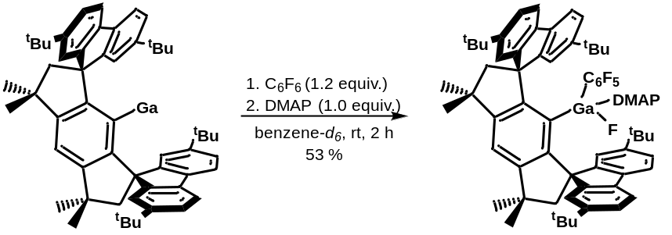
Inside a Glovebox, a J. Young NMR tube was charged with a solution of ^{t}Bu-M^{s}Fluind–Li·THF (30 mg, 0.0367 mmol, 1.0 equiv.) in benzene-d₆ (0.45 mL). A solution of GaCp* (7.5 mg, 0.0367 mmol, 1.0 equiv.) in benzene-d₆ (0.15 mL) was added to the NMR tube and heated at 70 °C for 16 hours to give a sticky yellow mixture. Hexafluorobenzene (8.19 mg, 0.044 mmol, 1.2 equiv.) and 4-dimethylaminopyridine (4.15 mg, 0.0367 mmol, 1.0 equiv.) were added and the NMR tube rotated for 2 hours at room temperature to give a pale orange solution. Subsequently, all volatiles were removed in vacuo, the white residue washed with pentane (3 x 1 mL) and dried again in vacuo. The product was extracted with benzene (0.5 mL) and filtered over Celite. XRD-quality crystals were grown by slow evaporation of a benzene solution at room temperature. The colorless crystals were isolated, washed with pentane (3 x 1 mL) and dried in vacuo to give ^{t}Bu-M^{s}Fluind–Ga^{III}(C₆F₅)F·DMAP (22 mg, 0.0194 mmol, 53 %) as white solid.
¹H NMR (500 MHz, C₆D₆): δ [ppm] = 7.76 (s, 2H, H^{Ar}), 7.63 (d, J = 1.8 Hz, 2H, H^{Ar}), 7.57 (s, 1H, H^{Ar}), 7.28 (dd, J = 7.9, 1.8 Hz, 2H, H^{Ar}), 7.18 (d, J = 1.8 Hz, 2H, H^{Ar}), 7.12 (d, J = 7.9 Hz, 2H, H^{Ar}), 6.99 (d, J = 7.9 Hz, 2H, H^{Ar}), 6.76 (d, J = 6.5 Hz, 2H, H^{DMAP}), 5.27 (d, J = 7.4 Hz, 2H, H^{DMAP}), 2.39 (d, J = 13.3 Hz, 2H, CH₂), 2.34 (d, J = 13.3 Hz, 2H, CH₂), 1.89 (s, 6H, 2xCH₃), 1.57 (s, 6H, 2xCH₃), 1.51 (s, 18H, ^{t}Bu), 1.48 (s, 24H, overlaying ^{t}Bu+Me^{DMAP}).
¹³C{¹H} NMR (126 MHz, C₆D₆): δ [ppm] = 156.0 (C^{Ar}), 155.7 (C^{Ar}), 155.3 (C^{Ar}), 153.6 (C^{Ar}), 150.0 (C^{Ar}), 149.8 (C^{Ar}), 149.4 (C^{Ar}), 145.4 ${(C}_{63,67-64,66}^{DMAP}$), 137.5 (C^{Ar}), 136.8 (C^{Ar}), 124.3${(C}_{H}^{Ar}$), 123.6 ${(C}_{H}^{Ar}$), 122.6 ${(C}_{H}^{Ar}$), 122.4 ${(C}_{H}^{Ar}$), 119.6 ${(C}_{H}^{Ar}$), 119.0 ${(C}_{5}^{Ar}$), 118.9 ${(C}_{15}^{Ar}), 106.4 {(C}_{63,67-64,66}^{DMAP}$), 67.4 (C_{9,21}), 63.7 ${(C}_{10,20}^{CH2})$, 41.8 (C_{11,17}), 38.0 ${(C}_{12,13-18,19}^{Me})$, 35.3 ${(C}_{26,38-46,57}^{tBu(q)})$, 35.2 ${(C}_{26,38-46,57}^{tBu(q)})$, 32.7 ${(C}_{68,69}^{Me(DMAP)})$, 32.0 ${(C}_{12,13-18,19}^{Me}$), 31.9 ${(C}_{Me}^{tBu})$, 31.9 ${(C}_{Me}^{tBu}$).
¹⁹F{¹H} NMR (565 MHz, C₆D₆): δ [ppm] = -119.3 (m, C₆F₅), -158.6 (t, J = 20.1 Hz, C₆F₅), -162.0 (m, C₆F₅), -182.1 (s, GaF).
HRMS (ESI): m/z calculated for [C₆₉H₇₅F₆GaN₂]-F⁺: 1095.5101 (M-F^{*+}); m/z found: 1095.5112 (M-F^{*+}).
Elemental Analysis for C₆₉H₇₅F₆GaN₂: C, 74.26; H, 6.77; N, 2.51. Found (%): satisfactory EA could not be obtained.
Synthesis of ^{t}Bu-M^{s}Fluind–Ga^{III}(N₄Ad₂) 5
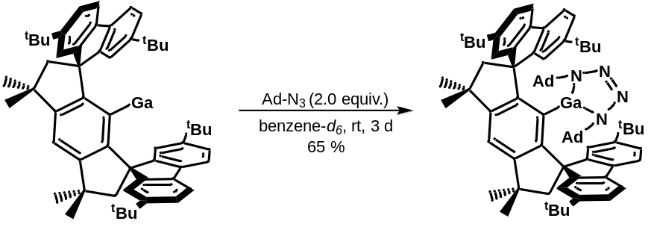
Inside a Glovebox, a J. Young NMR tube was charged with a solution of ^{t}Bu-M^{s}Fluind–Li·THF (30 mg, 0.0367 mmol, 1.0 equiv.) in benzene-d₆ (0.45 mL). A solution of GaCp* (7.5 mg, 0.0367 mmol, 1.0 equiv.) in benzene-d₆ (0.15 mL) was added to the NMR tube and heated at 80 °C for 16 hours to give a sticky yellow mixture. Then, 1-azidoadamantane (6.51 mg, 0.0367 mmol, 1.0 equiv.) in benzene-d₆ (0.1 mL) was added to the NMR tube. ¹H NMR spectroscopy indicated the presence of two compounds, starting material as well as the formation of a new compound in a ratio of 1:1. Thus, a second equivalent of 1-azidoadamantane (6.51 mg, 0.0367 mmol) was added, which gave a pale-yellow mixture. This mixture was rotated for 3 days at room temperature. ¹H NMR spectroscopy confirmed the consumption of the starting material and formation of a new compound. The solids were filtered off and slow evaporation of the resulting pale-yellow solution gave colorless crystals (XRD-quality), which were isolated, washed with pentane (2 x 1 mL) and dried in vacuo to give ^{t}Bu-M^{s}Fluind–Ga^{III}(N₄Ad₂) 5 (27 mg, 0.0239 mmol, 65 %) as white solid.
¹H NMR (500 MHz, DCM-d₂): δ [ppm] = 7.49 (s, 1H, H⁴), 7.38 (d, J = 8.0 Hz, 4H, H^{Ar}), 7.21 (dd, J = 8.0, 1.2 Hz, 4H, H^{Ar}), 7.01 (d, J = 1.7 Hz, 4H, H^{Ar}), 2.32 (s, 4H, $H_{8,13}^{CH2}$), 1.83 (br, 6H, $H_{CH}^{Ad}$), 1.63 (s, 12H, 4xCH₃), 1.54 (q, J = 12.5 Hz, 12H, $H_{CH2}^{Ad}$), 1.16 (s, 36H, ^{t}Bu), 1.07 (br, 12H, $H_{CH2}^{Ad}$).
¹³C{¹H} NMR (126 MHz, DCM-d₂): δ [ppm] = 154.3 (C^{Ar}), 152.8 (C^{Ar}), 151.1 (C^{Ar}), 150.7 (C^{Ar}), 137.9 (C^{Ar}), 125.5 ${(C}_{H}^{Ar}$), 123.1 ${(C}_{H}^{Ar}$), 119.7 ${(C}_{H}^{Ar}$), 119.4 ${(C}_{H}^{Ar}$), 66.7 (C_{7,12}), 58.4${(C}_{Fluind}^{CH2}$), 55.5 ${(C}_{57,67}^{Ad-N}$), 43.8 ${(C}_{Ad}^{CH2}$), 42.5${(C}_{9,14}^{Me(q)}$), 36.7 ${(C}_{Ad}^{CH2}$), 35.3 ${(C}_{29,33,49,53}^{tBu(q)}$), 33.4 ${(C}_{10,11,15,16}^{Me})$, 31.6 (C^{tBu}), 30.2 ${(C}_{Ad}^{CH})$.
Elemental Analysis for C₇₆H₉₅GaN₄: C, 80.47; H, 8.44; N, 4.94. Found (%): C, 80.54; H, 8.82; N, 4.73.

Synthesis of ^{t}Bu-M^{s}Fluind-C(H)=C-(Ga^{I})-Ph 6
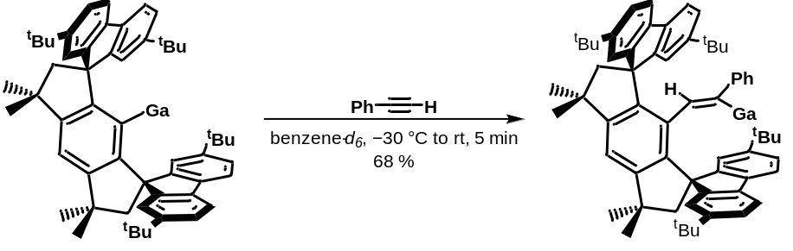
Inside a Glovebox, a J. Young NMR tube was charged with a solution of ^{t}Bu-M^{s}Fluind–Li·THF (30 mg, 0.0367 mmol, 1.0 equiv.) in benzene-d₆ (0.45 mL). A solution of GaCp* (7.5 mg, 0.0367 mmol, 1.0 equiv.) in benzene-d₆ (0.15 mL) was added to the NMR tube and heated at 70 °C for 16 hours to give a sticky yellow mixture. The NMR tube was cooled down to –30 °C and then phenylacetylene (3.75 mg, 0.0367 mmol, 1.0 equiv.) was added to the frozen mixture. The mixture was allowed to warm up to room temperature and the NMR tube was shaken for 5 min. Subsequently, the slightly turbid mixture was filtered to give a yellow solution. XRD-quality crystals were grown by slow evaporation a benzene solution at room temperature. The yellow crystals were isolated, washed with pentane (2 x 0.5 mL) and dried in vacuo to give ^{t}Bu-M^{s}Fluind-C(H)=C-(Ga^{I})-Ph 6 (23 mg, 0.025 mmol, 68 %) as yellow solid.
¹H NMR (500 MHz, C₆D₆): δ [ppm] = 7.65 (d, J = 1.8 Hz, 2H, H^{Ar}), 7.36 (d, J = 1.8 Hz, 2H, H^{Ar}), 7.32 (d, J = 7.9 Hz, 2H, H^{Ar}), 7.30 (s, 1H, H^{Ar}), 7.27 (d, J = 8.0, 2H, H^{Ar}), 7.14 – 7.10 (m, 4H, H^{Ar}), 7.04 (t, J = 7.6 Hz, 2H, H^{Ph}), 6.94 – 6.90 (m, 1H, H^{Ph}), 6.07 (d, J = 6.8 Hz, 2H, H^{Ph}), 5.18 (s, 1H, H^{vinyl}), 2.69 (d, J = 14.3 Hz, 2H, CH₂), 2.46 (d, J = 14.2 Hz, 2H, CH₂), 1.71 (s, 6H, 2xCH₃), 1.55 (s, 6H, 2xCH₃), 1.33 (s, 18H, ^{t}Bu), 1.26 (s, 18H, ^{t}Bu).
¹³C{¹H} NMR (126 MHz, C₆D₆): δ [ppm] = 174.1 (C-Ga), 155.4 (C^{Ar}), 154.9 (C^{Ar}), 153.7 (C^{Ar}), 150.6 (C^{Ar}), 149.7 (C^{Ar}), 143.9 (C^{Ar}), 143.2 (C^{Ar}), 138.5 (C^{Ar}), 138.4 (C^{Ar}), 133.7 (C^{Ar}), 127.6 ${(C}_{H}^{Ph})$, 127.5 ${(C}_{H}^{olefinic})$, 126.0 ${(C}_{H}^{Ph})$, 125.5 ${(C}_{H}^{Ar})$, 124.8 ${(C}_{H}^{Ph})$, 124.1 ${(C}_{H}^{Ar})$, 120.9 ${(C}_{H}^{Ar})$, 120.4 ${(C}_{H}^{Ar})$, 120.3 ${(C}_{H}^{Ar})$, 119.7 ${(C}_{H}^{Ar})$, 116.4 (C₄), 63.3 (C_{7,12}), 57.0 ${(C}_{8,13}^{CH2})$, 43.2 ${(C}_{9,14}^{Me(q)})$, 35.3 (C^{tBu(q)}), 34.9 (C^{tBu(q)}), 33.9 ${(C}_{10,11-15.16}^{Me}),$ 32.4 ${(C}_{10,11-15.16}^{Me}$), 31.9 ${(C}_{Fluind}^{tBu})$, 31.5 ${(C}_{Fluind}^{tBu})$.
Elemental Analysis for C₆₄H₇₁Ga: C, 84.47; H, 7.86. Found (%): C, 83.42; H, 7.95.

Synthesis of ^{t}Bu-M^{s}Fluind-C(H)=C-(Ga^{I})-^{t}Bu 7
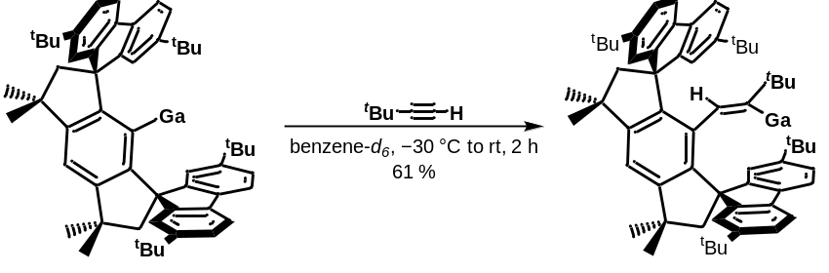
Inside a Glovebox, a J. Young NMR tube was charged with a solution of ^{t}Bu-M^{s}Fluind–Li·THF (30 mg, 0.0367 mmol, 1.0 equiv.) in benzene-d₆ (0.45 mL). A solution of GaCp* (7.5 mg, 0.0367 mmol, 1.0 equiv.) in benzene-d₆ (0.15 mL) was added to the NMR tube and heated at 70 °C for 16 hours to give a sticky yellow mixture. The NMR tube was cooled down to –30 °C and then 3,3-dimethyl-1-butyne (3.01 mg, 0.0367 mmol, 1.0 equiv.) was added to the frozen mixture. The mixture was allowed to warm up to room temperature and the NMR tube was rotated for 2 h. Subsequently, the slightly turbid mixture was filtered to give a yellow solution. XRD-quality crystals were grown by slow evaporation a benzene solution at room temperature. The yellow crystals were isolated, washed with pentane (2 x 0.5 mL) and dried in vacuo to give ^{t}Bu-M^{s}Fluind-C(H)=C-(Ga^{I})-^{t}Bu 7 (20 mg, 0.0224 mmol, 61 %) as a yellow solid.
¹H NMR (500 MHz, C₆D₆): δ [ppm] = 7.64 (d, J = 1.7 Hz, 2H, H^{Ar}), 7.55 (d, J = 7.9 Hz, 2H, H^{Ar}), 7.50 (d, J = 7.9 Hz, 2H, H^{Ar}), 7.40 (d, J = 1.8 Hz, 2H, H^{Ar}), 7.37 (s, 1H, H^{Ar}), 7.28 (dd, J = 8.0, 1.8 Hz, 2H, H^{Ar}), 7.25 (dd, J = 8.0, 1.8 Hz, 2H, H^{Ar}), 5.31 (s, 1H, H^{vinyl}), 2.65 (d, J = 13.9 Hz, 2H, CH₂), 2.31 (d, J = 14.0 Hz, 2H, CH₂), 1.70 (s, 6H, 2xCH₃), 1.50 (s, 6H, 2xCH₃), 1.35 (s, 18H, ^{t}Bu^{Fluind}), 1.29 (s, 18H, ^{t}Bu^{Fluind}), 0.21 (s, 9H, ^{t}Bu^{vinyl}).
¹³C{¹H} NMR (126 MHz, C₆D₆): δ [ppm] = 184.2 (C₃-Ga), 155.7 (C^{Ar}), 154.9 (C^{Ar}), 154.4 (C^{Ar}), 150.7 (C^{Ar}), 149.7 (C^{Ar}), 142.9 (C^{Ar}), 138.2 (C^{Ar}), 137.6 (C^{Ar}), 134.8 (C^{Ar}), 125.4 ${(C}_{H}^{Ar})$, 124.2 ${(C}_{H}^{Ar})$, 123.0 ${(C}_{2}^{vinyl-H})$, 121.4 ${(C}_{H}^{Ar})$, 120.7 ${(C}_{H}^{Ar})$, 120.3 ${(C}_{H}^{Ar})$, 119.8 ${(C}_{H}^{Ar})$, 116.5 (C₁₀) , 63.8 (C_{13,18}), 58.7 ${(C}_{14,19}^{CH2})$, 42.9 ${(C}_{15,20}^{Me(q)})$, 37.9 ${(C}_{4}^{tBu(q)})$, 35.3 ${(C}_{Fluind}^{tBu(q)})$, 35.0 ${(C}_{Fluind}^{tBu(q)})$, 34.0 ${(C}_{16,17-21.22}^{Me}$), 32.0 ${(C}_{16,17-21,22}^{Me})$, 31.9 ${(C}_{Fluind}^{tBu})$, 31.6 ${(C}_{Fluind}^{tBu})$, 30.4 ${(C}_{5-7}^{tBu})$.
Elemental Analysis for C₆₂H₇₅Ga: C, 83.67; H, 8.49. Found (%): C, 83.99; H, 8.46.

Synthesis of ^{t}Bu-M^{s}Fluind-C(Ph)=C-(Ga^{I})-Ph 8
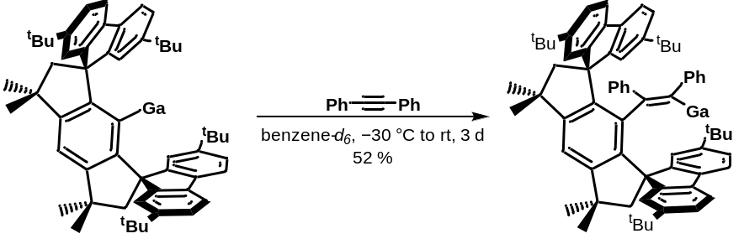
Inside a Glovebox, a J. Young NMR tube was charged with a solution of ^{t}Bu-M^{s}Fluind–Li·THF (30 mg, 0.0367 mmol, 1.0 equiv.) in benzene-d₆ (0.45 mL). A solution of GaCp* (7.5 mg, 0.0367 mmol, 1.0 equiv.) in benzene-d₆ (0.15 mL) was added to the NMR tube and heated at 70 °C for 16 hours to give a sticky yellow mixture. The NMR tube was cooled down to –30 °C and then diphenylacetylene (6.54 mg, 0.0367 mmol, 1.0 equiv.) was added to the frozen mixture. The mixture was allowed to warm up to room temperature and the NMR tube was rotated for 3 days. Subsequently, filtration gave a pale-orange solution. XRD-quality crystals were grown by slow evaporation a benzene solution at room temperature. The yellow crystals were isolated, washed with pentane (2 x 0.5 mL) and dried in vacuo to give ^{t}Bu-M^{s}Fluind-C(Ph)=C-(Ga^{I})-Ph 8 (18.7 mg, 0.019 mmol, 52 %) as a yellow solid.
¹H NMR (500 MHz, C₆D₆): δ [ppm] = 7.72 (d, J = 1.7 Hz, 2H, H^{Ar}), 7.45 (s, 1H, H₁₈), 7.33 (d, J = 7.9 Hz, 2H, H^{Ar}), 7.20 (d, J = 1.7 Hz, 2H, H^{Ar}), 7.18 (d, J = 8.1 Hz, 2H, H^{Ar}), 7.12 (dd, J = 8.0, 1.8 Hz, 2H, H^{Ar}), 7.04 (t, J = 7.7 Hz, 2H, H^{Ph}), 6.98 (dd, J = 8.0, 1.8 Hz, 2H, H^{Ar}), 6.90 – 6.82 (m, 1H, H^{Ph}), 6.47 – 6.39 (m, 1H, H^{Ph}), 6.36 (m, 2H, H^{Ph}), 6.18 (d, J = 7.7 Hz, 2H, H^{Ph}), 5.84 (d, J = 6.9 Hz, 2H, H^{Ph}), 2.51 (d, J = 14.2 Hz, 2H, CH₂), 2.46 (d, J = 14.2 Hz, 2H, CH₂), 1.64 (s, 6H, 2xCH₃), 1.61 (s, 6H, 2xCH₃), 1.35 (s, 18H, ^{t}Bu), 1.21 (s, 18H, ^{t}Bu).
¹³C{¹H} NMR (126 MHz, C₆D₆): δ [ppm] = 177.9 (C₃-Ga), 157.2 (C^{Ar}), 155.3 (C^{Ar}), 153.3 (C^{Ar}), 149.9 (C^{Ar}), 149.7 (C^{Ar}), 143.1 (C^{Ar}), 142.0 (C^{Ar}), 138.3 (C^{Ar}), 137.7 (C^{Ar}), 137.5 (C^{Ar}), 136.6 (C^{Ar}), 134.8 (C^{Ar}), 126.3 ($C_{H}^{Ph}$), 125.8 ${(C}_{H}^{Ar}$), 125.3 ($C_{H}^{Ph}$), 124.5 ${(C}_{H}^{Ar}$), 123.5 ($C_{H}^{Ph}$), 121.7 ${(C}_{H}^{Ar}$), 120.5 ${(C}_{H}^{Ar}$), 120.0 ${(C}_{H}^{Ar}$), 119.9 ${(C}_{H}^{Ar}$), 117.6 (C₁₈), 64.3 (C_{21,26}), 59.2 ($C_{22,27}^{CH2})$, 42.2 ${(C}_{23,28}^{Me(q)}$), 35.3 (C^{tBu(q)}), 34.8 (C^{tBu(q)}), 33.4 ${(C}_{24,25-29,30}^{Me}$), 33.2 ${(C}_{24,25-29,30}^{Me}$), 31.7 (C^{tBu}), 31.6 (C^{tBu}).
Elemental Analysis for C₇₀H₇₅Ga: C, 85.26; H, 7.67. Found (%): C, 85.25; H, 7.74.

Synthesis of ^{t}Bu-M^{s}Fluind-C(H)=C-Ph-(Ga^{III}MeI) 9
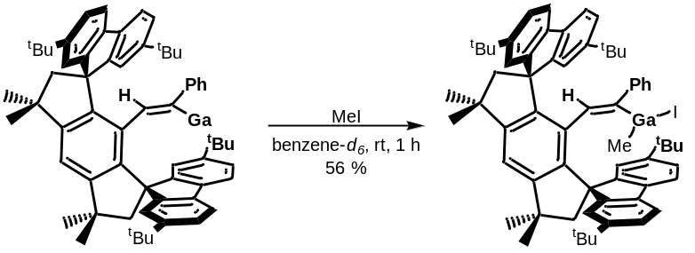
Inside a Glovebox, a J. Young NMR tube was charged with a solution of ^{t}Bu-M^{s}Fluind–Li·THF (30 mg, 0.0367 mmol, 1.0 equiv.) in benzene-d₆ (0.45 mL). A solution of GaCp* (7.5 mg, 0.0367 mmol, 1.0 equiv.) in benzene-d₆ (0.15 mL) was added to the NMR tube and heated at 70 °C for 16 hours to give a sticky yellow mixture. The NMR tube was cooled down to –30 °C and then phenylacetylene (3.75 mg, 0.0367 mmol, 1.0 equiv.) was added to the frozen mixture. The mixture was allowed to warm up to room temperature and the NMR tube was rotated for 1 h. Subsequently, iodomethane (5.21 mg, 0.0367 mmol, 1.0 equiv.) was added and the NMR tube with the pale-yellow solution rotated for 1 h. Filtration gave a pale-yellow solution and slow evaporation of the benzene solution yielded colorless crystals, which were isolated, washed with pentane (3 x 1 mL) and dried in vacuo (21.5 mg, 0.0205 mmol, 56 %).
¹H NMR (500 MHz, DCM-d₂): δ [ppm] = 7.36 (s, 1H, H₁₈), 7.32 (m, 4H, H^{Ar}), 7.25 (dd, J = 8.1, 1.8 Hz, 2H, H^{Ar}), 7.19 (m, 2H, H^{Ar}), 7.11 (dd, J = 8.0, 1.8 Hz, 2H, H^{Ar}), 6.95 (br, 3H, H^{Ph}), 6.90 (t, J = 7.4 Hz, 2H, H^{Ar}), 5.90 (br, 2H, H^{Ph}), 5.15 (s, 1H, H^{1-vinyl}), 2.47 (m, 2H, CH₂), 2.34 (d, J = 14.0 Hz, 2H, CH₂), 1.72 (s, 6H, 2xCH₃), 1.61 (s, 6H, 2xCH₃), 1.27 (s, 18H, ^{t}Bu), 1.17 (s, 18H, ^{t}Bu), 0.08 (s, 3H, GaMe).
¹³C{¹H} NMR (126 MHz, , DCM-d₂): δ [ppm] = 156.0 (C^{Ar}), 153.1 (C^{Ar}), 151.1 (C^{Ar}), 150.3 (C^{Ar}), 138.5 (C^{Ar}), 126.8 ${(C}_{H}^{Ar}$) , 126.0 ${(C}_{H}^{Ar}$), 125.7 ${(C}_{H}^{Ar}$), 124.0 ${(C}_{H}^{Ar}$), 120.5 ${(C}_{H}^{Ph}$), 119.2 ${(C}_{H}^{Ar}$), 117.3 ${(C}_{18}^{Ar}$), 63.3 (C_{12,24}) , 57.7 ${(C}_{13,23}^{CH2})$, 43.3 ${(C}_{14,20}^{Me(q)}$), 35.5 ${(C}_{29,40-50,60}^{tBu(q)})$, 35.1 ${(C}_{29,40-50,60}^{tBu(q)})$, 33.3 ${(C}_{15,16-21,22}^{Me})$, 33.1 ${(C}_{15,16-21,22}^{Me})$, 31.9 ${(C}_{Me}^{tBu}$), 31.8 ${(C}_{Me}^{tBu}$), 1.2 ${(C}_{9}^{GaMe}$).
Elemental Analysis for C₆₅H₇₄GaI·C₆H₆: C, 75.46; H, 7.14. Found (%): C, 74.98; H, 7.12.

Crystallographic Details

Data collection of all compounds was performed with a Bruker Venture D8 diffractometer at 100 K. For more details see the following Tables S2 and S3 giving selected crystal and structural refinement data.
The structures of 2, 4, and 9 were solved and refined with SHELXS/L-2013.⁵ All non-carbon atoms were refined anisotropically while carbon-bonded hydrogen atoms were placed on calculated positions isotropically. In case of 2 one ^{t}Bu group was refined as being disordered to split occupancies of 0.60/0.40 (C89-C92). The R_{int} value is comparable high, and above a resolution of about 1.2 Å the diffractivity is very poor (average ratio I/sigma < 2) as established by different crystallization trials and crystal measurements. The unit cell comprises a solvent accessible volume of 594 Å³, which is about 6.5 % of the unit cell. Astonishingly, the electron count for the VOID volume is 4.5 electrons only. That indicates the VOID to be basically empty. It is assumed that this is responsible for the weak intensities of the reflections above 1.2 Å. On the other hand, a non-disordered toluene molecule is expected to possess a volume of around 140 Å³. With Z = 8 a VOID volume of 1120 Å³ can be calculated, indicating potentially each 2nd VOID to be occupied by one toluene packing donor solvent or, alternatively, each VOID as being occupied by a half of one toluene molecule. Such a situation was indeed observed later on as in case of 4 and 8, which possess a half occupied packing donor solvent and symmetry half of a benzene molecule, respectively. For 4, two ^{t}Bu groups were refined as being disordered to split occupancies of 0.79/0.21 (C27-C29) and 0.73/0.27 (C46-C49). Additionally, the DMAP unit has been refined to split occupancies of 0.815/0.185 as well as two benzene solvent molecules (C70-C75 and C76-C81).
The structures 3, 5,and 8 were solved by direct methods using SHELXT 2018/2⁶ and refined by full-matrix least-squares methods against F² by SHELXL-2018/3⁷ employing shelXle (Revision 1449).⁸ All non-carbon atoms were refined anisotropically while carbon-bonded hydrogen atoms were placed on calculated positions isotropically. Disordered moieties were refined to two split occupancies using bond-length restraints and displacement-parameter restraints. The disorder models for specific groups (e.g. ^{t}Bu) were introduced by the program DSR.⁹
In detail for 3: The Ga(CH₃)I unit has been refined to split occupancies of 0.87/0.13 (Ga1A, C1A, I1A) and a THF packing donor solvent to 0.61/0.39 (O1, C1-C4). For 5: A benzene packing donor solvent molecule has been refined to split occupancies of 0.64/0.36 (C1-C6). For 6: The {Ga(CH=C(Ph)} unit has been refined to split occupancies of 0.95/0.05 (Ga1, C1-C8) as well as one ^{t}Bu unit to 0.63/0.37 (C1-C4). For 7: One ^{t}Bu unit has been refined to split occupancies of 0.81/0.19 (C2-C5). For 8: Two ^{t}Bu units have been refined to split occupancies of 0.90/0.10 and 0.89/0.11, respectively (C2-C5).
All graphics of the molecular solid-state structures were created using OLEX2 (version 1.5).¹⁰
CCDC 2341460-2341467 contain supplementary crystallographic data for 2-9. These data can be obtained free of charge from The Cambridge Crystallographic Data Centre via www.ccdc.cam.ac.uk/data_request/cif.

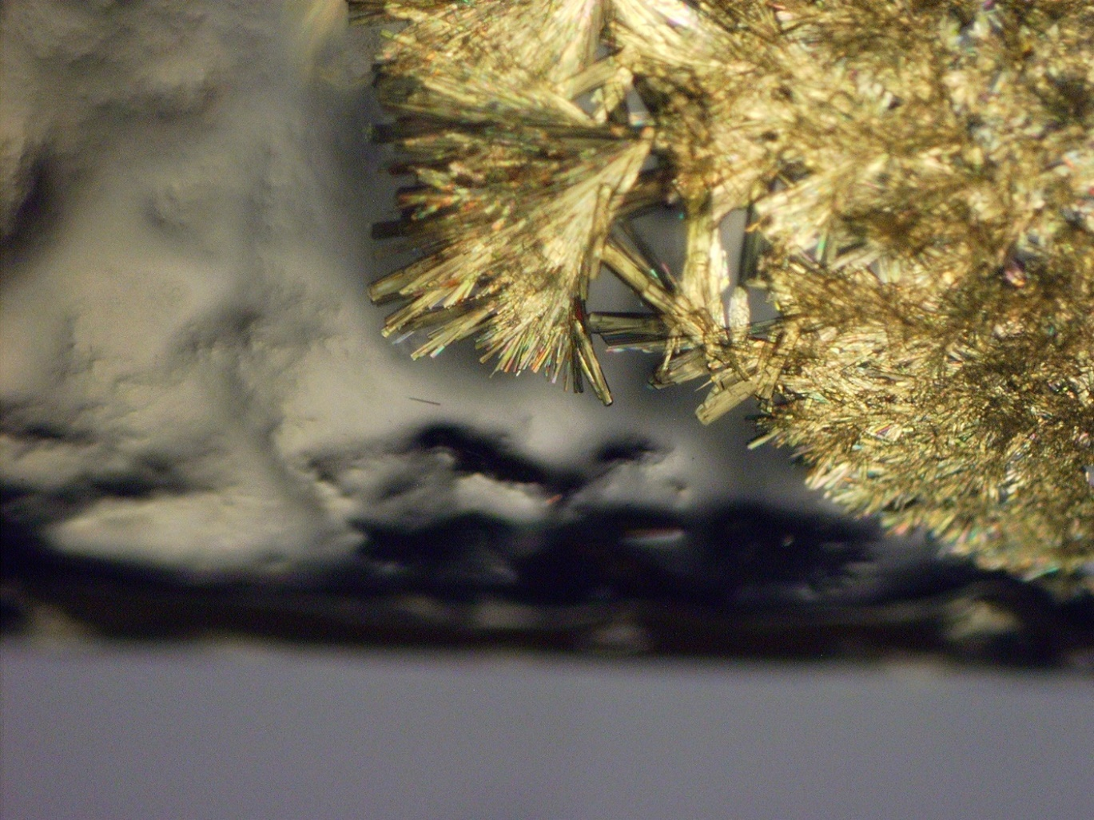
Figure S2. Yellow crystals of ^{t}Bu-M^{s}Fluind–Ga^{I} inside the J. Young NMR tube.

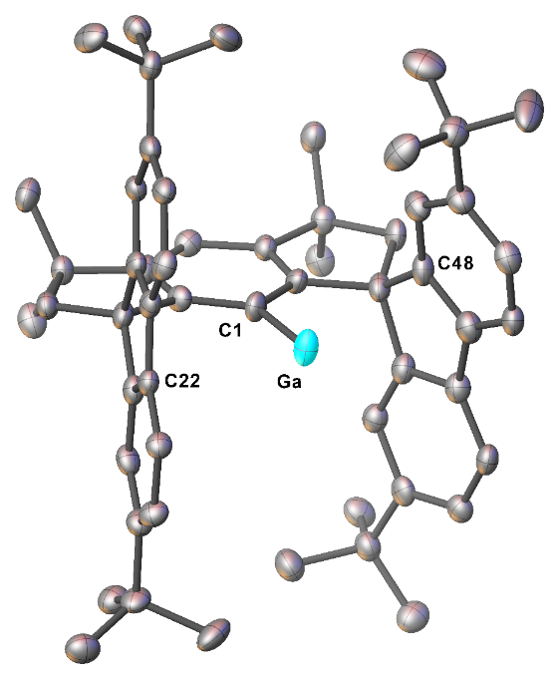
Figure S3. Molecular solid-state structure of 2 (ellipsoids represent 50% probability). Selected bond lengths / distances (Å): C1–Ga 2.079(10), Ga···C22 3.182(9), Ga···C48 3.062(10). Second molecule of 2 in asymmetric unit with one disordered ^{t}Bu group and hydrogen atoms are omitted for clarity.

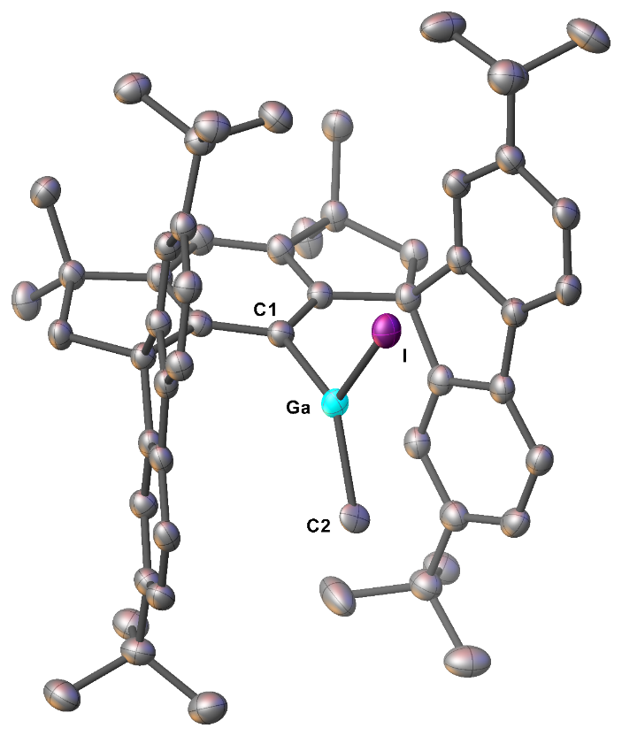
Figure S4. Molecular solid-state structure of 3 (ellipsoids represent 50% probability). Selected bond lengths (Å) and angles (°): Ga–C1 1.963(3), Ga–C2 1.994(4), Ga–I 2.5319(7), C1–Ga–I 112.50(8), C1–Ga–C2 133.40(15), I–Ga–C2 114.07(13). Disorder for Ga, I, C2 and solvent molecule THF and hydrogen atoms are omitted for clarity.

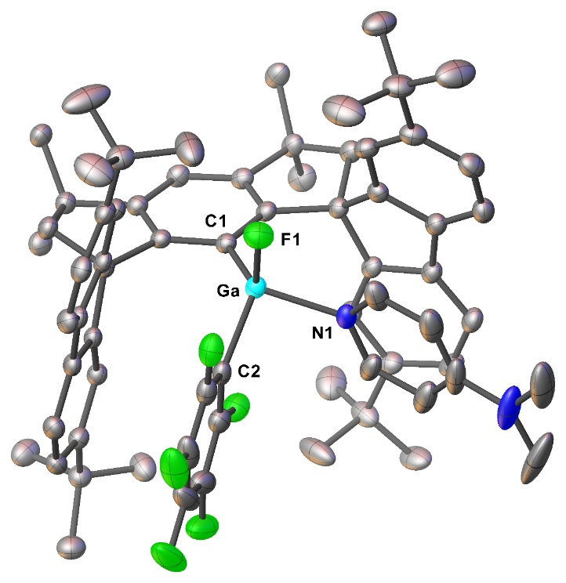
Figure S5. Molecular solid-state structure of 4 (ellipsoids represent 50% probability). Selected bond lengths (Å) and angles (°): Ga–C1 1.9851(18), Ga–C2 2.0087(19), Ga–F1 1.7925(12), Ga–N1 2.0308(14), C1–Ga–F1 111.81(6), C1–Ga–N1 122.81(8), C1–Ga–C2 120.61(8), F1–Ga–N1 93.42(7), F1–Ga–C2 112.11(7), N1–Ga–C2 91.96(8). Disorder for DMAP, two ^{t}Bu groups, 1.5 disordered benzene solvent molecules and hydrogen atoms are omitted for clarity.

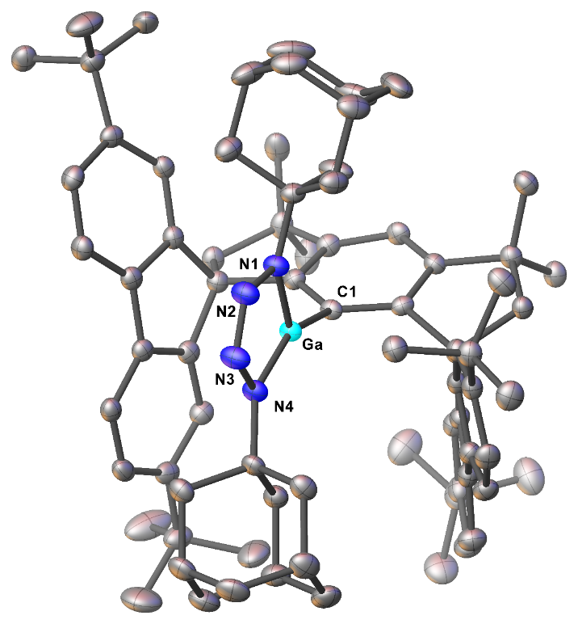
Figure S6. Molecular solid-state structure of 5 (ellipsoids represent 50% probability). Selected bond lengths (Å) and angles (°): Ga–C1 1.945(2), Ga–N1 1.858(2), Ga–N4 1.835(2), N1–N2 1.368(3), N2–N3 1.272(3), N3–N4 1.379(3), C1–Ga–N1 122.67(9), C1–Ga–N4 152.63(9), N1–Ga–N4 84.66(9), Ga–N1–N2 111.24(16), N1–N2–N3 116.2(2), N2–N3–N4 116.3(2), N3–N4–Ga 111.50(16). Two solvent molecules benzene (one of them disordered) and hydrogen atoms are omitted for clarity.
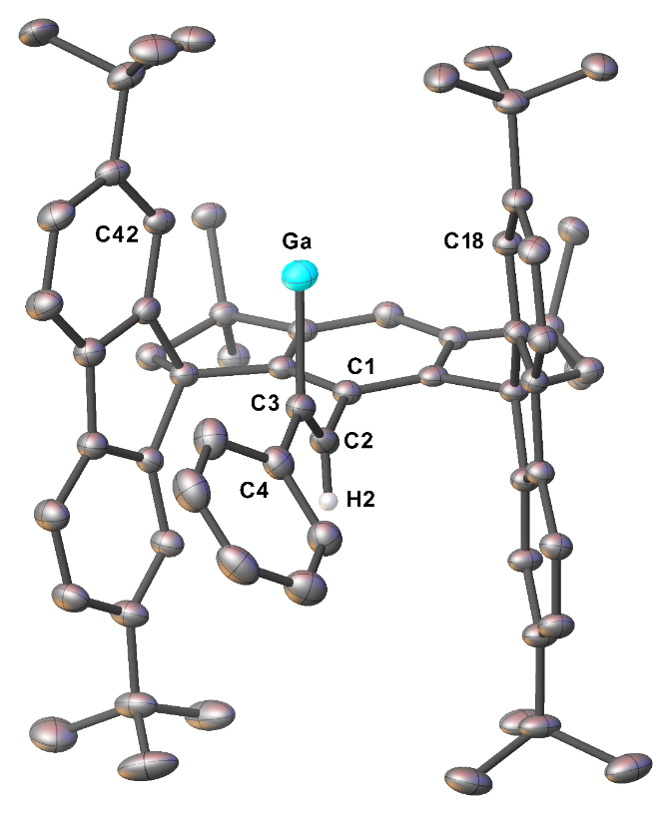
Figure S7. Molecular solid-state structure of 6 (ellipsoids represent 30% probability). Selected bond lengths (Å) and angles (°): C1–C2 1.501(5), C2–C3 1.280(6), C3–C4 1.502(6), Ga–C3 2.051(4), Ga···C18 3.349(3), Ga···C42 3.204(3), C2–C3–C4 121.4(4), C2–C3–Ga 119.9(3), Ga–C3–C4 118.6(3). Disorder for C2-C3-(Ga)-Ph, two ^{t}Bu groups and hydrogen atoms except for the vinylic hydrogen atom are omitted for clarity.

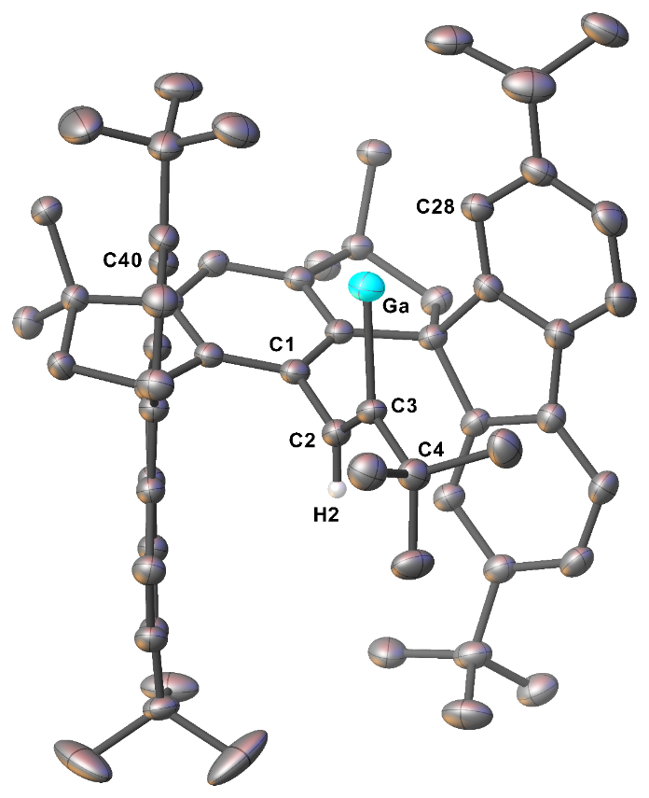
Figure S8. Molecular solid-state structure of 7 (ellipsoids represent 50% probability). Selected bond lengths (Å) and angles (°): C1–C2 1.485(3), C2–C3 1.297(3), C3–C4 1.536(3), Ga–C3 2.0711(19), Ga···C28 3.234(2), Ga···C40 3.2834(19), C2–C3–C4 123.04(17), C2–C3–Ga 117.55(14), Ga–C3–C4 119.38(14). Disorder for ^{t}Bu group and hydrogen atoms except for the vinylic hydrogen atom are omitted for clarity.

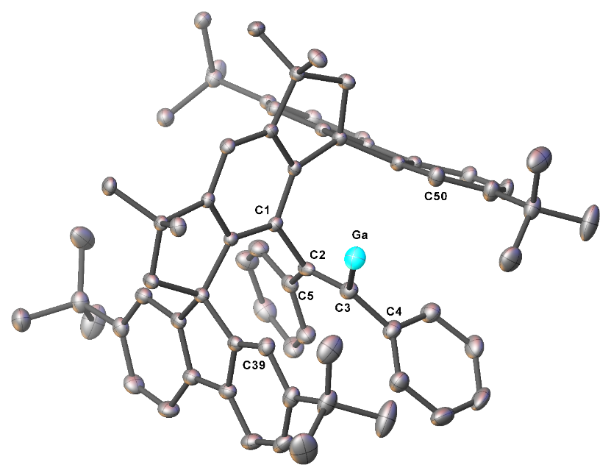
Figure S9. Molecular solid-state structure of 8 (ellipsoids represent 50% probability). Selected bond lengths (Å) and angles (°): C1–C2 1.523(3), C2–C3 1.357(3), C3–C4 1.478(3), C2–C5 1.481(3), Ga–C3 2.064(2), Ga···C39 3.138(2), Ga···C50 3.313(2), C1–C2–C5 121.15(18), C1–C2–C3 111.68(18), C2–C3–C4 127.60(19), C2–C3–Ga 113.69(15), Ga–C3–C4 118.49(15). Solvent molecule (0.5 benzene), two disordered ^{t}Bu groups and hydrogen atoms are omitted for clarity.

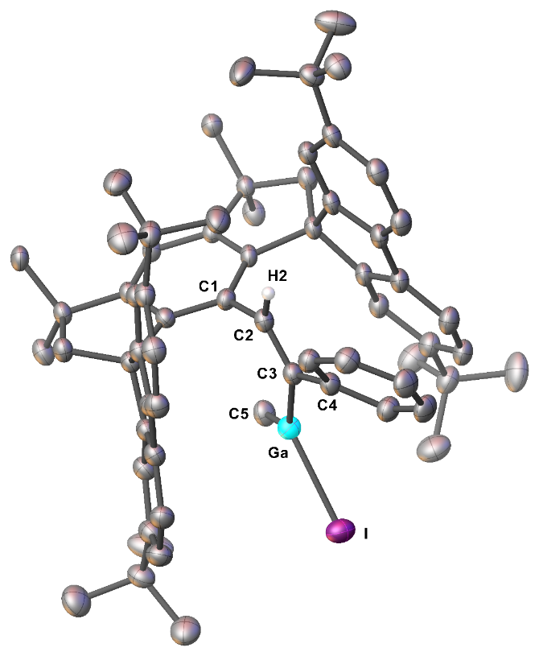
Figure S10. Molecular solid-state structure of 9 (ellipsoids represent 50% probability). Selected bond lengths (Å) and angles (°): C1–C2 1.482(3), C2–C3 1.332(4), C3–C4 1.490(4), Ga–C3 1.954(3), Ga–C5 1.962(3), Ga–I 2.5395(4), C1–C2–C3 126.9(2), C2–C3–C4 116.9(2), C2–C3–Ga 116.8(2), Ga–C3–C4 125.92(19), C5–Ga–I 110.80(9), C3–Ga–C5 131.91(12), C3–Ga–I 116.47(8). Solvent molecule benzene and hydrogen atoms except for the vinylic hydrogen atom are omitted for clarity.

Table S2. Crystal and structural refinement data of 2‒5.

 | 2 | 3 | 4 | 5
Empirical formula | C₅₆H₆₅Ga [+ solvent]¹⁾ | C₆₁H₆₈GaIO | C₇₈H₈₄F₆GaN₂ | C₈₈H₁₀₇GaN₄
Formula mass (g·mol^{–1}) | 807.80 | 1021.83 | 1233.19 | 1290.49
Crystal system | orthorhombic | monoclinic | triclinic | monoclinic
Space group | Pna2₁ | P2₁/n | P-1 | P2₁
a (Å) | 33.4169(11) | 10.1747(1) | 12.3149(5) | 10.6590(4)
b (Å) | 10.5744(3) | 18.4971(3) | 14.8552(6) | 17.1124(6)
c (Å) | 26.7187(9) | 28.5576(4) | 22.2748(8) | 20.0354(7)
α (°) | 90 | 90 | 71.289(2) | 90
β (°) | 90 | 92.591(1) | 78.140(2) | 91.972(2)
γ (°) | 90 | 90 | 65.803(2) | 90
V (Å³) | 9441.4(5) | 5369.11(13) | 3507.5(2) | 3652.3(2)
Z | 8 | 4 | 2 | 2
D_{calc} (Mg·m^{–3}) | 1.137 | 1.264 | 1.168 | 1.173
Wavelength (Å) | 1.54178 | 1.54178 | 1.54178 | 1.54178
Absorption coefficient (mm^{–1}) | 1.039 | 5.493 | 1.003 | 0.869
F(000) | 3456 | 2136 | 1302 | 1388
Reflection collected | 61152 | 112312 | 135271 | 83265
Reflection unique / R_{int}^{a)} | 17441 / 0.1912 | 10543 / 0.0223 | 14012 / 0.0231 | 13784 / 0.0370
Goodness-of-fit on F^{2 b)} | 1.043 | 1.041 | 1.055 | 1.082
Data / restrains / parameters | 17441 / 149 / 1093 | 10543 / 437 / 448 | 14012 / 127 / 948 | 11681 / 337 / 909
θ range for data collection (°) | 2.644 to 70.503 | 2.847 to 72.084 | 3.382 to 74.726 | 2.206 to 70.168
Limiting indices | 36 ≤ h ≤ 40,  12 ≤ k ≤ 12,  31 ≤ l ≤ 32 | 12 ≤ h ≤ 12,  22 ≤ k ≤ 22,  35 ≤ l ≤ 34 | 15 ≤ h ≤ 15,  18 ≤ k ≤ 18,  27 ≤ l ≤ 27 | 13 ≤ h ≤ 12,  20 ≤ k ≤ 20,  24 ≤ l ≤ 24
Final R indices [I ˃2σ(I)]^{c)} | R₁ = 0.0850, wR₂ = 0.2008 | R₁ = 0.0431, wR₂ = 0.1220 | R₁ = 0.0474, wR₂ = 0.1389 | R₁ = 0.0302, wR₂ = 0.0728
R indices (all data)^{c)} | R₁ = 0.1389, wR₂ = 0.2402 | R₁ = 0.0467, wR₂ = 0.1268 | R₁ = 0.0526, wR₂ = 0.1447 | R₁ = 0.0323, wR₂ = 0.0743
Largest diff. peak/hole (e·Å^{–3}) | 0.852/0.631 | 1.345/0.741 | 0.909/0.573 | 0.392/0.215
^{a)}R_{int} = ∑│$F_{0}^{2}$−$F_{0}^{2}$(mean)│/∑$F_{0}^{2}$, where $F_{0}^{2}$ (mean) is the average intensity of symmetry equivalent diffractions. ^{b)} S = [∑w ($F_{0}^{2}$−$F_{0}^{2}$) ²]/ (n-p) ^{1/2}, where n = number of reflections, p = number of parameters. ^{c)}R = [∑(║$F_{0}$│−│$F_{0}$│)/∑│$F_{0}$│); R[∑(w($F_{0}^{2}$−$F_{0}^{2}$))²/∑(w$F_{0}^{4}$)]^{1/2}. ¹⁾ Solvent accessible Void = 594 Å; electron count = 4.5. Solvent used for crystallization = toluene.

Table S3. Crystal and structural refinement data of 6‒9.

 | 6 | 7 | 8 | 9
Empirical formula | C₆₄H₇₁Ga | C₆₂H₇₅Ga | C₇₃H₇₈Ga | C₇₁H₈₀GaI
Formula mass (g·mol^{–1}) | 909.92 | 889.94 | 1025.07 | 1129.97
Crystal system | monoclinic | monoclinic | triclinic | monoclinic
Space group | C₂/c | P2₁/c | P-1 | P-1
a (Å) | 26.166(2) | 12.4707(3) | 12.7198(2) | 12.0748(3)
b (Å) | 14.9751(12) | 21.4575(5) | 14.5158(3) | 13.2855(3)
c (Å) | 28.302(4) | 19.1998(5) | 17.2206(3) | 21.1020(5)
α (°) | 90 | 90 | 89.594(1) | 97.753(1)
β (°) | 106.247(8) | 95.310(1) | 87.099(1) | 98.525(1)
γ (°) | 90 | 90 | 64.017(1) | 116.120(1)
V (Å³) | 10646.9(19) | 5115.6(2) | 2854.14(9) | 2928.51(12)
Z | 8 | 4 | 2 | 2
D_{calc} (Mg·m^{–3}) | 1.135 | 1.155 | 1.193 | 1.281
Wavelength (Å) | 1.54178 | 1.54178 | 1.54178 | 1.54178
Absorption coefficient (mm^{–1}) | 0.976 | 1.002 | 0.967 | 5.076
F(000) | 3888 | 1912 | 1094 | 1180
Reflection collected | 75458 | 67811 | 51434 | 74115
Reflection unique / R_{int}^{a)} | 9405 / 0.0518 | 10034 / 0.0539 | 11062 / 0.0448 | 11700 / 0.0472
Goodness-of-fit on F^{2 b)} | 1.027 | 1.051 | 1.002 | 1.049
Data / restraints / parameters | 9405 / 876 / 758 | 10034 / 162 / 627 | 14012 / 127 / 948 | 11700 / 0 / 675
θ range for data collection (°) | 3.253 to 66.805 | 3.096 to 72.061 | 2.569 to 72.113 | 3.933 to 74.417
Limiting indices | 31 ≤ h ≤ 31,  17 ≤ k ≤ 17,  33 ≤ l ≤ 33 | 14 ≤ h ≤ 15,  26 ≤ k ≤ 26,  23 ≤ l ≤ 23 | 15 ≤ h ≤ 15,  17 ≤ k ≤ 17,  21 ≤ l ≤ 21 | 15 ≤ h ≤ 15,  16 ≤ k ≤ 16,  26 ≤ l ≤ 26
Final R indices [I ˃2σ(I)]^{c)} | R₁ = 0.0735, wR₂ = 0.2045 | R₁ = 0.0478, wR₂ = 0.1316 | R₁ = 0.0484, wR₂ = 0.1320 | R₁ = 0.0418, wR₂ = 0.1170
R indices (all data)^{c)} | R₁ = 0.0735, wR₂ = 0.2193 | R₁ = 0.0570, wR₂ = 0.1411 | R₁ =0.0552, wR₂ = 0.1379 | R₁ = 0.0447, wR₂ = 0.1203
Largest diff. peak/hole (e·Å^{–3}) | 0.661/1.080 | 0.525/0.601 | 2.089/0.689 | 0.864/1.007
^{a)}R_{int} = ∑│$F_{0}^{2}$−$F_{0}^{2}$(mean)│/∑$F_{0}^{2}$, where $F_{0}^{2}$ (mean) is the average intensity of symmetry equivalent diffractions. ^{b)} S = [∑w ($F_{0}^{2}$−$F_{0}^{2}$) ²]/ (n-p) ^{1/2}, where n = number of reflections, p = number of parameters. ^{c)}R = [∑(║$F_{0}$│−│$F_{0}$│)/∑│$F_{0}$│); R[∑(w($F_{0}^{2}$−$F_{0}^{2}$))²/∑(w$F_{0}^{4}$)]^{1/2}.

Computational details

All geometry optimizations and frequency calculations were performed with the Gaussian16 program package¹¹ in conjunction with the dispersion-corrected wB97XD functional¹² and def2-SVP basis sets¹³. The absence of imaginary frequencies confirmed stationary points as minima. Single-point energies were calculated using the same functional but def2-TZVP basis sets;¹³ the population analysis including Wiberg bond analysis¹⁴ was performed at the same level of theory.
Thermal corrections obtained at the wB97XD /def2-SVP level of theory were calculated for standard conditions, i.e. 298.15 K and 1 bar. All energies are given in kJ mol⁻¹.
The selected frontier molecular orbitals have been visualized using VMD.¹⁵ The non-covalent interaction analysis was performed using NCIPLOT¹⁶ and illustrated using PyMol.¹⁷

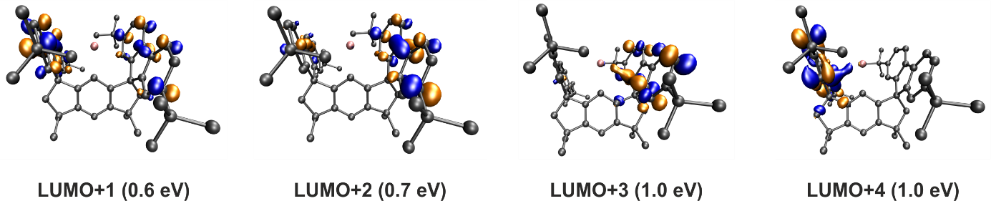
Figure S11. Selected unoccupied molecular orbitals of 2; isovalue at 0.05 (blue) and -0.05 (orange).
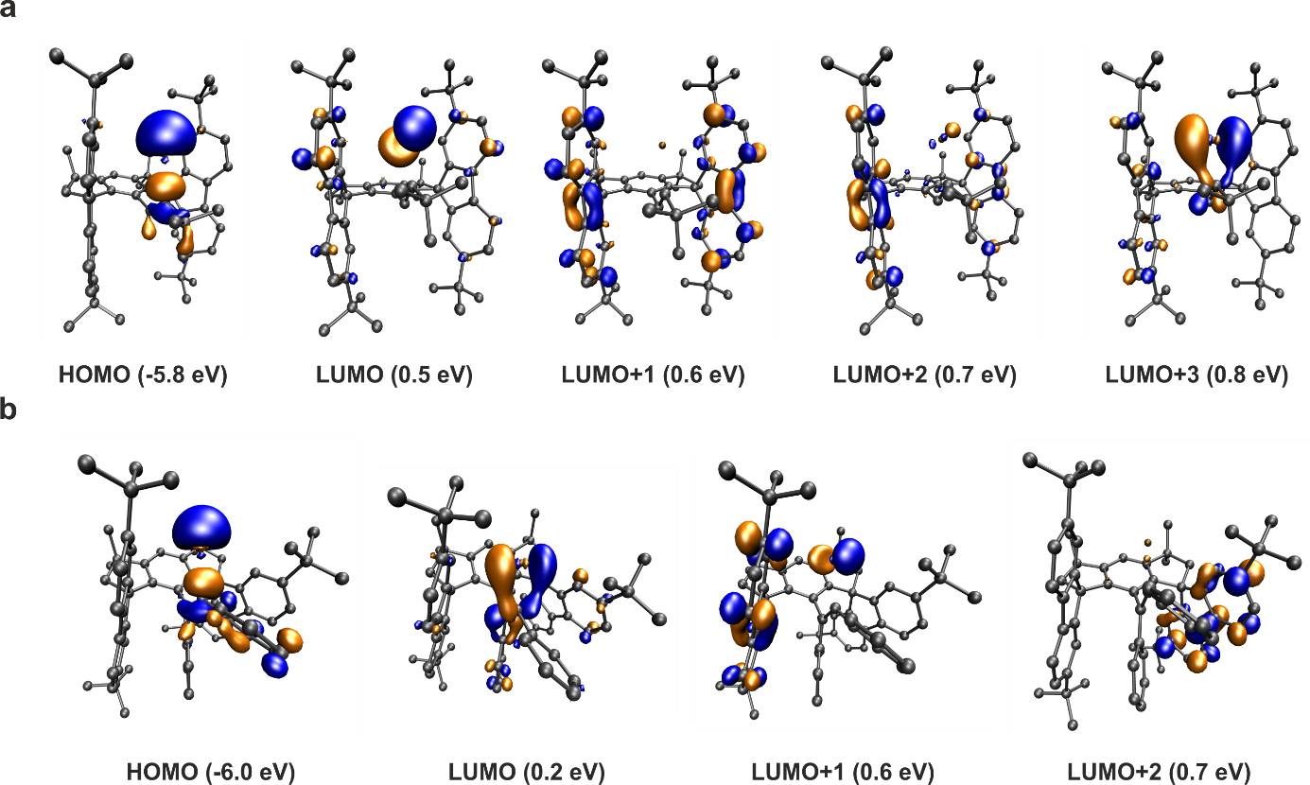
Figure S12. Selected frontier molecular orbitals of a) 7 and b) 8; isovalue at 0.05 (blue) and -0.05 (orange).
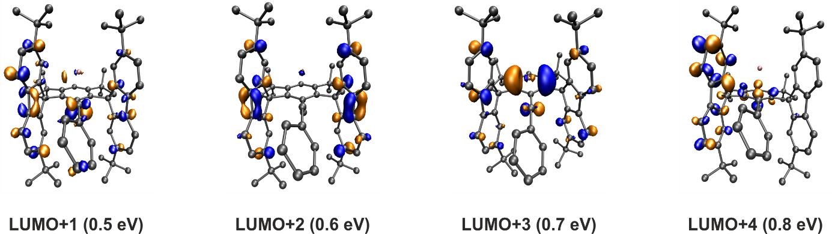
Figure S13. Selected unoccupied molecular orbitals of 6; isovalue at 0.05 (blue) and -0.05 (orange).

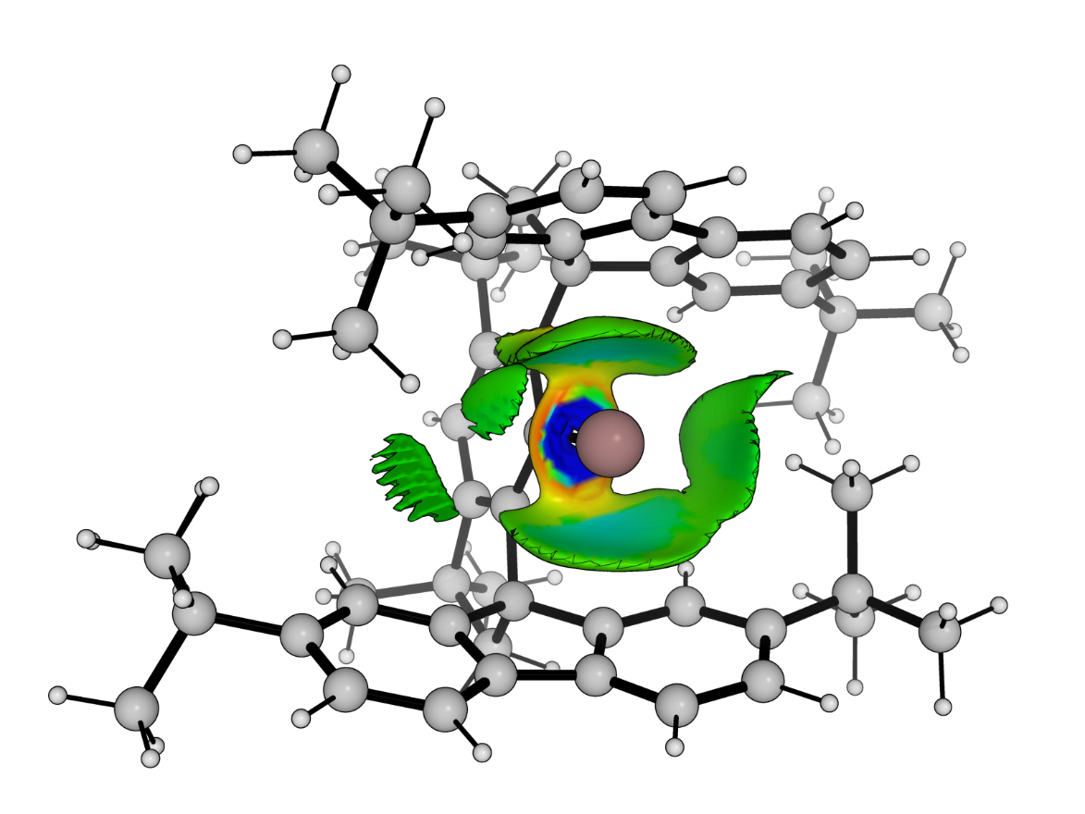
Figure S14. Non-covalent interaction analysis of 2.

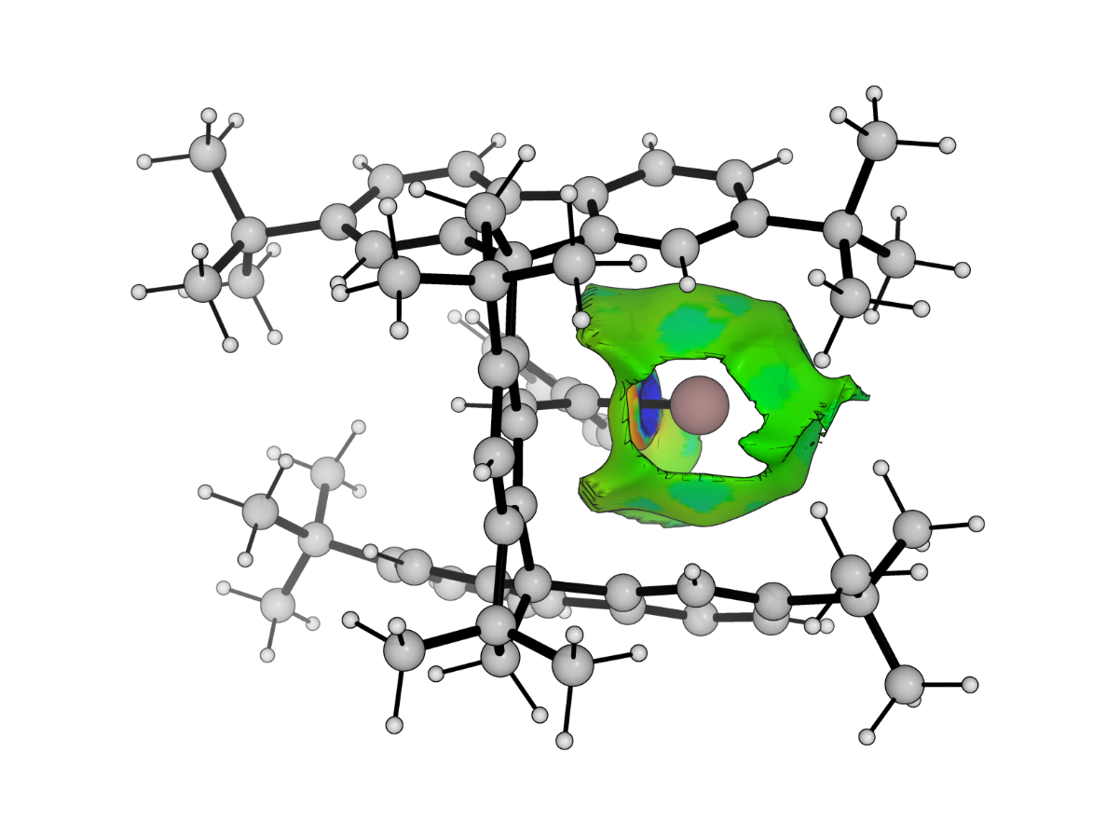
Figure S15. Non-covalent interaction analysis of 6.

Scheme S1. Free energies (wB97XD/def2TZVP//wB97XD/def2SVP) of the formation of 6-8, the gallacyclopropenes 6_{iso}-8_{iso} and the C–H activation products 6_{iso'}-7_{iso'} starting from 2 and alkynes.

Spectra
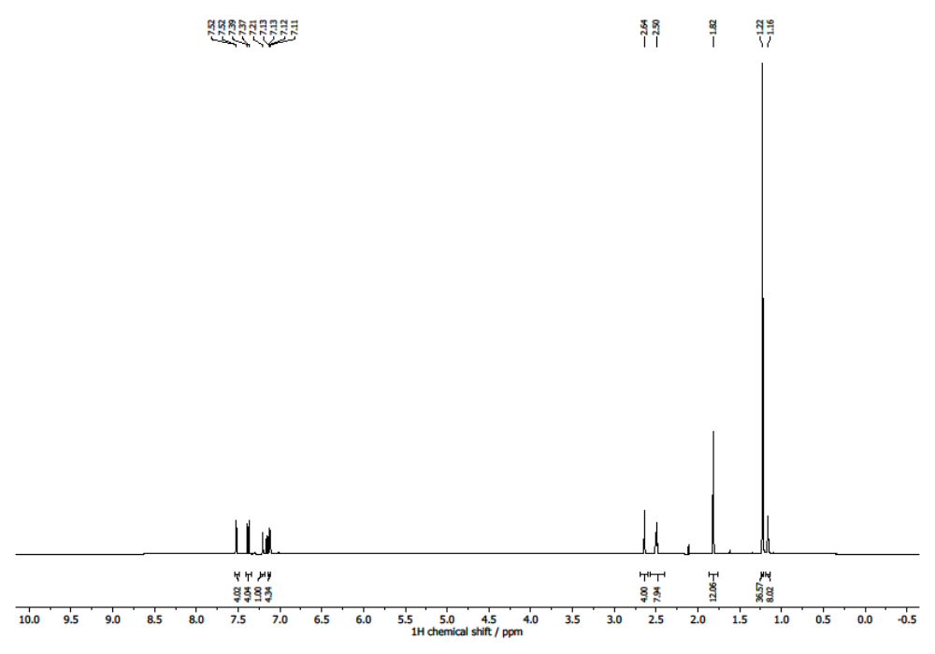
Figure S16. ¹H NMR spectrum (500 MHz, C₆D₆, 293 K) of compound 1.
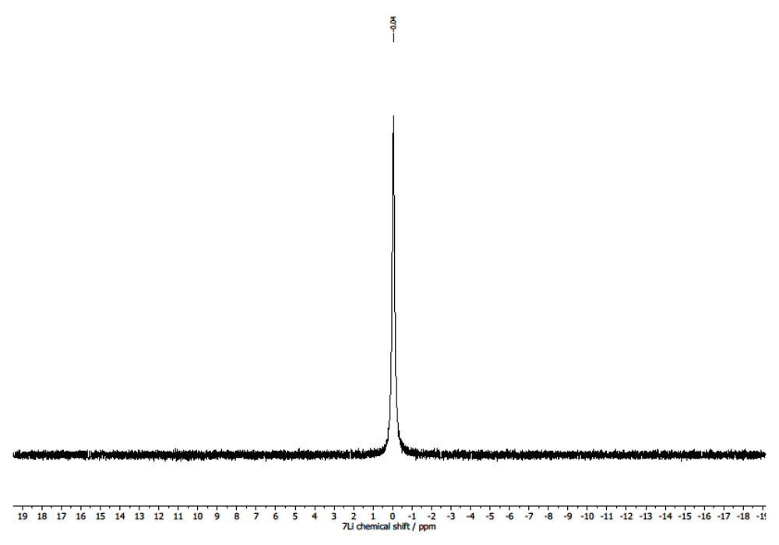Figure S17. ⁷Li NMR spectrum (194 MHz, C₆D₆, 293 K) of compound 1.
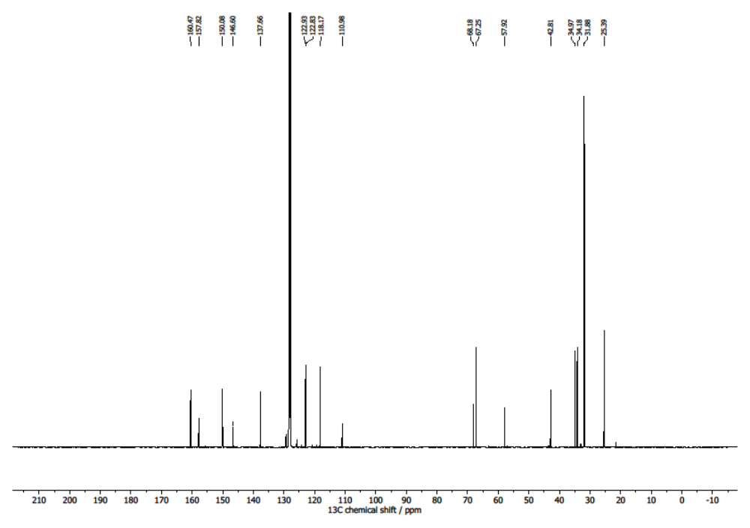
Figure S18. ¹³C{¹H} NMR spectrum (121 MHz, C₆D₆, 293 K) of compound 1.
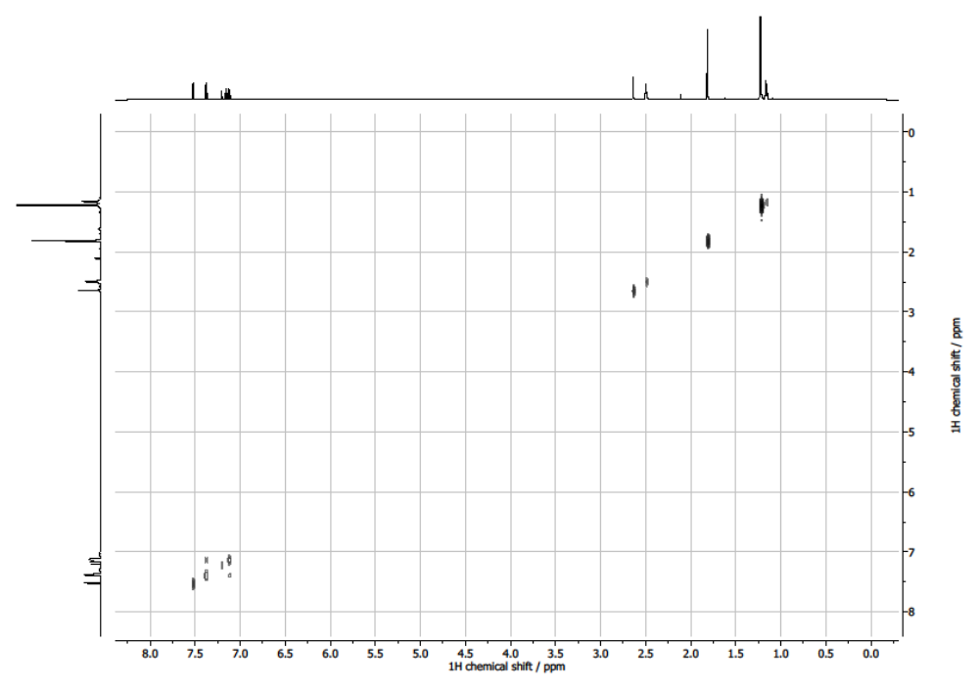
Figure S19. COSY NMR spectrum (500 MHz, C₆D₆, 293 K) of compound 1.
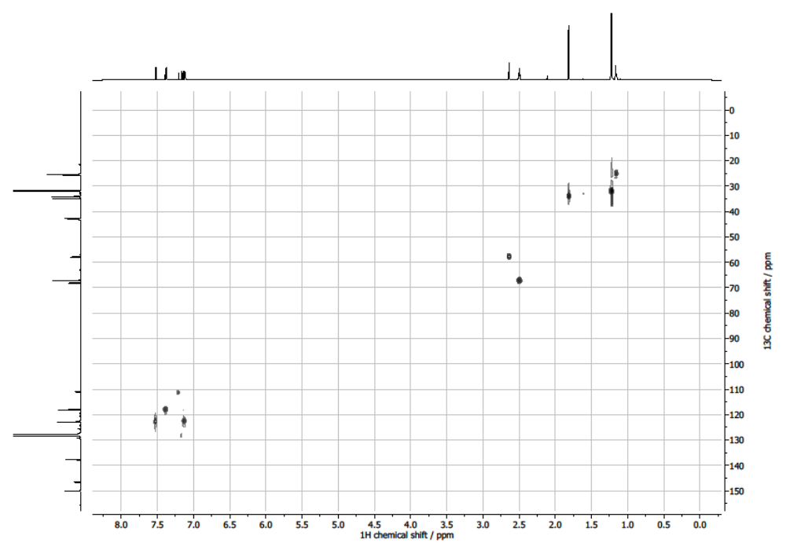
Figure S20. ¹H-¹³C HSQC spectrum (C₆D₆, 293 K) of compound 1.
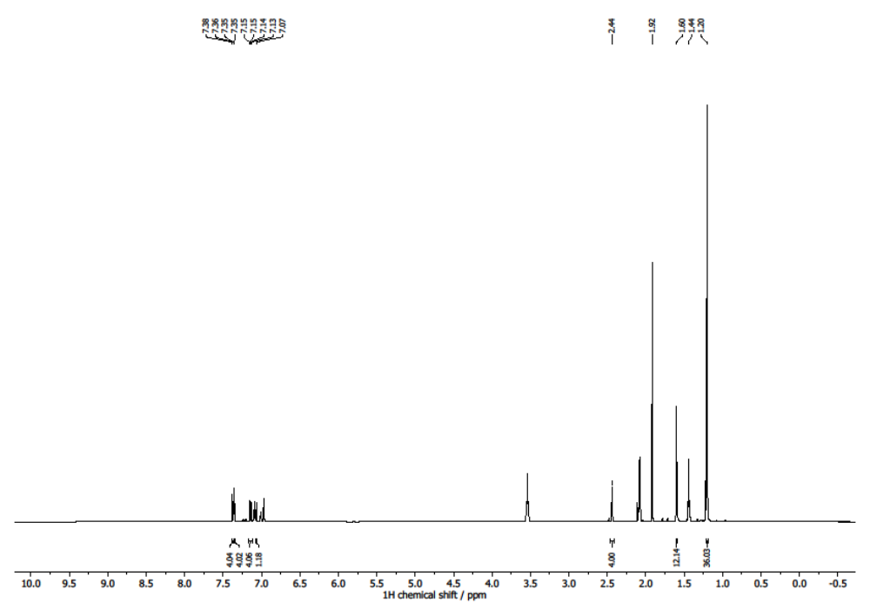
* GaCp*
# THF
#
#
*
Figure S21. ¹H NMR spectrum (500 MHz, toluene-d₈, 293 K) of compound 2.
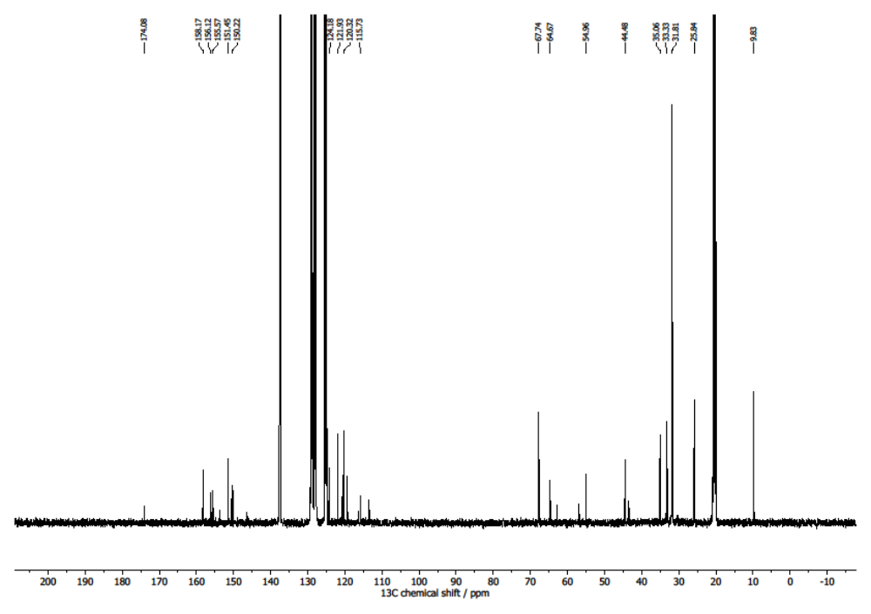
* GaCp*

*
Figure S22. ¹³C{¹H} NMR spectrum (121 MHz, toluene-d₈, 293 K) of compound 2.
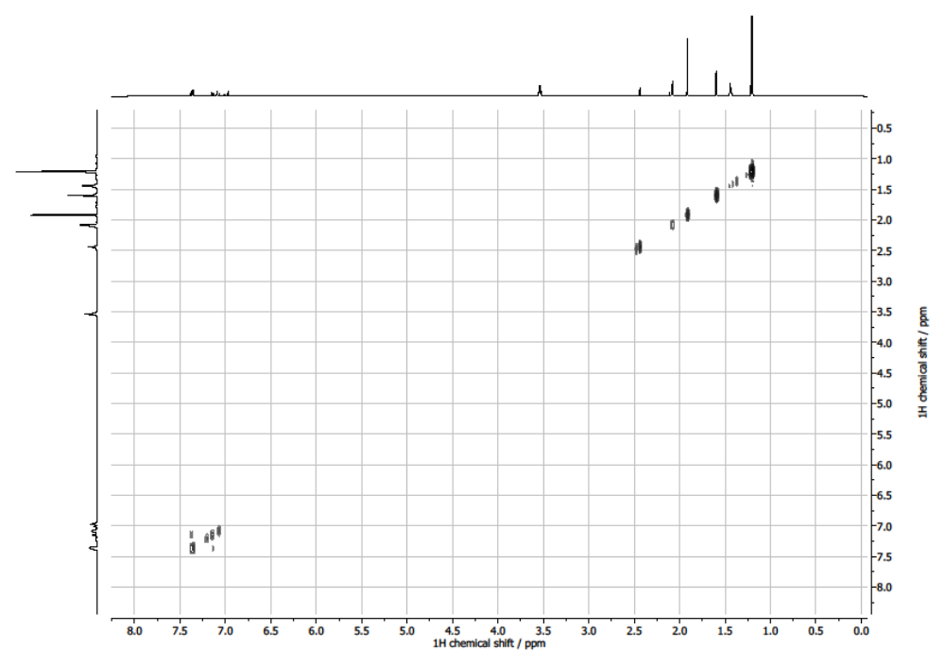
Figure S23. COSY NMR spectrum (500 MHz, toluene-d₈, 293 K) of compound 2.
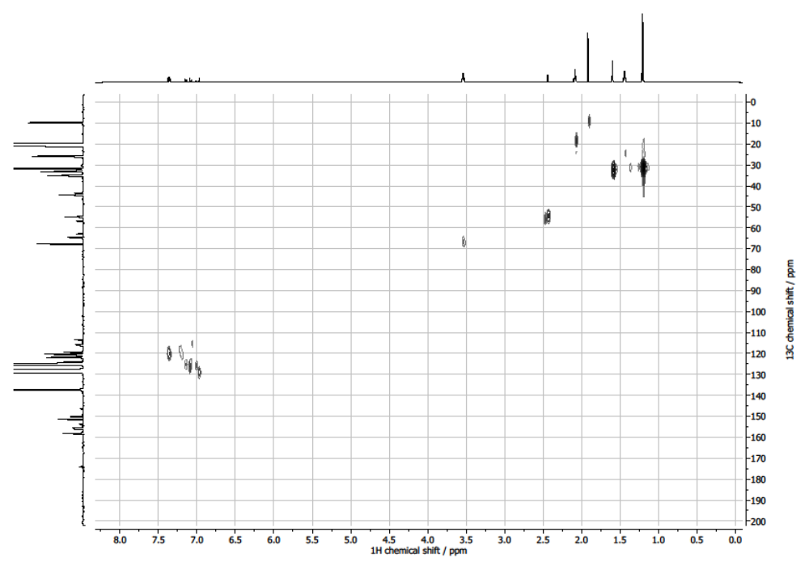
Figure S24. ¹H-¹³C HSQC spectrum (toluene-d₈, 293 K) of compound 2.
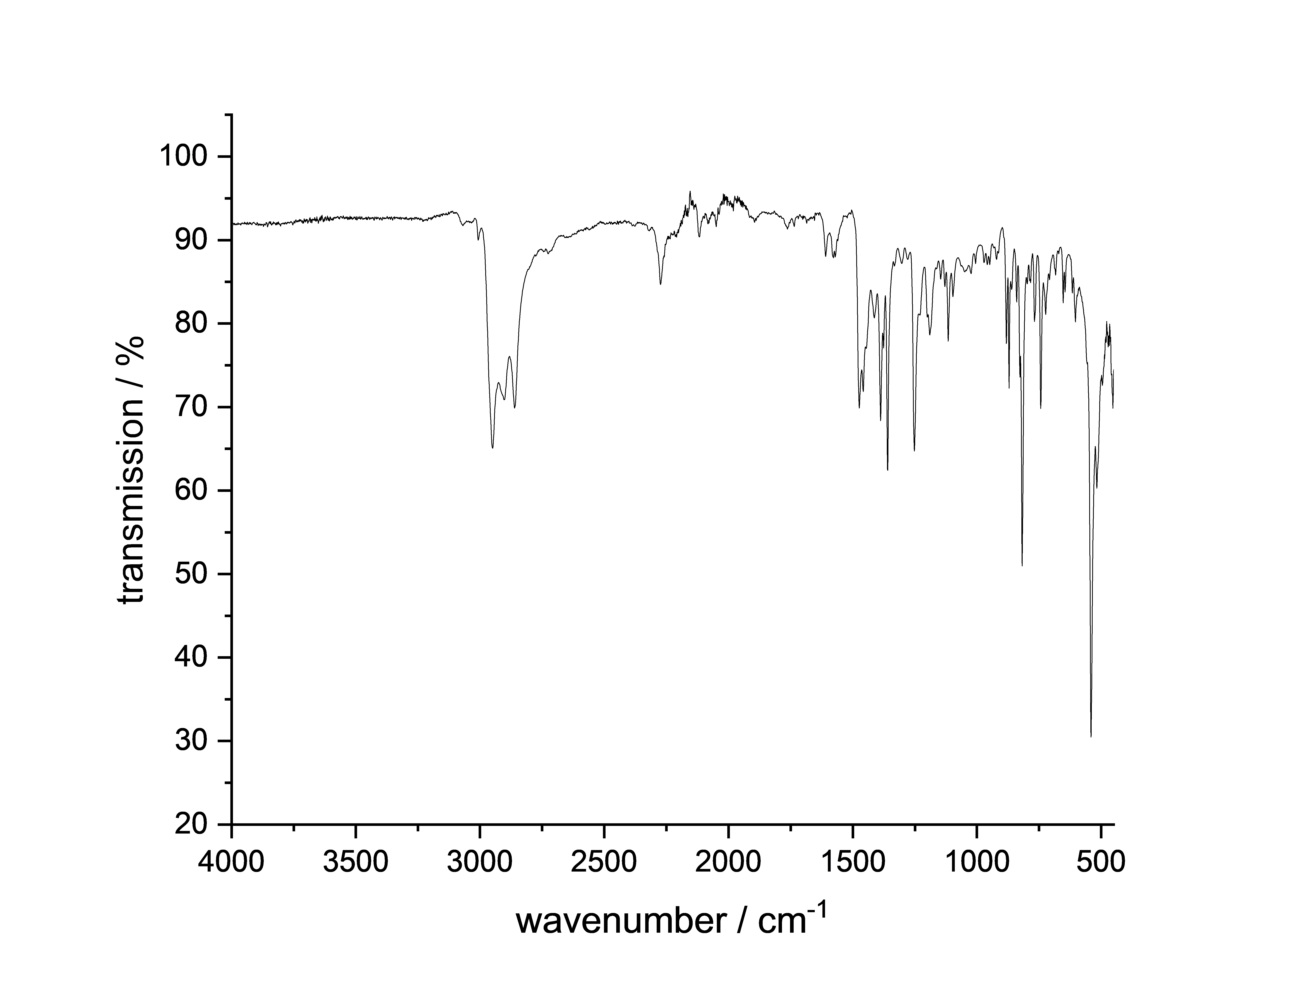
Figure S25. ATR-IR (diamond) spectrum of compound 2.
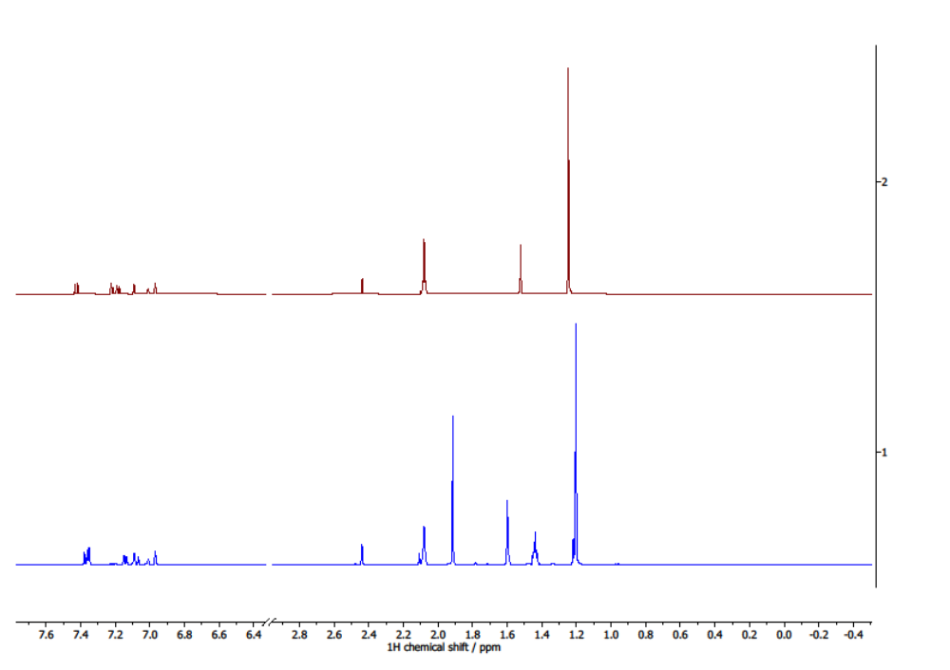
* GaCp*
# THF
#
*
Figure S26. Comparison of the ¹H NMR spectra (500 MHz, toluene-d₈, 293 K) of ^{t}Bu-M^{s}Fluind–Br (red, top) and ^{t}Bu-M^{s}Fluind–Ga^{I} (blue, bottom).
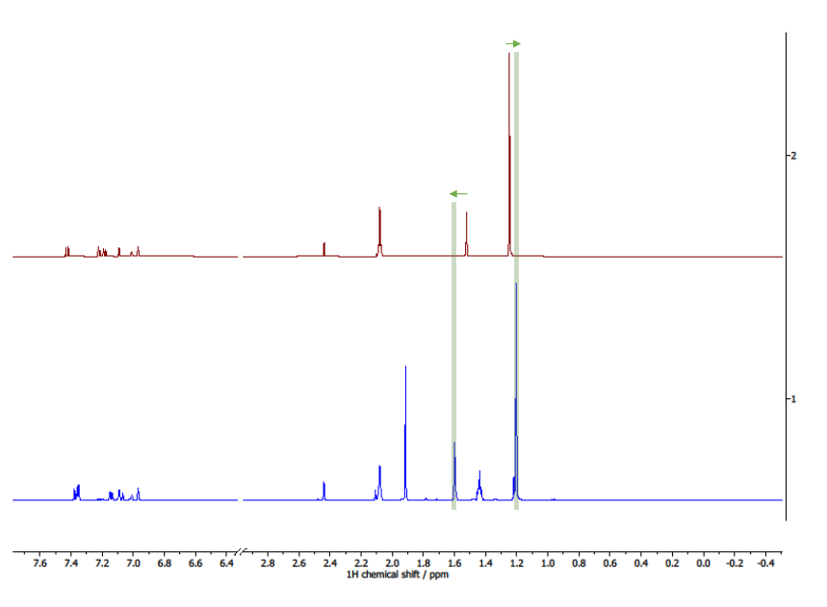
* GaCp*
# THF
*
#
Figure S27. Comparison of the ¹H NMR spectra (500 MHz, toluene-d₈, 293 K) of ^{t}Bu-M^{s}Fluind–Br (red, top) and ^{t}Bu-M^{s}Fluind–Ga^{I} (blue, bottom) highlighting in green the upfield shift of the ^{t}Bu groups as well as the downfield shift of the methyl groups for ^{t}Bu-M^{s}Fluind–Ga^{I}.
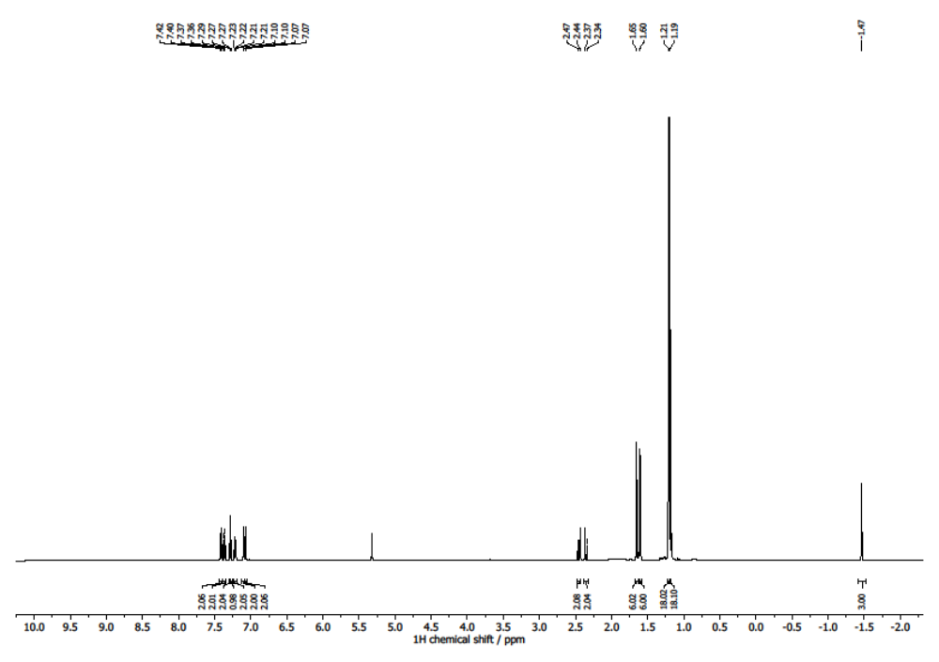
Figure S28. ¹H NMR spectrum (500 MHz, DCM-d₂, 293 K) of compound 3.
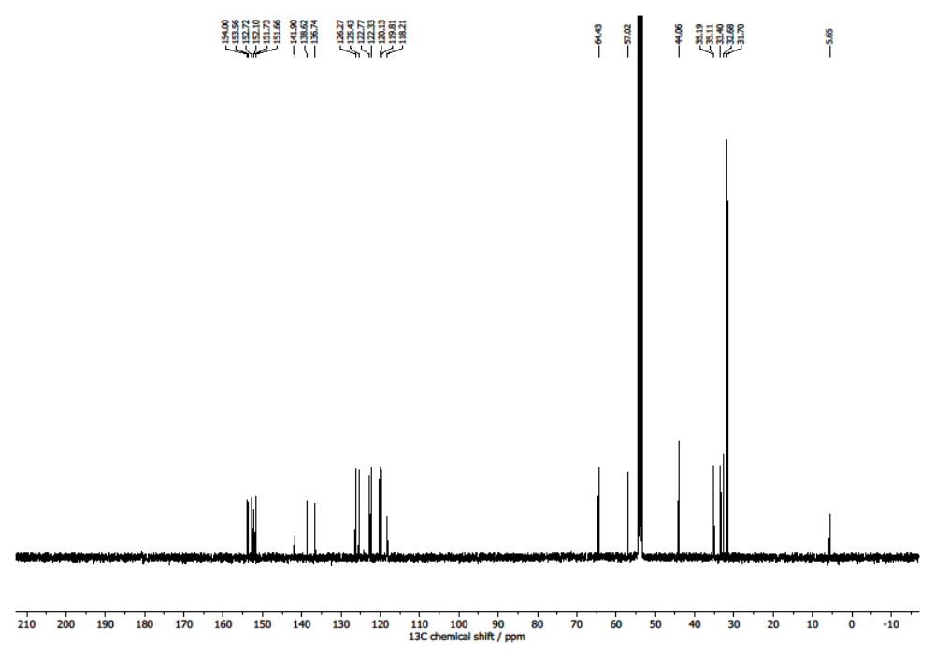
Figure S29. ¹³C{¹H} NMR spectrum (121 MHz, DCM-d₂, 293 K) of compound 3.
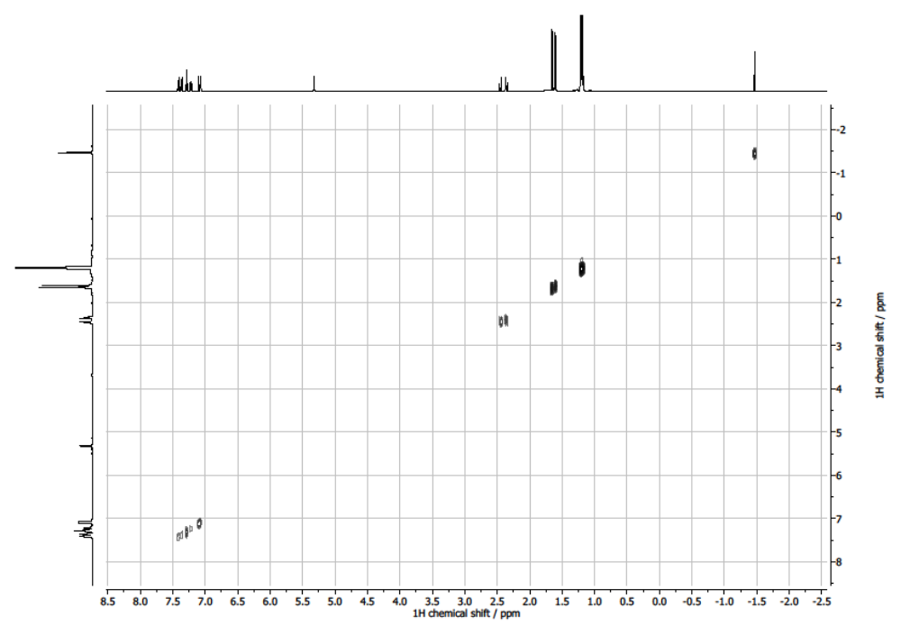
Figure S30. COSY NMR spectrum (500 MHz, DCM-d₂, 293 K) of compound 3.
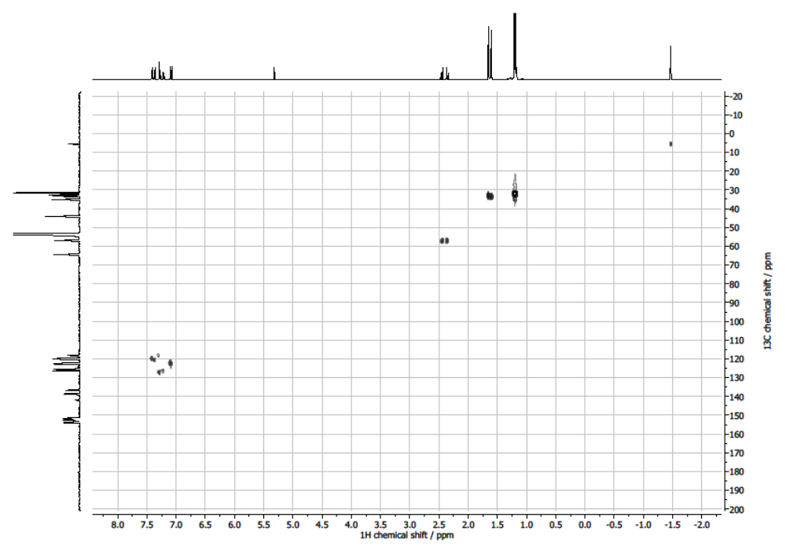
Figure S31. ¹H-¹³C HSQC spectrum (DCM-d₂, 293 K) of compound 3.
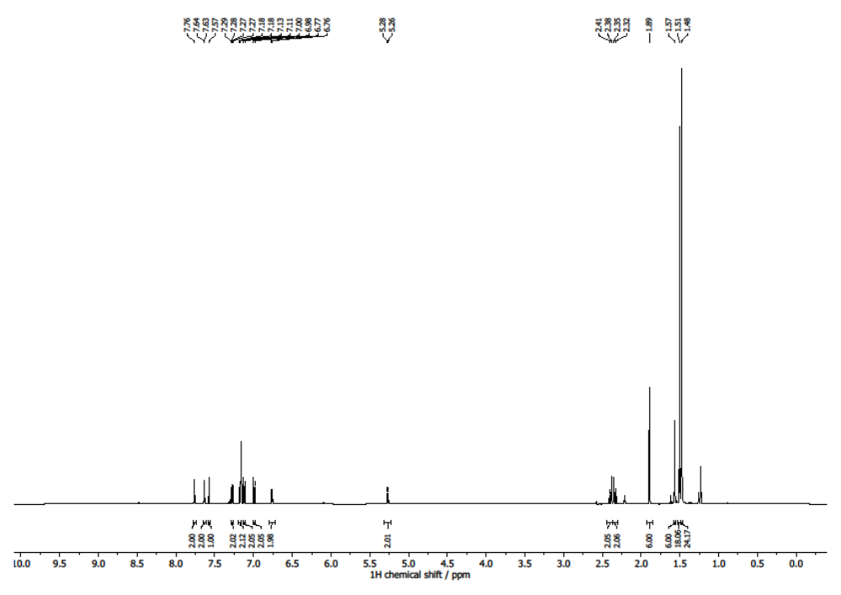
Figure S32. ¹H NMR spectrum (500 MHz, C₆D₆, 293 K) of compound 4.
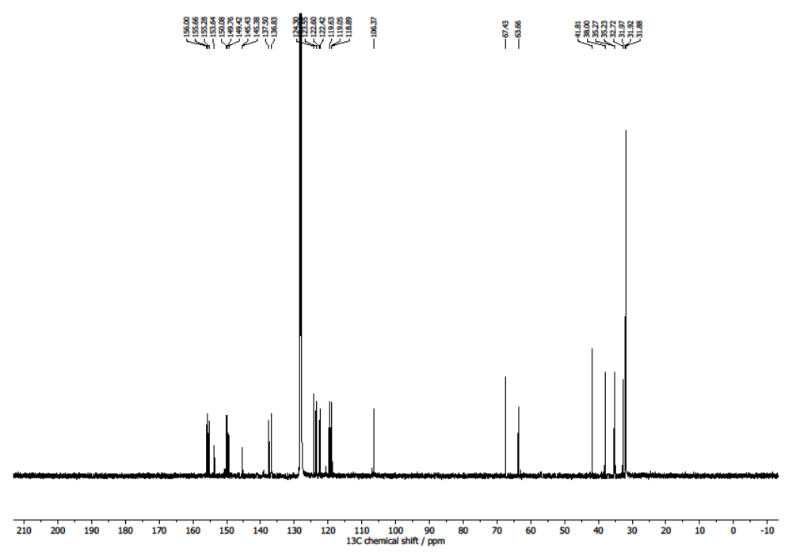
Figure S33. ¹³C{¹H} NMR spectrum (121 MHz, C₆D₆, 293 K) of compound 4.
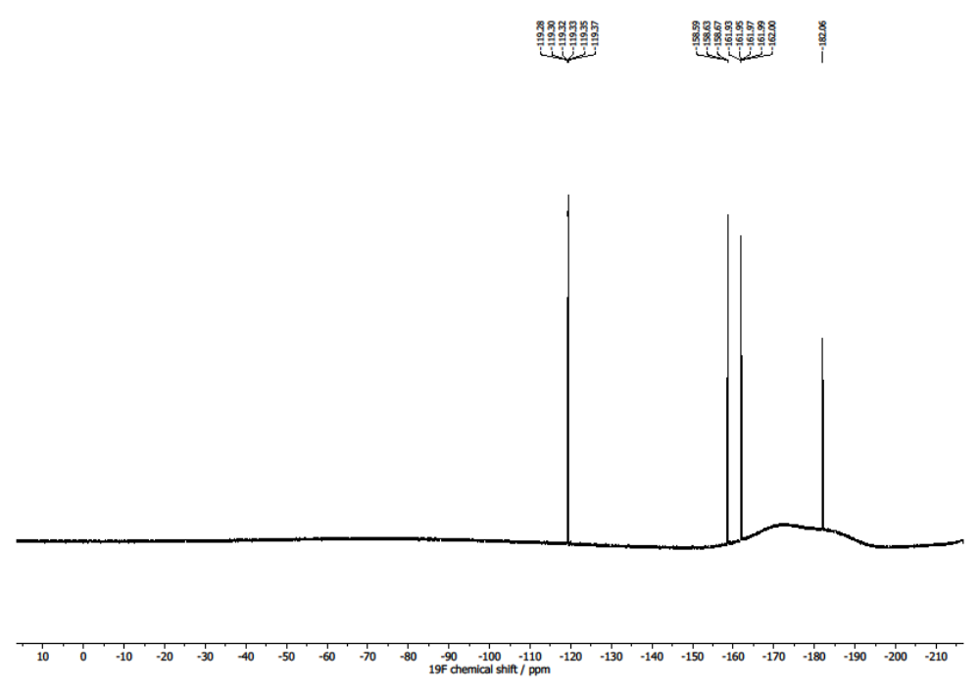
Figure S34. ¹⁹F{¹H} NMR spectrum (565 MHz, C₆D₆, 293 K) of compound 4.
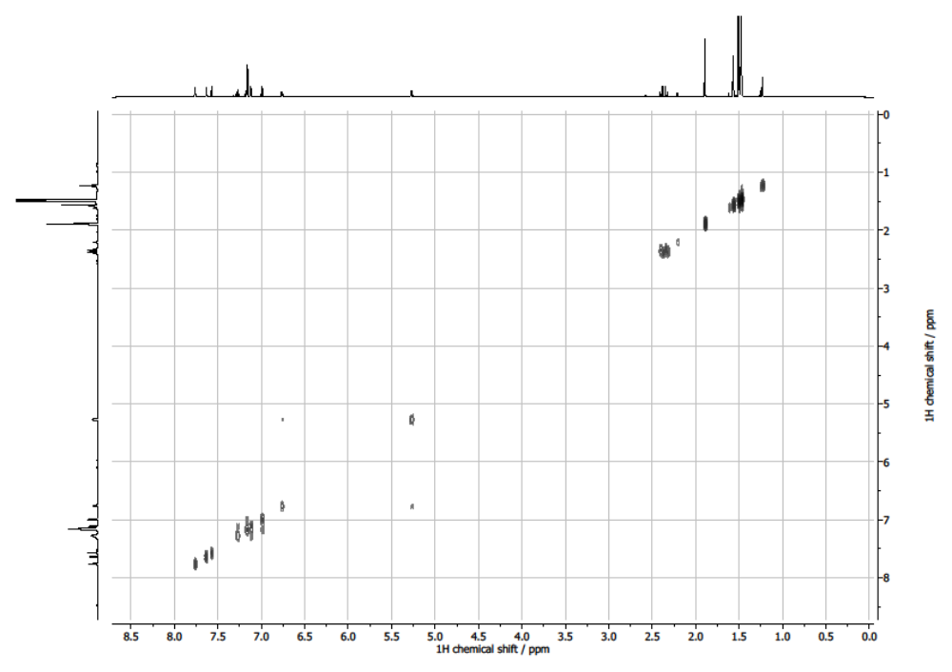
Figure S35. COSY NMR spectrum (500 MHz, C₆D₆, 293 K) of compound 4.
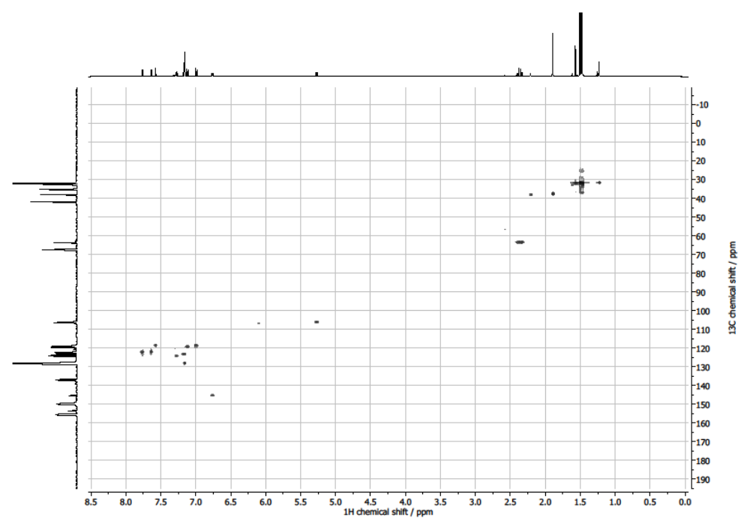
Figure S36. ¹H-¹³C HSQC spectrum (C₆D₆, 293 K) of compound 4.
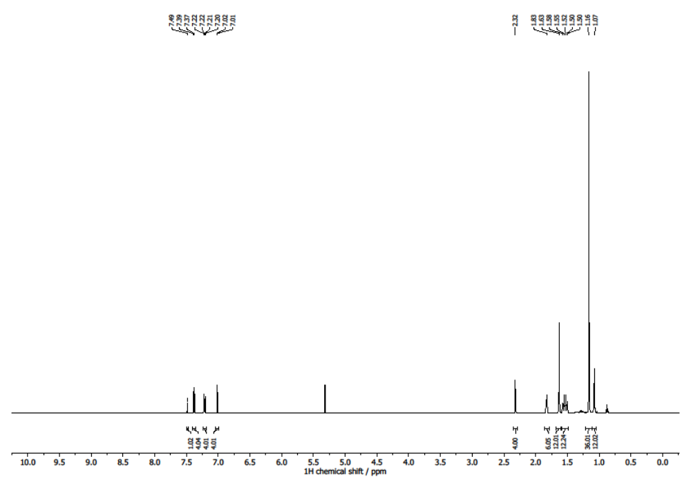
Figure S37. ¹H NMR spectrum (500 MHz, DCM-d₂, 293 K) of compound 5.
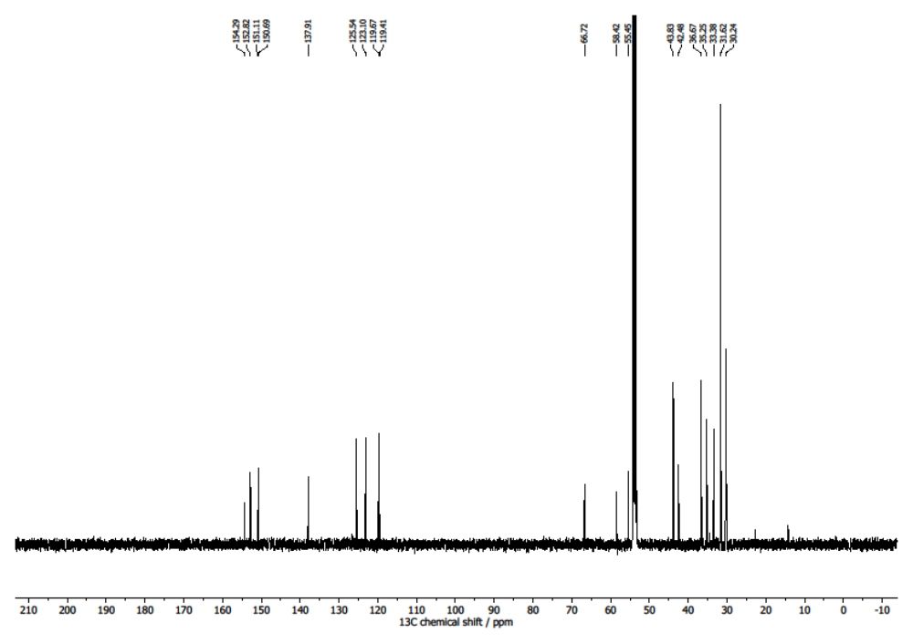
Figure S38. ¹³C{¹H} NMR spectrum (121 MHz, DCM-d₂, 293 K) of compound 5.
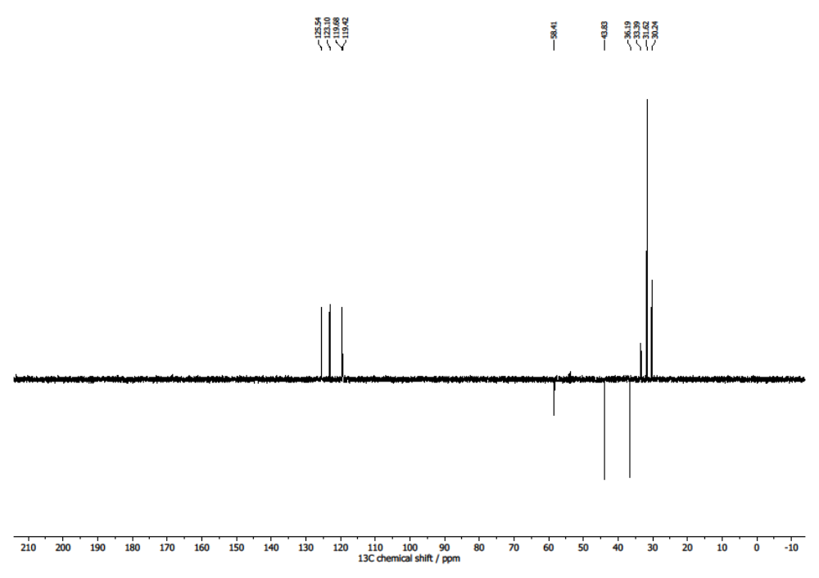
Figure S39. ¹³C{¹H} DEPT 135 NMR spectrum (121 MHz, DCM-d₂, 293 K) of compound 5.
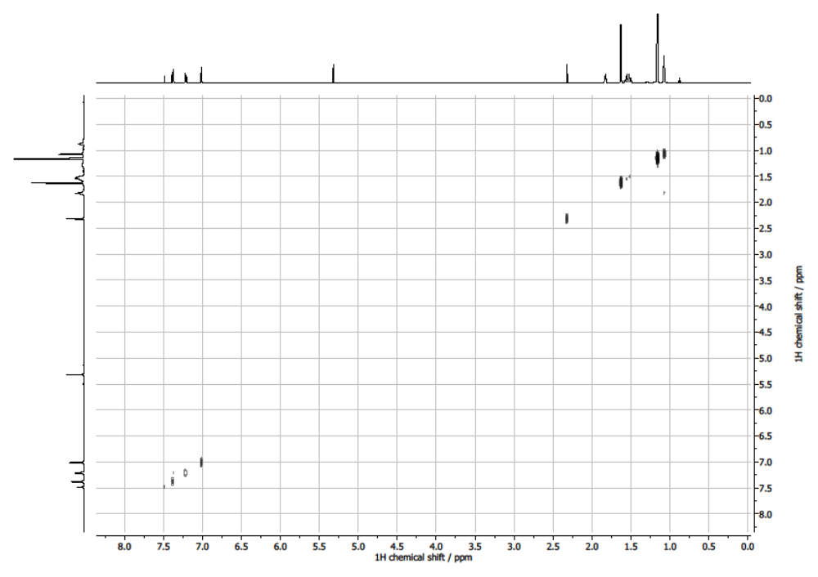
Figure S40. COSY NMR spectrum (500 MHz, DCM-d₂, 293 K) of compound 5.
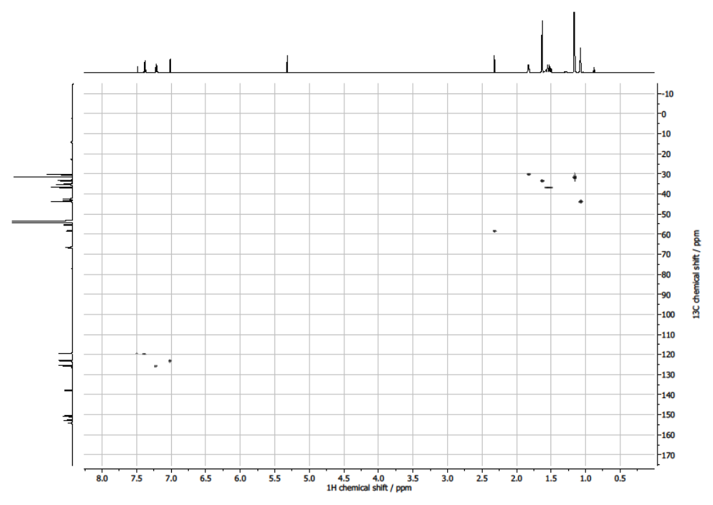
Figure S41. ¹H-¹³C HSQC spectrum (DCM-d₂, 293 K) of compound 5.
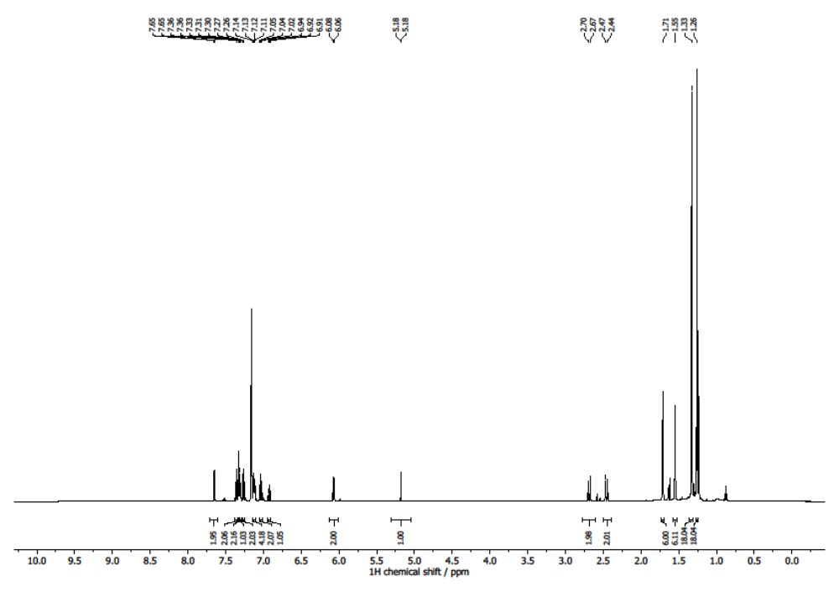
Figure S42. ¹H NMR spectrum (500 MHz, C₆D₆, 293 K) of compound 6.
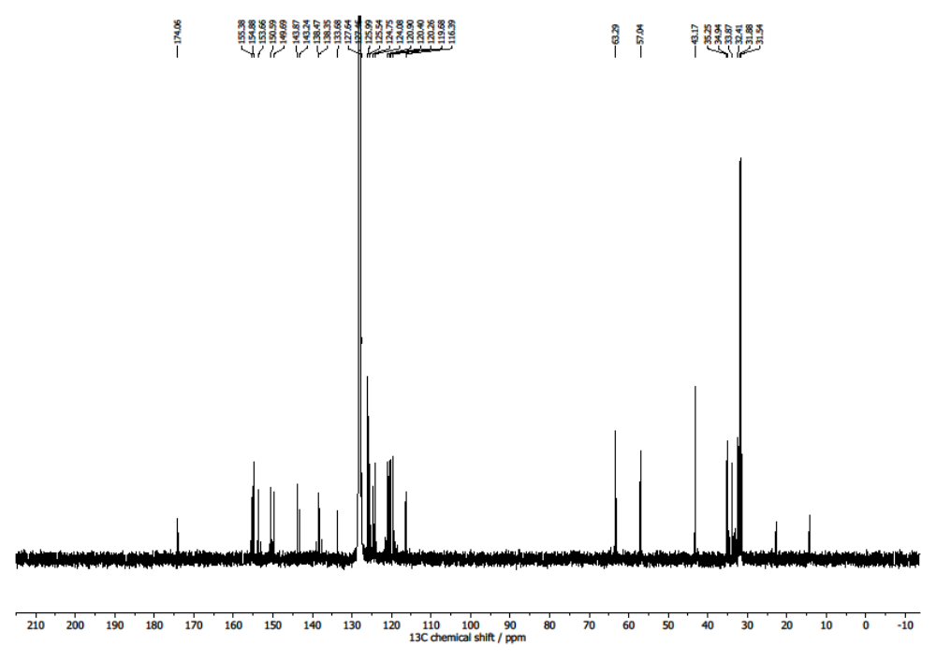
Figure S43. ¹³C{¹H} NMR spectrum (121 MHz, C₆D₆, 293 K) of compound 6.
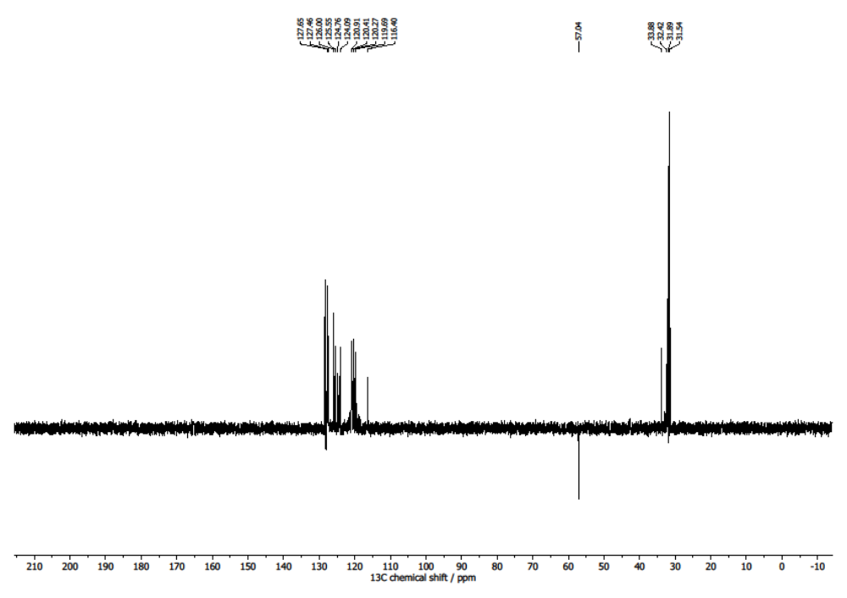
Figure S44. ¹³C{¹H} DEPT 135 NMR spectrum (121 MHz, C₆D₆, 293 K) of compound 6.
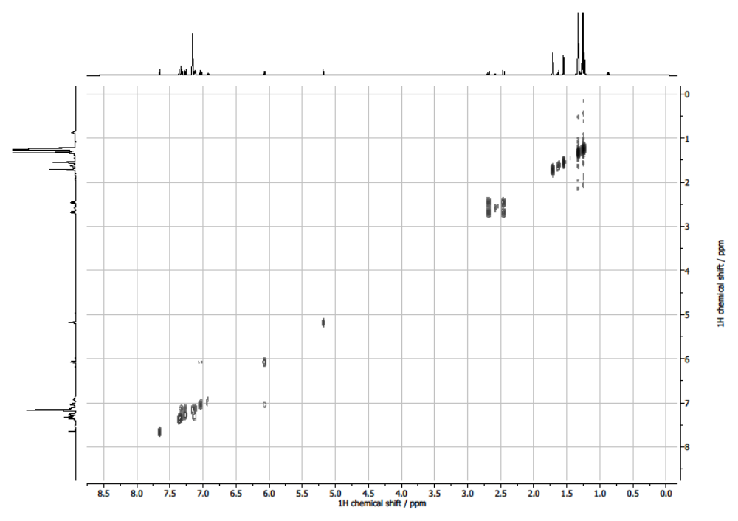
Figure S45. COSY NMR spectrum (500 MHz, C₆D₆, 293 K) of compound 6.
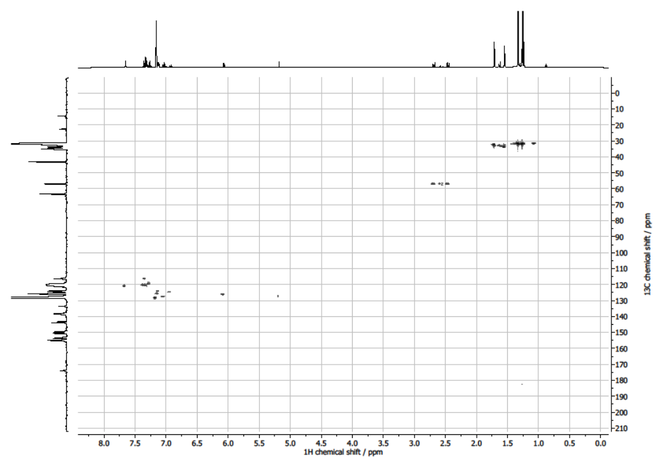
Figure S46. ¹H-¹³C HSQC spectrum (C₆D₆, 293 K) of compound 6.
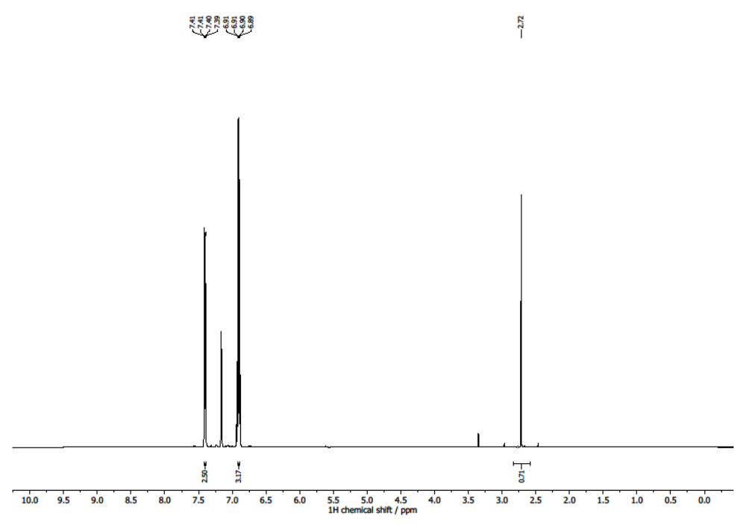
Figure S47. ¹H NMR spectrum (500 MHz, C₆D₆, 293 K) of phenylacetylene.
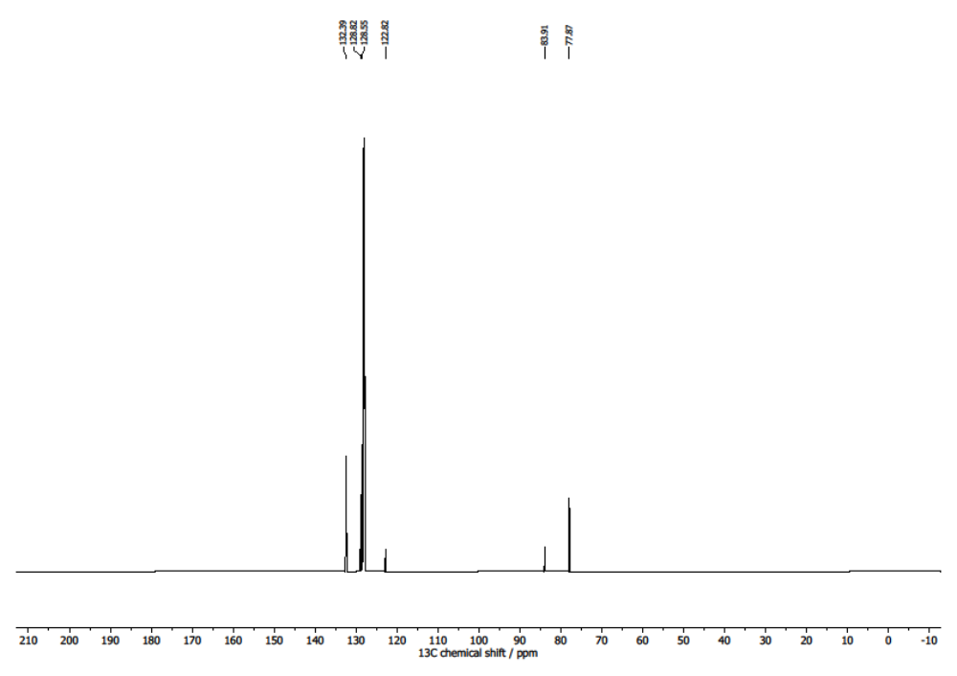
Figure S48. ¹³C{¹H} NMR spectrum (121 MHz, C₆D₆, 293 K) of phenylacetylene.
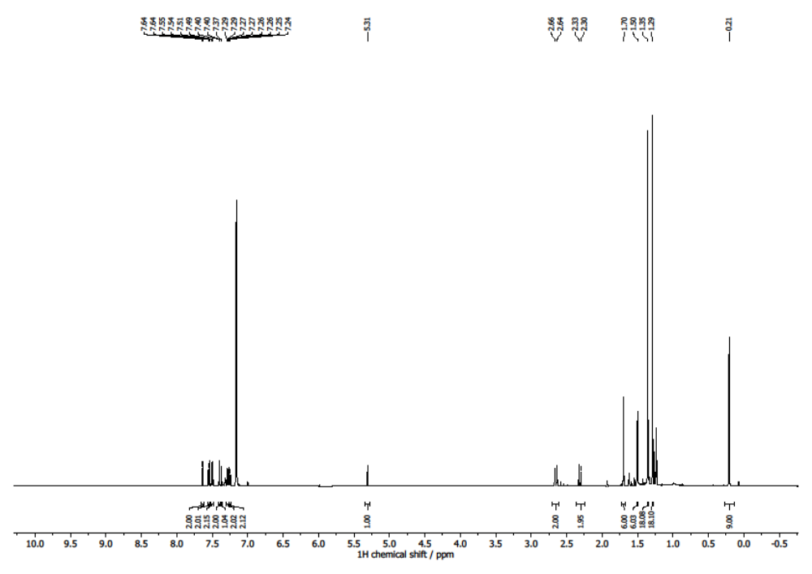
Figure S49. ¹H NMR spectrum (500 MHz, C₆D₆, 293 K) of compound 7.
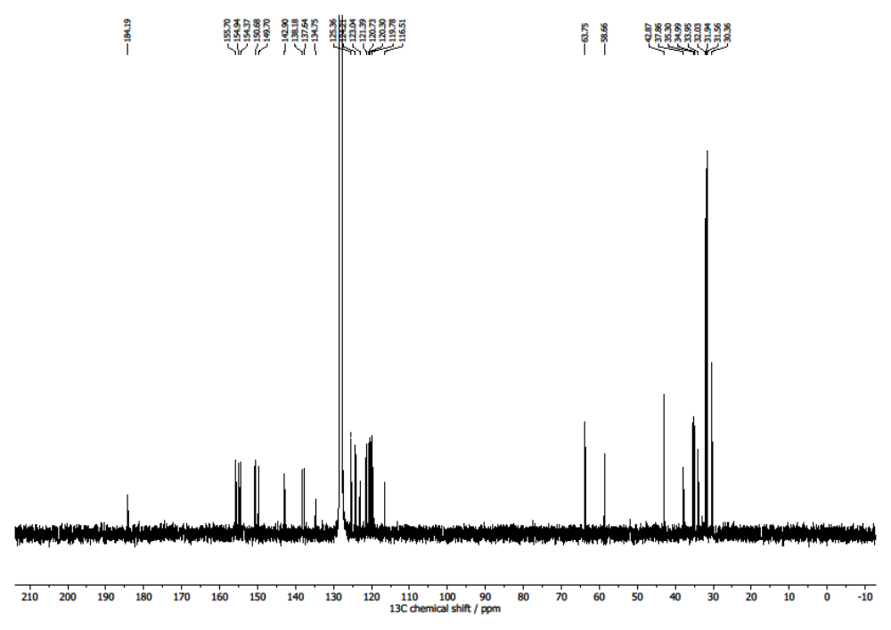
Figure S50. ¹³C{¹H} NMR spectrum (121 MHz, C₆D₆, 293 K) of compound 7.
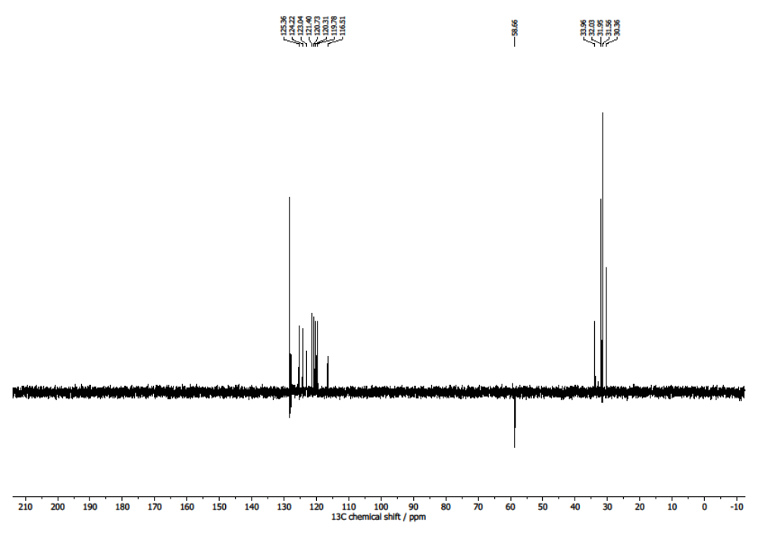
Figure S51. ¹³C{¹H} DEPT 135 NMR spectrum (121 MHz, C₆D₆, 293 K) of compound 7.
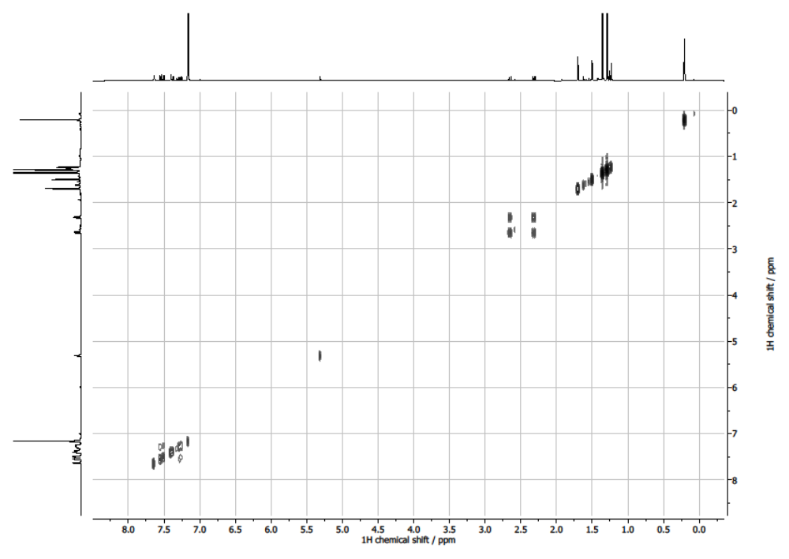
Figure S52. COSY NMR spectrum (500 MHz, C₆D₆, 293 K) of compound 7.
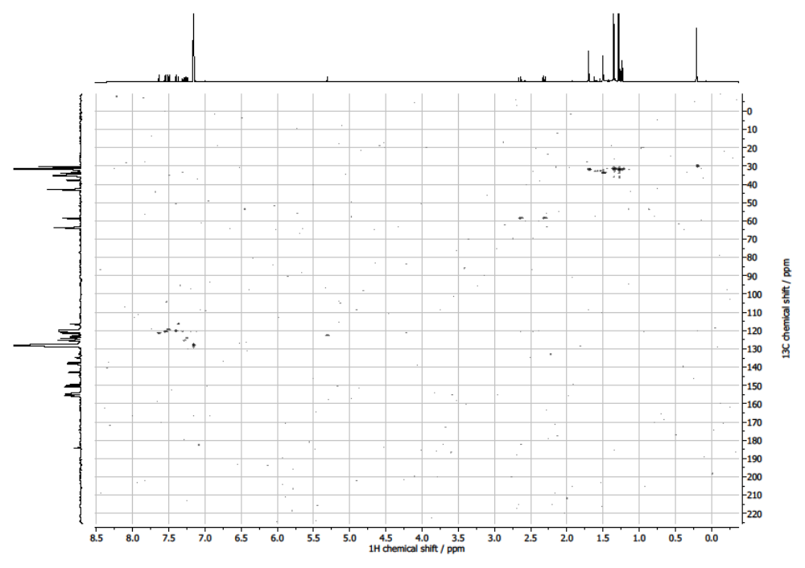
Figure S53. ¹H-¹³C HSQC spectrum (C₆D₆, 293 K) of compound 7.
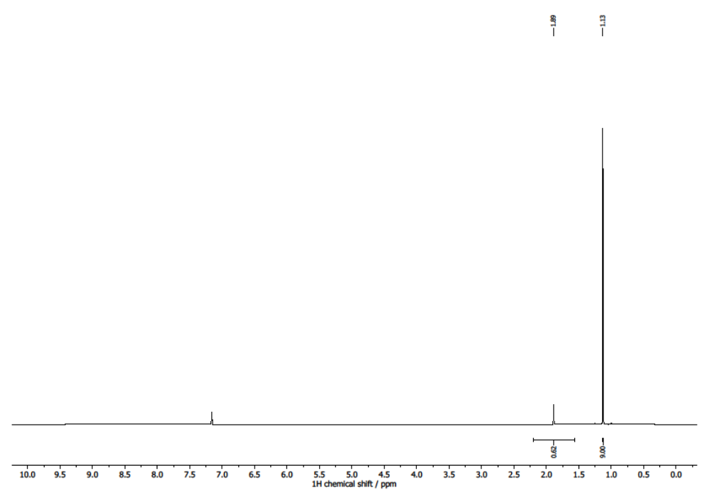
Figure S54. ¹H NMR spectrum (500 MHz, C₆D₆, 293 K) of 3,3-dimethyl-1-butyne.
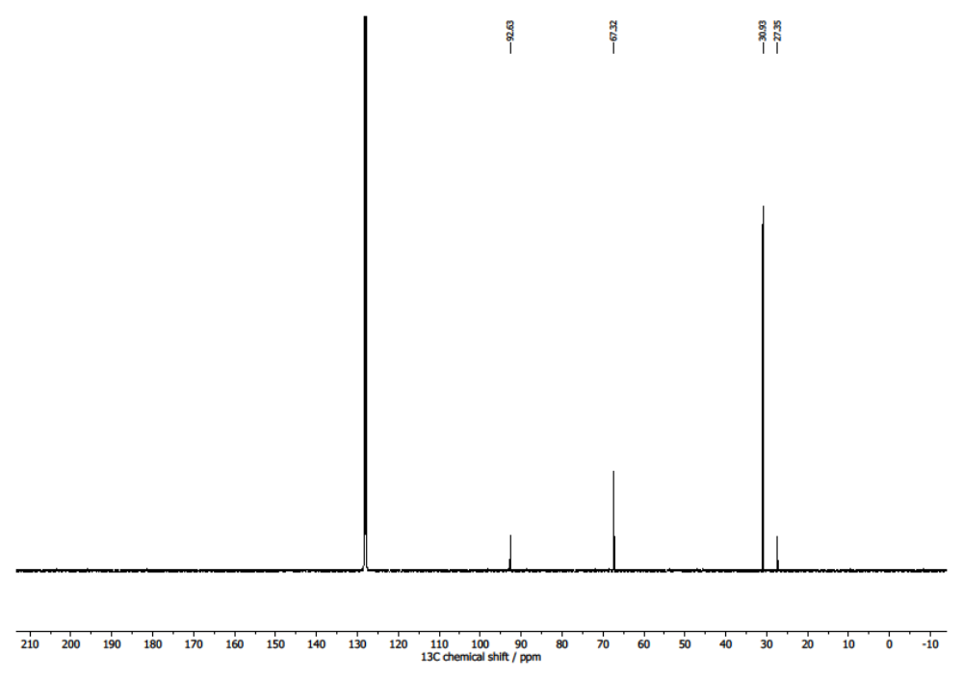
Figure S55. ¹³C{¹H} NMR spectrum (121 MHz, C₆D₆, 293 K) of 3,3-dimethyl-1-butyne.
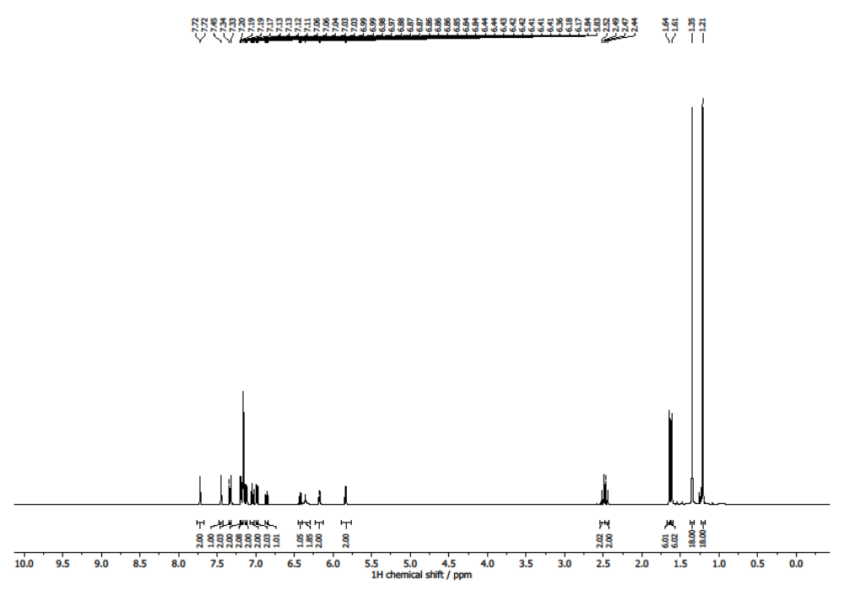
Figure S56. ¹H NMR spectrum (500 MHz, C₆D₆, 293 K) of compound 8.
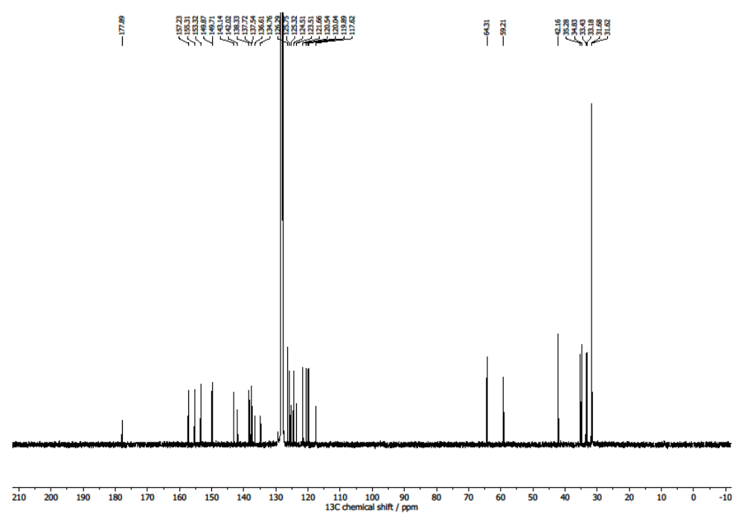
Figure S57. ¹³C{¹H} NMR spectrum (121 MHz, C₆D₆, 293 K) of compound 8.
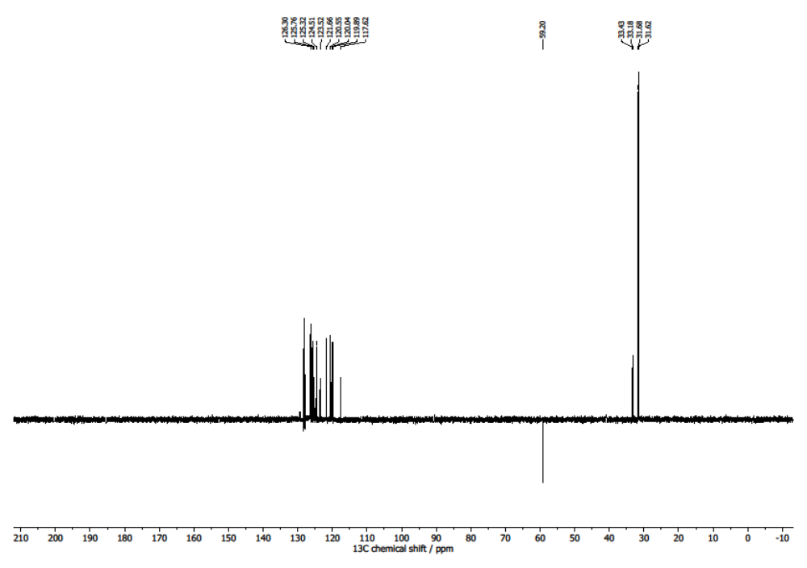
Figure S58. ¹³C{¹H} DEPT 135 NMR spectrum (121 MHz, C₆D₆, 293 K) of compound 8.
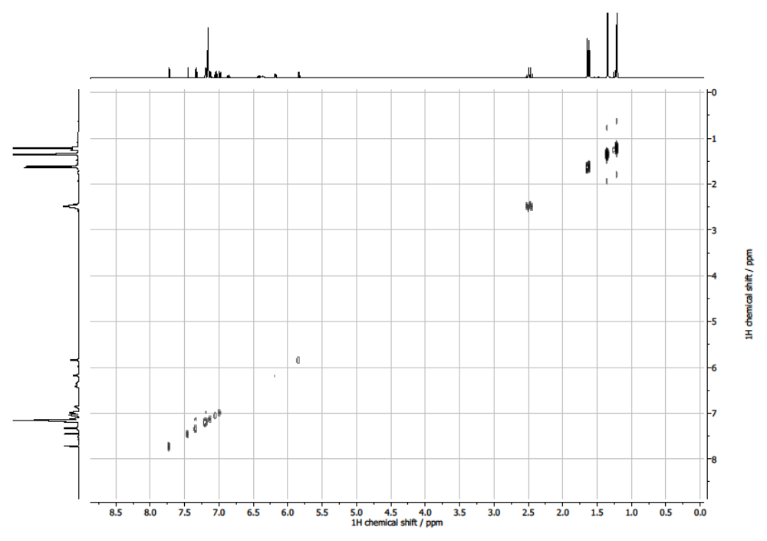
Figure S59. COSY NMR spectrum (500 MHz, C₆D₆, 293 K) of compound 8.
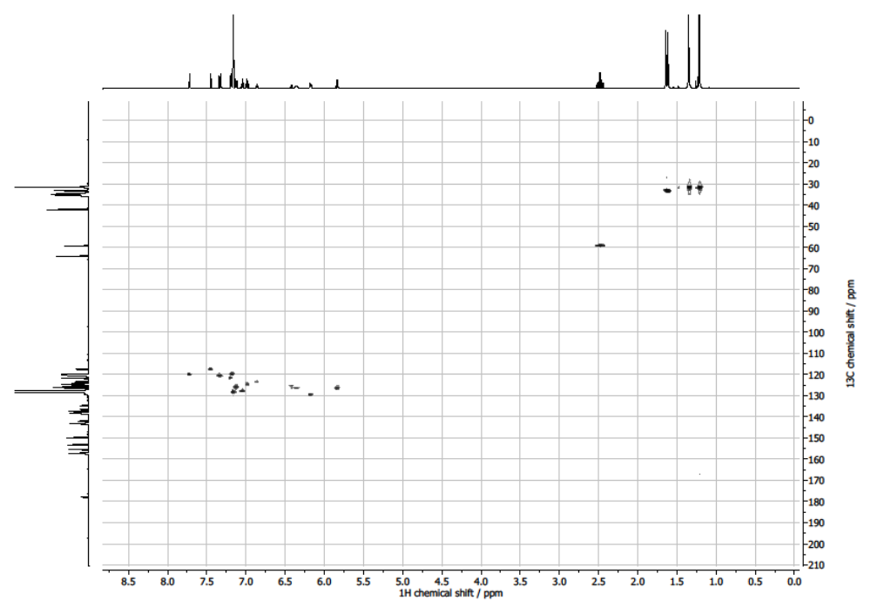
Figure S60. ¹H-¹³C HSQC spectrum (C₆D₆, 293 K) of compound 8.
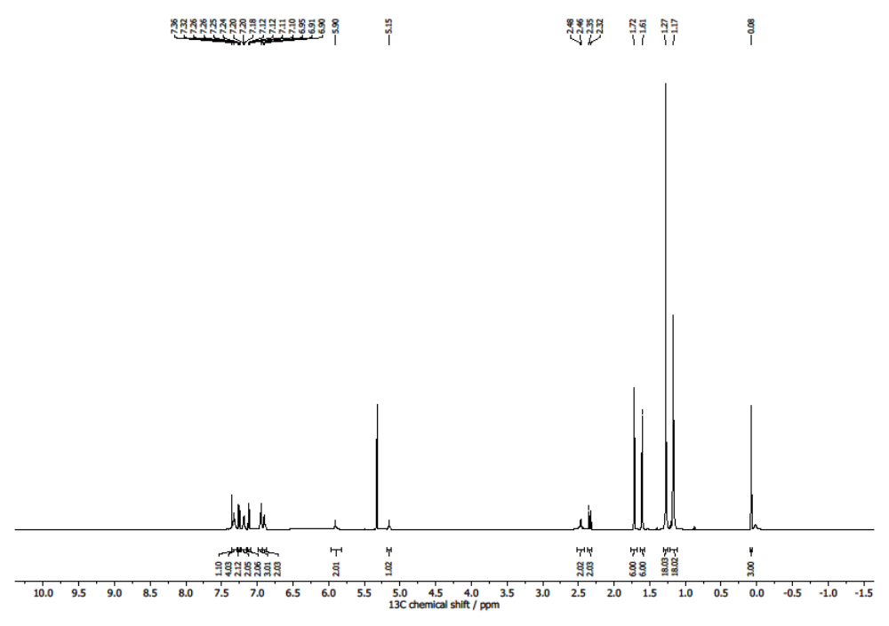
Figure S61. ¹H NMR spectrum (500 MHz, DCM-d₂, 293 K) of compound 9.
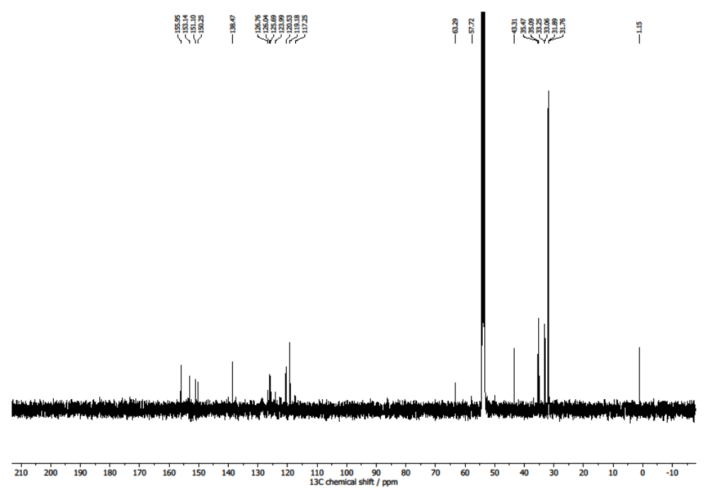
Figure S62. ¹³C{¹H} NMR spectrum (121 MHz, DCM-d₂, 293 K) of compound 9.
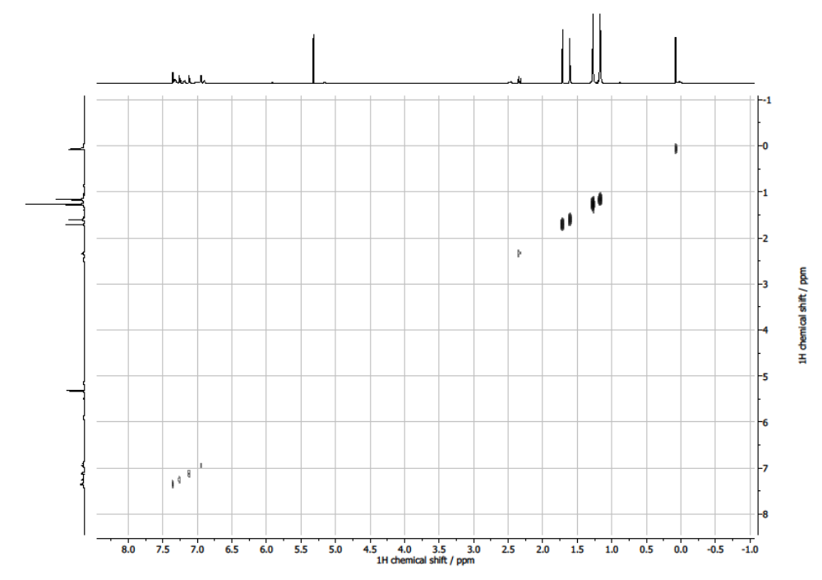
Figure S63. COSY NMR spectrum (500 MHz, DCM-d₂, 293 K) of compound 9.
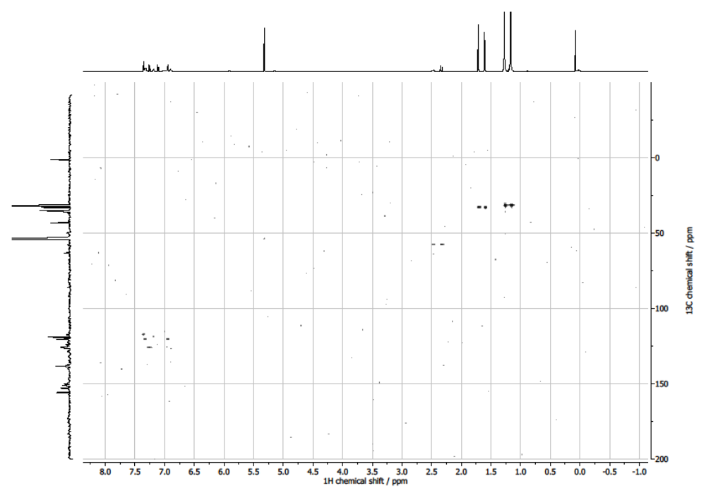
Figure S64. ¹H-¹³C HSQC spectrum (DCM-d₂, 293 K) of compound 9.

XYZ-coordinates
2
C 1.297222 -3.005522 -1.700228
H 1.456793 -3.551987 -3.789304
Ga 0.163816 0.138039 -1.551980
C 0.052448 0.005480 0.546720
C 0.536360 -1.107762 1.247089
C -0.479858 1.012076 1.362450
C 1.157645 -2.344833 0.617657
H 2.023729 -4.011038 1.794025
H 0.264367 -4.043450 1.633996
C 0.476623 -1.231313 2.638449
H -0.025767 -0.245594 4.505537
C -0.473758 0.961913 2.759023
C -1.203370 2.257072 0.871728
H -0.516102 3.923989 2.083533
H -2.255249 3.655952 2.221512
C 1.125773 -3.376259 1.786875
C 0.418746 -2.815068 -0.622711
H -1.608168 -2.719620 0.052868
C 2.554175 -2.111726 0.046449
H 3.526077 -1.084100 1.649361
C 0.939241 -2.596437 3.121833
H 2.106719 -1.868031 4.818158
H 3.062635 -2.083268 3.335481
H 2.555482 -3.503974 4.274163
H -0.287957 -2.713622 4.931863
H 0.148287 -4.294765 4.243150
H -1.104493 -3.293348 3.459903
C -0.004065 -0.176295 3.413310
C -1.005093 2.238804 3.390396
H -0.275880 3.851510 4.671634
H 1.002334 3.031909 3.732964
H 0.290237 2.234293 5.155510
H -2.632760 2.925515 4.671828
H -2.065208 1.279202 5.042962
H -3.083383 1.569819 3.615658
C -1.286191 3.141106 2.150032
C -2.557898 1.902764 0.262225
H -3.458072 0.742954 1.817198
C -0.522287 2.924960 -0.308276
H 1.460594 3.181889 0.453560
C -0.950777 -2.943201 -0.791393
C 2.638530 -2.578049 -1.272849
H 3.922650 -2.830110 -2.999462
C 3.644861 -1.497633 0.648767
C 2.241885 -2.505429 3.930327
C -0.139294 -3.261987 3.988334
C 0.065213 2.875950 4.289076
C -2.269472 1.986783 4.224283
C -3.585110 1.157650 0.815749
C -2.663874 2.391813 -1.049884
H -3.913885 2.517645 -2.811431
C -1.387631 3.029098 -1.409022
H -1.577895 3.667617 -3.468892
C 0.802509 3.319093 -0.408741
C -1.485725 -3.265697 -2.049578
H -0.967905 -3.787171 -4.084412
C 0.792874 -3.395068 -2.936317
C 3.840408 -2.475744 -1.969422
H 5.874265 -1.815255 -1.897686
C 4.862509 -1.378954 -0.034257
C -4.764659 0.909034 0.094215
H -5.755821 1.247276 -1.800207
C -3.818722 2.153507 -1.785876
C -0.922905 3.578003 -2.599523
H 0.765537 4.375257 -3.640110
C 1.304124 3.833872 -1.615774
C -0.588761 -3.521238 -3.097620
C -3.006448 -3.216270 -2.246302
H -4.802213 -4.033725 -1.317520
H -3.489875 -3.741442 -0.161570
H -3.399307 -5.132906 -1.264708
H -4.541745 -1.652275 -2.219467
H -2.969898 -1.114517 -2.865594
H -3.185590 -1.329040 -1.118040
H -4.528225 -3.688856 -3.717075
H -3.111172 -4.759300 -3.802518
H -3.022272 -3.093988 -4.438440
C 4.937210 -1.891779 -1.341249
C 6.094981 -0.712978 0.594871
H 6.707760 0.298925 2.413237
H 5.506060 -0.976231 2.694812
H 5.006138 0.584333 1.991451
H 7.429807 0.958132 0.156627
H 5.747470 1.214293 -0.377432
H 6.822465 0.140761 -1.299345
H 8.125509 -1.294838 1.151800
H 7.516966 -2.138848 -0.289862
H 6.924613 -2.603021 1.320879
C -4.859855 1.424992 -1.205459
C -5.888528 0.099634 0.758125
H -6.146242 -1.849285 1.704277
H -4.517544 -1.175804 1.920750
H -4.992609 -1.853754 0.347701
H -7.213847 0.326017 2.481390
H -6.782223 1.866536 1.691216
H -5.600898 1.034085 2.726904
H -7.843126 -0.732906 0.320042
H -6.761378 -0.698987 -1.088488
H -7.534819 0.802894 -0.514041
C 0.412823 3.973817 -2.690244
C 2.798138 4.167336 -1.720861
H 4.244605 5.453608 -0.712324
H 2.977141 4.837485 0.368160
H 2.598762 6.136304 -0.786241
H 4.687194 3.079563 -1.578681
H 3.344560 2.109199 -2.240330
H 3.424191 2.444160 -0.498374
H 4.247328 4.965157 -3.122712
H 2.627124 5.666635 -3.314549
H 2.967125 4.016227 -3.903596
C -3.709624 -4.079669 -1.184401
C -3.449767 -1.746176 -2.101950
C -3.431328 -3.719801 -3.631140
C 5.803454 -0.174582 2.001615
C 6.548567 0.466036 -0.284978
C 7.229962 -1.748458 0.697775
C -5.350476 -1.271098 1.208528
C -6.399011 0.877518 1.985672
C -7.069005 -0.140457 -0.190942
C 3.172863 5.207058 -0.649211
C 3.607758 2.875174 -1.494393
C 3.171367 4.735061 -3.095692

6
C 0.833445 0.611774 3.708047
H 1.170493 0.795119 4.732522
C 0.767052 -0.683683 3.201381
C 0.328851 -0.913689 1.894083
C 0.460845 -2.381610 1.524612
C 0.625310 -3.059833 2.919862
H -0.351736 -3.469097 3.216534
H 1.325770 -3.906267 2.876159
C 1.061332 -1.976143 3.947310
C 2.540841 -2.097089 4.340804
H 2.714578 -3.030731 4.898636
H 2.844585 -1.257201 4.985023
H 3.200448 -2.106076 3.463577
C 0.202691 -2.065331 5.217924
H 0.324541 -3.049036 5.698895
H -0.863620 -1.925935 4.983323
H 0.491813 -1.295844 5.950871
C -0.393680 2.715512 0.881863
C -0.304387 3.778404 2.024446
H 0.187340 4.697568 1.675043
H -1.325685 4.059202 2.319473
C 0.428682 3.144980 3.240810
C 1.859487 3.682255 3.396730
H 2.388794 3.159202 4.208391
H 1.845572 4.757208 3.636697
H 2.443848 3.550940 2.475607
C -0.350107 3.400923 4.538180
H 0.153962 2.945206 5.404811
H -1.365570 2.980350 4.477336
H -0.435931 4.481947 4.732342
C 0.533014 3.007680 -0.293418
C 1.921033 3.005704 -0.316844
H 2.462717 2.737459 0.589725
C 2.615883 3.316357 -1.496804
C 1.859288 3.611351 -2.642596
H 2.368345 3.855600 -3.576671
C 0.464469 3.582454 -2.637084
H -0.089728 3.787529 -3.555732
C -0.203126 3.280453 -1.453586
C -1.629444 3.120545 -1.145157
C -1.749972 2.735957 0.193929
C -2.990609 2.447586 0.748234
H -3.039116 2.132088 1.791890
C -4.151343 2.546763 -0.030329
C -4.012569 2.958813 -1.368776
H -4.901159 3.051083 -1.997550
C -2.772010 3.244364 -1.932504
H -2.701631 3.540949 -2.981288
C -5.547646 2.230697 0.525122
C -5.495883 1.773608 1.988419
H -6.512859 1.548032 2.343671
H -5.080341 2.551625 2.646759
H -4.893530 0.860714 2.110247
C -6.185115 1.103585 -0.306908
H -7.186930 0.858192 0.080464
H -5.571786 0.192111 -0.265971
H -6.296722 1.384886 -1.364462
C -6.423482 3.494394 0.443296
H -7.429872 3.291484 0.842971
H -6.539880 3.844405 -0.593044
H -5.981231 4.315934 1.027502
C 4.150598 3.361773 -1.543312
C 4.679059 2.649598 -2.801069
H 5.780292 2.647471 -2.797836
H 4.358326 3.146552 -3.728018
H 4.331039 1.605906 -2.834895
C 4.774353 2.676129 -0.319400
H 5.870565 2.663653 -0.416053
H 4.431675 1.633241 -0.232588
H 4.536752 3.199372 0.619113
C 4.588665 4.837961 -1.566531
H 5.687449 4.915909 -1.597715
H 4.231252 5.367906 -0.670103
H 4.185166 5.359104 -2.448107
C 1.648527 -2.635894 0.597572
C 1.261337 -3.416977 -0.499625
C 2.211801 -3.787925 -1.449395
H 1.929890 -4.392590 -2.314755
C 3.535177 -3.378765 -1.284494
H 4.269157 -3.681308 -2.034671
C 3.936127 -2.568719 -0.210150
C 2.959693 -2.191779 0.724116
H 3.211247 -1.526859 1.549141
C -0.190071 -3.621306 -0.433900
C -0.673430 -2.983417 0.712148
C -2.037071 -2.892258 0.956595
H -2.375859 -2.350097 1.841056
C -2.952709 -3.415046 0.034917
C -2.446230 -4.092633 -1.088589
H -3.138170 -4.517112 -1.818877
C -1.081622 -4.203799 -1.330772
H -0.725639 -4.700834 -2.235663
C -0.116956 0.130645 1.071572
C -0.038984 1.425989 1.599213
C 0.439040 1.667473 2.888469
C 5.619352 -1.193791 1.111994
H 6.673702 -0.880855 1.152293
H 5.390302 -1.706335 2.059031
H 5.006290 -0.281503 1.056434
C 5.395795 -2.104743 -0.102050
C 6.305066 -3.338544 0.043601
H 6.220351 -4.011861 -0.822278
H 6.043345 -3.914815 0.944436
H 7.359821 -3.031306 0.126378
C 5.784932 -1.319788 -1.368283
H 5.703745 -1.937286 -2.275052
H 6.826757 -0.968943 -1.295306
H 5.131480 -0.444876 -1.503383
C -4.820150 -2.338304 1.382436
H -4.353244 -1.344244 1.302012
H -4.502770 -2.790980 2.334195
H -5.909742 -2.190104 1.433056
C -4.468385 -3.222533 0.179460
C -5.004324 -2.536175 -1.091271
H -4.871894 -3.161379 -1.985973
H -4.474465 -1.589515 -1.276988
H -6.080200 -2.321439 -0.988929
C -5.148373 -4.591121 0.358415
H -6.240199 -4.472076 0.447403
H -4.782568 -5.095057 1.266275
H -4.951487 -5.255125 -0.496497
Ga 1.869243 -0.064986 -1.672584
C -0.768382 -0.154333 -0.235972
H -1.857053 -0.299396 -0.148518
C -0.167342 -0.321115 -1.424317
C -0.992022 -0.708147 -2.591037
C -0.499542 -1.647059 -3.512808
H 0.495972 -2.076721 -3.360448
C -1.273460 -2.078576 -4.588052
H -0.872154 -2.820997 -5.282231
C -2.557965 -1.569847 -4.774994
H -3.166354 -1.905292 -5.617961
C -3.054755 -0.620091 -3.881001
H -4.056735 -0.206819 -4.022283
C -2.281037 -0.191643 -2.806137
H -2.675446 0.560427 -2.119712

6_{iso}
C -1.308244 -1.549466 -2.897283
H -1.132146 -3.669191 -3.293436
C -0.432189 1.055446 -0.033241
C -1.025768 1.584782 -1.182977
C -0.019146 1.977576 0.928377
C -1.538030 0.796295 -2.374285
H -2.576193 1.729563 -4.092557
H -0.813431 1.857540 -4.123000
C -1.188439 2.958975 -1.369621
H -1.006812 4.927924 -0.477725
C -0.264467 3.347093 0.807612
C 0.811160 1.678408 2.160140
H -0.137054 2.779987 3.770485
H 1.554318 3.237804 3.540607
C -1.692040 1.901991 -3.462333
C -0.610998 -0.338053 -2.780404
H 1.286262 0.653428 -2.751530
C -2.823863 0.022782 -2.084268
H -4.021550 1.498879 -1.102806
C -1.729507 3.287678 -2.752343
H -3.165233 4.796278 -2.090790
H -3.858051 3.164723 -2.231592
H -3.515480 4.109382 -3.696315
H -0.823985 5.269883 -2.971470
H -1.139295 4.436681 -4.510876
H 0.228496 3.927846 -3.484125
C -0.841550 3.853027 -0.356077
C 0.143968 4.111432 2.058302
H -0.817676 5.292720 3.623061
H -1.902435 4.119040 2.828165
H -1.442065 5.619571 1.988363
H 1.491904 5.699706 2.700033
H 0.904820 5.883173 1.030001
H 2.162282 4.683403 1.408580
C 0.630809 2.972458 3.006394
C 2.263581 1.378095 1.786917
H 2.735682 2.997554 0.471314
C 0.430668 0.398849 2.881912
H -1.677214 0.677609 3.137490
C 0.768960 -0.297859 -2.903513
C -2.696916 -1.316867 -2.474458
H -3.677950 -3.243958 -2.584674
C -3.981543 0.471672 -1.463109
C -3.149209 3.869619 -2.685625
C -0.811754 4.287649 -3.469614
C -1.076088 4.826215 2.658933
C 1.240171 5.149632 1.779728
C 3.110815 2.098327 0.962935
C 2.690027 0.172394 2.366479
H 4.349616 -1.193554 2.615804
C 1.539743 -0.449624 3.039230
H 2.216010 -2.371007 3.770248
C -0.830754 0.005193 3.301142
C 1.499097 -1.477094 -3.126340
H 1.312868 -3.600186 -3.483103
C -0.612059 -2.712980 -3.201166
C -3.761992 -2.194592 -2.293245
H -5.757049 -2.424859 -1.555239
C -5.061782 -0.397126 -1.258748
C 4.428911 1.669105 0.732355
H 5.865660 0.121275 1.204094
C 3.993183 -0.265492 2.162535
C 1.373836 -1.686340 3.649230
H -0.016567 -3.067005 4.501675
C -1.026660 -1.258941 3.882984
C 0.779918 -2.665947 -3.308165
C 3.031613 -1.421812 -3.081412
H 4.646193 -0.468157 -4.198588
H 3.150650 0.492227 -4.155090
H 3.251984 -0.939254 -5.206678
H 4.560329 -0.772389 -1.660777
H 3.096233 -1.437794 -0.895436
H 3.073149 0.193631 -1.577128
H 4.757861 -2.730925 -3.144635
H 3.421779 -3.288985 -4.171038
H 3.333459 -3.481886 -2.395452
C -4.931159 -1.724662 -1.701069
C -6.352874 0.049201 -0.557709
H -7.241342 1.802972 0.359484
H -6.166747 2.192752 -0.998728
H -5.481474 1.714545 0.577128
H -7.485455 -0.495426 1.228966
H -5.720442 -0.695279 1.399219
H -6.664546 -1.874299 0.464297
H -8.480626 0.182348 -1.032321
H -7.664232 -1.185031 -1.821346
H -7.407663 0.465920 -2.428873
C 4.850358 0.487469 1.355744
C 5.349101 2.521937 -0.154148
H 5.338086 3.411442 -2.144046
H 3.715955 3.256246 -1.440769
H 4.550750 1.816280 -2.067139
H 6.249745 4.511834 -0.056537
H 6.037802 3.732975 1.534905
H 4.635797 4.423072 0.686417
H 7.327161 2.485476 -1.043746
H 6.601554 0.872450 -0.872947
H 7.266165 1.715351 0.552947
C 0.096717 -2.077529 4.059501
C -2.448107 -1.691173 4.266090
H -3.988929 -1.061095 5.680298
H -2.982663 0.277818 5.082463
H -2.323537 -0.854233 6.285701
H -4.383970 -1.912991 3.285659
H -2.989930 -2.161783 2.193808
H -3.452285 -0.525131 2.687199
H -3.532945 -3.420394 4.997540
H -1.892126 -3.295788 5.659901
H -2.139295 -3.841176 3.977872
C 3.546494 -0.532467 -4.226796
C 3.461498 -0.823455 -1.728692
C 3.662005 -2.814201 -3.206964
C -6.298702 1.523030 -0.135013
C -6.567060 -0.805468 0.705135
C -7.543269 -0.135049 -1.516552
C 4.695549 2.763228 -1.527595
C 5.580014 3.875784 0.544080
C 6.710040 1.854150 -0.386531
C -2.963671 -0.777769 5.393258
C -3.368759 -1.565234 3.036574
C -2.496077 -3.144798 4.752083
C -0.832057 -2.643040 0.403334
C 0.520607 -2.603731 0.252466
Ga -0.223214 -0.858941 0.206832
H -1.491198 -3.516348 0.522813
C 1.534409 -3.655421 0.125615
C 1.252405 -4.842940 -0.567008
C 2.821457 -3.479841 0.652657
C 2.230641 -5.820873 -0.731912
H 0.256389 -4.980660 -0.994974
C 3.796414 -4.462175 0.500582
H 3.047689 -2.548975 1.175444
C 3.506530 -5.634801 -0.197834
H 1.998244 -6.734907 -1.283803
H 4.794112 -4.307333 0.918443
H 4.274448 -6.400143 -0.330556

6_{iso'}
C 1.295251 3.157531 -0.884883
H 1.688430 3.819883 -2.912212
Ga 0.854335 -0.026547 -1.045288
C 0.735550 -0.175738 0.926970
C 0.776501 0.933102 1.780986
C 0.668460 -1.419506 1.562450
C 0.803087 2.392482 1.347399
H 0.368241 4.023277 2.767735
H 2.065372 3.552710 2.692345
C 0.791845 0.814641 3.171955
H 0.826257 -0.545799 4.860818
C 0.718977 -1.567221 2.951516
C 0.497097 -2.764338 0.878562
H 0.223546 -4.666891 1.975162
H 1.895302 -4.107879 1.855199
C 1.039526 3.156688 2.684481
C 1.865290 2.656713 0.291879
H 3.637056 2.036136 1.319635
C -0.462974 2.802959 0.599114
H -1.994271 2.334419 2.019961
C 0.853136 2.162515 3.869056
H -0.596745 1.677593 5.431197
H -1.322739 2.402380 3.981331
H -0.415365 3.423595 5.123086
H 1.930784 1.523327 5.665616
H 2.130517 3.245477 5.268767
H 2.986152 2.003522 4.314934
C 0.777010 -0.443772 3.772417
C 0.761585 -3.026859 3.376206
H -0.425783 -4.486612 4.479794
H -1.405703 -3.309036 3.582228
H -0.586817 -2.818347 5.082369
H 2.098914 -4.381166 4.445503
H 1.955682 -2.773950 5.194789
H 2.920890 -2.976185 3.712768
C 0.859697 -3.770830 2.011345
C 1.333488 -2.941740 -0.376619
H 3.281064 -2.432614 0.348493
C -0.911156 -2.955906 0.316269
H -2.146148 -2.366507 1.960002
C 3.235339 2.440495 0.389210
C -0.157129 3.270200 -0.684061
H -0.951504 4.066319 -2.534961
C -1.781548 2.739325 1.031267
C -0.445764 2.432233 4.643570
C 2.043807 2.236708 4.834249
C -0.487984 -3.430679 4.172449
C 2.006800 -3.304319 4.230919
C 2.705280 -2.757315 -0.519285
C 0.538405 -3.314550 -1.468780
H 0.531741 -3.817158 -3.577313
C -0.863119 -3.348572 -1.030583
H -2.016397 -3.924760 -2.766980
C -2.128967 -2.754096 0.939888
C 4.075243 2.736773 -0.690694
H 4.113340 3.465338 -2.728867
C 2.112115 3.439321 -1.980344
C -1.175047 3.705226 -1.528446
H -3.281973 4.004772 -1.742655
C -2.821542 3.178964 0.203061
C 3.314606 -2.935946 -1.766226
H 2.956299 -3.496752 -3.824618
C 1.132007 -3.527845 -2.712243
C -2.037559 -3.617777 -1.719127
H -4.172932 -3.687660 -1.613792
C -3.333037 -3.008183 0.261623
C 3.482577 3.230637 -1.868660
C 5.601643 2.586940 -0.611752
H 7.141828 1.806645 0.701448
H 5.607341 0.918241 0.812595
H 5.775388 2.520614 1.577761
H 7.208581 1.626435 -1.728606
H 5.870282 2.171366 -2.759181
H 5.674078 0.723515 -1.750492
H 7.332907 3.920478 -0.621844
H 5.881362 4.623476 0.141302
H 5.983841 4.496875 -1.629172
C -2.488471 3.662850 -1.074664
C -4.289804 3.170994 0.651208
H -5.528271 2.532615 2.313675
H -3.923991 3.100601 2.816762
H -4.108894 1.497325 2.055597
H -6.189519 2.345138 -0.035906
H -4.774802 1.332853 -0.425641
H -5.099123 2.794470 -1.365606
H -5.852148 4.647448 1.037815
H -4.742387 5.113915 -0.271333
H -4.205841 5.219112 1.421022
C 2.504763 -3.342923 -2.842196
C 4.806049 -2.662567 -1.998640
H 6.525680 -1.827424 -0.969005
H 5.455238 -2.756361 0.098607
H 4.977479 -1.126637 -0.446372
H 6.589257 -3.803202 -2.537171
H 5.091884 -4.438447 -3.258417
H 5.425715 -4.708900 -1.532804
H 6.018067 -1.389164 -3.293940
H 4.386907 -0.742347 -2.959476
H 4.601554 -2.076971 -4.111924
C -3.259969 -3.467060 -1.060182
C -4.662213 -2.745498 0.982810
H -5.690622 -3.448374 2.776903
H -3.921708 -3.416869 2.941729
H -4.695593 -4.694787 1.977388
H -5.674330 -1.031572 1.889108
H -4.637456 -0.612283 0.500941
H -3.906005 -0.990468 2.072835
H -6.803440 -2.848755 0.653846
H -5.900667 -4.108401 -0.213521
H -5.890613 -2.425691 -0.807224
C 6.047152 1.920519 0.696257
C 6.113130 1.729806 -1.781811
C 6.235093 3.989125 -0.685903
C -4.462643 2.538760 2.038080
C -5.134516 2.368379 -0.352427
C -4.800017 4.622741 0.711438
C 5.471707 -2.060989 -0.754409
C 5.517513 -3.980280 -2.352918
C 4.959144 -1.661077 -3.158834
C -4.744290 -3.627348 2.242081
C -4.721484 -1.260546 1.385637
C -5.876158 -3.052821 0.097332
H 2.183311 0.056218 -1.851372
C -0.841636 0.087373 -1.946355
C -1.959603 0.263908 -2.404735
C -3.276323 0.497239 -2.919870
C -3.535418 1.604652 -3.743817
C -4.334080 -0.362539 -2.584090
C -4.824889 1.851174 -4.205727
H -2.713597 2.272369 -4.007738
C -5.620667 -0.112281 -3.051238
H -4.126598 -1.221511 -1.945106
C -5.872157 0.996441 -3.859290
H -5.015233 2.718226 -4.842279
H -6.436257 -0.785901 -2.777583
H -6.883446 1.193877 -4.221271

7
Ga 2.092375 -0.049463 -1.379213
C -0.232283 -0.007305 0.885660
C -0.719949 0.041860 -0.524779
H -1.816709 0.083085 -0.590517
C 0.044495 0.053682 -1.626655
C -0.557996 0.142305 -3.030472
C 0.068348 1.351997 -3.747003
H -0.298530 1.426821 -4.783876
H 1.168737 1.275268 -3.791667
H -0.179820 2.285886 -3.224935
C -2.083993 0.300859 -3.032003
H -2.461052 0.376778 -4.064815
H -2.387960 1.212838 -2.494621
H -2.578037 -0.563417 -2.559085
C -0.188599 -1.132535 -3.807951
H -0.531080 -1.065117 -4.853755
H -0.654318 -2.014643 -3.348496
H 0.901584 -1.301526 -3.823768
C 0.000331 1.168094 1.616921
C 0.327661 1.136731 2.976413
C 0.460321 -0.075244 3.646897
H 0.704129 -0.100857 4.712873
C 0.242501 -1.253380 2.938036
C -0.100483 -1.218423 1.583942
C -0.020775 2.595030 1.096822
C -0.047417 3.429670 2.419240
H 0.537920 4.355500 2.322967
H -1.088403 3.727860 2.612166
C 0.445572 2.526152 3.580851
C 1.887656 2.845682 4.002842
H 1.942718 3.850038 4.451642
H 2.578332 2.823269 3.150153
H 2.246480 2.120425 4.749804
C -0.473034 2.669559 4.802690
H -0.477015 3.710623 5.163180
H -0.137146 2.029984 5.633930
H -1.507380 2.386919 4.554080
C -0.288737 -2.619702 1.026358
C -0.278792 -3.505420 2.315279
H -1.314232 -3.795789 2.544401
H 0.283044 -4.436718 2.154827
C 0.290695 -2.666629 3.491747
C 1.727764 -3.071040 3.854005
H 1.753202 -4.101329 4.242790
H 2.138578 -2.404832 4.628574
H 2.394999 -3.024113 2.982939
C -0.597872 -2.805314 4.735514
H -0.640757 -3.855585 5.065344
H -1.624590 -2.468068 4.526061
H -0.209466 -2.207883 5.575145
C 1.180607 2.941163 0.222177
C 0.773218 3.645999 -0.918206
C 1.726603 4.099162 -1.825640
H 1.429315 4.644436 -2.724421
C 3.074237 3.834158 -1.584421
H 3.811720 4.197831 -2.303262
C 3.500621 3.098440 -0.467483
C 2.521962 2.648259 0.432610
H 2.799967 2.041965 1.293914
C -0.693732 3.685319 -0.937172
C -1.167470 3.000102 0.185845
C -2.526481 2.783757 0.370171
H -2.852951 2.218588 1.244730
C -3.449043 3.248671 -0.576164
C -2.957203 3.974571 -1.675870
H -3.655935 4.363606 -2.419696
C -1.596746 4.195811 -1.867128
H -1.248927 4.742788 -2.746556
C 0.779778 -3.034605 0.020981
C 0.193621 -3.559868 -1.137826
C 1.003936 -4.045349 -2.159994
H 0.567441 -4.456095 -3.073305
C 2.389293 -3.989656 -2.014007
H 3.012435 -4.378322 -2.822296
C 2.997230 -3.439693 -0.874014
C 2.160945 -2.956037 0.144498
H 2.586011 -2.497423 1.036565
C -1.263415 -3.424834 -1.021693
C -2.300019 -3.723104 -1.903619
H -2.097567 -4.177547 -2.876330
C -3.608046 -3.424540 -1.532298
H -4.412169 -3.657455 -2.234055
C -3.919571 -2.837836 -0.292097
C -2.861945 -2.548881 0.580013
H -3.044074 -2.084119 1.550577
C -1.554107 -2.837363 0.212763
C 4.994618 2.809504 -0.261438
C 5.722031 4.140444 0.003863
H 6.799069 3.967159 0.158789
H 5.320749 4.634536 0.902226
H 5.611114 4.837341 -0.840535
C 5.236658 1.872379 0.929031
H 6.313686 1.669068 1.028687
H 4.725309 0.907384 0.789889
H 4.896704 2.313185 1.878723
C 5.580161 2.140286 -1.518296
H 6.648370 1.917701 -1.367068
H 5.500307 2.785325 -2.405626
H 5.056709 1.196447 -1.734729
C -4.954892 2.973627 -0.463975
C -5.705456 4.303969 -0.275551
H -6.790739 4.128373 -0.202004
H -5.532354 4.989636 -1.118476
H -5.376592 4.812415 0.643759
C -5.439982 2.283108 -1.752485
H -6.504808 2.013755 -1.668203
H -4.866302 1.363877 -1.944457
H -5.330438 2.932092 -2.633481
C -5.278886 2.056252 0.721260
H -6.357904 1.840375 0.745924
H -5.011179 2.517048 1.684192
H -4.749507 1.094847 0.641741
C 4.528396 -3.395739 -0.764012
C 5.130439 -2.720862 -2.009804
H 6.227763 -2.677301 -1.924362
H 4.751236 -1.692866 -2.115501
H 4.893970 -3.269035 -2.933523
C 4.990312 -2.607921 0.468934
H 6.089943 -2.572126 0.496544
H 4.654140 -3.073993 1.407819
H 4.621383 -1.570911 0.441763
C 5.053371 -4.839141 -0.653112
H 6.151965 -4.844861 -0.568602
H 4.779655 -5.437021 -1.535559
H 4.637731 -5.340637 0.234525
C -5.384104 -2.536321 0.057055
C -6.202422 -3.839436 0.002848
H -7.255211 -3.642249 0.260560
H -5.807601 -4.579939 0.715279
H -6.184722 -4.294080 -0.998466
C -5.947995 -1.528356 -0.959970
H -6.996429 -1.284664 -0.724255
H -5.917579 -1.921842 -1.986785
H -5.369570 -0.593624 -0.943769
C -5.530145 -1.939265 1.462389
H -6.591379 -1.736604 1.672516
H -4.987528 -0.987753 1.563480
H -5.162811 -2.628209 2.238285

7_{iso}
C -1.159877 3.036025 -1.687477
H -1.241573 3.510826 -3.797279
C -0.120945 0.169559 0.965318
C -0.559851 1.395519 1.475861
C 0.371725 -0.745414 1.900200
C -1.118255 2.554634 0.674025
H -1.978231 4.372612 1.604197
H -0.213474 4.345060 1.508882
C -0.512128 1.695131 2.839749
H -0.059429 0.960177 4.828408
C 0.367310 -0.488654 3.273310
C 1.036389 -2.073523 1.596563
H 0.240502 -3.491667 3.035205
H 1.996992 -3.334795 3.138492
C -1.097856 3.722781 1.710356
C -0.319198 2.884460 -0.574801
H 1.682150 2.794860 0.175890
C -2.497153 2.295779 0.071217
H -3.539026 1.390759 1.704930
C -0.978436 3.111158 3.134450
H -2.239057 2.582336 4.839936
H -3.111565 2.624361 3.290842
H -2.647572 4.144264 4.086073
H 0.155243 3.443763 4.978314
H -0.232977 4.929226 4.081601
H 1.050929 3.840140 3.490833
C -0.070015 0.742870 3.756070
C 0.857158 -1.677857 4.084401
H 0.089685 -3.044893 5.603582
H -1.175698 -2.308605 4.582785
H -0.385674 -1.349026 5.857306
H 2.477167 -2.231936 5.434684
H 2.002259 -0.519316 5.541822
H 2.971609 -1.092754 4.165397
C 1.067016 -2.767080 2.991693
C 2.415613 -1.880654 0.970125
H 3.297937 -0.435972 2.277252
C 0.349769 -2.906819 0.530317
H -1.666348 -2.921737 1.249593
C 1.055971 2.986547 -0.699698
C -2.522822 2.664041 -1.280445
H -3.734541 2.801122 -3.069718
C -3.614379 1.734751 0.673844
C -2.322537 3.112535 3.878341
C 0.059769 3.873200 3.968611
C -0.216740 -2.120027 5.089188
C 2.152175 -1.359593 4.846046
C 3.444883 -1.057100 1.392156
C 2.544272 -2.642678 -0.201937
H 3.851837 -3.177702 -1.840146
C 1.252336 -3.291797 -0.474381
H 1.488169 -4.424307 -2.303803
C -0.987817 -3.262206 0.462911
C 1.636561 3.271349 -1.946681
H 1.189874 3.742776 -4.009098
C -0.609918 3.377119 -2.916329
C -3.697396 2.524817 -2.013598
H -5.739049 1.886264 -1.974664
C -4.804576 1.573870 -0.048365
C 4.655766 -0.998736 0.682334
H 5.697334 -1.765524 -1.052909
C 3.732976 -2.600645 -0.920669
C 0.804759 -4.087288 -1.521600
H -0.881601 -5.029106 -2.436019
C -1.471037 -4.014449 -0.620253
C 0.777296 3.502707 -3.029276
C 3.163771 3.220230 -2.087152
H 4.922969 4.077545 -1.124905
H 3.577895 3.804404 -0.003245
H 3.510272 5.165803 -1.145587
H 4.704603 1.671526 -1.941455
H 3.173865 1.109130 -2.659189
H 3.284845 1.356631 -0.911895
H 4.734620 3.647690 -3.520142
H 3.322794 4.716310 -3.684507
H 3.252337 3.032673 -4.272685
C -4.823544 1.995761 -1.388749
C -6.065553 0.957436 0.574005
H -6.742483 0.027061 2.413168
H -5.532356 1.296971 2.678598
H -5.033495 -0.295957 2.049505
H -7.410501 -0.716057 0.179599
H -5.722920 -1.006706 -0.321712
H -6.776393 0.040080 -1.296811
H -8.100671 1.599319 1.043807
H -7.428304 2.374372 -0.409156
H -6.878751 2.889739 1.201188
C 4.775900 -1.786702 -0.470869
C 5.800464 -0.127428 1.221384
H 6.126353 1.912520 1.914424
H 4.488180 1.320274 2.245027
H 4.943517 1.785412 0.590617
H 7.142306 -0.170426 2.948202
H 6.667294 -1.786279 2.357690
H 5.514230 -0.805123 3.290115
H 7.751302 0.625217 0.642427
H 6.650330 0.384239 -0.733010
H 7.433780 -1.014808 0.049226
C -0.547374 -4.431724 -1.587822
C -2.967284 -4.343717 -0.697459
H -4.399108 -5.553575 0.425676
H -3.104868 -4.862129 1.432136
H -2.754956 -6.244343 0.368831
H -4.863063 -3.271190 -0.657876
H -3.508274 -2.314882 -1.328254
H -3.642500 -2.566147 0.419892
H -4.426988 -5.191292 -2.059508
H -2.839569 -5.973004 -2.167302
H -3.090844 -4.357334 -2.884694
C 3.826439 4.117834 -1.027506
C 3.607157 1.757710 -1.884545
C 3.635585 3.682367 -3.471325
C -5.820773 0.472447 2.008791
C -6.518395 -0.249282 -0.267675
C -7.181950 2.017434 0.601957
C 5.304864 1.301477 1.508566
C 6.309959 -0.759651 2.530926
C 6.970359 -0.034021 0.233842
C -3.325635 -5.306351 0.449645
C -3.788857 -3.048185 -0.558089
C -3.342864 -5.003841 -2.029979
C -1.382964 -0.711679 -2.408461
C -0.070436 -0.668401 -2.763033
Ga -0.290292 -0.262961 -0.924546
H -2.260236 -0.956044 -3.025880
C 0.642073 -0.902386 -4.077614
C 0.821595 0.455916 -4.773363
C 2.020127 -1.522971 -3.826084
C -0.195520 -1.833175 -4.964949
H -0.150771 0.939236 -4.953936
H 1.415893 1.136203 -4.147069
H 1.335667 0.330624 -5.740705
H 1.919594 -2.522308 -3.381777
H 2.586968 -1.619907 -4.766675
H 2.603630 -0.909792 -3.123934
H 0.310317 -2.018398 -5.926275
H -0.359056 -2.802011 -4.467019
H -1.181996 -1.395241 -5.182502

7_{iso'}
C 0.945877 2.968213 -1.340059
H 1.497226 3.208933 -3.423800
Ga 1.019360 -0.118376 -0.924844
C 0.472153 0.038949 0.978058
C 0.301364 1.269136 1.625189
C 0.354703 -1.086605 1.800877
C 0.283221 2.636631 0.952665
H -0.393310 4.447475 2.012068
H 1.319143 4.080457 2.210100
C 0.108465 1.382040 3.003356
H -0.068261 0.319656 4.886216
C 0.168543 -1.002567 3.184277
C 0.338719 -2.533066 1.341166
H -0.046954 -4.247992 2.686923
H 1.596895 -3.601538 2.749487
C 0.320334 3.623416 2.154702
C 1.426234 2.790686 -0.036163
H 3.124131 2.581839 1.250880
C -0.925952 2.806801 0.033984
H -2.560649 2.613537 1.401021
C 0.036051 2.827482 3.464693
H -1.542257 2.537911 4.946868
H -2.149814 2.962369 3.334606
H -1.399032 4.212313 4.356016
H 0.941071 2.543293 5.439488
H 1.119209 4.188104 4.784842
H 2.114714 2.855125 4.138490
C 0.050971 0.240379 3.801297
C 0.174956 -2.368410 3.853324
H -1.152771 -3.691768 4.968448
H -1.983760 -2.743792 3.718202
H -1.471642 -1.958953 5.230282
H 1.331407 -3.454658 5.352407
H 1.009215 -1.759552 5.784646
H 2.234181 -2.140258 4.550105
C 0.536946 -3.316366 2.673361
C 1.367191 -2.895914 0.284632
H 3.158625 -2.130377 1.168468
C -0.956628 -2.880287 0.610115
H -2.437989 -1.998531 1.874299
C 2.791659 2.738747 0.223738
C -0.522884 3.009462 -1.290252
H -1.173595 3.360985 -3.324106
C -2.274951 2.795051 0.366214
C -1.343119 3.153787 4.056030
C 1.115299 3.119229 4.517147
C -1.188383 -2.707937 4.474263
C 1.250256 -2.433190 4.947292
C 2.737347 -2.657860 0.311472
C 0.765615 -3.526828 -0.813141
H 1.107612 -4.443313 -2.746340
C -0.687935 -3.528523 -0.604742
H -1.541290 -4.457430 -2.359446
C -2.257672 -2.578391 0.967458
C 3.713705 2.871772 -0.819792
H 3.910214 3.136198 -2.959246
C 1.849664 3.084565 -2.397813
C -1.475044 3.209934 -2.285278
H -3.559412 3.415157 -2.719520
C -3.251388 3.031520 -0.610599
C 3.541627 -3.043223 -0.768050
H 3.530547 -4.032956 -2.690963
C 1.554545 -3.951698 -1.879731
C -1.735438 -3.945383 -1.414189
H -3.858845 -3.991831 -1.679444
C -3.333893 -2.964201 0.151617
C 3.212139 3.039606 -2.124857
C 5.230765 2.856641 -0.585309
H 6.676635 2.544768 1.000987
H 5.194528 1.586834 1.202969
H 5.189773 3.335294 1.558830
H 6.971538 1.749103 -1.292670
H 5.712897 1.940491 -2.530627
H 5.480167 0.778340 -1.209075
H 6.894097 4.256835 -0.797633
H 5.349974 5.029415 -0.348369
H 5.618511 4.478495 -2.017419
C -2.821680 3.229102 -1.935421
C -4.741395 3.171429 -0.259941
H -6.109946 2.846086 1.392293
H -4.517543 3.426495 1.911286
H -4.724857 1.732111 1.393964
H -6.675657 2.439063 -0.941911
H -5.375340 1.229970 -1.044967
H -5.473082 2.540683 -2.241753
H -6.197128 4.801416 -0.182786
H -4.997119 4.975582 -1.487060
H -4.526540 5.301807 0.196083
C 2.925315 -3.711830 -1.840495
C 5.040223 -2.720500 -0.831115
H 6.540417 -1.563800 0.229721
H 5.350720 -2.319461 1.307322
H 4.902528 -0.881488 0.351954
H 6.927461 -3.820811 -0.836059
H 5.586752 -4.699166 -1.609508
H 5.653594 -4.570875 0.162874
H 6.394333 -1.657897 -2.175301
H 4.702825 -1.088767 -2.247865
H 5.167537 -2.615880 -3.027620
C -3.048599 -3.670425 -1.024335
C -4.756943 -2.573517 0.572089
H -6.115067 -2.987076 2.233157
H -4.399004 -2.986968 2.700503
H -5.067274 -4.362657 1.793496
H -5.844966 -0.722723 0.990193
H -4.490526 -0.530036 -0.158229
H -4.167052 -0.703928 1.575063
H -6.804958 -2.665187 -0.136254
H -5.831628 -4.064924 -0.628358
H -5.616818 -2.492941 -1.444928
C 5.583037 2.564473 0.878798
C 5.882502 1.770049 -1.457568
C 5.804678 4.235524 -0.960599
C -5.030261 2.769502 1.192475
C -5.609626 2.295186 -1.178587
C -5.137902 4.649018 -0.445696
C 5.475421 -1.821624 0.333662
C 5.847218 -4.029510 -0.775928
C 5.341107 -1.979534 -2.147698
C -5.102341 -3.267742 1.902068
C -4.817770 -1.045542 0.756558
C -5.804288 -2.975533 -0.473609
H 2.510880 -0.024862 -1.369586
C -0.360054 -0.385904 -2.226243
C -1.294451 -0.493774 -3.002544
C -2.451711 -0.602252 -3.907015
C -2.417880 -1.962344 -4.624946
C -3.734948 -0.481697 -3.067542
C -2.396482 0.535167 -4.942067
H -1.495437 -2.074077 -5.213978
H -2.463336 -2.784368 -3.897155
H -3.279073 -2.051621 -5.306226
H -3.755592 0.481673 -2.538210
H -4.627307 -0.550380 -3.710876
H -3.775547 -1.284654 -2.317529
H -3.256137 0.464850 -5.627526
H -2.429990 1.513925 -4.442823
H -1.472415 0.482653 -5.536759

8
C -0.273540 -0.054536 0.820341
C 2.240092 0.295756 -2.042432
C 1.934925 1.353763 -2.915851
H 1.064817 1.977380 -2.704856
C -3.022926 2.452620 1.162274
H -3.049940 1.828510 2.057364
C 2.730268 1.614336 -4.025638
H 2.475419 2.447533 -4.685405
C 3.849830 0.823254 -4.296838
H 4.473965 1.031390 -5.168697
C 4.165106 -0.230023 -3.440540
H 5.039282 -0.854901 -3.638629
C 3.374854 -0.484448 -2.319652
H 3.631681 -1.308726 -1.648996
C -0.875624 -0.070621 -1.701707
C -2.178650 0.386719 -1.468171
H -2.462141 0.720300 -0.472208
C 0.154353 -0.009364 -0.628425
C -3.118940 0.445378 -2.493377
H -4.112222 0.850117 -2.284623
C -2.788775 0.004028 -3.771930
H -3.518781 0.060750 -4.582810
C -1.520698 -0.530644 -4.001045
H -1.261124 -0.923201 -4.986740
C -0.578240 -0.569930 -2.979931
H 0.402818 -1.002253 -3.173518
C -0.442786 -1.294747 1.470362
Ga 2.600677 0.165375 0.959648
C -0.682808 -1.369675 2.845459
C -0.703593 -0.221014 3.628265
H -0.850860 -0.286102 4.710108
C -0.509510 1.008704 3.015100
C -0.330354 1.106784 1.625133
C -0.282693 -2.696640 0.881149
C -0.793328 -3.618635 2.037022
H -1.795552 -3.984789 1.774535
H -0.152636 -4.505519 2.142887
C -0.871228 -2.788994 3.344706
C -2.249526 -2.944204 4.004945
H -2.429828 -3.994762 4.283125
H -3.051149 -2.627161 3.320203
H -2.325372 -2.336235 4.920123
C 0.217969 -3.182396 4.353048
H 0.073935 -4.221463 4.688412
H 0.187960 -2.533566 5.242090
H 1.223372 -3.106205 3.916927
C -0.404270 2.587868 1.221232
C -0.126779 3.321815 2.567015
H 0.934871 3.606571 2.591562
H -0.707062 4.253313 2.633682
C -0.420133 2.344895 3.731076
C -1.708341 2.701055 4.487029
H -1.579925 3.652155 5.027003
H -1.960383 1.926288 5.227957
H -2.563908 2.818415 3.809312
C 0.753125 2.322610 4.723818
H 0.911568 3.323280 5.156638
H 1.682906 2.008730 4.224644
H 0.561497 1.623977 5.553348
C -1.018217 -3.014914 -0.411999
C -2.380860 -2.934140 -0.660207
H -3.033334 -2.517031 0.108895
C -2.908678 -3.392904 -1.874856
C -2.012362 -3.907597 -2.827611
H -2.391782 -4.273170 -3.782688
C -0.642418 -3.978689 -2.592498
H 0.024377 -4.385039 -3.356504
C -0.144642 -3.534001 -1.371698
C 1.214448 -3.514197 -0.822145
C 1.159234 -3.015712 0.485223
C 2.314476 -2.906914 1.250643
H 2.244366 -2.527700 2.270028
C 3.558516 -3.296108 0.724604
C 3.588774 -3.785390 -0.591244
H 4.541445 -4.090338 -1.030277
C 2.436057 -3.899116 -1.365566
H 2.498071 -4.281396 -2.386834
C -1.800560 2.875054 0.669239
C -1.727881 3.587393 -0.534942
C -2.893878 3.913592 -1.215815
H -2.855488 4.461394 -2.159919
C -4.124269 3.498376 -0.701247
H -5.026463 3.748653 -1.259676
C -4.214048 2.750801 0.480604
C -0.313737 3.804480 -0.858642
C 0.472282 3.189579 0.126667
C 1.853200 3.316406 0.091493
H 2.452446 2.885663 0.900723
C 2.491210 4.011859 -0.948459
C 1.683752 4.604119 -1.930192
H 2.141106 5.154881 -2.751697
C 0.292987 4.511053 -1.891860
H -0.308705 4.998012 -2.662635
C -4.423973 -3.438499 -2.124109
C -4.918109 -4.854108 -1.768731
H -6.005490 -4.937919 -1.928479
H -4.705880 -5.090973 -0.714711
H -4.420611 -5.614387 -2.390186
C -4.759518 -3.141704 -3.594810
H -5.851632 -3.114565 -3.732609
H -4.369532 -3.911088 -4.276688
H -4.346555 -2.170367 -3.901240
C -5.170514 -2.416733 -1.254928
H -6.241154 -2.415644 -1.510847
H -4.775284 -1.404113 -1.418619
H -5.097212 -2.645500 -0.181461
C -5.537998 2.203394 1.030641
C -5.759474 2.733655 2.458691
H -6.708089 2.352064 2.868569
H -5.799602 3.833698 2.466978
H -4.954428 2.421052 3.140331
C -5.464633 0.664647 1.055864
H -6.406587 0.238060 1.435953
H -4.648960 0.302572 1.699890
H -5.292085 0.264587 0.045662
C -6.738041 2.614308 0.169188
H -7.664121 2.204403 0.600127
H -6.653647 2.229189 -0.858648
H -6.850189 3.708221 0.119725
C 1.492588 0.094117 -0.790359
C 4.860973 -3.210118 1.534085
C 4.619777 -2.709101 2.964041
H 5.574662 -2.673417 3.510065
H 3.945050 -3.377749 3.520966
H 4.194064 -1.694158 2.976088
C 5.830492 -2.239592 0.834015
H 6.775624 -2.167953 1.395225
H 5.397359 -1.228844 0.771190
H 6.071518 -2.568505 -0.187965
C 5.500470 -4.608638 1.616102
H 6.429813 -4.569691 2.206169
H 5.754143 -5.005282 0.622047
H 4.817317 -5.323890 2.099474
C 4.021770 4.140208 -0.951681
C 4.676734 2.754163 -0.819511
H 5.773718 2.850743 -0.837018
H 4.376778 2.091965 -1.644135
H 4.415786 2.261661 0.130493
C 4.439984 5.021504 0.240158
H 5.535055 5.140051 0.267098
H 4.126816 4.578539 1.197893
H 3.986830 6.022207 0.167500
C 4.541584 4.780197 -2.245272
H 5.640824 4.827260 -2.219132
H 4.172905 5.808892 -2.376372
H 4.252906 4.187848 -3.127145

8_{iso}
C 1.05838800 0.51558300 -3.27201900
H 1.45673200 2.52326800 -3.97241000
C -0.28458500 -1.42346500 -0.00785500
C 0.04765100 -2.20194600 -1.11941400
C -0.86612900 -2.09439700 1.06959900
C 0.66584300 -1.70464400 -2.41216900
H 1.24787500 -3.04116900 -4.08311700
H -0.48028500 -2.68078400 -3.97384200
C -0.19649300 -3.57676000 -1.16265200
H -0.88064500 -5.31562700 -0.06297200
C -1.04404000 -3.47850900 1.07739300
C -1.43293800 -1.45550700 2.32458900
H -0.82282400 -2.68981500 4.00484900
H -2.57694400 -2.59377400 3.83208700
C 0.41618400 -2.90574400 -3.37694500
C 0.06093100 -0.40294100 -2.91285700
H -2.02486700 -0.76635200 -2.59554000
C 2.13923400 -1.30783200 -2.30578000
H 2.95753900 -2.87777700 -1.10464900
C 0.15013800 -4.17469900 -2.51724000
H 1.20744500 -5.91869500 -1.73286000
H 2.27167800 -4.53954200 -2.09196500
H 1.61259700 -5.51699700 -3.42063900
H -1.22746600 -5.87648100 -2.48075200
H -0.81602000 -5.30449600 -4.11313000
H -1.94789100 -4.36953700 -3.09903800
C -0.71889200 -4.23352100 -0.04918100
C -1.58184500 -3.97935500 2.40848800
H -0.94003500 -5.28411500 4.03735400
H 0.40419500 -4.56509200 3.10940300
H -0.54066300 -5.90605600 2.41820200
H -3.32654300 -4.99441200 3.23516600
H -2.90808000 -5.50736100 1.58261500
H -3.70578400 -3.94266500 1.85451800
C -1.63803800 -2.67787700 3.26647500
C -2.70982400 -0.67183600 2.02390900
H -3.90405800 -2.13252900 1.01628900
C -0.54836800 -0.35901100 2.89124900
H 1.30015600 -1.41006500 3.13234700
C -1.27671400 -0.04256700 -2.93006000
C 2.36179000 -0.07120500 -2.92909600
H 3.84443000 1.39982800 -3.49982500
C 3.17777700 -1.96979000 -1.66517200
C 1.38317800 -5.08695800 -2.43292100
C -1.02952700 -4.97615000 -3.08345800
C -0.60728600 -4.99174300 3.02856500
C -2.95973400 -4.63999800 2.25903600
C -3.85915200 -1.10744100 1.38762700
C -2.59643200 0.65855100 2.45830000
H -3.60969300 2.56088200 2.64552700
C -1.23530400 0.86164300 2.97883300
H -1.06458700 2.96411900 3.46861900
C 0.79332400 -0.44728200 3.23083600
C -1.65647200 1.26469700 -3.27734100
H -0.90941800 3.17262800 -3.96275800
C 0.69750200 1.78818400 -3.69576200
C 3.65227700 0.44144600 -3.01283000
H 5.70321800 0.15837100 -2.47417600
C 4.48015600 -1.44977500 -1.69952200
C -4.95139600 -0.24359600 1.20126700
H -5.65900900 1.77106100 1.55266000
C -3.66874700 1.52761600 2.29555600
C -0.56002900 1.99684700 3.41580500
H 1.31463200 2.80728600 4.04729800
C 1.49836100 0.68954600 3.65426900
C -0.65189700 2.14992200 -3.68918100
C -3.12295300 1.68186800 -3.10976300
H -5.06693500 1.11965300 -3.92708500
H -3.91723400 -0.23323700 -3.84006600
H -3.73036800 1.00610900 -5.10279100
H -4.58736800 1.72809700 -1.48860100
H -2.91126500 2.01242200 -0.95864200
H -3.44600200 0.37435200 -1.35984500
H -4.39496400 3.43012000 -3.26161700
H -3.08584000 3.41375100 -4.46028400
H -2.73659400 3.80975800 -2.75197800
C 4.69660500 -0.26209400 -2.41763700
C 5.65124300 -2.11835800 -0.96592000
H 6.06184800 -3.77833800 0.36879600
H 4.76524100 -4.12162400 -0.79227600
H 4.45341600 -3.06318900 0.61003100
H 7.10949800 -1.57586700 0.56718800
H 5.54487600 -0.73521400 0.72827600
H 6.70372500 -0.23618300 -0.52464800
H 7.55409400 -3.05520500 -1.48923400
H 7.08734400 -1.73406600 -2.58474100
H 6.26554900 -3.30660000 -2.69703100
C -4.83360700 1.06982900 1.67460000
C -6.22610800 -0.78098600 0.53325800
H -6.80174400 -1.83341000 -1.28633200
H -5.16334000 -2.23616700 -0.73726500
H -5.47396800 -0.67040500 -1.52068100
H -7.77018000 -2.25244000 1.01473400
H -7.08605800 -1.42596300 2.44068900
H -6.15333200 -2.69341700 1.61299100
H -8.14993400 -0.09988900 -0.20206300
H -6.86872200 1.12371100 -0.34140000
H -7.60804700 0.77192300 1.24424700
C 0.79366200 1.90001600 3.74202100
C 2.98562400 0.56582100 4.01208500
H 4.15707900 -0.26385100 5.65975300
H 2.64097200 -1.14510900 5.34293200
H 2.59359900 0.43325900 6.16239900
H 4.80019000 -0.27466500 3.14936400
H 3.56627300 0.17302600 1.94238000
H 3.38192500 -1.30838200 2.91346500
H 4.74188500 1.80169000 4.31281800
H 3.25527000 2.55046100 4.91696200
H 3.57912700 2.49629600 3.16151600
C -4.00716600 0.84367100 -4.04952300
C -3.53798600 1.43142400 -1.64787600
C -3.33683300 3.16905300 -3.41641000
C 5.19849500 -3.33765100 -0.15247800
C 6.28705400 -1.10558900 0.00512400
C 6.69948300 -2.57805000 -1.99506600
C -5.89086200 -1.41619400 -0.82890700
C -6.84334200 -1.85065700 1.45457800
C -7.26602100 0.32190400 0.30001200
C 3.09962100 -0.14461100 5.37371700
C 3.71897700 -0.26165700 2.94036700
C 3.66975900 1.93587800 4.10349900
C 1.28249300 1.96320000 0.15830900
C 0.00366300 2.36301000 -0.11219400
Ga 0.11614600 0.47271000 0.02791300
C -0.61199100 3.66586400 -0.38609200
C -0.03164900 4.55961200 -1.30102500
C -1.82336200 4.02636800 0.22041000
C -0.64950600 5.77019100 -1.60212400
H 0.91018800 4.28560900 -1.78163500
C -2.43427300 5.24437000 -0.06950700
H -2.28717000 3.32639200 0.91727300
C -1.85330900 6.11930400 -0.98689000
H -0.18764100 6.44983900 -2.32235400
H -3.37790600 5.50675600 0.41485200
H -2.33737300 7.06898700 -1.22498200
C 2.52900700 2.68908400 0.42344100
C 3.76014100 2.07272800 0.15835000
C 2.53170800 3.97522300 0.98892200
C 4.96009800 2.72488100 0.42966200
H 3.75947800 1.06755400 -0.26820300
C 3.73179300 4.62313700 1.27117900
H 1.57975700 4.46075800 1.21495700
C 4.95039400 4.00250800 0.98967900
H 5.90822500 2.22647400 0.21358300
H 3.71756700 5.62035300 1.71738100
H 5.89017300 4.51224600 1.21374600

Phenylacetylene
C -1.512834 -1.207078 -0.000015
C -0.121135 -1.211118 0.000019
C 0.589644 -0.000058 0.000030
C -0.121033 1.211074 0.000016
C -1.512725 1.207160 -0.000013
C -2.211690 0.000068 -0.000033
H -2.056443 -2.154200 -0.000025
H 0.430009 -2.153256 0.000025
H 0.430205 2.153157 0.000025
H -2.056262 2.154323 -0.000021
H -3.303788 0.000123 -0.000060
C 2.026724 -0.000107 0.000069
C 3.237241 -0.000087 0.000037
H 4.311130 0.000734 -0.000612

tert-Butylacetylene
C -0.806680 0.795472 -1.217951
C -0.303178 -0.000007 0.000008
H -0.452388 1.836295 -1.182683
H -0.452342 0.344865 -2.156822
H -1.907884 0.804817 -1.232340
C -0.806728 -1.452509 -0.079935
C -0.806740 0.657043 1.297857
H -0.452319 -2.040359 0.779669
H -1.907931 -1.469575 -0.080706
H -0.452584 -1.942328 -0.999036
H -1.907942 0.664913 1.312984
H -0.452627 0.106039 2.181646
H -0.452325 1.695405 1.377080
C 1.172229 -0.000008 0.000031
C 2.381619 0.000024 0.000035
H 3.455215 -0.000161 -0.000067

Tolan
C -4.147124 -0.852781 -0.853910
C -2.755338 -0.855607 -0.856689
C -2.043448 -0.000051 -0.000024
C -2.755237 0.855567 0.856686
C -4.147011 0.852878 0.853959
C -4.846381 0.000081 0.000030
H -4.690520 -1.522193 -1.524201
H -2.204462 -1.521509 -1.523425
H -2.204257 1.521403 1.523403
H -4.690335 1.522330 1.524268
H -5.938491 0.000137 0.000054
C -0.606858 -0.000098 -0.000027
C 0.606869 -0.000111 -0.000004
C 2.043448 -0.000068 -0.000005
C 2.755244 0.856724 -0.855534
C 2.755327 -0.856770 0.855522
C 4.147019 0.854044 -0.852775
H 2.204274 1.523472 -1.521347
C 4.147113 -0.853948 0.852761
H 2.204443 -1.523571 1.521352
C 4.846379 0.000079 -0.000006
H 4.690350 1.524420 -1.522153
H 4.690499 -1.524269 1.522150
H 5.938488 0.000142 -0.000010

References
1. Alberti, A., Pedulli, G. F., Leardin, R., Tundo, A. & Zanardi, G. Radical adducts of dibenzofulvenes and 9-methylenanthrone - an esr study. Tetrahedron 42, 2533–2538; 10.1016/0040-4020(86)80018-7 (1986).
2. Matsuo, T. et al. Synthesis and Structures of a Series of Bulky “Rind-Br” Based on a Rigid Fused-Ring s-Hydrindacene Skeleton. Bull. Chem. Soc. Jpn. 84, 1178–1191; 10.1246/bcsj.20110090 (2011).
3. He, Y., Dai, C., Wang, D., Zhu, J. & Tan, G. Phosphine-Stabilized Germylidenylpnictinidenes as Synthetic Equivalents of Heavier Nitrile and Isocyanide in Cycloaddition Reactions with Alkynes. J. Am. Chem. Soc. 144, 5126–5135; 10.1021/jacs.2c00305 (2022).
4. Jutzi, P. & Schebaum, L. O. A novel synthetic route to pentaalkylcyclopentadienylgallium(I) compounds. J. Organomet. Chem. 654, 176–179; 10.1016/S0022-328X(02)01429-8 (2002).
5. Sheldrick, G. M. A short history of SHELX. Acta Cryst. A 64, 112–122; 10.1107/S0108767307043930 (2008).
6. Sheldrick, G. M. SHELXT - integrated space-group and crystal-structure determination. Acta Cryst. A 71, 3–8; 10.1107/S2053273314026370 (2015).
7. Sheldrick, G. M. Crystal structure refinement with SHELXL. Acta Cryst. C 71, 3–8; 10.1107/S2053229614024218 (2015).
8. Hübschle, C. B., Sheldrick, G. M. & Dittrich, B. ShelXle. A Qt graphical user interface for SHELXL. J. Appl. Crystallogr. 44, 1281–1284; 10.1107/S0021889811043202 (2011).
9. Kratzert, D., Holstein, J. J. & Krossing, I. DSR. Enhanced modelling and refinement of disordered structures with SHELXL. J. Appl. Crystallogr. 48, 933–938; 10.1107/S1600576715005580 (2015).
10. Dolomanov, O. V., Bourhis, L. J., Gildea, R. J., Howard, J. A. K. & Puschmann, H. OLEX2. A complete structure solution, refinement and analysis program. J. Appl. Crystallogr. 42, 339–341; 10.1107/S0021889808042726 (2009).
11. Gaussian 16, Revision C.01, M. J. Frisch, G. W. Trucks, H. B. Schlegel, G. E. Scuseria, M. A. Robb, J. R. Cheeseman, G. Scalmani, V. Barone, G. A. Petersson, H. Nakatsuji, X. Li, M. Caricato, A. V. Marenich, J. Bloino, B. G. Janesko, R. Gomperts, B. Mennucci, H. P. Hratchian, J. V. Ortiz, A. F. Izmaylov, J. L. Sonnenberg, D. Williams-Young, F. Ding, F. Lipparini, F. Egidi, J. Goings, B. Peng, A. Petrone, T. Henderson, D. Ranasinghe, V. G. Zakrzewski, J. Gao, N. Rega, G. Zheng, W. Liang, M. Hada, M. Ehara, K. Toyota, R. Fukuda, J. Hasegawa, M. Ishida, T. Nakajima, Y. Honda, O. Kitao, H. Nakai, T. Vreven, K. Throssell, J. A. Montgomery, Jr., J. E. Peralta, F. Ogliaro, M. J. Bearpark, J. J. Heyd, E. N. Brothers, K. N. Kudin, V. N. Staroverov, T. A. Keith, R. Kobayashi, J. Normand, K. Raghavachari, A. P. Rendell, J. C. Burant, S. S. Iyengar, J. Tomasi, M. Cossi, J. M. Millam, M. Klene, C. Adamo, R. Cammi, J. W. Ochterski, R. L. Martin, K. Morokuma, O. Farkas, J. B. Foresman and D. J. Fox, Gaussian, Inc., Wallingford CT, 2016 ,
12. Chai, J.-D. & Head-Gordon, M. Long-range corrected hybrid density functionals with damped atom-atom dispersion corrections. Phys. Chem. Chem. Phys, 10, 6615–6620; 10.1039/B810189B (2008).
13. Weigend, F. & Ahlrichs, R. Balanced basis sets of split valence, triple zeta valence and quadruple zeta valence quality for H to Rn. Design and assessment of accuracy. Phys. Chem. Chem. Phys, 7, 3297–3305; 10.1039/B508541A (2005).
14. Wiberg, K. B. Application of the pople-santry-segal CNDO method to the cyclopropylcarbinyl and cyclobutyl cation and to bicyclobutane. Tetrahedron 24, 1083–1096; 10.1016/0040-4020(68)88057-3 (1968).
15. Humphrey, W., Dalke, A. & Schulten, K. VMD. Visual molecular dynamics. J. Mol. Graph. 14, 33-8, 27-8; 10.1016/0263-7855(96)00018-5 (1996).
16. Contreras-García, J. et al. NCIPLOT. A program for plotting non-covalent interaction regions. J. Chem. Theory Comput. 7, 625–632; 10.1021/ct100641a (2011).
17. The PyMOL Molecular Graphics System, Version 1.2r3pre, Schrödinger, LLC. ,

