Additional Figures
Figure S1. MR leave-one-out sensitivity analysis for blood cell counts on CKD.
Figure S2. MR leave-one-out sensitivity analysis for blood cell counts on eGFR.
Figure S3. MR leave-one-out sensitivity analysis for blood cell counts on uACR.
Figure S4. Scatter plots for the effect of blood cell counts on CKD.
Figure S5. Scatter plots for the effect of blood cell counts on eGFR.
Figure S6. Scatter plots for the effect of blood cell counts on uACR.
Figure S7. Funnel plots for the effect of blood cell counts on CKD.
Figure S8. Funnel plots for the effect of blood cell counts on eGFR.
Figure S9. Funnel plots for the effect of blood cell counts on uACR.

Figure S1. MR leave-one-out sensitivity analysis for blood cell counts on CKD.
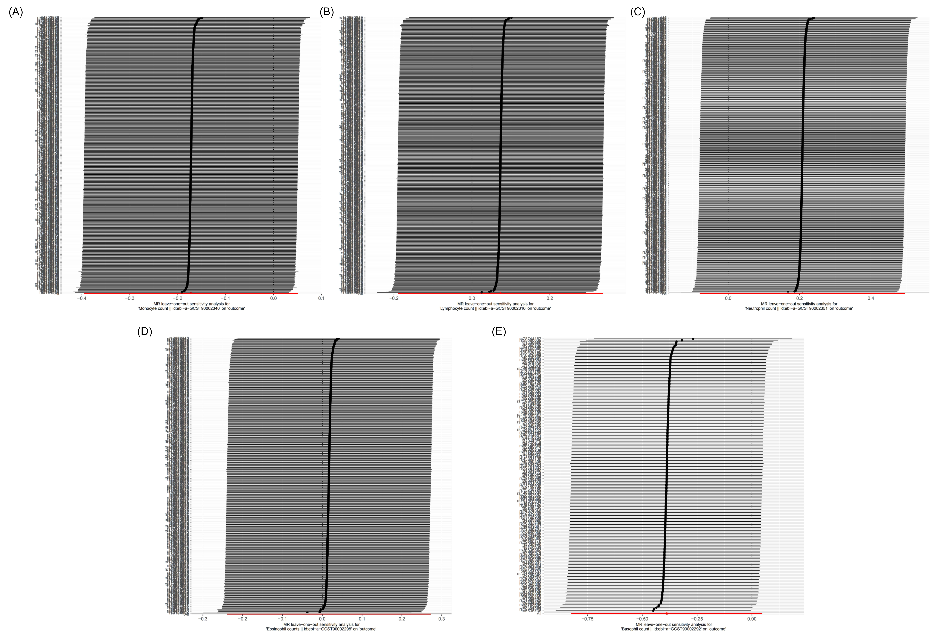
(A)Analysis for "monocyte count" on "CKD"
(B) Analysis for "lymphocyte count" on "CKD"
(C) Analysis for "neutrophil count" on "CKD"
(D) Analysis for "eosinophil count" on "CKD"
(E) Analysis for "basophil count" on "CKD"

Figure S2. MR leave-one-out sensitivity analysis for blood cell counts on eGFR.
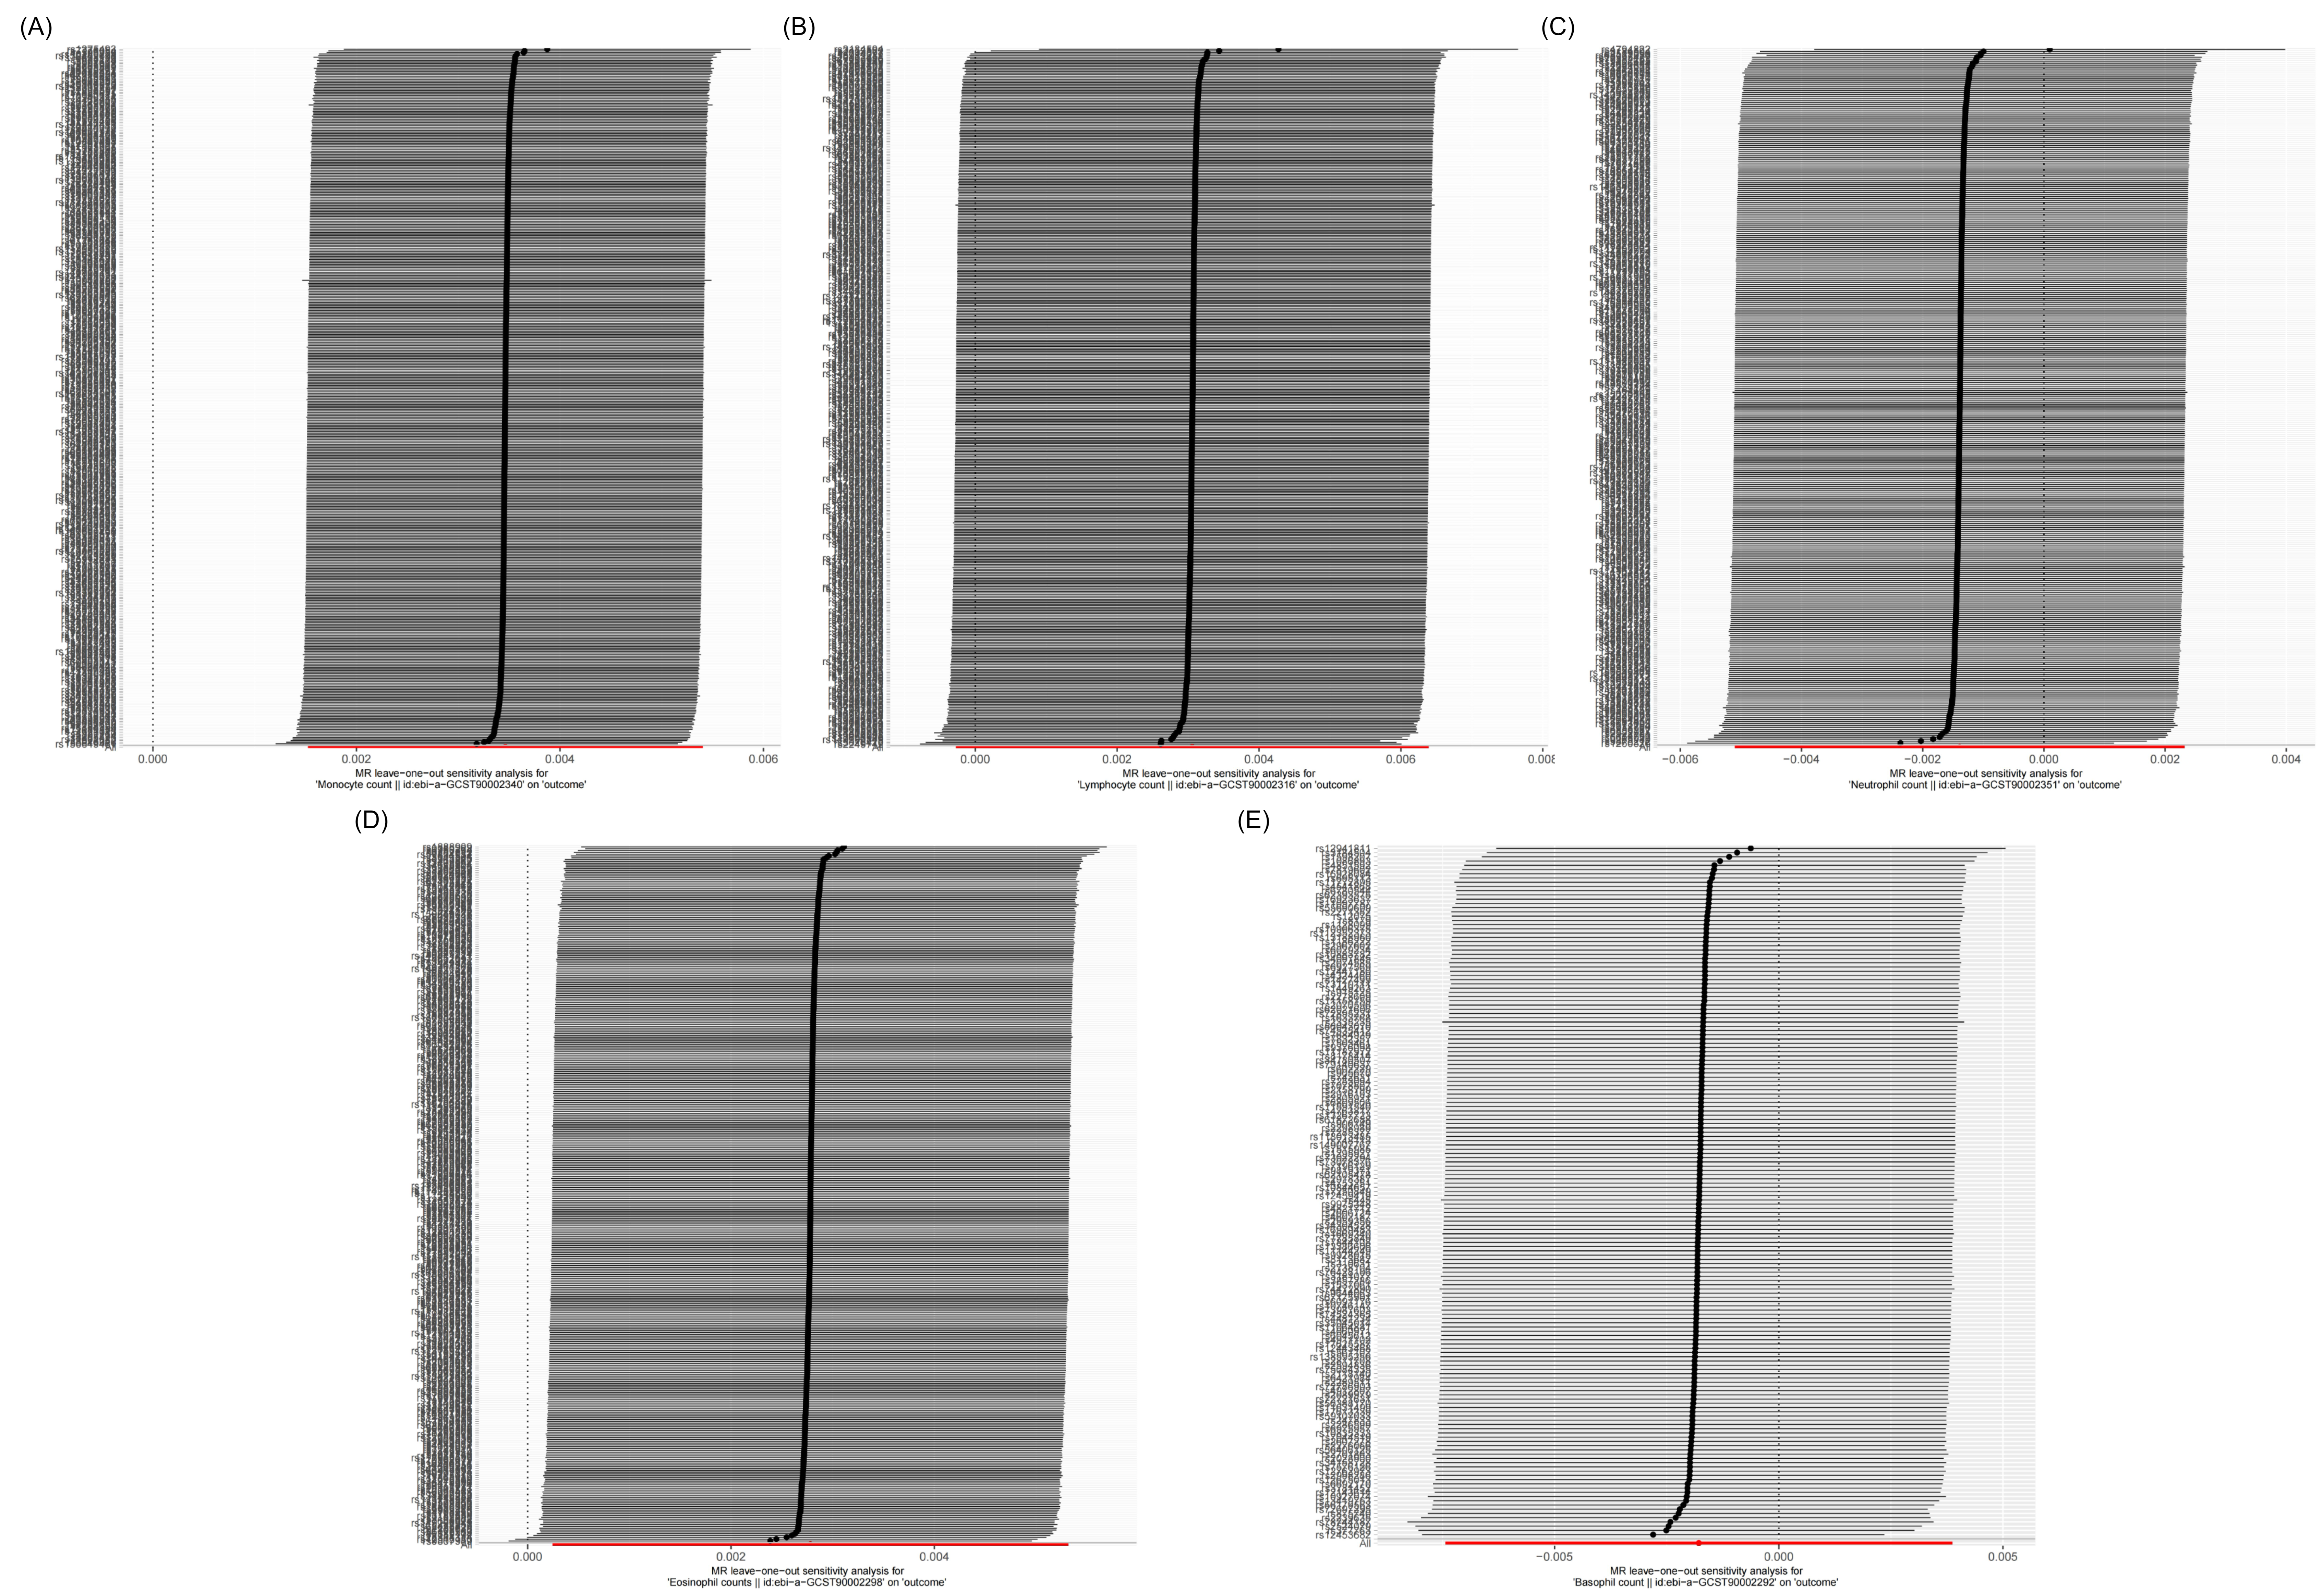
(A)Analysis for "monocyte count" on "eGFR"
(B) Analysis for "lymphocyte count" on "eGFR"
(C) Analysis for "neutrophil count" on "eGFR"
(D) Analysis for "eosinophil count" on "eGFR"
(E) Analysis for "basophil count" on "eGFR"

Figure S3. MR leave-one-out sensitivity analysis for blood cell counts on uACR.
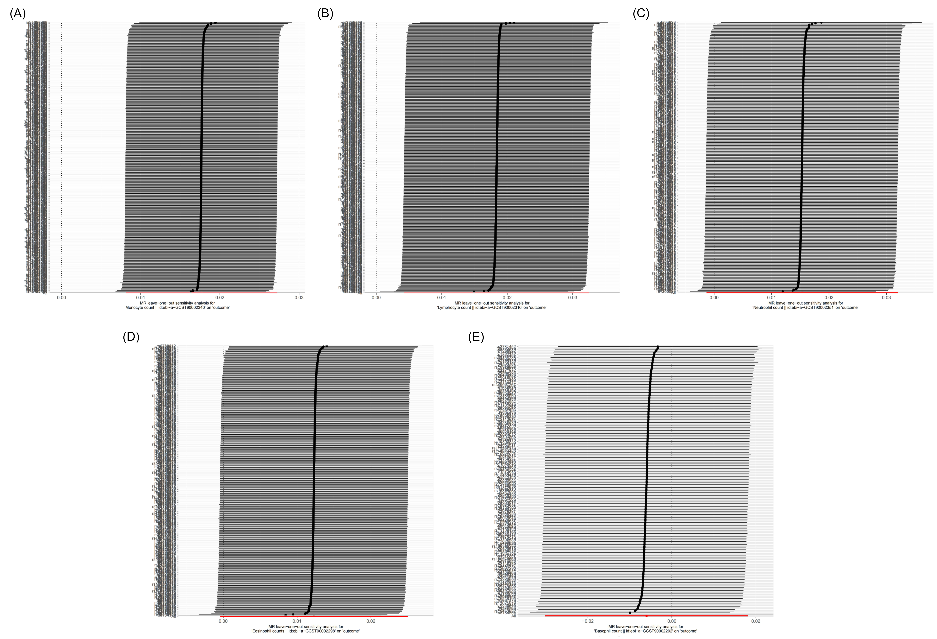
(A)Analysis for "monocyte count" on "uACR"
(B) Analysis for "lymphocyte count" on "uACR"
(C) Analysis for "neutrophil count" on "uACR"
(D) Analysis for "eosinophil count" on "uACR"
(E) Analysis for "basophil count" on "uACR"

Figure S4. Scatter plots for the effect of blood cell counts on CKD.
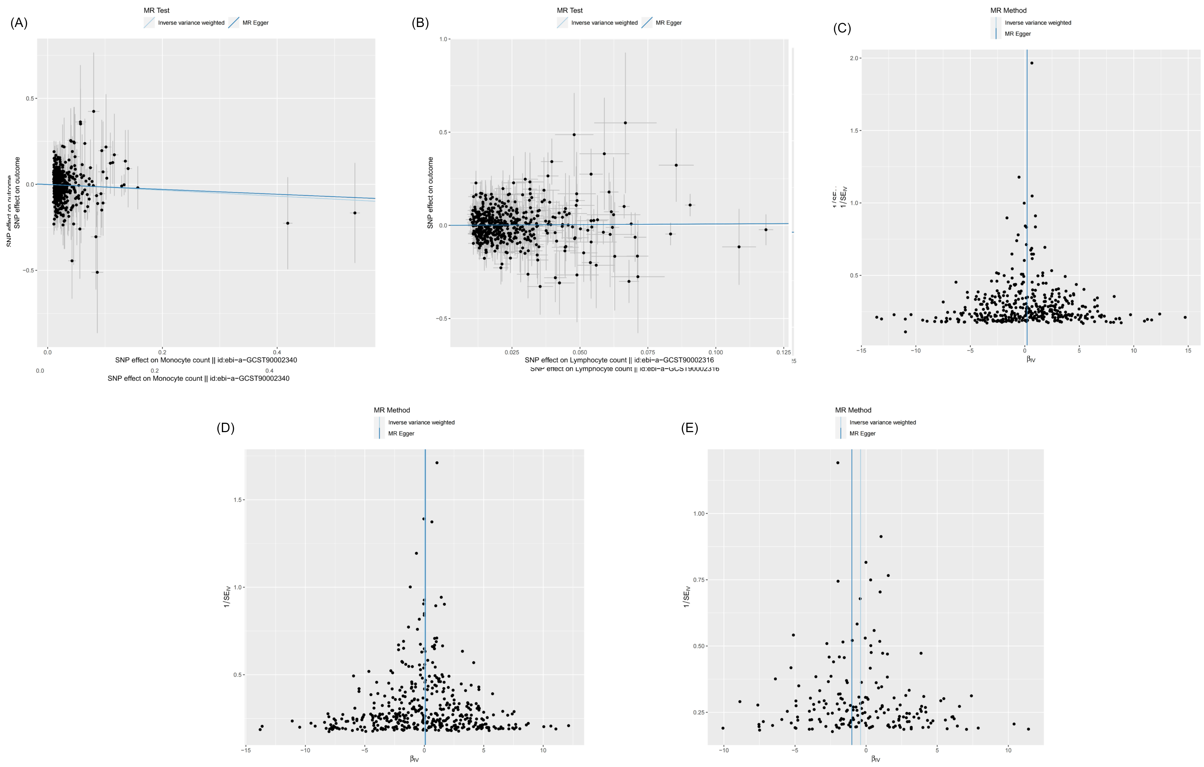
(A)Analysis for "monocyte count" on "CKD"
(B) Analysis for "lymphocyte count" on "CKD"
(C) Analysis for "neutrophil count" on "CKD"
(D) Analysis for "eosinophil count" on "CKD"
(E) Analysis for "basophil count" on "CKD"

Figure S5. Scatter plots for the effect of blood cell counts on eGFR.
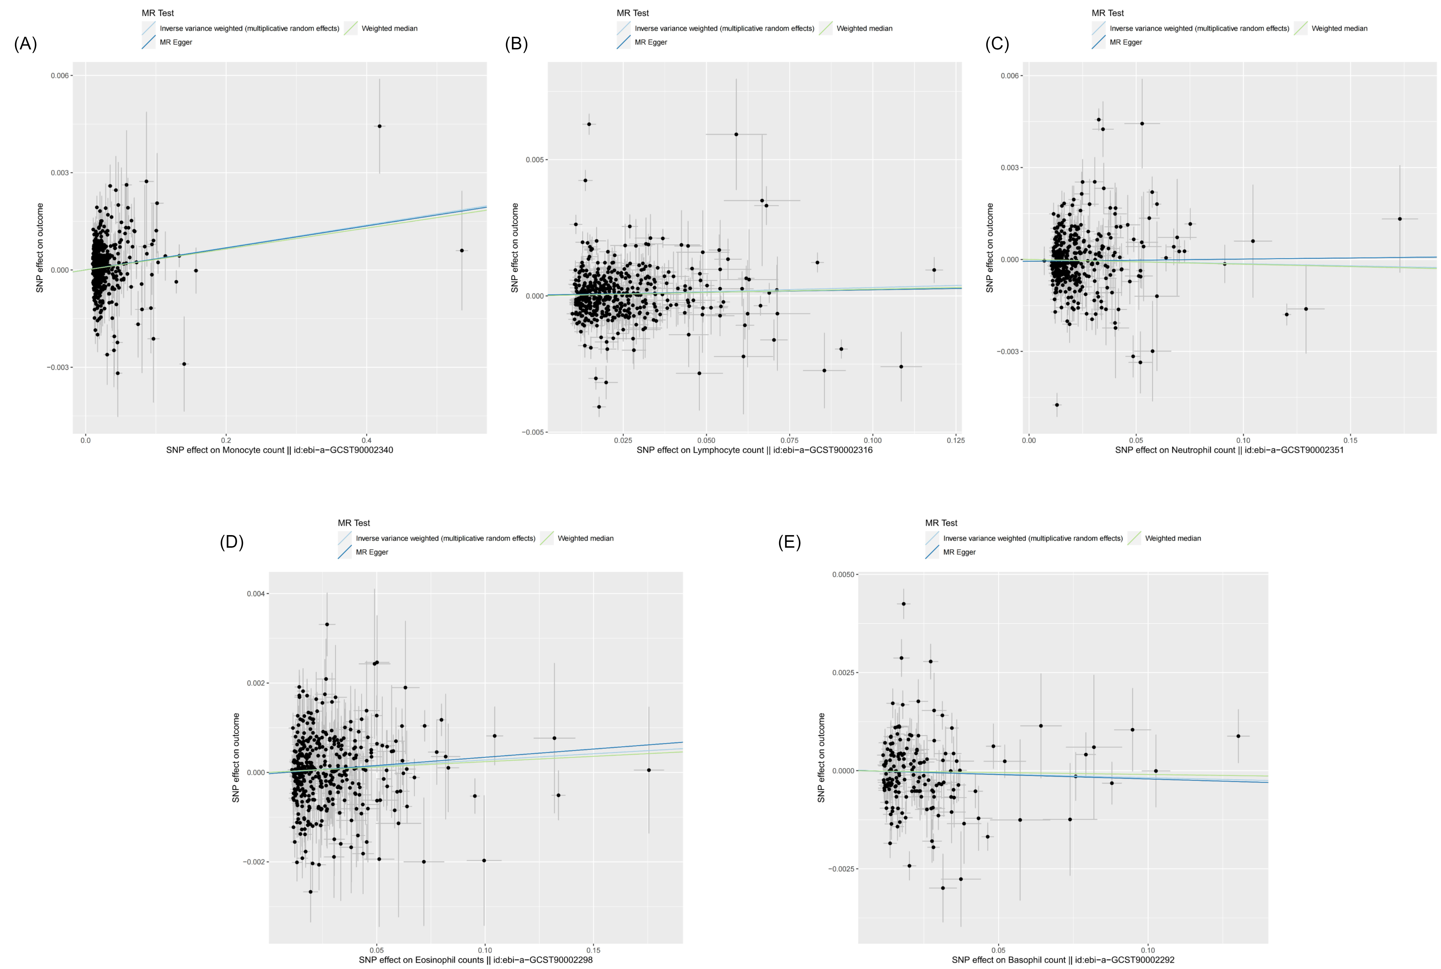
(A)Analysis for "monocyte count" on "eGFR"
(B) Analysis for "lymphocyte count" on "eGFR"
(C) Analysis for "neutrophil count" on "eGFR"
(D) Analysis for "eosinophil count" on "eGFR"
(E) Analysis for "basophil count" on "eGFR"

Figure S6. Scatter plots for the effect of blood cell counts on uACR.
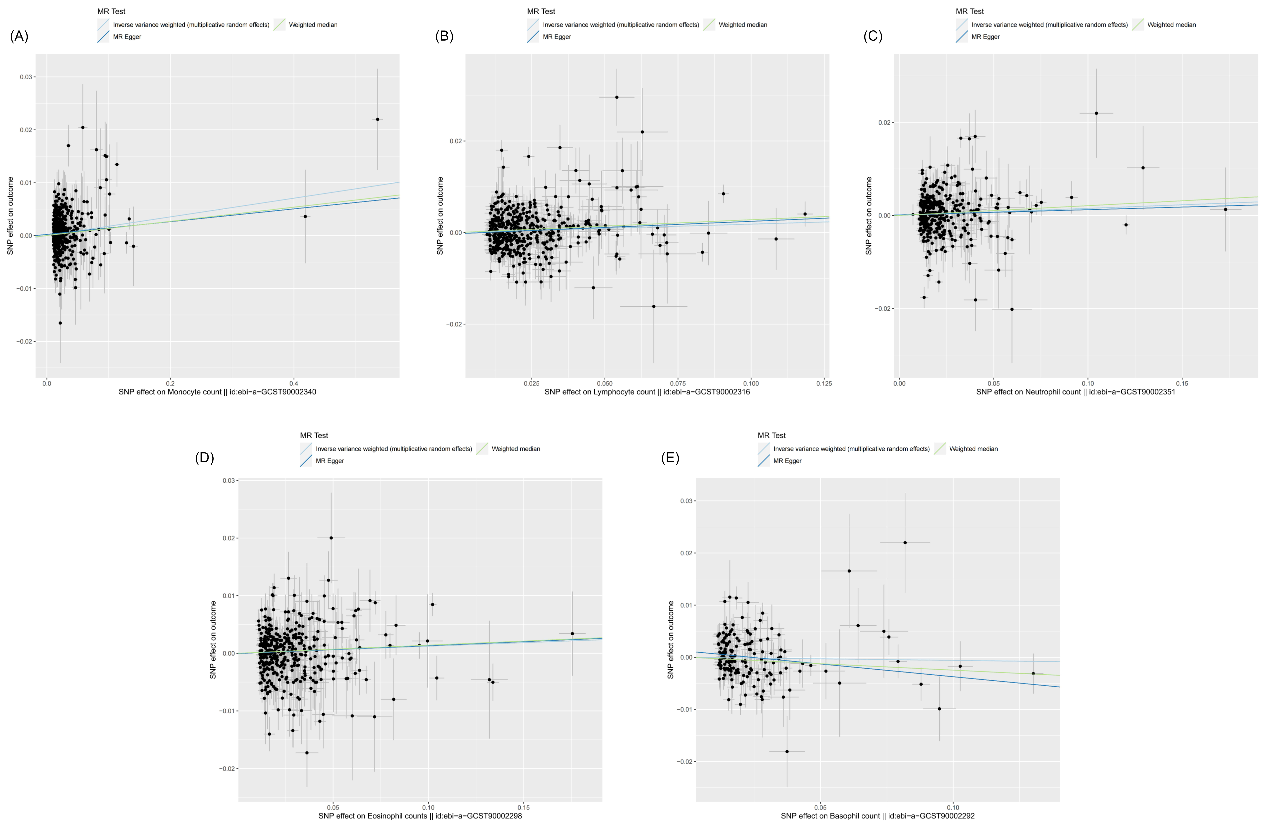
(A)Analysis for "monocyte count" on "uACR"
(B) Analysis for "lymphocyte count" on "uACR"
(C) Analysis for "neutrophil count" on "uACR"
(D) Analysis for "eosinophil count" on "uACR"
(E) Analysis for "basophil count" on "uACR"

Figure S7. Funnel plots for the effect of blood cell counts on CKD.
(A)Analysis for "monocyte count" on "CKD"
(B) Analysis for "lymphocyte count" on "CKD"
(C) Analysis for "neutrophil count" on "CKD"
(D) Analysis for "eosinophil count" on "CKD"
(E) Analysis for "basophil count" on "CKD"

Figure S8. Funnel plots for the effect of blood cell counts on eGFR.
(A)Analysis for "monocyte count" on "eGFR"
(B) Analysis for "lymphocyte count" on "eGFR"
(C) Analysis for "neutrophil count" on "eGFR"
(D) Analysis for "eosinophil count" on "eGFR"
(E) Analysis for "basophil count" on "eGFR"

Figure S9. Funnel plots for the effect of blood cell counts on uACR.
(A)Analysis for "monocyte count" on "uACR"
(B) Analysis for "lymphocyte count" on "uACR"
(C) Analysis for "neutrophil count" on "uACR"
(D) Analysis for "eosinophil count" on "uACR"
(E) Analysis for "basophil count" on "uACR"

