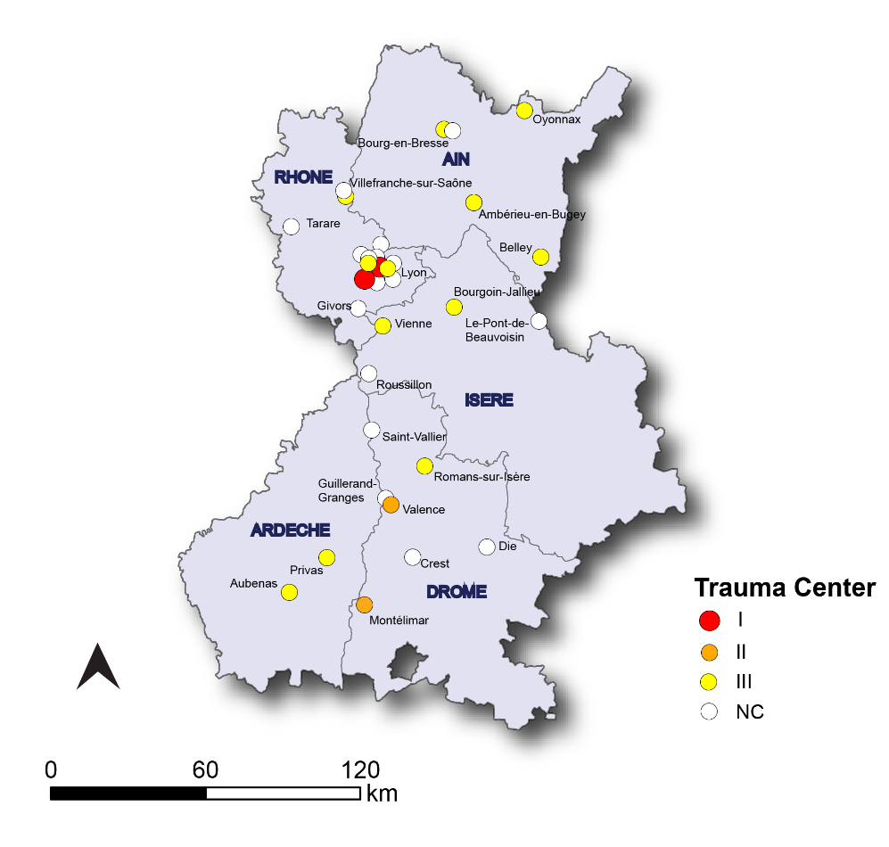

Supplementary file.1: Map of the RESUVaL area

