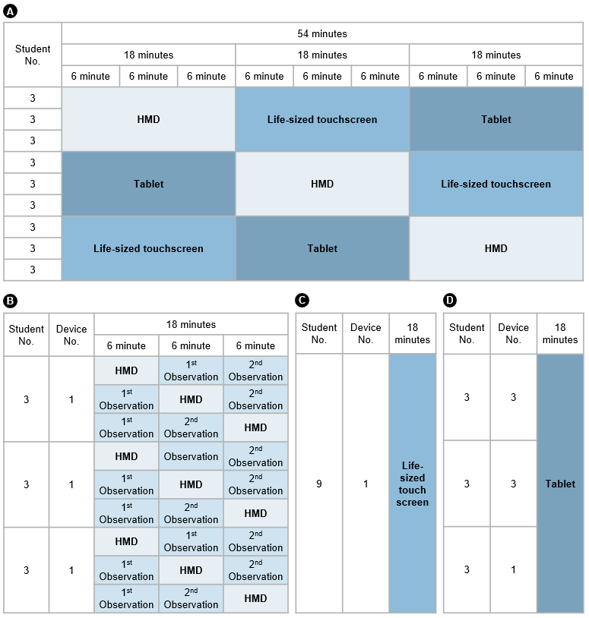
Figure S1. Time schedule of virtual dissection in the Human Anatomy laboratory using the virtual devices. (A) Head-mounted displays, a life-sized touchscreen, and tablets were used in the laboratory for 54 minutes. (B) Time schedule for head-mounted display-based learning. (C) Time schedule for life-sized touchscrenn-based learning, (D) Time schedule for tablet-based learning. Abbreviation: HMD: head-mounted display.

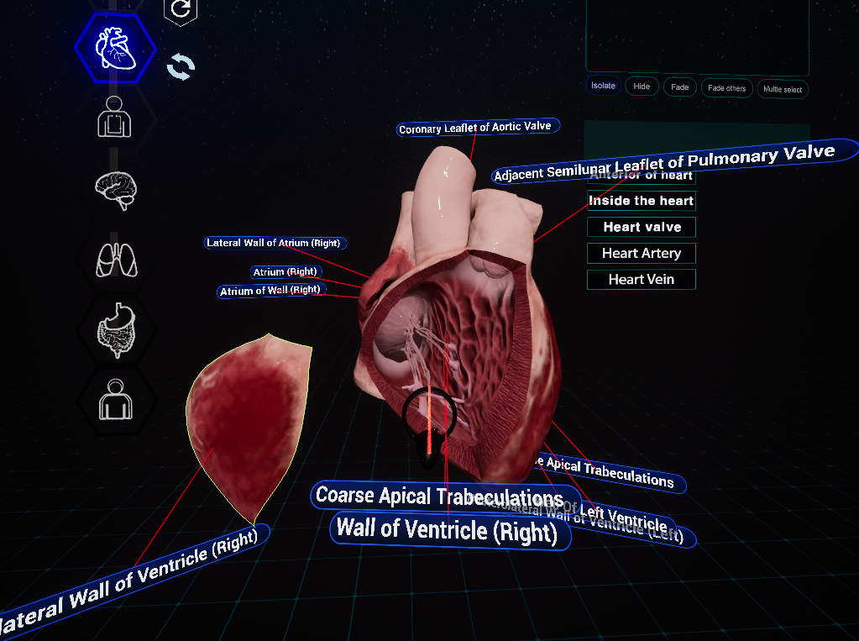
Figure S2. Heart model content from head-mounted display laboratory. Screenshot of the heart model from the head-mounted display-based laboratory with labels.
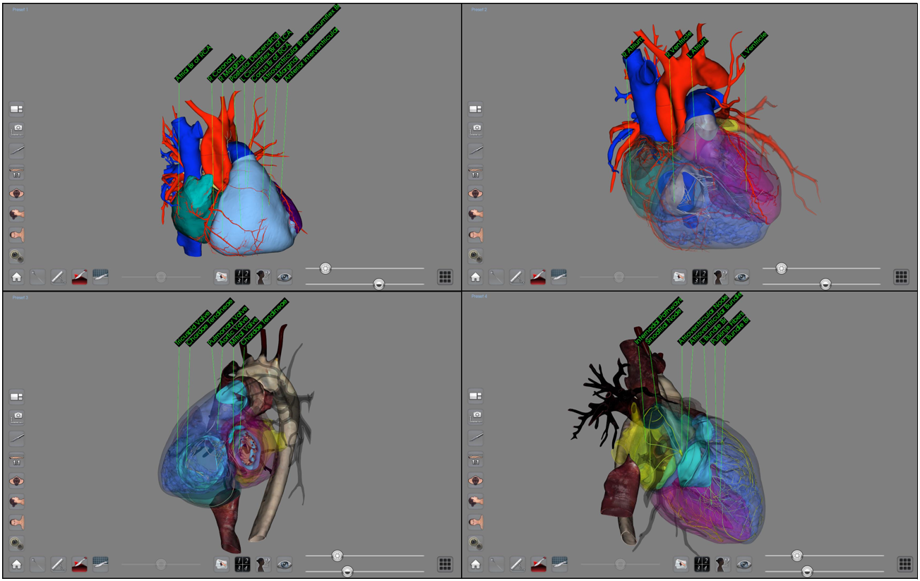
Figure S3. Heart model content from life-sized touchscreen laboratory. Screenshots of the heart model from the life-sized touchscreen-based laboratory with labels from various angles.
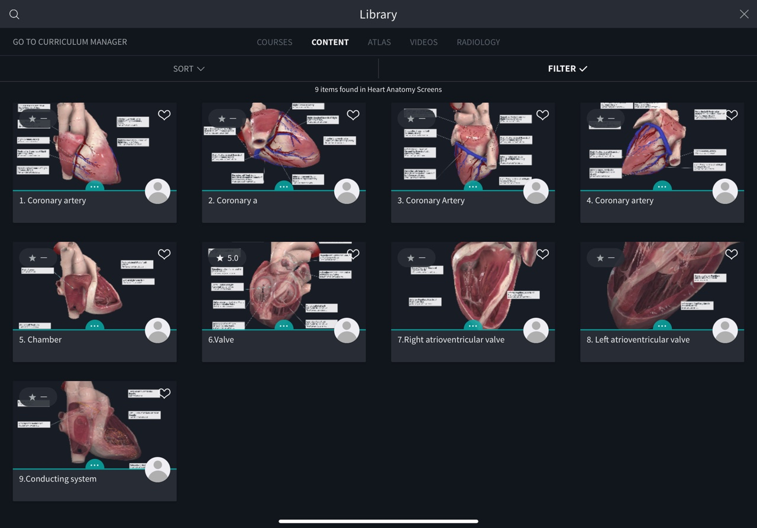
Figure S4. Heart model content from tablet-based laboratory. Screenshot of the heart models from the tablet-based laboratory with labels from various angles.
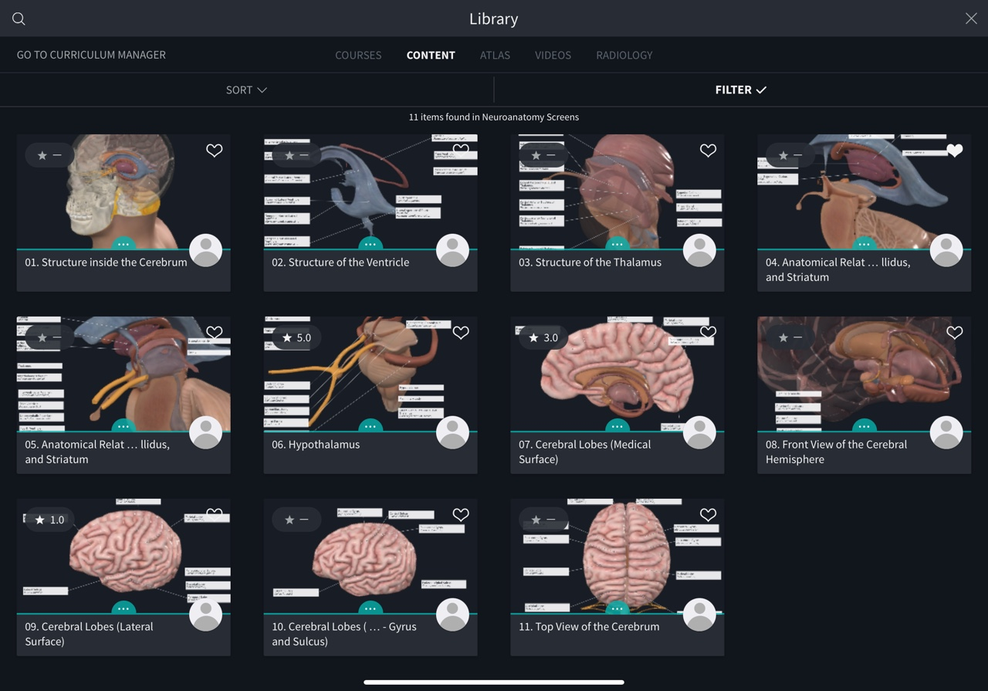
Figure S5. Diencephalon model content from tablet-based laboratory. Screenshot of diencephalon models from a tablet-based laboratory with labels from various angles.

