Supplemental figures and tables
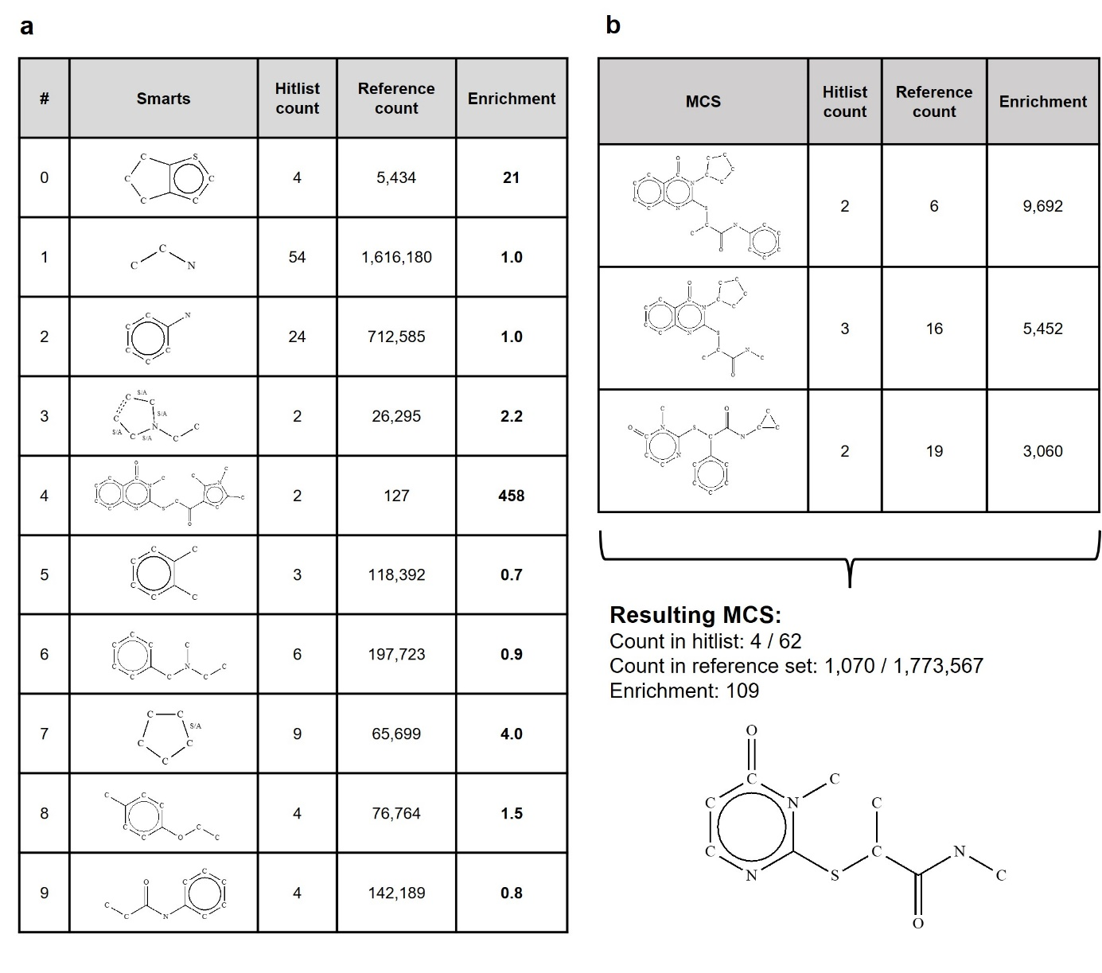
Supplementary Figure 1. Pharmacophore identification. Enrichment analysis of the identified MCS cluster centers and substructure pharmacophore identification. (a) Enrichment analysis on the 10 identified MCS cluster centers of the 62 confirmed hits. ‘Hitlist counts’ represents the number of hits in which the particular MCS is found, while the corresponding ‘Reference count’ represents the number of reference molecules (the Enamine HTS library containing 1,773,567 molecules) in which the same MCS is found. The ‘Enrichment’ equals the ‘Hitlist count’ divided by the ‘Reference count’. (b) Three MCS patterns within cluster center number 4 give a particular high enrichment. The common MCS derived from these 3 individual MCSs (shown in the bottom right) gives an enrichment of 109, and this MCS pattern was used for subsequent substructure searches. HTS, high-throughput screening; MCS, maximum common substructure; smarts, smiles arbitrary target specification or substructural patterns in molecules.

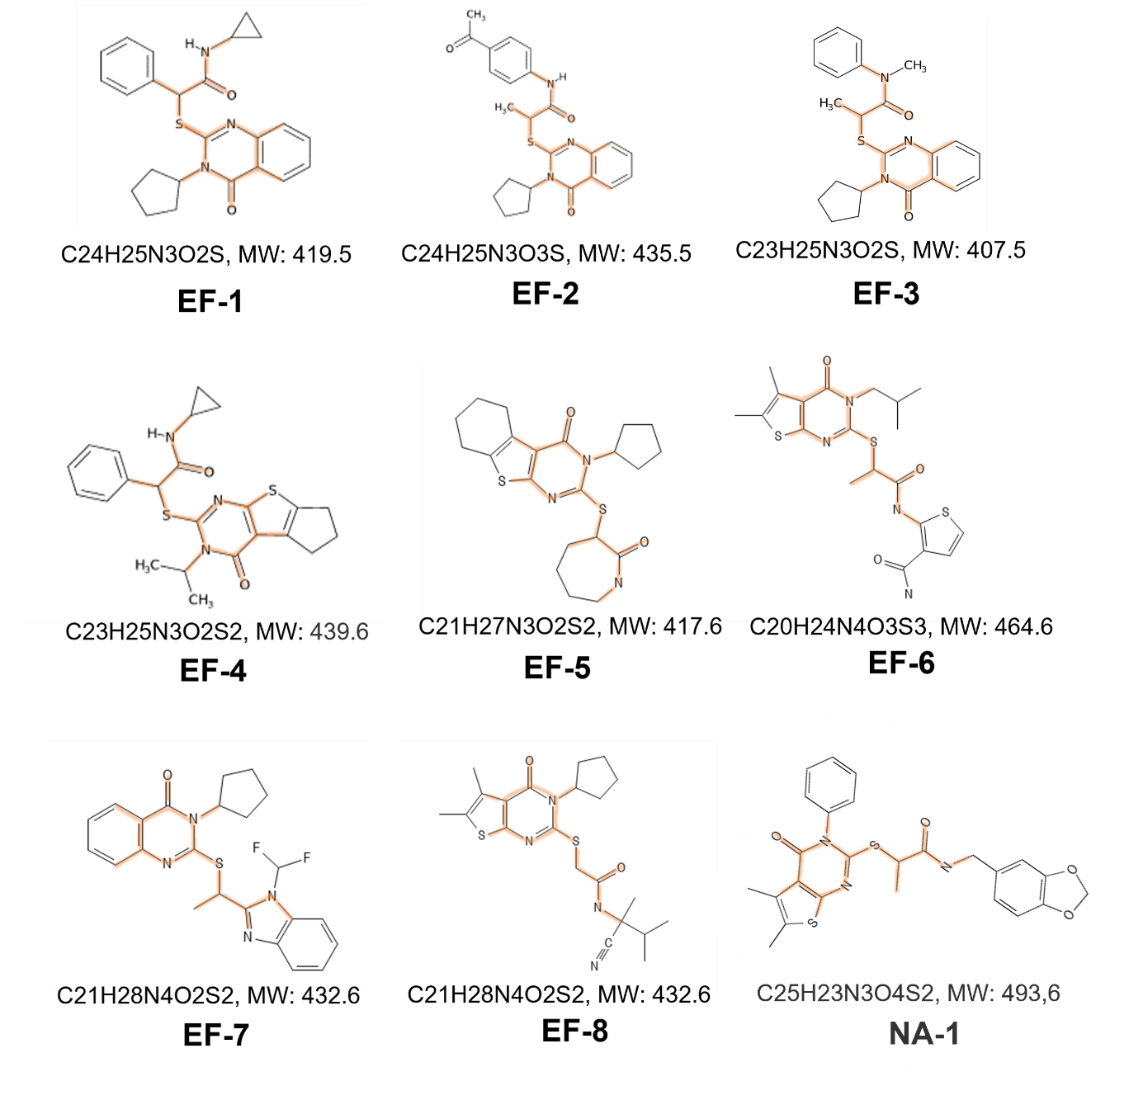
Supplementary Figure 2. Chemical structure and MW of the eight selected hit compounds. The common pharmacophore is highlighted in orange. MW, molecular weight; NA, non-active compound containing pharmacophore.
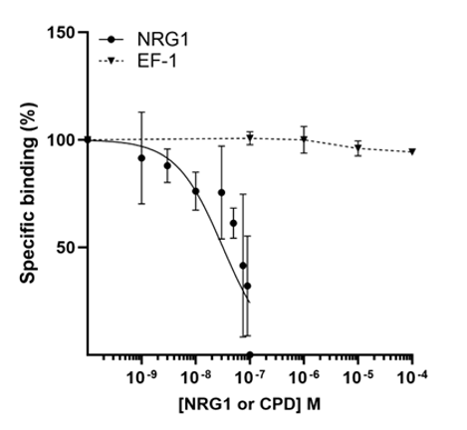
Supplementary Figure 3. Competition assay between 30 nM F-NRG1 and different concentrations of unlabeled NRG1 or EF-1. The Y-axis represents the percentage of specific binding of F-NRG1, the x-axis represents the molar concentration of unlabeled NRG-1 or EF-1 that was added. CPD, compound; F-NRG1, fluorescently labeled NRG1; M, molar concentration; NRG1, neuregulin-1.
a
 | Wild type mice
 | Ctrl | EF-1 | AngII/Veh | AngII/EF-1
IVSd (mm) | 0.9 ± 0.2 | 0.9 ± 0.1 | 0.8 ± 0.2 | 0.8 ± 0.1
IVSs (mm) | 1.1 ± 0.2 | 1.2 ± 0.1 | 1.0 ± 0.1 | 1.1 ± 0.2
LVIDd (mm) | 4.3 ± 0.4 | 4.2 ± 0.3 | 4.3 ± 0.3 | 4.4 ± 0.3
LVIDs (mm) | 3.5 ± 0.4 | 3.4 ± 0.3 | 3.7 ± 0.4 | 3.7 ± 0.4
LVPWd (mm) | 0.7 ± 0.1 | 0.75 ± 0.03 | 0.8 ± 0.1 | 0.8 ± 0.2
LVPWs (mm) | 0.9 ± 0.1 | 0.9 ± 0.1 | 0.9 ± 0.2 | 0.9 ± 0.2
FS (%) | 18.0 ± 2.9 | 18.5 ± 5.1 | 14.1 ± 4.0 | 16.6 ± 3.6
b
 | Wild type mice
 | Ctrl | AngII/Veh | AngII/NA-1
IVSd (mm) | 0.8 ± 0.1 | 1.0 ± 0.2 | 1.0 ± 0.2
IVSs (mm) | 1.1 ± 0.1 | 1.3 ± 0.3 | 1.4 ± 0.2
LVIDd (mm) | 4.1 ± 0.4 | 4.3 ± 0.5 | 4.3 ± 0.7
LVIDs (mm) | 3.4 ± 0.4 | 3.5 ± 0.3 | 3.5 ± 0.7
LVPWd (mm) | 0.8 ± 0.3 | 1.2 ± 0.4 | 0.9 ± 0.1
LVPWs (mm) | 1.0 ± 0.3 | 1.4 ± 0.4 | 1.1 ± 0.3
FS (%) | 18.2 ± 2.0 | 18.8 ± 5.0 | 18.1 ± 5.1
c
 | Wild type mice | Erbb4-null mice | P-value
LVIDd (mm) | 4.2 ± 0.4 | 5.0 ± 0.5 | 0.003
LVIDs (mm) | 3.5 ± 0.4 | 4.6 ± 0.6 | 0.0006
FS (%) | 18.1 ± 2.3 | 9.4 ± 6.1 | 0.001
d
 | Erbb4-null mice
 | Ctrl | AngII/Veh | AngII/EF-1 | P-value
IVSd (mm) | 0.9 ± 0.2 | 0.8 ± 0.2 | 1.0 ± 0.3 | /
IVSs (mm) | 1.1 ± 0.2 | 0.9 ± 0.3 | 1.2 ± 0.5 | /
LVIDd (mm) | 5.0 ± 0.5 | 5.5 ± 0.5 | 5.8 ± 0.3 | ‡0.04
LVIDs (mm) | 4.6 ± 0.6 | 5.0 ± 0.7 | 5.5 ± 0.5 | /
LVPWd (mm) | 0.7 ± 0.1 | 0.8 ± 0.1 | 1.0 ± 0.4 | ‡0.05
LVPWs (mm) | 0.7 ± 0.1 | 0.9 ± 0.1 | 1.1 ± 0.4 | /
FS (%) | 9.4 ± 6.1 | 8.3 ± 5.6 | 5.8 ± 3.5 | /

e
 | Wild type mice
 | w0
 | Ctrl | MI/Veh | MI/EF-1 | P-value
LVEDA (mm²) | 21.3 ± 2.4 | 22.2 ± 2.8 | 21.8 ± 1.4 | /
LVESA (mm²) | 14.8 ± 1.5 | 14.5 ± 1.4 | 15.5 ± 2.1 | /
LVEDV (µL) | 51.9 ± 7.9 | 57.1 ± 11.5 | 56.7 ± 5.5 | /
LVESV (µL) | 31.2 ± 6.2 | 27.9 ± 4.3 | 32.7 ± 6.7 | /
EF (%) | 42.7 ± 10.1 | 49.5 ± 11.5 | 42.7 ± 8.1 | /
 | w2
 | Ctrl | MI/Veh | MI/EF-1 | P-value
LVEDA (mm²) | 23.2 ± 2.1 | 27.2 ± 4.8 | 25.7 ± 1.6 | ¥0.04
LVESA (mm²) | 16.1 ± 1.7 | 22.3 ± 5.8 | 20.8 ± 2.9 | ¥0.01; ‡0.05
LVEDV (µL) | 63.6 ± 9.9 | 83.8 ± 24.0 | 73.6 ± 9.1 | ¥0.04
LVESV (µL) | 34.9 ± 7.0 | 62.0 ± 28.0 | 53.9 ± 14.5 | ¥0.01
EF (%) | 44.6 ± 5.0 | 29.0 ± 14.8 | 27.4 ± 14.1 | ¥0.05; ‡0.02
 | w3
 | Ctrl | MI/Veh | MI/EF-1 | P-value
LVEDA (mm²) | 21.6 ± 2.1 | 31.5 ± 6.0 | 26.5 ± 4.5 | ¥0.0005
LVESA (mm²) | 15.5 ± 2.1 | 28.0 ± 6.6 | 21.2 ± 5.8 | ¥0.0003; †0.03
LVEDV (µL) | 55.1 ± 7.7 | 107.5 ± 29.1 | 80.3 ± 22.9 | ¥0.0002; †0.04
LVESV (µL) | 31.1 ± 7.6 | 86.5 ± 32.3 | 56.6 ± 25.0 | ¥0.0002; †0.04
EF (%) | 42.8.3 ± 6.3 | 21.5 ± 9.4 | 32.2 ± 12.4 | ¥0.0007
 | w4
 | Ctrl | MI/Veh | MI/EF-1 | P-value
LVEDA (mm²) | 23.8 ± 3.0 | 30.3 ± 3.7 | 26.5 ± 4.1 | ¥0.005
LVESA (mm²) | 17.5 ± 2.9 | 26.2 ± 3.9 | 20.5 ± 4.2 | ¥0.0006; †0.01
LVEDV (µL) | 62.0 ± 13.6 | 96.0 ± 15.1 | 75.6 ± 17.6 | ¥0.001; †0.04
LVESV (µL) | 37.6 ± 9.9 | 76.1 ± 17.1 | 50.7 ± 16.6 | ¥0.001; †0.04
EF (%) | 44.6 ± 5.3 | 23.6 ± 10.3 | 33.9 ± 9.0 | ¥0.0003

Supplementary Table 1. Echocardiographic parameters. (a-d) Echocardiographic parameters obtained through the analysis of the M-mode short-axis views. (a) Wild type mice treated with AngII and EF-1. (b) Wild type mice treated with AngII and NA-1. (c) Comparison between wild type and Erbb4-null mice. (d) Erbb4-null mice treated with AngII and EF-1. (e) Echocardiographic parameters obtained through left ventricular trace analysis of the parasternal long-axis obtained in B-mode in wild type mice that underwent a sham or MI operation. Mice with the MI were treated with Veh or EF-1. Echocardiographic parameters were measured weekly (indicated by ‘w’). Data are presented as mean ± SD, n = 5-10 in each group, One-way ANOVA test with Tukey’s correction for multiple testing. ¥ shows significant P-values between (e) ctrl and MI/Veh groups; ‡ shows significant P-values between (d) ctrl and AngII/EF-1 groups and (e) ctrl and MI/EF-1 groups; † shows significant P-values between (e) MI/Veh and MI/EF-1 groups. AngII, angiotensin II; ANOVA, analysis of variance; Ctrl, control; DOX, doxorubicin; EF, ejection fraction; ERBB4, erythroblastic leukemia viral oncogene homolog 4; FS, fractional shortening; IVSd, interventricular septum thickness in diastole; IVSs, interventricular septum thickness in systole; LVIDd, left ventricular internal diameter in diastole; LVIDs, left ventricular internal diameter in systole; LVPWd, left ventricular posterior wall thickness in diastole; LVPWs, left ventricular posterior wall thickness in systole; MI, myocardial infarction; NA, non-activating pharmacophore-containing compound; SD, standard variation; Veh, vehicle.
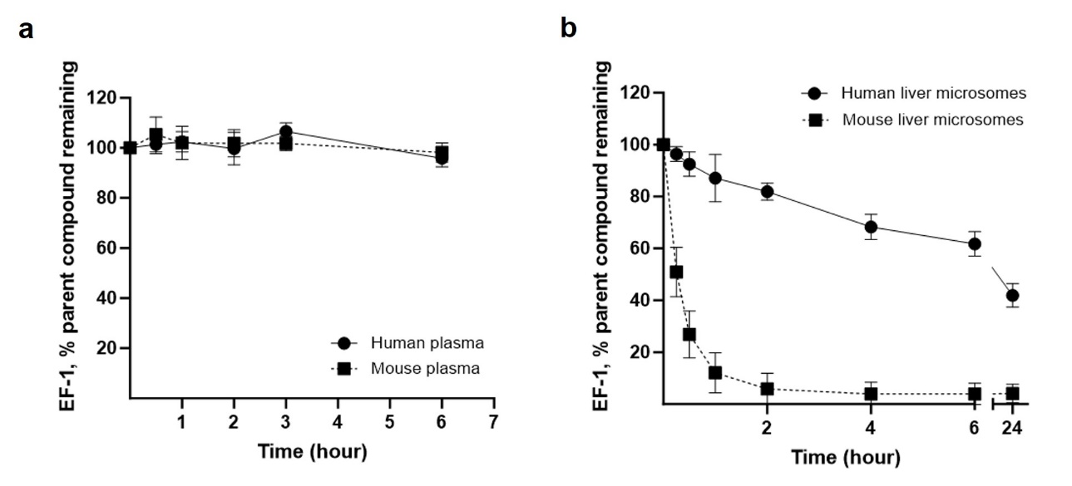
Supplementary Figure 4. Stability of EF-1 in plasma and liver microsomes. (a) Stability of EF-1 in plasma from human and mouse and (b) in liver microsomes isolated from human and mouse. Samples were analyzed in triplicate.
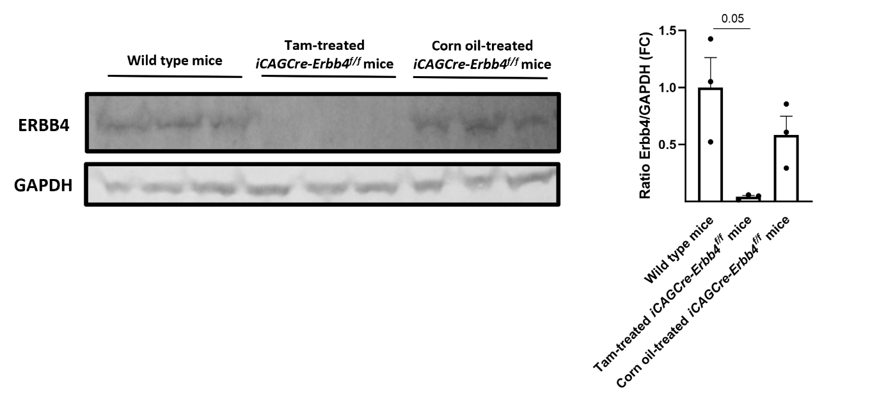
Supplementary Figure 5. Western blot of Erbb4 expression. Representative western blot image and corresponding graph of the validation of the presence of Erbb4 in wild type mice and in iCAGCre-Erbb4^{f/f} mice treated with tamoxifen or corn oil. Data are represented as mean ± SD, n = 3 in each group, One-way ANOVA test with Tukey’s correction for multiple testing. ANOVA, analysis of variance; ERBB4, erythroblastic leukemia viral oncogene homolog 4; GAPDH, glyceraldehyde-3-phosphate dehydrogenase; SD, standard deviation; Tam, tamoxifen.
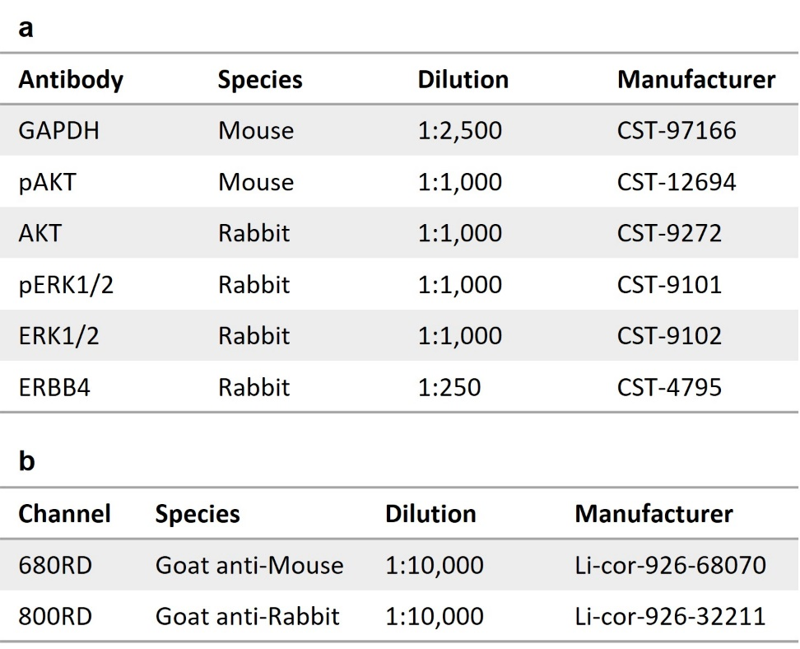
Supplementary Table 2. Overview of the (a) primary and (b) secondary antibodies used in western blot experiments. AKT, protein kinase B; CST, Cell Signaling Technologies; ERBB4, erythroblastic leukemia viral oncogene homolog 4; ERK, extracellular signal-regulated kinase; GAPDH, glyceraldehyde-3-phosphate dehydrogenase; RD, infrared dye.

