Pharmaceuticals and Personal Care Products (PPCPs) Impact Enriched Nitrifying Cultures
Carla Lopez¹, Mac-Anthony Nnorom¹, Yiu Fai Tsang², Charles W. Knapp¹

1 – Centre for Water, Environment, Sustainability & Public Health; Department of Civil & Environmental Engineering; University of Strathclyde, Glasgow, United Kingdom G1 1XJ
2 – Department of Science and Environmental Studies, The Education University of Hong Kong, Hong Kong

Table S1. Nitrogen mass balance
Substance | Concentrations (mg L⁻¹) | DNH₄⁺-N  (mg-N L⁻¹) | DNO₂⁻-N  (mg-N L⁻¹) | DNO₃⁻-N  (mg-N L⁻¹) | Difference (%)*
CF | 0 | 51.88 | 29.80 | 21.53 | 1.05
 | 0.025 | 52.92 | 20.1 | 32.30 | 0.97
 | 0.115 | 52.12 | 30.91 | 21.21 | 0.07
 | 1 | 51.52 | 28.90 | 23.09 | -0.91
 | 10 | 52.10 | 26.09 | 25.32 | 1.33
 | 40 | 51.92 | 27.22 | 23.04 | 3.19
 | 90 | 51.41 | 24.92 | 25.28 | 2.36
TCS | 0 | 47.46 | 5.56 | 41.46 | 0.93
 | 0.01 | 43.59 | 7.24 | 37.15 | -1.85
 | 0.1 | 24.06 | 6.59 | 17.88 | -1.65
 | 0.3 | 14.34 | 6.95 | 7.88 | -3.41
 | 0.5 | 14.67 | 6.92 | 7.45 | 2.03
 | 1 | 13.40 | 5.21 | 8.30 | -0.89
 | 2 | 13.24 | 6.14 | 6.90 | 1.54
DEET | 0 | 47.70 | 6.36 | 41.77 | -0.91
 | 0.02 | 44.82 | 8.94 | 37.86 | -4.43
 | 0.1 | 47.03 | 7.41 | 38.47 | 1.36
 | 1 | 35.24 | 14.71 | 19.60 | 2.65
 | 5 | 30.69 | 12.93 | 17.68 | 0.28
 | 10 | 29.49 | 13.80 | 15.73 | -0.14
AMP | 0 | 51.77 | 25.76 | 25.88 | 0.25
 | 0.5 | 43.94 | 21.89 | 22.00 | 0.11
 | 5 | 36.33 | 27.65 | 8.57 | 0.28
 | 50 | 19.43 | 13.02 | 6.24 | 0.88
 | 100 | 19.57 | 12.82 | 6.58 | 0.85
 | 175 | 15.89 | 10.49 | 5.70 | -1.87
 | 250 | 14.41 | 9.87 | 4.49 | 0.33
CST | 0 | 47.10 | 12.53 | 33.40 | 2.48
 | 0.1 | 44.83 | 13.50 | 30.08 | 2.77
 | 1 | 28.18 | 8.98 | 18.42 | 2.77
 | 10 | 7.61 | -0.59 | 4.32 | **
 | 100 | 3.49 | -0.49 | -0.02 | **
 | 350 | 2.18 | -0.51 | 0.24 | **
OFX | 0 | 46.90 | 9.27 | 39.82 | -4.67
 | 0.01 | 43.88 | 9.95 | 35.81 | -4.28
 | 0.1 | 41.37 | 13.36 | 27.55 | 1.12
 | 1 | 30.88 | 12.77 | 19.13 | -3.34
 | 5 | 31.27 | 9.24 | 19.94 | 6.66
 | 10 | 22.36 | 9.48 | 14.10 | -5.48
* Difference estimated as (DNH₄⁺-N - DNO_{X}-N)/ DNH₄⁺-N*100 ** Value excluded due to low concentration of oxidising species.

16S-rRNA gene sequencing and taxonomy classification
The 16S-rRNA gene sequences analysis (V3 and V4 regions) was performed with QIIME2 (version 2021.2) with similar workflow described by Al Ali et al. (2020). Briefly, the raw data were paired-end read merged and trimmed to remove primers, adapters sequences and low quality reads, following by denoising, chimera removal, and de-replication. Remaining sequences were classified taxonomically in term of amplicon sequence variant (ASV) using GreenGenes 16S-rRNA gene database available in the software website (www.qiime2.com). The results at phylum level are summarized in the Figure S1.

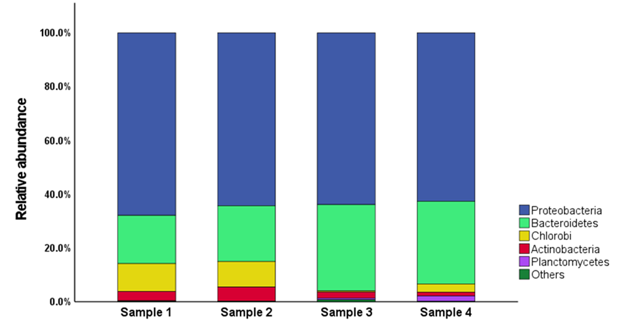
Fig. S1. Relative abundance of the total microbial community at phylum level.

Table S2. Relative abundance (total bacterial population) of nitrifying species
Nitrifying species | Average Abundance [%]
Nitrifying species | Sample 1 | Sample 2 | Sample 3 | Sample 4
k__Bacteria; p__Proteobacteria; c__Betaproteobacteria;o__  Nitrosomonadales;f__Nitrosomonadaceae | 4.35 | 4.23 | 5.76 | 5.71
k__Bacteria; p__Proteobacteria; c__Betaproteobacteria;o__  Nitrosomonadales;f__Nitrosomonadaceae;g__Nitrosomonas; | 0.92 | 0.86
k__Bacteria; p__Proteobacteria; c__Alphaproteobacteria;o__  Rhizobiales;f__Bradyrhizobiaceae;g__Nitrobacter;s__ | 0.83 | 0.79 | 0.14 | 0.36

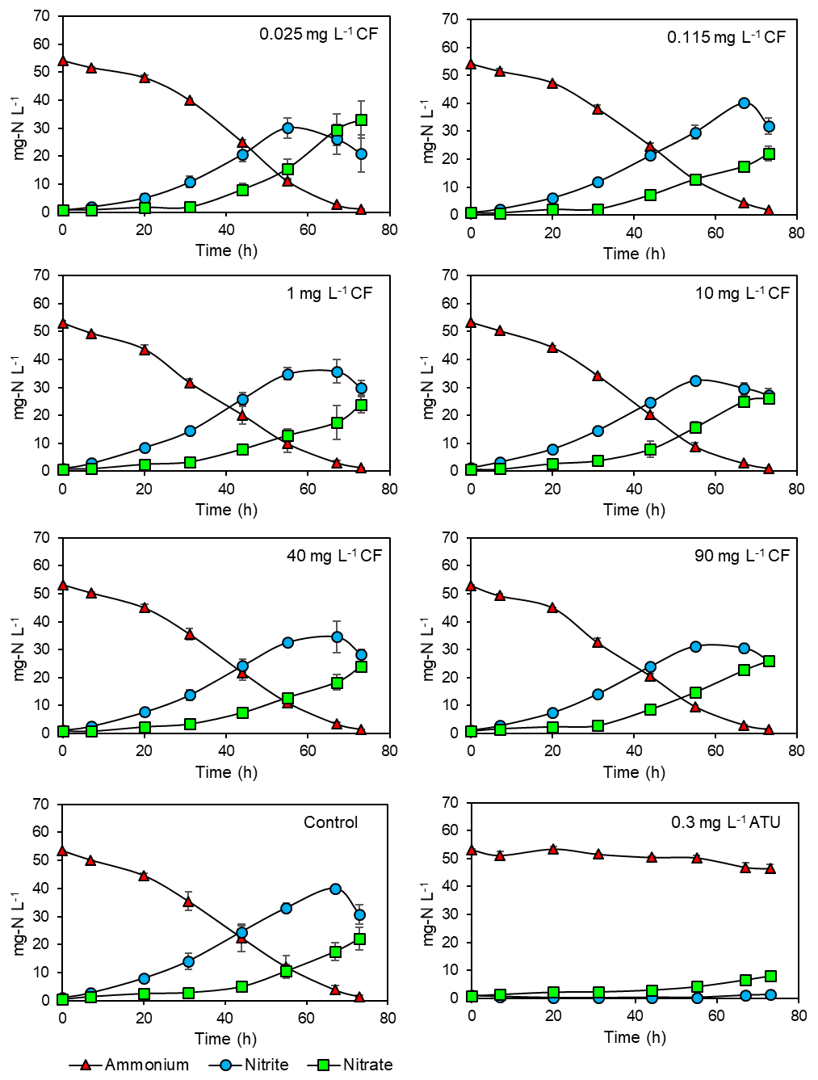
Fig. S2. Nitrification profile of nitrifying cultures in presence of caffeine (CF). Data points show average concentration ± highest and lowest values

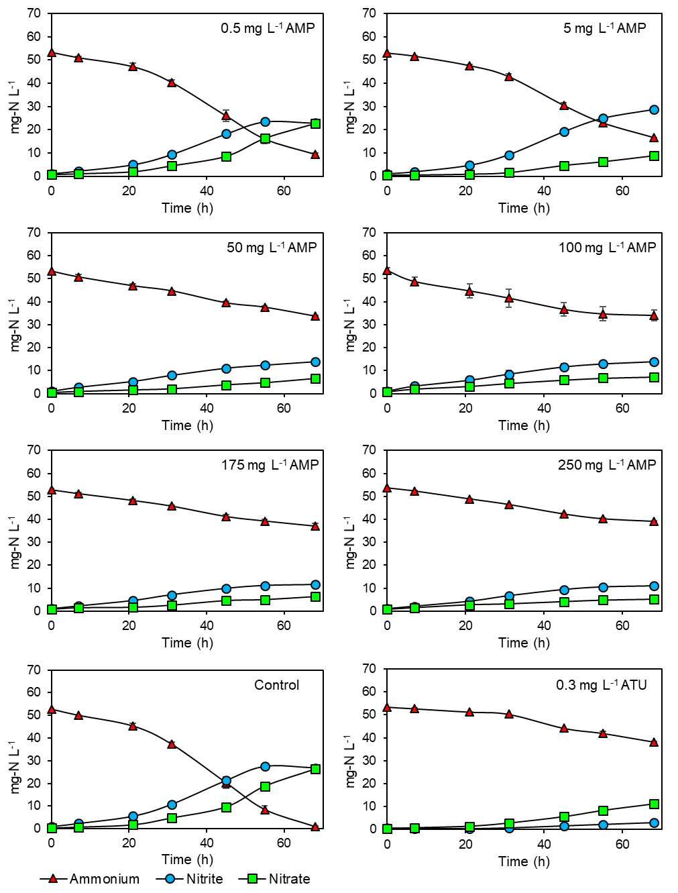
Fig. S3. Nitrification profile of nitrifying cultures in presence of ampicillin (AMP). Data points show average concentration ± highest and lowest values

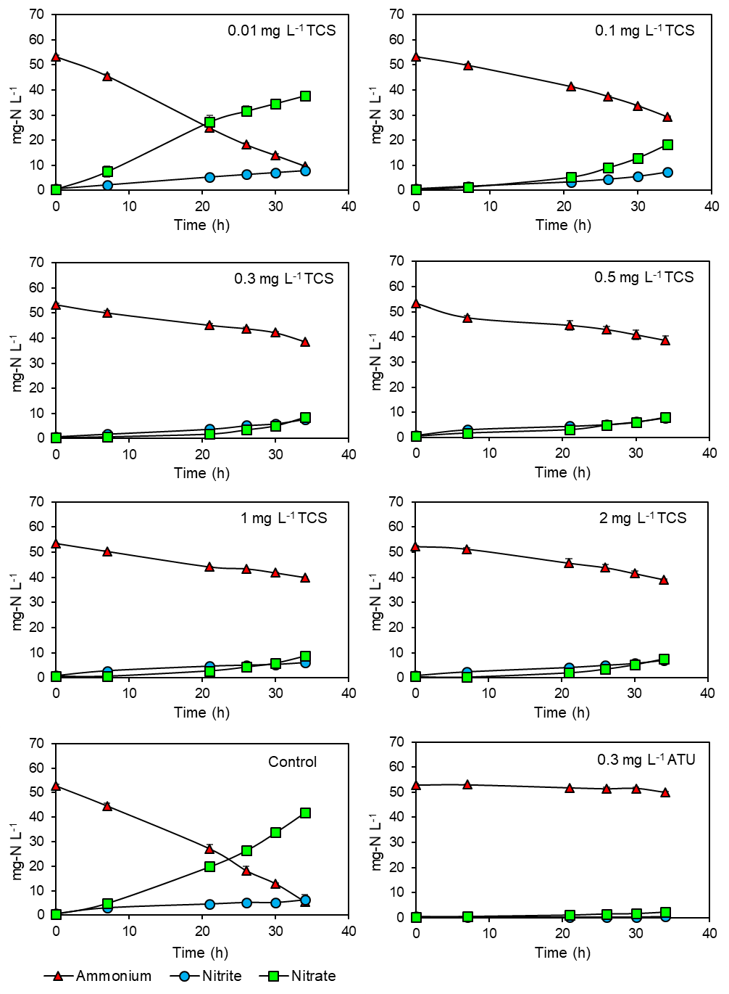
Fig. S4. Nitrification profile of nitrifying cultures in presence of triclosan (TCS). Data points show average concentration ± highest and lowest values

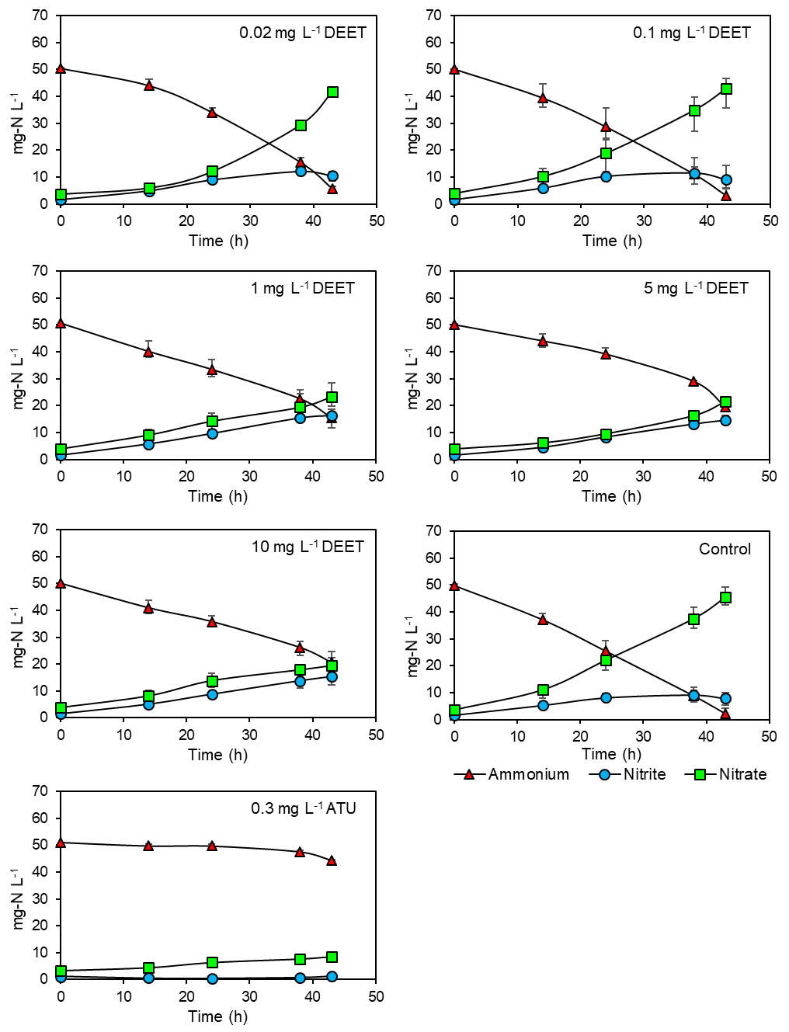
Fig. S5. Nitrification profile of nitrifying cultures in presence of DEET. Data points show average concentration ± highest and lowest values

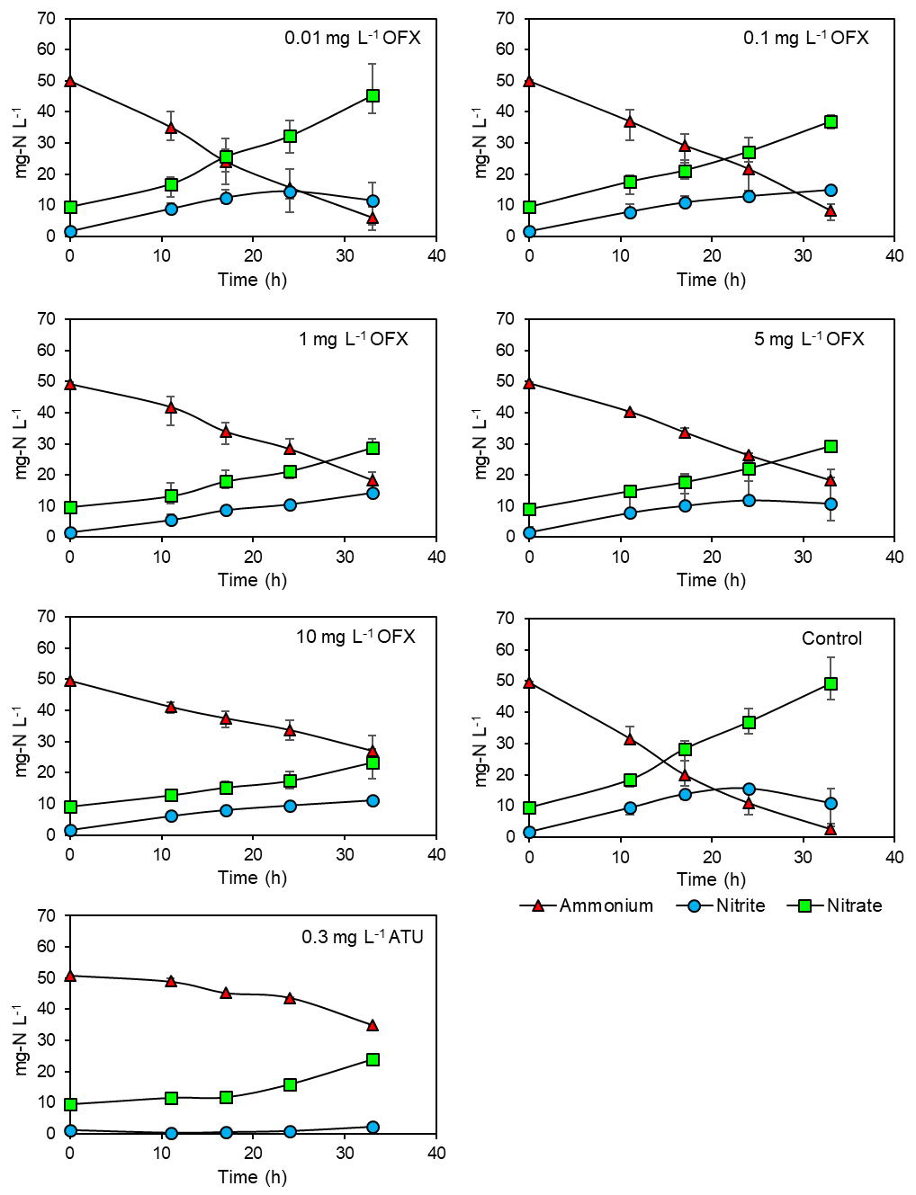
Fig. S6. Nitrification profile of nitrifying cultures in presence of ofloxacin (OFX). Data points show average concentration ± highest and lowest values

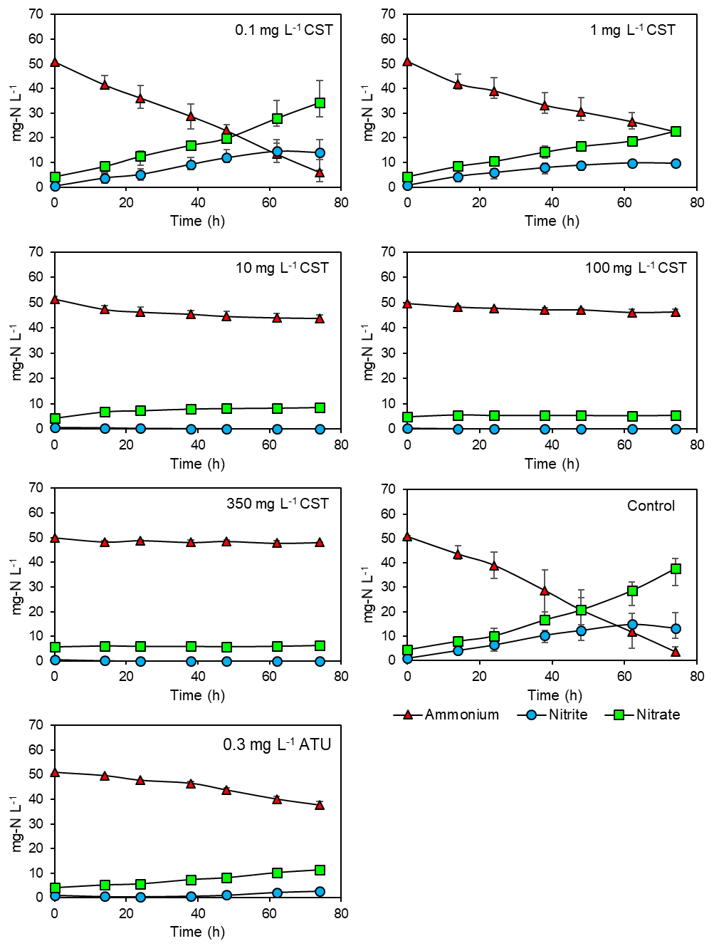
Fig. S7. Nitrification profile of nitrifying cultures in presence of colistin (CST). Data points show average concentration ± highest and lowest values

References
Al Ali AA, Naddeo V, Hasan SW, Yousef AF (2020) Correlation between bacterial community structure and performance efficiency of a full-scale wastewater treatment plant. J Water Process Eng. 37: 101472. https://doi.org/10.1016/j.jwpe.2020.101472

