Effective water well rehabilitation using a combined ultrasonic-mechanical method
Supplementary data
Fig. 1S
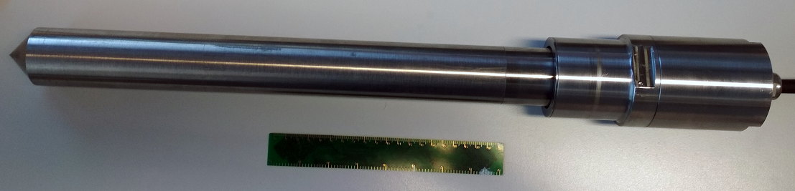
The ultrasonic emitter probe with piezoceramic oscillator.

Fig. 2S
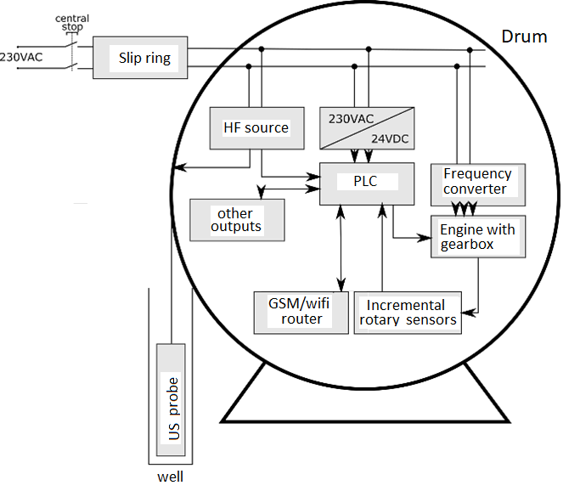
Block scheme of the cable drum fitted with ultrasound technology.
Table 1S. Technical data for the ultrasound generator.
Ultrasound generator
Type | KMC 1000-25DR
Power voltage | 220-230V / 50-60Hz, 1N – PE
Efficient/peak performance | 1 000 / 2 000 W
Operating frequency | 25 kHz
Cover | IP 20
Dimensions | 362 x 175 x 70mm (V)
Other features:
ATC = automatic tuning control
AM modulation = amplitude modulated ultrasound field (improved transfer of ultrasound energy into the solution)
APC = active power control according to the load
Continuous regulation of maximum ultrasonic power in the range of 50-100% (including a “DEGASS” function)
Option to turn on/off regulation
Remote on/off
Electronic internal timer
Soft start of high-frequency output

Table 2S. Technical data for the ultrasound emitter.
Ultrasound emitter
Type | MO (O 25/495_617/1000)
Number of ultrasonic transducers | 1/1 pc transducer MONO (1 kWef/2 kWsp)
Dimensions | D = 50/70, L = 617 (without flanges)
Material | Titanium
Operating frequency | 25 kHz

Table 3S. Control parameters of the device’s frequency converter.
Parameter | Values
Rated input voltage | 1f 220 V (-15%) ～ 240 V (+10%)
Rated input frequency | 50 Hz or 60 Hz, allowable range: 47～63Hz
Output frequency | 0 ~ 400 Hz
Control | SPWM
Speed control range | 1:100
Analog I/O | Input 0～10 V or 0～20mA, output 0～10 V or 0～20 mA
Digital I/O | five standard inputs
Serial communication | RS 485

