Results

Model comparison and analysis
Property | DenseGNN | ALIGNN | Schnet(kgcnn) | M3GNet(kgcnn) | MODNet | coGN | coNGN
Jdft2d | 32.5425±7.0394 | 43.4240±8.949 | 42.6637±13.7201 | 50.1719±11.90 | 33.192±7.343 | 37.1652±13.683 | 36.170±11.597
Phonons | 24.8470±1.7783 | 29.5390±2.115 | 38.9636±1.9760 | 34.1606±4.500 | 34.2751±2.0781 | 29.7117±1.997 | 28.887±3.284
Dielectric | 0.2837±0.0633 | 0.3449±0.0871 | 0.3277±0.0829 | 0.3120±0.063 | 0.2711±0.0714 | 0.3088±0.0859 | 0.3142±0.074
Perovskites | 0.0268±0.0007 | 0.0288±0.0009 | 0.0342±0.0005 | 0.0330±0.0001 | 0.0908±0.0028 | 0.0269±0.0008 | 0.0290±0.0011
Log gvrh | 0.0668±0.0011 | 0.0715±0.0006 | 0.0796±0.0022 | 0.0860±0.002 | 0.0731±0.0007 | 0.0689±0.0009 | 0.0670±0.0006
Log kvrh | 0.0512±0.0014 | 0.0568±0.0028 | 0.0590±0.0022 | 0.0580±0.003 | 0.0548±0.0025 | 0.0535±0.0028 | 0.0491±0.0026
Band gap | 0.1551±0.0031 | 0.1861±0.0030 | 0.2352±0.0034 | 0.1830±0.0050 | 0.2199±0.0059 | 0.1559±0.0017 | 0.1697±0.0035
Formation enthapy | 0.0170±0.0002 | 0.0215±0.0005 | 0.0218±0.0004 | 0.01950±0.0002 | 0.0448±0.0039 | 0.0170±0.0003 | 0.1780±0.0004
TableS1 presents the test mean absolute error(MAE) for multiple tasks of the MatBench. The models compared include ALIGNN, SchNet, M3GNet, MODNet, coGN, and coNGN. Standard deviations for all test results are also provided.

OC22/model | DenseGNN | coGN | GemNet-dT | PAiNN | DimeNetPP | Schnet
MAE(ID) | 1.6001 | 1.6183 | 1.6771 | 1.7160 | 1.960 | 2.0012
MAE(OOD) | 2.7986 | 2.8058 | 3.0837 | 3.6835 | 3.5186 | 4.8468
Average | 2.19935 | 2.2121 | 2.3804 | 2.6997 | 2.7393 | 3.4240
Table S2 presents the test MAE for multiple tasks of the OC22 benchmark dataset. Models for comparison are coGN, GemNet-dT, PAiNN, DimeNetPP and Schnet. The best results are indicated in bold font.

Molecules/Models | DenseGNN | AttentiveFP | HamNet | PAiNN | DMPNN | GIN | GAT | INorp | DimeNetPP | Schnet
Lipop | 0.3807 | 0.4836 | 0.4543 | 0.4419 | 0.3718 | 0.4632 | 0.4844 | 0.4671 | 0.4495 | 0.4899
FreeSolv | 0.5589 | 0.6037 | 0.6789 | 0.5341 | 0.5190 | 0.6638 | 0.6299 | 0.6991 | 0.5838 | 0.6333
ESOL | 0.3857 | 0.4223 | 0.5204 | - | 0.4340 | 0.4862 | 0.4569 | 0.5069 | 0.5213 | 0.4473
Table S3 presents the test MAE for multiple tasks of the Lipop, FreeSolv and ESOL benchmark datasets. Models for comparison are AttentiveFP, HamNet, PAiNN, DMPNN, GIN, GAT, INorp, DimeNetPP and Schnet. The best results are indicated in bold font.

Ablation study
Property | DenseGNN | Model1 | Model2 | Model3 | Model4 | DeeperDenseGNN
Jdft2d | 32.5425 | 33.2371 | 37.7566 | 35.6381 | 38.5513 | 31.8750
Phonons | 24.8470 | 26.9417 | 32.1046 | 29.2872 | 30.4843 | 23.1206
Dielectric | 0.2837 | 0.3022 | 0.3342 | 0.3040 | 0.3082 | 0.3032
Perovskites | 0.0268 | 0.0279 | 0.0311 | 0.0348 | 0.0313 | 0.0257
Log gvrh | 0.0668 | 0.0706 | 0.0797 | 0.0730 | 0.0751 | 0.0661
Log kvrh | 0.0512 | 0.0552 | 0.0632 | 0.0548 | 0.0571 | 0.0490
Table S4 presents the MAE results of ablation experiments on all models for jdft2d - exfoliation energy (meV/atom); phonons - phonon DOS peak frequency; dielectric - refractive index (unitless); perovskites - perovskite formation energy, in eV per atom; log gvrh - base 10 logarithm of the DFT Voigt-Reuss-Hill average shear moduli in GPa; log kvrh - base 10 logarithm of the DFT Voigt-Reuss-Hill average bulk moduli in GPa.

Our DCN and LOPE strategy improve GNN models in different fields
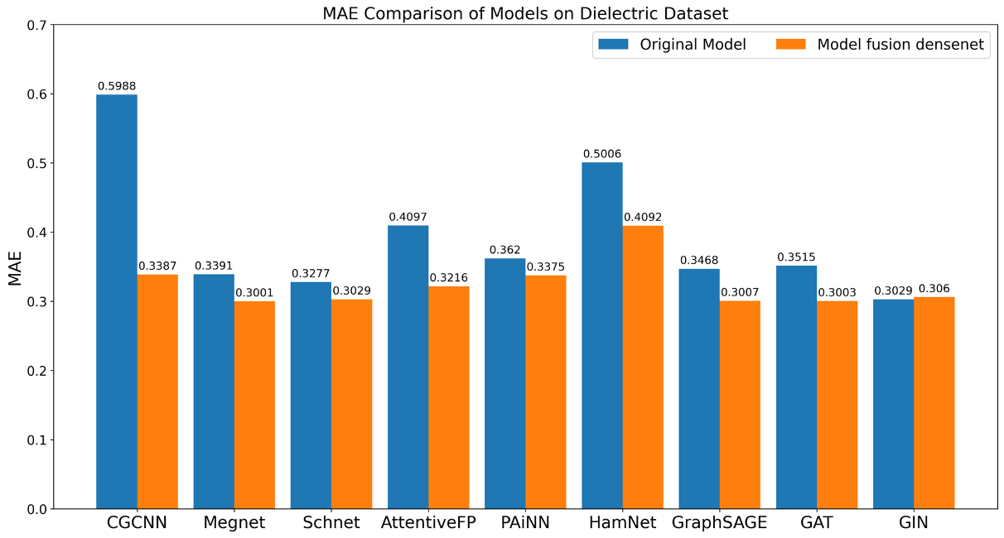

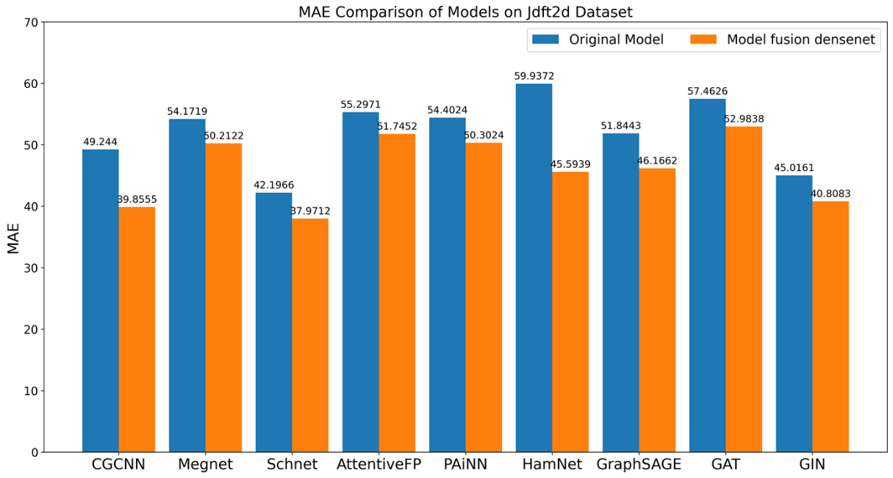

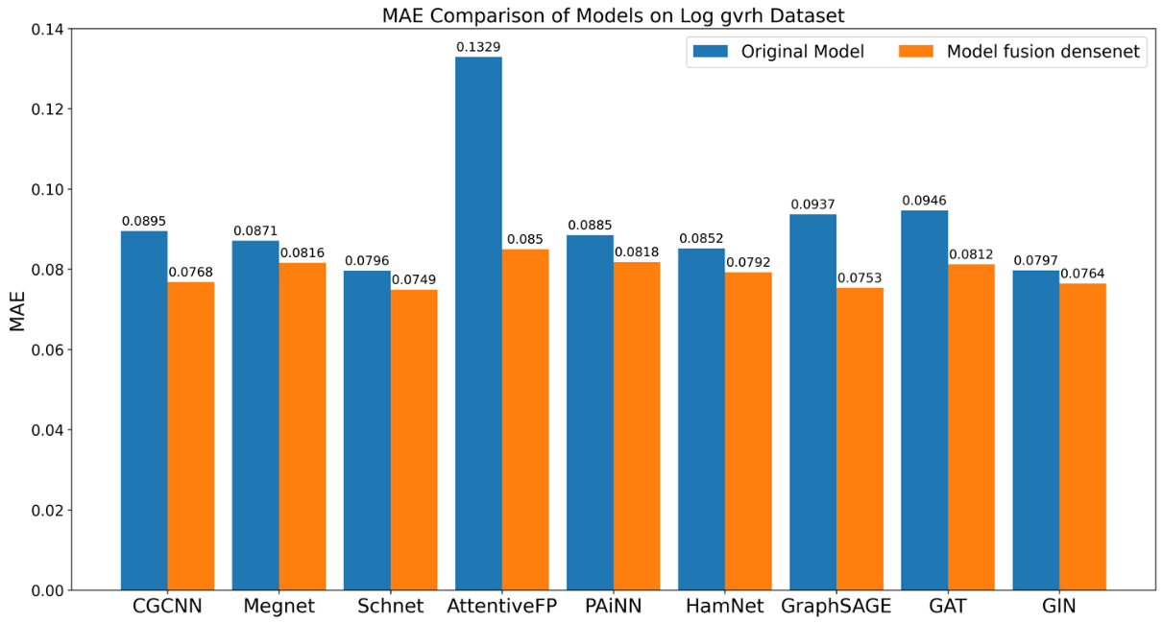

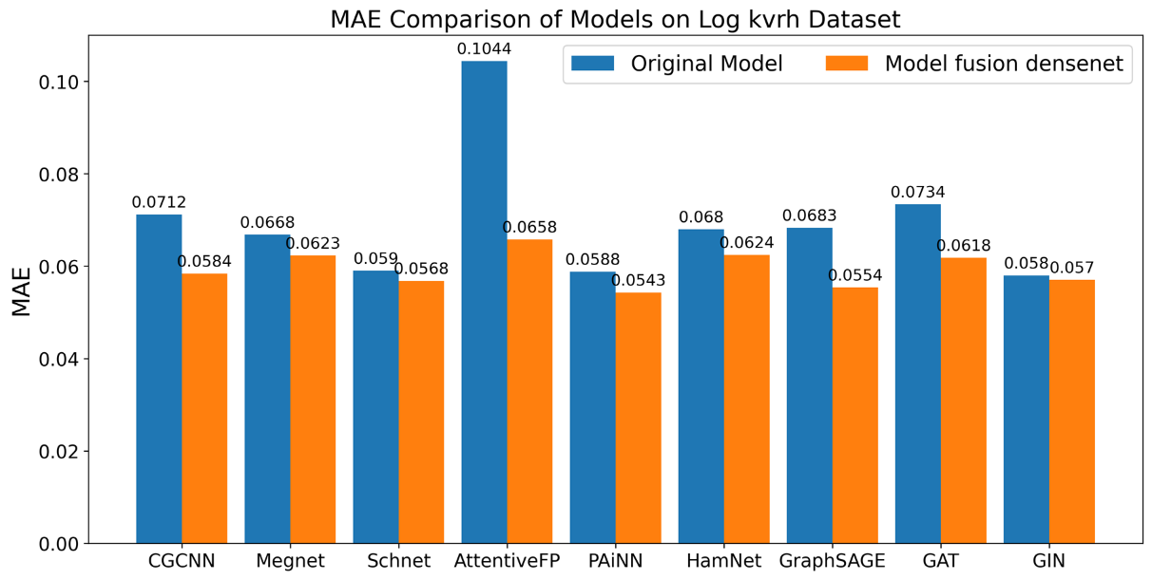

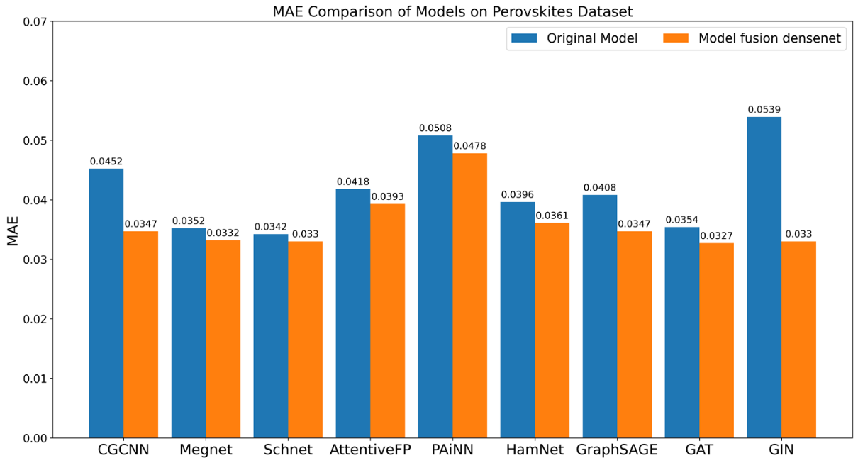

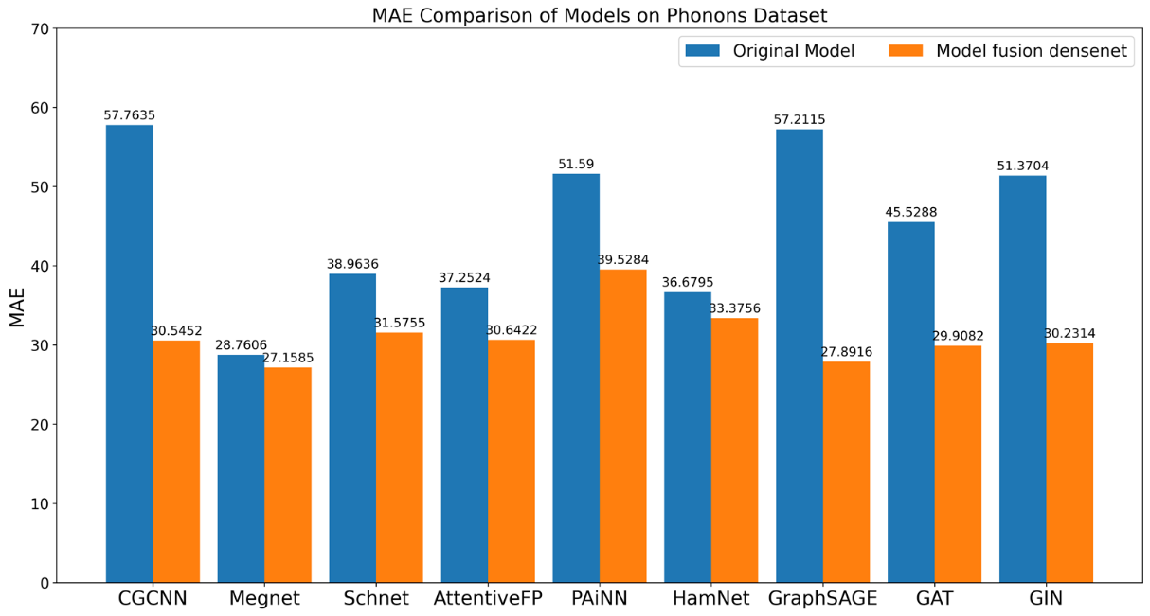
Figure S1, the MAE comparison of representative models in three specific domains (materials, molecular, and computer science) on 6 Matbench datasets before and after fusing the DCN strategy is shown.

Optimizing Edge Connectivity for Efficient Enhancements
Schnet / Radius | 4.0 | 5.0 | 6.0 | 8.0
Jdft2d | 52.9513 | 47.2116 | 43.8966 | 45.6324
Phonons | 48.7089 | 42.155 | 40.1608 | 40.7092
Dielectric | 0.3231 | 0.3140 | 0.3168 | 0.3018
Perovskites | 0.0408 | 0.0386 | 0.0349 | 0.0388
Log gvrh | 0.0864 | 0.0824 | 0.0792 | 0.0789
Log kvrh | 0.0644 | 0.0619 | 0.0601 | 0.0604

CGCNN/ Radius | 4.0 | 5.0 | 6.0 | 8.0
Jdft2d | 45.0284 | 42.1485 | 41.9138 | 39.8461
Phonons | 40.6583 | 40.4221 | 39.8657 | 40.6511
Dielectric | 0.3615 | 0.3485 | 0.3381 | 0.3423
Perovskites | 0.0380 | 0.0382 | 0.0374 | 0.0383
Log gvrh | 0.0828 | 0.0806 | 0.0805 | 0.0826
Log kvrh | 0.0626 | 0.0613 | 0.0604 | 0.0609

MEGNet / Radius | 4.0 | 5.0 | 6.0 | 8.0
Jdft2d | 57.861 | 54.1602 | 53.2526 | 54.830
Phonons | 30.1969 | 30.2264 | 30.1585 | 36.1921
Dielectric | 0.3279 | 0.3312 | 0.3298 | 0.3402
Perovskites | 0.0428 | 0.0421 | 0.0419 | 0.0409
Log gvrh | 0.0871 | 0.0852 | 0.0846 | 0.0867
Log kvrh | 0.0638 | 0.0634 | 0.0618 | 0.0634

DenseGNN/KNN | 6 | 12 | 18 | 24
Jdft2d | 37.6720 | 32.5425 | 33.2046 | 33.3927
Phonons | 26.0533 | 24.8470 | 25.2097 | 26.0858
Dielectric | 0.3213 | 0.2837 | 0.3100 | 0.3015
Perovskites | 0.0268 | 0.0287 | 0.0282 | 0.0282
Log gvrh | 0.0717 | 0.0668 | 0.0688 | 0.0695
Log kvrh | 0.0553 | 0.0512 | 0.0524 | 0.0536

Edges numbers | DenseGNN | CGCNN | Schnet | MEGNet | coGN
Jdft2d | 56040 | 126676 | 126676 | 126676 | 56971
Phonons | 119003 | 452302 | 452302 | 452302 | 113959
Dielectric | 982466 | 4867630 | 4867630 | 4867630 | 777655
Perovskites | 1196573 | 6099290 | 6099290 | 6099290 | 2167618
Log gvrh | 1186890 | 5417274 | 5417274 | 5417274 | 1083580
Log kvrh | 1186890 | 5417274 | 5417274 | 5417274 | 1083580

Nodes numbers | DenseGNN | CGCNN | Schnet | MEGNet | coGN
Jdft2d | 4575 | 4575 | 4575 | 4575 | 2296
Phonons | 9521 | 9521 | 9521 | 9521 | 4342
Dielectric | 80487 | 80487 | 80487 | 80487 | 31521
Perovskites | 94640 | 94640 | 94640 | 94640 | 85648
Log gvrh | 94777 | 94777 | 94777 | 94777 | 41305
Log kvrh | 94777 | 94777 | 94777 | 94777 | 41305
Table S5, Summary of MAE comparisons for different GNN Models on the Matbench Dataset.
1. Schnet (radius-based approach for crystal graphs) at different radii;
2. CGCNN (radius-based approach for crystal graphs) at different radii;
3. MEGNet (radius-based approach for crystal graphs) at different radii;
4. DenseGNN (k-nearest-neighbors approach for crystal graphs) at various k values;
5. Comparison of all edges and nodes for DenseGNN, Schnet, CGCNN, MEGNet, and coGN on the Matbench dataset.

