Table S1: Cut off values of ΔSpO₂-Ex and 6MWD
Parameters | Cut off value | AUC | Sensitivity | Specificity
ΔSpO₂-Ex (%) | 6.7 | 0.72 | 0.57 | 0.96
6MWD (m) | 220 | 0.62 | 0.68 | 0.63

6MWD, Six-Minute Walk Distance; ΔSpO₂-Ex, averaged decrease in peripheral oxygen saturation during exercise; AUC, area under the curve.

Table S2: Baseline characteristics of Long- and Short-6MWD groups
Characteristics | All | Long-6MWD | Short-6MWD | P value
Subjects, n | 55 | 26 | 29 | -
Age, y | 80.7 ± 6.7 | 79.2 ± 6.7 | 82.2 ± 6.6 | 0.098
Gender (Female) | 25 (45%) | 9 (35%) | 16 (55%) | 0.177
Body mass index, kg/m² | 21.3 ± 4.3 | 21.0 ± 3.4 | 21.6 ± 5.0 | 0.614
Vital signs
Heart rate, beats per minute | 73.0 ± 15.4 | 71.7 ± 15.7 | 74.2 ± 15.3 | 0.556
Systolic blood pressure, mmHg | 111.2 ± 19.0 | 112.5 ± 18.6 | 110.0 ± 19.7 | 0.640
Diastolic blood pressure, mmHg | 63.2 ± 11.5 | 62.8 ± 12.2 | 62.4 ± 11.0 | 0.882
Medical history
Coronary artery disease, n | 24 (44%) | 15 (58%) | 9 (31%) | 0.060
Valvular disease, n | 23 (42%) | 7 (27%) | 16 (55%) | 0.055
Atrial fibrillation, n | 31 (56%) | 16 (62%) | 15 (52%) | 0.588
Hypertension, n | 45 (82%) | 19 (73%) | 26 (90%) | 0.164
Diabetes mellitus, n | 16 (29%) | 7 (27%) | 9 (31%) | 0.775
Pulmonary disease, n | 12 (22%) | 5 (19%) | 7 (24%) | 0.751
Laboratory measurements
NT-proBNP (pg/mL) | 3084  (1373, 5781) | 1690  (1078, 4038) | 4332  (2322, 6146) | 0.006
Creatinine (mg/dL) | 1.8 ± 1.3 | 1.6 ± 0.8 | 2.0 ± 1.6 | 0.363
eGFR (mL/min/1.73 m²) | 34.3 ± 18.3 | 36.3 ± 17.3 | 32.5 ± 19.2 | 0.448
Hematocrit (%) | 35.8 ± 6.1 | 37.7 ± 5.7 | 34.0 ± 6.0 | 0.022
Hemoglobin (g/dL) | 11.5 ± 2.1 | 12.3 ± 2.0 | 10.9 ± 1.9 | 0.008
Echocardiography parameters
LVEF, % | 45.7 ± 18.0 | 47.3 ± 18.3 | 44.3 ± 17.9 | 0.543
LVDd, mm | 53.9 ± 10.4 | 56.3 ± 10.1 | 51.8 ± 10.5 | 0.107
TRPG, mmHg | 26.3 ± 7.1 | 25.4 ± 7.5 | 26.9 ± 6.9 | 0.533
Pulmonary function tests
%VC, % | 73.2 ± 22.0 | 82.1 ± 17.8 | 65.0 ± 22.7 | 0.003
FEV 1%, % | 74.5 ± 11.6 | 74.7 ± 11.7 | 74.4 ± 11.8 | 0.913
Drug therapy
ACE inhibitor or ARB, n | 27 (49%) | 14 (54%) | 13 (45%) | 0.593
MRA, n | 25 (45%) | 14 (54%) | 11 (38%) | 0.285
β-blocker, n | 48 (87%) | 22 (85%) | 26 (90%) | 0.232
SGLT2 inhibitor, n | 14 (25%) | 8 (31%) | 6 (21%) | 0.537
ARNI, n | 14 (25%) | 8 (31%) | 6 (21%) | 0.537
Loop diuretic, n | 50 (91%) | 24 (92%) | 26 (90%) | 1.000
6-minute walk test
6MWD (m) | 237.5 ± 106.7 | 333.3 ± 59.4 | 151.6 ± 51.4 | <0.001
SpO₂ at rest (%) | 98.3 ± 1.5 | 98.5 ± 1.7 | 98.2 ± 1.3 | 0.534
SpO₂ during the 6MWT (%) | 92.5 ± 4.4 | 93.0 ± 4.1 | 92.1 ± 4.8 | 0.489
ΔSpO₂-Ex (%) | 5.8 ± 4.3 | 5.5 ± 3.8 | 6.1 ± 4.7 | 0.617

Data are presented as the mean ± SD or median with interquartile range (IQR).
6MWD, Six-Minute Walk Distance; ΔSpO₂-Ex, averaged decrease in peripheral oxygen saturation during exercise; ACE, Angiotensin-converting enzyme; ARB, Angiotensin II receptor blockers; ARNI, Angiotensin receptor-neprilysin inhibitor; eGFR, estimated glomerular filtration rate; FEV1 %, Forced expiratory volume in 1 second as a percentage of predicted; LVDd, Left ventricular end-diastolic dimension; LVEF, Left ventricular ejection fraction; MRA, Mineralocorticoid receptor antagonist; NT-proBNP, N-terminal pro b-type natriuretic peptide; SGLT2, Sodium glucose cotransporter 2; TRPG, Tricuspid regurgitant pressure gradient; %VC, Percent vital capacity.

Table S3: The 6MWD for each trial
Trials | 6MWD
RESOLVD | 381 ± 84 m
PRESERVED-HF | 249.0 ± 113.8 m
PARALLAX | 303.3 ± 105.4 m
INOVATE-HF | 304.1 ± 111.5 m

6MWD, Six-Minute Walk Distance.

Figure S1
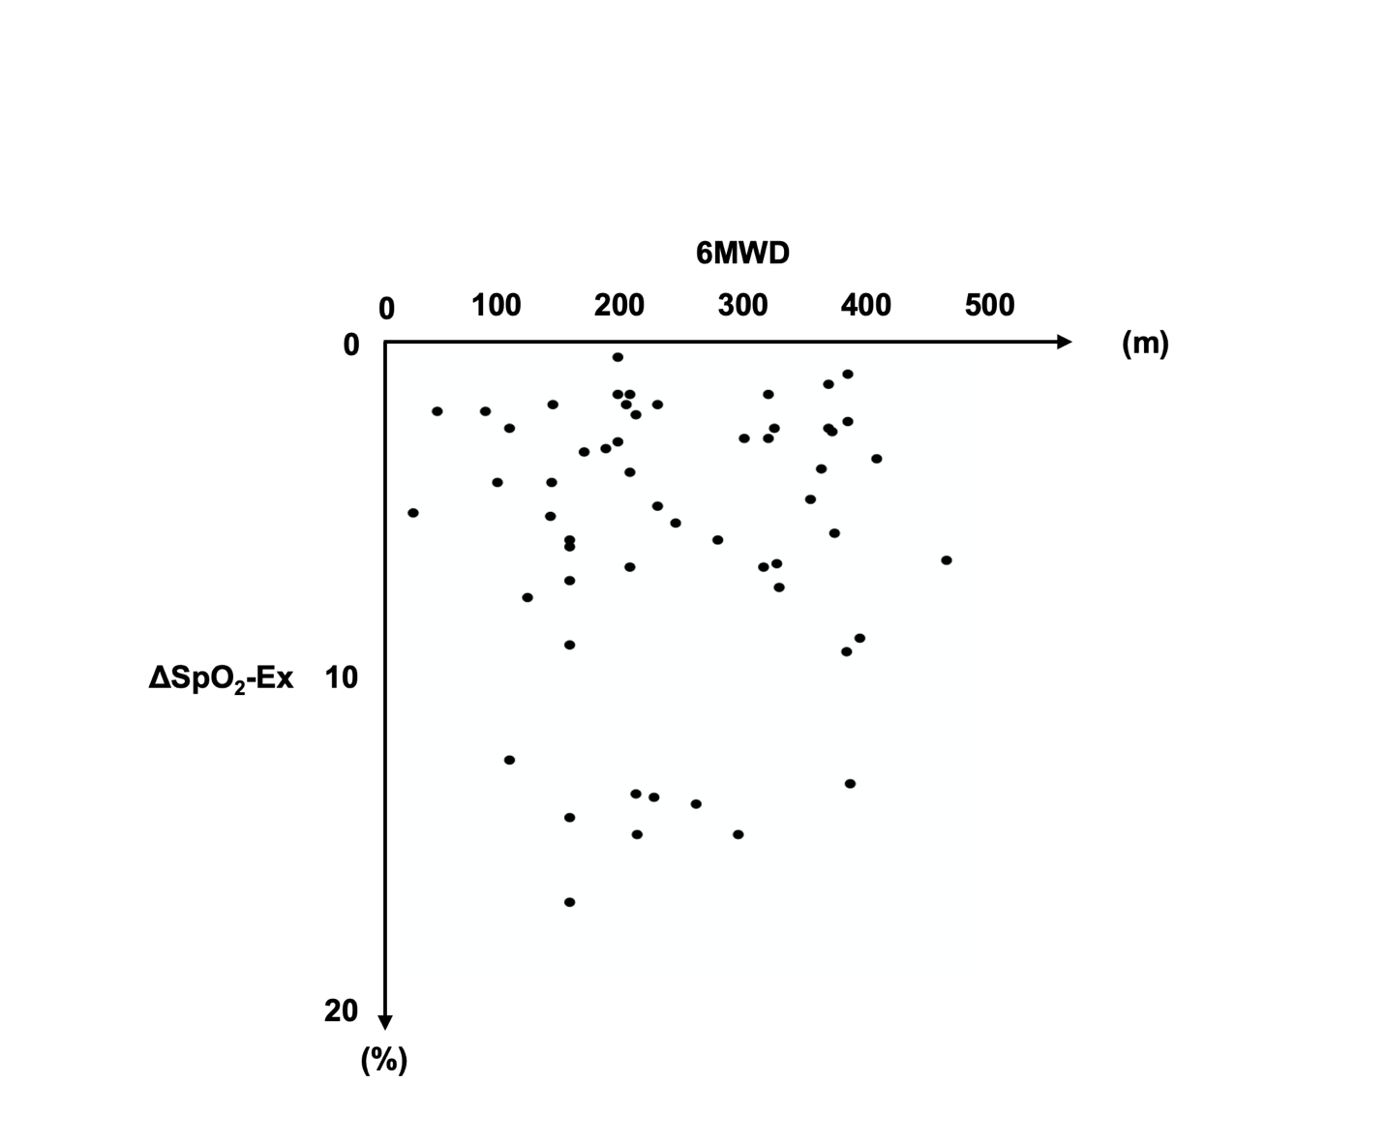

Figure S1: The distribution of ΔSpO₂-Ex levels and 6MWD
There was no correlation between ΔSpO₂-Ex and 6MWD (r=-0.04, p=0.782).
6MWD, Six-Minute Walk Distance; ΔSpO₂-Ex, averaged decrease in peripheral oxygen saturation during exercise.

