Supplementary Material Appendix S.1. Additional results.

Taxonomic diversity
Table S.1.1. Multiple linear regressions for the species richness. The model excludes 6 outliers (see Supplementary Material Appendix S. 5 for the full model). The significant results are highlighted in italics (P-value < 0.05). The model’s residuals were not normally distributed, so we also used the log-transformed species richness.
 | Log Species Richness
 | MLE | P-value
Temperature² | -0.018 | <0.001
Temperature | -0.022 | <0.001
Precipitation (Log 10) | -0.024 | <0.001
Solar radiation | 0.044 | <0.001
Urbanization (Log 10) | -0.055 | <0.001
Proportion cropland (Log 10) | 0.018 | <0.001
LU Diversity (Shannon-Weaver index) | -0.005 | 0.004
Number of records (Log 10) | 0.309 | <0.001
Marginal R² | 0.763
Conditional R² | 0.784

Phylogenetic diversity
Table S.1.2. Multiple linear regressions for the indices of phylogenetic diversity. The significant results are highlighted in italics (P-value < 0.05). The residuals for Faith’s PD were not normally distributed or homoskedastic; thus, we repeated the models using the cubic root-transformed Faith’s PD index. The models for MPD and cubic root-transformed Faith’s PD exclude 1 outlier each (see Supplementary Material Appendix S. 5 for the full model).
 | Phylogenetic  MPD |  | Phylogenetic MNTD |  | Phylogenetic  Faith’s PD |  | CBRT Phylogenetic  Faith’s PD
 | MLE | P-value | MLE | P-value | MLE | P-value | MLE | P-value
Temperature² | -4.205 | <0.001 | -0.708 | <0.001 | -40.012 | <0.001 | -0.188 | <0.001
Temperature | 7.609 | <0.001 | 7.744 | <0.001 | -0.418 | 0.959 | 0.084 | <0.001
Precipitation (Log 10) | -3.101 | <0.001 | -0.323 | 0.404 | -49.899 | <0.001 | -0.184 | <0.001
Solar radiation | 13.845 | <0.001 | 6.040 | <0.001 | 148.224 | <0.001 | 0.588 | <0.001
Urbanization (Log 10) | -0.337 | 0.287 | 4.245 | <0.001 | -95.916 | <0.001 | -0.267 | <0.001
Proportion cropland (Log 10) | 0.562 | 0.057 | -0.991 | <0.001 | 37.999 | <0.001 | 0.106 | <0.001
LU Diversity (Shannon-Weaver index) | 0.144 | 0.572 | 0.815 | <0.001 | -11.046 | 0.003 | -0.011 | 0.322
Number of records (Log 10) | 7.695 | <0.001 | -14.413 | <0.001 | 579.368 | <0.001 | 1.770 | <0.001
Marginal R² | 0.333 |  | 0.403 |  | 0.661 |  | 0.688
Conditional R² | 0.538 |  | 0.435 |  | 0.697 |  | 0.756

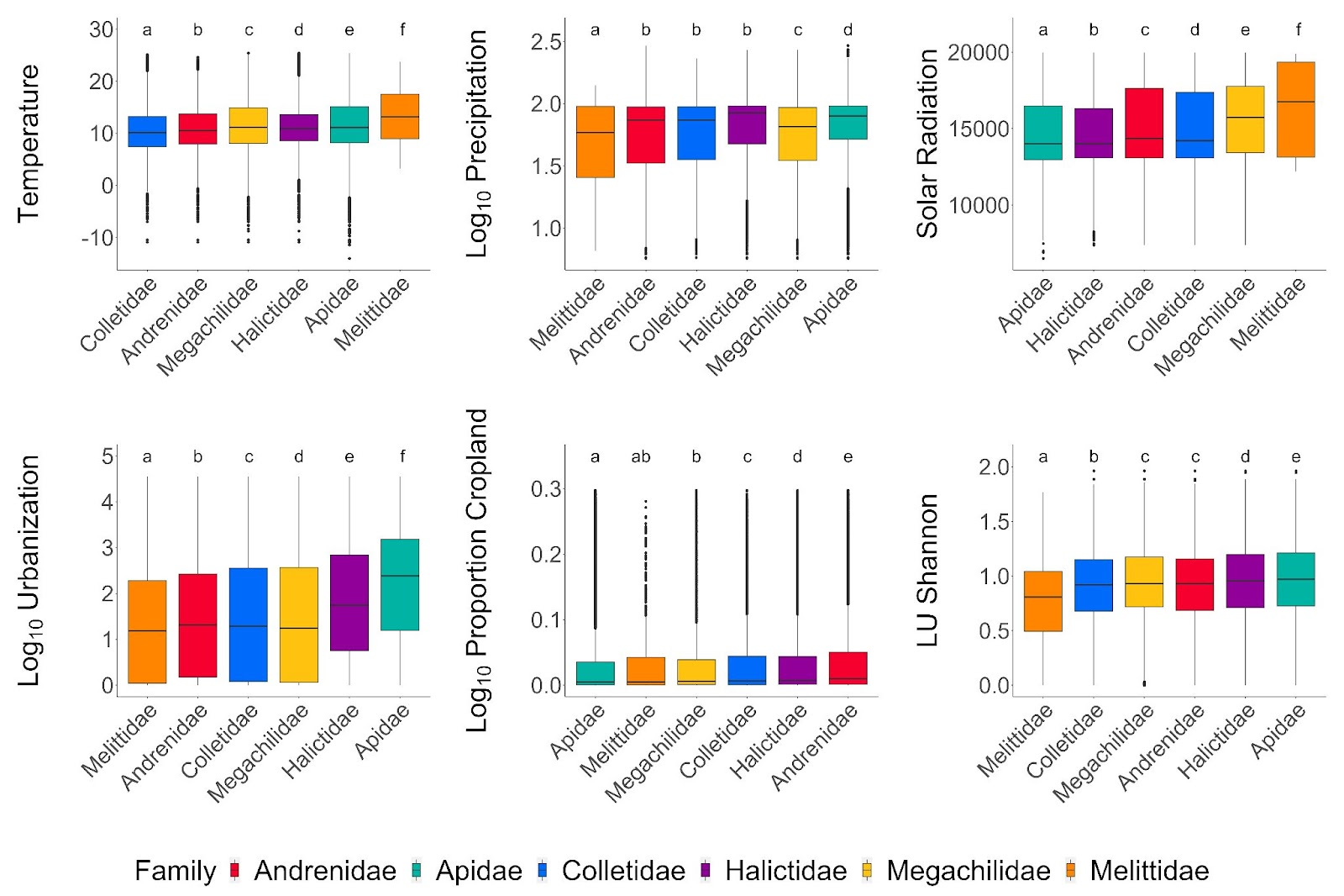Figure S.1.1. Boxplots of environmental associations for the studied bee families (Hymenoptera: Anthophila). We evaluated the values of each environmental factor for the pixels in which species of each bee family were found. The letters on top of each boxplot denote significant differences among families extracted from an LME model including the random intercept of ecoregion.

Functional diversity
Table S.1.3. Multiple linear regressions for the indices of functional diversity. The significant results are highlighted in italics (P-value < 0.05). The residuals for the MNTD model were not normally distributed and heteroscedastic, the square root transformation solved the issues. Additionally, the square root-transformed model for MNTD excluded 2 outliers.
 | Functional  MPD |  | Functional  MNTD |  | Functional  SQRT MNTD
 | MLE | P-value | MLE | P-value | MLE | P-value
Temperature² | 0.001 | 0.010 | 0.004 | <0.001 | 0.008 | <0.001
Temperature | 0.008 | <0.001 | 0.006 | <0.001 | 0.010 | <0.001
Precipitation (Log 10) | 0.012 | <0.001 | 0.007 | <0.001 | 0.014 | <0.001
Solar radiation | 0.009 | <0.001 | -0.001 | 0.094 | -0.004 | 0.005
Urbanization (Log 10) | 0.009 | <0.001 | 0.008 | <0.001 | 0.017 | <0.001
Proportion cropland (Log 10) | -0.001 | 0.058 | -0.002 | <0.001 | -0.005 | <0.001
LU Diversity (Shannon-Weaver index) | 0.003 | <0.001 | 0.002 | <0.001 | 0.004 | <0.001
Number of records (Log 10) | 0.003 | <0.001 | -0.024 | <0.001 | -0.050 | <0.001
Marginal R² | 0.130 |  | 0.383 |  | 0.425
Conditional R² | 0.221 |  | 0.406 |  | 0.449

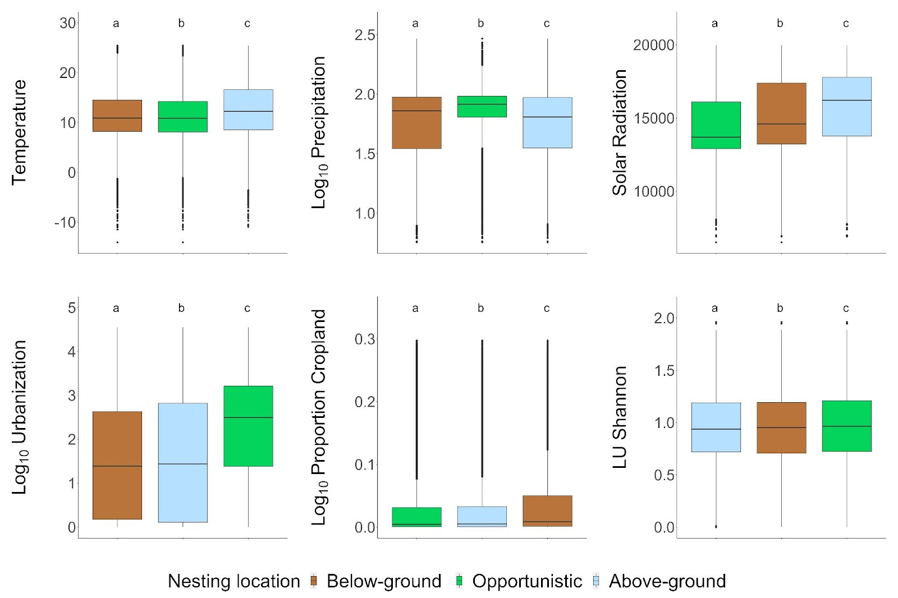Figure S.1.2. Associations of nesting location with urbanization, climate, and land use. We evaluated the values of each environmental factor for the grid cells in which above-ground, below-ground, and opportunistic bee species were found. The letters on top of each boxplot denote significant differences among nesting strategies extracted from an LME model including the random intercept of ecoregion.
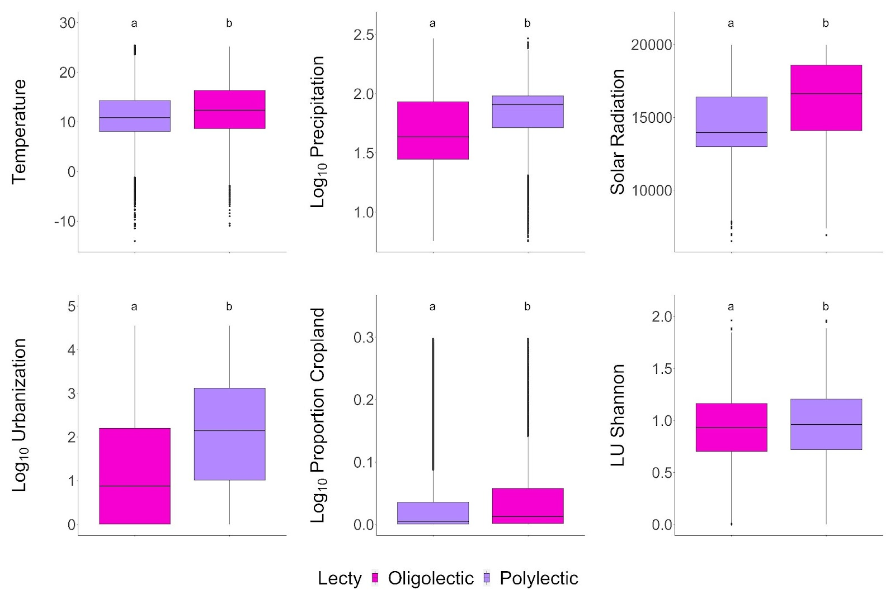Figure S.1.3. Associations of lecty with urbanization, climate, and land use. We evaluated the values of each environmental factor for the grid cells in which oligolectic and polylectic bee species were found. The letters on top of each boxplot denote significant differences among oligolectic and polylactic species, extracted from an LME model including the random intercept of ecoregion.
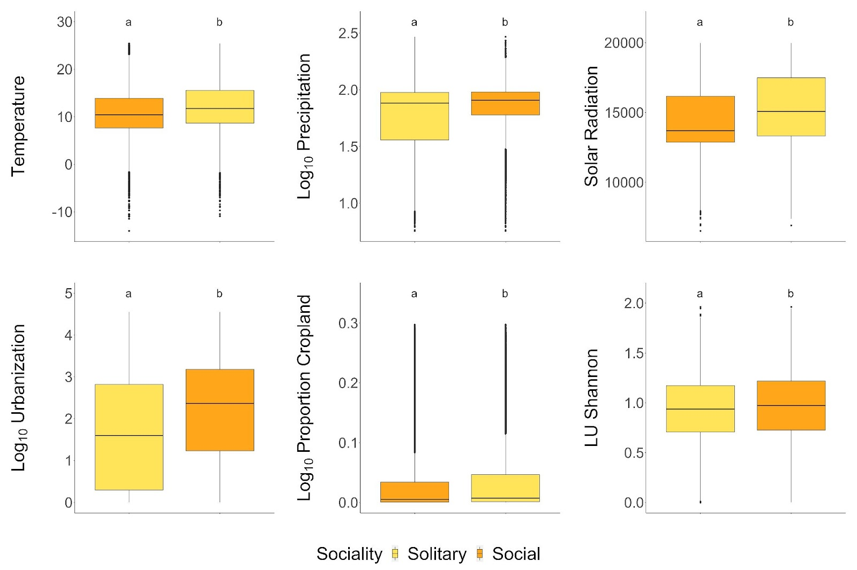Figure S.1.4. Associations of sociality with urbanization, climate, and land use. We evaluated the values of each environmental factor for the grid cells in which solitary and eusocial bee species were found. The letters on top of each boxplot denote significant differences among solitary and eusocial species, extracted from an LME model including the random intercept of ecoregion.
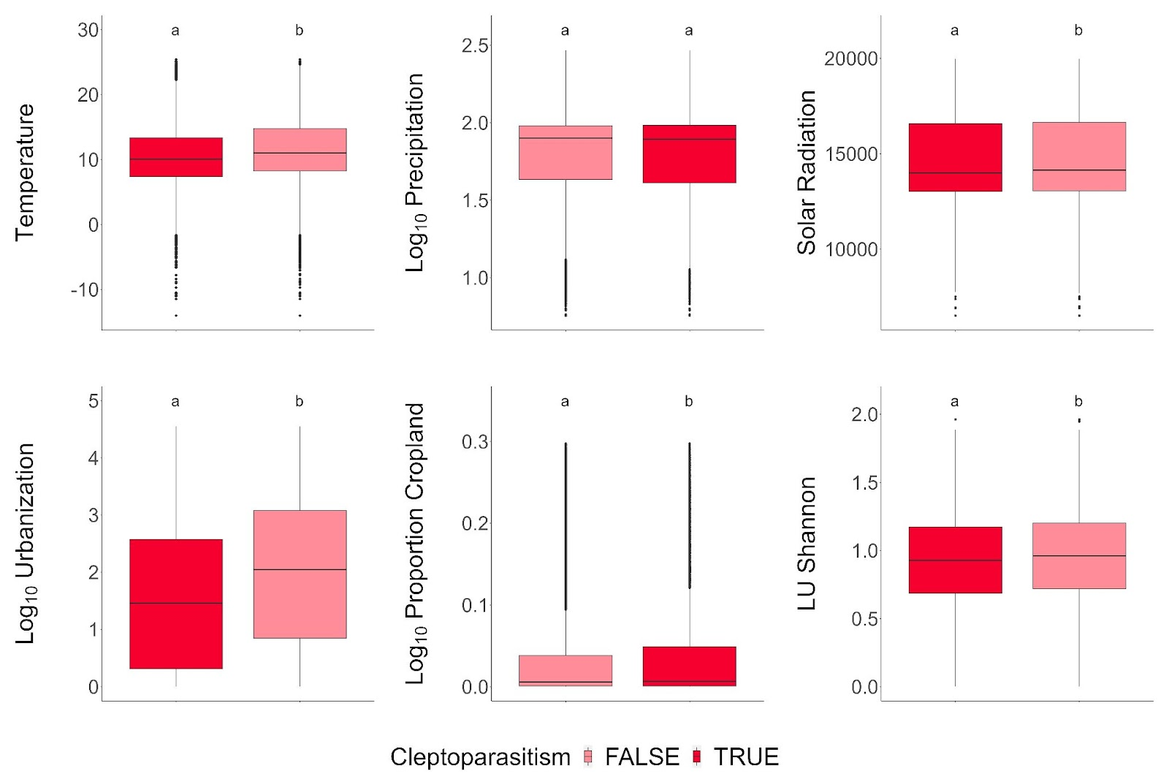Figure S.1.5. Associations of kleptoparasitism with urbanization, climate, and land use. We evaluated the values of each environmental factor for the grid cells in which free-living and parasitic bee species were found. The letters on top of each boxplot denote significant differences among free-living and parasitic species, extracted from an LME model including the random intercept of ecoregion.
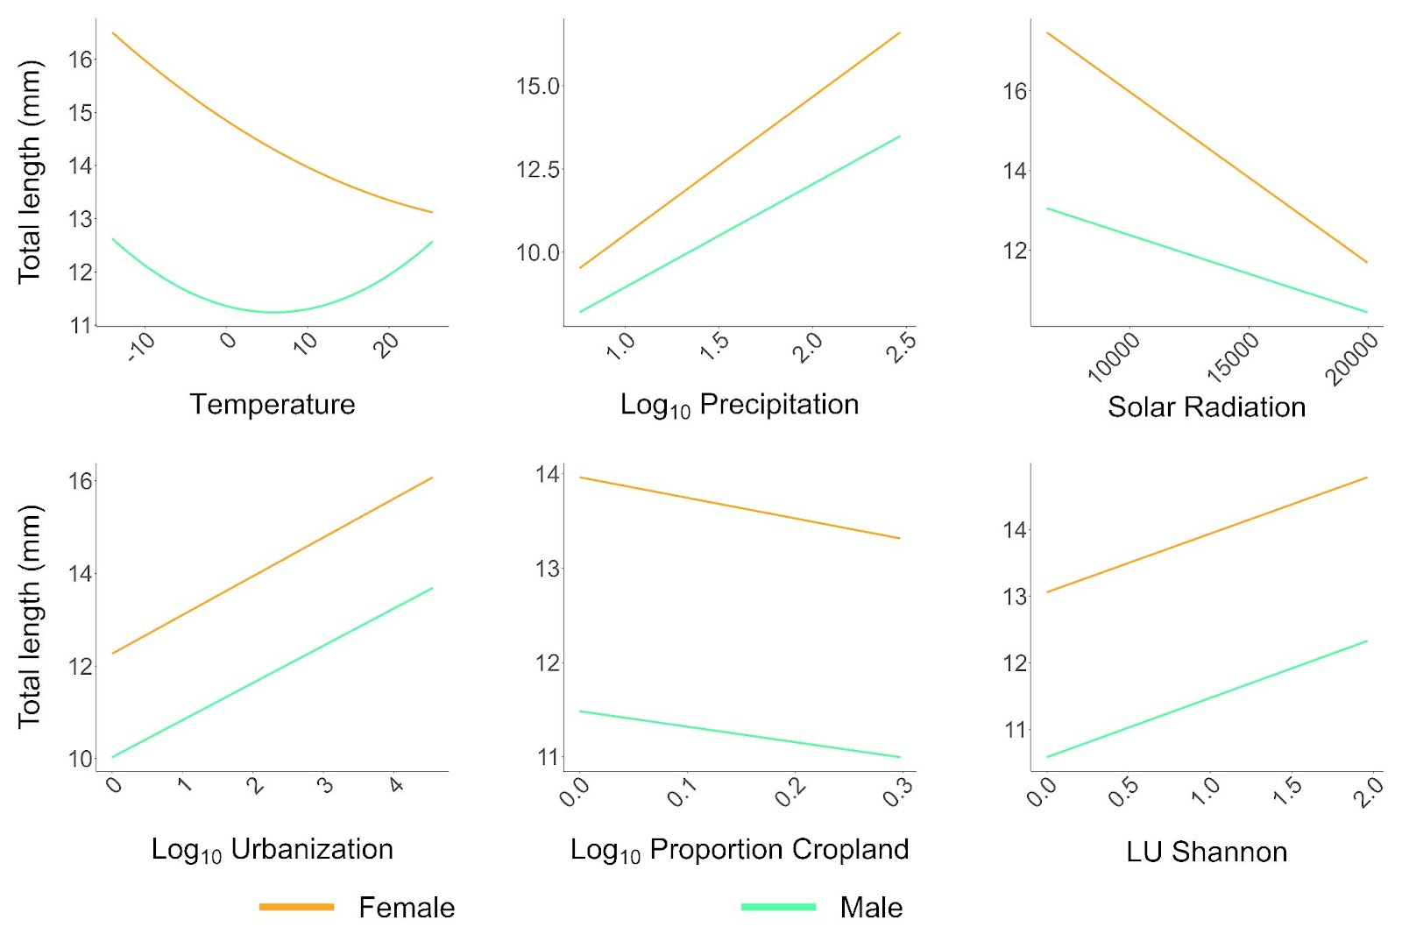Figure S.1.6. Effects of climate, urbanization, and land use on bee species lengths. The results are based on an LME model including a random intercept for ecoregion. The orange lines represent female lengths, while the green lines represent male lengths.

Supplementary Material Appendix S.2. Bee diversity maps.

Taxonomic diversity

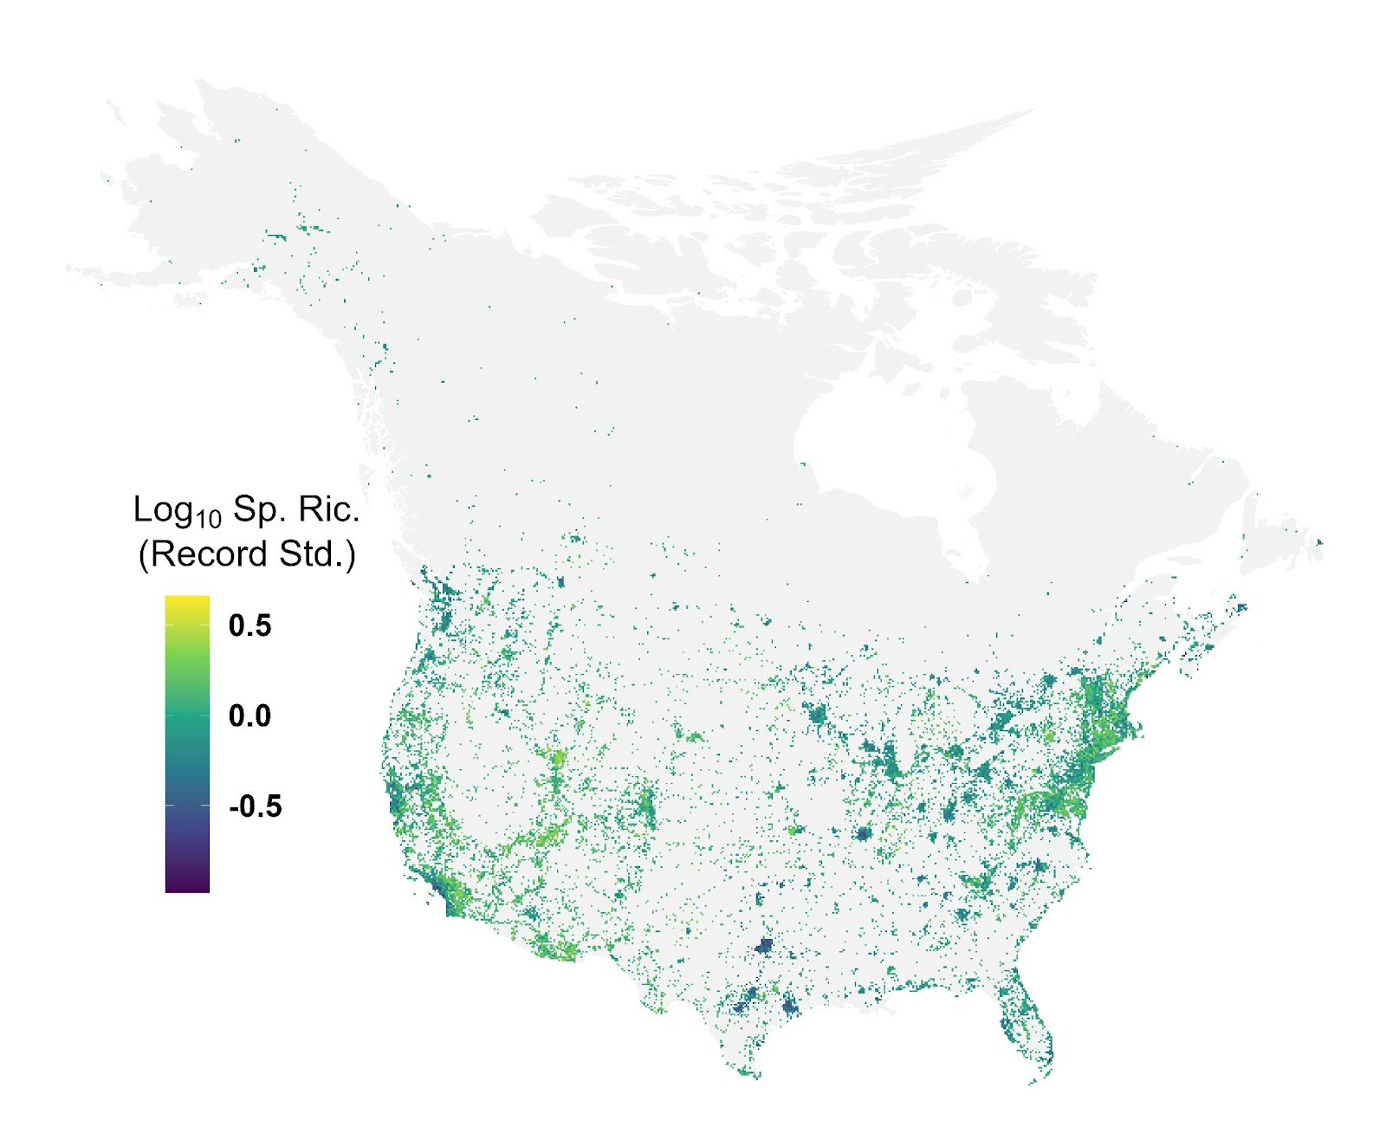
Figure S.2.1. Bee species richness across North America North of Mexico. We standardized species richness by sampling intensity within each grid cell by fitting a linear regression with the natural log of bee species richness as the response and the number of records as the explanatory variable. The values plotted here are regression residuals, with higher numbers indicating higher species richness after controlling for sampling intensity.

Phylogenetic diversity
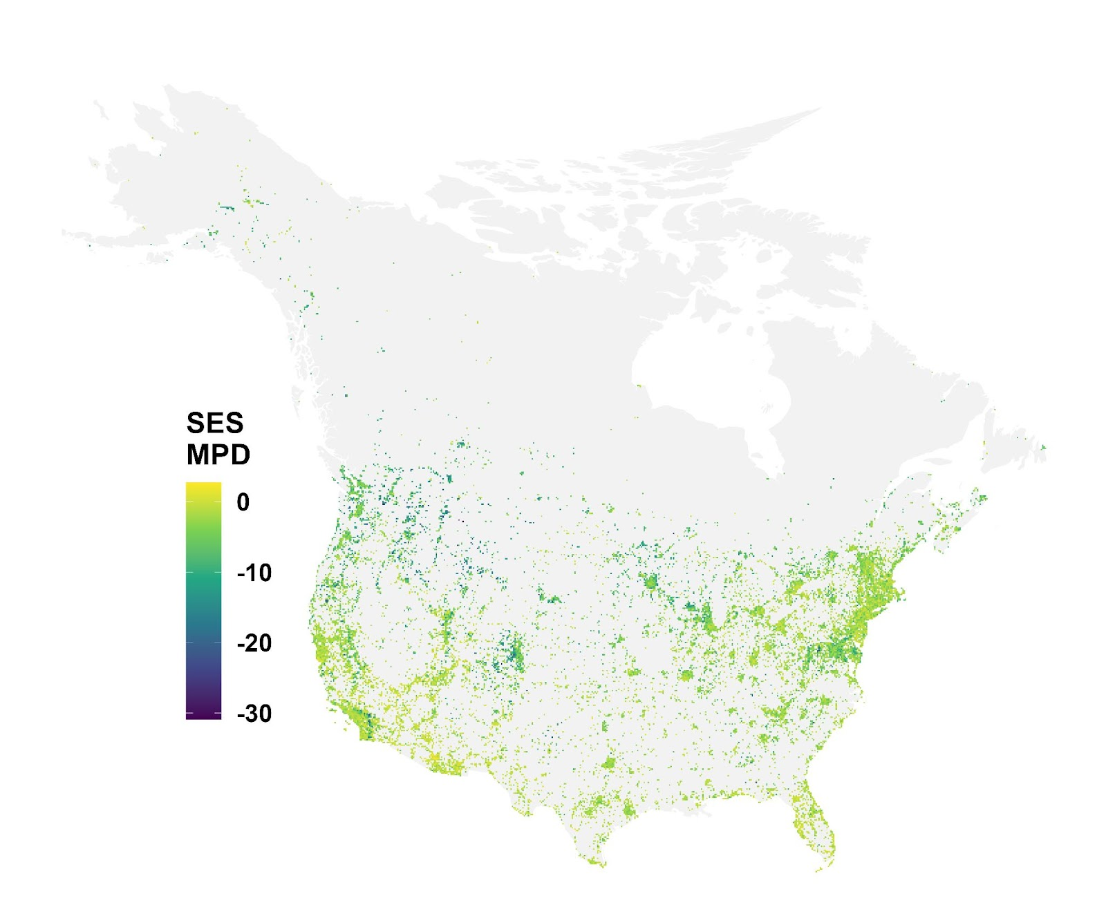
Figure S.2.2. Map standardized effect sizes of phylogenetic mean pairwise distance (SES MPD) across North America North of Mexico. Positive values indicate higher MPD than expected by randomization based on species swapping within the ecoregion level II species pool.
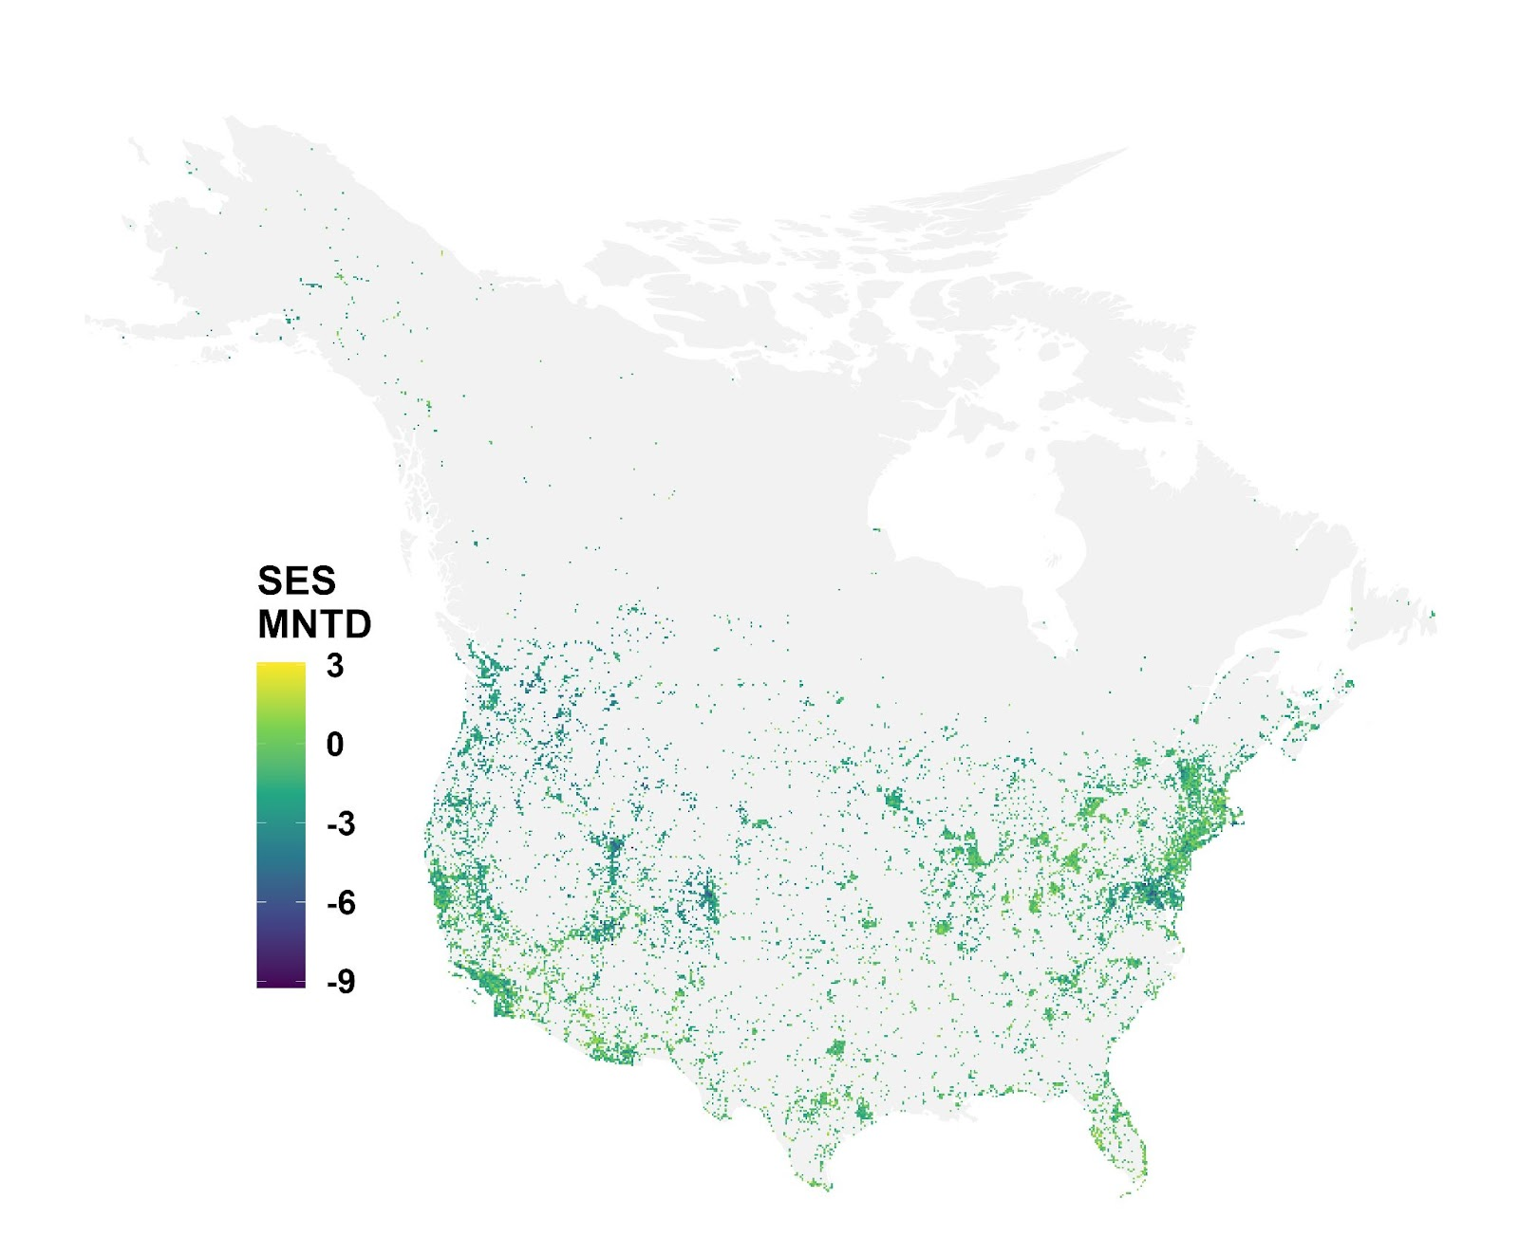
Figure S.2.3. Map standardized effect sizes of phylogenetic mean nearest taxon distance (SES MNTD) across North America North of Mexico. Positive values indicate higher MNTD than expected by randomization based on species swapping within the ecoregion level II species pool.
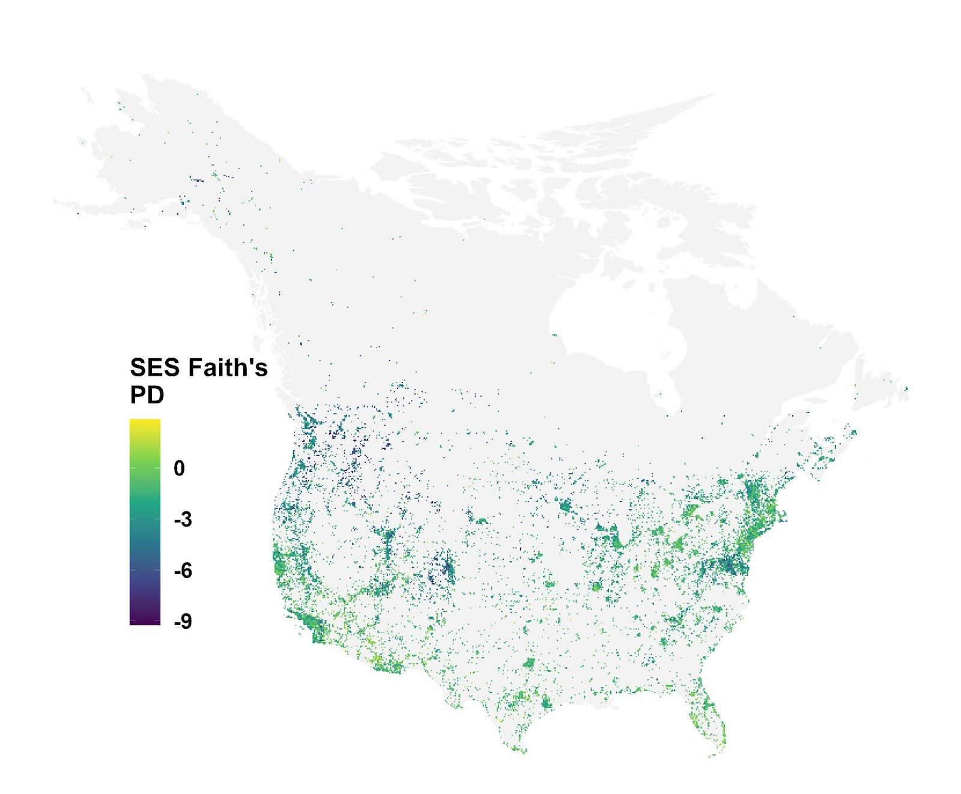
Figure S.2.4. Map standardized effect sizes of Faith’s phylogenetic diversity (SES Faith’s PD) across North America North of Mexico. Positive values indicate higher Faith’s PD than expected by randomization based on species swapping within the ecoregion level II species pool.

Functional diversity
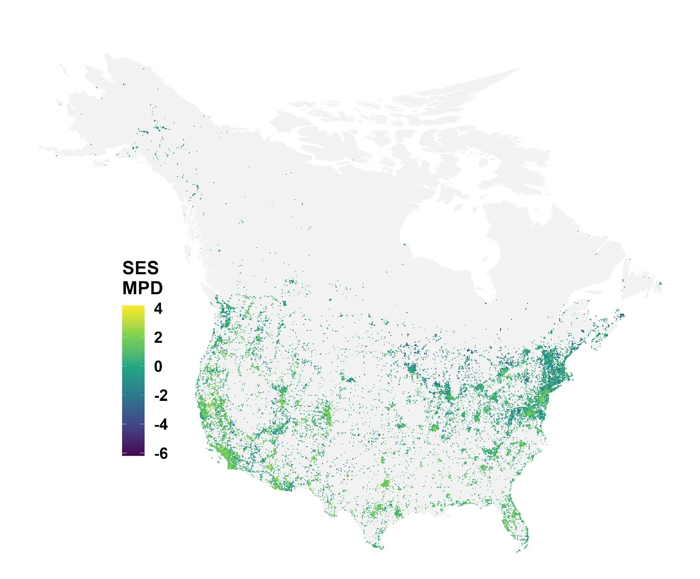
Figure S.2.5. Map standardized effect sizes of functional mean pairwise distance (SES MPD) across North America North of Mexico. Positive values indicate higher MPD than expected by randomization based on species swapping within the ecoregion level II species pool. Functional SES MPD was based on bee size (body length for females and males), nest location (above-ground, below-ground, or opportunistic), trophic specialization (oligolectic or polylectic), sociality (eusocial or solitary), kleptoparasitism (free-living or parasitic).
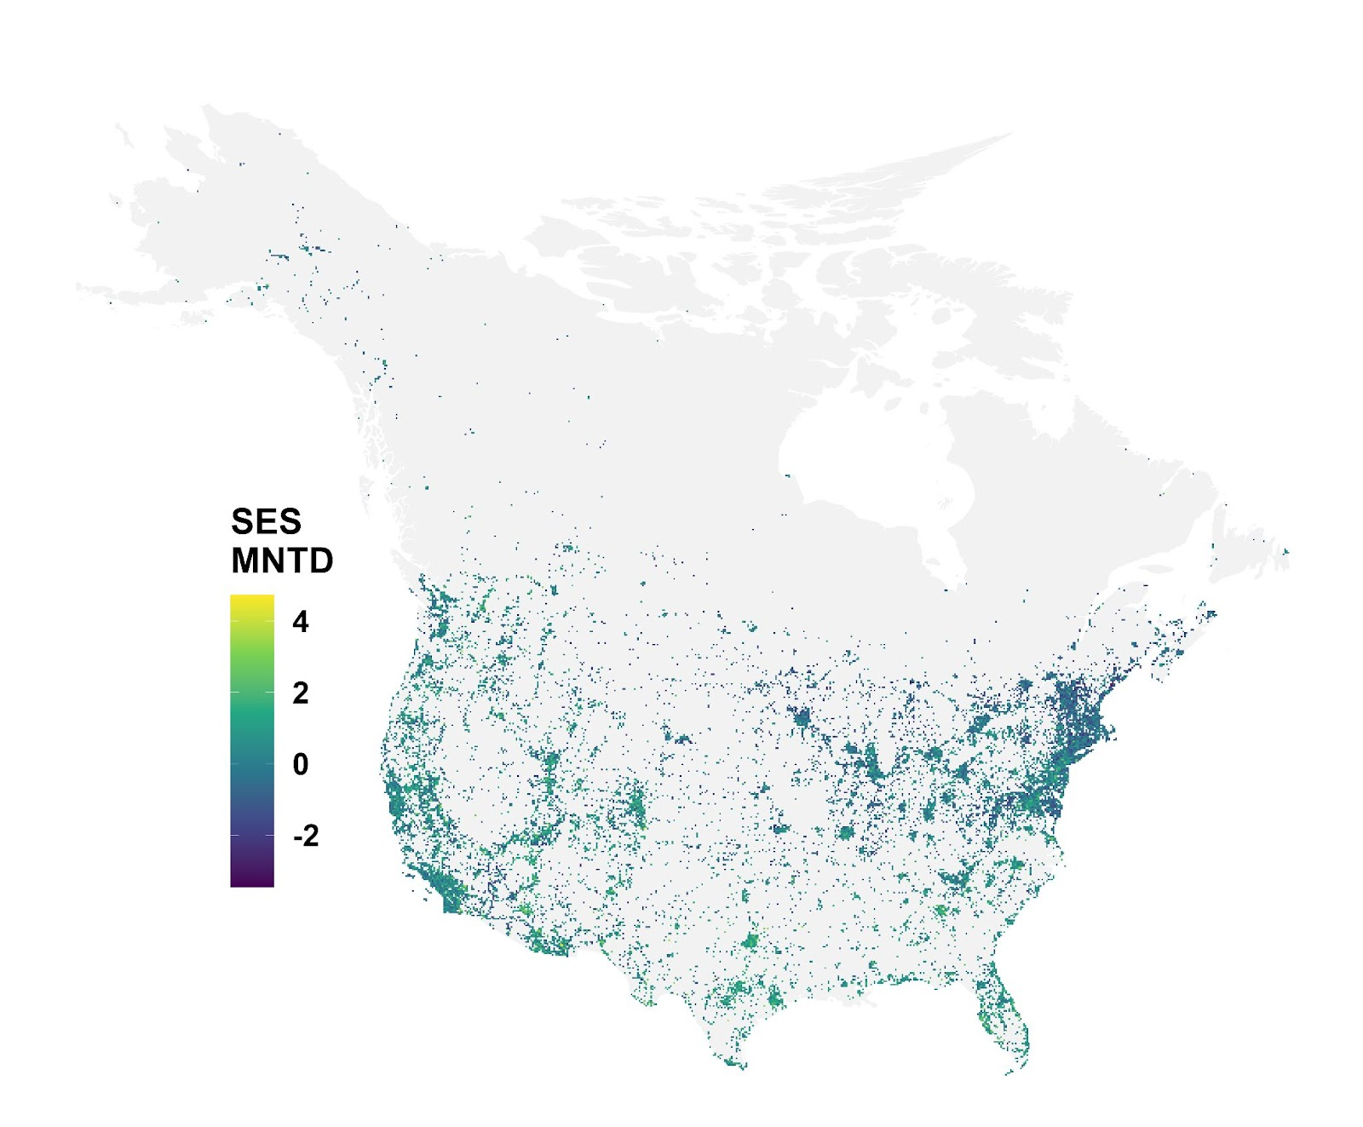
Figure S.2.6. Map standardized effect sizes of functional mean nearest taxon distance (SES MNTD) across North America North of Mexico. Positive values indicate higher MNTD than expected by randomization based on species swapping within the ecoregion level II species pool. Functional SES MNTD was based on bee size (boy length for females and males), nest location (above-ground, below-ground, or opportunistic), trophic specialization (oligolectic or polylectic), and sociality (eusocial or solitary), kleptoparasitism (free-living or parasitic).

Supplementary Material Appendix S.3. Bee diversity analysis for native species.

Taxonomic diversity
Table S.3.1. Multiple linear regressions for the species richness. The model excludes 10 outliers. The significant results are highlighted in italics (P-value < 0.05). The model’s residuals were not normally distributed so we also used the log-transformed species richness.
 | Log Native  Species Richness (No Outliers) |  | Log Native  Species Richness
 | MLE | P-value | MLE | P-value
Temperature² | -0.011 | <0.001 | -0.011 | <0.001
Temperature | -0.011 | <0.001 | -0.011 | <0.001
Precipitation (Log 10) | -0.020 | <0.001 | -0.021 | <0.001
Solar radiation | 0.044 | <0.001 | 0.044 | <0.001
Urbanization (Log 10) | -0.044 | <0.001 | -0.044 | <0.001
Proportion cropland (Log 10) | 0.018 | <0.001 | 0.018 | <0.001
LU Diversity (Shannon-Weaver index) | -0.006 | <0.001 | -0.005 | <0.001
Number of records (Log 10) | 0.307 | <0.001 | 0.306 | <0.001
Marginal R² | 0.780 |  | 0.776
Conditional R² | 0.795 |  | 0.791

Phylogenetic diversity
Table S.3.2. Multiple linear regressions for the indices of phylogenetic diversity for native bee species. The significant results are highlighted in italics (P-value < 0.05). The residuals for Faith’s PD were not normally distributed or homoskedastic; thus, we cubic root-transformed the index. The models for MNTD and the cubic root-transformed Faith’s PD exclude, respectively, 2 and 3 outliers (see Supplementary Material Appendix S. 5 for the full model). The residuals for MPD were not normally distributed, but no transformation solved the issue.
 | Phylogenetic  MPD |  | Phylogenetic MNTD |  | Phylogenetic  Faith’s PD |  | CBRT Phylogenetic  Faith’s PD
 | MLE | P-value | MLE | P-value | MLE | P-value | MLE | P-value
Temperature² | -3.873 | <0.001 | -0.830 | <0.001 | -25.197 | <0.001 | -0.140 | <0.001
Temperature | 7.884 | <0.001 | 6.548 | <0.001 | 20.109 | 0.012 | 0.141 | <0.001
Precipitation (Log 10) | -2.841 | <0.001 | -0.599 | 0.126 | -43.334 | <0.001 | -0.162 | <0.001
Solar radiation | 14.657 | <0.001 | 6.787 | <0.001 | 154.136 | <0.001 | 0.621 | <0.001
Urbanization (Log 10) | -0.357 | 0.290 | 2.446 | <0.001 | -78.203 | <0.001 | -0.223 | <0.001
Proportion cropland (Log 10) | 0.362 | 0.256 | -0.960 | <0.001 | 39.212 | <0.001 | 0.108 | <0.001
LU Diversity (Shannon-Weaver index) | 0.185 | 0.501 | 0.528 | 0.011 | -13.602 | <0.001 | -0.020 | 0.070
Number of records (Log 10) | 7.740 | <0.001 | -13.376 | <0.001 | 564.648 | <0.001 | 1.746 | <0.001
Marginal R² | 0.323 |  | 0.399 |  | 0.671 |  | 0.693
Conditional R² | 0.530 |  | 0.441 |  | 0.698 |  | 0.752

Functional diversity
Table S.3.3. Multiple linear regressions for the indices of functional diversity for native bee species. The significant results are highlighted in italics (P-value < 0.05).
 | Functional  MPD |  | Functional  MNTD |  | Functional  SQRT MNTD
 | MLE | P-value | MLE | P-value | MLE | P-value
Temperature² | 0.001 | 0.022 | 0.003 | <0.001 | 0.007 | <0.001
Temperature | 0.002 | 0.075 | 0.002 | <0.001 | 0.004 | <0.001
Precipitation (Log 10) | 0.011 | <0.001 | 0.006 | <0.001 | 0.014 | <0.001
Solar radiation | 0.010 | <0.001 | 0.000 | 0.740 | -0.001 | 0.438
Urbanization (Log 10) | 0.004 | <0.001 | 0.003 | <0.001 | 0.008 | <0.001
Proportion cropland (Log 10) | -0.001 | 0.078 | -0.002 | <0.001 | -0.005 | <0.001
LU Diversity (Shannon-Weaver index) | 0.002 | 0.002 | 0.001 | <0.001 | 0.003 | <0.001
Number of records (Log 10) | 0.005 | <0.001 | -0.021 | <0.001 | -0.047 | <0.001
Marginal R² | 0.078 |  | 0.370 |  | 0.417
Conditional R² | 0.175 |  | 0.401 |  | 0.449

Supplementary Material Appendix S.4. SES phylogenetic and functional diversity results.
We standardized all metrics of phylogenetic and functional diversity (PD & FD) to account for differences in species richness among grid cells. We used ‘uniform’ null models, which consider species to be equally present across samples (i.e., shuffling species names in the presence matrix so that all species had equal probability of being selected). ‘Uniform’ null models are most appropriate for metrics of diversity based on species presences, since other models use species abundances to weight the species probability to be present in a sample. We restricted the null communities to calculate the standardized effect sizes (SES) geographically, so that they could only contain species that were present within the same ecoregion (ecoregion level II; Omernik and Griffith 2014). While the use of ecoregions to draw species for the null communities is better than assuming that species are continentally distributed, it may not reflect well bee distribution areas, which are still unknown for most species. The selected null model establishes a common baseline that allows us to compare species diversity across a large spatial scale and to control for regional species availability.
The models for phylogenetic SES MNTD, SES Faith’s PD, and functional SES MPD included 1 outlier each. We assessed the models with and without outliers and verified that the results were equivalent. We arcsine-transformed phylogenetic SES MPD so that the residuals were normally distributed. We present the raw models with outliers in the Supplementary Material Appendix S. 5.

Phylogenetic diversity
Bee phylogenetic diversity generally increased with urbanization, solar radiation, and decreased with precipitation and the sampling intensity. Phylogenetic diversity peaked at warm to hot temperatures. Despite this, the environmental effects were not fully consistent across metrics of phylogenetic diversity. SES Faith’s PD included a positive effect of landscape heterogeneity and negative effect of proportion of cropland. Climate, population, and land use explained 13.3, 16.0, 15.7, and 16.7% of the variance in the models of SES MPD, arcsine-transformed SES MPD, SES MNTD, and SES Faith’s PD, respectively. Geographic location and ecoregion explained, respectively, additional 66.9, 55.3, 55.2, 62.7 and of the variance. Thus, bee communities include more phylogenetic lineages in more urbanized areas, in warm to hot, sunny, and arid climates. Samples with more species tend to display lower phylogenetic diversity.
Table S.4.1. Multiple linear regressions for the standardized effect sizes of the indices of phylogenetic diversity. The significant results are highlighted in italics (P-value < 0.05). The SES MPD model’s residuals were not normally distributed, so we used the arcsine-transformed SES MPD. The models for SES MNTD and Faith’s PD exclude, each, 1 outlier (see Supplementary Material Appendix S. 5 for the full model).
 | Phylogenetic  SES MPD |  | Phylogenetic  Arcsine SES MPD |  | Phylogenetic SES MNTD |  | Phylogenetic  SES Faith’s PD
 | MLE | P-value | MLE | P-value | MLE | P-value | MLE | P-value
Temperature² | -0.447 | <0.001 | -0.070 | <0.001 | -0.071 | <0.001 | -0.183 | <0.001
Temperature | 1.210 | <0.001 | 0.327 | <0.001 | 0.392 | <0.001 | 0.625 | <0.001
Precipitation (Log 10) | -0.374 | <0.001 | -0.123 | <0.001 | -0.071 | <0.001 | -0.141 | <0.001
Solar radiation | 1.563 | <0.001 | 0.359 | <0.001 | 0.450 | <0.001 | 0.833 | <0.001
Urbanization (Log 10) | 0.247 | <0.001 | 0.054 | <0.001 | 0.187 | <0.001 | 0.202 | <0.001
Proportion cropland (Log 10) | -0.041 | 0.253 | 0.000 | 0.992 | -0.044 | <0.001 | -0.003 | 0.049
LU Diversity (Shannon-Weaver index) | 0.033 | 0.289 | -0.007 | 0.422 | 0.029 | 0.008 | 0.033 | 0.027
Number of records (Log 10) | -0.381 | <0.001 | -0.133 | <0.001 | -0.330 | <0.001 | -0.280 | <0.001
Marginal R² | 0.133 |  | 0.160 |  | 0.157 |  | 0.167
Conditional R² | 0.802 |  | 0.713 |  | 0.709 |  | 0.794

Functional diversity
Bee functional diversity increased with urbanization, precipitation, solar radiation, and land use. Bee functional diversity increased with the number of observations. Bee functional diversity increased quadratically with temperature, being highest at either cold or hot extremes. Urbanization, climate, and land use explained, respectively, 14.0 and 13.1% of the variances of SES MPD and SES MNTD, whereas ecoregion and geographical locations explained additional 15.1 and 8.6%. Hence, bee traits are most diverse in densely populated and highly urbanized areas, with wetter and sunnier climates and more extreme temperatures, and more diverse landscapes. Samples with more observations also tended to be more functionally diverse.
Table S.4.2. Multiple linear regressions for the standardized effect sizes of the indices of functional diversity. The significant results are highlighted in italics (P-value < 0.05).
 | Functional  SES MPD |  | Functional  SES MNTD
 | MLE | P-value | MLE | P-value
Temperature² | 0.028 | 0.014 | 0.075 | <0.001
Temperature | 0.090 | <0.001 | 0.099 | <0.001
Precipitation (Log 10) | 0.281 | <0.001 | 0.189 | <0.001
Solar radiation | 0.222 | <0.001 | 0.121 | <0.001
Urbanization (Log 10) | 0.265 | <0.001 | 0.179 | <0.001
Proportion cropland (Log 10) | -0.029 | 0.026 | -0.023 | 0.026
LU Diversity (Shannon-Weaver index) | 0.066 | <0.001 | 0.064 | <0.001
Number of records (Log 10) | 0.124 | <0.001 | 0.119 | <0.001
Marginal R² | 0.134 |  | 0.129
Conditional R² | 0.289 |  | 0.218

Supplementary Material Appendix S.5. Bee diversity analysis with outliers.

Taxonomic diversity
Table S.5.1. Raw model for the multiple linear regressions for the bee richness. The significant results are highlighted in italics (P-value < 0.05).
Log
Species Richness
 | MLE | P-value
Temperature² | -0.018 | <0.001
Temperature | -0.022 | <0.001
Precipitation (Log 10) | -0.024 | <0.001
Solar radiation | 0.044 | <0.001
Urbanization (Log 10) | -0.055 | <0.001
Proportion cropland (Log 10) | 0.018 | <0.001
LU Diversity (Shannon-Weaver index) | -0.004 | 0.004
Number of records (Log 10) | 0.308 | <0.001
Marginal R² | 0.760
Conditional R² | 0.782

Phylogenetic diversity
Table S.5.2. Raw model for the multiple linear regressions for the standardized effect sizes of bee Faith’s phylogenetic diversity. The significant results are highlighted in italics (P-value < 0.05).
 | SES MNTD |  | SES Faith’s PD
 | MLE | P-value | MLE | P-value
Temperature² | -0.072 | <0.001 | -0.184 | <0.001
Temperature | 0.394 | <0.001 | 0.625 | <0.001
Precipitation (Log 10) | -0.071 | 0.005 | -0.141 | <0.001
Solar radiation | 0.449 | <0.001 | 0.834 | <0.001
Urbanization (Log 10) | 0.188 | <0.001 | 0.202 | <0.001
Proportion cropland (Log 10) | -0.044 | <0.001 | -0.033 | 0.050
LU Diversity (Shannon-Weaver index) | 0.029 | 0.008 | 0.033 | 0.027
Number of records (Log 10) | -0.331 | <0.001 | -0.280 | <0.001
Marginal R² | 0.157 |  | 0.155
Conditional R² | 0.710 |  | 0.808

Table S.5.3. Multiple linear regressions for the raw indices of phylogenetic diversity. The significant results are highlighted in italics (P-value < 0.05).
 | Phylogenetic  MPD |  | CBRT Phylogenetic  Faith’s PD
 | MLE | P-value | MLE | P-value
Temperature² | -4.220 | <0.001 | -0.188 | <0.001
Temperature | 7.584 | <0.001 | 0.082 | <0.001
Precipitation (Log 10) | -3.121 | <0.001 | -0.184 | <0.001
Solar radiation | 13.829 | <0.001 | 0.590 | <0.001
Urbanization (Log 10) | -0.331 | 0.295 | -0.265 | <0.001
Proportion cropland (Log 10) | 0.555 | 0.060 | 0.107 | <0.001
LU Diversity (Shannon-Weaver index) | 0.135 | 0.597 | -0.011 | 0.302
Number of records (Log 10) | 7.700 | <0.001 | 1.768 | <0.001
Marginal R² | 0.332 |  | 0.687
Conditional R² | 0.537 |  | 0.756

Table S.5.4. Multiple linear regressions for the raw indices of phylogenetic diversity using native species. The significant results are highlighted in italics (P-value < 0.05).
 | Phylogenetic  MNTD |  | CBRT Phylogenetic  Faith’s PD
 | MLE | P-value | MLE | P-value
Temperature² | -0.837 | <0.001 | -0.141 | <0.001
Temperature | 6.523 | <0.001 | 0.139 | <0.001
Precipitation (Log 10) | -0.614 | 0.118 | -0.163 | <0.001
Solar radiation | 6.781 | <0.001 | 0.621 | <0.001
Urbanization (Log 10) | 2.444 | <0.001 | -0.221 | <0.001
Proportion cropland (Log 10) | -0.957 | <0.001 | 0.106 | <0.001
LU Diversity (Shannon-Weaver index) | 0.528 | 0.011 | -0.021 | 0.062
Number of records (Log 10) | -13.394 | <0.001 | 1.744 | <0.001
Marginal R² | 0.399 |  | 0.692
Conditional R² | 0.440 |  | 0.750

Functional diversity
Table S.5.5. Arc-sine transformed functional MNTD model including 2 outliers. The significant results are highlighted in italics (P-value < 0.05).
Functional
SQRT MNTD
 | MLE | P-value
Temperature² | 0.008 | <0.001
Temperature | 0.011 | <0.001
Precipitation (Log 10) | 0.014 | <0.001
Solar radiation | -0.004 | 0.004
Urbanization (Log 10) | 0.017 | <0.001
Proportion cropland (Log 10) | -0.005 | <0.001
LU Diversity (Shannon-Weaver index) | 0.004 | <0.001
Number of records (Log 10) | -0.050 | <0.001
Marginal R² | 0.424
Conditional R² | 0.448

Supplementary Material Appendix S.6. Bee diversity analysis of SES with native species.

Phylogenetic diversity
Table S.6.1. Multiple linear regressions for the indices of phylogenetic diversity for native bee species. The significant results are highlighted in italics (P-value < 0.05). The SES MPD model’s residuals were not normally distributed, so we used the arcsine-transformed SES MPD. The model for MNTD excludes 1 outlier.
 | Phylogenetic  SES MPD |  | Phylogenetic  Arcsine SES MPD |  | Phylogenetic SES MNTD |  | Phylogenetic  SES Faith’s PD
 | MLE | P-value | MLE | P-value | MLE | P-value | MLE | P-value
Temperature² | -0.464 | <0.001 | -0.063 | <0.001 | -0.064 | <0.001 | -0.174 | <0.001
Temperature | 1.198 | <0.001 | 0.326 | <0.001 | 0.349 | <0.001 | 0.589 | <0.001
Precipitation (Log 10) | -0.362 | <0.001 | -0.106 | <0.001 | -0.074 | 0.003 | -0.133 | <0.001
Solar radiation | 1.661 | <0.001 | 0.370 | <0.001 | 0.481 | <0.001 | 0.893 | <0.001
Urbanization (Log 10) | 0.186 | <0.001 | 0.035 | 0.001 | 0.106 | <0.001 | 0.123 | <0.001
Proportion cropland (Log 10) | -0.051 | 0.180 | -0.001 | 0.946 | -0.042 | 0.035 | -0.034 | 0.052
LU Diversity (Shannon-Weaver index) | 0.052 | 0.117 | -0.001 | 0.916 | 0.014 | 0.198 | 0.026 | 0.092
Number of records (Log 10) | -0.413 | <0.001 | -0.143 | <0.001 | -0.368 | <0.001 | -0.330 | <0.001
Marginal R² | 0.163 |  | 0.193 |  | 0.184 |  | 0.195
Conditional R² | 0.759 |  | 0.659 |  | 0.678 |  | 0.768

Table S.6.2. Raw model for SES MNTD for native species. The significant results are highlighted in italics (P-value < 0.05).
 | Phylogenetic SES MNTD
 | MLE | P-value
Temperature² | -0.065 | <0.001
Temperature | 0.351 | <0.001
Precipitation (Log 10) | -0.074 | <0.001
Solar radiation | 0.481 | <0.001
Urbanization (Log 10) | 0.106 | <0.001
Proportion cropland (Log 10) | -0.042 | <0.001
LU Diversity (Shannon-Weaver index) | 0.014 | 0.196
Number of records (Log 10) | -0.369 | <0.001
Marginal R² | 0.184
Conditional R² | 0.679

Functional diversity
Table S.6.3. Multiple linear regressions for the indices of functional diversity for native bee species. The significant results are highlighted in italics (P-value < 0.05). The model for SES MPD excludes 1 outlier.
 | Functional  SES MPD (No Outliers) |  | Functional SES MPD |  | Functional SES MNTD
 | MLE | P-value | MLE | P-value | MLE | P-value
Temperature² | 0.033 | 0.004 | 0.033 | 0.004 | 0.096 | <0.001
Temperature | -0.022 | 0.377 | -0.024 | 0.342 | -0.002 | 0.916
Precipitation (Log 10) | 0.292 | <0.001 | 0.291 | <0.001 | 0.210 | <0.001
Solar radiation | 0.263 | <0.001 | 0.262 | <0.001 | 0.187 | <0.001
Urbanization (Log 10) | 0.147 | <0.001 | 0.147 | <0.001 | 0.030 | 0.007
Proportion cropland (Log 10) | -0.030 | 0.023 | -0.030 | 0.023 | -0.017 | 0.113
LU Diversity (Shannon-Weaver index) | 0.049 | <0.001 | 0.049 | <0.001 | 0.044 | <0.001
Number of records (Log 10) | 0.105 | <0.001 | 0.104 | <0.001 | 0.087 | <0.001
Marginal R² | 0.074 |  | 0.073 |  | 0.060
Conditional R² | 0.216 |  | 0.216 |  | 0.145

