Supplementary Information
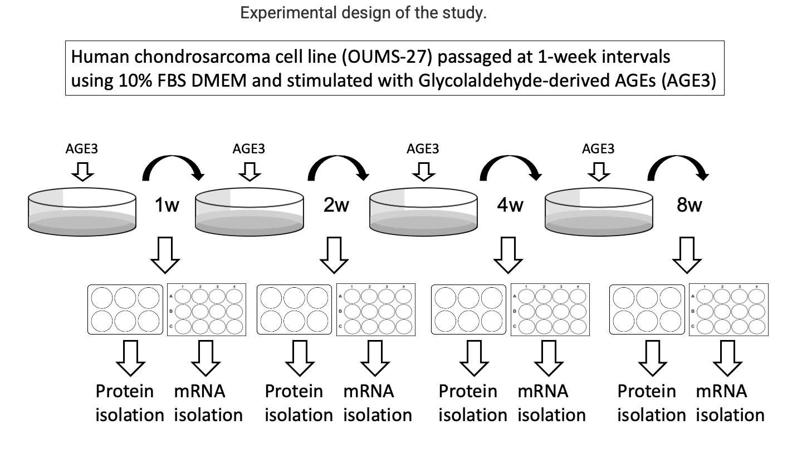
Online Resource 1
OUMS-27 cells were cultured in DMEM, with 10% FBS and 2.0 x 10⁵ OUMS-27 cells were seeded per well in 6-well tissue culture plates, followed by culture in the presence or absence of AGE3 for 7 days. Cells were passaged at 1-week intervals and used to isolate various proteins and mRNA for analysis. Isolated samples were stored at -80°C until use.

