Bacterial BEF relationships: degradation metabolic trade-offs with growth rate but not with nitrogen processing pathways
Teigen, Megan¹ and Cuellar-Gempeler, Catalina¹
¹ California Polytechnic State University, Humboldt, 1st Harpst Street, Arcata CA 95521.
Corresponding author:
Megan Teigen
Email: megan.b.teigen@gmail.com

Non-significant statistical data for monoculture degradation rate vs. function and mixed culture degradation rate vs. function are listed respectively (S1, S2).
Supplement 1. Monoculture degradation rate vs. function. Results of linear regression significance test of degradation rate compared with the specific nitrogen functions. Degrees of freedom for all tests were 26.
Functional Assay | R-squared | F-statistic | p-value
Bradford | -0.2247 | 0.4068 | 0.6322
Nitrate | -0.02918 | 0.2346 | 0.6322
Ammonia | -0.02518 | 0.3367 | 0.6322
Chitinase | 0.0303 | 1.844 | 0.6322
Protease | 0.1158 | 4.534 | 0.6322

Supplement 2. Mixed culture degradation rate vs. function. Results of linear regression significance test on mixed community group abundance at the end of the degradation compared with each functional assay. Degrees of freedom for all tests were 18. No significance results produced p > 0.05.
Functional Assay | R-squared | F-statistic | p-value
Bradford | -0.04253 | 0.2249 | 0.8756
Nitrate | 0.0006859 | 1.013 | 0.8756
Ammonia | -0.05381 | 0.02981 | 0.8756
Chitinase | -0.05408 | 0.0252 | 0.8756
Protease | -0.01312 | 0.754 | 0.8756

Analysis for complementarity, selection, and net effects were performed following Loreau and Hector, 2001 and Clark et. al. 2019. R package partitionBEFsp (Clark et. al. 2019) was used for analysis along with a linear regression model for statistical significance. While no statistical significance was observed (Supp 1), the complementarity effect had a slightly positive correlation with species richness (S3, S4).
Supplementary 3. Complementarity/Selection Test.
Results of linear regression significance test of effect measured against species richness. Degrees of freedom for all tests was 18. No values were significant.
Measure | R-squared | F-statistic | p-value
Complementarity | -0.03776 | 0.3086 | 0.5854
Selection | 0.0319 | 1.626 | 0.2185
Net Effect | -0.01424 | 0.7333 | 0.4031

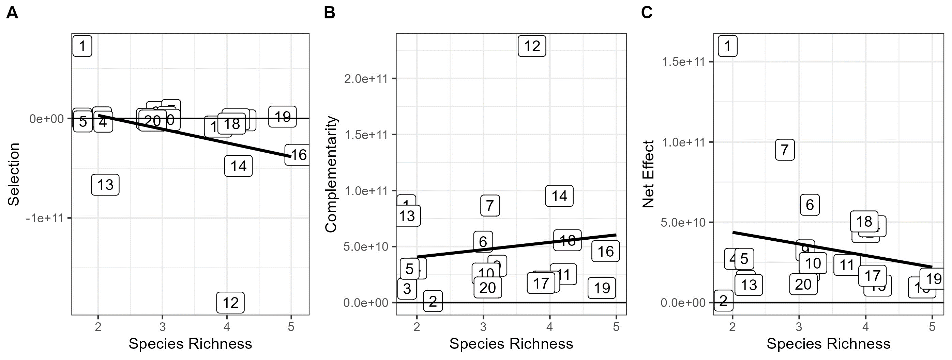
Supplementary 4. Selection, Complementarity, and Net Effects on Species Richness. No significant correlation was observed. Numbers match groups from Table 2. Black angled lines represent the best fit line for the linear regression model.

