Supplementary Material

Spatiotemporal Dynamics and Exposure Analysis of Daily PM2.5 using a Remote Sensing-Based Machine Learning Model and Multi-time Meteorological Parameters
Binjie Chen ¹, Yi lin ², Jinsong Deng ¹*, Zheyu Li ³, Li Dong ¹, Yibo Huang ¹, Ke Wang ¹, Wu Yang ¹
¹College of Environment and Resource Sciences, Zhejiang University, Hangzhou 310058, China
²Department of Geography, University of Hong Kong, Hongkong, 999077, China
³Eleanor Roosevelt College, University of California-San Diego, La Jolla, CA, 92093, USA
* Correspondence: jsong_deng@zju.edu.cn

Number of Pages: 8
Number of Figures: 4
Number of Tables: 2

Statistical Metrics
Coefficient of determination (R²), root mean square error (RMSE), and mean absolute error (MAE) are utilized to quantitatively assess the performance of our proposed models. The specific formulas of above statistical metrics are as follows (1) - (3):
$R^{2}=1- \frac{\sum_{i=1}^{n}{{(y_{i}^{Measured}-y_{i}^{Estimated})}^{2}}}{\sum_{i=1}^{n}{{(y_{i}^{Measured}-\overline{y^{Estimated}})}^{2}}}$ | (1)
$RMSE=\sqrt{\frac{1}{n}\sum_{i=1}^{n}{{(y_{i}^{Measured}-y_{i}^{Estimated})}^{2}}}$ | (2)
$MAE= \frac{1}{n}\sum_{i=1}^{n}{\left|y_{i}^{Measured}-y_{i}^{Estimated}\right|}$ | (3)
Where n represents the total number of estimating records, $y_{i}^{Measured}$ represents the i^{th} record of ground-measured PM_{2.5} concentrations, $y_{i}^{Estimated}$ represents the i^{th} record of model-estimated PM_{2.5} concentrations, $\overline{y^{Estimated}}$ represents the mean of the total model-estimated PM_{2.5} concentrations.

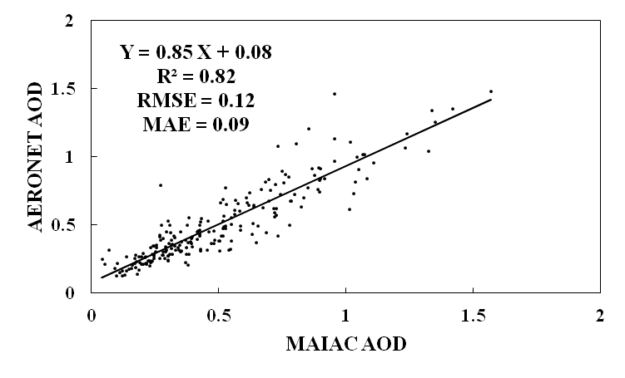
Figure S1. Scatter plots of the MAIAC AOD and AERONET AOD.

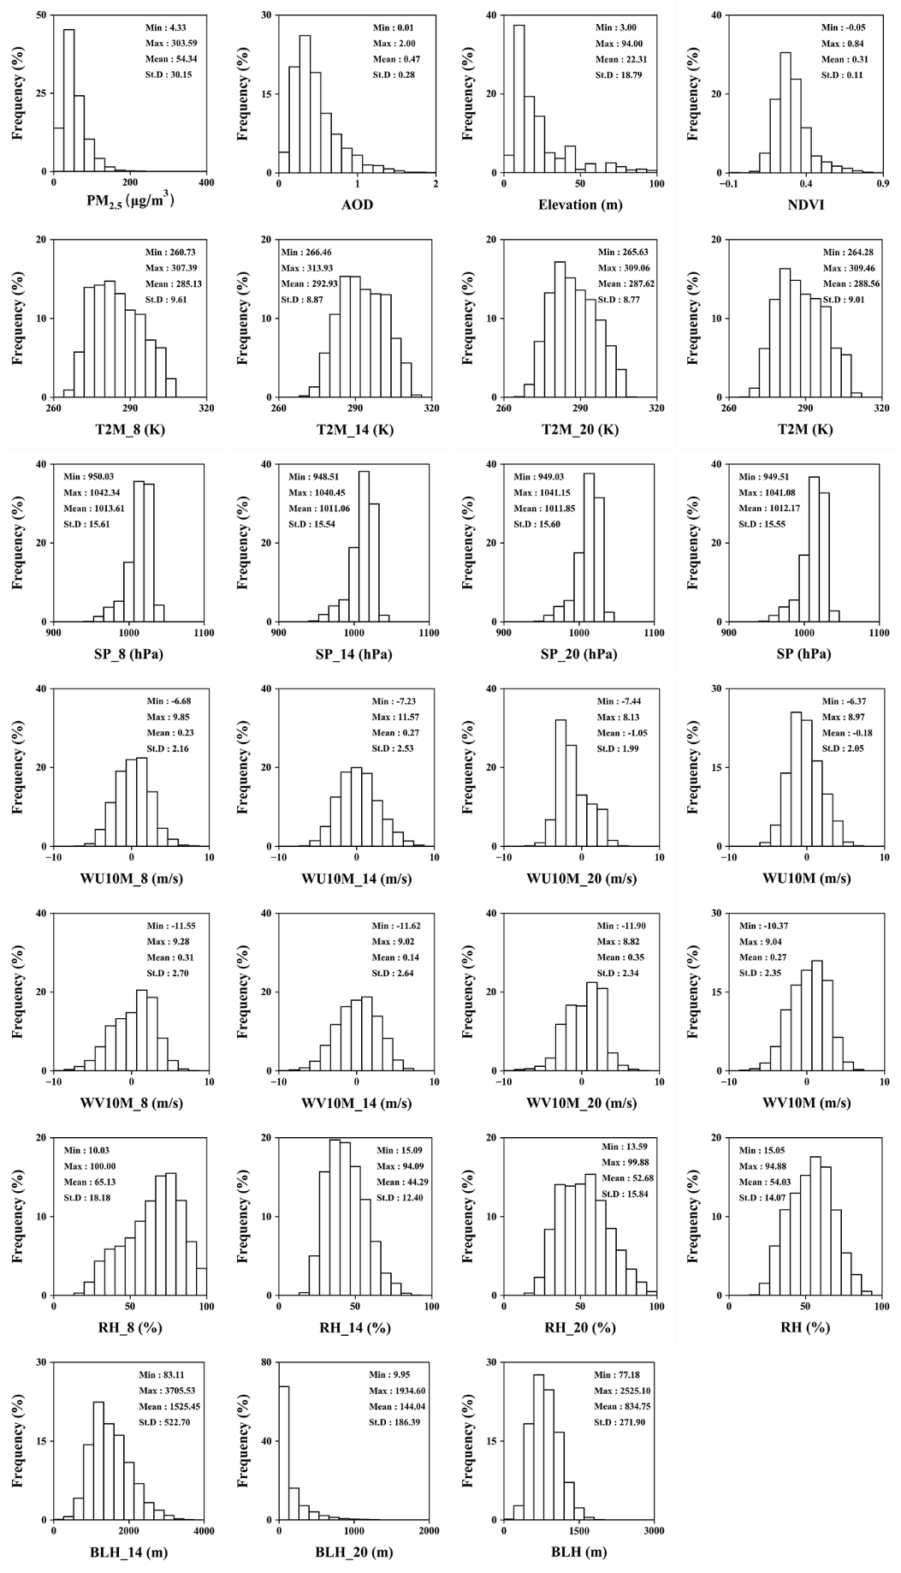
Figure S2. Histogram and the descriptive statistics (minimum, maximum, mean and standard deviation) of the dependent and independent variables included in model. Meteorological fields with suffix of 8, 14, and 20 represent the meteorological conditions at the local time of 08:00, 14:00, and 20:00. Meteorological fields with no suffix represent the daily mean meteorological conditions.
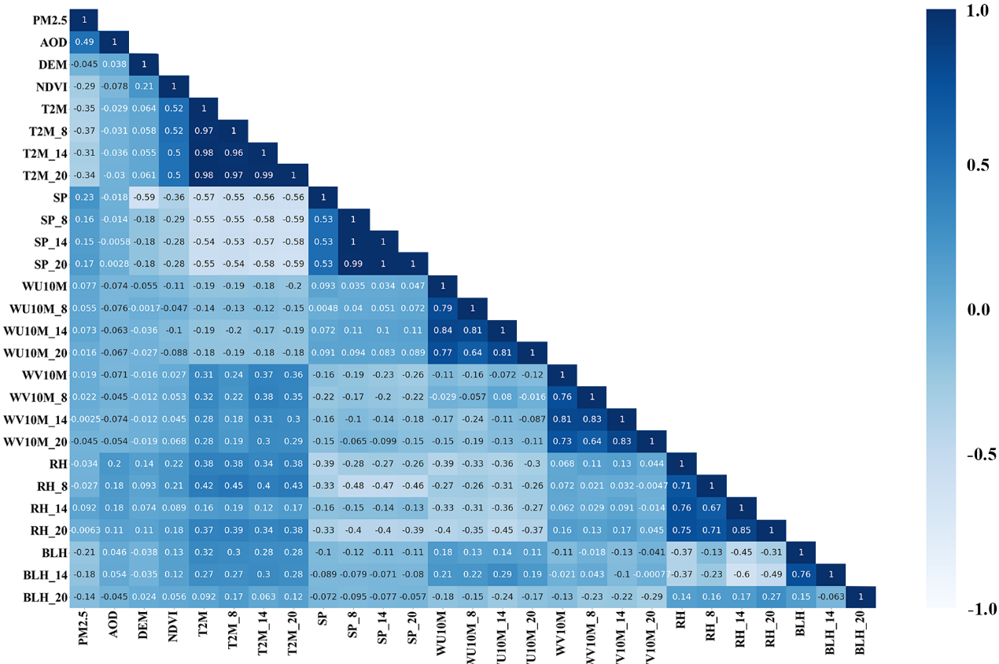
Figure S3. Matrix of Pearson correlation coefficients between variables, the darker blue indicating the greater positive correlation while the lighter indicating the greater negative correlation.
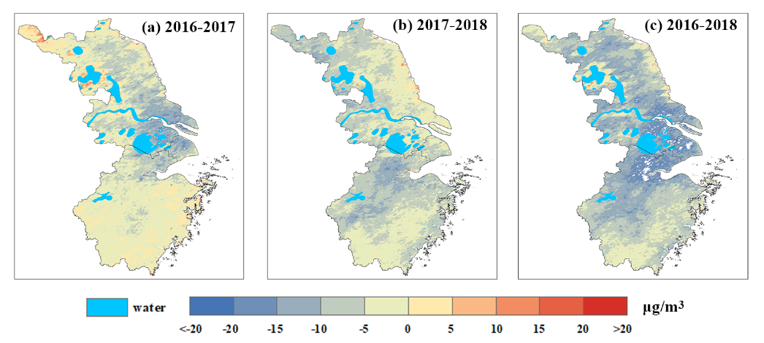
Figure S4. Yearly changes of estimated PM_{2.5} concentration distributions. The red color represents PM_{2.5} concentrations increasing, and the blue color represents PM_{2.5} concentrations decreasing. (a), (b), (c) are the changes between 2016 and 2017, 2017 and 2018, 2016 and 2018, respectively.

Table S1. Detail information of used AERONET sites
AERONET site | Longitude (°) | Latitude (°) | Elevation (m)
SONET_Nanjing | 118.957 | 32.115 | 52
SONET_Shanghai | 121.481 | 31.284 | 84
Taihu | 120.215 | 31.421 | 20
XuZhou-CUMT | 117.142 | 34.217 | 59

Table S2. Detail description of the data.
Product | Variable | Unit | Spatial Resolution | Temporal Resolution | Source
PM_{2.5} | PM_{2.5} | ug/m³ | - | Hourly | CNEMC, http://www.cnemc.cn/
MCD19A2 | MAIAC AOD | - | 1km | Daily | NASA, https://ladsweb.modaps.eosdis.nasa.gov/
MOD13A3 | NDVI | - | 1km | Monthly | NASA, https://ladsweb.modaps.eosdis.nasa.gov/
ASTER GDEM V1 | DEM | m | 30m | - | GSCloud, http://www.gscloud.cn
Landscan | Population | million | 1km | - | ORNL, https://landscan.ornl.gov/landscan-datasets
ERA-Interim | 2-meter Temperature | K | 0.125° | 6-hour | ECMWF, http://www.ecmwf.int/
ERA-Interim | Surface Pressure | hPa | 0.125° | 6-hour | ECMWF, http://www.ecmwf.int/
ERA-Interim | 10-meter U-Wind Component | m/s | 0.125° | 6-hour | ECMWF, http://www.ecmwf.int/
ERA-Interim | 10-meter V-Wind Component | m/s | 0.125° | 6-hour | ECMWF, http://www.ecmwf.int/
ERA-Interim | Boundary Layer Height | m | 0.125° | 6-hour | ECMWF, http://www.ecmwf.int/
ERA-Interim | Relative Humidity | % | 0.125° | 6-hour | ECMWF, http://www.ecmwf.int/

