SUPPORTING INFORMATION

Cyrene as Solvent for Nanoparticles Synthesis

Ashkan Yazdanshenas, Jiaying Bi, Hannah Lacey, Devin J. Boski, Oscar J. Moreno Piza, Christian C. Sanchez Sierra, Emil A. Hernandez-Pagan
Department of Chemistry and Biochemistry, University of Delaware, Newark, Delaware, 19716, USA.
Email: emilhp@udel.edu

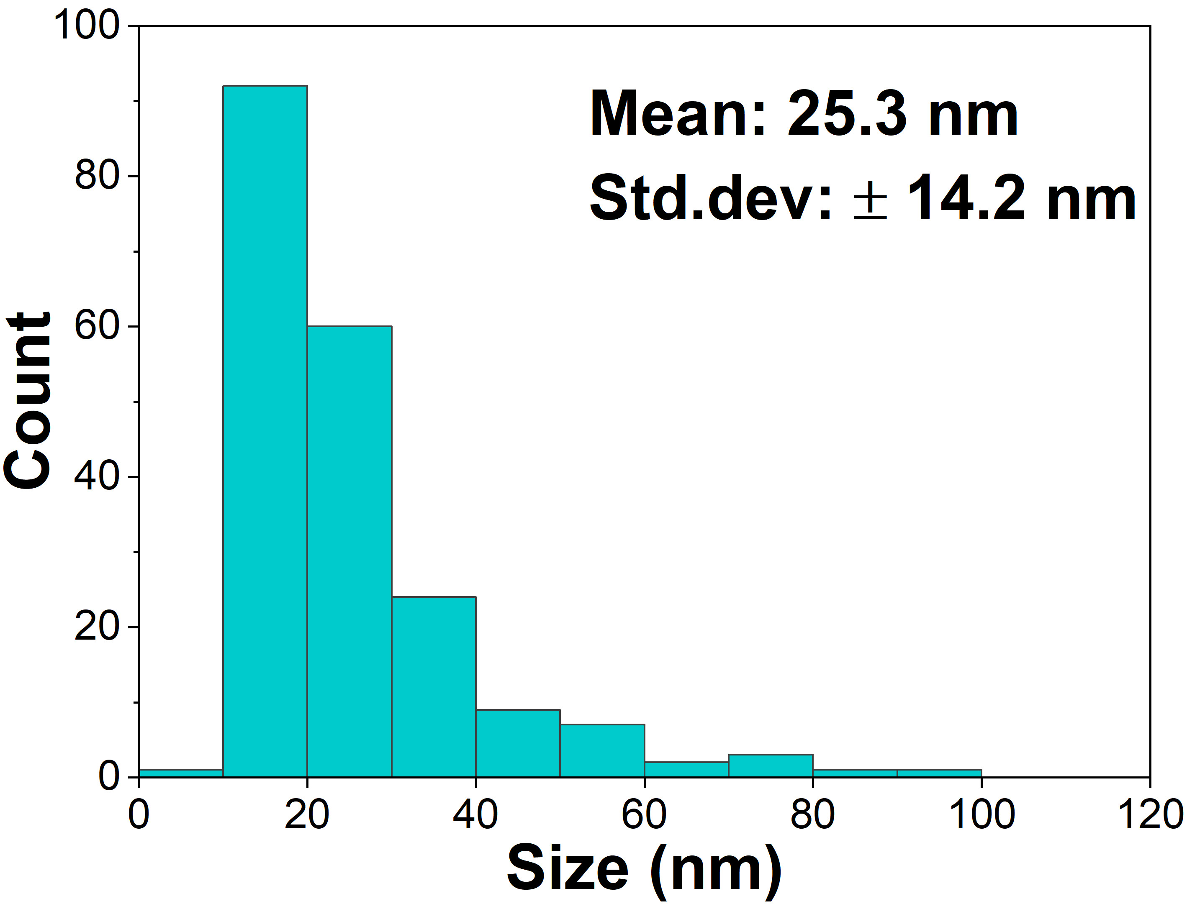
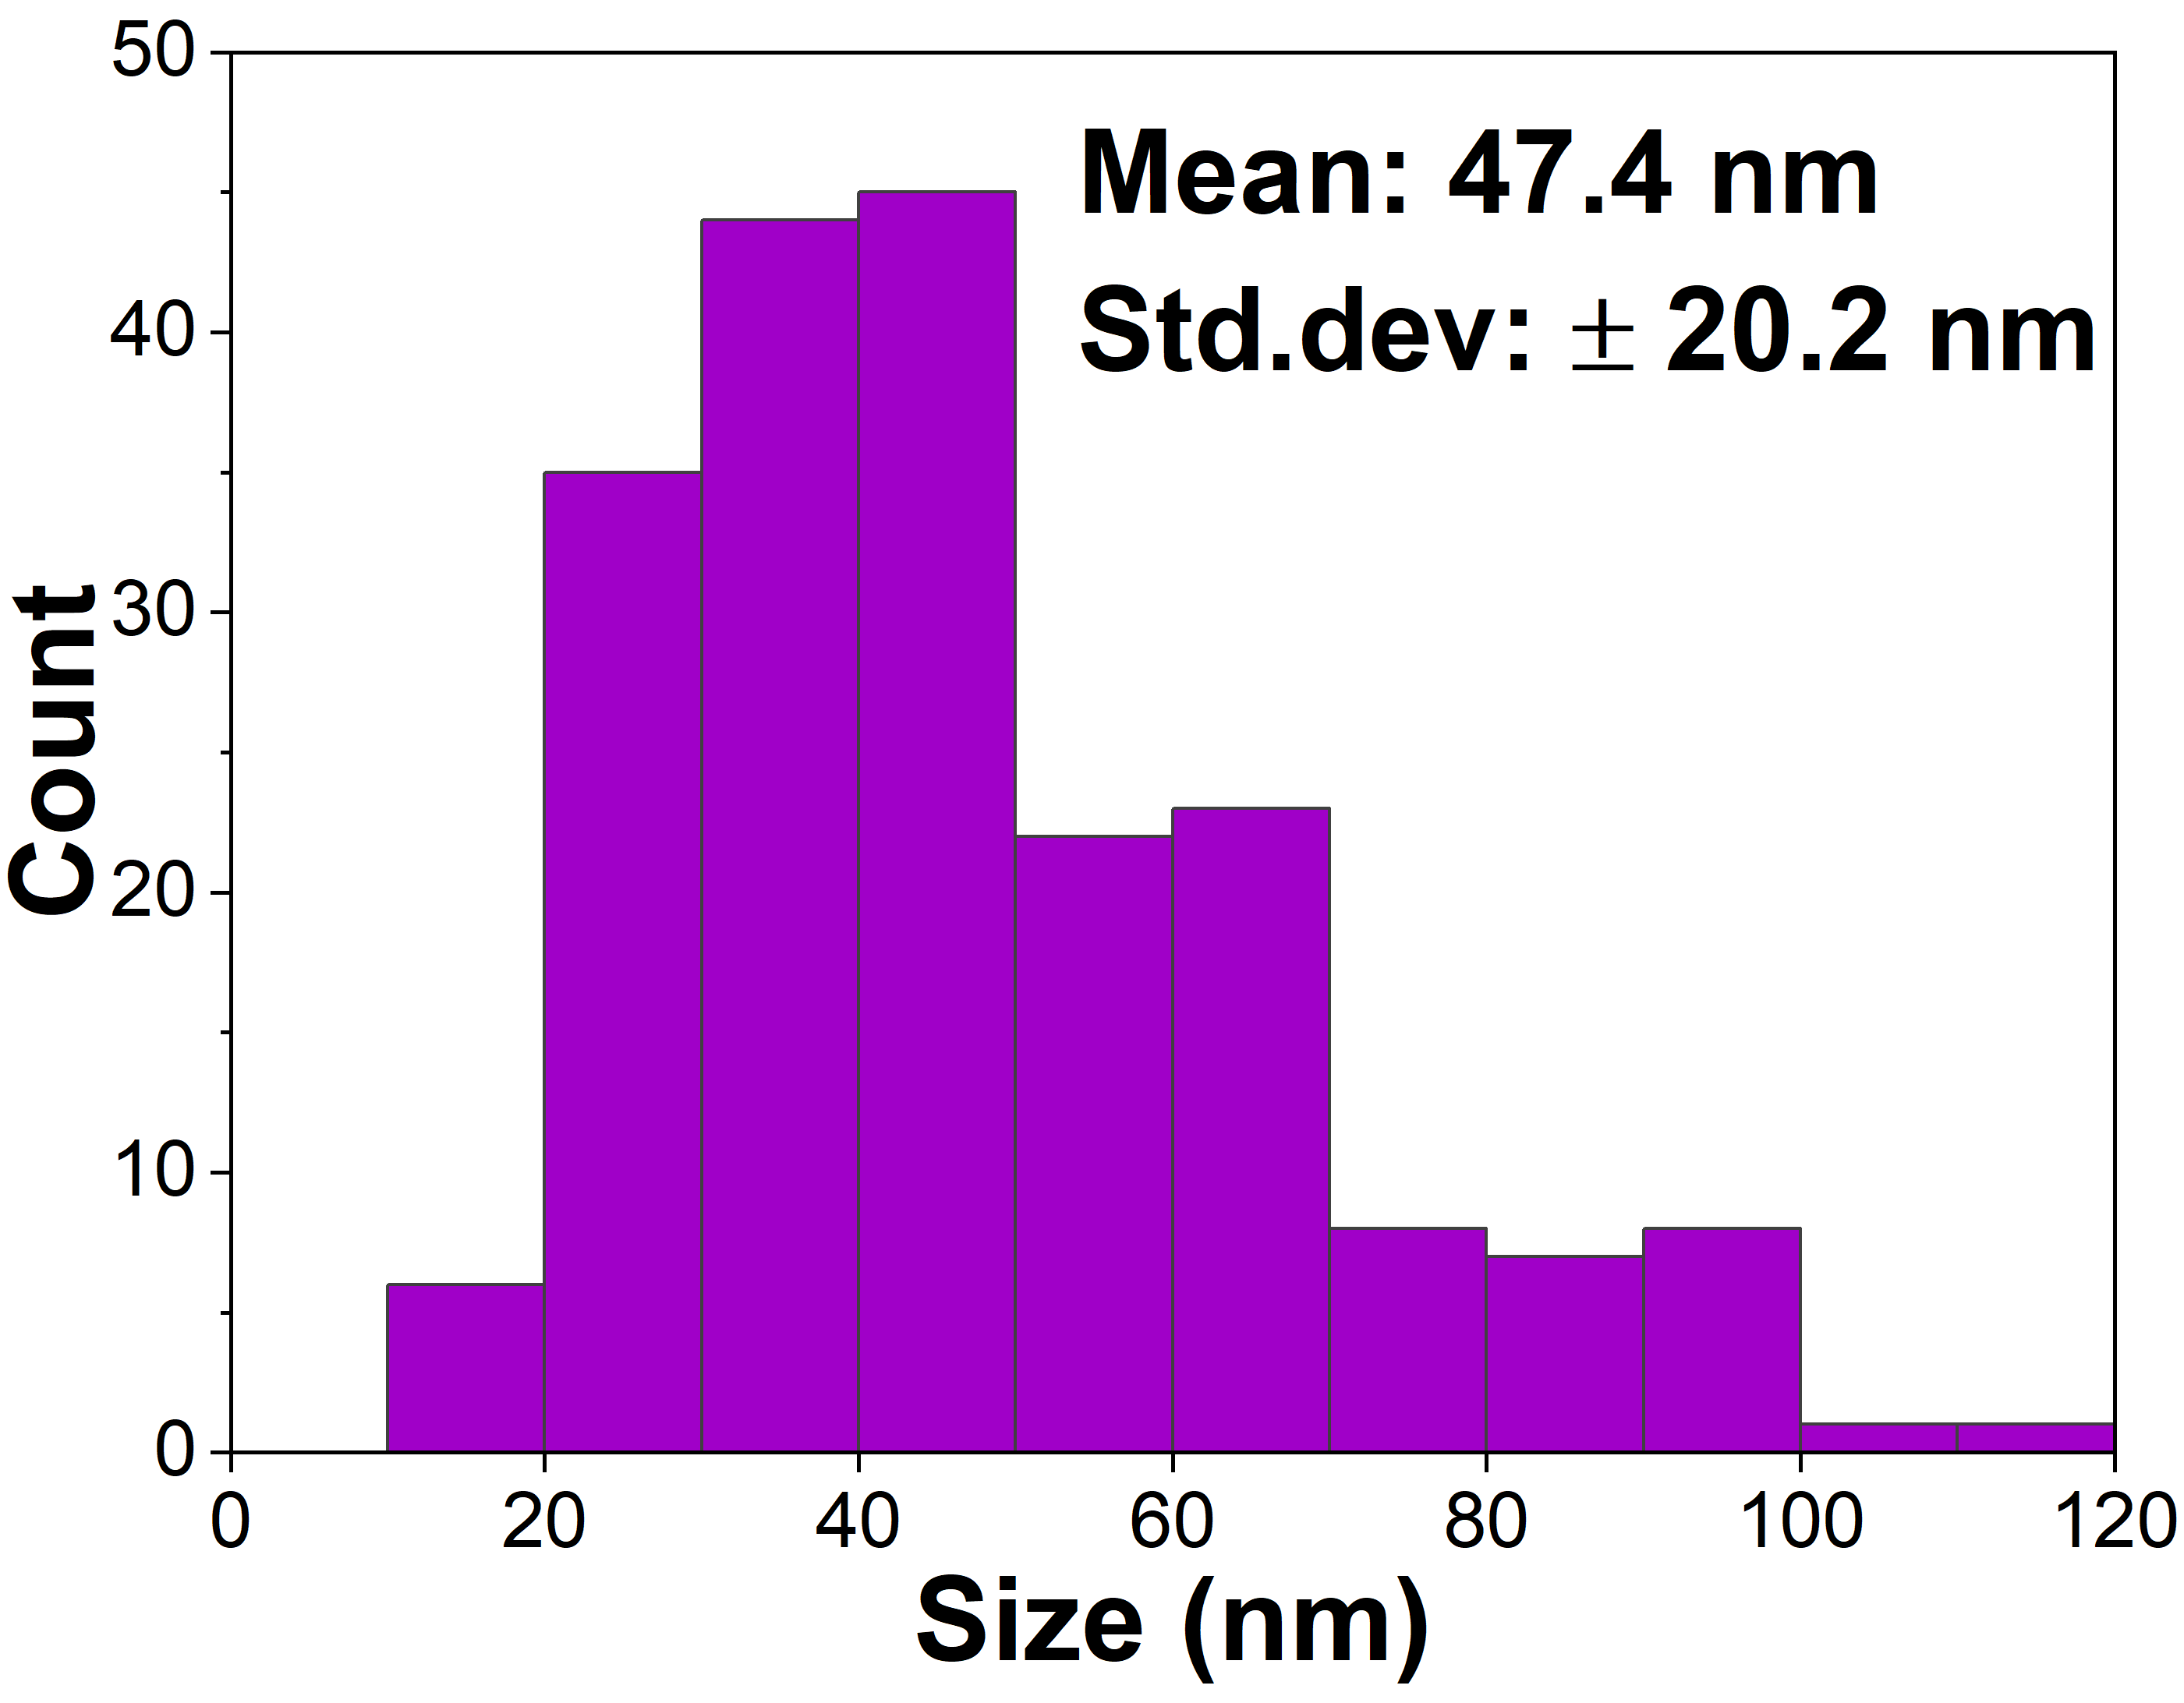

Figure SI1. Histogram of the nanoparticles distribution for reactions with a) AgF and b) Ag(OAc) precursors.

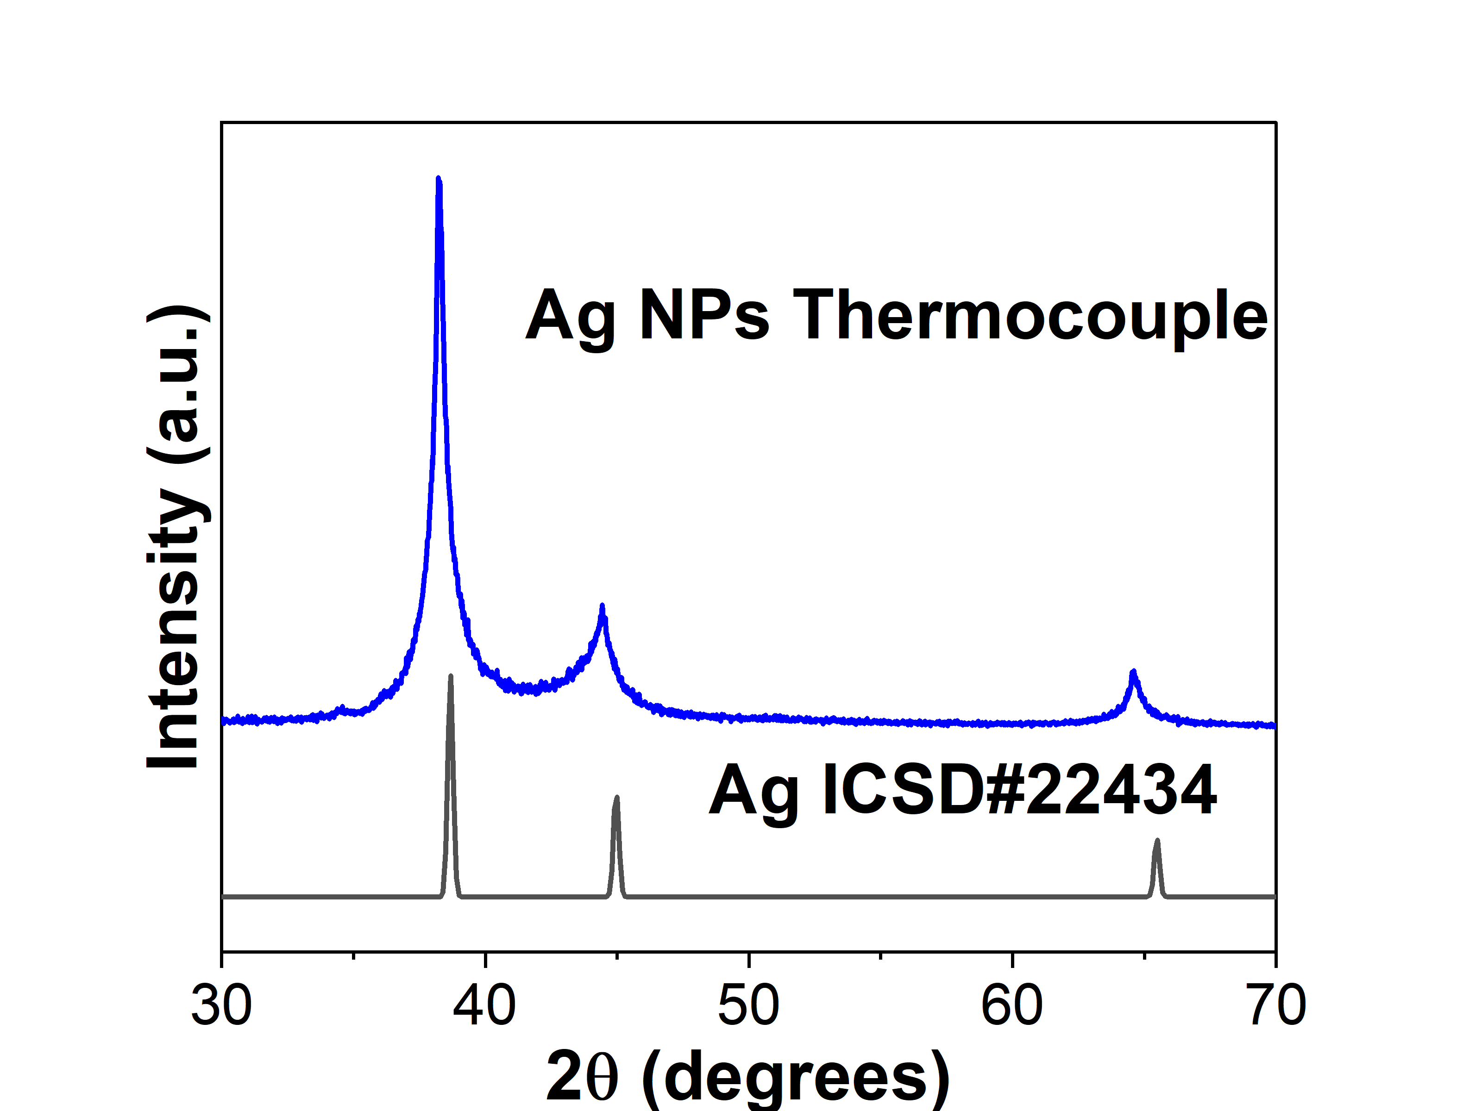
Figure SI2. PXRD of the control reaction with the thermocouple covered by the NMR tube to eliminate the possibility of it acting as a reducing agent.

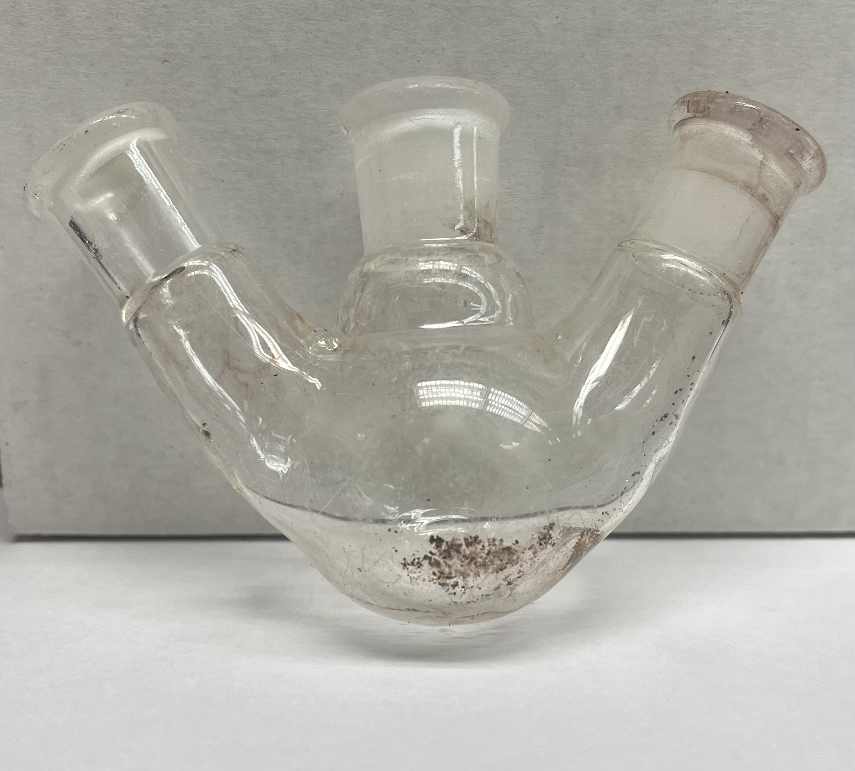
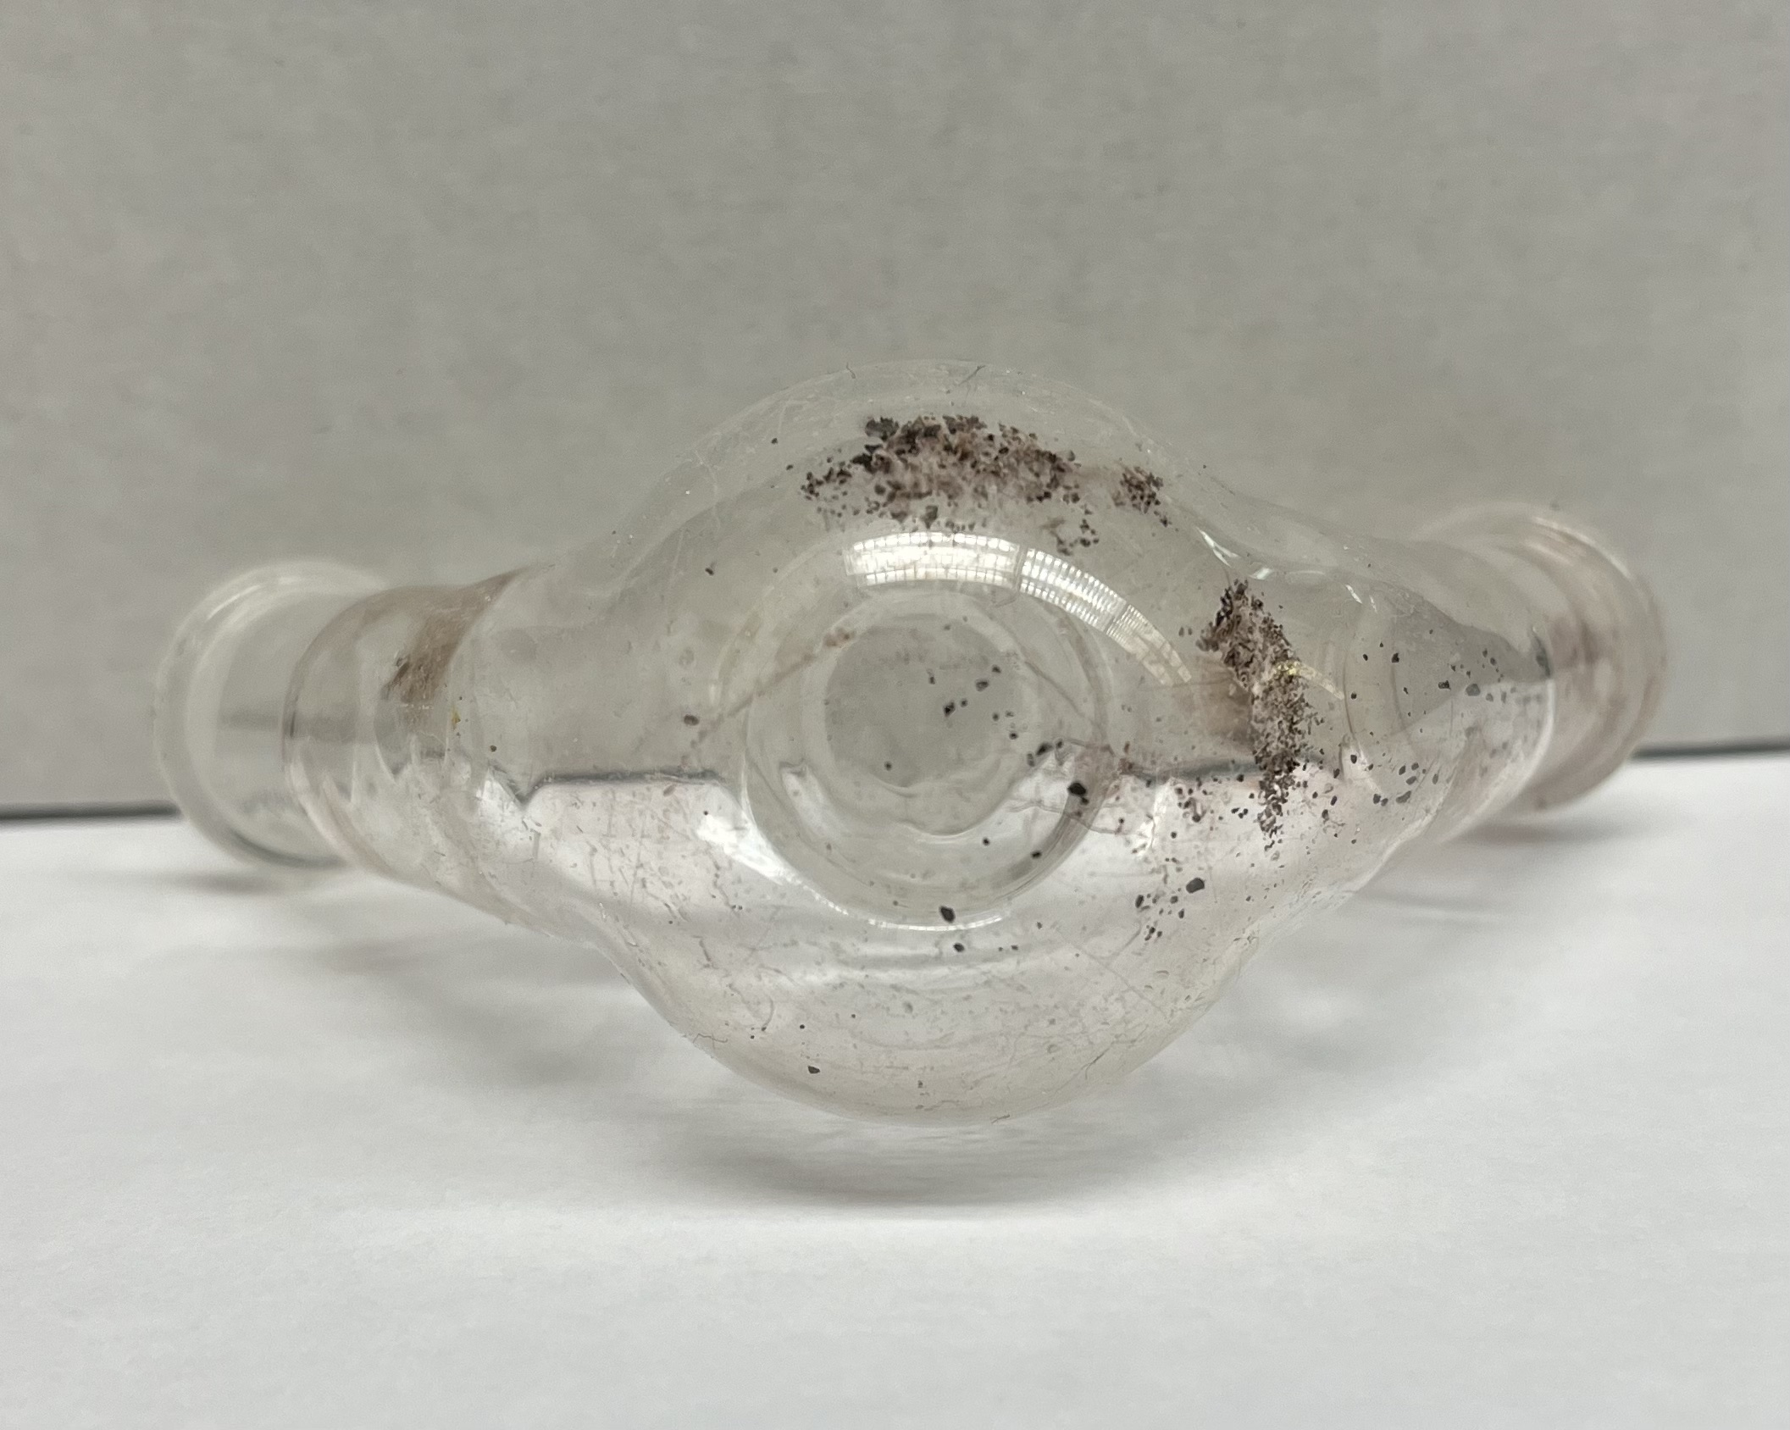

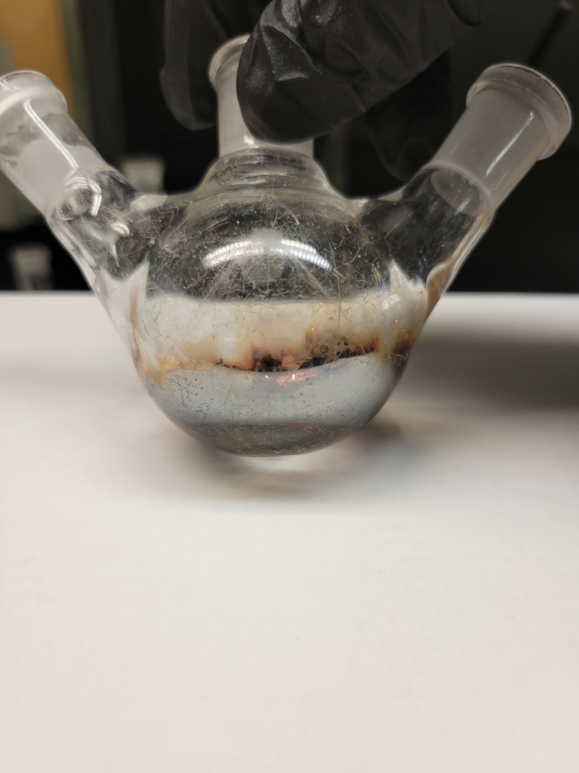
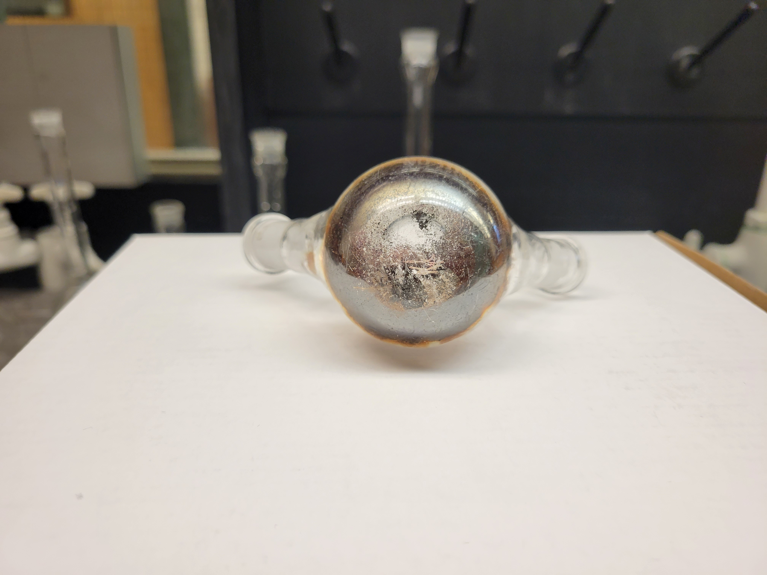

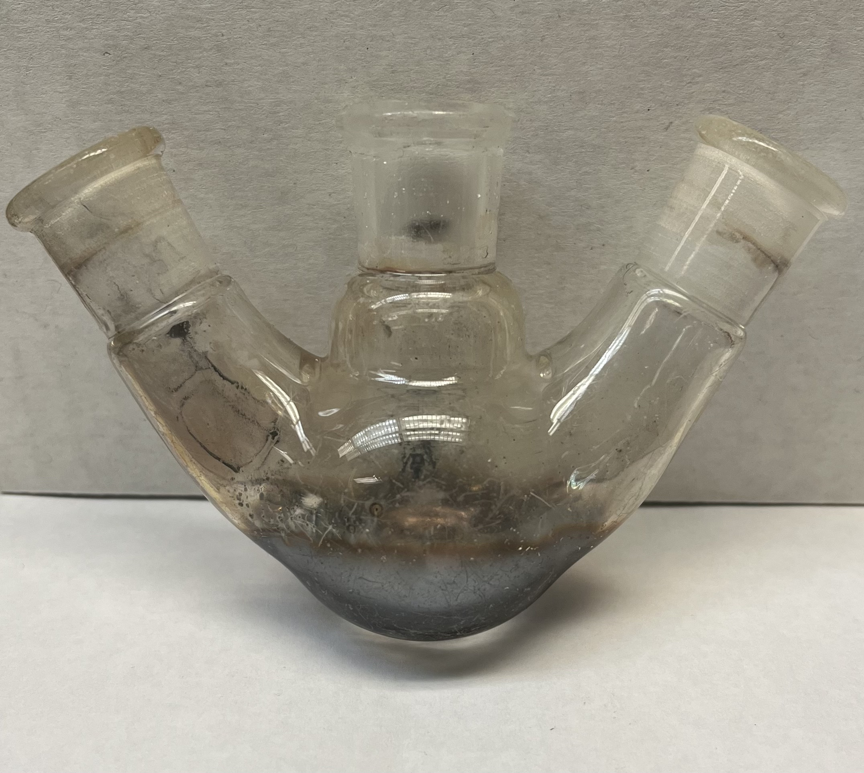
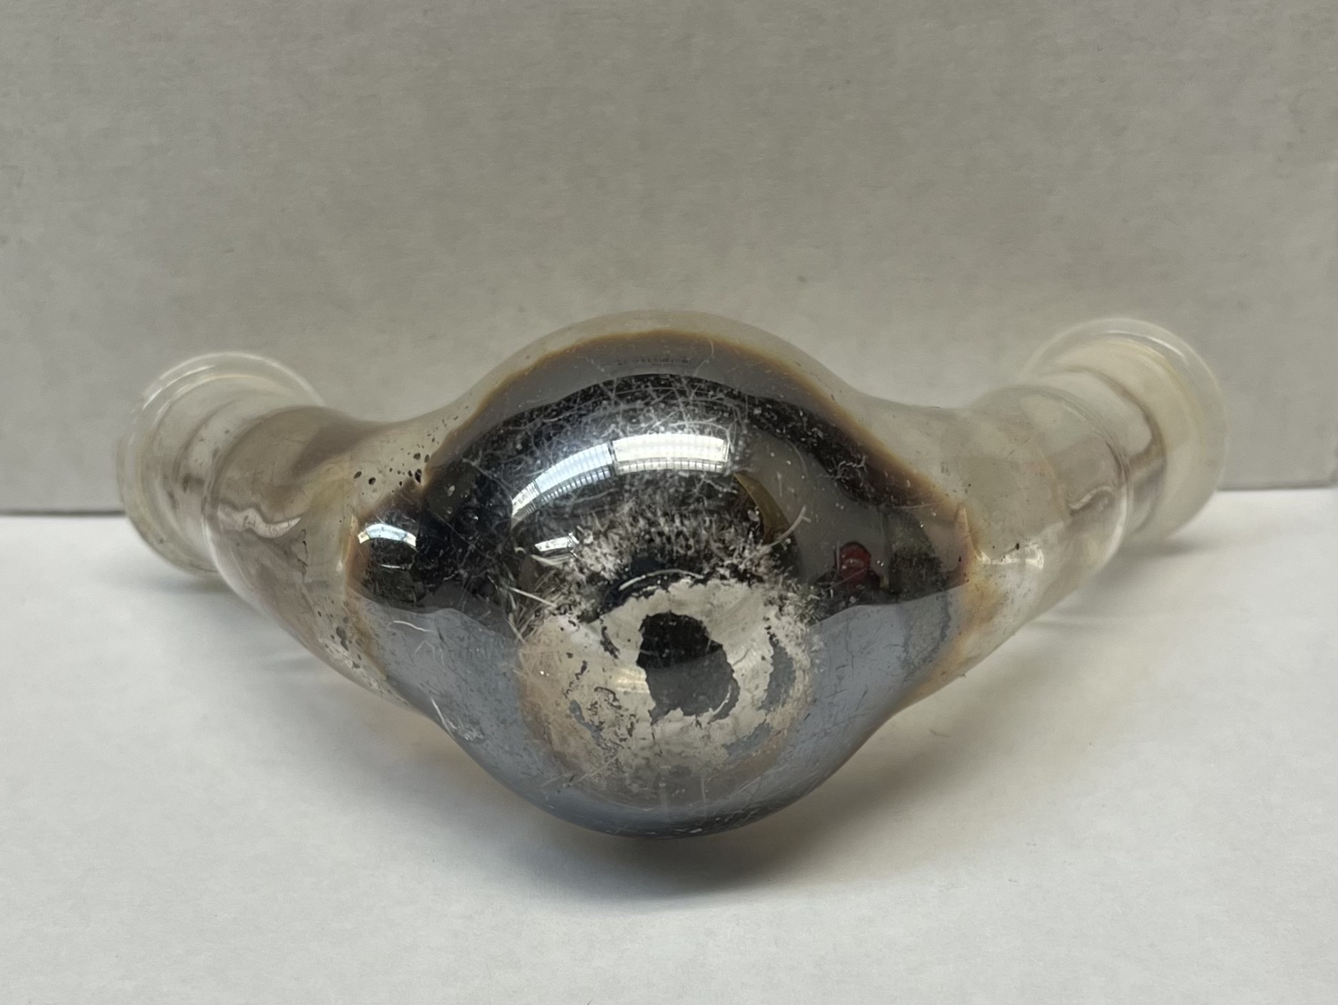

Figure SI3. Formation of silver mirror in the bottom of the flask during an inert reaction condition is an indication for the presence of aldehyde, similar to that in Tollen’s test.

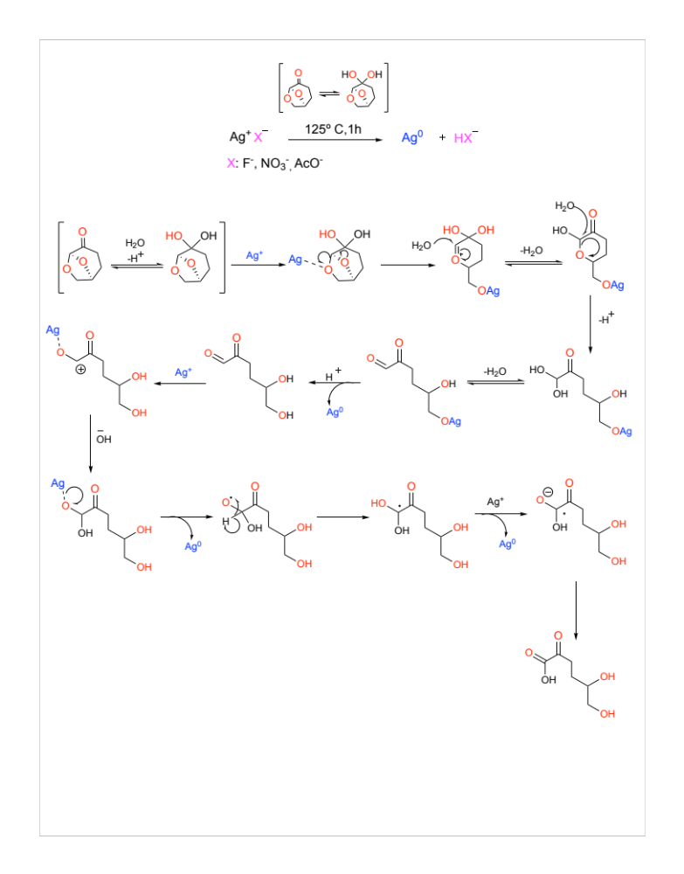
Scheme SI1. Proposed mechanism of Cyrene as a reducing agent

When the synthesis is performed without any PVP ligand, the formation of Ag NPs is accompanied by formation a silver mirror on the walls of the flask. Based on this observation, scheme S1 depicts a possible mechanism that begins with the equilibrium of Cyrene and its geminal diol due to moisture¹ and water from the non-anhydrous salts. Subsequently, Ag⁺ is coordinated with the oxygen of the acetal causing the opening of the bicyclic to generate a highly electrophilic pyran ring. The nucleophilic attack of two water molecules can then lead to the formation of an α-hydroxyketone, which is in equilibrium with the respective glyoxal. A second Ag⁺ can coordinate with the oxygen of the aldehyde causing activation of the carbonyl group, which undergoes a nucleophilic attack by the OH⁻ ion forming a radical cation. The migration of hydrogen generates a gem-diol intermediate, which continues to oxidize until the formation of the carboxylic acid.

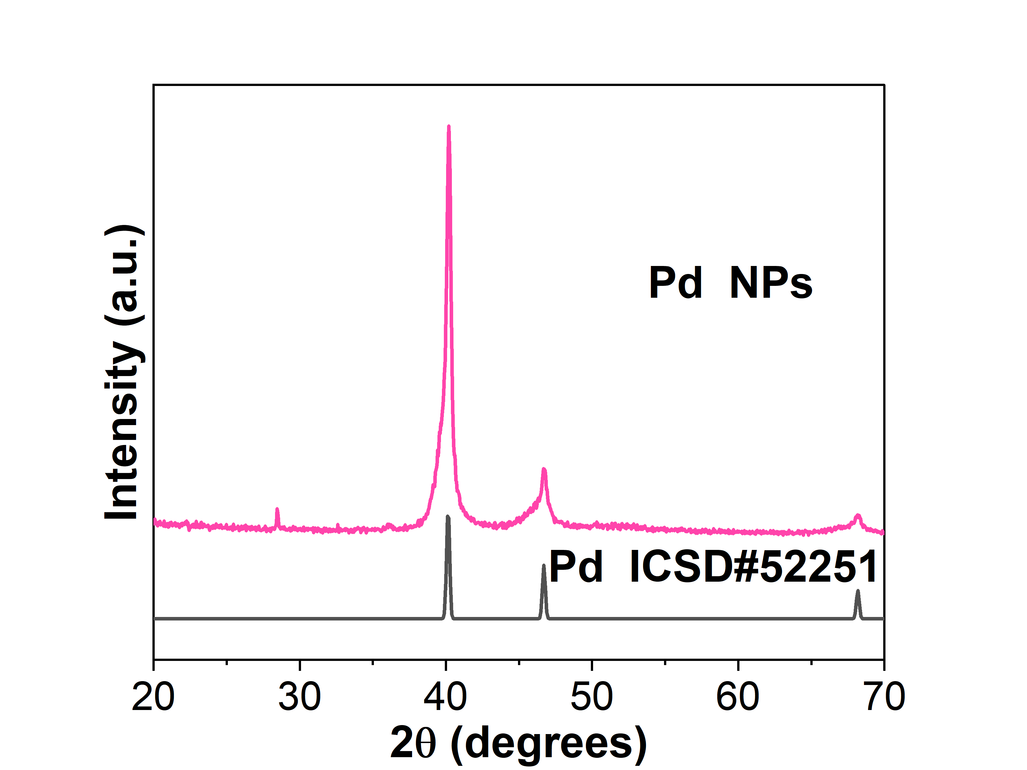
Figure SI4. PXRD of the Pd NPs synthesized using K₂PdCl₄ salt from 2$θ$ of 20-70 degrees demonstrating the extra peak around 28 degrees possibly related to unreacted precursor.

(1) De bruyn, M.; Fan, J.; Budarin, V. L.; Macquarrie, D. J.; Gomez, L. D.; Simister, R.; Farmer, T. J.; Raverty, W. D.; McQueen-Mason, S. J.; Clark, J. H. A New Perspective in Bio-Refining: Levoglucosenone and Cleaner Lignin from Waste Biorefinery Hydrolysis Lignin by Selective Conversion of Residual Saccharides. Energy Environ. Sci. 2016, 9 (8), 2571–2574. https://doi.org/10.1039/C6EE01352J.

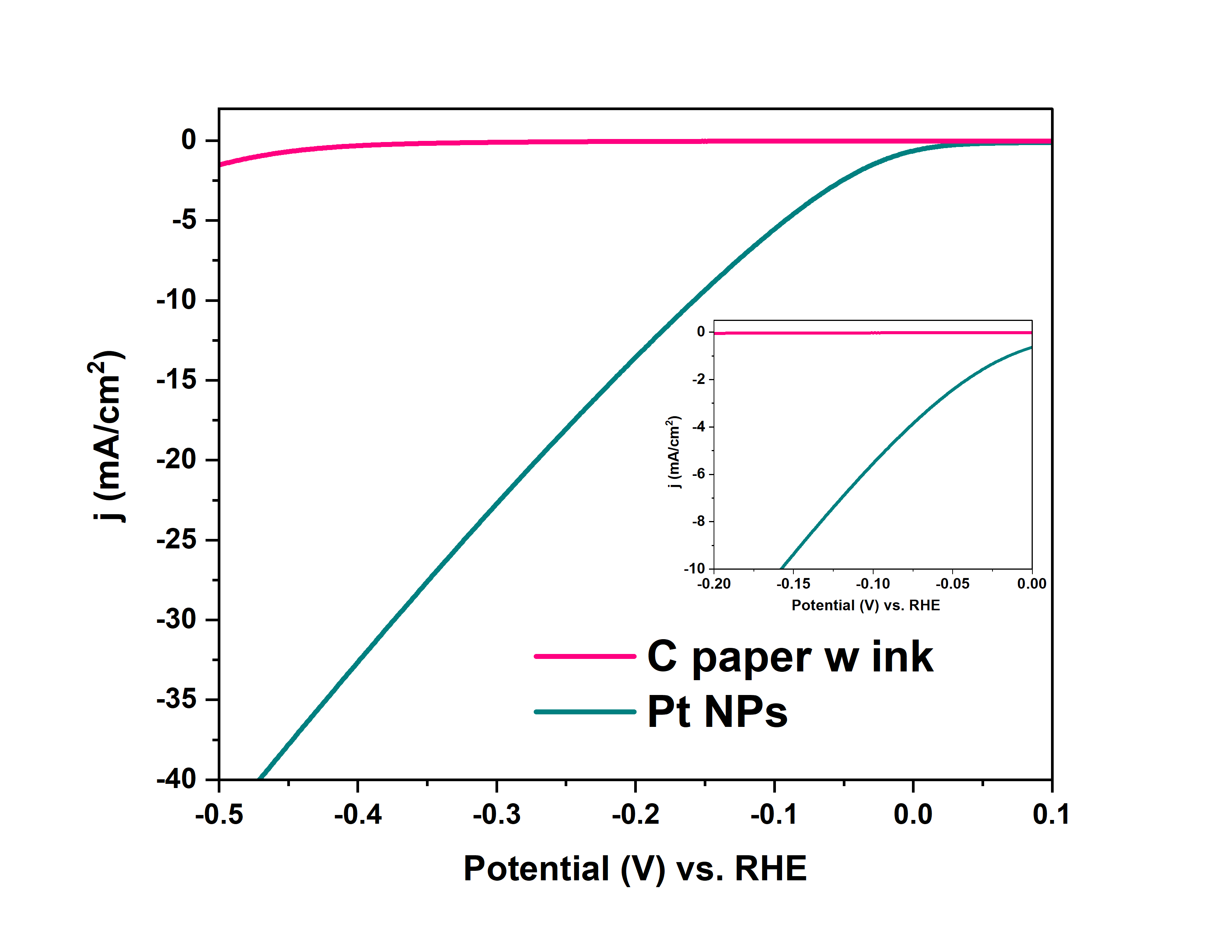
Figure SI5. Linear Sweep Voltammograms of the control, Carbon paper with nanoparticles-free ink (pink), Ag NPs (blue), and Pt NPs (cyan) using a scan rate of 50 mV.

