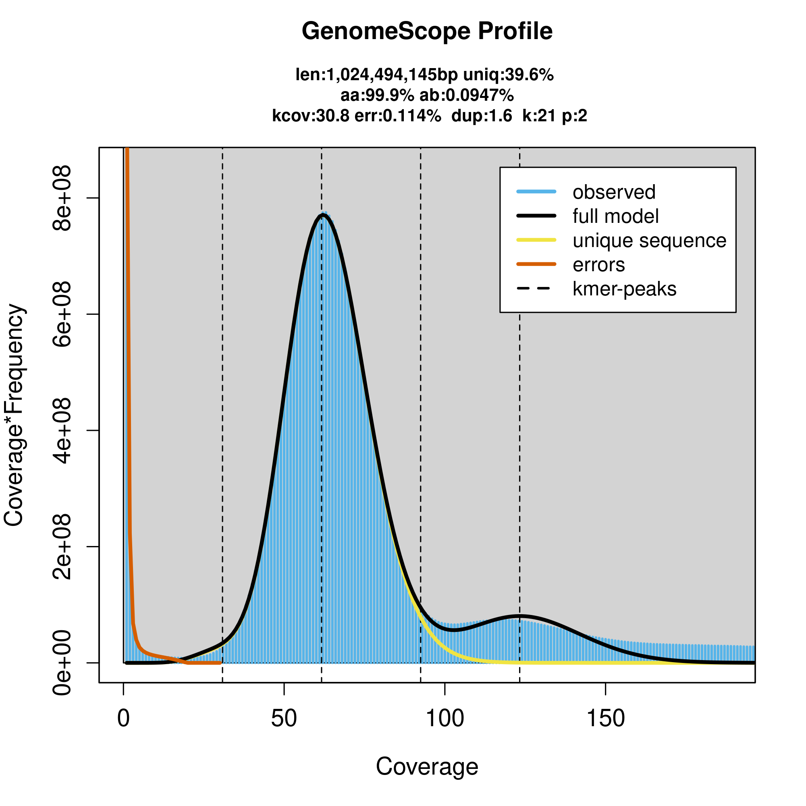

Supplementary Figure S1. k-mer (17 k-mer) distribution and estimation of genome size and heterozygosity of L. luteus.

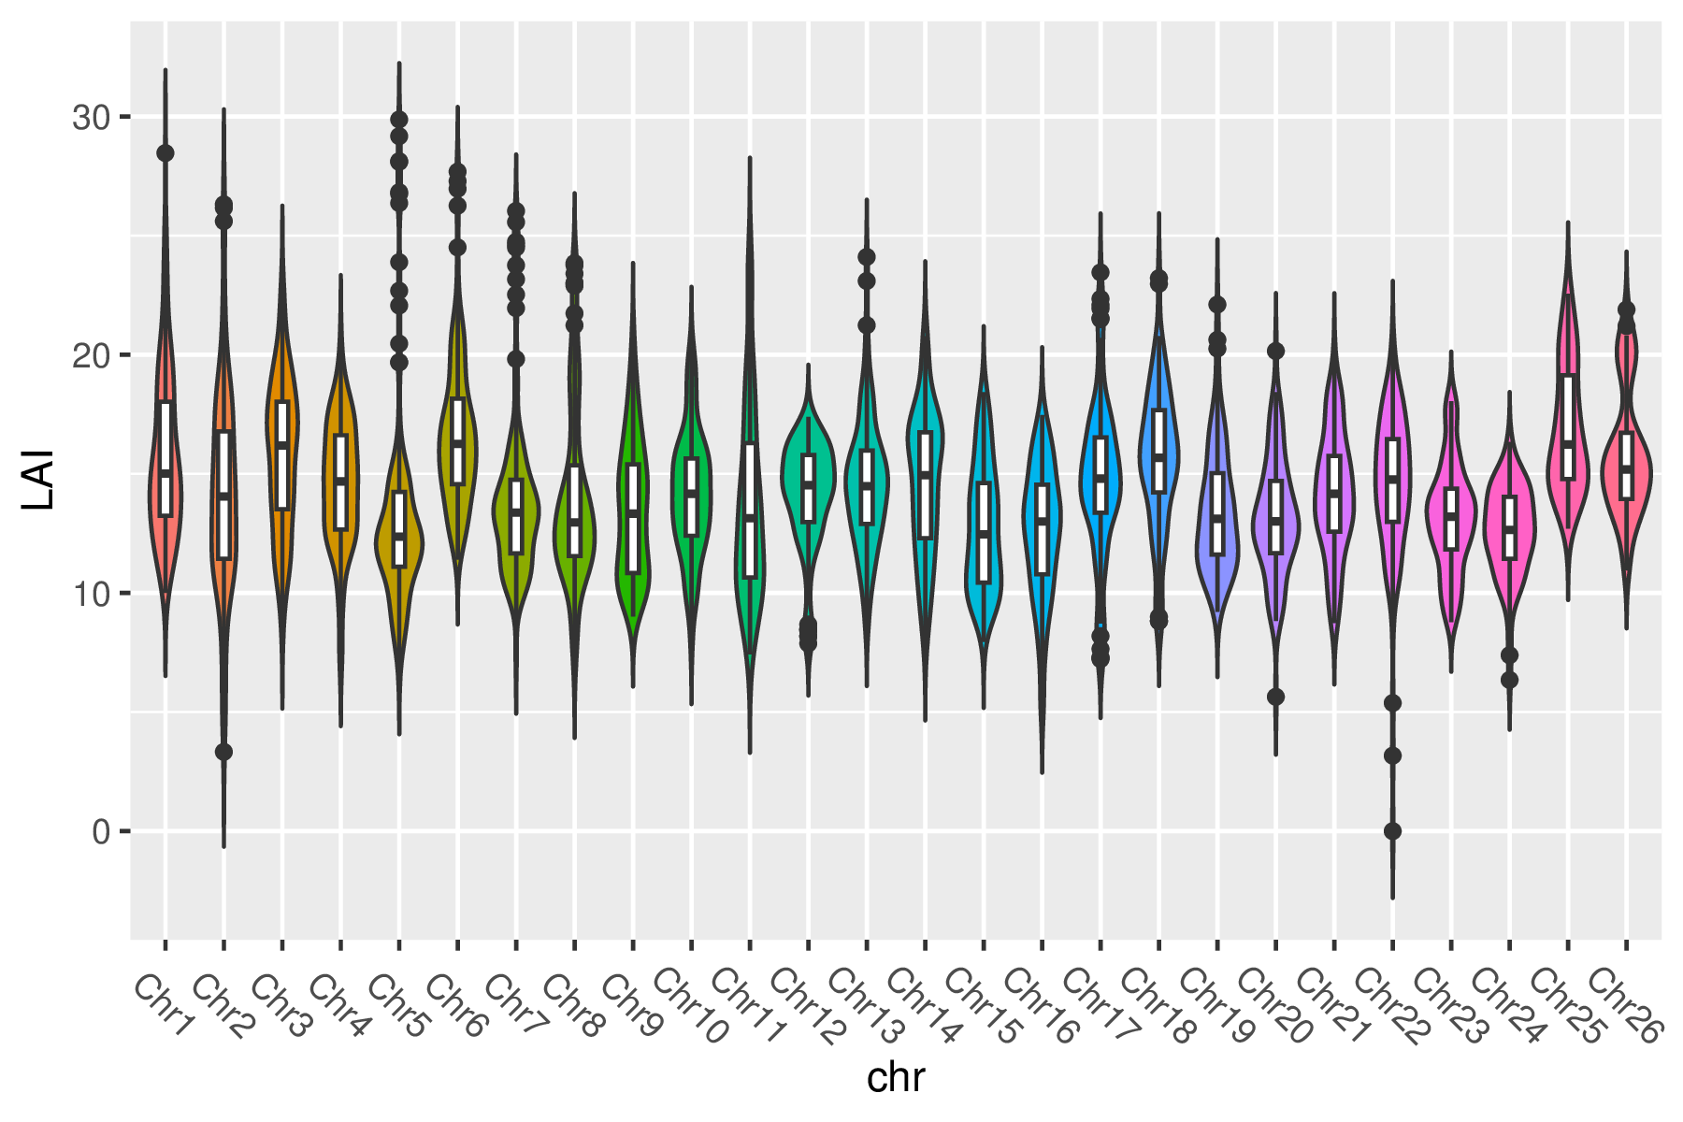
Supplementary Figure S2. LAI index of the 26 yellow lupin chromosomes.

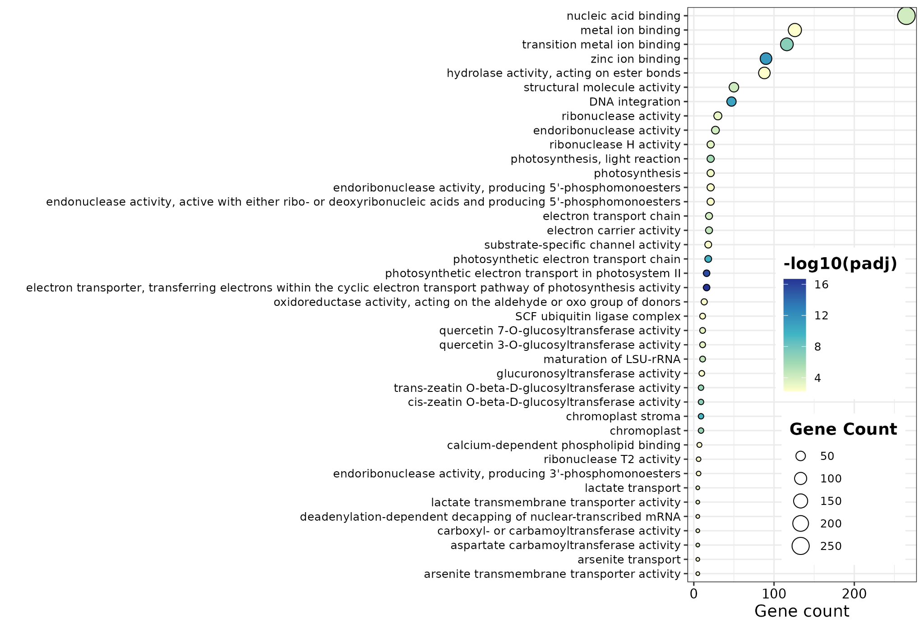
Supplementary Figure S3. GO enrichment analysis for the Top 40 yellow lupin-specific gene families. More detail of enriched terms in Supplementary Table S14

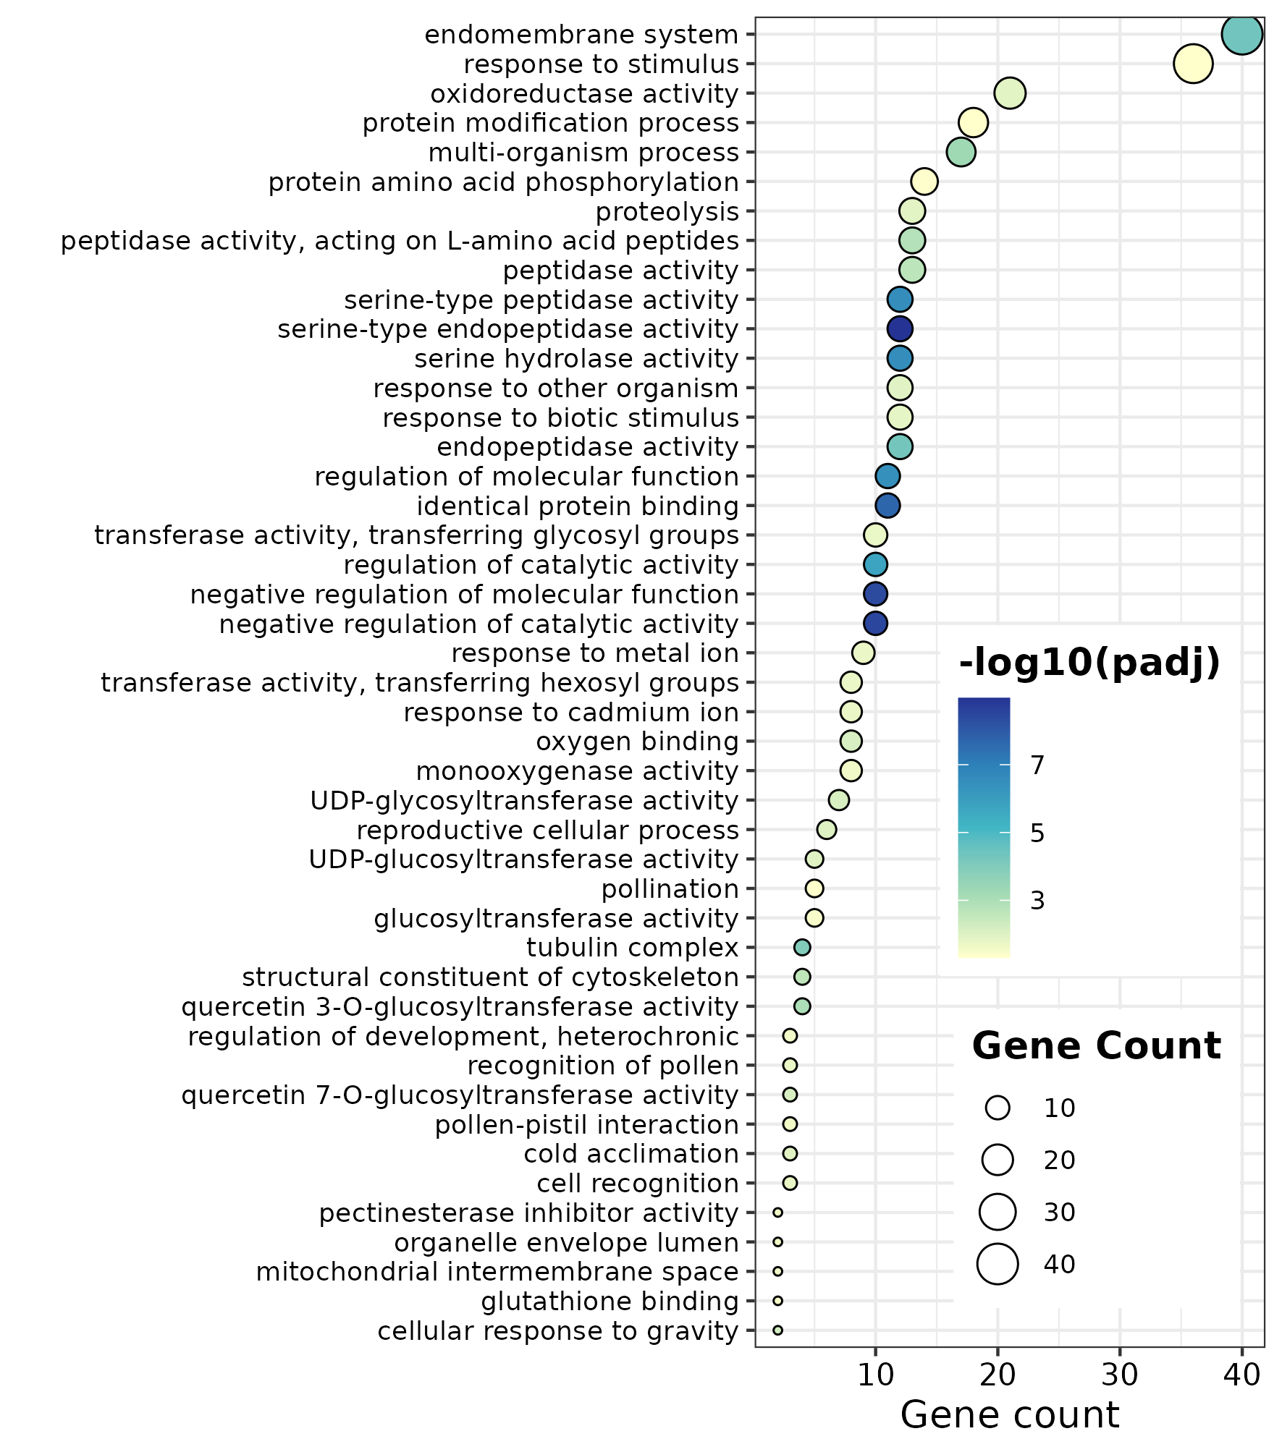
Supplementary Figure S4. GO enrichment analysis of contracted gene families
in Lupinus luteus.

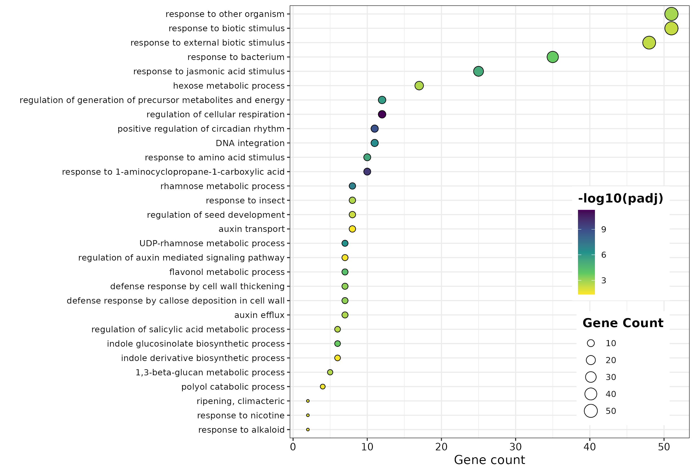
Supplementary Figure S5. GO enrichment analysis of unique gene families
in Lupinus luteus in comparative genomics analysis between Lupinus species.

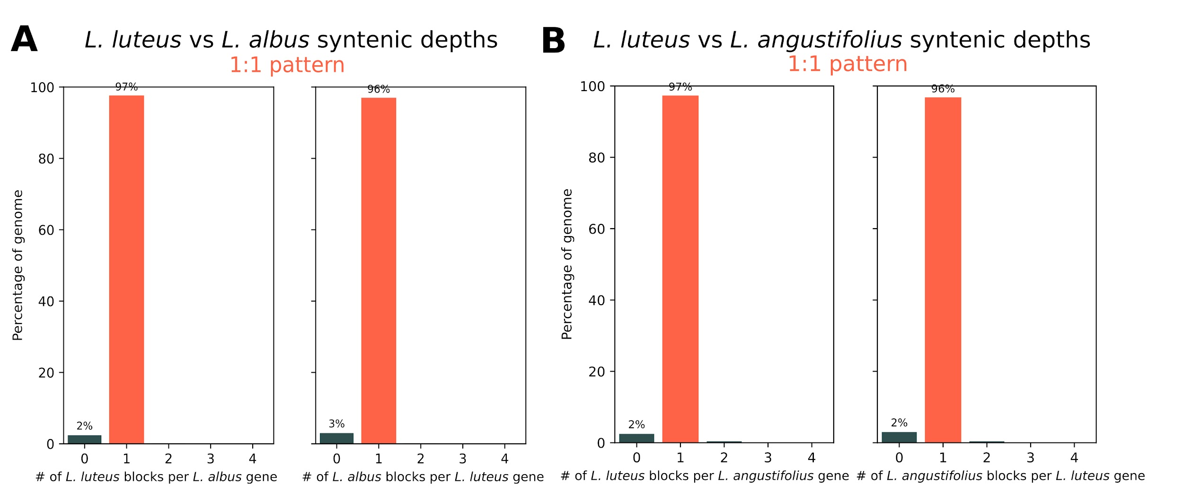Supplementary Figure S6. Synteny depth between lupins.

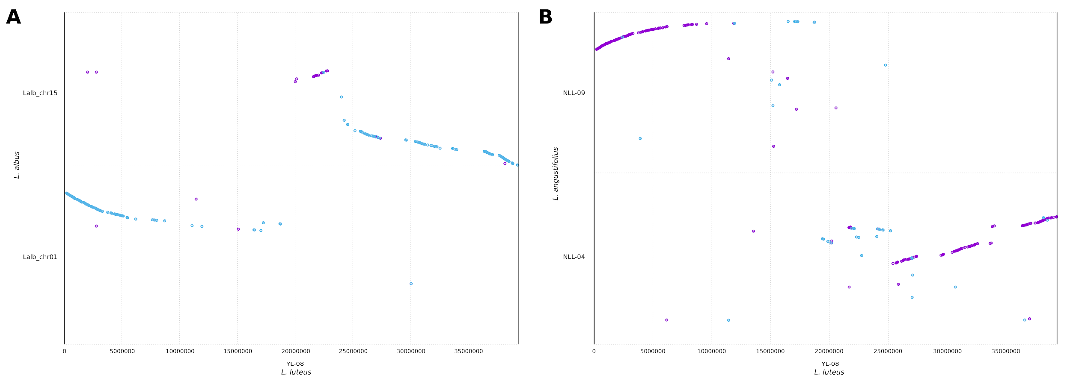
Supplementary Figure S7. Synteny of L. luteus chromosome 8 and their relatives L. albus and L. angustifolius

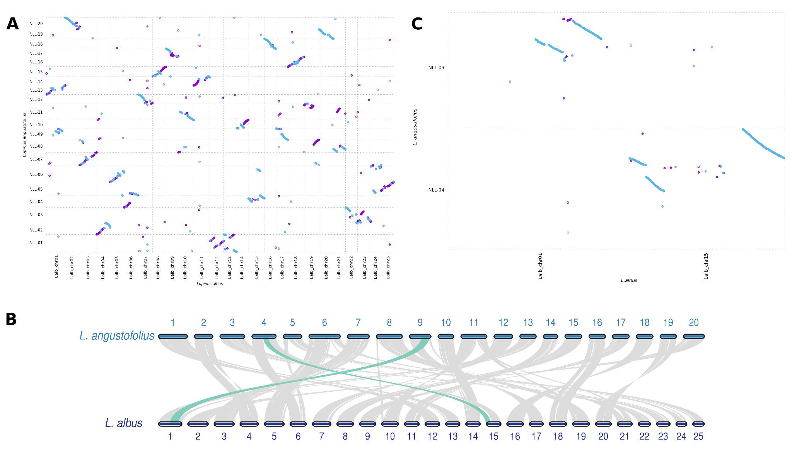
Supplementary Figure S8. Synteny analysis of L. albus and L. angustifolius. Numbers represent the chromosome order. Each line represents one block. Green lines indicate the event of fusion which originates on chromosome 8 in the L. luteus genome.
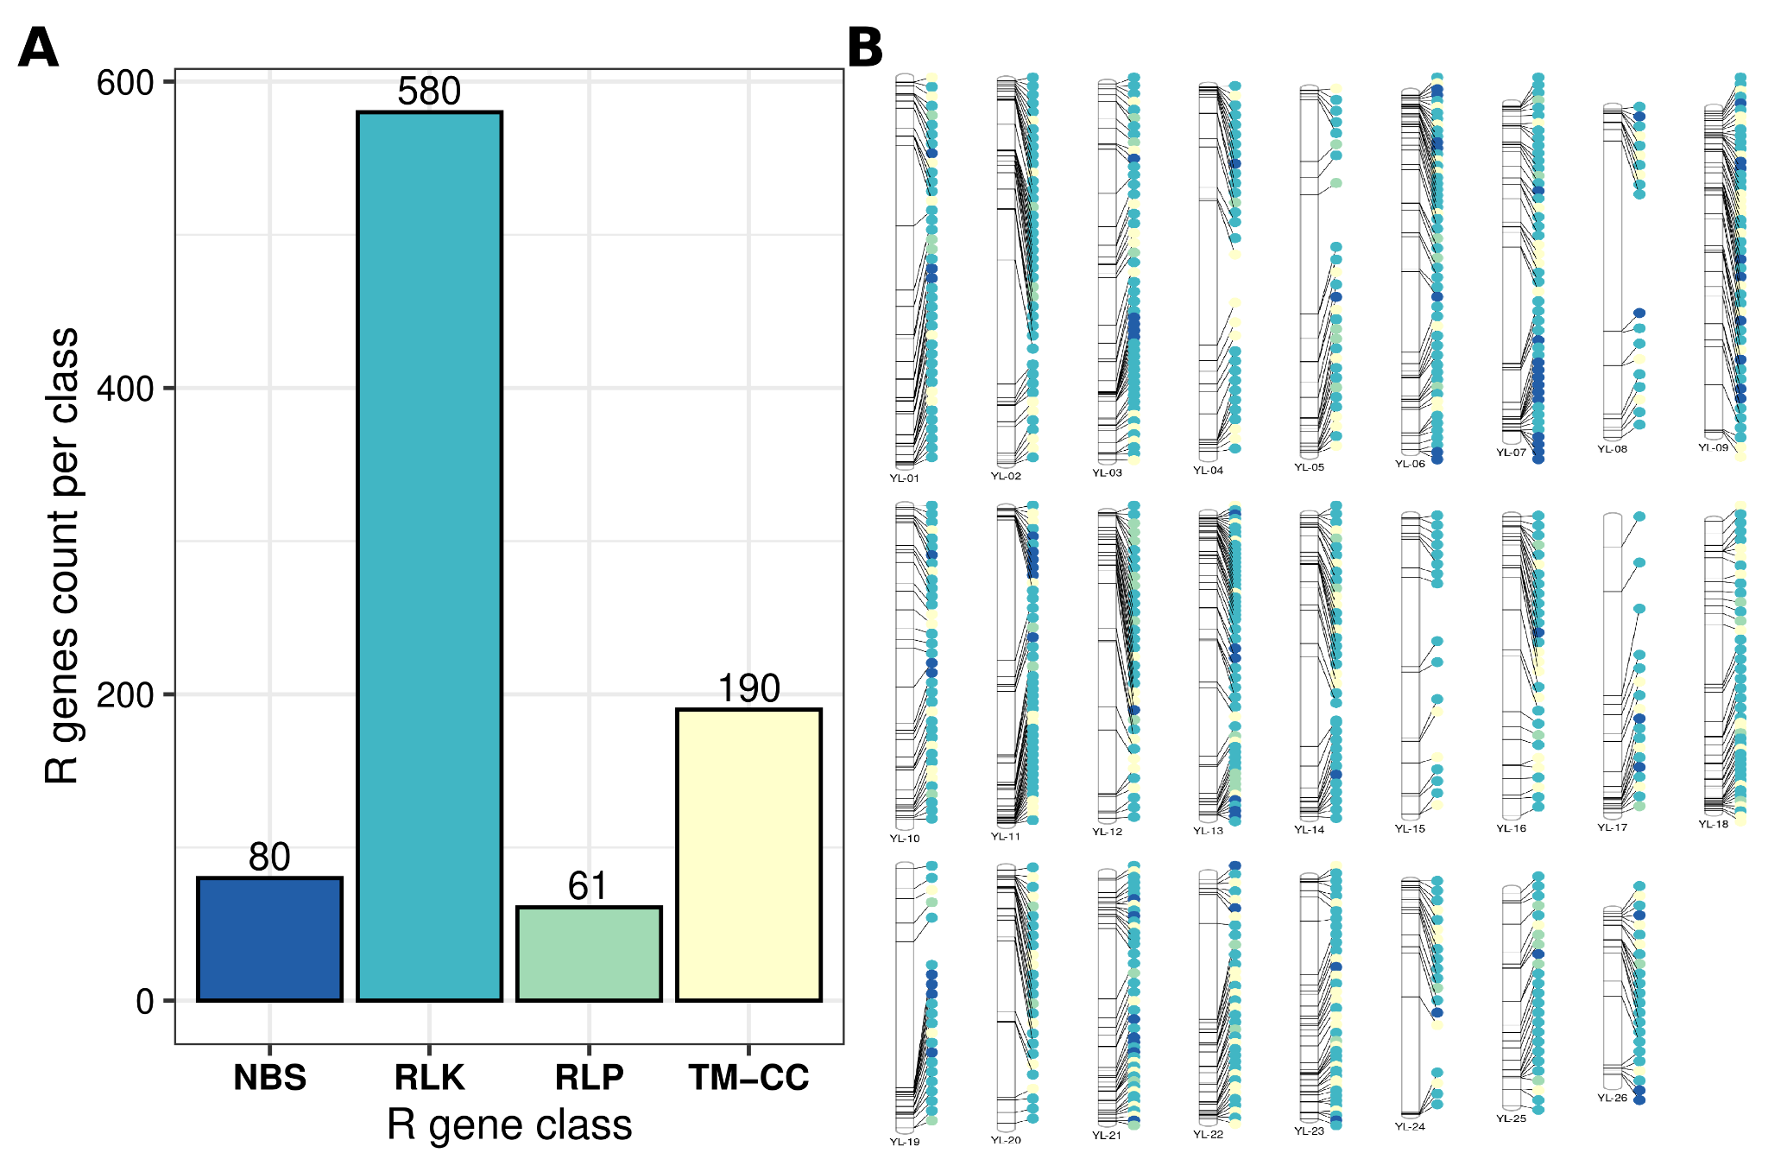
Supplementary Figure S9. identification of Resistant disease-related (R) genes in the L. luteus genome. A) Classes of R genes present in the L. luteus genome. B) Chromosomal location of R genes classes in the L.luteus genome. colors in B are the same than in A
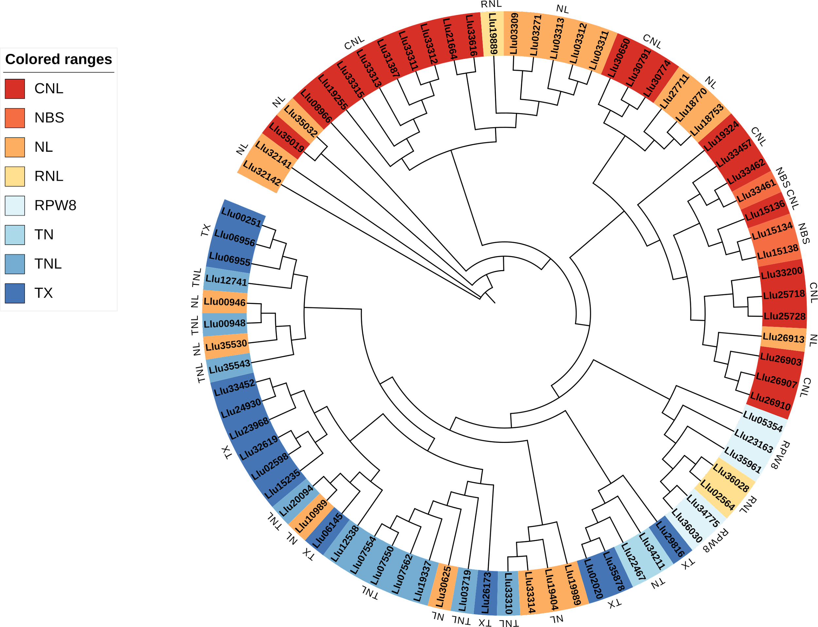
Supplementary Figure S10. Phylogenetic analysis of the NBS-type genes in L. luteus

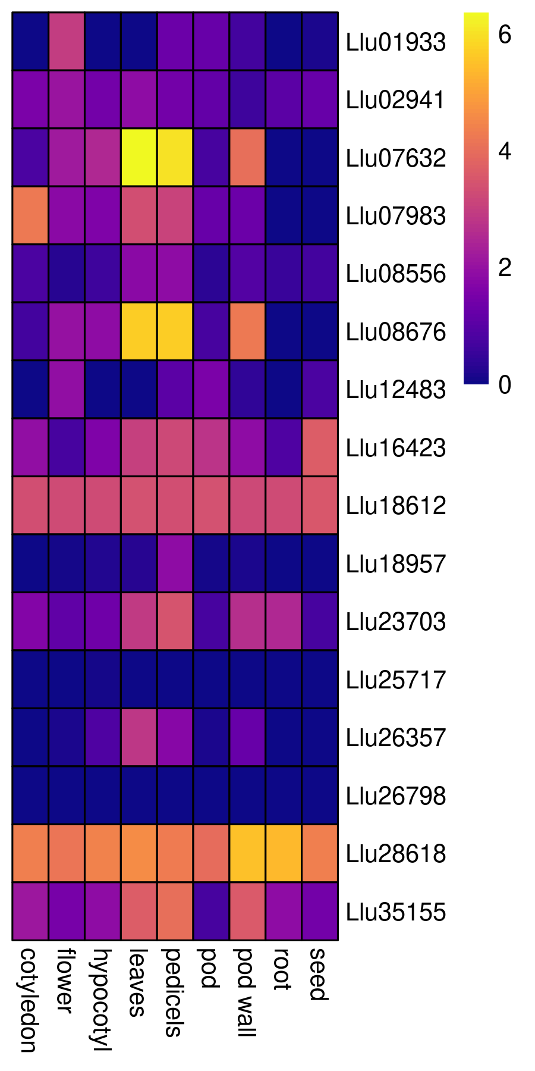
Supplementary Figure S11. Expression analysis of QA and Gramine biosynthesis-related genes in the L. luteus genome. The scale color represents log-transformed normalized TMM counts

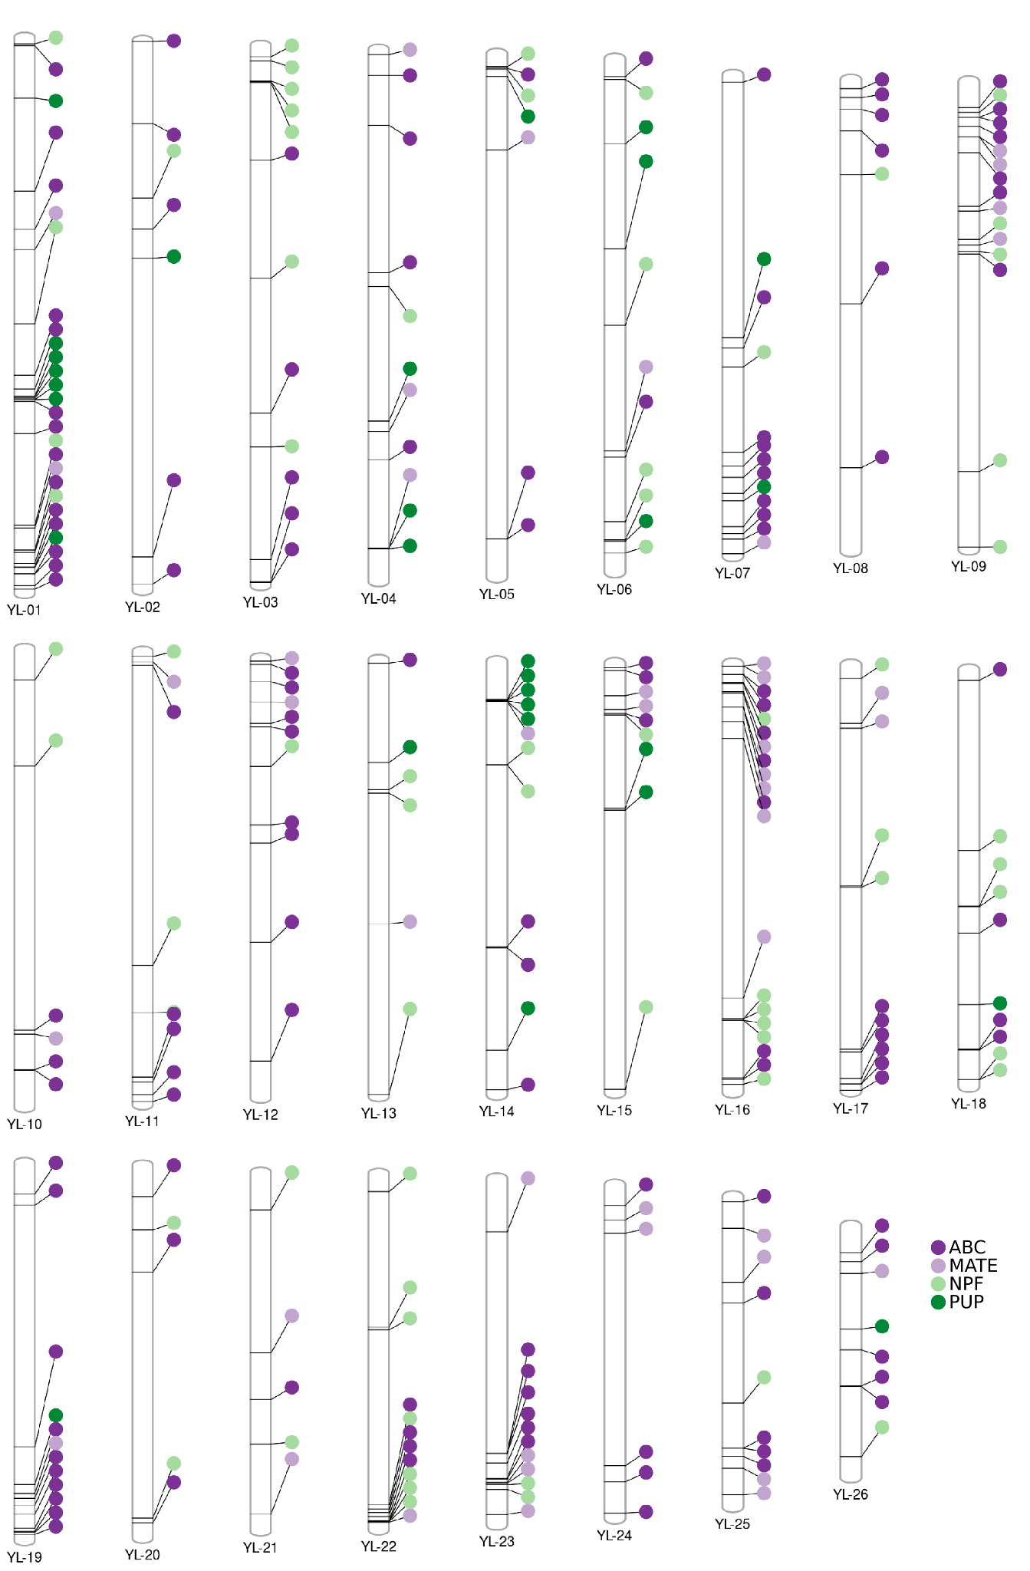
Supplementary Figure S12. Chromosomal location of secondary metabolite transporters genes in the L.luteus genome.

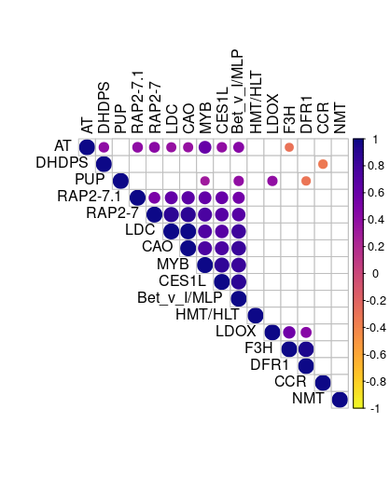
Supplementary Figure S13. Correlogram of alkaloid biosynthesis-related genes in the L. luteus genome. The Pearson correlation coefficient was calculated using TMM normalized counts. circle size represents the significant correlation coefficient (p-value < 0.05). Blank spaces represent a non-significant correlation coefficient.

