Supporting Information

Optimizing the coordination environment of Cu single-atom catalyst for efficient electroreduction of CO₂ to CH₃OH
Guodong Sun*¹, Yanan Cao², Deqing Li³, Yingfei Ma¹, Mengchen Sun²
*¹ A. Prof G. Sun, Materials and packaging engineering, Fujian Polytechnic Normal University, Fuzhou, Fujian Province, 350330, the People's Republic of China, Email: sunguodong20@mails.ucas.ac.cn.
² School of Chemical Sciences, National Engineering Laboratory for VOCs Pollution Control Material & Technology, University of Chinese Academy of Sciences, Beijing, 100049, the People's Republic of China.
³ School of Vehicle and Mobility, Tsinghua University, Beijing, 100049, the People's Republic of China.

Supplementary Index
Fig. S1 HAADF-STEM images of (a) CuN₃-C and (b) CuN₄-C catalysts.
Fig. S2 High-resolution X-ray photoelectron spectroscopy (XPS) of (a) CuN₃-C and (b) CuN₄-C catalysts.
Fig. S3 Deconvoluted N 1s spectra of (a) CuN₃-C and (b) CuN₄-C catalysts.
Fig. S4 Fourier transforms of the Cu K-edge EXAFS oscillations in the k space of simulated (a) CuN₃-C and (b) CuN₄-C catalysts.
Fig. S5 TEM images of (a) CuN₃-C and (b) CuN₄-C catalysts.
Fig. S6 HAADF-STEM images of (a) N-C and (b) C samples.
Fig. S7 Deconvoluted N 1s spectra of (a) N-C and (b) C samples.
Fig. S8 Amperage curves of CO₂ reduction catalyzed by CuN₃-C in first 300 seconds at different potentials.
Fig. S9 LSV and Faradaic efficiency distributions of CO₂RR on (a) N-C and (b) C samples.
Fig. S10 HAADF-STEM images of CuN₃-C catalyst after test.
Fig. S11 Structure and morphology of catalysts after the CO₂RR electrolysis.
Fig. S12 EXAFS spectra of CuN₃-C catalyst after the CO₂RR electrolysis
Fig. S13 Model of CuN₃-C catalyst.
Fig. S14 Model of CuN₄-C catalyst.
Table S1. EXAFS fitting parameters at the Cu K-edge for various samples（Ѕ₀²=0.90 from Cu-foil）
Table. S2 The Onset potential and current density of catalysts reacting with different gases.
Table. S3 The Onset potential and Current density of catalysts reacting with different gases.
Table.S4 Faradaic efficiency distributions of CO₂RR over Cu₄N-C
Table. S5 Faradaic efficiency distributions of CO₂RR over CuN₃-C
Table S6 Comparison of the FE of CH₃OH in aqueous conditions from this work and previous representative reports.
Table S7 Comparison of the rate of CH₃OH in aqueous conditions from this work and previous representative reports.
Table S8 The Onset potential and Current density of C and N-C reacting with different gases.
Table S9 Faradaic efficiency distributions of CO₂RR over C and N-C
Table S10 Nyquist plot of catalysts over the frequency from 0.1 MHz to 0.1 Hz
Table 11. EXAFS fitting parameters at the Cu K-edge for various samples（Ѕ₀²=0.90 from Cu-
Table 12 Energy of the CH₃OH pathway on CuN₃-C catalyst
Table 13 D-band center of catalysts

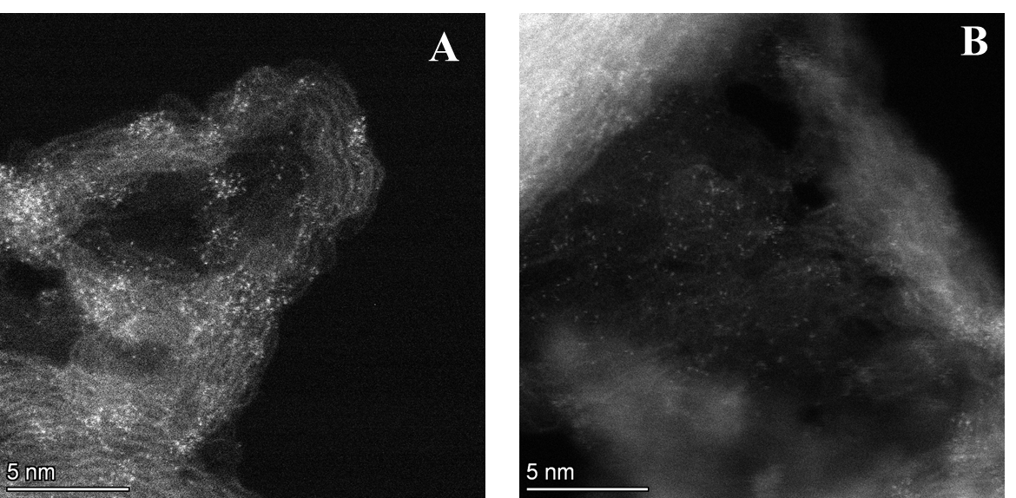
Fig. S1 HAADF-STEM images of (a) CuN₃-C and (b) CuN₄-C catalysts.

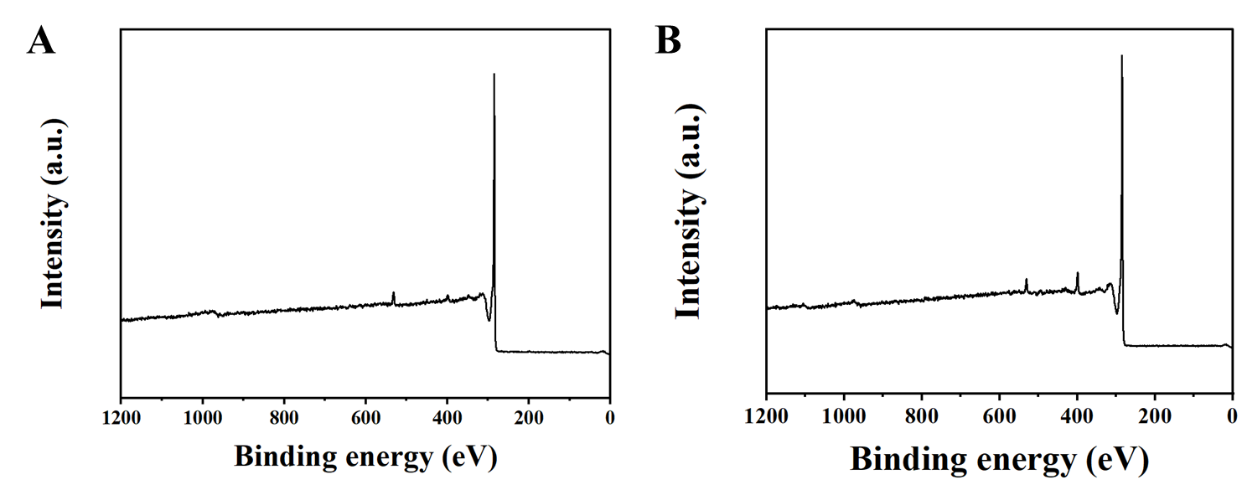
Fig. S2 High-resolution X-ray photoelectron spectroscopy (XPS) of (a) CuN₃-C and (b) CuN₄-C catalysts.

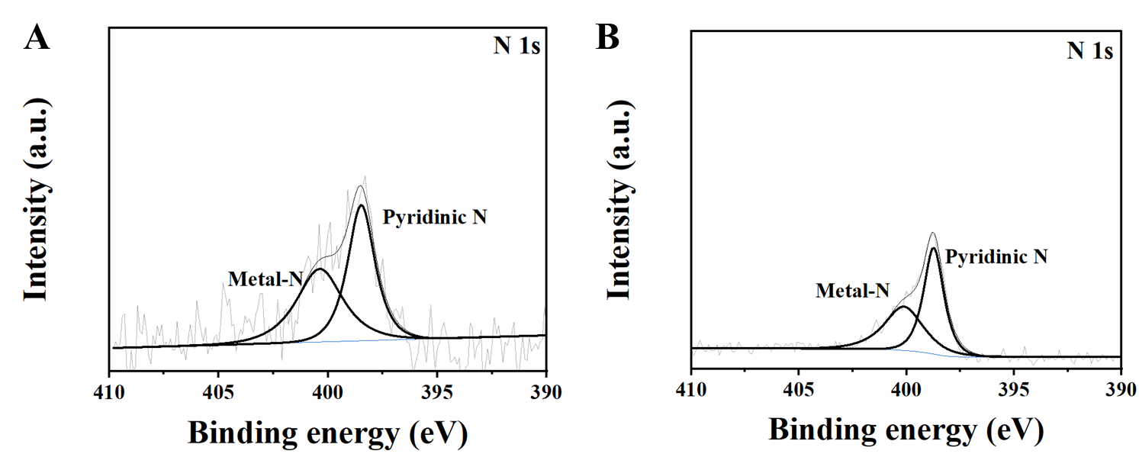
Fig. S3 Deconvoluted N 1s spectra of (a) CuN₃-C and (b) CuN₄-C catalysts.

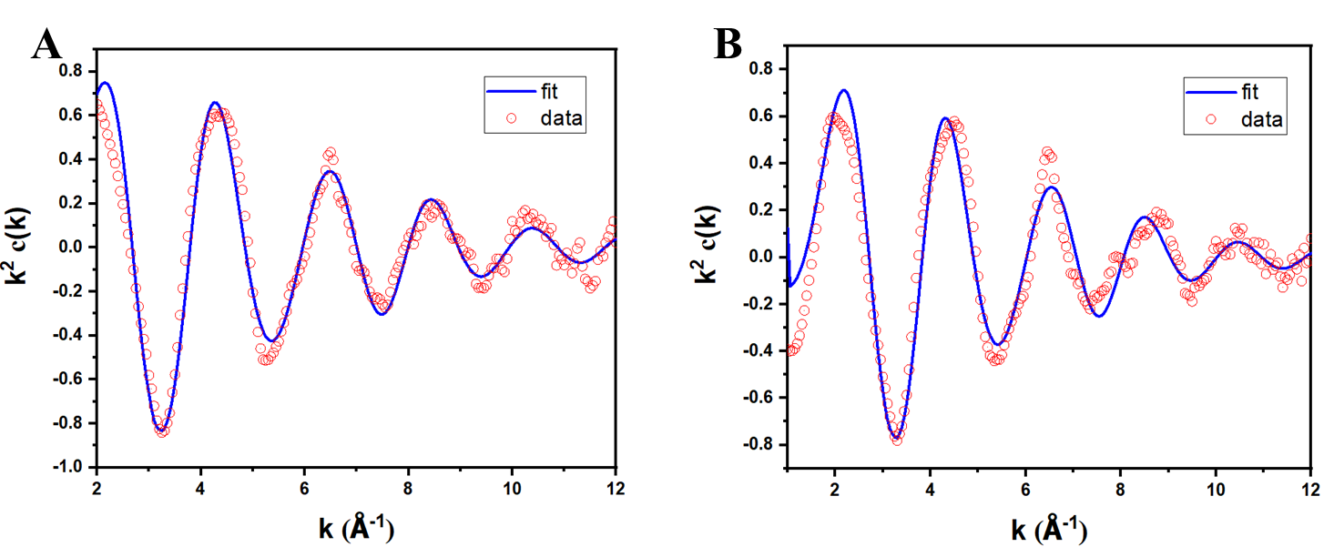
Fig. S4 Fourier transforms of the Cu K-edge EXAFS oscillations in the k space of simulated (a) CuN₃-C and (b) CuN₄-C catalysts.

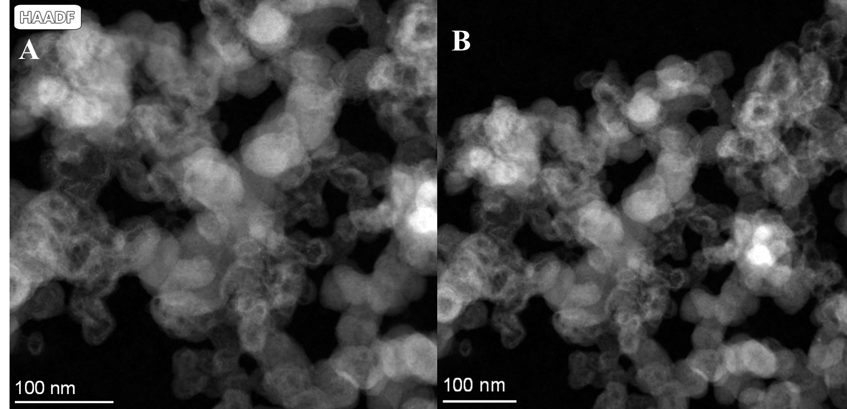
Fig. S5 TEM images of (a) CuN₃-C and (b) CuN₄-C catalysts.

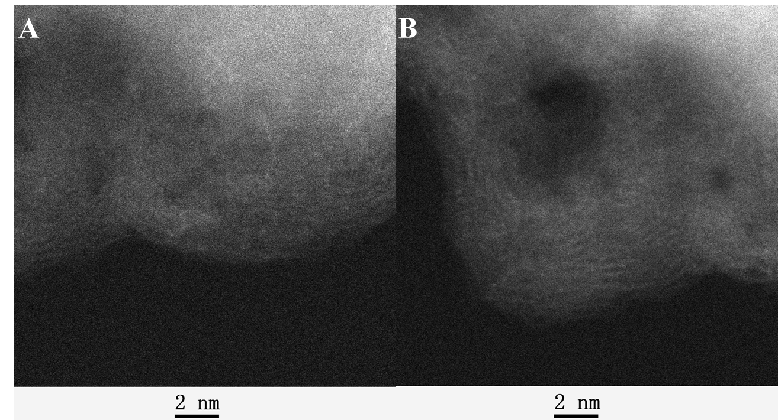
Fig. S6 HAADF-STEM images of (a) N-C and (b) C samples.

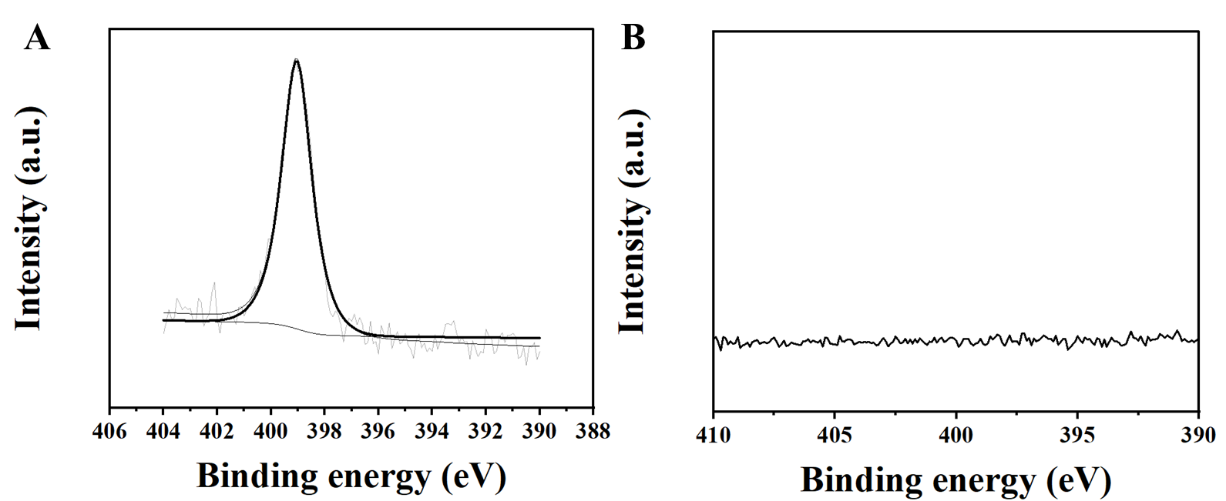
Fig. S7 Deconvoluted N 1s spectra of (a) N-C and (b) C samples.

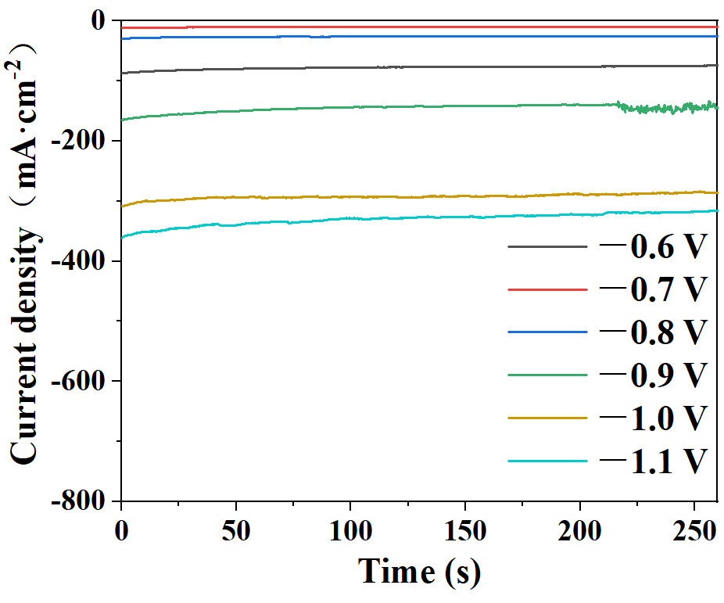
Fig. S8 Amperage curves of CO₂ reduction catalyzed by CuN₃-C in first 300 seconds at different potentials.

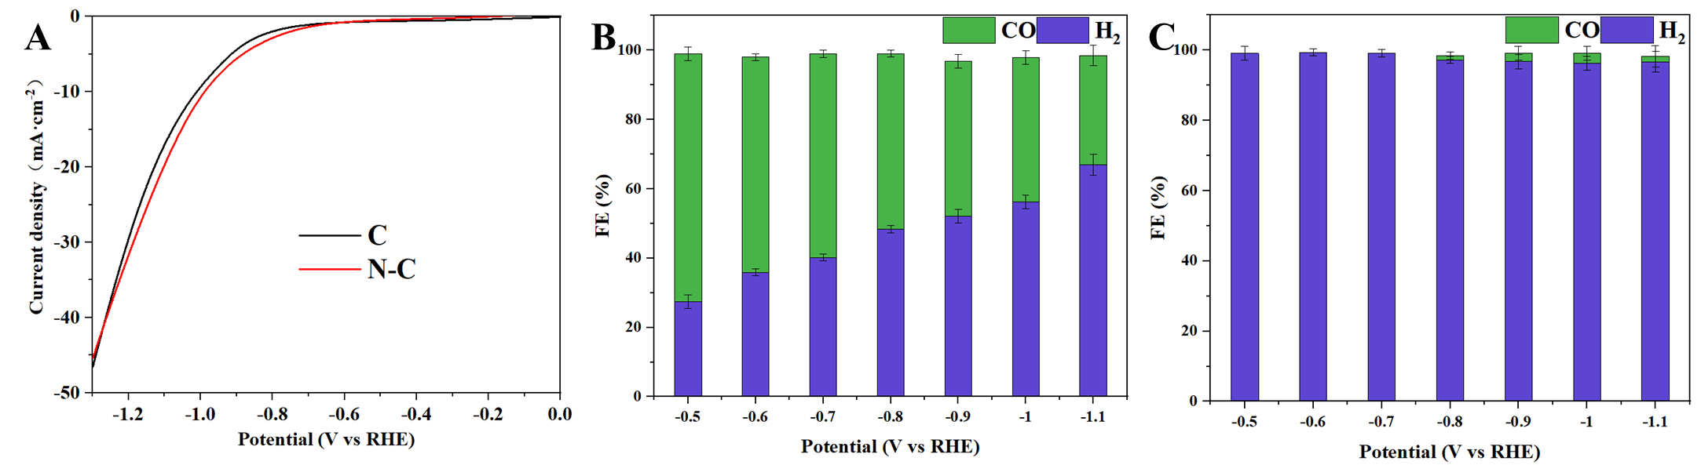
Fig. S9 LSV and Faradaic efficiency distributions of CO₂RR on (a) N-C and (b) C samples.

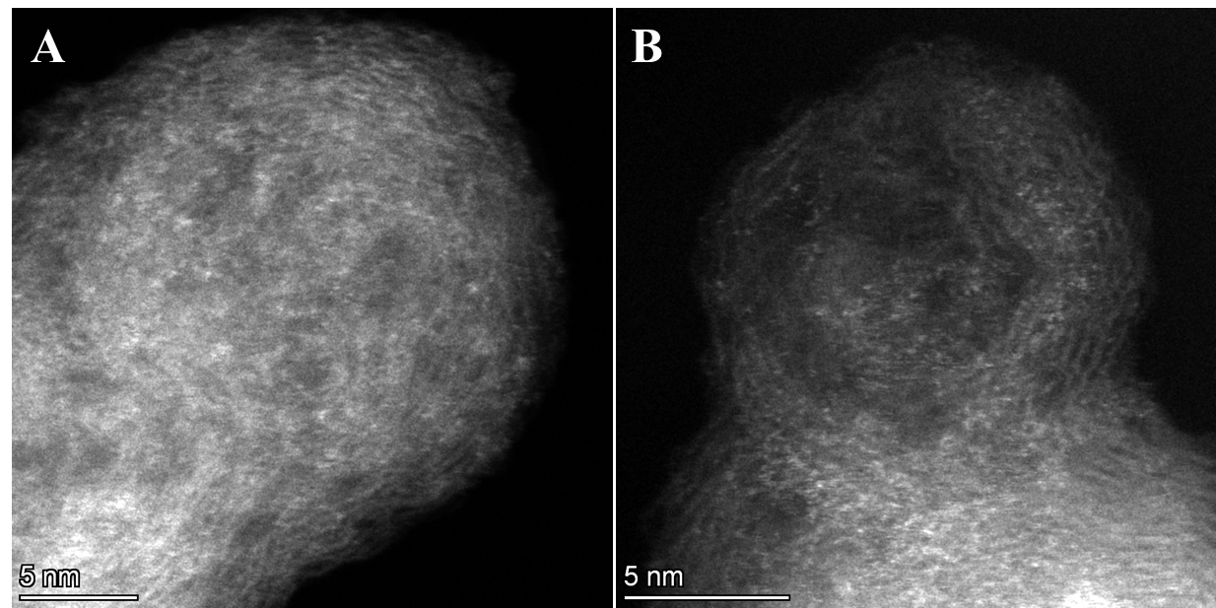
Fig. S10 HAADF-STEM images of CuN₃-C catalyst after test.

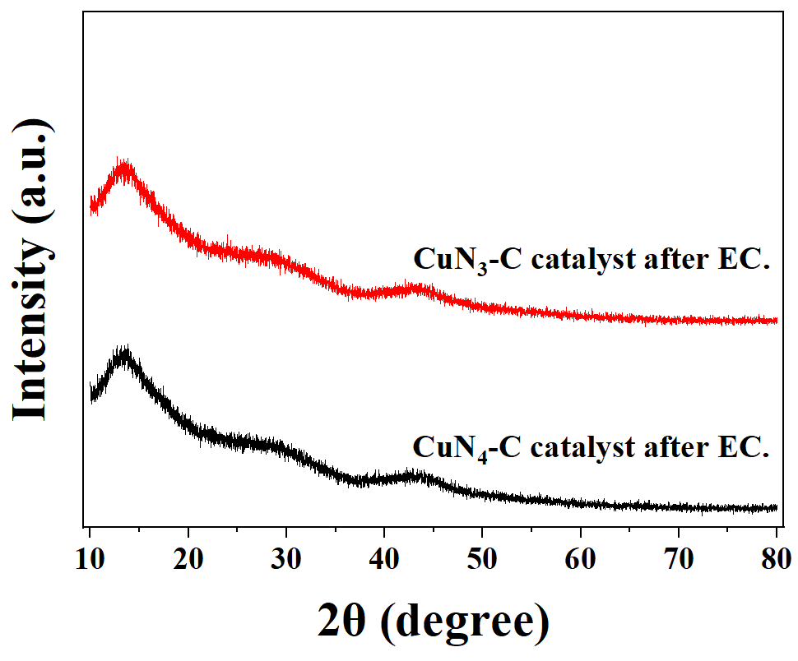
Fig. S11 Structure and morphology of catalysts after the CO₂RR electrolysis.

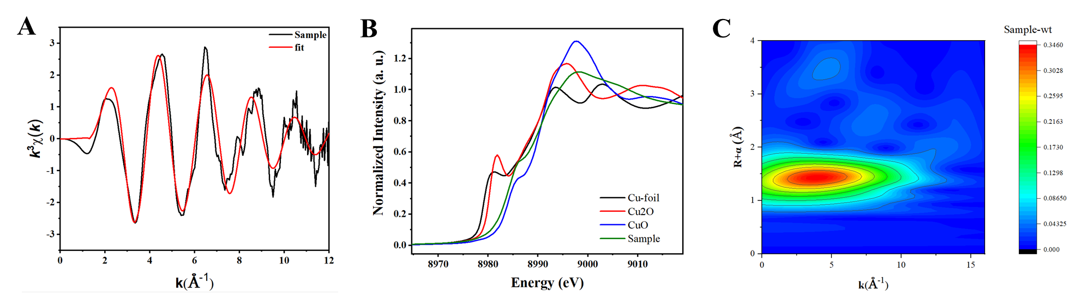
Fig. S12 EXAFS spectra of CuN₃-C catalyst after the CO₂RR electrolysis

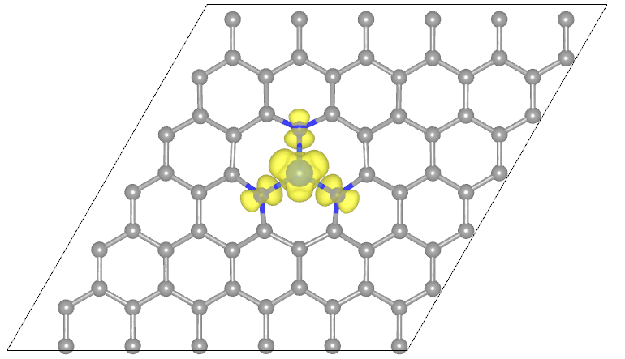
Fig. S13 Model of CuN₃-C catalyst.

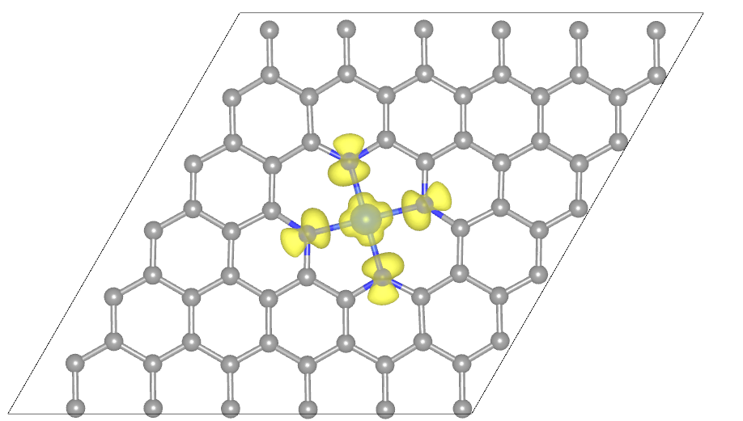
Fig. S14 Model of CuN₄-C catalyst.

Table S1. EXAFS fitting parameters at the Cu K-edge for various samples（Ѕ₀²=0.90 from Cu-foil）
Sample | Shell | CNª | R(Å)^{b} | σ²(Å²)^{c} | ΔE₀(eV)^{d} | S₀² | R factor
CuN₃-C | Cu-N | 3.1±0.1 | 1.95 | 0.005 | 4.8±0.7 | 0.7000(set) | 0.007
CuN₄-C | Cu-N | 4.0±0.1 | 1.95 | 0.008 | 4.2±0.3 | 0.7000(set) | 0.003
ªCN: coordination numbers; ^{b}R: bond distance; ^{c}σ²: Debye-Waller factors; ^{d} ΔE₀: the inner potential correction. R factor: goodness of fit. Error bounds that characterize the structural parameters obtained by EXAFS spectroscopy were estimated as CN±20%; R ± 1%; σ² ± 20%.

Table. S2 The Onset potential and current density of catalysts reacting with different gases.
Sample | Gaseous atmosphere | Onset potential  (V, Current density = −20 mA cm²) | Current density  (mA cm², at-1.1 V)
CuN₃-C | Ar | −0.61 | −316
CuN₃-C | CO₂ | −0.45 | −560
CuN₄-C | Ar | −0.71 | −301
CuN₄-C | CO₂ | −0.65 | −471

Table. S3 The Onset potential and Current density of catalysts reacting with different gases.
Potential  (V) | FE (%, over CuN₃-C)
Potential  (V) | CO | CH₃OH | H₂
−0.6 | 58.88 | 25.63 | 13.86
−0.7 | 47.16 | 40.12 | 11.17
−0.8 | 39.41 | 53.49 | 8.62
−0.9 | 29.10 | 61.45 | 5.79
−1.0 | 11.54 | 80.15 | 3.86
−1.1 | 20.37 | 65.22 | 9.18

Table.S4 Faradaic efficiency distributions of CO₂RR over CuN₄-C
Potential  (V) | FE (%, over CuN₄-C)
Potential  (V) | CO | CH₃OH | H₂
−0.6 | 78.9 | 0 | 20.86
−0.7 | 74.16 | 2.58 | 23.17
−0.8 | 65.18 | 4.77 | 28.21
−0.9 | 53.5 | 8.12 | 32.96
−1.0 | 47.17 | 16.11 | 34.02
−1.1 | 39.66 | 30.99 | 27.11

Table. S5 Faradaic efficiency distributions of CO₂RR over CuN₃-C
Potential  (V) | FE  (%) | Partial current density  (mA cm²)
−0.6 | −25.63 | −11.53
−0.7 | −40.12 | −34.90
−0.8 | −53.49 | −86.65
−0.9 | −61.45 | −164.07
−1.0 | −80.15 | −332.33
−1.1 | −65.22 | −363.92

Table S6 Comparison of the FE of CH₃OH in aqueous conditions from this work and previous representative reports.
Catalysts | FE_{CH3OH}  (%) | REF
CuSAs/TCNFs | 44 | ¹
CoO/CN/Ni | 45 | ²
CuN₄-C | 45.1 | This work
Cu-₃(HHTQ) | 53.6 | ³
Ti₃(Al_{1−x}Cu_{x})C₂ | 59.1 | ⁴
Ag,S-Cu₂O/Cu | 67.4 | ⁵
Cu₂NCN | 70 | ⁶
CoO/CN/Ni | 70.7 | ²
Co₃O₄/N-RGO | 74.8 | ⁷
Cu_{2−x}Se | 77 | ⁸
CuN₃-C | 78 | This work

Table S7 Comparison of the rate of CH₃OH in aqueous conditions from this work and previous representative reports.
Catalysts | CH₃OH production rate | REF
CuPc | 3.8 | ⁹
CuSAs/TCNFs | 737.133 | ¹
CoO/CN/Ni | 178.7565 | ²
CoPc/CNT | 200 | ¹⁰
Cu-₃(HHTQ) | 18.51468 | ³
Ti₃(Al_{1−x}Cu_{x})C₂ | 217.4145 | ⁴
Ag,S-Cu₂O/Cu | 1428.321 | ⁵
Cu₂NCN | 1115.889 | ⁶
CoO/CN/Ni | 129.4335 | ²
Pd/SnO₂ | 2 | ¹¹
Co₃O₄/N-RGO | 51.6753 | ⁷
CuN₃-C | 5321.244 | This work
Cu_{2−x}Se | 556.2004 | ⁸
Pd₈₃Cu₁₇ | 439.3782 | ¹²
Sn₁ /Vo -CuO-_{x} | 1025.25 | ¹³
计算方法

Table S8 The Onset potential and Current density of C and N-C reacting with different gases.
Sample | Onset potential  (V, Current density = −10 mA cm²) | Current density  (mA cm², at −1.1 V)
C | −1.01 | −16.82
N-C | −0.98 | −19.76

Table S9 Faradaic efficiency distributions of CO₂RR over C and N-C
Potential  (V) | FE (%, over C) |  |  | FE (%, over N-C)
Potential  (V) | CO | CH₃OH | H₂ | CO | CH₃OH | H₂
-0.6 | 0 | 0 | 99.12 | 71.55 | 0 | 27.46
-0.7 | 0 | 0 | 99.43 | 62.16 | 0 | 35.88
-0.8 | 0 | 0 | 99.19 | 58.81 | 0 | 40.16
-0.9 | 1.24 | 0 | 97.22 | 50.68 | 0 | 48.34
-1.0 | 2.37 | 0 | 96.77 | 44.73 | 0 | 52.17
-1.1 | 2.88 | 0 | 96.28 | 41.75 | 0 | 56.21

Table S10 Nyquist plot of catalysts over the frequency from 0.1 MHz to 0.1 Hz
Sample | Charge-transfer resistance  （Ω）
CuN₃-C | 6.2
CuN₄-C | 8.4

Table 11. EXAFS fitting parameters at the Cu K-edge for various samples（Ѕ₀²=0.90 from Cu-foil）
Sample | Shell | CNª | R(Å)^{b} | σ²(Å²)^{c} | ΔE₀(eV)^{d} | R factor
CuN₃-C | Cu-N | 3.1±0.1 | 1.95 | 0.00084 | 6.2±0.7 | 0.0019
ªCN: coordination numbers; ^{b}R: bond distance; ^{c}σ²: Debye-Waller factors; ^{d} ΔE₀: the inner potential correction. R factor: goodness of fit. Error bounds that characterize the structural parameters obtained by EXAFS spectroscopy were estimated as CN±20%; R ± 1%; σ² ± 20%.

Table 12 Energy of the CH₃OH pathway on CuN₃-C catalyst
Intermediates | Energy (eV) | Energy (eV)
*+CO₂ | 0 | 0
*COOH | -0.65 | -0.45
*CO | 0.9 | -1.29
*CHO | -0.56 | -0.15
*CHOH | 1.87 | -0.41
*CH₂OH | -1.3 | -0.82

Table 13 D-band center of catalysts
Cu 3d | d-band center (eV)
CuN₃-C | -1.58
CuN₄-C | -3.12

1 Yang, H. et al. Scalable Production of Efficient Single-Atom Copper Decorated Carbon Membranes for CO2 Electroreduction to Methanol. Journal of the American Chemical Society 141, 12717-12723, doi:10.1021/jacs.9b04907 (2019).
2 Wang, L. et al. Ternary heterostructural CoO/CN/Ni catalyst for promoted CO2 electroreduction to methanol. Journal of Catalysis 393, 83-91, doi:10.1016/j.jcat.2020.11.012 (2021).
3 Liu, J. et al. Tricycloquinazoline‐Based 2D Conductive Metal–Organic Frameworks as Promising Electrocatalysts for CO2Reduction. Angewandte Chemie International Edition 60, 14473-14479, doi:10.1002/anie.202103398 (2021).
4 Zhao, Q. et al. Selective Etching Quaternary MAX Phase toward Single Atom Copper Immobilized MXene (Ti3C2Clx) for Efficient CO2 Electroreduction to Methanol. ACS Nano 15, 4927-4936, doi:10.1021/acsnano.0c09755 (2021).
5 Li, P. et al. In situ dual doping for constructing efficient CO2-to-methanol electrocatalysts. Nature Communications 13, doi:10.1038/s41467-022-29698-3 (2022).
6 Kong, S. et al. Delocalization state-induced selective bond breaking for efficient methanol electrosynthesis from CO2. Nature Catalysis 6, 6-15, doi:10.1038/s41929-022-00887-z (2022).
7 Bharath, G. et al. Self-Assembled Co3O4 Nanospheres on N-Doped Reduced Graphene Oxide (Co3O4/N-RGO) Bifunctional Electrocatalysts for Cathodic Reduction of CO2 and Anodic Oxidation of Organic Pollutants. ACS Applied Energy Materials 4, 11408-11418, doi:10.1021/acsaem.1c02196 (2021).
8 Yang, D. et al. Selective electroreduction of carbon dioxide to methanol on copper selenide nanocatalysts. Nature Communications 10, doi:10.1038/s41467-019-08653-9 (2019).
9 Kusama, S., Saito, T., Hashiba, H., Sakai, A. & Yotsuhashi, S. Crystalline Copper(II) Phthalocyanine Catalysts for Electrochemical Reduction of Carbon Dioxide in Aqueous Media. ACS Catalysis 7, 8382-8385, doi:10.1021/acscatal.7b02220 (2017).
10 Guo, T. et al. Enhancing effect of cobalt phthalocyanine dispersion on electrocatalytic reduction of CO2 towards methanol. Environmental Science and Pollution Research 30, 122755-122773, doi:10.1007/s11356-023-30883-0 (2023).
11 Zhang, W. et al. Electrochemical Reduction of Carbon Dioxide to Methanol on Hierarchical Pd/SnO2 Nanosheets with Abundant Pd–O–Sn Interfaces. Angewandte Chemie International Edition 57, 9475-9479, doi:10.1002/anie.201804142 (2018).
12 Lu, L. et al. Highly Efficient Electroreduction of CO2 to Methanol on Palladium–Copper Bimetallic Aerogels. Angewandte Chemie International Edition 57, 14149-14153, doi:10.1002/anie.201808964 (2018).
13 Guo, W. et al. Highly Efficient CO2 Electroreduction to Methanol through Atomically Dispersed Sn Coupled with Defective CuO Catalysts. Angewandte Chemie International Edition 60, 21979-21987, doi:10.1002/anie.202108635 (2021).

