Supplementary Material

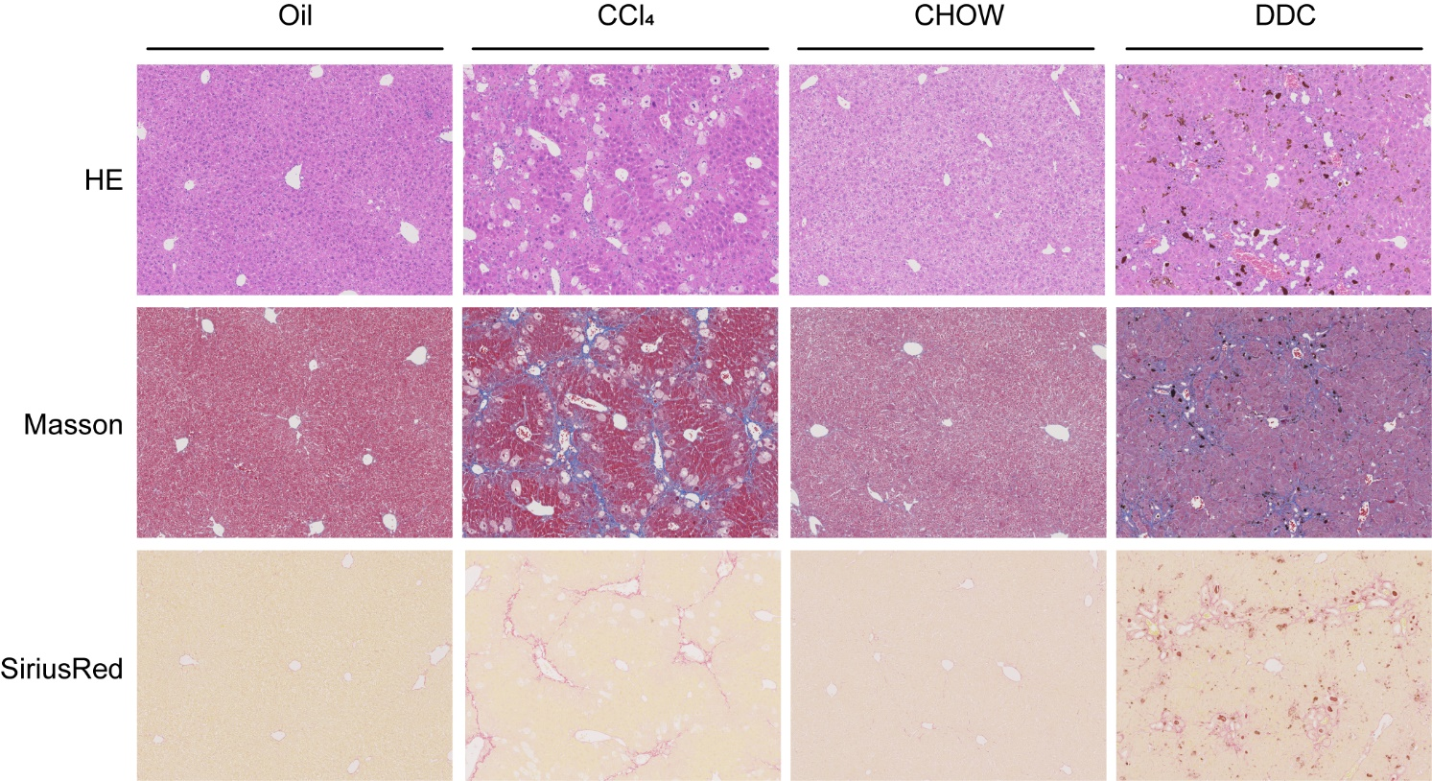
Supplementary Figures
Supplementary Figure 1 Liver fibrosis was assessed by HE, Masson and Sirius red staining. WT mice (C57BL/6) were treated with olive oil or CCl₄ (0.75 mL/kg) for 8 weeks or were fed with standard diet that supplemented with 0.1% 5-diethoxycarbonyl-1,4-dihydrocollidine (DDC) for 4 weeks.

