Efficient algorithmic coupling technique for precision recycling of seven types of mixed plastic waste
Keyu Zhu ^{a,b,c}, Zhijie Pan ^{a,b,c}, Junrong Chen ^{a,b,c}, Songwei Yang ^{a,b,c}, Changlin Cao ^{a,b,c,*}, Jianjun Li ^{d}, Siyang Liu ^{d}, Hai Wang ^{d}, Qingrong Qian ^{a,b,c}, Qinghua Chen ^{a,b,c}

College of Environmental and Resource Sciences, College of Carbon Neutral Modern Industry, Fujian Normal University, Fuzhou 350007, China
Engineering Research Center of Polymer Green Recycling of Ministry of Education, Fujian Normal University, Fuzhou 350007, China
Key Laboratory of Pollution Control & Resource Reuse, Fuzhou 350007, China
Kingfa Sci. & Tech. Co., Ltd., Guangzhou, Guangdong 510520, China

*Corresponding author: College of Environmental and Resource Sciences, College of Carbon Neutral Modern Industry, Fujian Normal University, Fuzhou 350007, Fujian Province, China.
E-mail addresses: caochlin3@fjnu.edu.cn (C. Cao).
Full postal address: College of Environmental and Resource Sciences, College of Carbon Neutral Modern Industry, Fujian Normal University

Supplementary Information

Table S1 The size of data set
Sample | Size
ABS | 36
HDPE | 93
LDPE | 73
PET | 78
PP | 219
PS | 49
PVC | 17

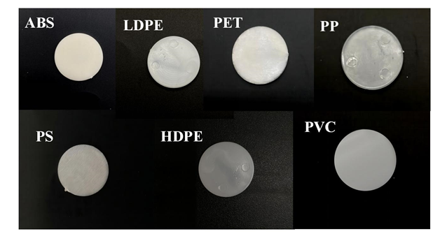
Fig. S1. Photo of the prepared samples

Table S2 Results on the ablation study of preprocessing methods in the Linear-SVC algorithm
Test | Preprocessing methods |  | Accuracy (%)
 | Hampel filter | StandardScaler
1 |  |  | 88.8
2 |  |  | 91.2
3 |  |  | 92.3
4 |  |  | 94.7

Table S3 Precision, recall, and F1-score of each algorithm in seven types plastic classification
Model | Type | Precision (%) | Recall (%) | F1-score (%)
 | ABS | 50 | 21 | 30
 | HDPE | 55 | 67 | 60
 | LDPE | 52 | 71 | 60
DT | PP | 68 | 68 | 68
 | PET | 86 | 79 | 82
 | PS | 63.8 | 72 | 70
 | PVC | 0 | 0 | 0
 | ABS | 88 | 50 | 64
 | HDPE | 56 | 75 | 64
 | LDPE | 42 | 65 | 51
Adaboost | PP | 90 | 82 | 86
 | PET | 91 | 82 | 86
 | PS | 93 | 78 | 85
 | PVC | 20 | 25 | 22
 | ABS | 83 | 71 | 77
 | HDPE | 79 | 79 | 79
 | LDPE | 45 | 1 | 62
KNN | PP | 86 | 82 | 84
 | PET | 97 | 82 | 89
 | PS | 73 | 61 | 67
 | PVC | 0 | 0 | 0
 | ABS | 67 | 57 | 62
 | HDPE | 83 | 83 | 83
 | LDPE | 54 | 88 | 67
RF | PP | 90 | 86 | 88
 | PET | 97 | 89 | 93
 | PS | 83 | 83 | 83
 | PVC | 100 | 0.5 | 67
 | ABS | 93 | 100 | 96
 | HDPE | 88 | 83 | 85
 | LDPE | 79 | 82 | 80
MLP | PET | 96 | 100 | 99
 | PP | 99 | 99 | 99
 | PS | 100 | 83 | 91
 | PVC | 80 | 100 | 89
 | ABS | 100 | 100 | 100
 | HDPE | 82 | 88 | 84
 | LDPE | 76 | 76 | 76
Linear-SVC | PET | 100 | 100 | 100
 | PP | 100 | 99 | 99
 | PS | 100 | 94 | 97
 | PVC | 100 | 100 | 100

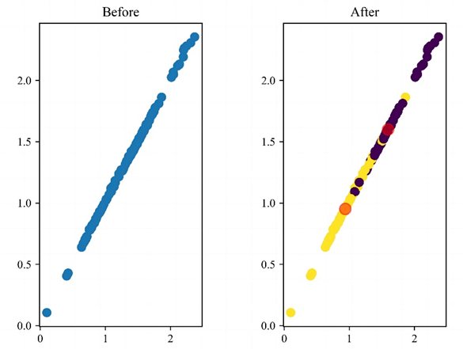
Fig. S2. The comparison chart before and after K-means clustering
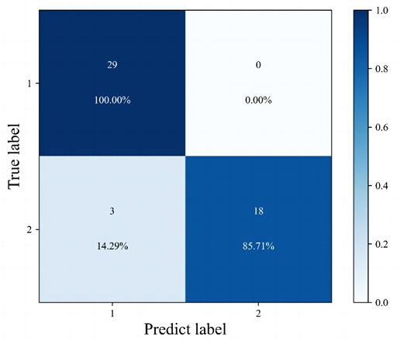
Fig. S3. The confusion matrix of MLP in two types plastic classification

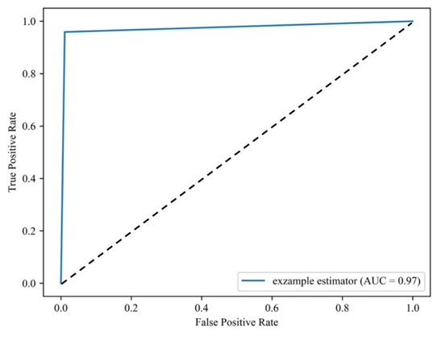
Fig. S4. The ROC-curve of MLP in two types plastic classification

