Supplemental figures
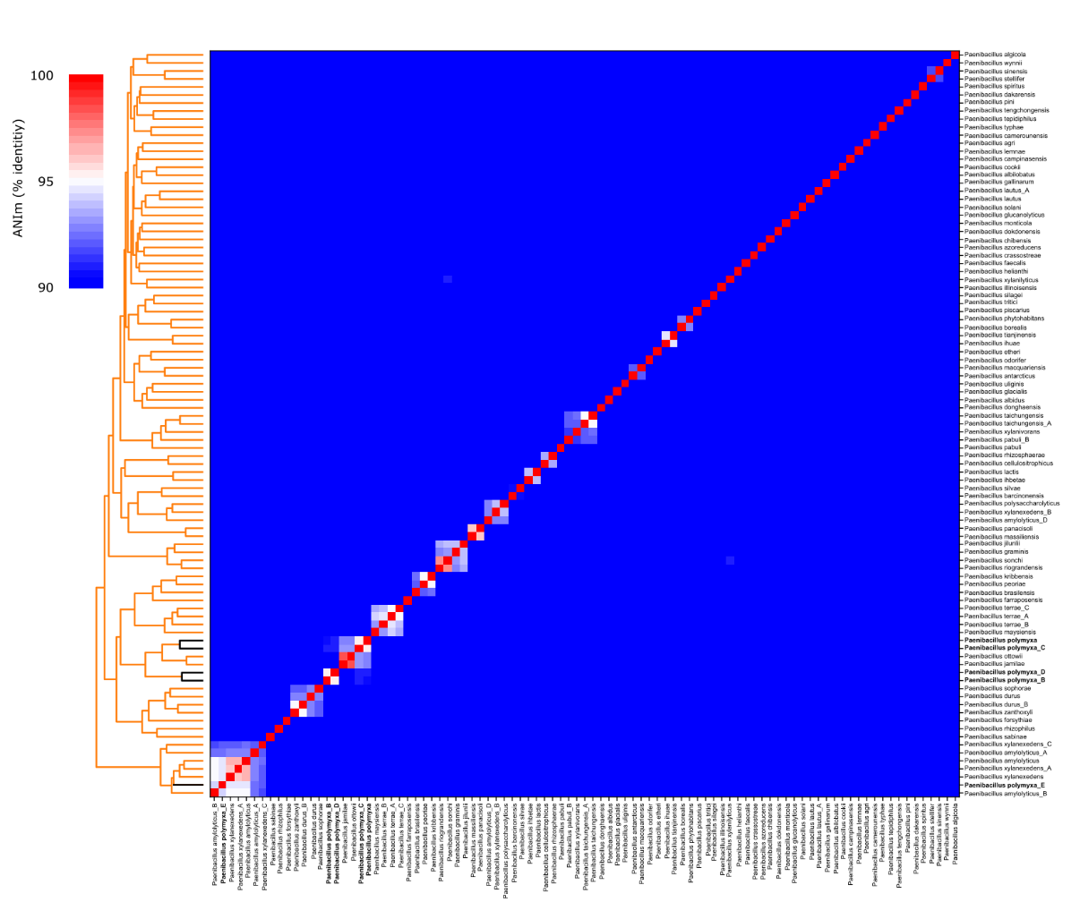
Figure S1 Average nucleotide identity results for 93 Paenibacillus species representative strains based on mummer comparisons. The representative strains of GTDB-validated Paenibacillus species were selected for this analysis. Strains of the different P. polymyxa groups are indicated in bold and black bars on the dendrogram.

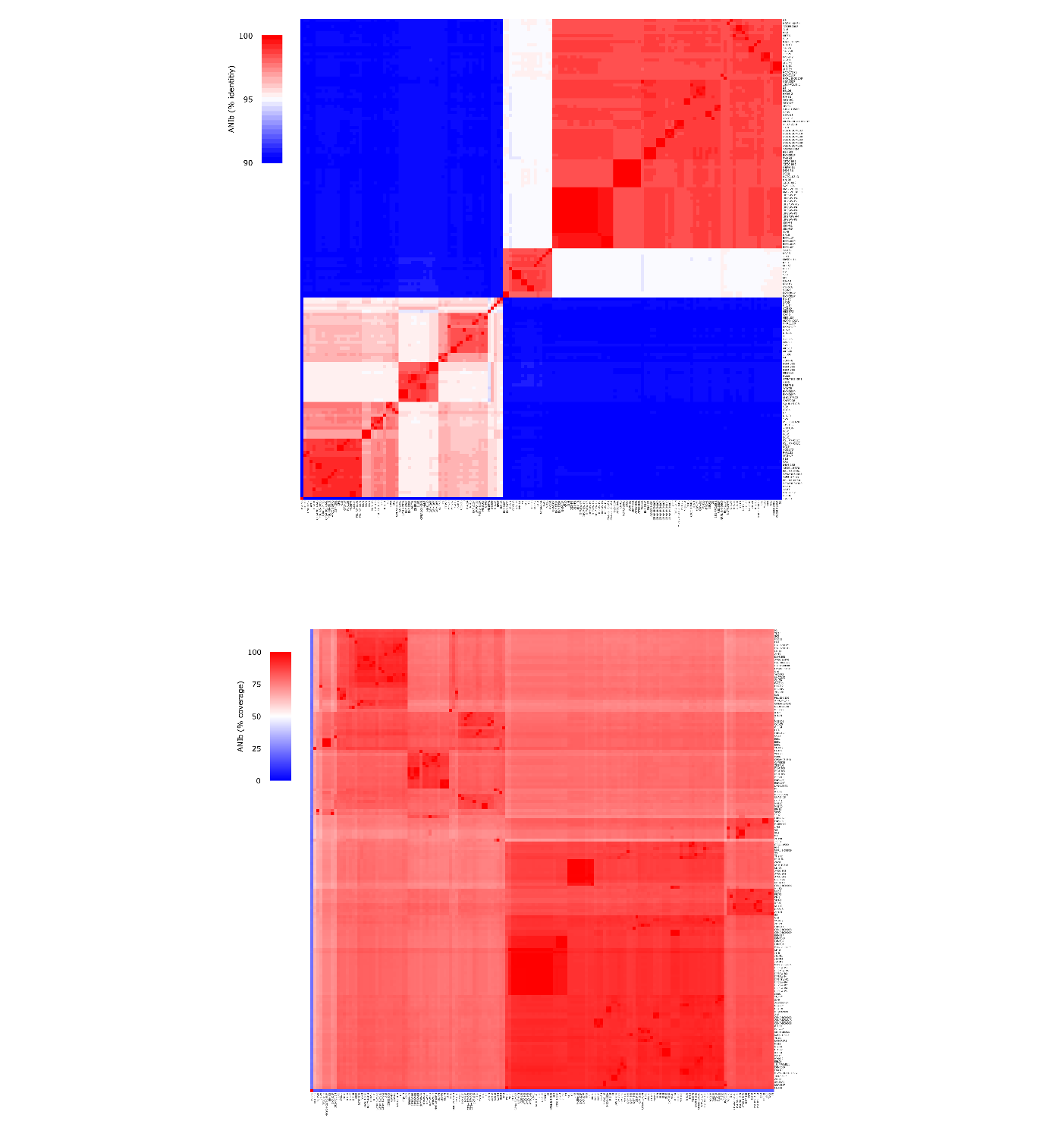
Figure S2 Average nucleotide identity results for 157 P. polymyxa strains based on blast comparisons. (A) Percentage identity and (B) percentage alignment coverage.

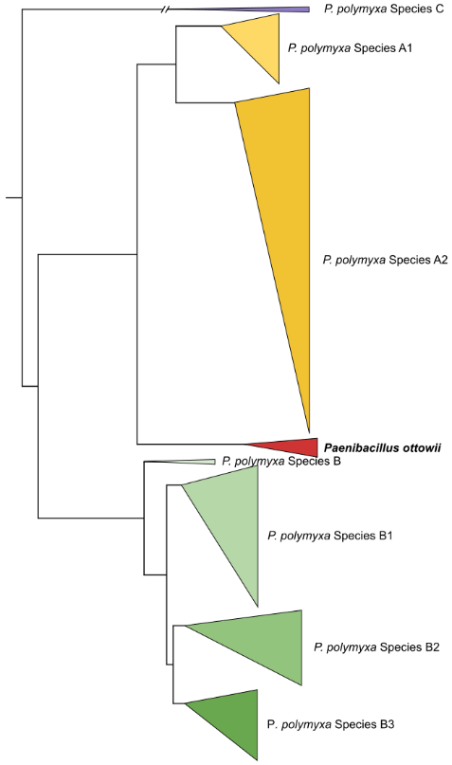
Figure S3 Phylogenetic reconstruction P. polymyxa species groups and P. ottowii. Single copy orthologous protein sequences were detected and aligned for 157 P. polymyxa genomes and 5 P. ottowii genomes using Orthofinder resulting in an alignment of 1388 sequences for a total of 403,770 amino acids. The tree was build using FastTree with default parameters.

