Supplementary Table 1. The conventional physical therapy protocol

Time | Goal | Exercises | Frequency
4 weeks | For flexibility and mobility | Passive movements | 10min/day, 5 days/week
4 weeks | For flexibility and mobility | Stretching | 10min/day, 5 days/week
4 weeks | For improvement in muscle Strength | Resistance Exercises | 10min/day, 5 days/week
4 weeks | For improvement in balance, Strength, and coordination | Gait training | 10min/day, 5 days/week

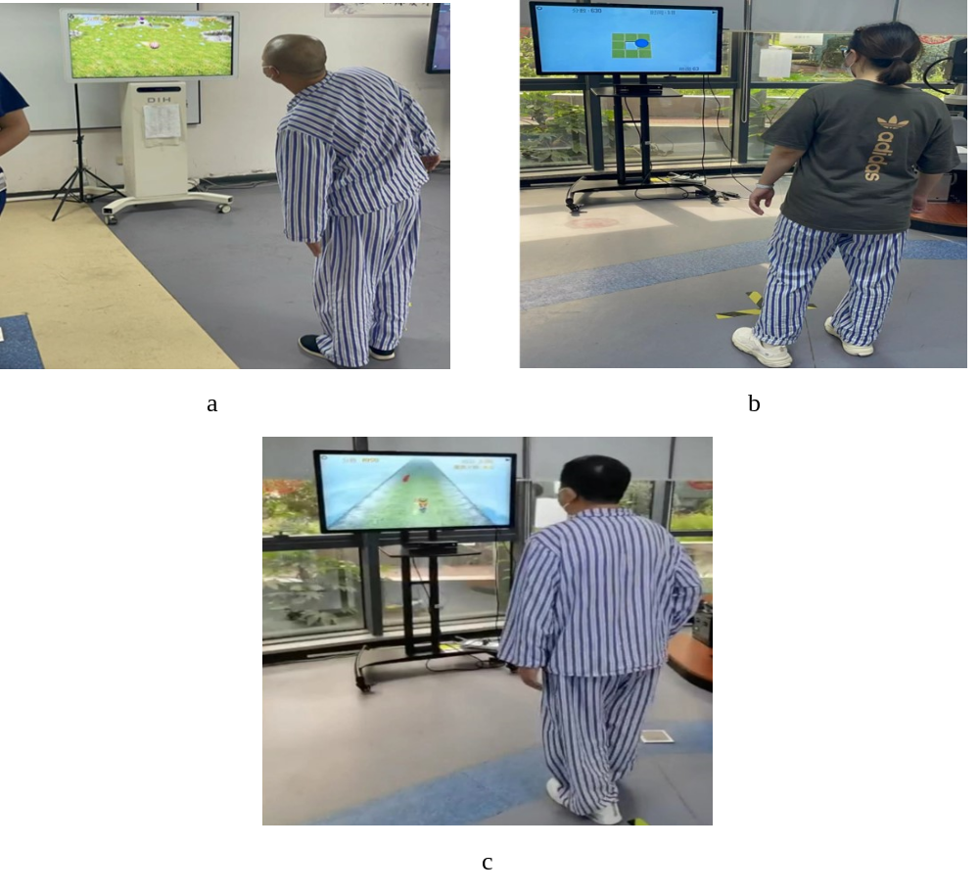

Supplementary Figure 1: Three Doctor kinetic VR training games. a: rolling the ball; b: falling the ball; c: running and jumping.

Supplementary Table 2. The virtual reality training protocol.
Time | Goal | Games | Frequency
Zero session | To get the familiarity and orientation | Different games | 5 min
4 weeks | To achieve Torso control ability (including flexion and extension of the trunk in all directions), Standing secondary balance, Trunk core muscle strength | Roll the ball | 10 min/day, 5 days/week
4 weeks | To achieve Dynamic balance ability, walking function (including forward backward and horizontal lateral movement in all directions) | Falls the ball | 10 min/day, 5 days/week
4 weeks | To achieve Dynamic balance ability, Coordination function, Walking function, Reaction speed. | Run and jump | 10 min/day, 5 days/week

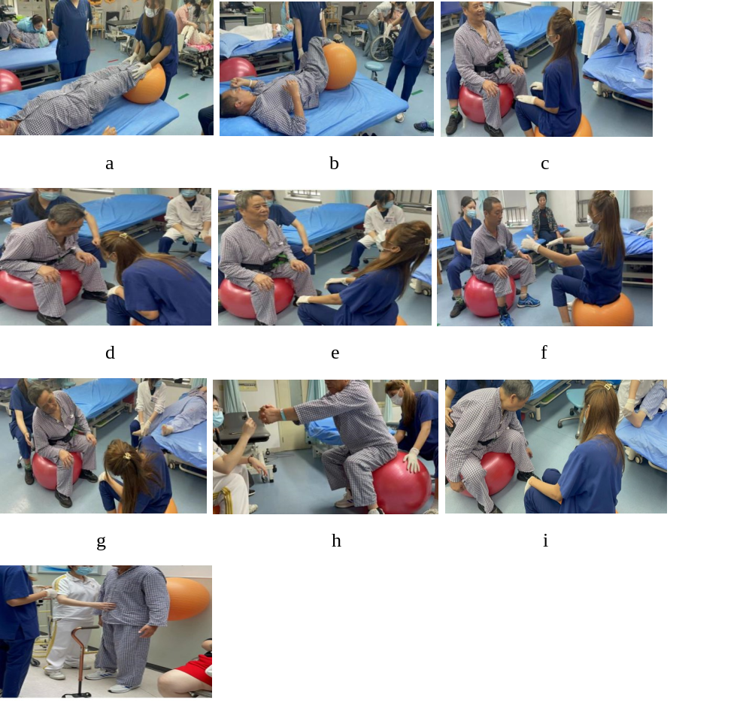
Supplementary Figure 2. Eight exercises in three different positions of body. Supine Exercise (a: Bridging; b: Lower trunk rotation), Sitting Exercise (c: Static sitting; d: Front and back bending; e: Swiss ball rocking; f: Trunk letteral flexion; g: Forward reach; h: Lateral reach) Standing Exercise (i: Swiss ball wall squats with knee extension; j: Swiss ball wall squats with knee bending).

Supplementary Table 3. The Swiss ball training protocol
Time | Goal | Tasks | Frequency
Zero session | Orientation | Tasks description
Zero session | Orientation | Practice of some exercises
4 weeks | Balance & mobility | Supine exercises
4 weeks | Balance & mobility | Bridging (hamstring curl) | 5 reps/set, 3 sets/session =75 sec
4 weeks | Balance & mobility | Lower trunk rotation | 5 reps/set, 3 sets/session =75 sec
4 weeks | Balance & mobility | Sitting exercises
4 weeks | Balance & mobility | Static sitting balance | 5 reps/set, 3 sets/session =75 sec
4 weeks | Balance & mobility | Front and back bending | 5 reps/set, 3 sets/session =75 sec
4 weeks | Balance & mobility | Trunk lateral flexion | 5 reps/set, 3 sets/session =75 sec
4 weeks | Balance & mobility | Swiss ball rocking | 5 reps/set, 3 sets/session =75 sec
4 weeks | Balance & mobility | Forward reach | 5 reps/set, 3 sets/session =75 sec
4 weeks | Balance & mobility | Lateral reach | 5 reps/set, 3 sets/session =75 sec
4 weeks | Balance & mobility | Standing exercises
4 weeks | Balance & mobility | Wall squatting exercises (Swiss ball squats) with knees in extension | 5 reps/set, 3 sets/session =75 sec
4 weeks | Balance & mobility | Wall squat with knees bending | 5 reps/set, 3 sets/session =75 sec

