Supplementary information:

Supplementary Information 1. Multicollinearity test, Variance Inflation Factor and stepwise selection procedure to define the cofounding variables for the matching analysis for Protected Areas, Indigenous Land, Non-Timber Forest Products, Logging and Mining Concessions. (a) Using forest loss between 2000 and 2021, and (b) using forest loss between 2005 and 2021.

a. Using forest loss between 2000 and 2021

Protected Areas
Multicollinearity test;
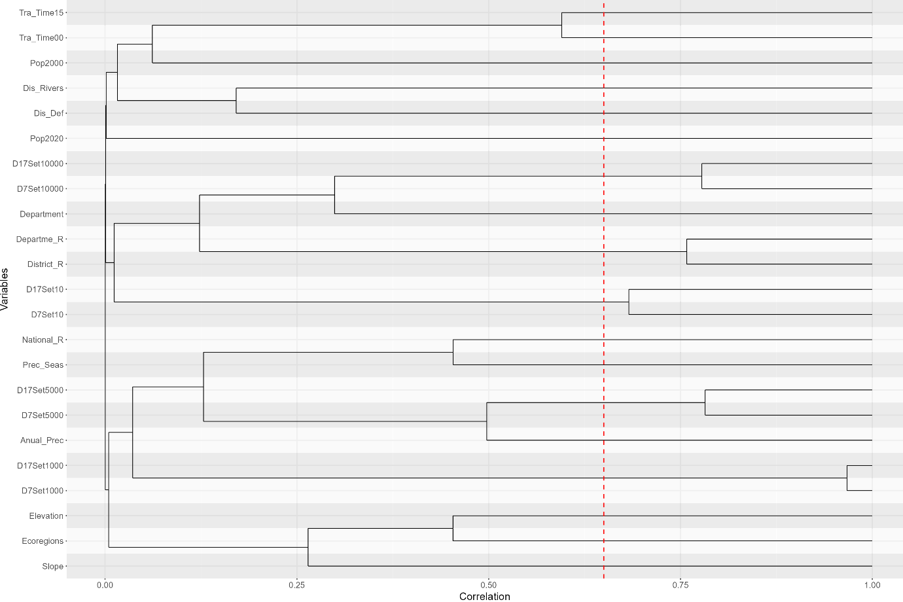

Variance Inflation Factor by variable;
Var | group | VIF
Department | 1 | 1.69410506
Anual_Prec | 2 | 2.85282176
Prec_Seas | 3 | 3.53124285
Dis_Def | 4 | 1.36829199
Dis_Rivers | 5 | 1.17805185
Departme_R | 6 | 5.13261878
District_R | 6 | 12.0544236
National_R | 7 | 5.60758165
D17Set10 | 8 | 4.30559456
D7Set10 | 8 | 4.81883665
D7Set1000 | 9 | 61.6261501
D17Set1000 | 9 | 64.4311409
D17Set5000 | 10 | 20.6796504
D7Set5000 | 10 | 33.8760741
D7Set10000 | 11 | 23.3817136
D17Set10000 | 11 | 34.2521592
Ecoregions | 12 | 3.33167367
Elevation | 13 | 4.69407298
Pop2000 | 14 | 1.36399994
Pop2020 | 15 | 1.00027113
Slope | 16 | 2.20557753
Tra_Time00 | 17 | 2.90541488
Tra_Time15 | 18 | 4.8376098

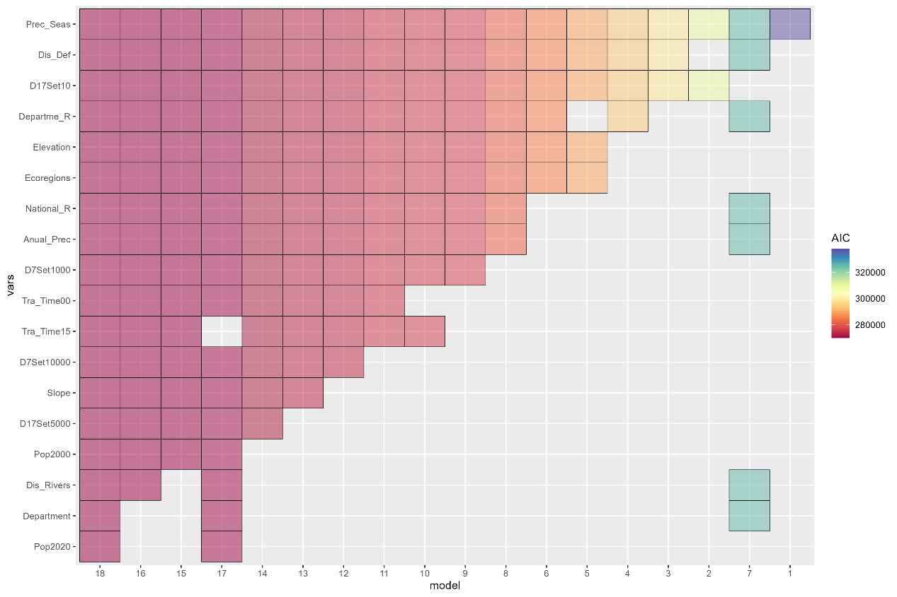
Stepwise selection;

Indigenous Land
Multicollinearity test;
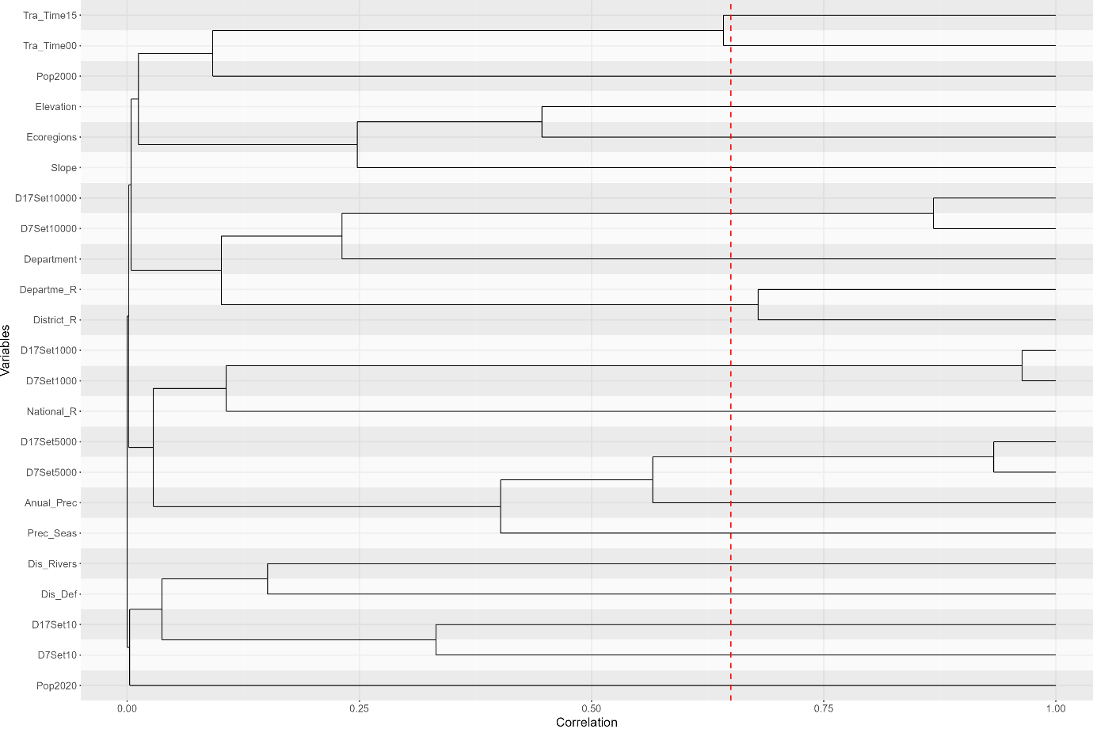

Variance inflation Factor by variable;
Var | group | VIF
Department | 1 | 2.19445602
Anual_Prec | 2 | 3.31152158
Prec_Seas | 3 | 3.40904303
Dis_Def | 4 | 1.41305574
Dis_Rivers | 5 | 1.27464194
Departme_R | 6 | 3.81017051
District_R | 6 | 11.3640337
National_R | 7 | 4.52945918
D7Set10 | 8 | 1.76056892
D7Set1000 | 9 | 53.3749843
D17Set1000 | 9 | 57.2514218
D17Set5000 | 10 | 40.6755706
D7Set5000 | 10 | 47.9756595
D7Set10000 | 11 | 23.6815111
D17Set10000 | 11 | 33.4487312
D17Set10 | 12 | 1.85457387
Ecoregions | 13 | 3.02130728
Elevation | 14 | 4.60987649
Pop2000 | 15 | 1.56141907
Pop2020 | 16 | 1.00018363
Slope | 17 | 2.24934757
Tra_Time00 | 18 | 2.90189409
Tra_Time15 | 19 | 5.31730491

Stepwise selection;
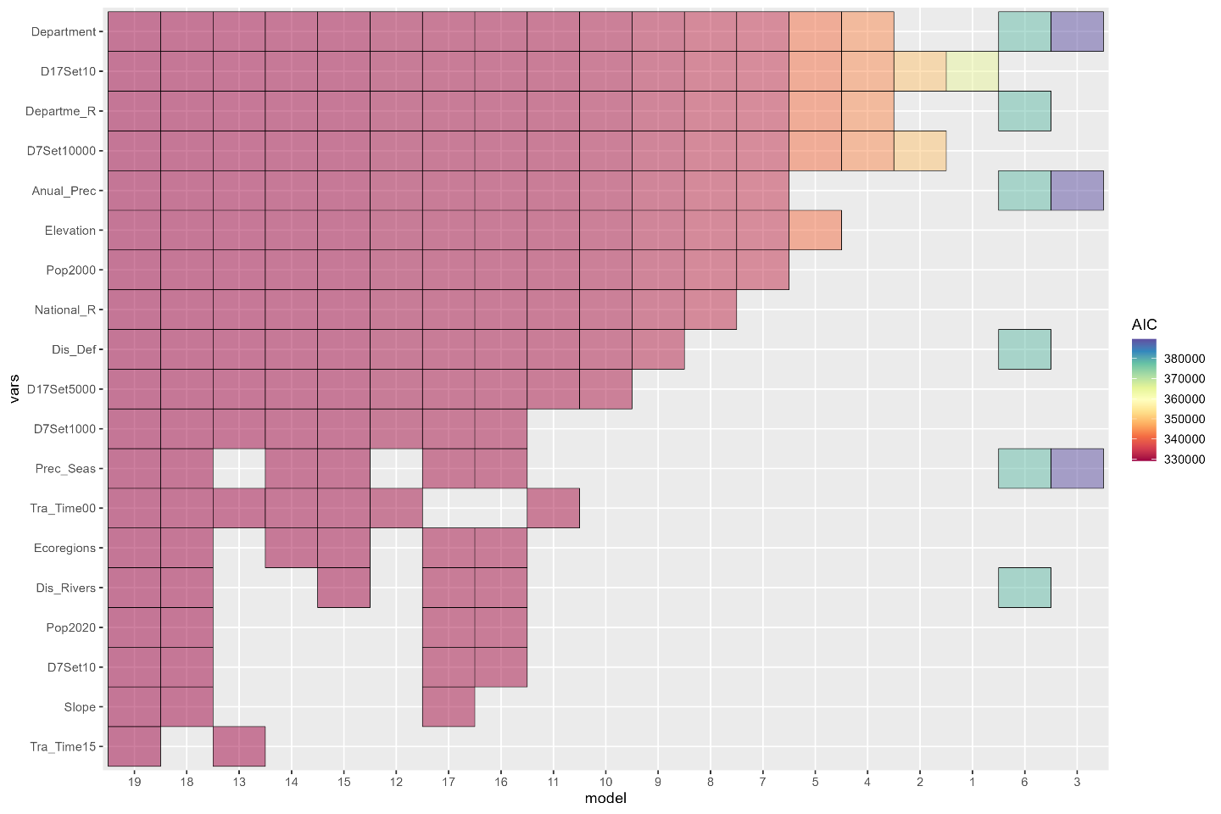

Non-Forest Wood Products Concessions
Multicollinearity test;
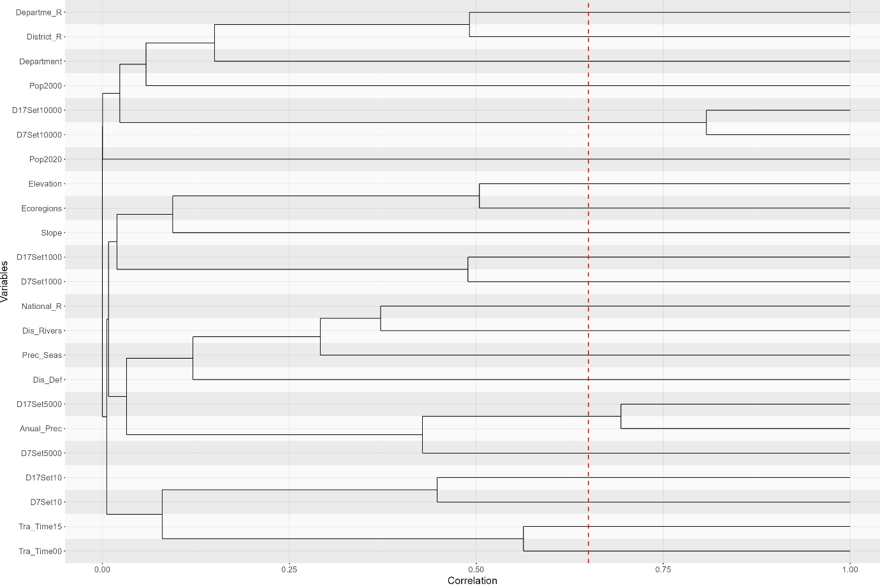

Variance inflation Factor by variable;
Var | group | VIF
Department | 1 | 2.09877851
Anual_Prec | 2 | 4.65457237
D17Set5000 | 2 | 6.61218438
Prec_Seas | 3 | 3.95249265
Dis_Def | 4 | 1.65341497
Dis_Rivers | 5 | 2.20988578
District_R | 6 | 15.5332299
Departme_R | 7 | 6.45208089
National_R | 8 | 7.794971
D7Set10 | 9 | 5.57654657
D7Set1000 | 10 | 4.19331782
D7Set5000 | 11 | 19.4181469
D7Set10000 | 12 | 37.6485804
D17Set10000 | 12 | 52.603992
D17Set10 | 13 | 3.21616542
D17Set1000 | 14 | 7.5332907
Ecoregions | 15 | 2.42091915
Elevation | 16 | 3.17439799
Pop2000 | 17 | 1.90806452
Pop2020 | 18 | 1.00000966
Slope | 19 | 1.85049982
Tra_Time00 | 20 | 4.45627221
Tra_Time15 | 21 | 7.00173175

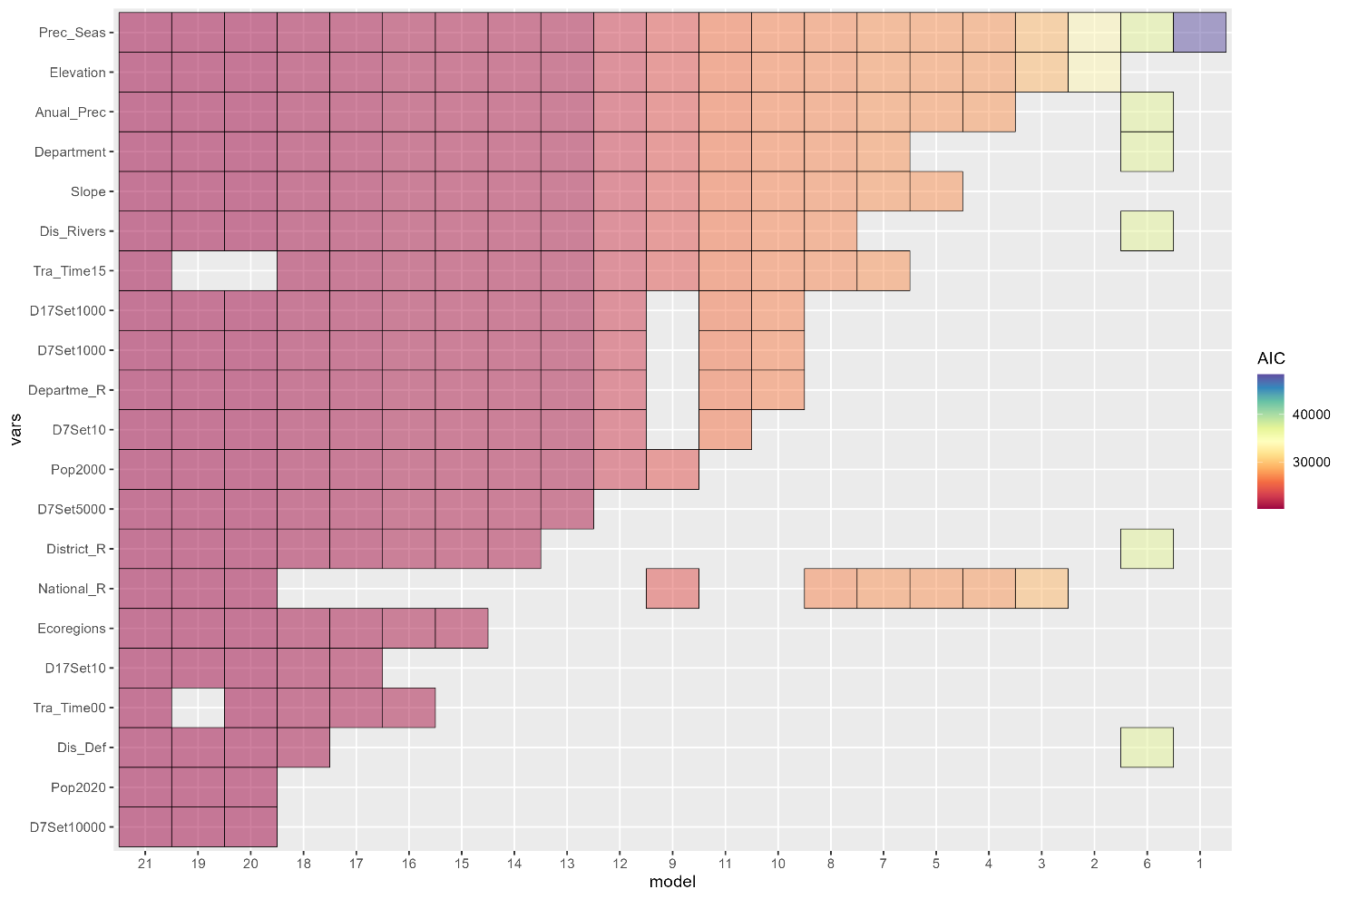
Stepwise selection;

Logging Concessions
Multicollinearity test;
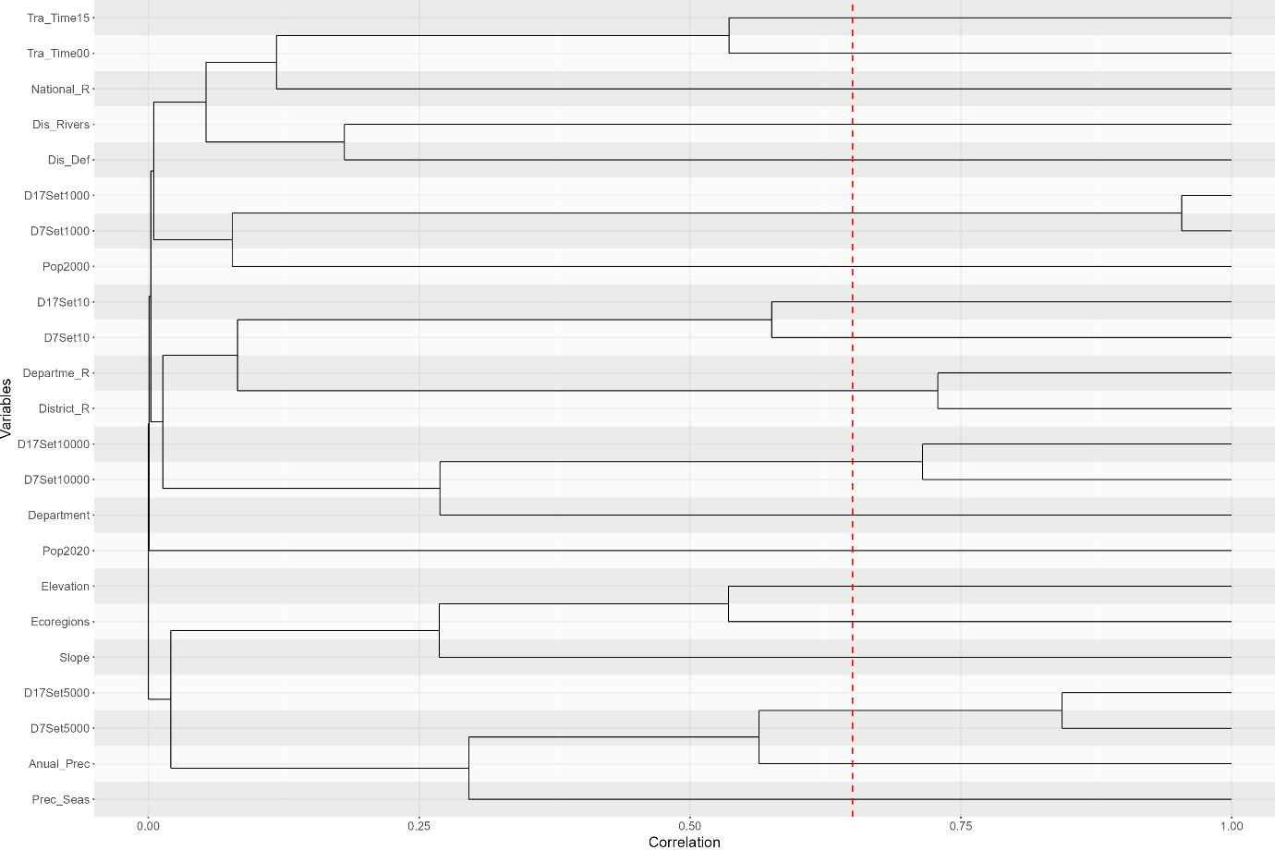

Variance inflation Factor by variable;

Var | group | VIF
Department | 1 | 1.83808801
Anual_Prec | 2 | 2.98684928
Prec_Seas | 3 | 3.15715866
Dis_Def | 4 | 1.50683415
Dis_Rivers | 5 | 1.36056907
Departme_R | 6 | 6.49834371
District_R | 6 | 9.98329249
National_R | 7 | 3.33535586
D7Set10 | 8 | 3.97791752
D7Set1000 | 9 | 38.3017824
D17Set1000 | 9 | 39.6623864
D17Set5000 | 10 | 15.0174351
D7Set5000 | 10 | 21.3873501
D7Set10000 | 11 | 9.62467823
D17Set10000 | 11 | 15.1633337
D17Set10 | 12 | 2.98374578
Ecoregions | 13 | 3.57540282
Elevation | 14 | 4.20529081
Pop2000 | 15 | 1.54920249
Pop2020 | 16 | 1.00033482
Slope | 17 | 2.28341774
Tra_Time00 | 18 | 3.12845917
Tra_Time15 | 19 | 5.65273446

Stepwise selection;
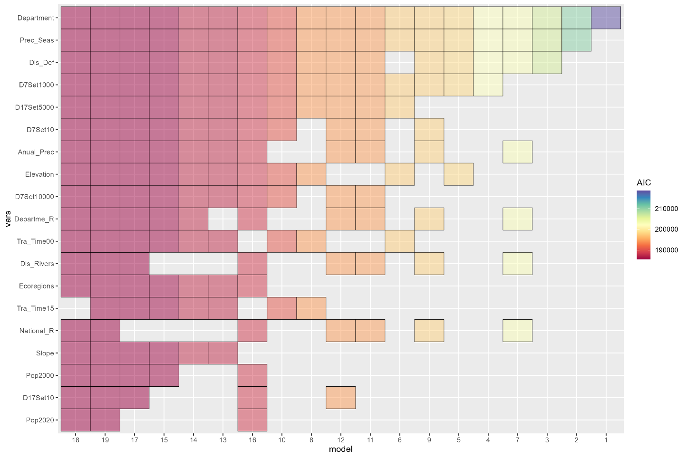

Mining Concessions
Multicollinearity test;
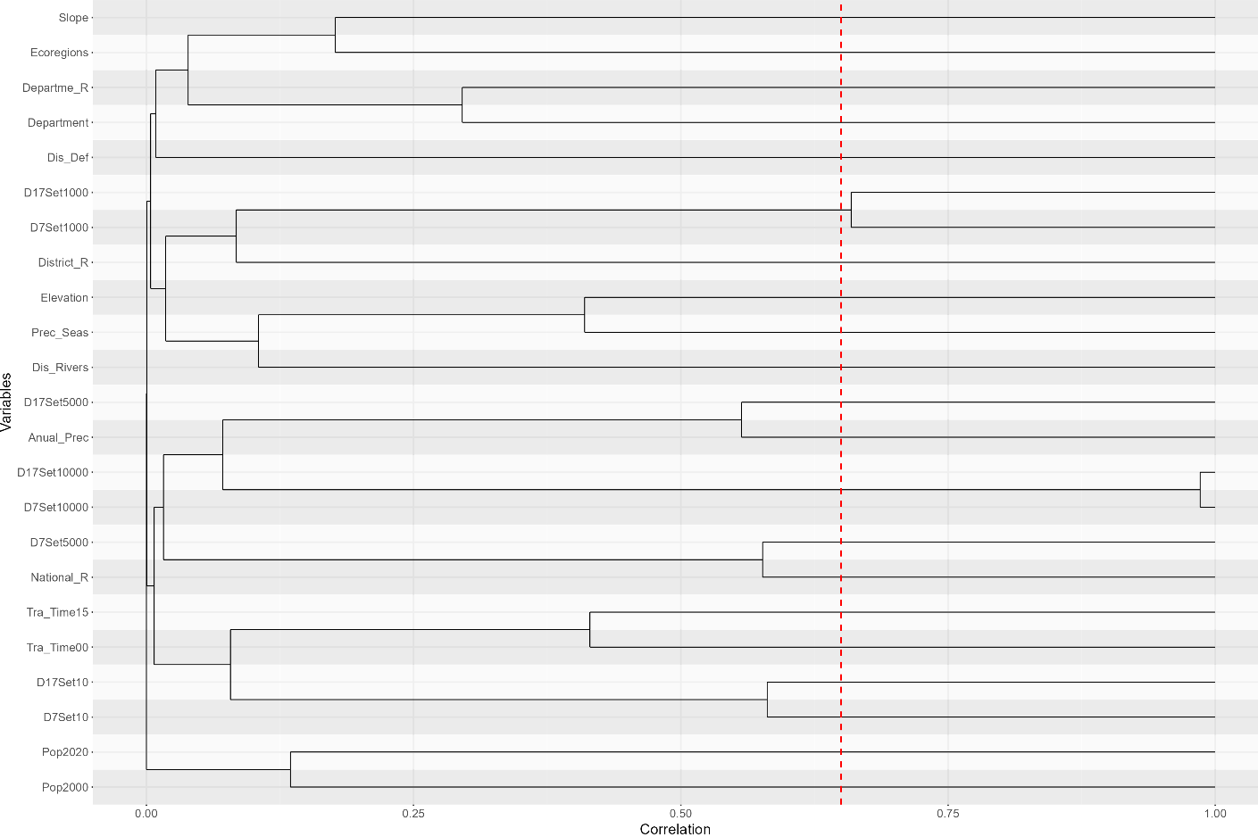

Variance inflation Factor by variable;
Var | group | VIF
Department | 1 | 1.6869039
Annual_Prec | 2 | 5.0444801
Prec_Seas | 3 | 2.57623926
Dis_Def | 4 | 1.18717379
Dis_Rivers | 5 | 1.17463211
District_R | 6 | 2.22154243
Departme_R | 7 | 1.45972314
National_R | 8 | 2.60994788
D7Set10 | 9 | 2.73540411
D7Set1000 | 10 | 3.10659558
D17Set1000 | 10 | 3.24517234
D7Set5000 | 11 | 33.8989558
D7Set10000 | 12 | 1059.52664
D17Set10000 | 12 | 1076.67637
D17Set10 | 13 | 2.62288626
D17Set5000 | 14 | 2.27191718
Ecoregions | 15 | 2.0537503
Elevation | 16 | 4.99714187
Pop2000 | 17 | 1.12631253
Pop2020 | 18 | 1.01965654
Slope | 19 | 1.89082079
Tra_Time00 | 20 | 1.75665039
Tra_Time15 | 21 | 3.05832659

Stepwise selection;
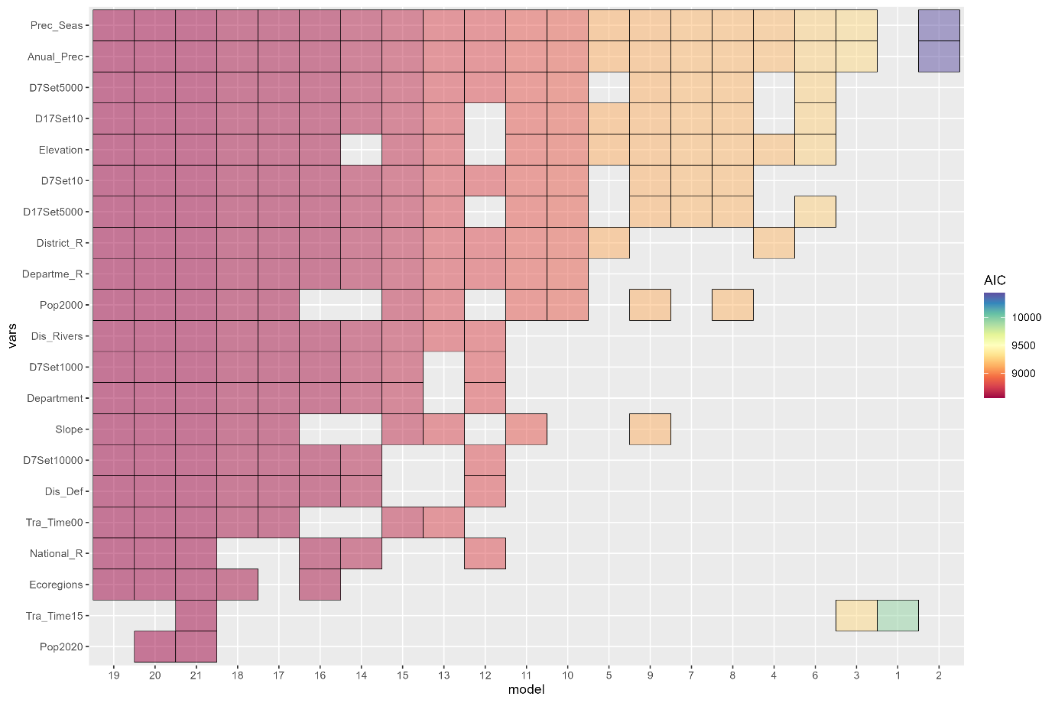

b. Using forest loss between 2000 and 2021

Protected Areas
Multicollinearity test;
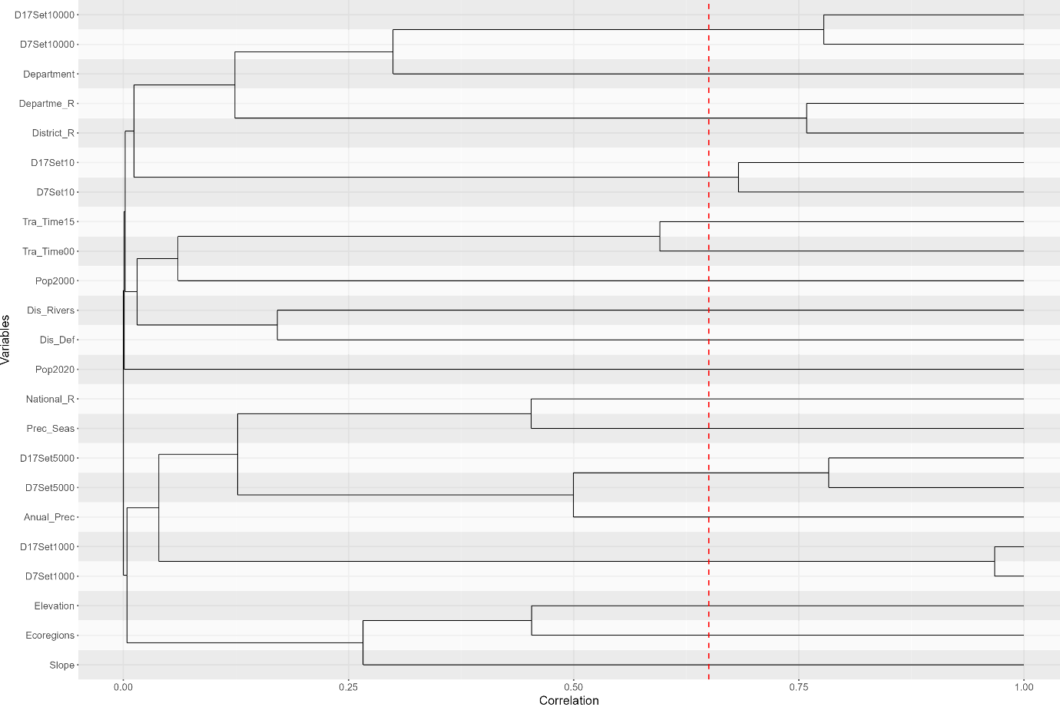

Variance inflation Factor by variable;
Var | group | VIF
Department | 1 | 1.70014234
Annual_Prec | 2 | 2.87951693
Prec_Seas | 3 | 3.53894051
Dis_Def | 4 | 1.36478415
Dis_Rivers | 5 | 1.17763838
Departme_R | 6 | 5.11269927
District_R | 6 | 11.9920476
National_R | 7 | 5.57722652
D17Set10 | 8 | 4.29002332
D7Set10 | 8 | 4.80215704
D7Set1000 | 9 | 62.0565573
D17Set1000 | 9 | 64.8474427
D17Set5000 | 10 | 20.7730329
D7Set5000 | 10 | 34.0061548
D7Set10000 | 11 | 23.2850221
D17Set10000 | 11 | 34.1245127
Ecoregions | 12 | 3.34939643
Elevation | 13 | 4.70984898
Pop2000 | 14 | 1.35338576
Pop2020 | 15 | 1.00027387
Slope | 16 | 2.20901518
Tra_Time00 | 17 | 2.89241513
Tra_Time15 | 18 | 4.79611185

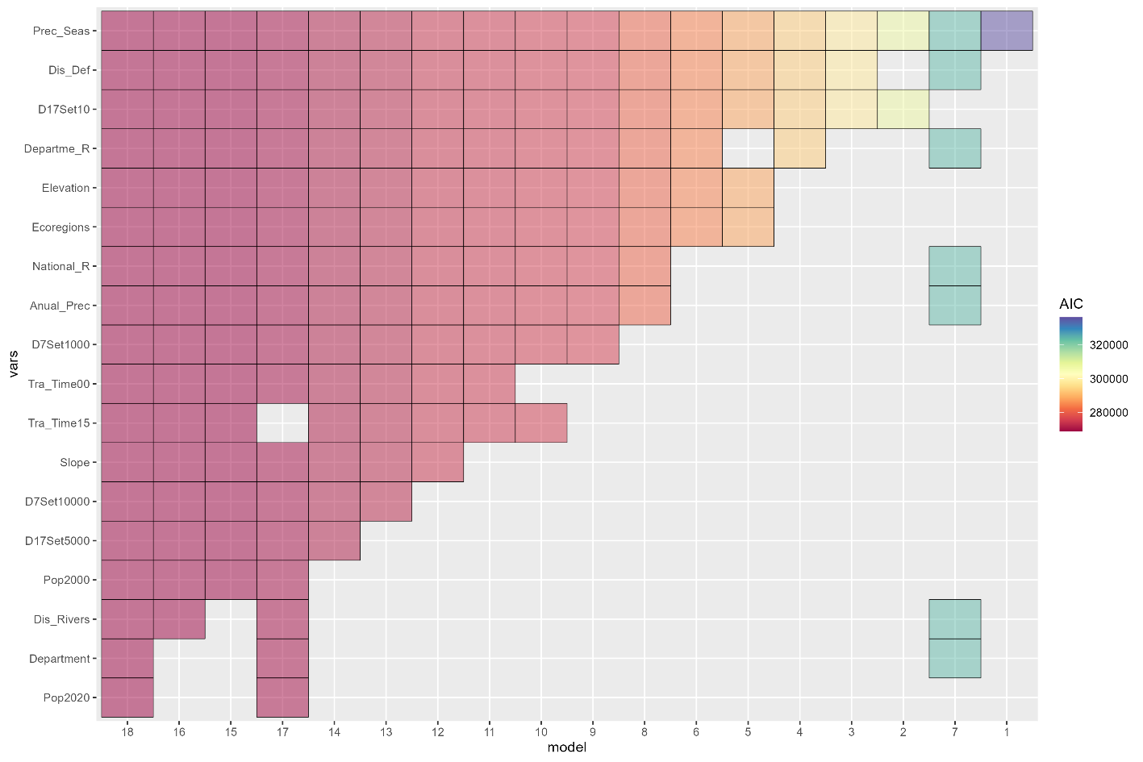
Stepwise selection;

Indigenous Land
Multicollinearity test;
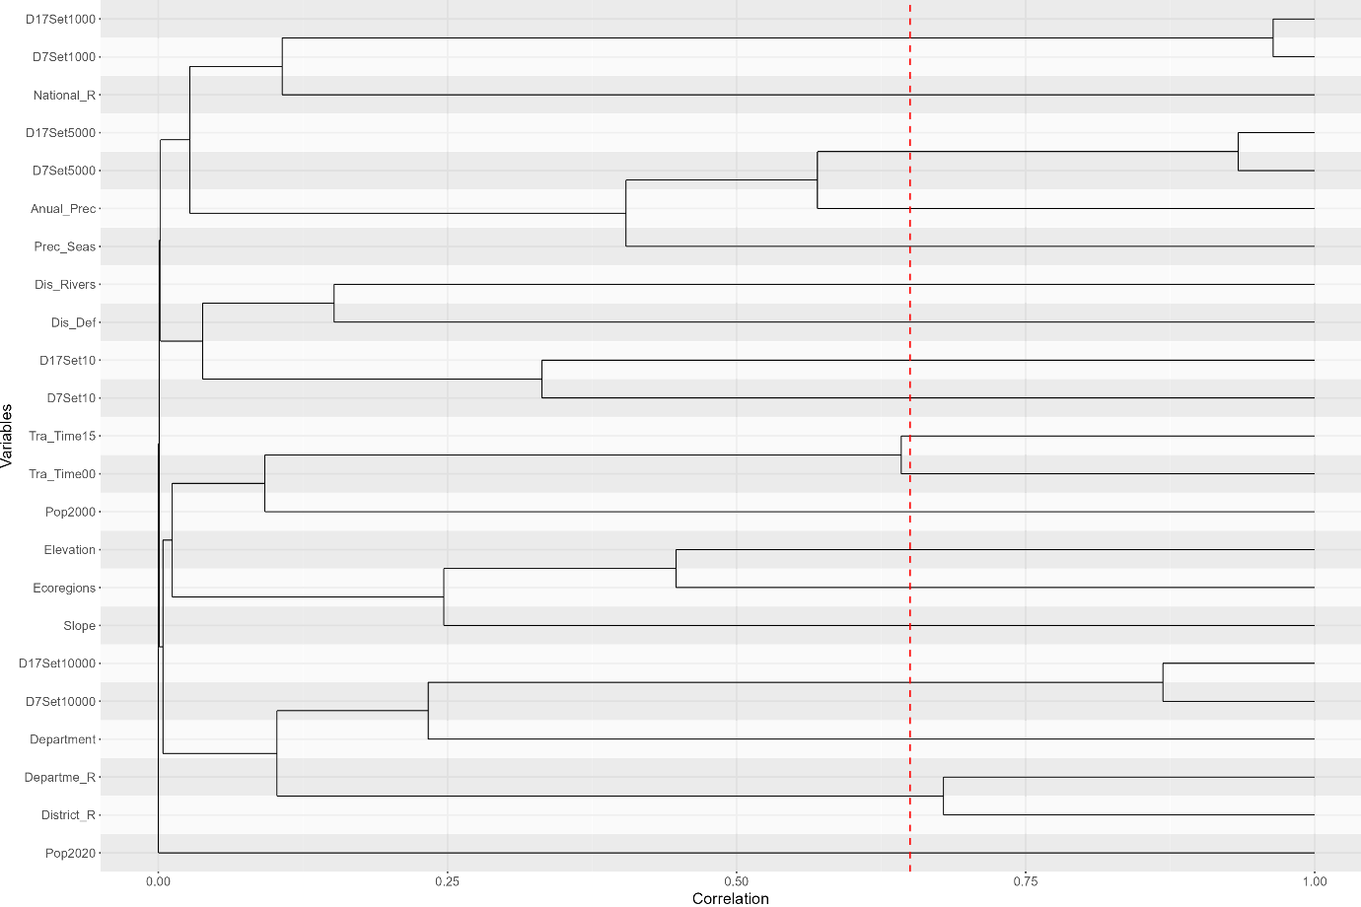

Variance inflation Factor by variable;
Var | group | VIF
Department | 1 | 2.2154294
Anual_Prec | 2 | 3.33513276
Prec_Seas | 3 | 3.42771306
Dis_Def | 4 | 1.40730056
Dis_Rivers | 5 | 1.27518501
Departme_R | 6 | 3.80106149
District_R | 6 | 11.3278977
National_R | 7 | 4.50326403
D7Set10 | 8 | 1.75303791
D7Set1000 | 9 | 53.9291412
D17Set1000 | 9 | 57.8071985
D17Set5000 | 10 | 40.9357329
D7Set5000 | 10 | 48.3214537
D7Set10000 | 11 | 23.6881173
D17Set10000 | 11 | 33.4433869
D17Set10 | 12 | 1.84265421
Ecoregions | 13 | 3.03896826
Elevation | 14 | 4.62881758
Pop2000 | 15 | 1.5637275
Pop2020 | 16 | 1.00018766
Slope | 17 | 2.23930851
Tra_Time00 | 18 | 2.89179082
Tra_Time15 | 19 | 5.27061543

Stepwise selection;
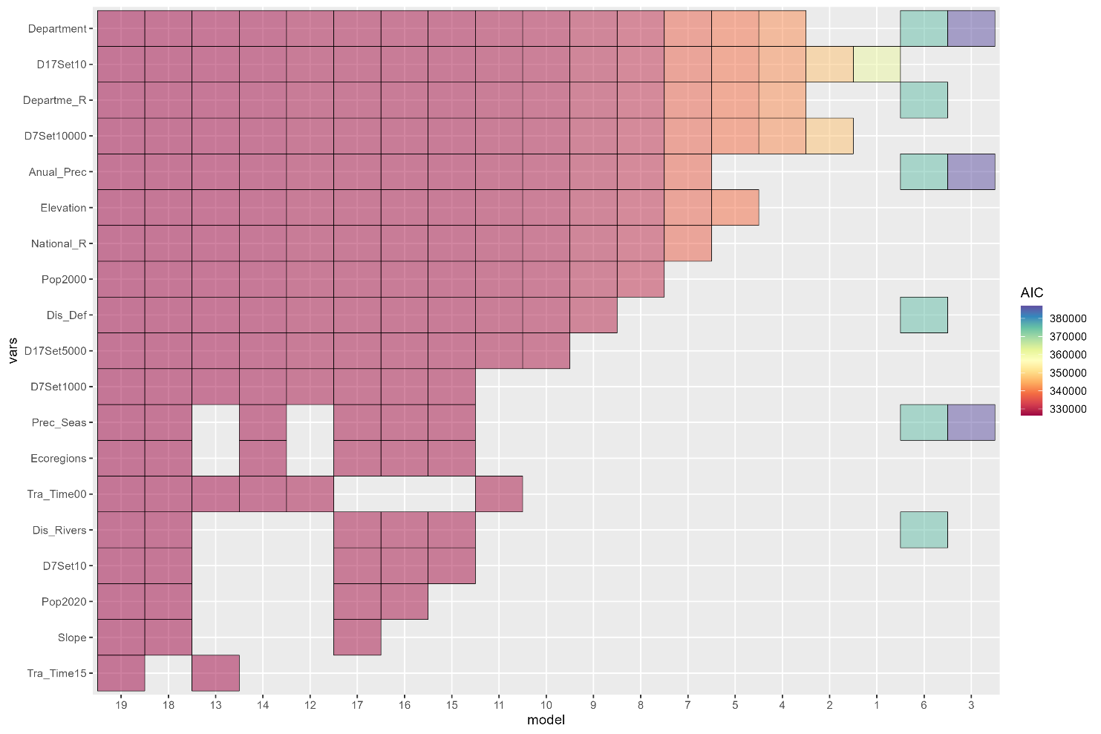

Non-Forest Wood Products Concessions
Multicollinearity test;
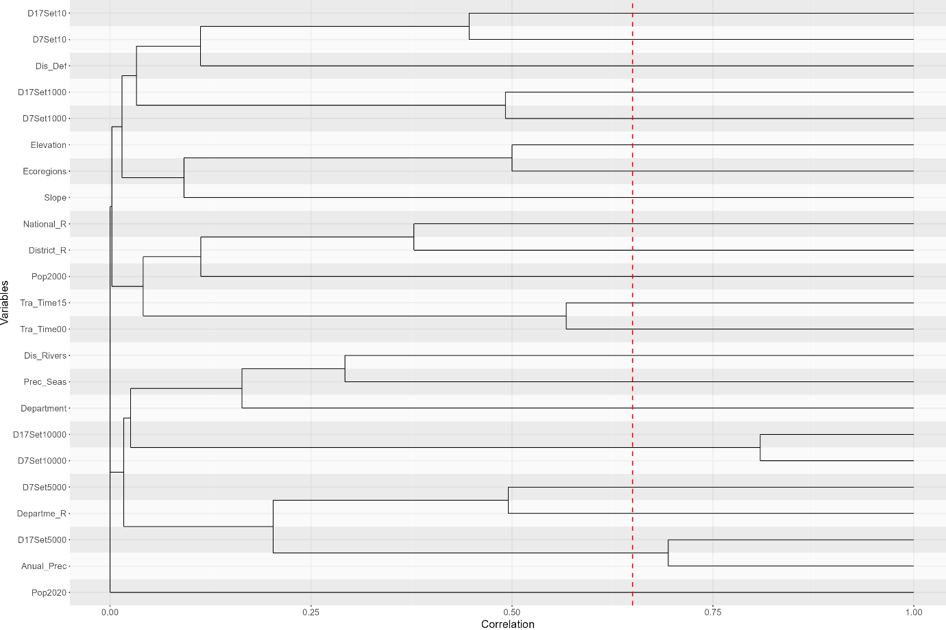

Variance inflation Factor by variable;
Var | group | VIF
Department | 1 | 2.11210655
Anual_Prec | 2 | 4.71337521
D17Set5000 | 2 | 6.67126669
Prec_Seas | 3 | 3.99010228
Dis_Def | 4 | 1.64642879
Dis_Rivers | 5 | 2.20999834
District_R | 6 | 15.8804416
Departme_R | 7 | 6.64068636
National_R | 8 | 8.02658122
D7Set10 | 9 | 5.59660847
D7Set1000 | 10 | 4.2286813
D7Set5000 | 11 | 19.9048953
D7Set10000 | 12 | 39.0438042
D17Set10000 | 12 | 54.4050632
D17Set10 | 13 | 3.22903314
D17Set1000 | 14 | 7.59270567
Ecoregions | 15 | 2.41245979
Elevation | 16 | 3.17121992
Pop2000 | 17 | 1.90581278
Pop2020 | 18 | 1.00003389
Slope | 19 | 1.85314495
Tra_Time00 | 20 | 4.50836976
Tra_Time15 | 21 | 7.05995502

Stepwise selection;
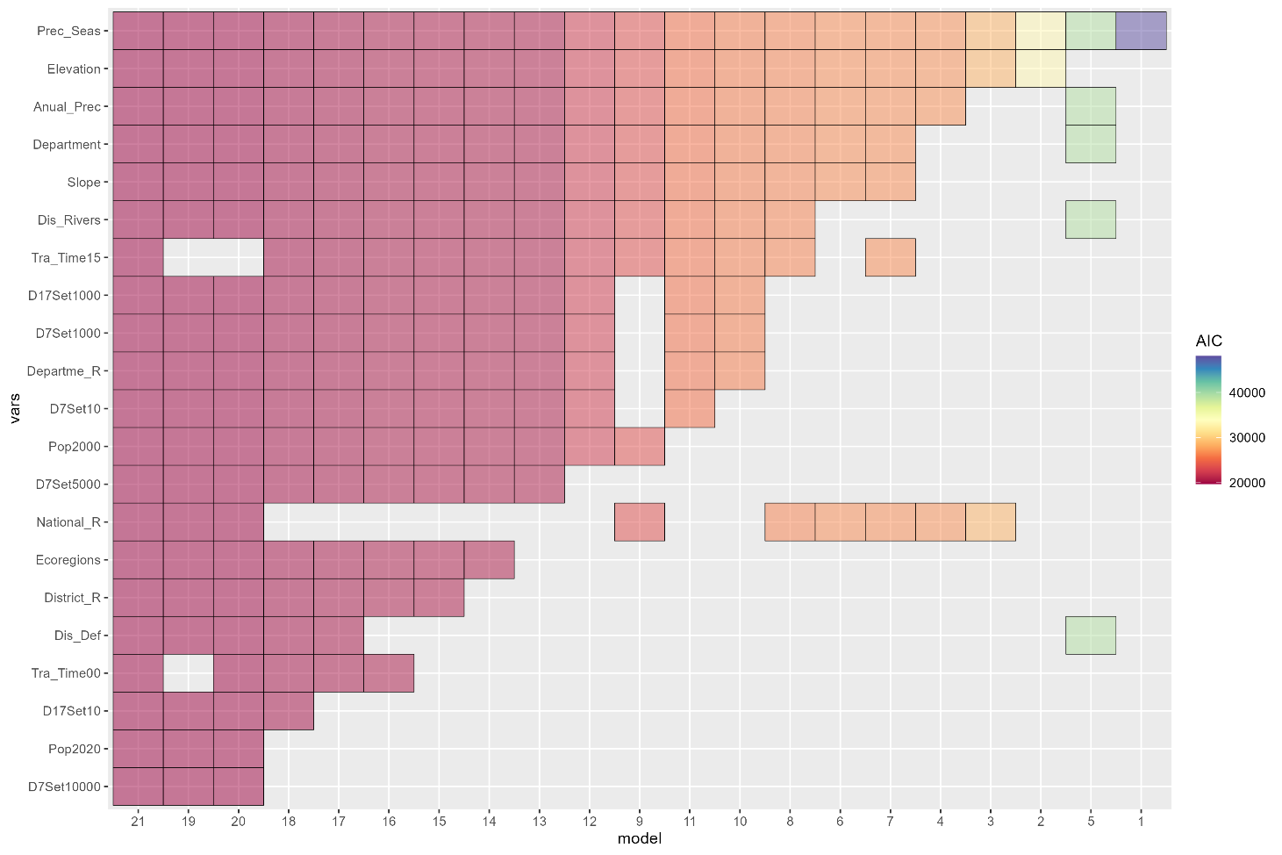

Logging Concessions
Multicollinearity test;
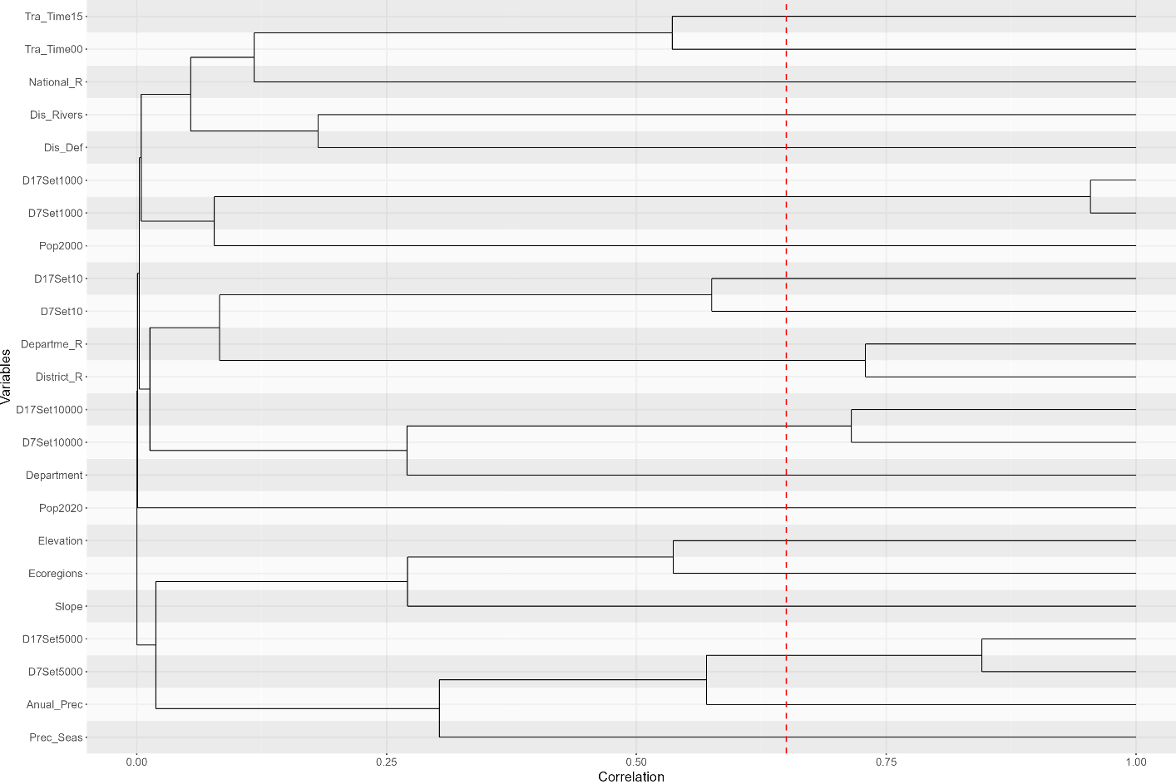

Variance inflation Factor by variable;
Var | group | VIF
Department | 1 | 1.85254175
Anual_Prec | 2 | 3.04920354
Prec_Seas | 3 | 3.18989818
Dis_Def | 4 | 1.50020318
Dis_Rivers | 5 | 1.36106862
Departme_R | 6 | 6.50270305
District_R | 6 | 9.94926024
National_R | 7 | 3.3173399
D7Set10 | 8 | 3.95708447
D7Set1000 | 9 | 38.5058044
D17Set1000 | 9 | 39.8587022
D17Set5000 | 10 | 15.1429439
D7Set5000 | 10 | 21.52099
D7Set10000 | 11 | 9.5897273
D17Set10000 | 11 | 15.0764452
D17Set10 | 12 | 2.96715304
Ecoregions | 13 | 3.61481608
Elevation | 14 | 4.22913825
Pop2000 | 15 | 1.54049625
Pop2020 | 16 | 1.00034697
Slope | 17 | 2.28996688
Tra_Time00 | 18 | 3.11251851
Tra_Time15 | 19 | 5.60574318

Stepwise selection;
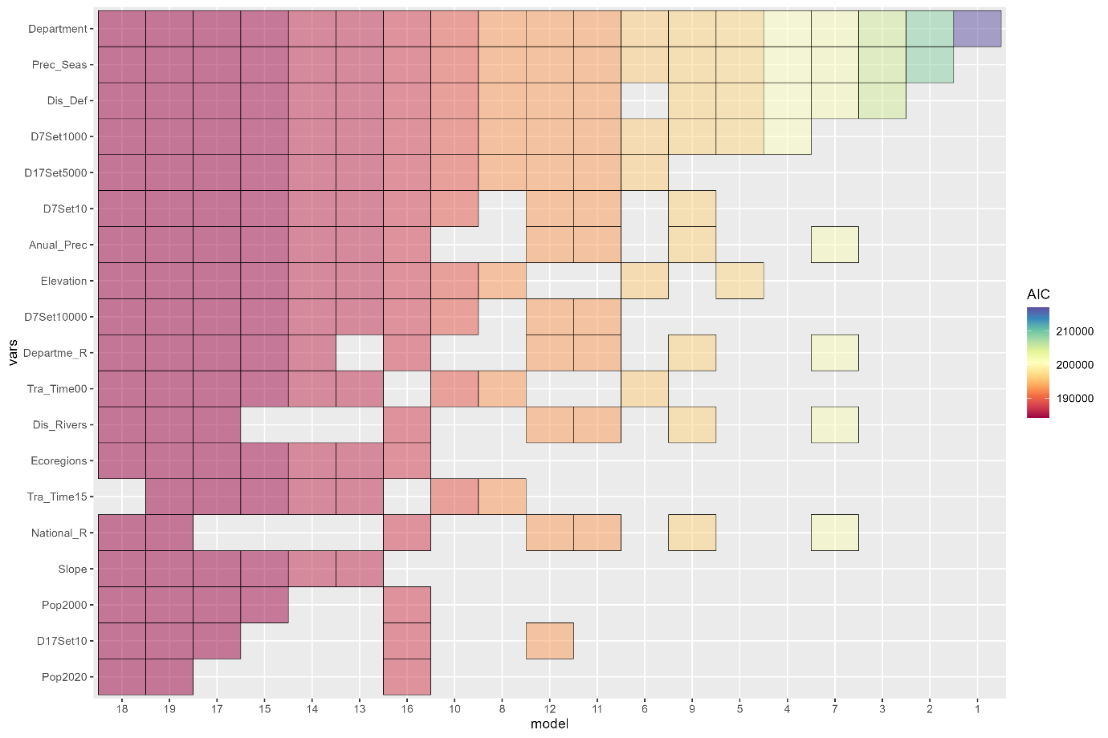

Mining Concessions
Multicollinearity test;
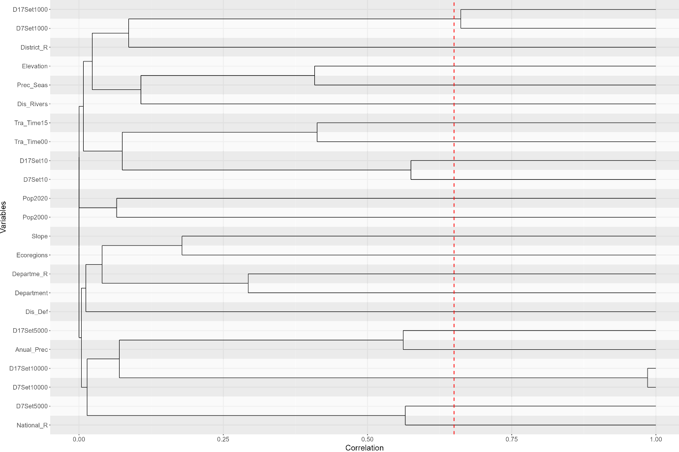

Variance inflation Factor by variable;
Var | group | VIF
Department | 1 | 1.67666738
Anual_Prec | 2 | 5.1482157
Prec_Seas | 3 | 2.58168868
Dis_Def | 4 | 1.18972465
Dis_Rivers | 5 | 1.17881281
District_R | 6 | 2.25267595
Departme_R | 7 | 1.45853411
National_R | 8 | 2.55295592
D7Set10 | 9 | 2.73060923
D7Set1000 | 10 | 3.16678838
D17Set1000 | 10 | 3.31905188
D7Set5000 | 11 | 33.5047508
D7Set10000 | 12 | 1013.263
D17Set10000 | 12 | 1030.74226
D17Set10 | 13 | 2.60711572
D17Set5000 | 14 | 2.29503248
Ecoregions | 15 | 2.04822636
Elevation | 16 | 4.97062432
Pop2000 | 17 | 1.11487862
Pop2020 | 18 | 1.00457076
Slope | 19 | 1.87056591
Tra_Time00 | 20 | 1.75749217
Tra_Time15 | 21 | 3.03938536

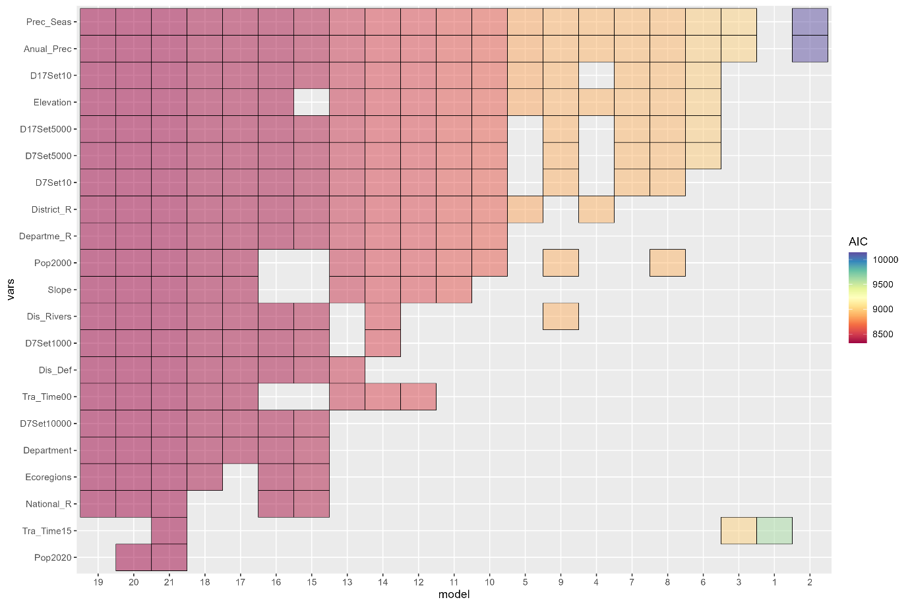
Stepwise selection;

Supplementary Information 2. Indices of covariate imbalance before and after the matching runs for each governance mechanism, to assess the robustness of the matching analysis reducing bias in the control units. (a) Using forest loss between 2000 and 2021, and (b) Using forest loss between 2005 and 2021.
- Indices of covariate imbalance for matching analysis using forest loss between 2000 and 2021
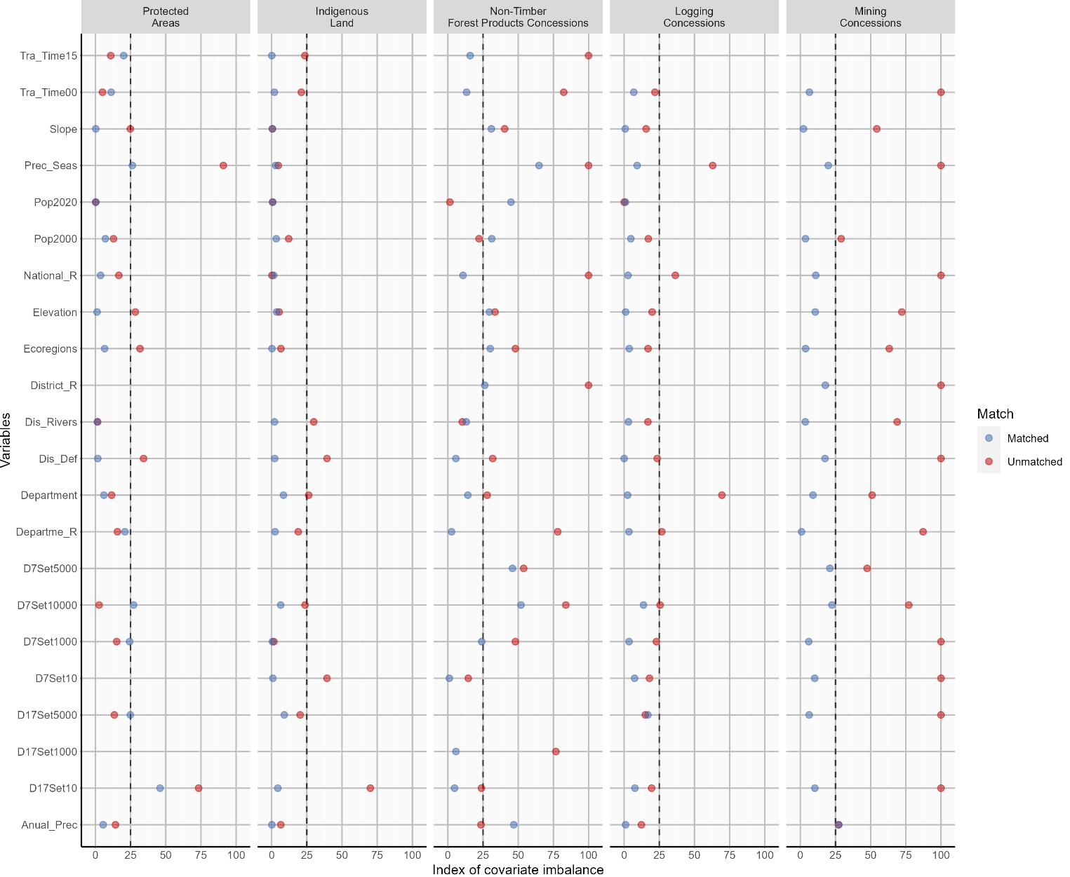

- Indices of covariate imbalance for matching analysis using forest loss between 2005 and 2021
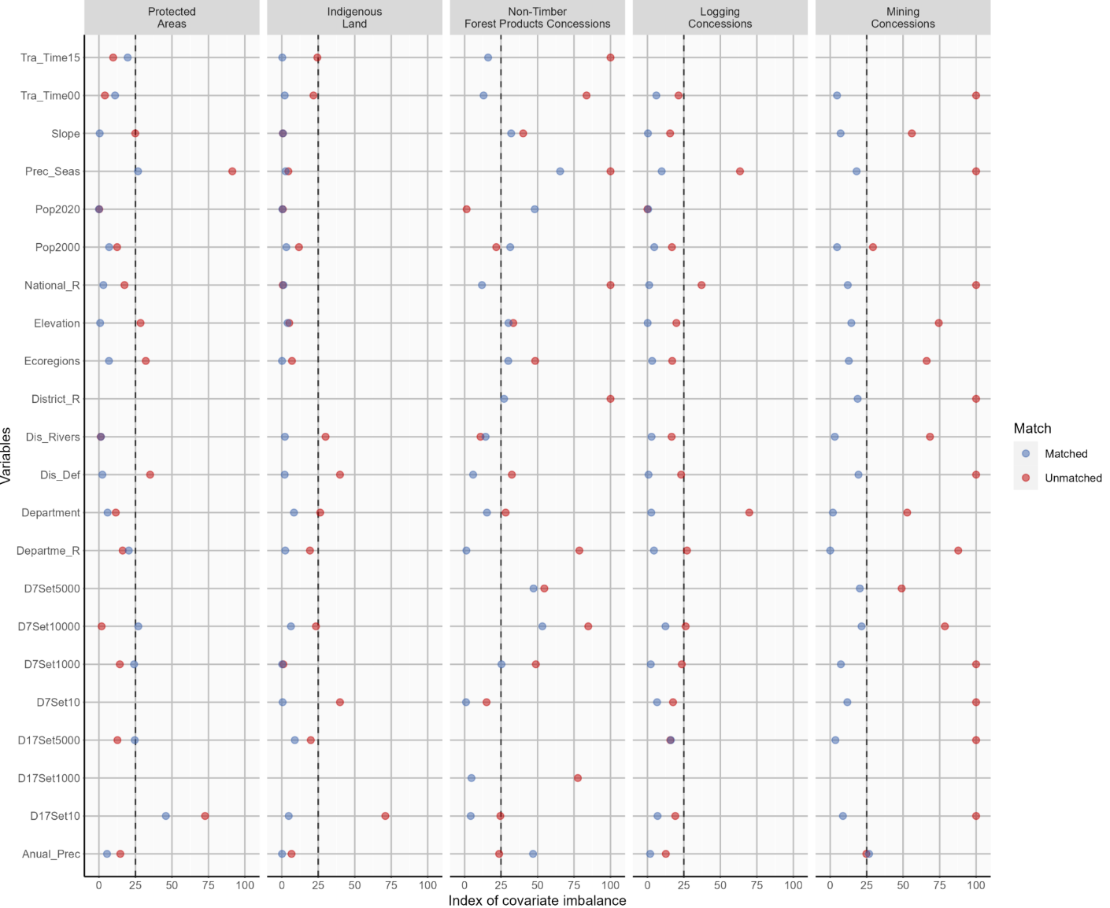

Supplementary Information 3. Propensity score values before and after matching for the matching runs for each governance mechanism to assess the robustness of the matching analysis reducing bias in the control units. (a) Using forest loss between 2000 and 2021 (b) Using forest loss between 2005 and 2021.
(a) Propensity score values sing forest loss between 2000 and 2021

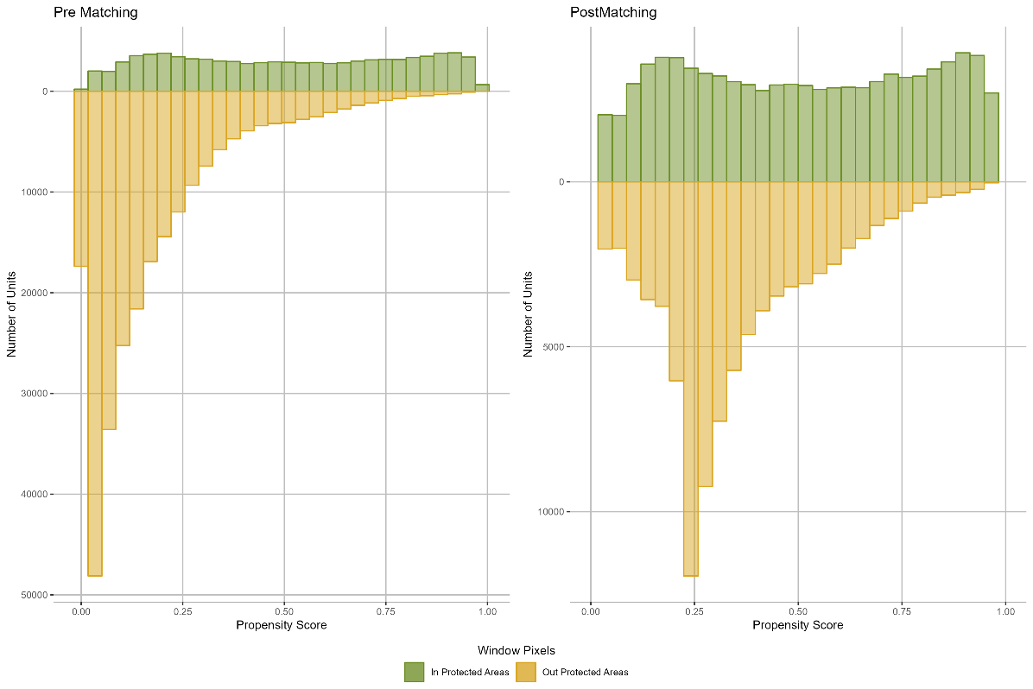
Protected Areas

Indigenous Land
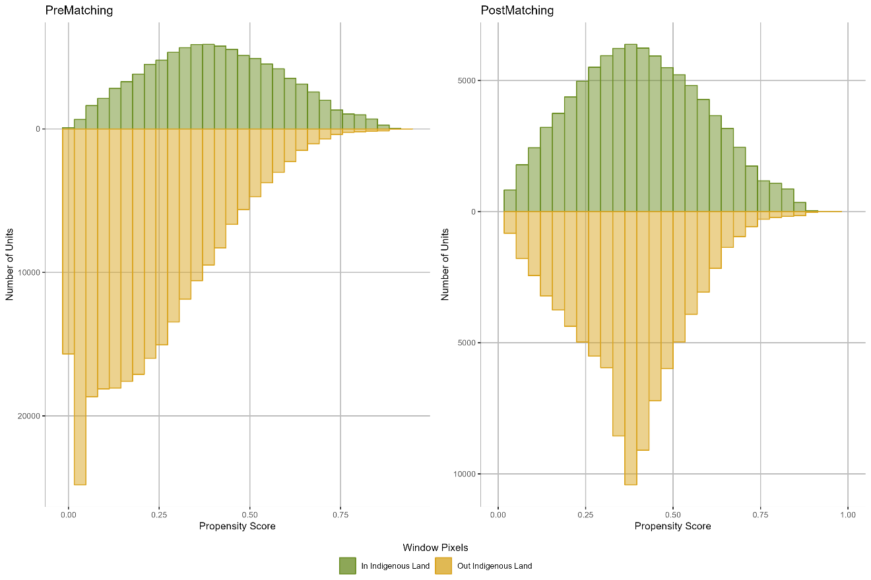

Non-Timber Forest Products Concessions
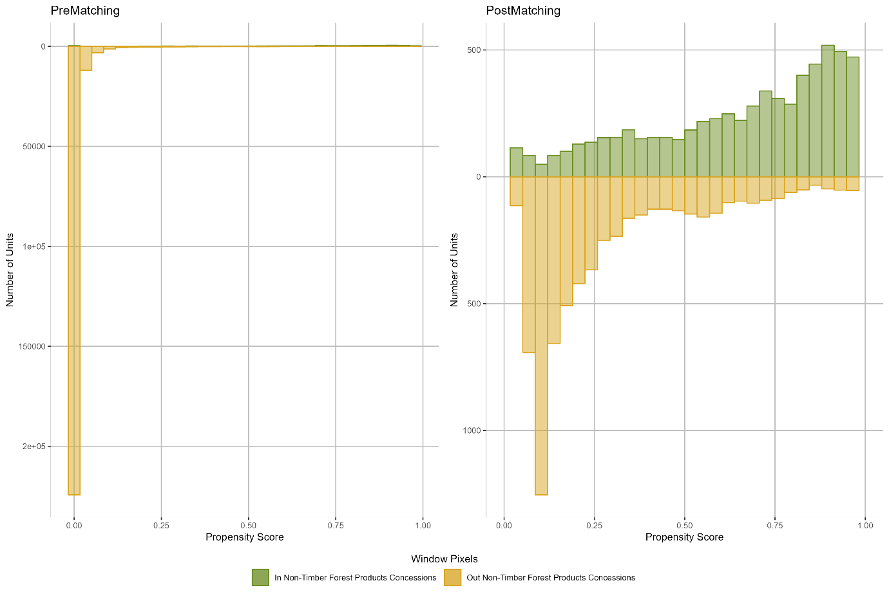

Logging Concessions
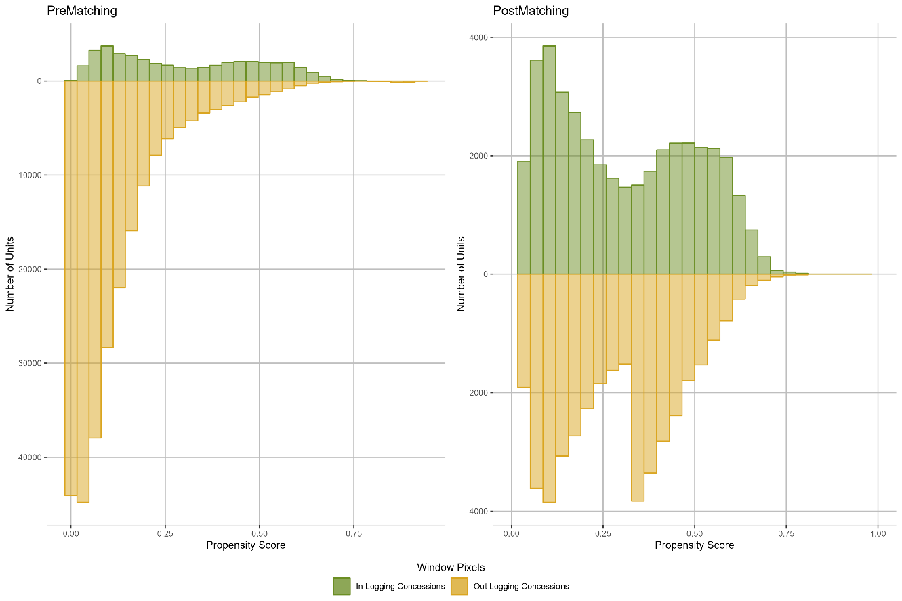

Mining Concessions
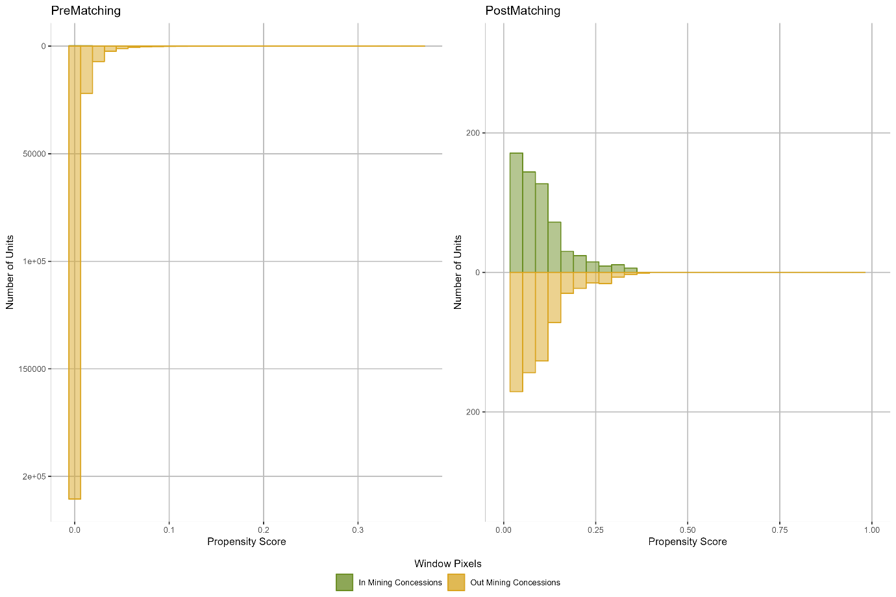

(b) Propensity score values Using forest loss between 2005 and 2021

Protected Areas
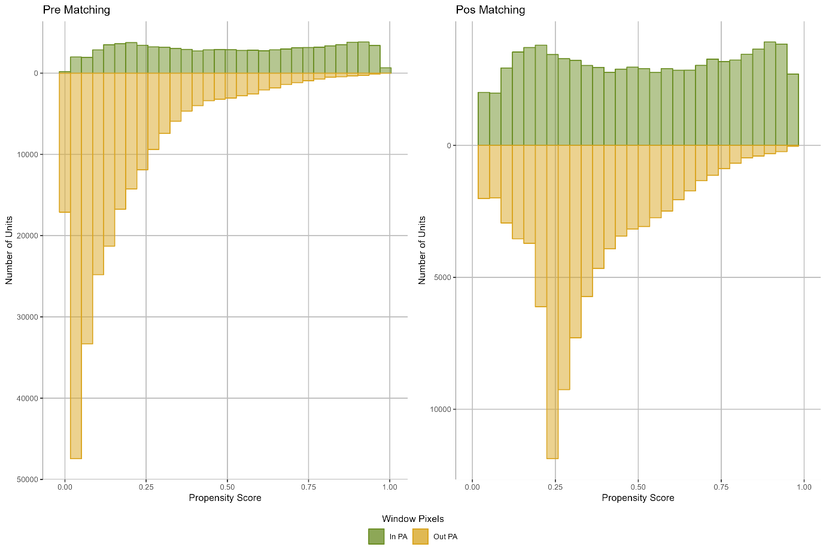

Indigenous land
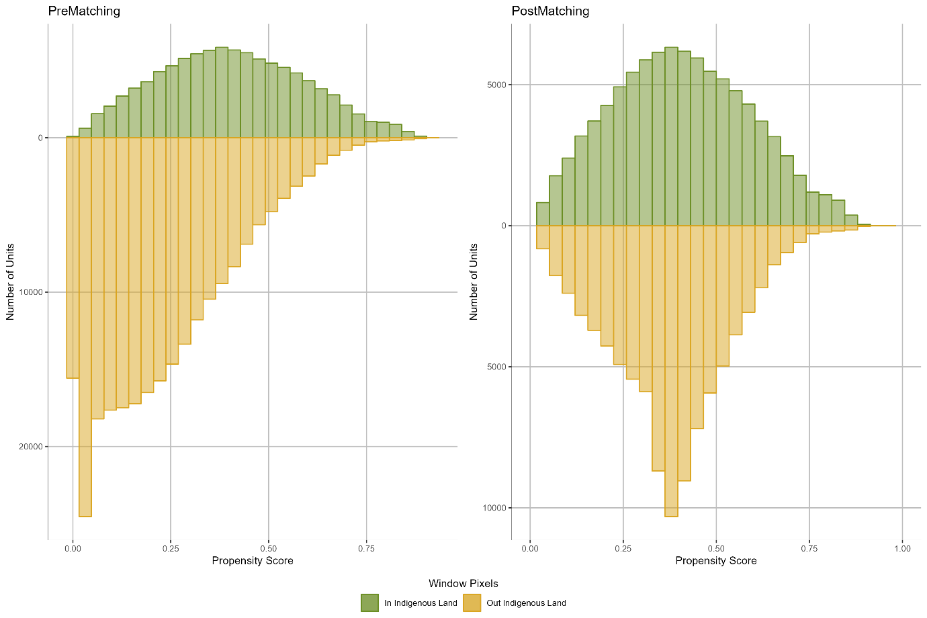

Non-Timber Forest Products Concessions
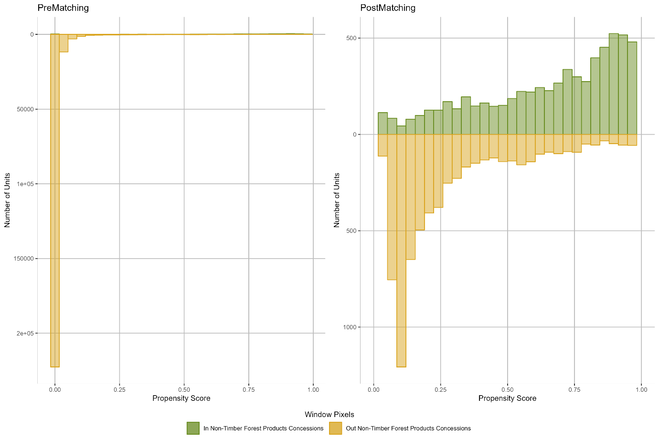

Logging Concessions

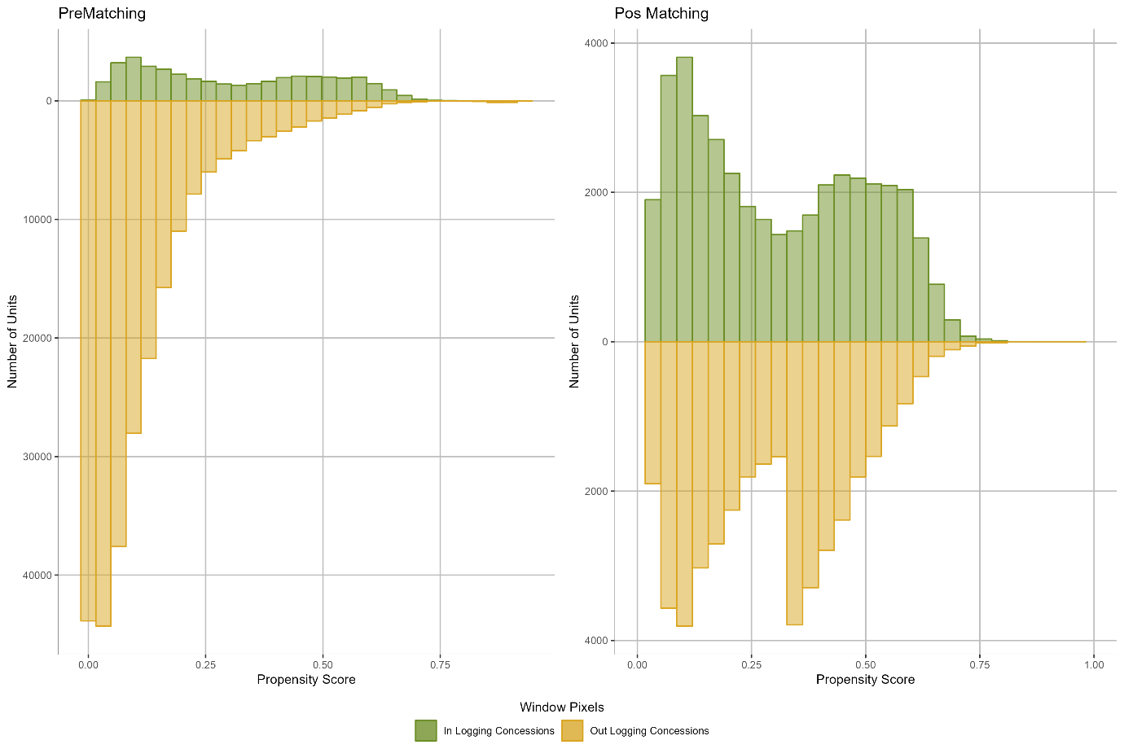

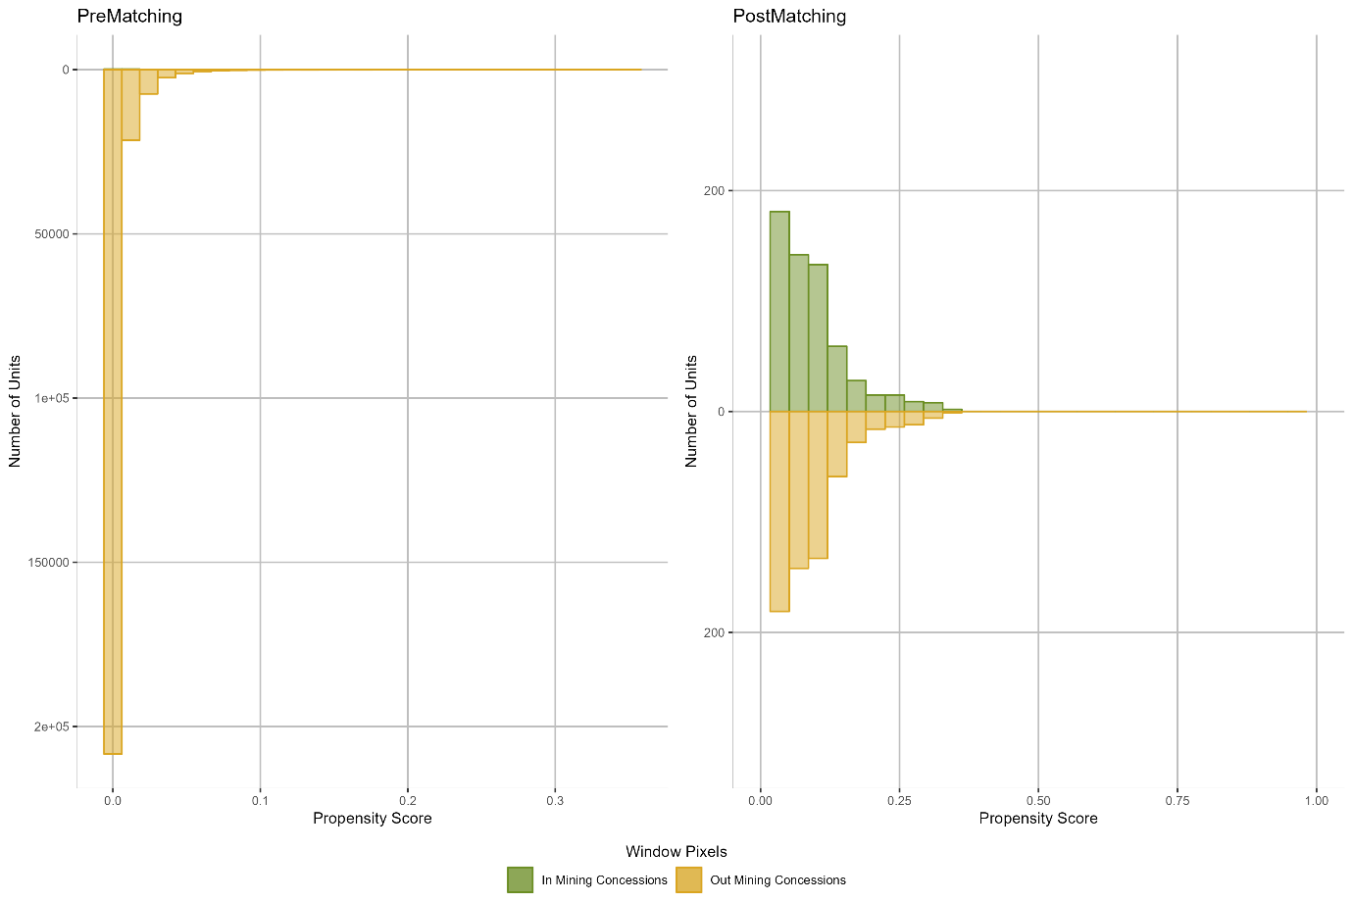
Mining Concessions

Supplementary Material 4. Compiled overview of all pre- and post-matching variables estimates for protected areas (PA), Indigenous land (IL), Non-Timber Forest Products Concessions (NTC), logging concessions (LC) and mining concessions (MC). (a) Using forest loss between 2000 and 2021 (b) Using forest loss between 2005 and 2021.
(a)
type | time | variable | Means Treated | Means Control | Std. Mean Difference | eCDF Mean | eCDF Max | Percent Balance Improvement (%)
PA | before | Anual_Prec | 2226.58 | 2315.27 | -0.15 | 0.04 | 0.20 | 61.56
PA | after | Anual_Prec | 2226.58 | 2188.44 | 0.06 | 0.04 | 0.14 | 61.56
PA | before | D17Set10 | 30523.67 | 16640.52 | 0.62 | 0.21 | 0.31 | 37.35
PA | after | D17Set10 | 30523.67 | 21222.81 | 0.41 | 0.13 | 0.22 | 37.35
PA | before | D17Set5000 | 119418.04 | 108455.19 | 0.14 | 0.05 | 0.10 | -84.71
PA | after | D17Set5000 | 119418.04 | 100535.31 | 0.24 | 0.07 | 0.13 | -84.71
PA | before | D7Set1000 | 70611.50 | 63238.10 | 0.17 | 0.08 | 0.15 | -61.18
PA | after | D7Set1000 | 70611.50 | 59677.05 | 0.25 | 0.09 | 0.16 | -61.18
PA | before | D7Set10000 | 144984.63 | 142649.82 | 0.03 | 0.04 | 0.09 | -956.02
PA | after | D7Set10000 | 144984.63 | 122490.19 | 0.26 | 0.08 | 0.13 | -956.02
PA | before | Departme_R | 55891.50 | 64504.34 | -0.24 | 0.08 | 0.12 | -34.31
PA | after | Departme_R | 55891.50 | 47189.05 | 0.24 | 0.10 | 0.17 | -34.31
PA | before | Department | 16.51 | 15.93 | 0.12 | 0.07 | 0.31 | 47.54
PA | after | Department | 16.51 | 16.19 | 0.06 | 0.04 | 0.18 | 47.54
PA | before | Dis_Def | 1979.77 | 2889.76 | -0.45 | 0.07 | 0.14 | 95.15
PA | after | Dis_Def | 1979.77 | 2016.49 | -0.02 | 0.01 | 0.10 | 95.15
PA | before | Dis_Rivers | 13503.79 | 13345.72 | 0.02 | 0.01 | 0.02 | 7.91
PA | after | Dis_Rivers | 13503.79 | 13357.87 | 0.01 | 0.01 | 0.03 | 7.91
PA | before | Ecoregions | 3.87 | 3.08 | 0.29 | 0.09 | 0.14 | 79.40
PA | after | Ecoregions | 3.87 | 3.70 | 0.06 | 0.02 | 0.04 | 79.40
PA | before | Elevation | 667.39 | 478.64 | 0.29 | 0.06 | 0.41 | 95.92
PA | after | Elevation | 667.39 | 675.93 | -0.01 | 0.04 | 0.24 | 95.92
PA | before | National_R | 94808.34 | 107933.09 | -0.19 | 0.06 | 0.10 | 78.13
PA | after | National_R | 94808.34 | 92107.01 | 0.04 | 0.05 | 0.15 | 78.13
PA | before | Pop2000 | 0.01 | 0.02 | -0.14 | 0.10 | 0.18 | 45.09
PA | after | Pop2000 | 0.01 | 0.02 | -0.07 | 0.10 | 0.17 | 45.09
PA | before | Pop2020 | -0.79 | -1.03 | 0.00 | 0.10 | 0.15 | 54.69
PA | after | Pop2020 | -0.79 | -0.89 | 0.00 | 0.08 | 0.13 | 54.69
PA | before | Prec_Seas | 39.86 | 27.72 | 0.95 | 0.17 | 0.41 | 71.14
PA | after | Prec_Seas | 39.86 | 36.22 | 0.28 | 0.06 | 0.19 | 71.14
PA | before | Slope | 20.80 | 15.38 | 0.24 | 0.02 | 0.20 | 99.18
PA | after | Slope | 20.80 | 20.75 | 0.00 | 0.01 | 0.08 | 99.18
PA | before | Tra_Time00 | 2099.17 | 2041.11 | 0.06 | 0.04 | 0.09 | -123.76
PA | after | Tra_Time00 | 2099.17 | 1967.83 | 0.13 | 0.05 | 0.13 | -123.76
PA | before | Tra_Time15 | 1887.98 | 1779.12 | 0.13 | 0.05 | 0.14 | -84.48
PA | after | Tra_Time15 | 1887.98 | 1691.50 | 0.24 | 0.06 | 0.17 | -84.48
IL | before | Anual_Prec | 2276.38 | 2315.30 | -0.07 | 0.02 | 0.11 | 97.79
IL | after | Anual_Prec | 2276.38 | 2277.21 | 0.00 | 0.01 | 0.04 | 97.79
IL | before | D17Set10 | 8579.63 | 16643.44 | -1.15 | 0.18 | 0.28 | 93.78
IL | after | D17Set10 | 8579.63 | 8890.37 | -0.04 | 0.01 | 0.04 | 93.78
IL | before | D17Set5000 | 125428.36 | 108454.59 | 0.20 | 0.06 | 0.11 | 55.81
IL | after | D17Set5000 | 125428.36 | 117678.78 | 0.09 | 0.04 | 0.08 | 55.81
IL | before | D7Set10 | 18325.50 | 26865.91 | -0.46 | 0.12 | 0.18 | 97.82
IL | after | D7Set10 | 18325.50 | 18171.05 | 0.01 | 0.01 | 0.01 | 97.82
IL | before | D7Set1000 | 64024.52 | 63239.73 | 0.02 | 0.02 | 0.05 | 66.86
IL | after | D7Set1000 | 64024.52 | 63750.31 | 0.01 | 0.04 | 0.07 | 66.86
IL | before | D7Set10000 | 164982.12 | 142645.18 | 0.24 | 0.08 | 0.12 | 72.90
IL | after | D7Set10000 | 164982.12 | 158887.21 | 0.07 | 0.03 | 0.06 | 72.90
IL | before | Departme_R | 52857.83 | 64509.49 | -0.22 | 0.03 | 0.08 | 87.36
IL | after | Departme_R | 52857.83 | 51486.60 | 0.03 | 0.05 | 0.09 | 87.36
IL | before | Department | 14.36 | 15.93 | -0.23 | 0.05 | 0.13 | 68.12
IL | after | Department | 14.36 | 14.88 | -0.08 | 0.04 | 0.06 | 68.12
IL | before | Dis_Def | 1855.76 | 2890.26 | -0.53 | 0.07 | 0.15 | 94.58
IL | after | Dis_Def | 1855.76 | 1899.53 | -0.02 | 0.01 | 0.05 | 94.58
IL | before | Dis_Rivers | 10409.77 | 13346.83 | -0.33 | 0.08 | 0.12 | 93.34
IL | after | Dis_Rivers | 10409.77 | 10588.65 | -0.02 | 0.01 | 0.01 | 93.34
IL | before | Ecoregions | 3.23 | 3.08 | 0.06 | 0.02 | 0.03 | 96.46
IL | after | Ecoregions | 3.23 | 3.22 | 0.00 | 0.00 | 0.01 | 96.46
IL | before | Elevation | 446.20 | 478.68 | -0.06 | 0.03 | 0.16 | 32.22
IL | after | Elevation | 446.20 | 467.04 | -0.04 | 0.02 | 0.11 | 32.22
IL | before | National_R | 107746.38 | 107933.48 | 0.00 | 0.03 | 0.06 | -582.61
IL | after | National_R | 107746.38 | 106438.96 | 0.01 | 0.02 | 0.05 | -582.61
IL | before | Pop2000 | 0.01 | 0.02 | -0.31 | 0.04 | 0.09 | 73.22
IL | after | Pop2000 | 0.01 | 0.02 | -0.03 | 0.02 | 0.05 | 73.22
IL | before | Pop2020 | -0.41 | -1.03 | 0.01 | 0.04 | 0.09 | 9.54
IL | after | Pop2020 | -0.41 | -0.96 | 0.01 | 0.01 | 0.04 | 9.54
IL | before | Prec_Seas | 27.03 | 27.72 | -0.04 | 0.04 | 0.13 | 40.12
IL | after | Prec_Seas | 27.03 | 27.45 | -0.03 | 0.02 | 0.07 | 40.12
IL | before | Slope | 15.49 | 15.38 | 0.01 | 0.01 | 0.04 | 24.23
IL | after | Slope | 15.49 | 15.58 | 0.00 | 0.01 | 0.05 | 24.23
IL | before | Tra_Time00 | 1796.53 | 2041.23 | -0.24 | 0.04 | 0.10 | 90.89
IL | after | Tra_Time00 | 1796.53 | 1817.13 | -0.02 | 0.01 | 0.03 | 90.89
IL | before | Tra_Time15 | 1531.96 | 1779.23 | -0.27 | 0.05 | 0.10 | 99.59
IL | after | Tra_Time15 | 1531.96 | 1532.89 | 0.00 | 0.01 | 0.04 | 99.59
NTC | before | Anual_Prec | 2456.92 | 2317.70 | 0.27 | 0.04 | 0.18 | -98.10
NTC | after | Anual_Prec | 2456.92 | 2883.46 | -0.83 | 0.10 | 0.24 | -98.10
NTC | before | D17Set10 | 13749.73 | 16768.51 | -0.32 | 0.06 | 0.10 | 82.84
NTC | after | D17Set10 | 13749.73 | 13268.16 | 0.05 | 0.05 | 0.12 | 82.84
NTC | before | D17Set1000 | 31275.52 | 62279.65 | -1.98 | 0.18 | 0.35 | 93.91
NTC | after | D17Set1000 | 31275.52 | 32185.19 | -0.06 | 0.05 | 0.11 | 93.91
NTC | before | D7Set10 | 24017.32 | 27058.49 | -0.20 | 0.05 | 0.09 | 93.55
NTC | after | D7Set10 | 24017.32 | 23841.52 | 0.01 | 0.06 | 0.13 | 93.55
NTC | before | D7Set1000 | 44363.26 | 63644.34 | -1.25 | 0.13 | 0.30 | 48.21
NTC | after | D7Set1000 | 44363.26 | 39456.79 | 0.32 | 0.09 | 0.24 | 48.21
NTC | before | D7Set10000 | 81194.33 | 143393.16 | -1.58 | 0.18 | 0.39 | 37.10
NTC | after | D7Set10000 | 81194.33 | 108145.47 | -0.68 | 0.10 | 0.26 | 37.10
NTC | before | D7Set5000 | 78344.02 | 113319.55 | -1.00 | 0.12 | 0.26 | 13.54
NTC | after | D7Set5000 | 78344.02 | 101252.82 | -0.66 | 0.09 | 0.22 | 13.54
NTC | before | Departme_R | 23427.67 | 64856.38 | -1.51 | 0.22 | 0.38 | 98.43
NTC | after | Departme_R | 23427.67 | 23733.63 | -0.01 | 0.01 | 0.04 | 98.43
NTC | before | Department | 16.94 | 15.93 | 2.33 | 0.19 | 0.76 | 45.52
NTC | after | Department | 16.94 | 16.31 | 1.46 | 0.17 | 0.30 | 45.52
NTC | before | Dis_Def | 2034.44 | 2914.47 | -0.40 | 0.06 | 0.15 | 81.98
NTC | after | Dis_Def | 2034.44 | 2184.45 | -0.07 | 0.01 | 0.08 | 81.98
NTC | before | Dis_Rivers | 12330.76 | 13376.66 | -0.13 | 0.03 | 0.05 | -31.86
NTC | after | Dis_Rivers | 12330.76 | 10967.29 | 0.16 | 0.06 | 0.16 | -31.86
NTC | before | District_R | 19733.59 | 87159.66 | -2.35 | 0.32 | 0.52 | 74.84
NTC | after | District_R | 19733.59 | 28387.46 | -0.30 | 0.06 | 0.13 | 74.84
NTC | before | Ecoregions | 2.21 | 3.07 | -0.78 | 0.09 | 0.15 | 38.11
NTC | after | Ecoregions | 2.21 | 2.67 | -0.42 | 0.05 | 0.08 | 38.11
NTC | before | Elevation | 312.86 | 477.27 | -1.01 | 0.09 | 0.59 | 9.85
NTC | after | Elevation | 312.86 | 379.22 | -0.41 | 0.02 | 0.26 | 9.85
NTC | before | National_R | 26488.65 | 108652.35 | -2.95 | 0.31 | 0.61 | 90.67
NTC | after | National_R | 26488.65 | 30459.57 | -0.14 | 0.05 | 0.12 | 90.67
NTC | before | Pop2000 | 0.01 | 0.02 | -2.77 | 0.13 | 0.21 | -44.14
NTC | after | Pop2000 | 0.01 | 0.01 | -0.33 | 0.08 | 0.25 | -44.14
NTC | before | Pop2020 | 0.01 | -1.00 | 121.88 | 0.14 | 0.25 | -3321.93
NTC | after | Pop2020 | 0.01 | 0.02 | -0.94 | 0.13 | 0.27 | -3321.93
NTC | before | Prec_Seas | 49.35 | 27.65 | 3.34 | 0.29 | 0.77 | 67.28
NTC | after | Prec_Seas | 49.35 | 44.59 | 0.73 | 0.07 | 0.40 | 67.28
NTC | before | Slope | 8.89 | 15.34 | -0.76 | 0.04 | 0.13 | 20.41
NTC | after | Slope | 8.89 | 12.36 | -0.41 | 0.02 | 0.13 | 20.41
NTC | before | Tra_Time00 | 1217.96 | 2052.20 | -1.45 | 0.13 | 0.35 | 84.42
NTC | after | Tra_Time00 | 1217.96 | 1312.28 | -0.16 | 0.04 | 0.12 | 84.42
NTC | before | Tra_Time15 | 642.43 | 1791.39 | -2.58 | 0.20 | 0.56 | 87.74
NTC | after | Tra_Time15 | 642.43 | 726.38 | -0.19 | 0.01 | 0.08 | 87.74
LC | before | Anual_Prec | 2237.97 | 2315.27 | -0.13 | 0.04 | 0.18 | 91.35
LC | after | Anual_Prec | 2237.97 | 2244.75 | -0.01 | 0.01 | 0.04 | 91.35
LC | before | D17Set10 | 19406.11 | 16640.52 | 0.20 | 0.07 | 0.14 | 60.66
LC | after | D17Set10 | 19406.11 | 18312.93 | 0.08 | 0.04 | 0.08 | 60.66
LC | before | D17Set5000 | 98190.98 | 108455.19 | -0.22 | 0.06 | 0.12 | -12.16
LC | after | D17Set5000 | 98190.98 | 89962.60 | 0.17 | 0.05 | 0.13 | -12.16
LC | before | D7Set10 | 30836.48 | 26861.65 | 0.20 | 0.09 | 0.15 | 58.75
LC | after | D7Set10 | 30836.48 | 29286.94 | 0.08 | 0.04 | 0.07 | 58.75
LC | before | D7Set1000 | 53449.82 | 63238.10 | -0.35 | 0.05 | 0.13 | 84.66
LC | after | D7Set1000 | 53449.82 | 52397.38 | 0.04 | 0.03 | 0.06 | 84.66
LC | before | D7Set10000 | 122389.15 | 142649.82 | -0.35 | 0.07 | 0.17 | 46.20
LC | after | D7Set10000 | 122389.15 | 113974.33 | 0.15 | 0.05 | 0.14 | 46.20
LC | before | Departme_R | 48193.17 | 64504.34 | -0.32 | 0.07 | 0.12 | 87.27
LC | after | Departme_R | 48193.17 | 49957.68 | -0.03 | 0.02 | 0.07 | 87.27
LC | before | Department | 19.27 | 15.93 | 0.74 | 0.16 | 0.41 | 96.45
LC | after | Department | 19.27 | 19.38 | -0.03 | 0.04 | 0.07 | 96.45
LC | before | Dis_Def | 3641.29 | 2889.76 | 0.23 | 0.04 | 0.15 | 99.80
LC | after | Dis_Def | 3641.29 | 3639.62 | 0.00 | 0.02 | 0.10 | 99.80
LC | before | Dis_Rivers | 15160.58 | 13345.72 | 0.17 | 0.05 | 0.09 | 81.81
LC | after | Dis_Rivers | 15160.58 | 15524.58 | -0.03 | 0.02 | 0.04 | 81.81
LC | before | Ecoregions | 2.72 | 3.08 | -0.19 | 0.04 | 0.07 | 78.54
LC | after | Ecoregions | 2.72 | 2.79 | -0.04 | 0.01 | 0.01 | 78.54
LC | before | Elevation | 369.39 | 478.64 | -0.29 | 0.05 | 0.19 | 94.49
LC | after | Elevation | 369.39 | 373.99 | -0.01 | 0.01 | 0.10 | 94.49
LC | before | National_R | 81224.35 | 107933.09 | -0.47 | 0.08 | 0.19 | 92.31
LC | after | National_R | 81224.35 | 79545.74 | 0.03 | 0.03 | 0.07 | 92.31
LC | before | Pop2000 | 0.01 | 0.02 | -0.82 | 0.07 | 0.12 | 72.13
LC | after | Pop2000 | 0.01 | 0.01 | -0.05 | 0.03 | 0.10 | 72.13
LC | before | Pop2020 | -0.96 | -1.03 | 0.00 | 0.07 | 0.14 | -1360.10
LC | after | Pop2020 | -0.96 | -0.23 | -0.01 | 0.03 | 0.06 | -1360.10
LC | before | Prec_Seas | 35.97 | 27.72 | 0.67 | 0.12 | 0.30 | 85.30
LC | after | Prec_Seas | 35.97 | 34.83 | 0.09 | 0.02 | 0.09 | 85.30
LC | before | Slope | 12.61 | 15.38 | -0.21 | 0.03 | 0.06 | 94.74
LC | after | Slope | 12.61 | 12.73 | -0.01 | 0.00 | 0.03 | 94.74
LC | before | Tra_Time00 | 2311.64 | 2041.11 | 0.23 | 0.05 | 0.13 | 68.58
LC | after | Tra_Time00 | 2311.64 | 2224.63 | 0.07 | 0.03 | 0.08 | 68.58
MC | before | Anual_Prec | 2602.90 | 2315.28 | 0.21 | 0.15 | 0.37 | -0.77
MC | after | Anual_Prec | 2602.90 | 3012.48 | -0.30 | 0.09 | 0.21 | -0.77
MC | before | D17Set10 | 3854.03 | 16640.55 | -4.18 | 0.29 | 0.56 | 91.44
MC | after | D17Set10 | 3854.03 | 4218.46 | -0.12 | 0.01 | 0.04 | 91.44
MC | before | D17Set5000 | 39114.58 | 108455.35 | -2.27 | 0.31 | 0.51 | 94.28
MC | after | D17Set5000 | 39114.58 | 37235.26 | 0.06 | 0.03 | 0.14 | 94.28
MC | before | D7Set10 | 6625.58 | 26861.68 | -3.48 | 0.31 | 0.55 | 91.08
MC | after | D7Set10 | 6625.58 | 7215.16 | -0.10 | 0.01 | 0.12 | 91.08
MC | before | D7Set1000 | 20382.56 | 63238.28 | -2.73 | 0.31 | 0.50 | 94.45
MC | after | D7Set1000 | 20382.56 | 21276.48 | -0.06 | 0.02 | 0.07 | 94.45
MC | before | D7Set10000 | 82878.52 | 142649.95 | -1.13 | 0.18 | 0.31 | 70.80
MC | after | D7Set10000 | 82878.52 | 95916.05 | -0.25 | 0.05 | 0.19 | 70.80
MC | before | D7Set5000 | 79001.01 | 112698.80 | -0.60 | 0.12 | 0.17 | 55.75
MC | after | D7Set5000 | 79001.01 | 91607.39 | -0.23 | 0.04 | 0.19 | 55.75
MC | before | Departme_R | 19722.70 | 64504.57 | -2.05 | 0.26 | 0.41 | 98.98
MC | after | Departme_R | 19722.70 | 19899.61 | -0.01 | 0.03 | 0.13 | 98.98
MC | before | Department | 12.93 | 15.93 | -0.46 | 0.16 | 0.41 | 82.35
MC | after | Department | 12.93 | 12.35 | 0.09 | 0.14 | 0.32 | 82.35
MC | before | Dis_Def | 376.69 | 2889.77 | -5.22 | 0.14 | 0.54 | 84.21
MC | after | Dis_Def | 376.69 | 469.95 | -0.19 | 0.00 | 0.09 | 84.21
MC | before | Dis_Rivers | 7012.73 | 13345.72 | -0.85 | 0.17 | 0.33 | 94.87
MC | after | Dis_Rivers | 7012.73 | 7274.28 | -0.04 | 0.03 | 0.11 | 94.87
MC | before | District_R | 6752.91 | 86527.57 | -7.34 | 0.41 | 0.74 | 86.68
MC | after | District_R | 6752.91 | 8705.14 | -0.18 | 0.02 | 0.12 | 86.68
MC | before | Ecoregions | 4.72 | 3.08 | 0.57 | 0.18 | 0.29 | 94.05
MC | after | Ecoregions | 4.72 | 4.61 | 0.04 | 0.01 | 0.02 | 94.05
MC | before | Elevation | 1091.67 | 478.63 | 0.62 | 0.17 | 0.53 | 85.29
MC | after | Elevation | 1091.67 | 993.56 | 0.10 | 0.07 | 0.18 | 85.29
MC | before | National_R | 10202.63 | 107933.41 | -8.25 | 0.42 | 0.74 | 93.04
MC | after | National_R | 10202.63 | 11938.91 | -0.15 | 0.02 | 0.16 | 93.04
MC | before | Pop2000 | 0.07 | 0.02 | 0.24 | 0.28 | 0.45 | 87.34
MC | after | Pop2000 | 0.07 | 0.06 | 0.04 | 0.05 | 0.14 | 87.34
MC | before | Prec_Seas | 44.08 | 27.72 | 1.48 | 0.22 | 0.59 | 84.74
MC | after | Prec_Seas | 44.08 | 41.90 | 0.20 | 0.04 | 0.24 | 84.74
MC | before | Slope | 30.59 | 15.38 | 0.45 | 0.10 | 0.27 | 95.85
MC | after | Slope | 30.59 | 29.93 | 0.02 | 0.03 | 0.14 | 95.85
MC | before | Tra_Time00 | 662.02 | 2041.11 | -3.35 | 0.22 | 0.61 | 95.52
MC | after | Tra_Time00 | 662.02 | 692.20 | -0.07 | 0.01 | 0.12 | 95.52

(b)
type | time | variable | Means Treated | Means Control | Std. Mean Difference | eCDF Mean | eCDF Max | Percent Balance Improvement (%)
PA | before | Anual_Prec | 2226.86 | 2317.70 | -0.15 | 0.04 | 0.20 | 62.29
PA | after | Anual_Prec | 2226.86 | 2188.59 | 0.07 | 0.04 | 0.13 | 62.29
PA | before | D17Set10 | 30538.00 | 16768.51 | 0.61 | 0.21 | 0.30 | 36.99
PA | after | D17Set10 | 30538.00 | 21272.35 | 0.41 | 0.13 | 0.22 | 36.99
PA | before | D17Set5000 | 119459.23 | 109121.02 | 0.13 | 0.05 | 0.10 | -93.76
PA | after | D17Set5000 | 119459.23 | 100772.35 | 0.23 | 0.07 | 0.13 | -93.76
PA | before | D7Set1000 | 70634.86 | 63644.34 | 0.16 | 0.08 | 0.14 | -68.47
PA | after | D7Set1000 | 70634.86 | 59792.33 | 0.25 | 0.09 | 0.16 | -68.47
PA | before | D7Set10000 | 145033.14 | 143393.16 | 0.02 | 0.04 | 0.09 | -1395.26
PA | after | D7Set10000 | 145033.14 | 122651.10 | 0.26 | 0.08 | 0.13 | -1395.26
PA | before | Departme_R | 55914.33 | 64856.38 | -0.25 | 0.08 | 0.12 | -26.11
PA | after | Departme_R | 55914.33 | 47429.54 | 0.24 | 0.10 | 0.17 | -26.11
PA | before | Department | 16.51 | 15.93 | 0.12 | 0.07 | 0.32 | 48.86
PA | after | Department | 16.51 | 16.20 | 0.06 | 0.04 | 0.18 | 48.86
PA | before | Dis_Def | 1981.05 | 2914.47 | -0.46 | 0.07 | 0.14 | 93.38
PA | after | Dis_Def | 1981.05 | 2032.45 | -0.03 | 0.01 | 0.09 | 93.38
PA | before | Dis_Rivers | 13503.65 | 13376.66 | 0.01 | 0.01 | 0.02 | -10.14
PA | after | Dis_Rivers | 13503.65 | 13363.53 | 0.01 | 0.01 | 0.03 | -10.14
PA | before | Ecoregions | 3.87 | 3.07 | 0.29 | 0.09 | 0.14 | 78.61
PA | after | Ecoregions | 3.87 | 3.69 | 0.07 | 0.02 | 0.04 | 78.61
PA | before | Elevation | 667.05 | 477.27 | 0.29 | 0.06 | 0.41 | 97.18
PA | after | Elevation | 667.05 | 672.97 | -0.01 | 0.04 | 0.24 | 97.18
PA | before | National_R | 94847.27 | 108652.35 | -0.20 | 0.06 | 0.09 | 82.72
PA | after | National_R | 94847.27 | 92599.65 | 0.03 | 0.05 | 0.15 | 82.72
PA | before | Pop2000 | 0.01 | 0.02 | -0.14 | 0.10 | 0.18 | 43.75
PA | after | Pop2000 | 0.01 | 0.02 | -0.07 | 0.10 | 0.17 | 43.75
PA | before | Pop2020 | -0.79 | -1.00 | 0.00 | 0.10 | 0.15 | 95.84
PA | after | Pop2020 | -0.79 | -0.78 | 0.00 | 0.08 | 0.13 | 95.84
PA | before | Prec_Seas | 39.86 | 27.65 | 0.95 | 0.17 | 0.41 | 70.69
PA | after | Prec_Seas | 39.86 | 36.15 | 0.29 | 0.06 | 0.20 | 70.69
PA | before | Slope | 20.79 | 15.34 | 0.24 | 0.02 | 0.20 | 98.11
PA | after | Slope | 20.79 | 20.68 | 0.00 | 0.01 | 0.08 | 98.11
PA | before | Tra_Time00 | 2099.65 | 2052.20 | 0.05 | 0.04 | 0.09 | -170.42
PA | after | Tra_Time00 | 2099.65 | 1970.05 | 0.13 | 0.05 | 0.13 | -170.42
PA | before | Tra_Time15 | 1888.52 | 1791.39 | 0.12 | 0.05 | 0.14 | -102.25
PA | after | Tra_Time15 | 1888.52 | 1696.45 | 0.23 | 0.05 | 0.17 | -102.25
IL | before | Anual_Prec | 2277.50 | 2317.72 | -0.07 | 0.02 | 0.11 | 97.15
IL | after | Anual_Prec | 2277.50 | 2278.61 | 0.00 | 0.01 | 0.04 | 97.15
IL | before | D17Set10 | 8611.93 | 16771.38 | -1.16 | 0.18 | 0.29 | 93.32
IL | after | D17Set10 | 8611.93 | 8949.56 | -0.05 | 0.01 | 0.04 | 93.32
IL | before | D17Set5000 | 125782.50 | 109119.81 | 0.20 | 0.06 | 0.11 | 55.08
IL | after | D17Set5000 | 125782.50 | 118051.30 | 0.09 | 0.04 | 0.08 | 55.08
IL | before | D7Set10 | 18390.93 | 27062.66 | -0.46 | 0.12 | 0.18 | 98.56
IL | after | D7Set10 | 18390.93 | 18287.32 | 0.01 | 0.01 | 0.01 | 98.56
IL | before | D7Set1000 | 64190.54 | 63645.63 | 0.01 | 0.02 | 0.05 | 72.61
IL | after | D7Set1000 | 64190.54 | 64033.16 | 0.00 | 0.04 | 0.07 | 72.61
IL | before | D7Set10000 | 165387.03 | 143387.71 | 0.24 | 0.08 | 0.12 | 73.13
IL | after | D7Set10000 | 165387.03 | 159434.12 | 0.06 | 0.03 | 0.06 | 73.13
IL | before | Departme_R | 52956.64 | 64861.32 | -0.22 | 0.03 | 0.08 | 87.65
IL | after | Departme_R | 52956.64 | 51587.56 | 0.03 | 0.05 | 0.09 | 87.65
IL | before | Department | 14.36 | 15.93 | -0.23 | 0.05 | 0.13 | 68.23
IL | after | Department | 14.36 | 14.88 | -0.08 | 0.04 | 0.06 | 68.23
IL | before | Dis_Def | 1864.22 | 2914.96 | -0.53 | 0.08 | 0.16 | 94.99
IL | after | Dis_Def | 1864.22 | 1905.25 | -0.02 | 0.01 | 0.05 | 94.99
IL | before | Dis_Rivers | 10428.56 | 13377.71 | -0.33 | 0.08 | 0.12 | 92.87
IL | after | Dis_Rivers | 10428.56 | 10620.81 | -0.02 | 0.01 | 0.01 | 92.87
IL | before | Ecoregions | 3.23 | 3.07 | 0.07 | 0.02 | 0.03 | 97.32
IL | after | Ecoregions | 3.23 | 3.22 | 0.00 | 0.00 | 0.01 | 97.32
IL | before | Elevation | 445.73 | 477.31 | -0.06 | 0.03 | 0.16 | 22.98
IL | after | Elevation | 445.73 | 468.81 | -0.04 | 0.02 | 0.12 | 22.98
IL | before | National_R | 108073.83 | 108652.14 | -0.01 | 0.03 | 0.06 | -73.62
IL | after | National_R | 108073.83 | 107045.81 | 0.01 | 0.02 | 0.05 | -73.62
IL | before | Pop2000 | 0.01 | 0.02 | -0.31 | 0.04 | 0.09 | 73.65
IL | after | Pop2000 | 0.01 | 0.02 | -0.03 | 0.02 | 0.05 | 73.65
IL | before | Pop2020 | -0.41 | -1.00 | 0.01 | 0.04 | 0.09 | 38.05
IL | after | Pop2020 | -0.41 | -0.74 | 0.00 | 0.01 | 0.04 | 38.05
IL | before | Prec_Seas | 26.99 | 27.65 | -0.04 | 0.04 | 0.13 | 42.25
IL | after | Prec_Seas | 26.99 | 27.38 | -0.03 | 0.02 | 0.07 | 42.25
IL | before | Slope | 15.49 | 15.34 | 0.01 | 0.01 | 0.04 | -4.22
IL | after | Slope | 15.49 | 15.65 | -0.01 | 0.01 | 0.05 | -4.22
IL | before | Tra_Time00 | 1800.35 | 2052.32 | -0.25 | 0.04 | 0.10 | 90.66
IL | after | Tra_Time00 | 1800.35 | 1822.12 | -0.02 | 0.01 | 0.03 | 90.66
IL | before | Tra_Time15 | 1536.44 | 1791.49 | -0.27 | 0.05 | 0.10 | 98.50
IL | after | Tra_Time15 | 1536.44 | 1539.91 | 0.00 | 0.01 | 0.04 | 98.50
NTC | before | Anual_Prec | 2456.92 | 2317.70 | 0.27 | 0.04 | 0.18 | -98.10
NTC | after | Anual_Prec | 2456.92 | 2883.46 | -0.83 | 0.10 | 0.24 | -98.10
NTC | before | D17Set10 | 13749.73 | 16768.51 | -0.32 | 0.06 | 0.10 | 82.84
NTC | after | D17Set10 | 13749.73 | 13268.16 | 0.05 | 0.05 | 0.12 | 82.84
NTC | before | D17Set1000 | 31275.52 | 62279.65 | -1.98 | 0.18 | 0.35 | 93.91
NTC | after | D17Set1000 | 31275.52 | 32185.19 | -0.06 | 0.05 | 0.11 | 93.91
NTC | before | D7Set10 | 24017.32 | 27058.49 | -0.20 | 0.05 | 0.09 | 93.55
NTC | after | D7Set10 | 24017.32 | 23841.52 | 0.01 | 0.06 | 0.13 | 93.55
NTC | before | D7Set1000 | 44363.26 | 63644.34 | -1.25 | 0.13 | 0.30 | 48.21
NTC | after | D7Set1000 | 44363.26 | 39456.79 | 0.32 | 0.09 | 0.24 | 48.21
NTC | before | D7Set10000 | 81194.33 | 143393.16 | -1.58 | 0.18 | 0.39 | 37.10
NTC | after | D7Set10000 | 81194.33 | 108145.47 | -0.68 | 0.10 | 0.26 | 37.10
NTC | before | D7Set5000 | 78344.02 | 113319.55 | -1.00 | 0.12 | 0.26 | 13.54
NTC | after | D7Set5000 | 78344.02 | 101252.82 | -0.66 | 0.09 | 0.22 | 13.54
NTC | before | Departme_R | 23427.67 | 64856.38 | -1.51 | 0.22 | 0.38 | 98.43
NTC | after | Departme_R | 23427.67 | 23733.63 | -0.01 | 0.01 | 0.04 | 98.43
NTC | before | Department | 16.94 | 15.93 | 2.33 | 0.19 | 0.76 | 45.52
NTC | after | Department | 16.94 | 16.31 | 1.46 | 0.17 | 0.30 | 45.52
NTC | before | Dis_Def | 2034.44 | 2914.47 | -0.40 | 0.06 | 0.15 | 81.98
NTC | after | Dis_Def | 2034.44 | 2184.45 | -0.07 | 0.01 | 0.08 | 81.98
NTC | before | Dis_Rivers | 12330.76 | 13376.66 | -0.13 | 0.03 | 0.05 | -31.86
NTC | after | Dis_Rivers | 12330.76 | 10967.29 | 0.16 | 0.06 | 0.16 | -31.86
NTC | before | District_R | 19733.59 | 87159.66 | -2.35 | 0.32 | 0.52 | 74.84
NTC | after | District_R | 19733.59 | 28387.46 | -0.30 | 0.06 | 0.13 | 74.84
NTC | before | Ecoregions | 2.21 | 3.07 | -0.78 | 0.09 | 0.15 | 38.11
NTC | after | Ecoregions | 2.21 | 2.67 | -0.42 | 0.05 | 0.08 | 38.11
NTC | before | Elevation | 312.86 | 477.27 | -1.01 | 0.09 | 0.59 | 9.85
NTC | after | Elevation | 312.86 | 379.22 | -0.41 | 0.02 | 0.26 | 9.85
NTC | before | National_R | 26488.65 | 108652.35 | -2.95 | 0.31 | 0.61 | 90.67
NTC | after | National_R | 26488.65 | 30459.57 | -0.14 | 0.05 | 0.12 | 90.67
NTC | before | Pop2000 | 0.01 | 0.02 | -2.77 | 0.13 | 0.21 | -44.14
NTC | after | Pop2000 | 0.01 | 0.01 | -0.33 | 0.08 | 0.25 | -44.14
NTC | before | Pop2020 | 0.01 | -1.00 | 121.88 | 0.14 | 0.25 | -3321.93
NTC | after | Pop2020 | 0.01 | 0.02 | -0.94 | 0.13 | 0.27 | -3321.93
NTC | before | Prec_Seas | 49.35 | 27.65 | 3.34 | 0.29 | 0.77 | 67.28
NTC | after | Prec_Seas | 49.35 | 44.59 | 0.73 | 0.07 | 0.40 | 67.28
NTC | before | Slope | 8.89 | 15.34 | -0.76 | 0.04 | 0.13 | 20.41
NTC | after | Slope | 8.89 | 12.36 | -0.41 | 0.02 | 0.13 | 20.41
NTC | before | Tra_Time00 | 1217.96 | 2052.20 | -1.45 | 0.13 | 0.35 | 84.42
NTC | after | Tra_Time00 | 1217.96 | 1312.28 | -0.16 | 0.04 | 0.12 | 84.42
NTC | before | Tra_Time15 | 642.43 | 1791.39 | -2.58 | 0.20 | 0.56 | 87.74
NTC | after | Tra_Time15 | 642.43 | 726.38 | -0.19 | 0.01 | 0.08 | 87.74
LC | before | Anual_Prec | 2238.26 | 2317.70 | -0.13 | 0.04 | 0.19 | 84.91
LC | after | Anual_Prec | 2238.26 | 2250.39 | -0.02 | 0.01 | 0.04 | 84.91
LC | before | D17Set10 | 19471.00 | 16768.51 | 0.20 | 0.07 | 0.14 | 63.62
LC | after | D17Set10 | 19471.00 | 18482.27 | 0.07 | 0.03 | 0.08 | 63.62
LC | before | D17Set5000 | 98433.89 | 109121.02 | -0.22 | 0.06 | 0.12 | -2.42
LC | after | D17Set5000 | 98433.89 | 90619.81 | 0.16 | 0.05 | 0.12 | -2.42
LC | before | D7Set10 | 30930.56 | 27058.49 | 0.20 | 0.09 | 0.15 | 62.13
LC | after | D7Set10 | 30930.56 | 29544.31 | 0.07 | 0.04 | 0.07 | 62.13
LC | before | D7Set1000 | 53575.38 | 63644.34 | -0.36 | 0.05 | 0.13 | 90.15
LC | after | D7Set1000 | 53575.38 | 52879.55 | 0.03 | 0.03 | 0.06 | 90.15
LC | before | D7Set10000 | 122642.79 | 143393.16 | -0.36 | 0.07 | 0.17 | 52.75
LC | after | D7Set10000 | 122642.79 | 115064.25 | 0.13 | 0.04 | 0.13 | 52.75
LC | before | Departme_R | 48307.42 | 64856.38 | -0.32 | 0.07 | 0.12 | 83.38
LC | after | Departme_R | 48307.42 | 50658.30 | -0.05 | 0.02 | 0.08 | 83.38
LC | before | Department | 19.27 | 15.93 | 0.74 | 0.16 | 0.42 | 96.16
LC | after | Department | 19.27 | 19.40 | -0.03 | 0.04 | 0.07 | 96.16
LC | before | Dis_Def | 3652.95 | 2914.47 | 0.23 | 0.04 | 0.15 | 96.60
LC | after | Dis_Def | 3652.95 | 3681.31 | -0.01 | 0.02 | 0.09 | 96.60
LC | before | Dis_Rivers | 15161.46 | 13376.66 | 0.17 | 0.05 | 0.09 | 82.84
LC | after | Dis_Rivers | 15161.46 | 15498.89 | -0.03 | 0.02 | 0.04 | 82.84
LC | before | Ecoregions | 2.71 | 3.07 | -0.19 | 0.04 | 0.07 | 80.85
LC | after | Ecoregions | 2.71 | 2.77 | -0.03 | 0.01 | 0.01 | 80.85
LC | before | Elevation | 368.43 | 477.27 | -0.29 | 0.05 | 0.20 | 99.17
LC | after | Elevation | 368.43 | 367.76 | 0.00 | 0.01 | 0.10 | 99.17
LC | before | National_R | 81455.18 | 108652.35 | -0.48 | 0.08 | 0.20 | 96.71
LC | after | National_R | 81455.18 | 80719.87 | 0.01 | 0.03 | 0.07 | 96.71
LC | before | Pop2000 | 0.01 | 0.02 | -0.80 | 0.07 | 0.11 | 72.02
LC | after | Pop2000 | 0.01 | 0.01 | -0.05 | 0.03 | 0.09 | 72.02
LC | before | Pop2020 | -0.97 | -1.00 | 0.00 | 0.07 | 0.13 | -1809.67
LC | after | Pop2020 | -0.97 | -0.48 | 0.00 | 0.03 | 0.06 | -1809.67
LC | before | Prec_Seas | 35.97 | 27.65 | 0.68 | 0.12 | 0.31 | 84.55
LC | after | Prec_Seas | 35.97 | 34.77 | 0.10 | 0.02 | 0.09 | 84.55
LC | before | Slope | 12.59 | 15.34 | -0.21 | 0.03 | 0.06 | 97.50
LC | after | Slope | 12.59 | 12.64 | 0.00 | 0.00 | 0.03 | 97.50
LC | before | Tra_Time00 | 2316.24 | 2052.20 | 0.22 | 0.05 | 0.12 | 71.37
LC | after | Tra_Time00 | 2316.24 | 2238.88 | 0.07 | 0.03 | 0.08 | 71.37
MC | before | Anual_Prec | 2580.65 | 2317.70 | 0.19 | 0.15 | 0.37 | -7.55
MC | after | Anual_Prec | 2580.65 | 2977.27 | -0.29 | 0.08 | 0.18 | -7.55
MC | before | D17Set10 | 3897.76 | 16768.54 | -4.18 | 0.29 | 0.57 | 92.80
MC | after | D17Set10 | 3897.76 | 4207.97 | -0.10 | 0.01 | 0.05 | 92.80
MC | before | D17Set5000 | 39441.41 | 109121.19 | -2.26 | 0.31 | 0.51 | 96.76
MC | after | D17Set5000 | 39441.41 | 38383.39 | 0.03 | 0.03 | 0.11 | 96.76
MC | before | D7Set10 | 6726.44 | 27058.53 | -3.47 | 0.31 | 0.55 | 89.75
MC | after | D7Set10 | 6726.44 | 7437.96 | -0.12 | 0.02 | 0.12 | 89.75
MC | before | D7Set1000 | 20619.67 | 63644.53 | -2.71 | 0.32 | 0.50 | 93.27
MC | after | D7Set1000 | 20619.67 | 21729.95 | -0.07 | 0.02 | 0.07 | 93.27
MC | before | D7Set10000 | 82459.90 | 143393.30 | -1.15 | 0.18 | 0.31 | 72.64
MC | after | D7Set10000 | 82459.90 | 94796.32 | -0.23 | 0.05 | 0.17 | 72.64
MC | before | D7Set5000 | 78519.66 | 113319.74 | -0.62 | 0.12 | 0.18 | 58.51
MC | after | D7Set5000 | 78519.66 | 90498.90 | -0.21 | 0.05 | 0.16 | 58.51
MC | before | Departme_R | 19781.06 | 64856.62 | -2.06 | 0.26 | 0.42 | 99.97
MC | after | Departme_R | 19781.06 | 19786.55 | 0.00 | 0.03 | 0.12 | 99.97
MC | before | Department | 12.81 | 15.93 | -0.47 | 0.16 | 0.40 | 96.45
MC | after | Department | 12.81 | 12.93 | -0.02 | 0.13 | 0.27 | 96.45
MC | before | Dis_Def | 383.43 | 2914.48 | -5.20 | 0.14 | 0.54 | 82.66
MC | after | Dis_Def | 383.43 | 491.07 | -0.22 | 0.00 | 0.08 | 82.66
MC | before | Dis_Rivers | 7074.77 | 13376.65 | -0.84 | 0.17 | 0.33 | 95.42
MC | after | Dis_Rivers | 7074.77 | 7304.57 | -0.03 | 0.03 | 0.11 | 95.42
MC | before | District_R | 6866.39 | 87159.99 | -7.29 | 0.41 | 0.74 | 86.00
MC | after | District_R | 6866.39 | 8857.12 | -0.18 | 0.02 | 0.13 | 86.00
MC | before | Ecoregions | 4.78 | 3.07 | 0.59 | 0.19 | 0.30 | 80.67
MC | after | Ecoregions | 4.78 | 4.41 | 0.13 | 0.04 | 0.06 | 80.67
MC | before | Elevation | 1112.27 | 477.26 | 0.64 | 0.18 | 0.54 | 80.52
MC | after | Elevation | 1112.27 | 976.07 | 0.14 | 0.06 | 0.14 | 80.52
MC | before | National_R | 10290.06 | 108652.68 | -8.19 | 0.42 | 0.74 | 92.41
MC | after | National_R | 10290.06 | 12189.89 | -0.16 | 0.02 | 0.13 | 92.41
MC | before | Pop2000 | 0.07 | 0.02 | 0.25 | 0.28 | 0.45 | 83.89
MC | after | Pop2000 | 0.07 | 0.06 | 0.04 | 0.05 | 0.12 | 83.89
MC | before | Prec_Seas | 44.15 | 27.65 | 1.48 | 0.22 | 0.59 | 86.16
MC | after | Prec_Seas | 44.15 | 42.09 | 0.18 | 0.04 | 0.24 | 86.16
MC | before | Slope | 31.13 | 15.34 | 0.47 | 0.10 | 0.29 | 87.26
MC | after | Slope | 31.13 | 29.01 | 0.06 | 0.03 | 0.10 | 87.26
MC | before | Tra_Time00 | 665.34 | 2052.20 | -3.33 | 0.22 | 0.61 | 96.75
MC | after | Tra_Time00 | 665.34 | 687.26 | -0.05 | 0.01 | 0.13 | 96.75

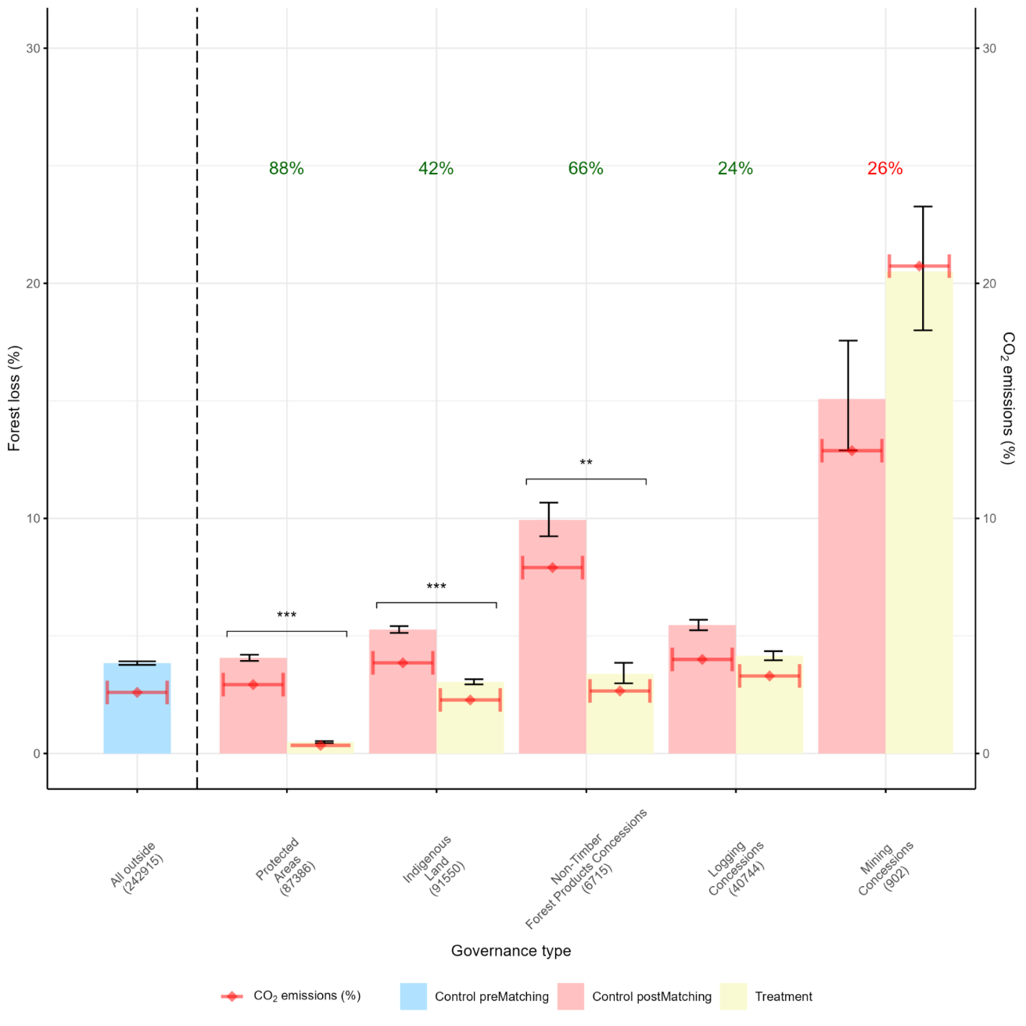

Supplementary Material 5. Estimated proportional forest loss and carbon emissions inside Protected Areas, Indigenous land, Non-Timber Forest Products, Logging and Mining Concessions in the Peruvian Amazon from 2005 to 2021 against analogous matched areas. black lines, 95% CI; Percentage values on top of each governance mechanism reflect the decrease (green) or increase (red) in deforestation proportional to the matched control pixels. statistically significant difference between control and treatment, *p < 0.05, **p < 0.01, ***p < 0.001). In parenthesis are the number of pixels used for the treatment and control of the matching analysis for each governance mechanism assessed.

