Supplementary material

Supplementary Methods

Data collection and biomarkers extraction
We extracted three biomarkers using in-house algorithms, by applying Computer Vision techniques on OCT line scans. The biomarkers are: Choroidal Vascularity Index, Choroidal Pachyvessels Area and PR+RPE disruption score.
Choroidal Vascularity Index (CVI). This biomarker was extracted and measured following the method described in [32].
This requires, as a first step, the binarization of the input image: we used the Niblack thresholding algorithm to binarize the image. The purpose of this step is to heuristically estimate and segment the vascular area in the choroid (black pixels in the choroidal area in Fig. S1a, in the middle).
Second, we segmented the choroidal layer: we used the segmentation information provided by Discovery and extracted the choroidal area in the binarized image (Fig. S1a, on the right).
Finally, we calculated the CVI. This biomarker is obtained by simply dividing the number of pixels imaging the vessels by the number of pixels imaging the choroid.
Choroidal Pachyvessels Area (PV_AREA). This biomarker can be described as the area of the largest pachy vessel. We compute this starting from the results of the first two steps described above. Then, we leverage morphological operators to show the pachy vessels as bulbs, shown in Figure S1b, and select the largest one. The area of the selected one is the biomarker PV_AREA.
PR+RPE disruption score (DSCORE). This biomarker is a quantification of the integrity of IZ, EZ, and RPE layers (photoreceptors and retinal pigment epithelium). To detect the disruptions of these layers, we compare each of these layers in the patient's scan with a template. This template is obtained using the same layers of a healthy eye scan, following these steps:
- Use the segmentation provided by Discovery and crop IZ, EZ, and RPE layers from the healthy scans.
- Rotate these layers to make them horizontal.
- Squash these layers to get rid of curvatures and fit it into a matrix with size of W*H.
- Take the average of all windows with size of w*H (w < W) inside the arrays to create the initial template (with size of w*H).
- Normalize to obtain the final template.
To detect disruption, we will follow similar steps:
- Repeat the same pre-processing of the patient scan (see steps 1-3 above)
- Apply template matching between this array and the obtained template using OpenCV
- Calculate a disruption score based on the places where there was a low matching score between the template and the layer.
The steps to create the template and an example of low matching score are shown in Figure S1c.

Data Annotation and Quality Control
To support the expert ophthalmologist in their annotation task, we implemented a heuristic method to perform a preliminary classification of patients as recurrent and non-recurrent, based on simple thresholding of the fluid volumes in the time series. This involved monitoring subretinal fluid (SRF) levels, with occurrences marked when SRF exceeded 3 nanoliters and decreased in subsequent visits. Patients characterized by multiple occurrences would be labeled as recurrent
This purely heuristic approach proved insufficient due to various factors, such as influence of patient history, comorbidity, surgery, low SRF levels, or the presence of atypical OCT scans. As a consequence it is necessary to incorporate human expert knowledge, to verify or reject the automatically generated label.
As In the future, it could be beneficial to add a label for the category of chronic patients.

Feature-importance analysis using statistics
The effect sizes were estimated using the Cohen d formula:
$D=2$∙ $\frac{μ1-μ2}{σ1+σ2}$
with $μ1$, $σ1$ the average and variance of the recurrent group, and $μ2$, $σ2$ the average and variance of the non-recurrent group.

Supplementary Result
We used Multivariate Logistic Regression fitting all biomarkers simultaneously as statistically significant predictors: age (p=2.76E-5, log_odd = 0.29), SRF (p=1.73E-5, log_odd = 0.33), IRF (p=1.09E-2, log_odd = 0.22), GCL_IPL (p=1.43E-3, log_odd = 0.39), INL_OPL (P = 7.47E-5, log_odd = -0.51), ONL (p=8.69E-3, log_odd = -0.23), CC_CS (p=4.05E-5, log_odd = 0.3). The correlations between biomarkers (see the Results section in the main text, "Correlation among OCT-derived biomarkers", and Fig….) play a role, as correlated parameters provide similar information to the model, explaining why some biomarkers are not significant in this supplementary analysis.

Supplementary Figures
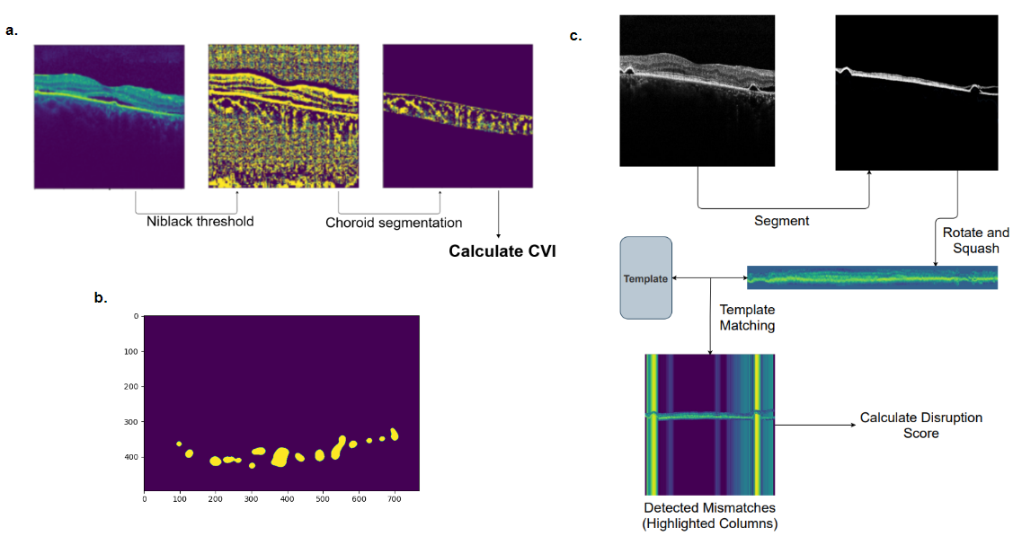
Figure S1: Extraction of handmade biomarkers from OCT-line scans. Representative images of the algorithm to extract a. Choroidal Vascularity Index (CVI). b. Choroidal Pachyvessels Area (PV_AREA) and c. PR+RPE disruption score (DSCORE).

