Supplementary Information
Ultrasensitive piezoelectric sensor based on two-dimensional Na₂Cl crystals with periodic atom vacancies
Tao Wang^{1,#}, Yan Fan^{2,#}, Jie Jiang^{1,#}, Yangyang Zhang^{3,#}, Yingying Huang^{4,}*, Liuyuan Zhu⁴, Haifei Zhan⁵, Chunli Zhang⁶, Bingquan Peng⁷, Zhen Gu⁸, Qiubo Pan⁴, Junjie Wu⁶, Junlang Chen², Pei Li¹, Lei Zhang⁹, Liang Chen^{1,}*, Chaofeng Lü^{3,5,}*, and Haiping Fang^{4,10,}*

¹School of Physical Science and Technology, Ningbo University, Ningbo, 315211, China.
²Department of Optical Engineering, Zhejiang A&F University, Hangzhou, 311300, China.
³Faculty of Mechanical Engineering & Mechanics, Ningbo University, Ningbo, 315211, China.
⁴School of Physics, East China University of Science and Technology, Shanghai, 200237, China.
⁵College of Civil Engineering and Architecture, Zhejiang University, Hangzhou, 310027, China.
⁶Department of Engineering Mechanics, Zhejiang University, Hangzhou, 310027, China.
⁷Wenzhou Institute, University of Chinese Academy of Sciences, Wenzhou, 325000, China.
⁸Key Laboratory of Smart Manufacturing in Energy Chemical Process Ministry of Education, East China University of Science and Technology, Shanghai, 200237, China.
⁹MOE Key Laboratory for Nonequilibrium Synthesis and Modulation of Condensed Matter, School of Physics, Xi’an Jiaotong University, Xi’an, 710049, China.
¹⁰School of Physics, Zhejiang University, Hangzhou, 310027, China.

#These authors contributed equally to this work.
*Corresponding author. E-mail: fanghaiping@sinap.ac.cn (H.F.); lucf@nbu.edu.cn (C.L.); liangchen@zafu.edu.cn (L.C.); huangyingying@ecust.edu.cn (Y.H.)

Contents:
Supplementary Note 1: Experimental setup for tuning fork test
Supplementary Note 2: Calculation model and calculation method of polarization
Supplementary Note 3: Dependence of piezoelectric response on the surface area of the sensor
Supplementary Note 4: Characterization of two-dimensional (2D) N2Cl crystal structure within GO membrane by TEM, EDS, and SEM
Supplementary Note 5: Elemental analysis of Na-Cl crystals in Na-Cl@GO membrane.
Supplementary Note 6: Piezoelectric performance of the sensor in high-pressure range of 0.1 to 100 kPa
Supplementary Note 7: Performance comparison between the sensor and other pressure sensors reported in recent five years
Supplementary Note 8: Effective modulus of the piezoelectric material of Na-Cl@GO membrane
Supplementary Note 9: Transformation relation between the applied pressure (P) and the open-circuit output voltage (Voc) of piezoelectric sensor
Supplementary Note 10: Detection of tiny airflow fluctuations surrounding a flapping butterfly with the piezoelectric sensor
Supplementary Video 1: Movies of experiments for real-time motoring of airflow pressure variations surrounding a flapping butterfly by the sensors

Supplementary Note 1: Experimental setup for tuning fork test
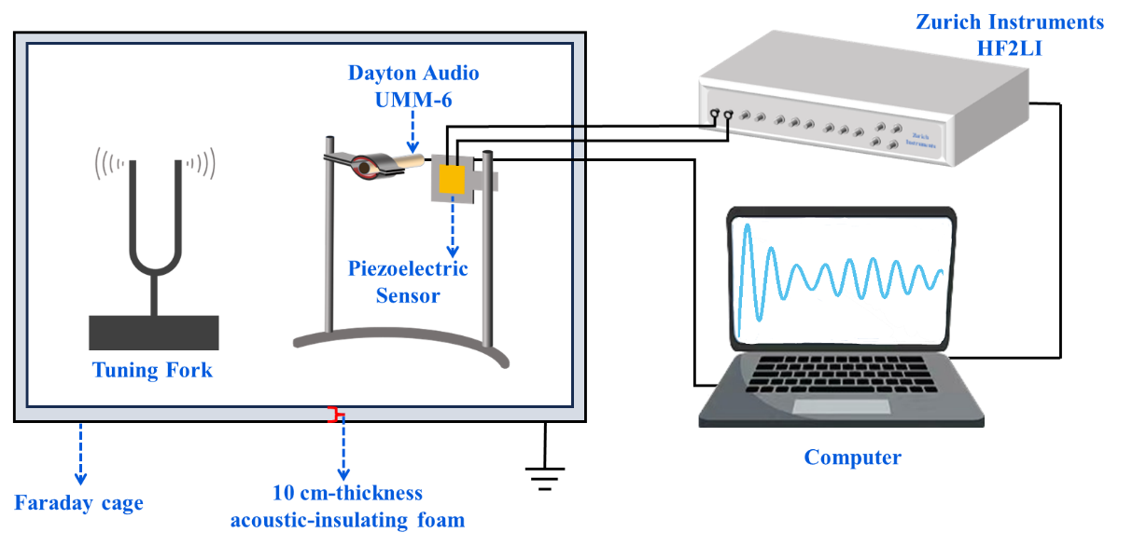
Supplementary Fig. 1 | Schematic of the experimental setup for the piezoelectric sensor test.

To evaluate the minimum detection limit of the piezoelectric sensor, an experimental setup was built as shown in supplementary Fig. 1. The voltage output response of the piezoelectric sensor to the sound signal was tested using tuning forks as a sound source. The sound frequency was controlled by the frequency of the tuning fork. The piezoelectric sensors fixed in a frame were placed 5 cm away from the sound source. An acoustic tester (UMM-6, Dayton Audio) was placed on the side of the frame, in the same plane as the sensor, to record sound pressure signals. The sensor holder (or the frame) was placed on the 10 cm-thickness acoustic-insulating foam. The tuning fork was also set on foam. A digital lock-in amplifier (HF2LI, Zurich Instruments) was used to record electric signals with a sampling frequency of 230261 per second. The decay processes of acoustic pressure with a frequency of ~260 Hz were detected. The data with the frequency of ~260 Hz were filtered by a band-pass filter (250 Hz-270 Hz), as well as the 50 Hz alternating current (AC) signal and its harmonics.

Supplementary Note 2: Calculation model and calculation method of polarization
To explore the origin of piezoelectricity, the calculation model of two-dimensional (2D) Na₂Cl crystals on graphene surface (Na₂Cl@graphene) was considered. The original structure of 2D Na₂Cl crystal was built based on the lattice information from TEM experiments. The lattice constant of square Na₂Cl crystal is 3.96 Å, and each unit cell contains two Na atoms and one Cl atom. After optimized, the lattice constant of square Na₂Cl crystal and rhombic graphene crystal are 3.81 Å and 2.47 Å. Therefore, with a reasonable lattice mismatch of 2.03%, the 2D Na₂Cl@graphene structure was constructed, containing a 2×8 Na₂Cl supercell and a 3×7 graphene supercell with orthorhombic lattice.
Considering that the Na₂Cl@graphene phase exhibits noncentrosymmetry which lacks the inversion symmetry in out of plane direction, the popular Berry phase method ^{1,2} is not suitable for the calculation of polarization of Na₂Cl@graphene structure. We proposed a method to calculate the polarization of 2D structure. By analyzing the Bader charge of atoms, the electric charge of each layer was obtained. Then based on the charge of each layer and the average height between layers, the electric dipole of D can be calculated. The polarization P is calculated using P = D/A, where A is the surface area of 2D structure. With this method, the polarization of MoS₂/WS₂ bilayers in out of plane direction was obtained, which is 0.65 pC/m. This value is very close to the polarization value of 0.60 pC/m ³ from the Berry phase calculation, indicating that the calculation method of polarization proposed by us is reasonable.

Supplementary Note 3: Dependence of piezoelectric response on the surface area of the sensor
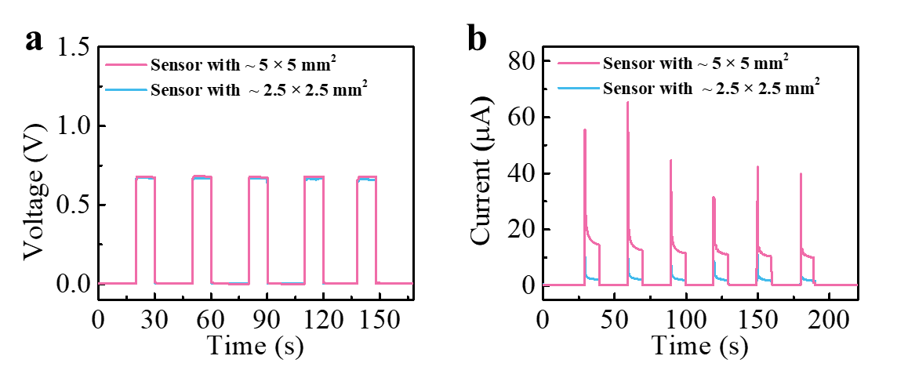
Supplementary Fig. 2 | Dependence of piezoelectric response on the surface area of the sensor. a, Open-circuit voltage response curve of the sensor with sizes of ~5 × 5 mm² and ~2.5 × 2.5 mm². b, Short-circuit current response curve of the sensor with sizes of ~5 × 5 mm² and ~2.5 × 2.5 mm².

The Na−Cl@GO membrane with a surface area of ~5 × 5 mm² was cut into a membrane of one-fourth of the original area size (~2.5 × 2.5 mm²), and then the open-circuit voltage and short-circuit current of the corresponding sensors were measured, respectively. As shown in Supplementary Fig. 2, by comparing the pressure responses of the sensors in different sizes, it was found that under the constant pressure the open-circuit voltage remains constant while the short-circuit current is in proportion to the device size. The short-circuit current of the sensor with a size of ~2.5 × 2.5 mm² is one-fourth of that of the sensor with a size of ~5 × 5 mm².

Supplementary Note 4: Characterization of two-dimensional (2D) N₂Cl crystal structure within GO membrane by TEM, EDS, and SEM

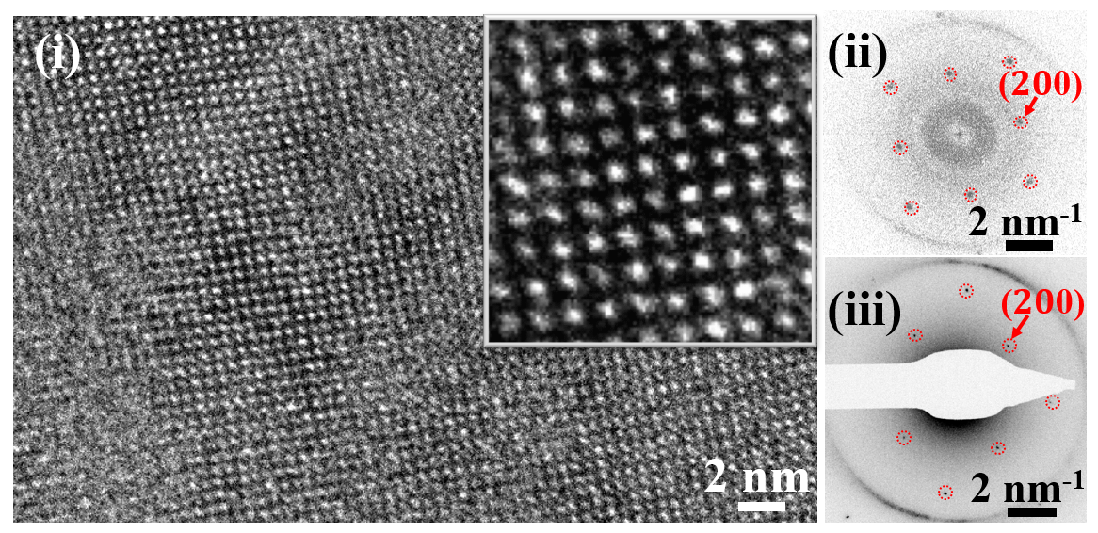
Supplementary Fig. 3 | Structure characterization of 2D N₂Cl crystal structure within GO membrane by transmission electron microscopy (TEM) experiments. (i) High-resolution TEM image of Na₂Cl crystals observed in the GO membranes. (ii) Fast Fourier transform (FFT) of the region marked in (i). (iii) Diffraction pattern of the crystal structure obtained in electron diffraction mode.

High-resolution TEM images directly observed the crystals with atomic resolution (Supplementary Fig. 3 (i)). The crystals have a square structure with a lattice spacing of 3.96 ± 0.03 Å (Fig.2a (i)). The fast Fourier transform (FFT) (Supplementary Fig. 3 (ii)) of randomly selected regions in the high-resolution TEM image showed two stable diffraction patterns, which correspond to the reflections of the crystals and GO sheets, respectively. The electron diffraction patterns (Supplementary Fig. 3 (iii)) further confirmed the square lattice spacing, consistent with the FFT results.

Supplementary Note 5: Elemental analysis of Na-Cl crystals in Na-Cl@GO membrane.

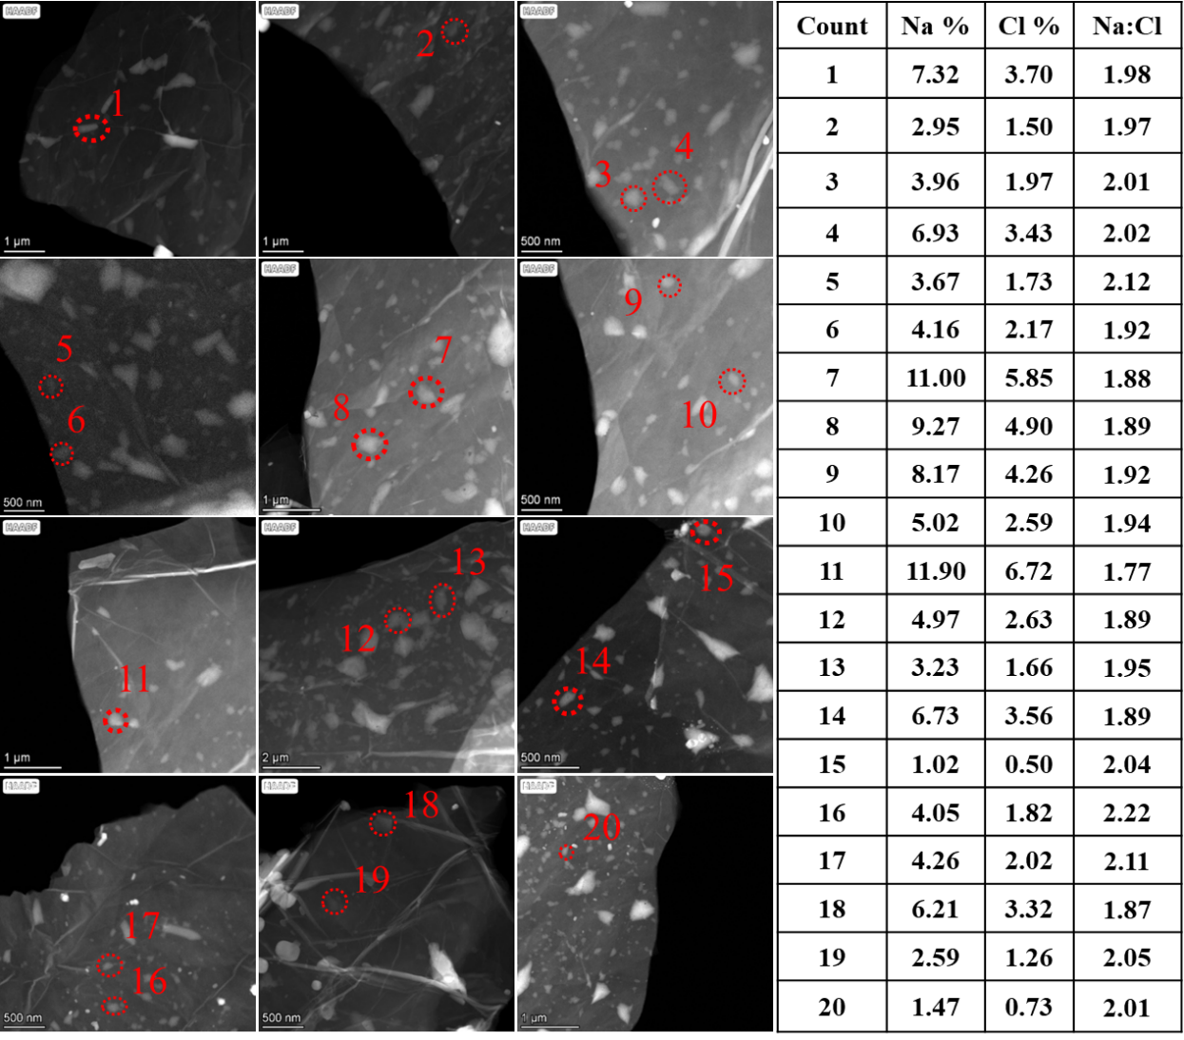
Supplementary Fig. 4 | Elemental analysis of Na−Cl@GO membrane by High-angle annular dark-field scanning transmission electron microscopy (HADDF-STEM). The selected areas of energy-dispersive X-ray spectroscopy (EDS) are denoted by the red circles in the HADDF-STEM images. The table on the right shows the atomic fractions of C, O, Na, and Cl in the selected areas of Na-Cl@GO membrane from the left images.

The table on the right shows the atomic percentages of Na and Cl. The energy-dispersive X-ray spectroscopy (EDS) results obtained from 20 areas of the Na-Cl@GO membrane showed that the crystal domain was mainly composed of Na and Cl with an atomic ratio of ~2:1.

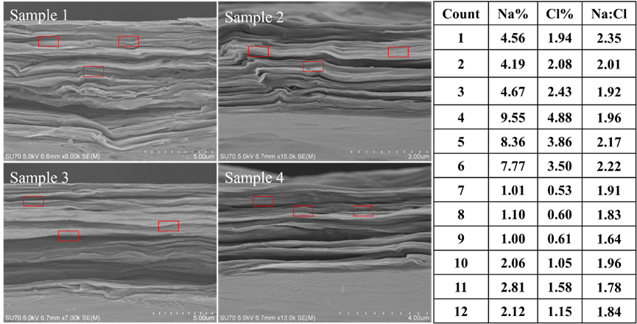
Supplementary Fig. 5 | Elemental analysis of Na−Cl@GO membrane by Scanning Electron Microscopy (SEM). The image on the left shows the cross-section of Na−Cl@GO membrane by SEM. The table on the right shows the atomic percentages of Na and Cl in the selected areas of Na−Cl@GO membrane, based on EDS analysis.

As shown in the cross-section images (Supplementary Fig. 5), the Na−Cl@GO membrane thickness is about 5 μm and the structure is indeed compacted. The table on the right shows the atomic percentages of Na and Cl. The EDS results obtained from 12 areas of the Na−Cl@GO membrane also showed that the crystal domain was mainly composed of Na and Cl with an atomic ratio of ~2:1.

Supplementary Note 6: Piezoelectric performance of the sensor in high-pressure range of 0.1 to 100 kPa

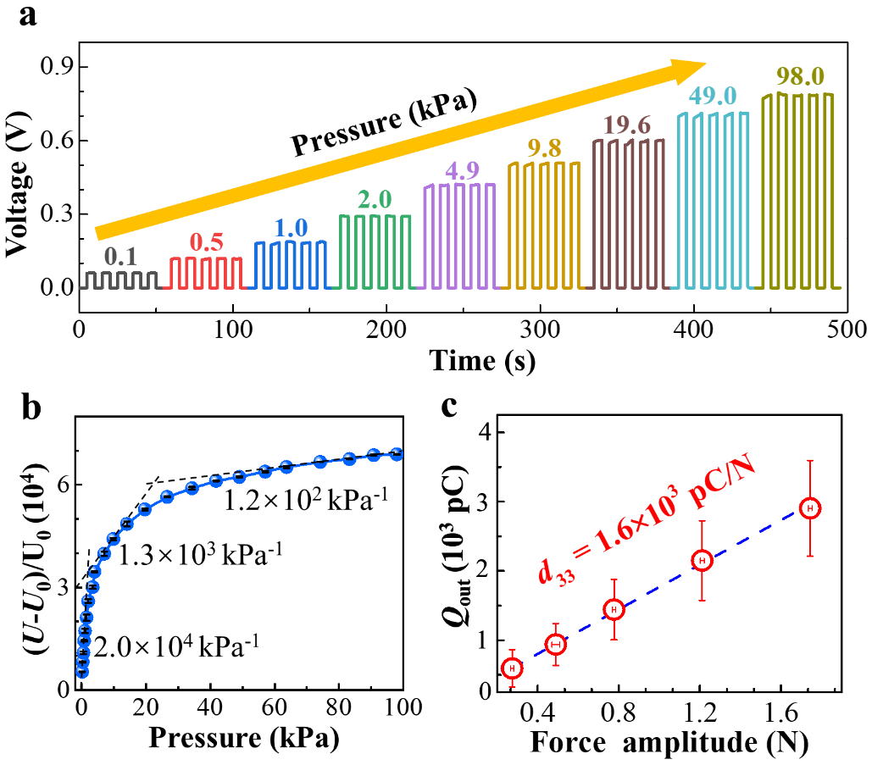
Supplementary Fig. 6 | Pressure sensing of piezoelectric sensor at high pressures. a, Voltage response under the step-like increased pressure. b, Normalized relative voltage change ((U-U₀)/U₀) as a function of the applied pressure. c, Direct piezoelectric measurements of the sensor with an increasing force range of 0.2–1.8 N.

The piezoelectric coefficient (d₃₃) is 1.6×10³ pC/N (Supplementary Fig. 6c), which was obtained using direct piezoelectric measurement (ZMpiezo-B) under the applied dynamic load in the regime of 0.2–1.8 N. This d₃₃ value is not only three orders of magnitude larger than the piezoelectric coefficient of 2D materials, such as 2.1 pC/N for MoS₂/WS₂ heterobilayer ³ and 0.34 pC/N for monolayer α-In₂Se₃ ⁴, but also far larger than ~7.6×10² pC/N for the most recently reported textured PZT ceramics ⁵.

Supplementary Note 7: Performance comparison between the sensor and other pressure sensors reported in recent five years
Supplementary Table 1 | Performance parameters comparison between the proposed sensor and other pressure sensors reported in recent five years. The pressure-sensing mechanism parameters include the peak sensitivity (S_{P}), low pressure detection limit (P_{L}), sensing range (R_{S}), response time (τ_{r}), recovery time (τ_{d}), and stable repeat cycles or durability (D).

Sensing Mechanism | S_{P} | P_{L} | R_{S} | τ_{r /}τ_{d} | D | Year | Ref.
Piezoresistive | 2027.5 kPa⁻¹ | 0.3 Pa | 0.3 Pa−200 kPa | 18 ms | 10000 | 2023 | Ref.⁶
Piezoresistive | 13662 kPa⁻¹ | 14 Pa | 14 Pa−450 kPa | 200 ms | 250 | 2023 | Ref.⁷
Piezoresistive | 20 kPa⁻¹ | 0.6 Pa | 0.6 Pa−300 kPa | 20/20 ms | 3000 | 2023 | Ref.⁸
Capacitive | 0.15 kPa⁻¹ | 0.35 Pa | 0.35 Pa−450 kPa | 6/6 ms | 10000 | 2022 | Ref.⁹
Capacitive | 19 kPa⁻¹ | 0.05 Pa | 0.05 Pa−90 kPa | 0.8 ms | 1000 | 2022 | Ref.¹⁰
Piezoresistive | 3.06 kPa⁻¹ | 120 Pa | 120 Pa−380 kPa | 9.43 ms | 2000 | 2022 | Ref.¹¹
Piezoresistive | 476 kPa⁻¹ | 17.1 Pa | 17.1 Pa−3.4 kPa | 0.41/0.12 s | 10000 | 2022 | Ref.¹²
Piezoresistive | 30.3 kPa⁻¹ | 87 Pa | 87 Pa–20 kPa | 19/23 ms | 4000 | 2022 | Ref.¹³
Piezoresistive | 13.1 kPa⁻¹ | 1.6 Pa | 1.6 Pa–800 kPa | 0.675/0.55 ms | 1000 | 2022 | Ref.¹⁴
Piezoresistive | 62 kPa⁻¹ | 0.1 Pa | 0.1-1.3 Pa | 15/25 ms | -- | 2022 | Ref.¹⁵
Piezoresistive | 51.14 kPa⁻¹ | 210 Pa | 210 Pa−13.7 kPa | 99/93 ms | 5000 | 2022 | Ref.¹⁶
Piezoresistive | 19.77 kPa⁻¹ | 1.3 Pa | 1.3 Pa−2 MPa | 12/82 ms | 6000 | 2022 | Ref.¹⁷
Piezoresistive | 690.91 kPa⁻¹ | 710 Pa | 0.71-20.09 kPa | 106/95 ms | 10000 | 2022 | Ref.¹⁸
Piezoresistive | 6.33 kPa⁻¹ | 30 Pa | 30 Pa−20 kPa | 161/227 ms | 6000 | 2022 | Ref.¹⁹
Capacitive | 1.005 kPa⁻¹ | 0.5 Pa | 0.5 Pa−200 kPa | 40/40 ms | 6000 | 2022 | Ref.¹⁷
Piezoresistive | 28.43 kPa⁻¹ | 0.8 Pa | 0.8 Pa−7.5 kPa | 98/99 ms | 5000 | 2022 | Ref.²⁰
Piezoresistive | 509.8 kPa⁻¹ | 7.8 Pa | 7.8 Pa−20.3 kPa | 67/45ms | 10000 | 2022 | Ref.²¹
Piezoresistive | 12 kPa⁻¹ | 252 Pa | 252 Pa−45 kPa | 84/80 ms | 23000 | 2022 | Ref.²²
Piezoresistive | 50.45 kPa⁻¹ | 0.209 Pa | 0.209−400 Pa | 39/31 ms | 4000 | 2022 | Ref.²³
Piezoresistive | 3.1 kPa⁻¹ | 1 Pa | 1 Pa–400 kPa | 15/22 ms | 10000 | 2022 | Ref.²⁴
Piezoresistive | 0.57 kPa⁻¹ | 10 Pa | 10 Pa–200 kPa | 2/2 ms | 6000 | 2022 | Ref.²⁵
Triboelectric | 6.28 kPa⁻¹ | 0.65 Pa | 0.65 Pa–140 kPa | 92 ms | 3000 | 2022 | Ref.²⁶
Piezoresistive | 224 kPa⁻¹ | 650 Pa | 0.65–19.61 kPa | 63/40 ms | 15000 | 2022 | Ref.²⁷
Capacitive | 4.5 kPa⁻¹ | 0.2 Pa | 0.2 Pa−10 kPa | 50/50 ms | 500 | 2021 | Ref.²⁸
Capacitive | 3.13 kPa⁻¹ | 0.07 Pa | 0.07 Pa−50 kPa | 94 ms | 5000 | 2021 | Ref.²⁹
Capacitive | 5.5 kPa⁻¹ | 2 Pa | 2 Pa−250 kPa | 70/93 ms | 20000 | 2021 | Ref.³⁰
Capacitive | 46730 kPa⁻¹ | 20 Pa | 20 Pa−1.4MPa | 98/70 ms | 10000 | 2021 | Ref.³¹
Piezoresistive | 649.3 kPa⁻¹ | 4 Pa | 4 Pa−20.55 kPa | 123/139 ms | 10000 | 2021 | Ref.³²
Piezoresistive | 95.2 kPa⁻¹ | 0.4 Pa | 0.4 Pa−10 kPa | 95/82 ms | 25000 | 2021 | Ref.³³
Piezoresistive | 298.4 kPa⁻¹ | 7.1 Pa | 7.1 Pa−39.3 kPa | 7/16 ms | 10000 | 2021 | Ref.³⁴
Capacitive | 0.141 kPa⁻¹ | 980 Pa | 0.98−100 kPa | 190/215 ms | 1000 | 2020 | Ref.³⁵
Capacitive | 3302.9 kPa⁻¹ | 0.08 Pa | 0.08 Pa−360 kPa | 9/18 ms | 5000 | 2020 | Ref.³⁶
Piezoresistive | 3.5 kPa⁻¹ | 1Pa | 1Pa−218 kPa | 31/52 ms | 10000 | 2020 | Ref.³⁷
Piezoresistive | 4200 kPa⁻¹ | 20 Pa | 20 Pa−30 kPa | 8/20 ms | 4000 | 2020 | Ref.³⁸
Piezoresistive | 151.4 kPa⁻¹ | 4.4 Pa | 4.4 Pa−15 kPa | 125/104 ms | 10000 | 2020 | Ref.³⁹
Piezoresistive | 128 kPa⁻¹ | 100 Pa | 100 Pa−623 kPa | 320/98 ms | 1000 | 2020 | Ref.⁴⁰
Piezoresistive | 10.75 kPa⁻¹ | 0.87 Pa | 0.87 Pa−61.5 kPa | 34/52 ms | 1000 | 2020 | Ref.⁴¹
Piezoresistive | 99.5 kPa⁻¹ | 9 Pa | 9 Pa−4.5 kPa | 4/13 ms | 10000 | 2020 | Ref.⁴²
Piezoresistive | 383666 kPa⁻¹ | 0.25 Pa | 0.25 Pa−56 kPa | 75/50 ms | 1000 | 2020 | Ref.⁴³
Piezoresistive | 15.22 kPa⁻¹ | 200 Pa | 0.2−44.9 kPa | 74/67 ms | 3000 | 2020 | Ref.⁴⁴
Capacitive | 760 kPa⁻¹ | 0.05 Pa | 0.05 Pa−2.4 kPa | 0.03125 ms | -- | 2020 | Ref.⁴⁵
Piezoresistive | 609 kPa⁻¹ | 6 Pa | 6 Pa−10 kPa | 232/225 ms | 6000 | 2019 | Ref.⁴⁶
Piezoresistive | 114.6 kPa⁻¹ | 1 Pa | 1 Pa−10 kPa | 189 ms | 10000 | 2019 | Ref.⁴⁷
Piezoresistive | 26.13 kPa⁻¹ | 200 Pa | 200 Pa−982 kPa | 83/88 ms | 1000 | 2019 | Ref.⁴⁸
Piezoresistive | 1036.04 kPa⁻¹ | 6.2 Pa | 6.2 Pa−20 kPa | 50/40 ms | 10000 | 2019 | Ref.⁴⁹
Piezoresistive | 0.13 kPa⁻¹ | 0.5 Pa | -- | -- | -- | 2019 | Ref.⁵⁰
Capacitive | 1.0 kPa⁻¹ | 2 Pa | 2 Pa−20 kPa | 140/110 ms | 1000 | 2018 | Ref.⁵¹
Capacitive | 0.7 kPa⁻¹ | 12 Pa | 12 Pa−430 kPa | -- | 30000 | 2018 | Ref.⁵²
Piezoresistive | 121 kPa⁻¹ | 0.015 Pa | 0.015 Pa−10 kPa | 7/7 ms | 2000 | 2018 | Ref.⁵³
Piezoelectric | 3.5×10⁶ kPa⁻¹ | 0.001 Pa | 0.001Pa-100 kPa | 0.001/0.238 ms | 11000 |  | This work

Supplementary Note 8: Effective modulus of the piezoelectric material of Na-Cl@GO membrane
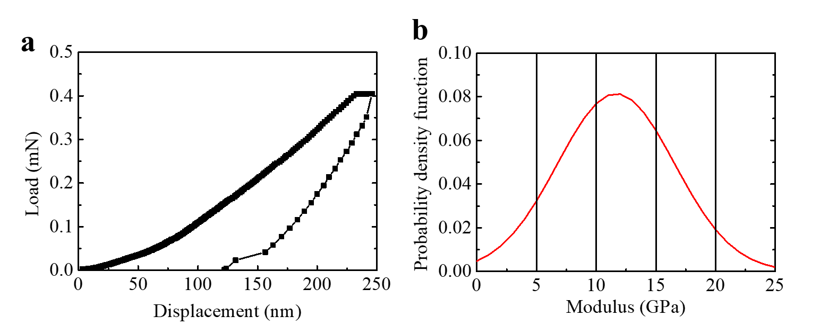
Supplementary Fig. 7 | Effective modulus measurement for Na-Cl@GO membrane through nanoindentation. a, Load-displacement curve. b, Distribution of the estimated modulus of the Na-Cl@GO membrane.

The effective modulus $E$ is calculated according to the following formula ⁵⁴:
$E=\left(1-v^{2}\right){\left(\frac{1}{E_{r}}-\frac{1-v_{i}^{2}}{E_{i}}\right)}^{-1}$ (1)
where ν denotes the Poisson’s ratio for the specimen, E_{r} represents the reduced modulus that accounts for the effects of non-rigid indenters on the indentation behavior of the membrane, E_{i} and ν_{i} are the elastic modulus (1147 GPa) and Poisson ratio (0.07) of the diamond indenter, respectively. Here , in which S is the slope of the unloading curve (the initial unloading stiffness), and A denotes the projected area of the indentation impression. S and A can be automatically obtained by the indentation tester.
To determine the effective modulus E of Na-Cl@GO membrane, the Poisson’s ratio should be determined first. Graphene oxide (GO) exhibits a wide range of reported Poisson's ratios. Atomistic simulations have indicated a notably negative Poisson's ratio of −0.567 for fully oxidized graphene ⁵⁵. Experimental studies have reported Poisson's ratios for GO films ranging from −0.25 to −0.55 ⁵⁶. Additionally, the Poisson's ratio of graphene can vary significantly, shifting between positive and negative values depending on factors such as strain and defects. For instance, at zero tensile strain, the Poisson's ratio is approximately 0.3 ⁵⁷. Meanwhile, NaCl possesses a known Poisson’s ratio of about 0.252, whereas the Poisson's ratio for Na₂Cl has not been reported. Considering the Poisson’s ratio of common solid-state crystals typically falls within the range of 0 to 0.5 ⁵⁸, and since the sample consists of regions with both oxidized graphene and pristine graphene, an assumed overall Poisson's ratio of 0.18 is employed for the membrane sample (a common assumption in experimental settings). When the effective modulus E of Na-Cl@GO membrane is determined, such assumption will lead to a maximum overestimation of 38.72% if ν= 0.5 or a slight underestimation of 3.24% if ν = 0.
Based on the measurement results, there were instances where no data were recorded for specific testing sites, while in other cases, recorded data exhibited anomalous profiles that deviated from the typical nanoindentation outcomes. These abnormal testing results were attributed to the incomplete oxidation of graphene oxide (GO) and the non-uniform distribution of Na₂Cl crystals within the membrane. Out of the 25 conducted tests, we were able to obtain 15 effective measurements. In Supplementary Fig. 7a, a representative load-displacement curve obtained during the nanoindentation test is presented, while Supplementary Fig. 7b illustrates the distribution of the estimated modulus, showing a well-fitted normal distribution. As expected, the membrane exhibited varying effective moduli at different locations, closely correlated with the distribution of Na₂Cl within the GO membranes. Based on these results, the average effective modulus for the Na-Cl@GO membrane was determined to be 11.66 ± 4.90 GPa, considering a 95% confidence interval.

Supplementary Note 9: Transformation relation between the applied pressure (P) and the open-circuit output voltage (V_{oc}) of piezoelectric sensor
The constitutive relations for a typical piezoelectrical material can be given as
(2)
where σ, γ, D, and E are tensors of stress, strain, electrical displacement, and the intensity of the electric field, respectively, while s^{E}, d, and ε^{σ} are tensors of elastic compliance under the condition of a closed circuit, piezoelectric strain constant, and dielectric constant at fixed stress, respectively. This constitutive model can be rewritten in the matrix form as
(3)
(4)
The piezoelectric sensor is fixed with one surface patching on a plane of an object, while the other is free. As a result, the sensor undergoes a simple compression state along the thickness direction (z direction) in various tests, such as weight tests, tuning fork experiments and butterfly tests. The stresses along other directions are approximately zero due to the absence of applied force. Consequently, the constitutive model can be simplified as follows:
(5)
where P represents the applied pressure in thickness direction. The charge of the piezoelectric sensor can be given as , where A and h denote the effective area and thickness of the piezoelectric material.
To measure the output voltage, the sensor is connected to a voltmeter with resistance R. Subsequently, the current in the circuit can be expressed as , which can be further rewritten as
(6)
where represents the equivalent capacitance of the piezoelectric sensor. Accordingly, the output voltage can be expressed as
(7)
Equation (7) indicates that the sensor's output voltage is influenced by the external resistance. In the ongoing experiments, the resistance of the electrochemical workstation measures 4 GΩ, a significantly high value that effectively renders the circuit in an approximate open-circuit state. Consequently, the correlation between applied pressure and output voltage can be simplified as
(8)
The capacitance C_{p} is obtained using an impedance analyzer (Supplementary Fig. 8), while the piezoelectric constant d₃₃ is measured using direct piezoelectric measurement (ZMpiezo-B), as shown in Supplementary Fig. 6c. Given these measured parameters (C_{p} = 150 nf, d₃₃ = 1.6 × 10³ pC/N, A_{p} = 1.77 × 10⁻⁴ m²), the output voltage can be calculated accordingly. The output voltages recorded in experiments are shown in Supplementary Fig. 9, and a comparison between the theoretical and experimental output voltages is depicted in Supplementary Fig. 9.

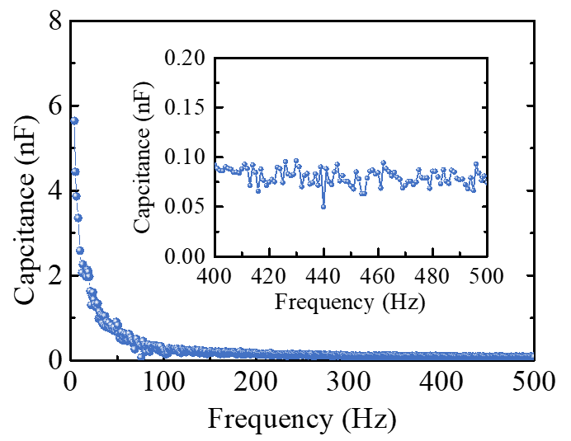
Supplementary Fig. 8 | Capacitance of the piezoelectric sensor versus varying frequency.

The impedance analyzer data (Supplementary Fig. 8) clearly indicate that the capacitance of the flexible sensor exhibits a discernible decrease as the frequency increases from 4 Hz to 500 Hz, with the most significant sensitivity being observed at frequencies below 100 Hz. At the lowest sweeping frequency of 4 Hz, the capacitance of the sensor is recorded at 150 nF. Based on the fitting method, it can be estimated that at the frequency of 0.1 Hz, the capacitance would be approximately 250 nF. On the other hand, the inset graph depicts that the capacitance value drops significantly to about 78 pF when the frequency is increased to 500 Hz.

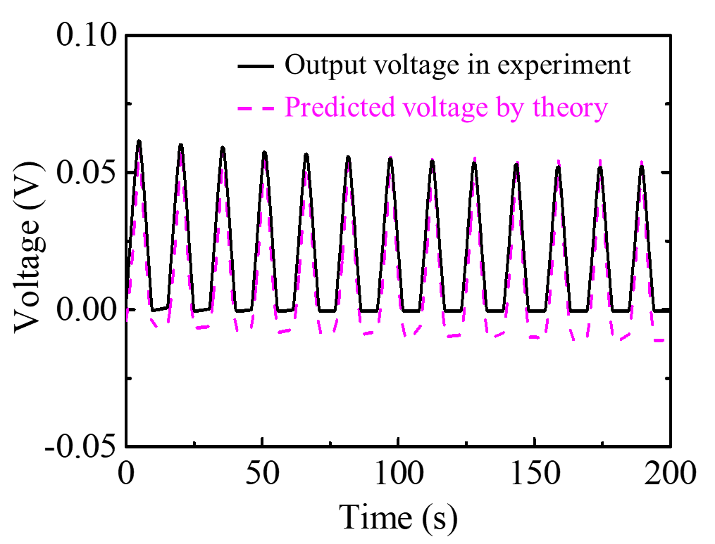
Supplementary Fig. 9 | Comparison of the output voltage between theory and experiment.

The consistency between the recorded output voltage signals in the experiment and the voltage predicted by the electromechanical theory in Equations (7-8) is illustrated in Supplementary Fig. 9. This consistency validates the effectiveness of the theory, establishing a solid foundation for deriving pressure signals from the sensor's output voltage signals.
For a pressure sensor, the pressure applied on the device should be obtained quantitatively, which depends on the physical mechanism between the output voltage and the applied pressure. Here, based on Equation (8), the relationship between the applied pressure P_{z} and the piezoelectric sensor’s open-circuit output voltage V_{oc} can be determined as
(9)
where d₃₃, A_{p}, and C_{p} are the piezoelectric constant, effective area, and equivalent capacitance of the sensor, respectively. The predicted pressure with Equation (9) is remarkably consistent with the applied pressure in the experiment, as shown in Supplementary Fig. 10, validating the effectiveness of the theoretical model.

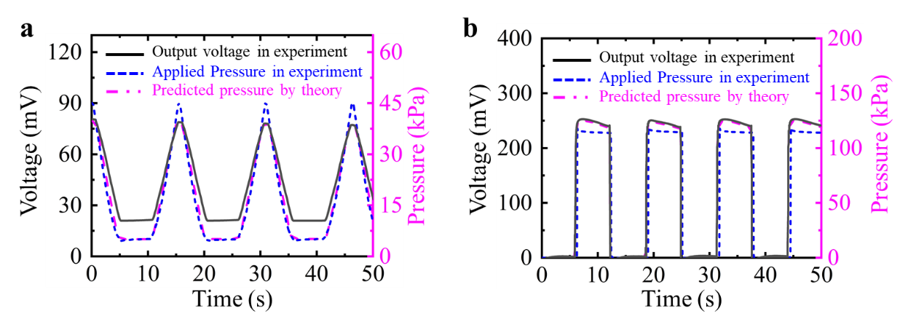
Supplementary Fig. 10 | Validation of the inversion method by comparing the predicted pressure by theory and applied pressure in experiment. a, Triangular wave load. b, Square wave load.

Given the broad operational range of the pressure sensor (from 1 mPa to 100 kPa), it is crucial to assess how variations in applied pressure values affect certain parameters (A_{p}, C_{p}, d₃₃). When subjected to varying amplitudes of external pressure, the sensor's surface area (A_{p}) and capacitance (C_{p}) may experience minor fluctuations. For instance, as the applied pressure transitions from 0 mPa to 200 kPa, A_{p} and C_{p} will exhibit an approximate increase of 0.0006% and 0.0023%, respectively, as detailed in Equation (10). Here ε_{z} stands for the strain in the vertical direction, while ε_{x} and ε_{y} stand for the strain in the horizontal direction. In the current assessment, the crystal's elastic modulus within the sensor is set as 11.66 GPa, with a Poisson's ratio of 0.18, based on results obtained from indentation tests.
(10-1)
(10-2)
(10-3)
(10-4)
However, the piezoelectric constant d₃₃ would change dramatically with the applied external excitation, such as amplitude and frequency of applied voltage ⁵⁹. Here, the piezoelectric constant d₃₃ under faint pressure (< 100 mPa) can be obtained from the tuning fork experiment (260 Hz) (Supplementary Fig. 6a). In this experiment, the sound pressure near the piezoelectric sensor was measured using a sound pressure meter, which exhibits the pressure ranges from 90.4 mPa (73 dB) to 1.0 mPa (34 dB). Employing the data of the applied pressure and output voltage of the sensor, the piezoelectric constant d₃₃ can be obtained. When the applied pressure is close to 1 mPa, the piezoelectric constant d₃₃ can reach 1.25 × 10⁶ pC/N. Owing to this giant piezoelectric constant, the piezoelectric sensor exhibits merits including high sensitivity and low detection limit.
Employing Equation (9) and the expression of the piezoelectric constant d₃₃ under faint pressure condition, the pressure generated by the butterfly flap can be obtained accordingly, as shown in Fig. 3b.

Supplementary Fig. 11 | Dependence of piezoelectric constant d₃₃ on applied pressure under faint pressure below 0.1 Pa. Data from tuning fork experiments with a ~260 Hz sound source.

Supplementary Note 10: Detection of tiny airflow fluctuations surrounding a flapping butterfly with the piezoelectric sensor

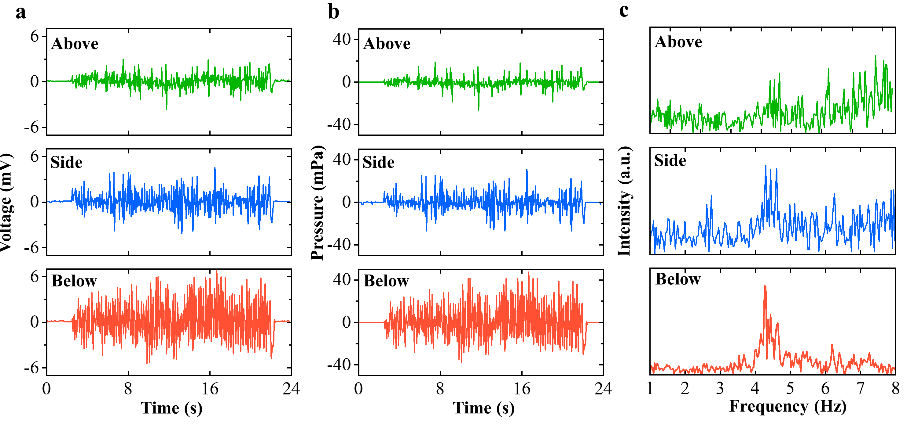
Supplementary Fig. 12 | Detection of tiny airflow fluctuations surrounding a flapping butterfly with the piezoelectric sensor. a, Voltage output response of the sensors above, on the side of, and below a flapping butterfly in real time. b, Air pressure variations above, on the side of, and below a flapping butterfly in real time. c, Wing-beat frequency of the flapping butterfly.

The sensors were fixed above, on the side of, and below a flapping butterfly, respectively. The distance of the sensors from the butterfly is 5 cm to monitor the real-time variations of airflow pressure surrounding a flapping butterfly. The movies of experiments for real-time motoring of airflow pressure surrounding a flapping butterfly by the sensors are provided in the Supplementary Video 1.

Supplementary Video 1: Movies of experiments for real-time motoring of airflow pressure variations surrounding a flapping butterfly by the sensors

References
1. King-Smith, R. D. & Vanderbilt, D. Theory of polarization of crystalline solids. Phys. Rev. B 47, 1651–1654 (1993).
2. Spaldin, N. A. A beginner's guide to the modern theory of polarization. J. Solid State Chem. 195, 2–10 (2012).
3. Rogée, L. et al. Ferroelectricity in untwisted heterobilayers of transition metal dichalcogenides. Science 376, 973–978 (2022).
4. Xue, F. et al. Multidirection piezoelectricity in mono- and multilayered hexagonal alpha-In₂Se₃. ACS Nano 12, 4976–4983 (2018).
5. J. Li et al. Lead zirconate titanate ceramics with aligned crystallite grains. Science 380, 87–93 (2023).
6. Wang, C. et al. Ultra-sensitive and wide sensing-range flexible pressure sensors based on the carbon nanotube film/stress-induced square frustum structure. ACS Appl. Mater. Interfaces 15, 8546–8554 (2023).
7. Liao, W. et al. Ultrasensitive Mg²⁺-modulated carbon nanotube/tannic acid aerogels for high-performance wearable pressure sensors. ACS Sustainable Chem. Eng. 11, 2186-2197 (2023).
8. Yuan, H. et al. Hierarchical wrinkling-cracking architectures for flexible pressure sensors. Adv. Mater. Interfaces 10, 2202169 (2023).
9. Zhang, Y. et al. Highly stable flexible pressure sensors with a quasi-homogeneous composition and interlinked interfaces. Nat. Commun. 13, 1317 (2022).
10. Zhang, J. H. et al. Versatile self-assembled electrospun micropyramid arrays for high-performance on-skin devices with minimal sensory interference. Nat. Commun. 13, 5839 (2022).
11. Zhuo, S., Song, C., Rong, Q., Zhao, T. & Liu, M. Shape and stiffness memory ionogels with programmable pressure-resistance response. Nat. Commun. 13, 1743 (2022).
12. Li, Y. et al. Ultrasensitive pressure sensor sponge using liquid metal modulated nitrogen-doped graphene nanosheets. Nano Lett. 22, 2817-2825 (2022).
13. Xia, S.-Y. et al. Laser-induced graphene (LIG)-based pressure sensor and triboelectric nanogenerator towards high-performance self-powered measurement-control combined system. Nano Energy 96, 107099 (2022).
14. Yang, H. et al. A nature-inspired hierarchical branching structure pressure sensor with high sensitivity and wide dynamic range for versatile medical wearables. Biosens. Bioelectron. 203, 114028 (2022).
15. Gou, G.-Y. et al. Two-stage amplification of an ultrasensitive MXene-based intelligent artificial eardrum. Sci. Adv. 8, eabn2156 (2022).
16. Su, T. et al. Flexible MXene/bacterial cellulose film sound detector based on piezoresistive sensing mechanism. ACS Nano 16, 8461–8471 (2022).
17. Guo, X. et al. Biologically emulated flexible sensors with high sensitivity and low hysteresis: toward electronic skin to a sense of touch. Small 18, e2203044 (2022).
18. Yin, T. et al. 3D porous structure in MXene/PANI foam for a high-performance flexible pressure sensor. Small 18, e2204806 (2022).
19. Liu, Y. et al. Biodegradable, breathable leaf vein-based tactile sensors with tunable sensitivity and sensing range. Small 18, e2106906 (2022).
20. Ma, Y. et al. Flexible and highly-sensitive pressure sensor based on controllably oxidized MXene. InfoMat. 4, e12328 (2022).
21. Yang, M. et al. High-performance flexible pressure sensor with a self-healing function for tactile feedback. Adv. Sci. 9, e2200507 (2022).
22. Li, J. et al. Interfacially locked metal aerogel inside porous polymer composite for sensitive and durable flexible piezoresistive sensors. Adv. Sci. 9, e2201912 (2022).
23. Jung, Y. et al. Irregular Microdome Structure‐Based Sensitive Pressure Sensor Using Internal Popping of Microspheres. Adv. Funct. Mater. 32, 2201147 (2022).
24. Cao, K. et al. Beyond skin pressure sensing: 3D printed laminated graphene pressure sensing material combines extremely low detection limits with wide detection range. Adv. Funct. Mater. 32, 2202360 (2022).
25. Chen, J. et al. Ultrafast-response/recovery flexible piezoresistive sensors with DNA-like double helix yarns for epidermal pulse monitoring. Adv. Mater. 34, e2104313 (2022).
26. Lei, H. et al. 3D-printed endoplasmic reticulum rGO microstructure based self-powered triboelectric pressure sensor. Chem. Eng. J. 445, 136821 (2022).
27. Li, L. et al. MXene/rGO/PS spheres multiple physical networks as high-performance pressure sensor. Nano Energy 95, 106986 (2022).
28. Su, Q. et al. A stretchable and strain-unperturbed pressure sensor for motion interference-free tactile monitoring on skins. Sci. Adv. 7, eabi4563 (2021).
29. Ha, K. H. et al. Highly sensitive capacitive pressure sensors over a wide pressure range enabled by the hybrid responses of a highly porous nanocomposite. Adv. Mater. 33, e2103320 (2021).
30. Sharma, S. et al. Hydrogen-bond-triggered hybrid nanofibrous membrane-based wearable pressure sensor with ultrahigh sensitivity over a broad pressure range. ACS Nano 15, 4380–4393 (2021).
31. Gao, L. et al. Highly sensitive pseudocapacitive iontronic pressure sensor with broad sensing range. Nano-Micro Lett. 13, 140 (2021).
32. Su, T. et al. MXene/cellulose nanofiber-foam based high performance degradable piezoresistive sensor with greatly expanded interlayer distances. Nano Energy 87, 106151 (2021).
33. Yang, J. et al. Nanocellulose intercalation to boost the performance of MXene pressure sensor for human interactive monitoring. J. Mater. Sci. 56, 13859–13873 (2021).
34. Chao, M. et al. Breathable Ti₃C₂T_{x} MXene/protein nanocomposites for ultrasensitive medical pressure sensor with degradability in solvents. ACS Nano 15, 9746–9758 (2021).
35. Lee, S. et al. Nanomesh pressure sensor for monitoring finger manipulation without sensory interference. Science 370, 966–970 (2020).
36. Bai, N. et al. Graded intrafillable architecture-based iontronic pressure sensor with ultra-broad-range high sensitivity. Nat. Commun. 11, 209 (2020).
37. Zhao, T. et al. Pollen-shaped hierarchical structure for pressure sensors with high sensitivity in an ultrabroad linear response range. ACS Appl. Mater. Interfaces 12, 55362–55371 (2020).
38. Sun, Q. J. et al. Bioinspired, self-powered, and highly sensitive electronic skin for sensing static and dynamic pressures. ACS Appl. Mater. Interfaces 12, 37239–37247 (2020).
39. Cheng, Y. et al. Bioinspired microspines for a high-performance spray Ti₃C₂T_{x} MXene-based piezoresistive sensor. ACS Nano 14, 2145–2155 (2020).
40. Wang, L., Zhang, M., Yang, B., Tan, J. & Ding, X. Highly compressible, thermally stable, light-weight, and robust aramid nanofibers/Ti₃AlC₂ MXene composite aerogel for sensitive pressure sensor. ACS Nano 14, 10633–10647 (2020).
41. Lu, Y. et al. Highly stretchable, elastic, and sensitive MXene-based hydrogel for flexible strain and pressure sensors. Research 2020, 2038560 (2020).
42. Gao, Y. et al. Microchannel-confined MXene based flexible piezoresistive multifunctional micro-force sensor. Adv. Funct. Mater. 30, 1909603 (2020).
43. Li, G., Chen, D., Li, C., Liu, W. & Liu, H. Engineered microstructure derived hierarchical deformation of flexible pressure sensor induces a supersensitive piezoresistive property in broad pressure range. Adv. Sci. 7, 2000154 (2020).
44. Wang, Y. et al. Hierarchically patterned self-powered sensors for multifunctional tactile sensing. Sci. Adv. 6, eabb9083 (2020).
45. Huang, Y.-C. et al. Sensitive pressure sensors based on conductive microstructured air-gap gates and two-dimensional semiconductor transistors. Nat. Electron. 3, 59–69 (2020).
46. Zhu, M. et al. Hollow MXene sphere/reduced graphene aerogel composites for piezoresistive sensor with ultra-high sensitivity. Adv. Electron. Mater. 6, 1901064 (2019).
47. Zhuo, H. et al. A carbon aerogel with super mechanical and sensing performances for wearable piezoresistive sensors. J. Mater. Chem. A 7, 8092–8100 (2019).
48. Pyo, S., Lee, J., Kim, W., Jo, E. & Kim, J. Multi‐layered, hierarchical fabric-based tactile sensors with high sensitivity and linearity in ultrawide pressure range. Adv. Funct. Mater. 29, 1902484 (2019).
49. Yang, T. et al. Highly sensitive 1T-MoS₂ pressure sensor with wide linearity based on hierarchical microstructures of leaf vein as spacer. Adv. Electron. Mater. 6, 1900916 (2019).
50. Chen, M. et al. An ultrahigh resolution pressure sensor based on percolative metal nanoparticle arrays. Nat. Commun. 10, 4024 (2019).
51. Kim, H. et al. Transparent, flexible, conformal capacitive pressure sensors with nanoparticles. Small 14, 1703432 (2018).
52. Boutry, C. M. et al. A stretchable and biodegradable strain and pressure sensor for orthopaedic application. Nat. Electron. 1, 314–321 (2018).
53. Yin, B., Liu, X., Gao, H., Fu, T. & Yao, J. Bioinspired and bristled microparticles for ultrasensitive pressure and strain sensors. Nat. Commun. 9, 5161 (2018).
54. Oliver, W. C. & Pharr, G. M. An improved technique for determining hardness and elastic modulus using load and displacement sensing indentation experiments. J. Mater. Res. 7, 1564–1583 (1992).
55. Wan, J., Jiang, J.-W. & Park, H. S. J. N. Negative Poisson's ratio in graphene oxide. Nanoscale 9, 4007–4012 (2017).
56. Wen, Y. et al. Chemically modified graphene films with tunable negative Poisson’s ratios. Nat. Commun. 10, 2446 (2019).
57. Jiang, J.-W., Chang, T., Guo, X. & Park, H. S. J. N. l. Intrinsic negative Poisson’s ratio for single-layer graphene. Nano Lett. 16, 5286 (2016).
58. Woo, S., Park, H. C. & Son, Y.-W. Poisson's ratio in layered two-dimensional crystals. Phys. Rev. B 93, 075420 (2016).
59. Park, D.-S. et al. Induced giant piezoelectricity in centrosymmetric oxides. Science 375, 653–657 (2022).

