Supplementary Material of “Compound dry-hot-fire events in South America: an unapparent, long-range and deadly ripple effect”
Djacinto Monteiro dos Santos et al.
*Correspondence to: renata.libonati@igeo.ufrj.br (RL); santos.djacinto@gmail.com (DMS)

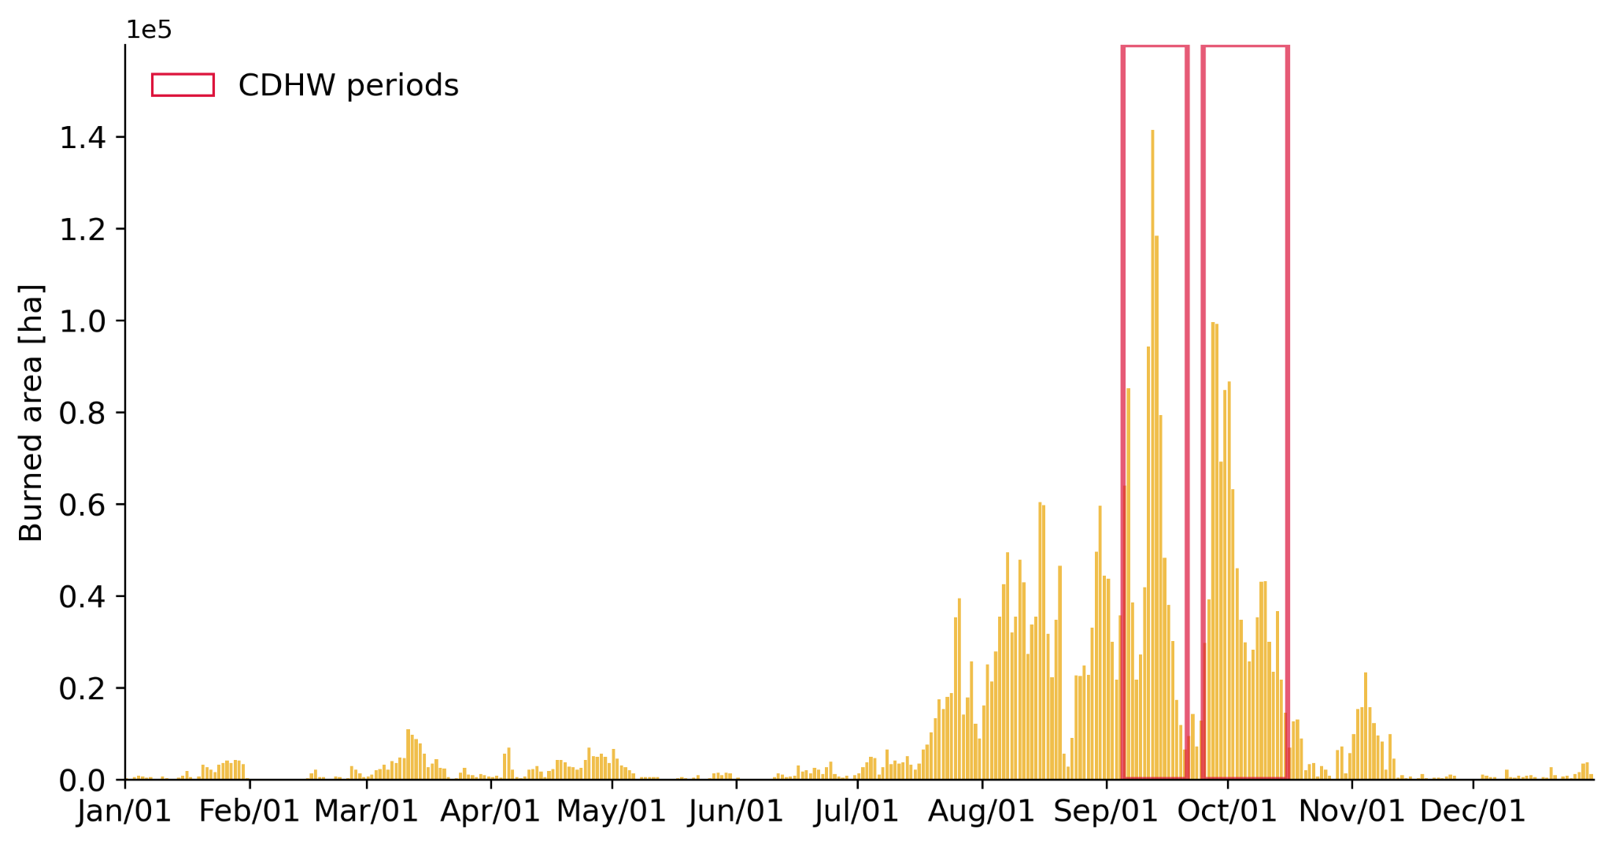

Figure S1. Daily burned Area [ha] from ALARMES (https://www.alarmes.lasa.ufrj.br) during the Pantanal fires in 2020. The CDHW periods between September 5th- 20th and September 25th - October 15th, as identified in Libonati et al.¹, are highlighted by the rectangles in red.

Table S1. EURAD-IM model quality indicators calculated with hourly PM_{2.5} concentration observed/modeled from September 12th to October 1st, 2020, at the CETESB meteorological stations inside the metropolitan area of São Paulo (inMASP), outside the metropolitan area (outMASP), and inside the São Paulo city (SPCity). Pearson’s correlations (r) were positive and over 0.50 for the three regions when GFAS fire emission was included in the model, reducing the Bias, MAE, and RMSE.
Obs x Model | EURAD-IM  No GFAS | EURAD-IM  GFAS SP | EURAD-IM GFAS PANTANAL | EURAD-IM  GFAS BR
InMASP
bias | -18.21 | -14.02 | -15.15 | -13.63
MAE | 18.69 | 14.82 | 15.67 | 14.54
RMSE | 26.01 | 21.51 | 22.63 | 21.17
r* | 0.34 | 0.65 | 0.65 | 0.66
SPCity
bias | -11.89 | -8.69 | -9.77 | -8.31
MAE | 13.49 | 11.09 | 11.72 | 10.91
RMSE | 19.43 | 16.64 | 17.48 | 16.36
r* | 0.50 | 0.61 | 0.59 | 0.62
OutMASP
bias | -26.57 | -22.06 | -24.51 | -21.58
MAE | 26.61 | 22.16 | 24.52 | 21.71
RMSE | 32.19 | 27.53 | 30.04 | 27.06
r* | 0.31 | 0.57 | 0.50 | 0.58
MAE = Mean Absolute Error; RMSE = Root Mean Square Error. * p-value < 0.05.

Table S2. EURAD-IM model quality indicators calculated with hourly Temperature (T2m), Relative Humidity (RH), and Wind Speed (WS) observed/modeled from September 12th to October 1st, 2020, at the CETESB meteorological stations inside the metropolitan area of São Paulo (inMASP), outside the metropolitan area (outMASP), and inside the São Paulo city (SPCity). Although the bias was low, the model overestimated wind speed in all areas. For WD, the model tends to overestimate at InMASP, presenting a positive bias, while for the other regions, SPCity and OutMASP, the model tends to underestimate, presenting a negative bias. For T2m and RH, the model presented a Pearson’s correlation coefficient over 0.80, indicating good agreement with observation at all three regions analyzed.
Obs x Model | Temperature  (T2m) | Relative Humidity  (RH) | Wind Speed  (WS) | Wind Direction  (WD)
InMASP
bias | -1.05 | 0.63 | 1.48 | 10.80
MAE | 2.73 | 12.83 | 1.57 | 63.01
RMSE | 3.56 | 15.81 | 1.83 | 86.07
r* | 0.83 | 0.85 | 0.48 | 0.44
SPCity
bias | -1.37 | 4.79 | 2.16 | -4.98
MAE | 3.53 | 14.06 | 2.20 | 46.64
RMSE | 5.19 | 17.56 | 2.50 | 78.01
r* | 0.82 | 0.84 | 0.36 | 0.56
OutMASP
bias | -1.52 | -1.92 | 1.81 | -17.06
MAE | 3.09 | 11.75 | 1.99 | 68.29
RMSE | 3.98 | 14.60 | 2.32 | 84.15
r* | 0.82 | 0.81 | 0.61 | 0.34
MAE = Mean Absolute Error; RMSE = Root Mean Square Error. * p-value < 0.05.

Table S3. EURAD-IM model setup.

Gas and aerosol scheme
Chemical scheme |  | RACM-MIM²
Aerosol scheme |  | MADE³
Chemical initial and boundary conditions |  | CAMS-IFS
Emissions
Anthropogenic | EDGARv4.3.2⁴
Anthropogenic Temporal profiles | EDGARv4.3.2⁴
Anthropogenic Vertical profiles | Mailler et al.⁵
Biogenic | MEGANv2.1⁶
Fires | GFASv1.2⁷
Meteorological parameterization
Surface | NOAH⁸
PBL | YSU⁹
Radiation | RRTMG¹⁰
Micro-Physics | WSM3⁹
Convection | Grell-3D¹¹
Initial and boundary conditions | NCEP-FNL
Nudging | only PBL
Model Domain
Horizontal resolution | 25 km
Grid sizes (lon x lat) | 110 x 101
Vertical levels | 23 (up to 100 hPa)
Height first level | 54 m

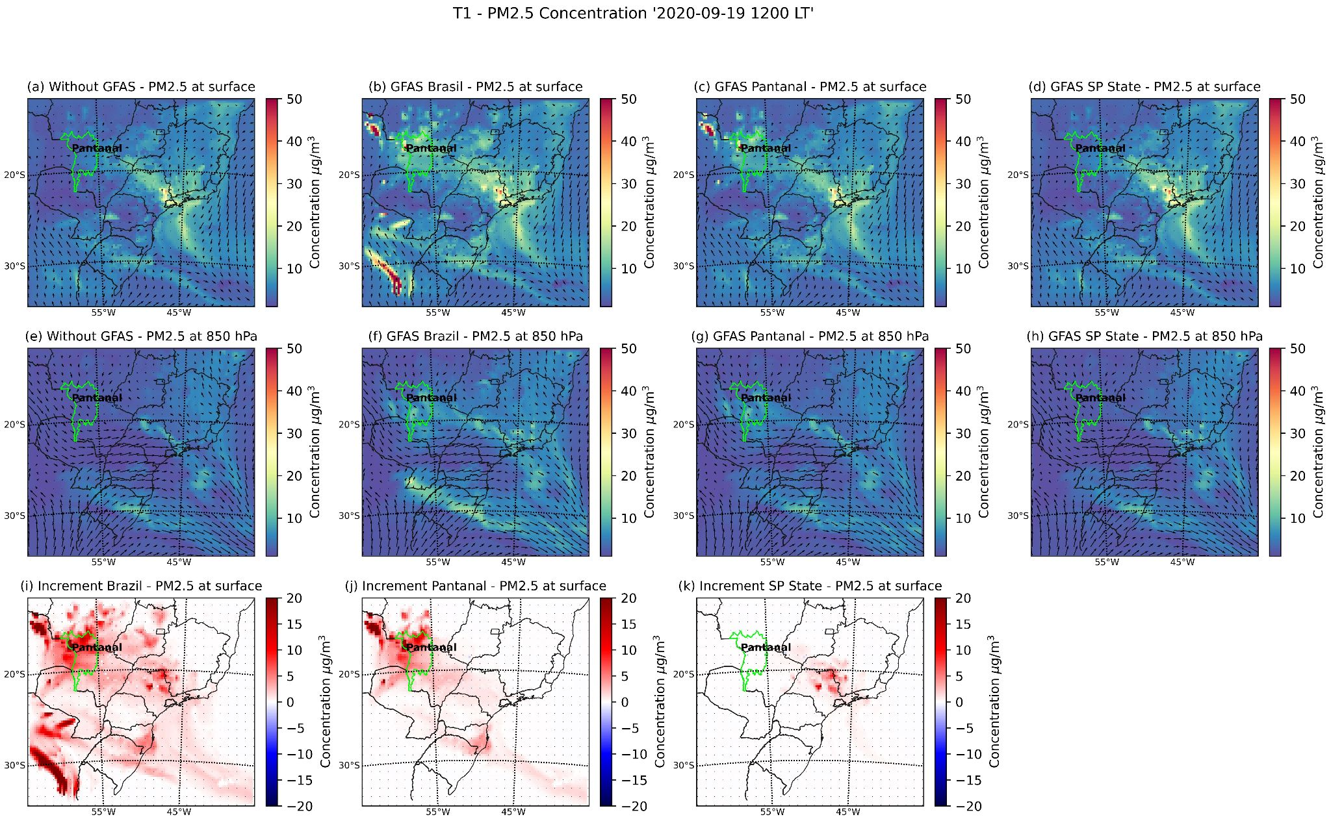

Figure S2: PM2.5 concentrations on September 19, 2020, at 1200 LT during T1 episode modeled by EURAD-IM with 25-km horizontal resolution: at the surface (a) without GFAS; (b) with GFAS Brazil; (c) with GFAS Pantanal; (d) with GFAS SP State; at 850 hPa (e) without GFAS; (f) with GFAS Pantanal; (g) with GFAS SP State; increment at surface (i) with GFAS Brazil; (j) with GFAS Pantanal; and (k) with GFAS SP State.

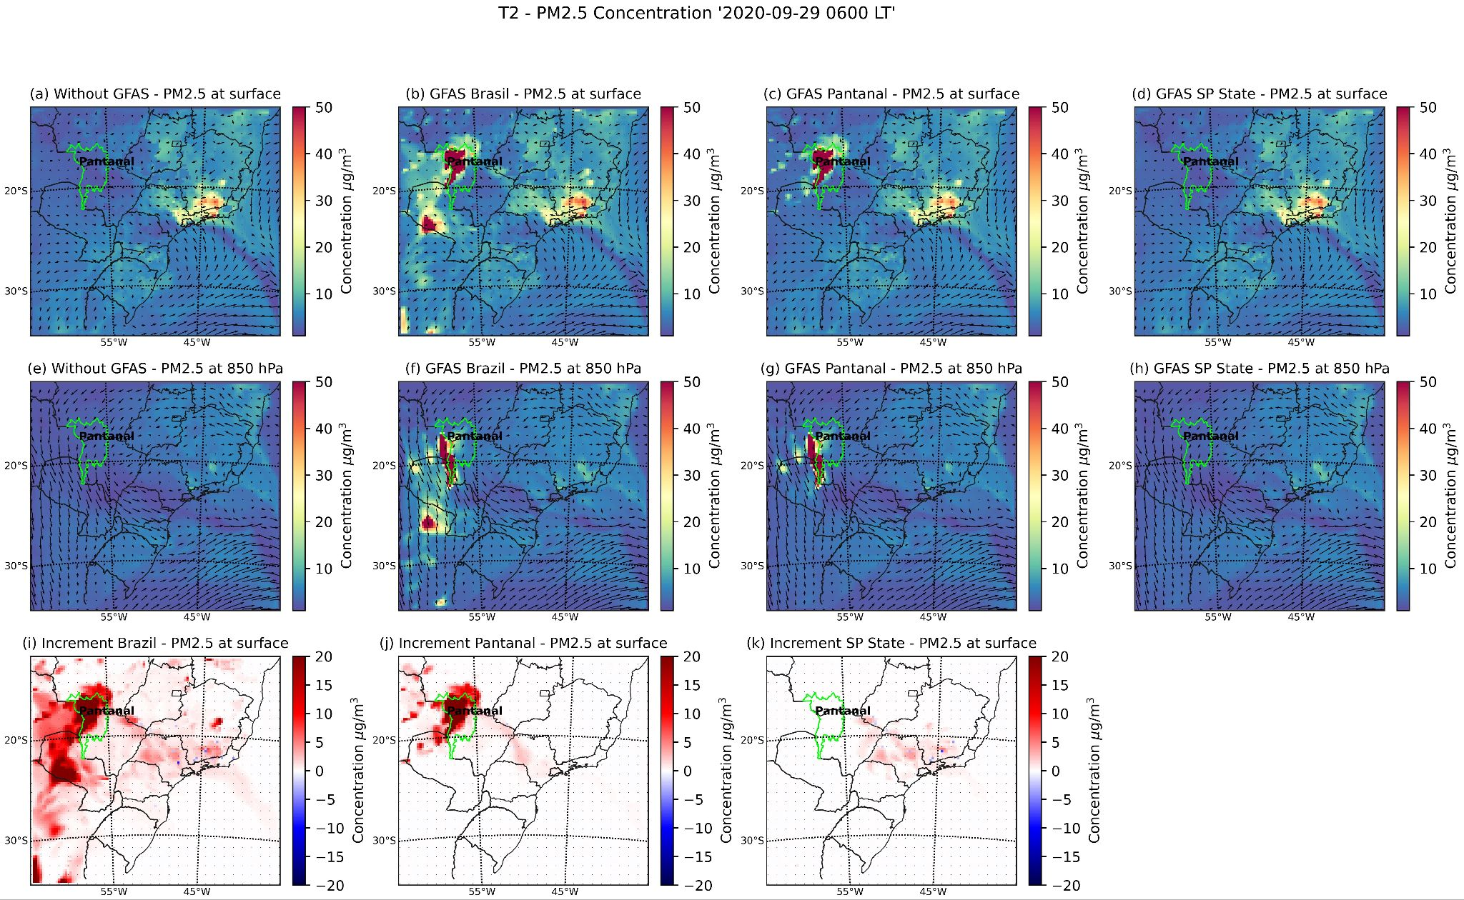

Figure S3 -PM2.5 concentrations on September 29, 2020, at 0600 LT during the T2 episode modeled by EURAD-IM with 25-km horizontal resolution at surface level: (a) without GFAS; (b) with GFAS Brazil; (c) with GFAS Pantanal; (d) with GFAS SP State; and at 850 hPa (e) without GFAS; (f) with GFAS Pantanal; (g) with GFAS SP State; increment at the surface (i) with GFAS Brazil; (j) with GFAS Pantanal; and (k) with GFAS SP State.

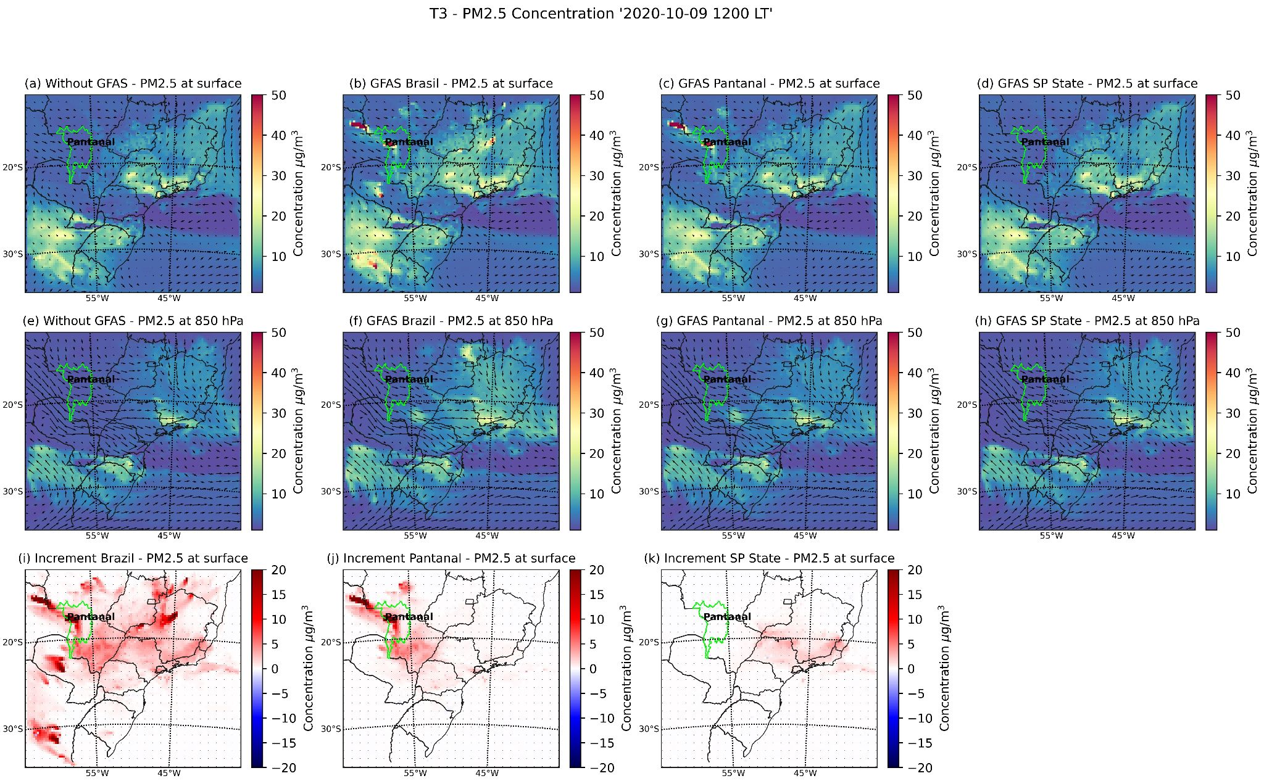

Figure S4 - PM2.5 concentrations on September 9, 2020, at 1200 LT during the T3 episode modeled by EURAD-IM with 25-km horizontal resolution at surface level: (a) without GFAS; (b) with GFAS Brazil; (c) with GFAS Pantanal; (d) with GFAS SP State; and at 850 hPa (e) without GFAS; (f) with GFAS Pantanal; (g) with GFAS SP State; increment at surface (i) with GFAS Brazil; (j) with GFAS Pantanal; and (k) with GFAS SP State.

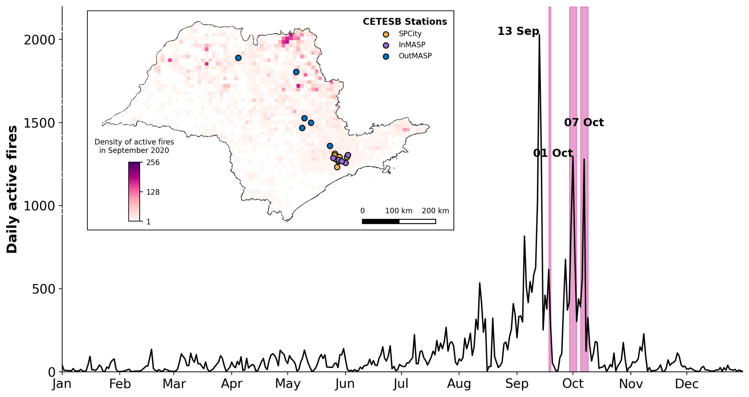

Figure S5 - Daily active fire counts throughout 2020 and active fire density (total in each grid cell) in SPS during September 2020. The data displayed were gathered from VIIRS active fire products within SPS. The violet-shaded boxes denote the PM peaks in Table 1.

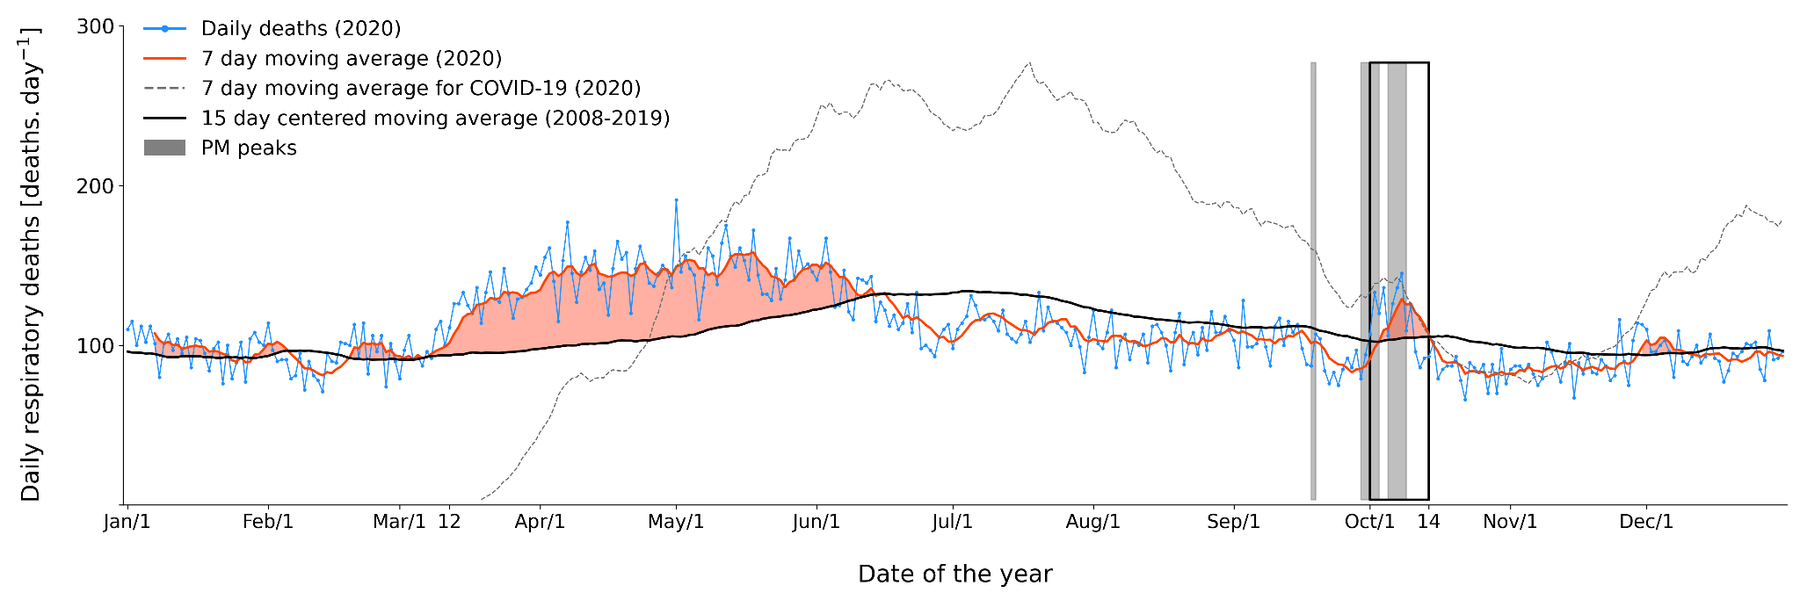

Figure S6 - Daily respiratory deaths over the SPS throughout 2020 (blue), including the corresponding 7-day moving average (red). The black line shows the expected values (15-day centered moving average considering the mean values of daily respiratory deaths for 2008–2019), and the dark gray dotted line represents deaths caused by COVID-19. From left to right, the PMP1, PMP2, and PMP3 periods are represented by the gray bars, respectively.

Mesoregions | Observed Deaths | Expected Deaths | Excess  Deaths | Observed-to-expected ratio  (95% confidence interval)
Araraquara | 329 | 218 | 111 | 1.51 (1.27–1.79)
Araçatuba | 437 | 192 | 245 | 2.28 (1.92–2.70)
Assis | 205 | 152 | 53 | 1.34 (1.09–1.66)
Bauru | 580 | 431 | 149 | 1.34 (1.19–1.52)
Campinas | 1,148 | 926 | 222 | 1.24 (1.14–1.35)
Itapetininga | 210 | 189 | 21 | 1.11 (0.91–1.35)
Litoral Sul Paulista | 117 | 116 | 1 | 1.01 (0.78–1.30)
Macro Metropolitana Paulista | 778 | 701 | 77 | 1.11 (1.00–1.23)
Marília | 240 | 135 | 105 | 1.78 (1.44–2.20)
Metropolitana de São Paulo | 5,057 | 5,128 | -71 | 0.99 (0.95–1.03)
Piracicaba | 472 | 360 | 112 | 1.31 (1.14–1.50)
Presidente Prudente | 408 | 237 | 171 | 1.72 (1.47–2.02)
Ribeirão Preto | 1,088 | 649 | 439 | 1.68 (1.52–1.85)
São José do Rio Preto | 994 | 468 | 526 | 2.12 (1.90–2.37)
Vale do Paraíba Paulista | 539 | 550 | -11 | 0.98 (0.87–1.10)

Table S4 - Observed, expected, and excess deaths for each mesoregion of the SPS, with the observed-to-expected mortality ratio and their 95% confidence interval, during the period of high excess mortality: October 1st to October 14th.

References
1. Libonati, R. et al. Assessing the role of compound drought and heatwave events on unprecedented 2020 wildfires in the Pantanal. Environ. Res. Lett. 17, 015005 (2022).
2. Geiger, H., Barnes, I., Bejan, I., Benter, T. & Spittler, M. The tropospheric degradation of isoprene: an updated module for the regional atmospheric chemistry mechanism. Atmos. Environ. 37, 1503–1519 (2003).
3. Kaiser, J. C. et al. The MESSy aerosol submodel MADE3 (v2.0b): description and a box model test. Geosci. Model Dev. 7, 1137–1157 (2014).
4. Crippa, M. et al. Gridded Emissions of Air Pollutants for the Period 1970–2012 withinEDGAR v4.3.2. https://essd.copernicus.org/preprints/essd-2018-31/essd-2018-31.pdf (2018) doi:10.5194/essd-2018-31.
5. Mailler, S., Khvorostyanov, D. & Menut, L. Impact of the vertical emission profiles on background gas-phase pollution simulated from the EMEP emissions over Europe. Atmospheric Chem. Phys. 13, 5987–5998 (2013).
6. Guenther, A. et al. Estimates of global terrestrial isoprene emissions using MEGAN (Model of Emissions of Gases and Aerosols from Nature). Atmospheric Chem. Phys. 6, 3181–3210 (2006).
7. Kaiser, J. W. et al. Biomass burning emissions estimated with a global fire assimilation system based on observed fire radiative power. Biogeosciences 9, 527–554 (2012).
8. Ek, M. B. et al. Implementation of Noah land surface model advances in the National Centers for Environmental Prediction operational mesoscale Eta model. J. Geophys. Res. Atmospheres 108, (2003).
9. Hong, S.-Y., Noh, Y. & Dudhia, J. A New Vertical Diffusion Package with an Explicit Treatment of Entrainment Processes. Mon. Weather Rev. 134, 2318–2341 (2006).
10. Mlawer, E. J., Taubman, S. J., Brown, P. D., Iacono, M. J. & Clough, S. A. Radiative transfer for inhomogeneous atmospheres: RRTM, a validated correlated-k model for the longwave. J. Geophys. Res. Atmospheres 102, 16663–16682 (1997).
11. Grell, G. A. & Dévényi, D. A generalized approach to parameterizing convection combining ensemble and data assimilation techniques. Geophys. Res. Lett. 29, 38-1-38–4 (2002).

